Assignment 6.1 creating database custom and loading the datasets.

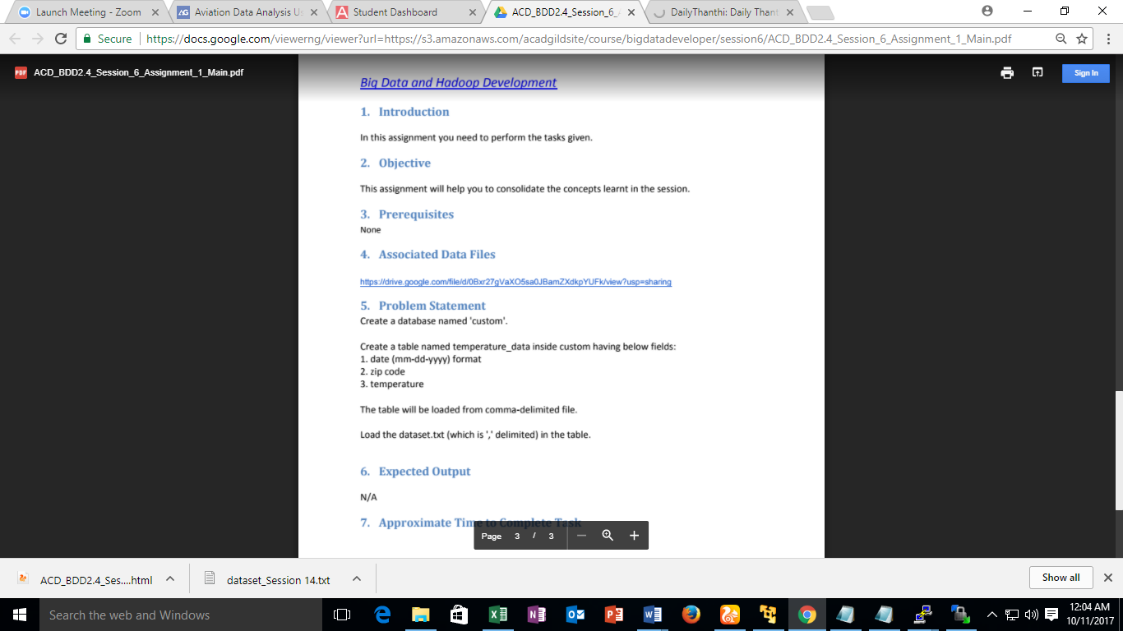

Assignment Answer:

