Assignment 6.1 creating database custom and loading the datasets.
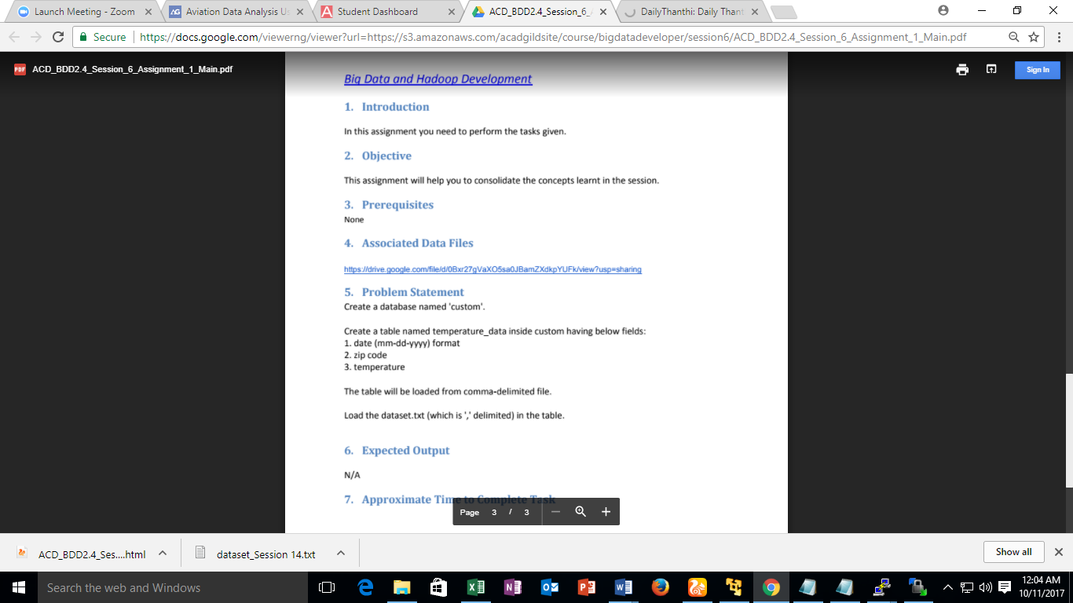
Assignment Answer:
