Session 6: HIVE Introduction
Assignment 6.2
Write HIVE commands to achieve the tasks provided in the problem statement.

Introduction
In this assignment we are going to perform the below tasks using HIVE commands.

Input Data set
https://drive.google.com/file/d/0Bxr27gVaXO5sa0JBamZXdkpYUFk/view?usp=sharing

Problem Statement
- Fetch date and temperature from temperature_data where zip HIVE Commands is greater than 300000 and less than 399999.
- Calculate maximum temperature corresponding to every year from temperature_data table.
- Calculate maximum temperature from temperature_data table corresponding to those years which have at least 2 entries in the table.
- Create a view on the top of last query, name it temperature_data_vw.
- Export contents from temperature_data_vw to a file in local file system, such that each file is '|' delimited.

Prerequisite
- Create a DATABASE “custom” and create a TABLE “temperature_data” inside custom having below fields:
date (mm-dd-yyyy) format
zip code
temperature
As part of the Assignment 6.1 we had created the Database as per the above,
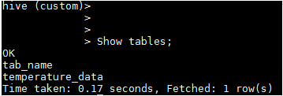
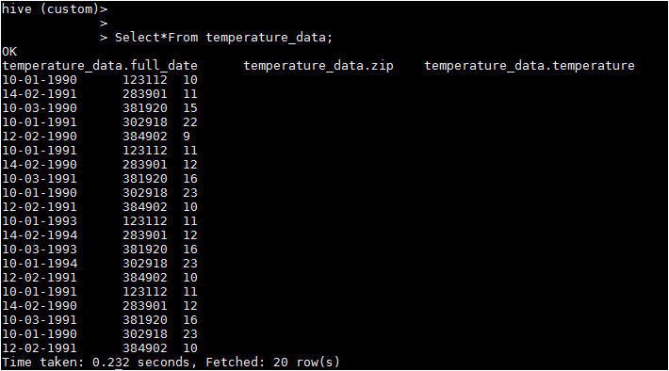
Hence we are going to perform the task provided for this assignment.

Task1
Fetch date and temperature from temperature_data where zip is greater than 300000 and less than 399999.

HIVE Commands
hive (custom) >Select * From temperature_data where zip BETWEEN 300000 AND 399999;

Output
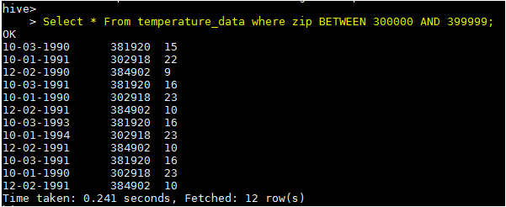

Task2
Calculate maximum temperature corresponding to every year from temperature_data table.

HIVE Commands
hive (custom) > SELECT SUBSTRING(full_date,7,4), MAX(temperature) FROM custom.temperature_data GROUP BY SUBSTRING(full_date,7,4);

Output
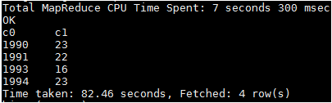

TASK 3
Calculate maximum temperature from temperature_data table corresponding to those years which have at least 2 entries in the table.

HIVE Commands
hive(custom)>SELECT full_date, MAX(t1.temperature) as temperature FROM (SELECT SUBSTRING(full_date,7,4) full_date, temperature FROM temperature_data)t1 GROUP BY full_date HAVING count(t1.full_date)>=2;

Output
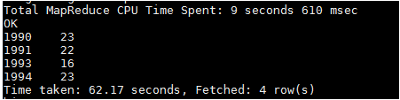

TASK 4
Create a view on the top of last query, name it temperature_data_vw.

HIVE Commands
CREATE VIEW temperature_data_vw AS SELECT full_date, MAX(t1.temperature) as temperature FROM (SELECT SUBSTRING(full_date,7,4) full_date, temperature FROM temperature_data)t1 GROUP BY full_date HAVING count(t1.full_date)>=2;


Output
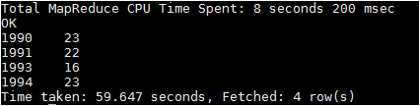

TASK 5
Export contents from temperature_data_vw to a file in local file system, such that each file is '|' delimited.

HIVE Commands
INSERT OVERWRITE LOCAL DIRECTORY '/home/acadgild/hadoop/temperature_data_vw.txt' ROW FORMAT DELIMITED FIELDS TERMINATED BY '|' SELECT * FROM temperature_data_vw;
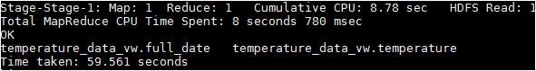

Output
cat /home/acadgild/hadoop/temperature_data_vw.txt/*
