Session 6: HIVE Operations
Assignment 7.1
Calculate the number of employees corresponding to each skill from the table 'employee' which is loaded in the Demo.

Introduction
In this assignment, I’m going to create a table called ‘emp_details’ with a table name called ‘employee’ which contains the columns name, technology, nos and the location. The given dataset file will be loaded in to the database ‘emp_details’ into the table employee.
The given dataset file is placed at home/acadgild/hadoop.

Associated Data files
https://drive.google.com/file/d/0Bxr27gVaXO5sQWV4UUpOXzNuZDA/view?usp=sharing

Problem Statement
Calculate the number of employees corresponding to each skill from the table 'employee' which is loaded in the Demo.

HIVE Queries
- CREATE DATABASE emp_details;
- USE emp_details;
- CREATE TABLE employee
(name STRING,
technology STRING,
nos INT,
location STRING)
ROW FORMAT DELIMITED
FIELDS TERMINATED BY ',';
LOAD DATA LOCAL INPATH '/home/acadgild/hadoop/emp_details.txt'
INTO TABLE emp_details.employee;

- Creating a Database named emp_details
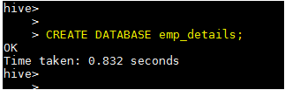
- Create a Table employee with the columns name, technology and location as STRING type and nos as integer type. We are taking the input data from the location '/home/acadgild/hadoop/emp_details.txt'

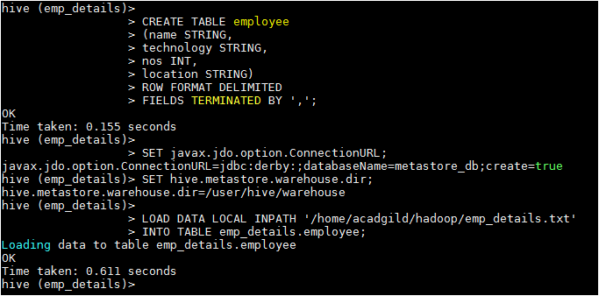

- Data in the table employee
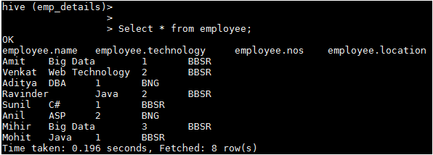

Task
Now, calculate the number of employees corresponding to each skill from the table 'employee'

HIVE Query
Select technology, SUM(t1.nos) as No_Of_Employee FROM(Select technology, nos FROM employee) t1 GROUP BY technology;

Expected Output
