Session 7: HIVE Operations
Assignment 7.2
This Data set is about Olympics. Write HIVE programs to finish the provided tasks

Introduction
The data set consists of the following fields:
Athlete: This field consists of the athlete name
Age: This field consists of athlete ages
Country: This fields consists of the country names which participated in Olympics
Year: This field consists of the year
Closing Date: This field consists of the closing date of ceremony
Sport: Consists of the sports name
Gold Medals: No. of Gold medals
Silver Medals: No. of Silver medals
Bronze Medals: No. of Bronze medals
Total Medals: Consists of total no. of medals

Associated Data files
https://drive.google.com/open?id=0ByJLBTmJojjzV1czX3Nha0R3bTQ

Problem Statement
1. Write a Hive program to find the number of medals won by each country in swimming.
2. Write a Hive program to find the number of medals that India won year wise.
3. Write a Hive Program to find the total number of medals each country won.
4. Write a Hive program to find the number of gold medals each country won.

HIVE Queries create a Database and a table providing the Input Dataset.
CREATE DATABASE olympic;
USE olympic;
CREATE TABLE olympic_data
(Athlete STRING, Age INT, Country STRING, Year INT, Closing_Date STRING, Sport STRING, Gold_Medals INT, Silver_Medals INT, Bronze_Medals INT,Total_Medals INT)
ROW FORMAT DELIMITED FIELDS TERMINATED BY '\t';
LOAD DATA LOCAL INPATH '/home/acadgild/hadoop/olympic_data.json'
INTO TABLE olympic_data;

Task1
Write a Hive program to find the number of medals won by each country in swimming.

HIVE Query
SELECT country, SUM(total_medals) as Total_Medals FROM olympic_data WHERE sport<=>'Swimming' GROUP BY country;
Expected Output
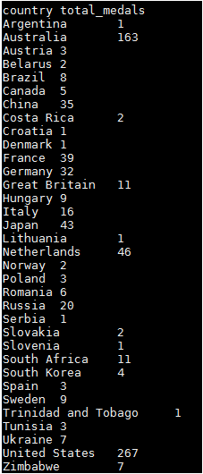

TASK2
Write a Hive program to find the number of medals that India won year wise.

HIVE Query
SELECT year, SUM(total_medals) FROM olympic_data Where country<=>'India' GROUP BY year;
Expected Output
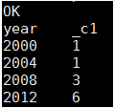

TASK3
Write a Hive Program to find the total number of medals each country won.

HIVE Query
SELECT country, SUM(total_medals) as Total_Medals FROM olympic_data GROUP BY country;

Expected Output
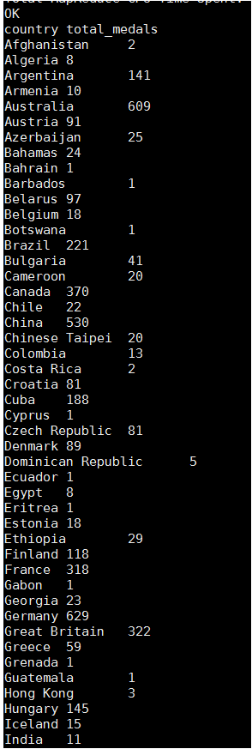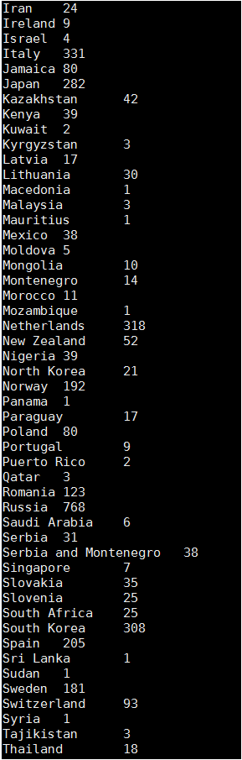
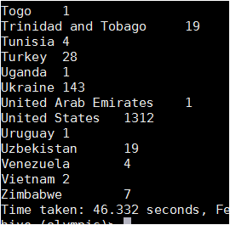

Task4
Write a Hive program to find the number of gold medals each country won.

HIVE Query
SELECT country, SUM(gold_medals) as GOLD_Medals FROM olympic_data GROUP BY country;
Expect Output
