RDD’S IN SPARK
Assignment 17.1

Problem Statement

1. Write a program to read a text file and print the number of rows of data in the document.
2. Write a program to read a text file and print the number of words in the document.
3. We have a document where the word separator is -, instead of space. Write a spark
code, to obtain the count of the total number of words present in the document.

Sample document :

This-is-my-first-assignment.
It-will-count-the-number-of-lines-in-this-document.
The-total-number-of-lines-is-3

Solution:-
Starting Spark shell
Command - spark-shell
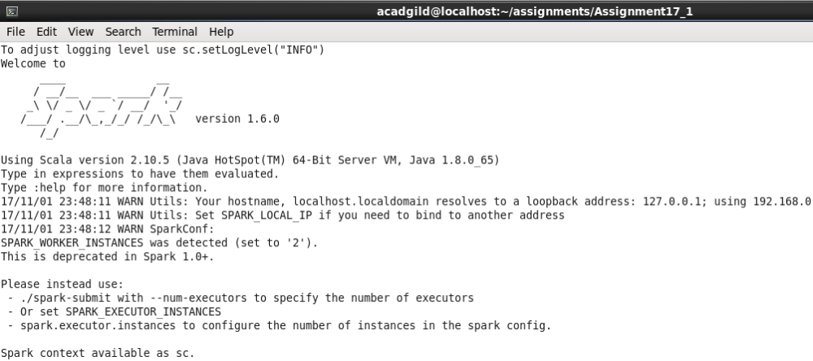

Created file1.txt (space separated words), file2.txt(hyphen separated words) and placed them at /home/acadgild/assignments/Assignment17_1 in VM
Files- 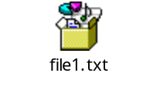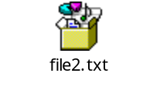
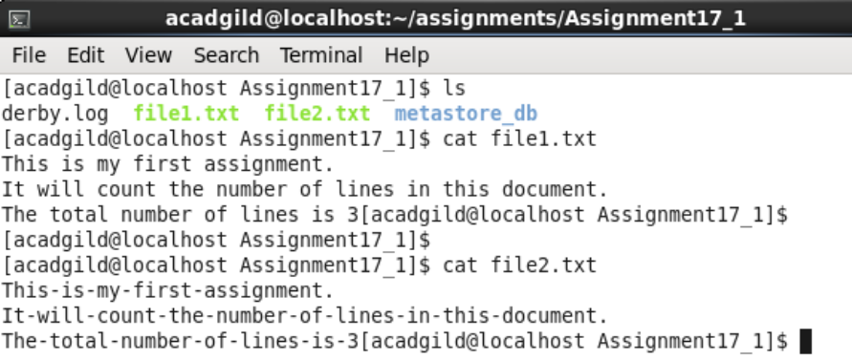
- Write a program to read a text file and print the number of rows of data in the document.

Loading the text file to RDD –
scala> val textData = sc.textFile(“file1.txt”);

Finding count of data rows –
scala> textData.count();

Screenshot:-

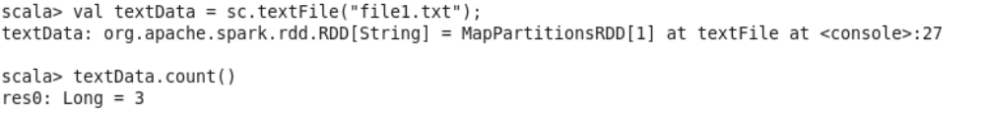

- Write a program to read a text file and print the number of words in the document.

Loading the text file to RDD –
scala> val textData = sc.textFile(“file1.txt”);

Since the RDD has already been created. Re-using the same for solution to this problem.

Splitting a line by space and counting words per line

Scala> val wordCount = textData.flatMap(line => line.split(" ")).map(word => (word, 1)).reduceByKey(_ + _);

scala> wordCount.foreach(println);

scala> wordCount.map(_._2).sum();

Screenshot:-

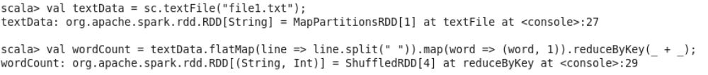
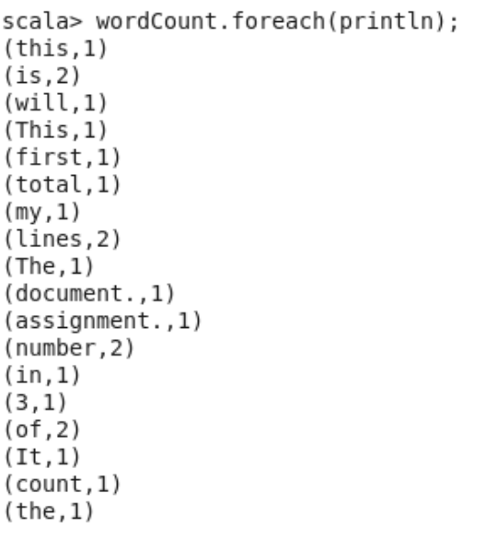
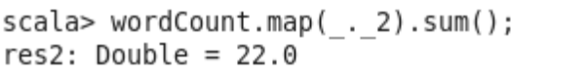

The command returns that there are 22 words in the file1.txt.

- We have a document where the word separator is -, instead of space. Write a spark code, to obtain the count of the total number of words present in the document.

Loading the text file to RDD –
scala> val textData2 = sc.textFile(“file2.txt”);

Splitting a line by hyphen and counting words per line.

Scala> val wordCount2 = textData2.flatMap(line => line.split("-")).map(word => (word, 1)).reduceByKey(_ + _);

scala> wordCount2.foreach(println);

scala> wordCount2.map(_._2).sum();

Screenshot:-
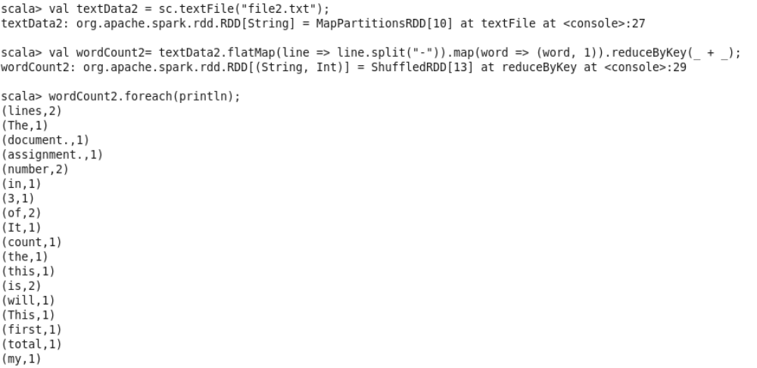

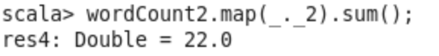

The command returns that there are 22 words in the file2.txt.

