REQUIREMENTS AND IMPLEMENTATION DOCUMENT
PROJECT 1: SALES PERFORMANCE DASHBOARD
Tools Used: Microsoft Excel and Power BI

1. REAL-WORLD SCENARIO
Sales organisations generate large amounts of order data through their daily business activities. Analysing this information manually can make it difficult to understand overall sales performance, identify trends, and compare product and regional performance.
This project focuses on developing an interactive Sales Performance Dashboard that transforms raw sales data into meaningful business information. The dashboard helps a Sales Manager monitor revenue, track monthly performance, compare products and regions, and make informed business decisions.

2. PROJECT OBJECTIVE
The main objective of this project is to analyse sales data and develop an interactive dashboard using Microsoft Excel and Power BI.
The project aims to:
- Clean and organise the provided sales dataset.
- Calculate important sales performance indicators.
- Analyse monthly revenue trends.
- Compare product-wise and region-wise sales.
- Create interactive dashboard filters.
- Present meaningful business insights through an executive summary.

3. BUSINESS USE CASE
Primary Stakeholder: Sales Manager.
Business Need:
The Sales Manager needs a clear and consolidated view of sales performance across different products, regions, and months to understand where revenue is being generated.
Business Decisions Supported:
- Identify high-performing and low-performing products.
- Compare sales performance across different regions.
- Understand monthly revenue trends.
- Support sales planning and resource allocation.
Expected Business Benefits:
The dashboard supports faster performance reviews, clearer identification of sales trends, and more informed business planning. These are expected benefits; no measured financial improvement is claimed by this project.

4. PROBLEM STATEMENT
The business needs a reliable and understandable way to review sales performance using order-level data.
The project uses the provided sales dataset as input and produces validated KPI summaries, product-wise and region-wise comparisons, monthly revenue trends, interactive Power BI dashboard views, and an executive summary.
Input Data:
- Order ID
- Order Date
- Product
- Quantity
- Unit Price
- Total Sales
- Region
- Salesperson
Expected Outputs:
- Total Revenue
- Total Orders
- Units Sold
- Average Order Value
- Monthly Revenue Trends
- Product Performance Analysis
- Regional Sales Analysis
- Executive Summary
Project Constraints:
The dataset contains 240 order records covering January to June 2026. Website visits, leads, costs, and expenses were not provided. Therefore, conversion rate and profit could not be calculated.
Success Conditions:
The project is considered successful when the data is properly validated, KPI calculations are accurate, dashboard values match the Excel summaries, interactive filters work correctly, and the final project files are organised.

5. REQUIRED FEATURES
The project includes the following features:
- Calculation of key sales performance indicators.
- Monthly revenue trend analysis.
- Product-wise sales comparison.
- Region-wise sales comparison.
- Interactive Region, Product, and Date Range filters.
- KPI cards for displaying important sales metrics.
- Charts and visual representations of sales performance.
- Executive summary containing meaningful business observations.
- Data validation and calculation verification.

6. FUNCTIONAL AND PROFESSIONAL REQUIREMENTS
Stakeholder:
The primary stakeholder is the Sales Manager or business user responsible for reviewing sales performance.
Project Scope:
The project covers data cleaning, data validation, KPI calculations, monthly trend analysis, product and regional comparisons, interactive dashboard filters, and an executive summary.
Out of Scope:
Conversion-rate analysis, profit and margin analysis, forecasting, and customer-level analysis are not included because the required source data is unavailable.
Repeatable Workflow:
The original dataset is preserved separately. Data cleaning and validation are performed in a separate Excel workbook. The cleaned data is then used for dashboard development, and screenshots are retained as supporting evidence.
Edge Cases and Exceptions:
The following data-quality conditions are considered during validation:
- Blank or missing fields.
- Duplicate order IDs or records.
- Invalid date values.
- Non-positive quantities.
- Missing product or region values.
- Inconsistencies between quantity multiplied by unit price and total sales.
Any identified exceptions should be investigated and documented rather than silently changing the original data.
Validation Evidence:
Screenshots of data validation, KPI calculations, dashboard visuals, and interactive filter testing are retained in the project folder.
Future Improvements:
Additional website traffic, lead, cost, and expense information can be included in future versions to support conversion-rate and profit analysis.

7. TECHNICAL / METHOD REQUIREMENTS
Tools Used:
- Microsoft Excel – Data cleaning, formatting, validation, PivotTables, and preliminary analysis.
- Microsoft Power BI – KPI cards, charts, interactive slicers, and executive summary.
Technology Selection:
Excel and Power BI were selected because they are suitable for the available dataset and project requirements. SQL was not required for the completed workflow.
Project Organisation:
The original dataset, cleaned workbook, Power BI dashboard, documentation, presentation, and screenshots are maintained in clearly organised folders.
Version Control:
Important project changes can be maintained through dated copies or a version-controlled repository. The original dataset is preserved without overwriting the only source copy.
Data Integrity:
The original field meanings are preserved, calculations are validated, and unavailable data fields are clearly disclosed.
Responsible Data Handling:
Personal or confidential information should not be included in publicly shared portfolio screenshots or repositories. Only project data permitted for publication should be shared.

8. SUGGESTED TECHNOLOGY STACK
The internship guidelines recommend tools such as Power BI, Tableau, or Looker Studio for data visualisation, along with SQL and Excel for data preparation and analysis.
For this project, the following tools were selected:
- Microsoft Excel
- Microsoft Power BI
These tools were sufficient to complete the data preparation, analysis, KPI calculations, and dashboard development required for this project.

9. STEP-BY-STEP IMPLEMENTATION PLAN
Step 1: Understanding the Project
Reviewed the business scenario and identified the stakeholder, project objectives, required outputs, and success conditions.
Step 2: Dataset Inspection
Inspected the original dataset and reviewed the available columns, data types, date range, and total number of records.
Step 3: Data Cleaning and Validation
Cleaned and formatted the dataset using Microsoft Excel. Checked missing values, duplicate records, invalid entries, and sales calculation consistency.
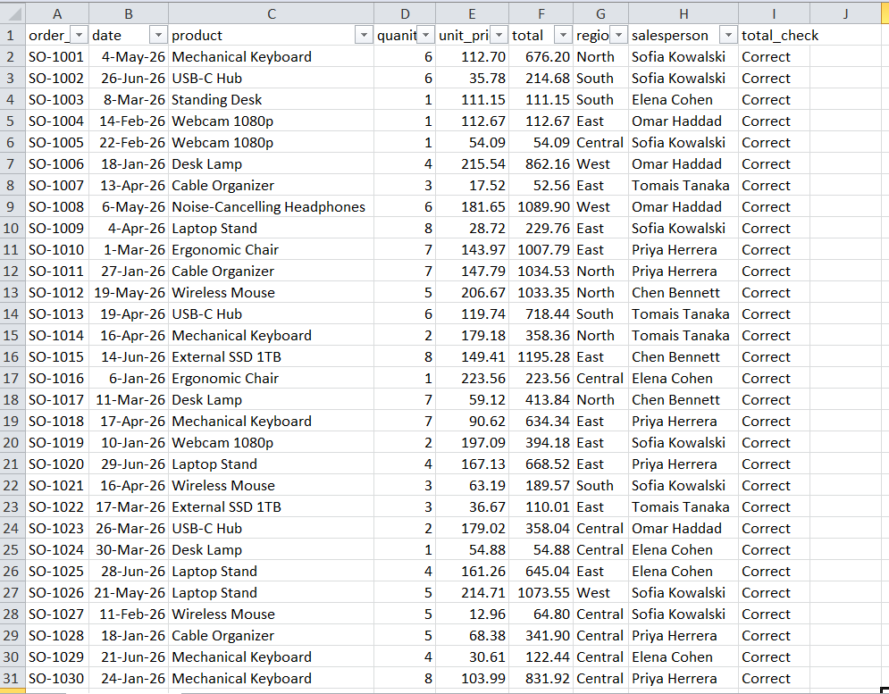
Step 4: Data Analysis
Created KPI calculations, PivotTables, and summary calculations to analyse the sales data.
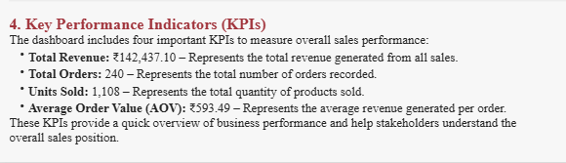
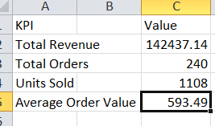
Step 5: Dashboard Development
Imported the cleaned dataset into Power BI and developed KPI cards, monthly revenue charts, product comparisons, regional comparisons, and interactive slicers.
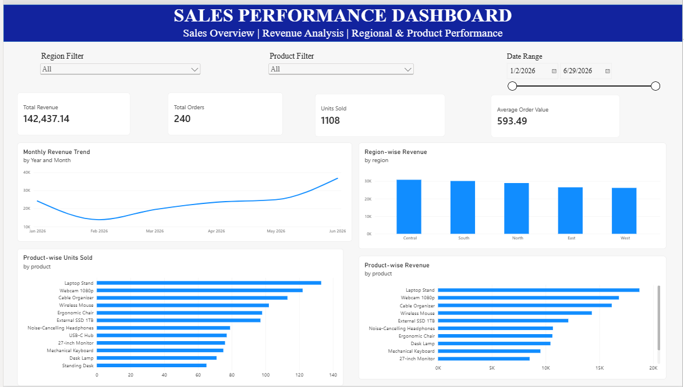
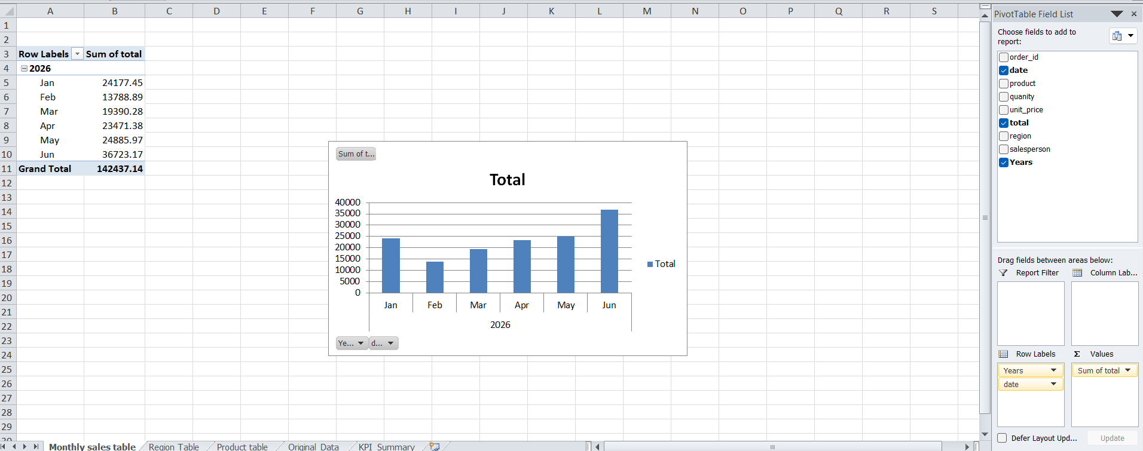
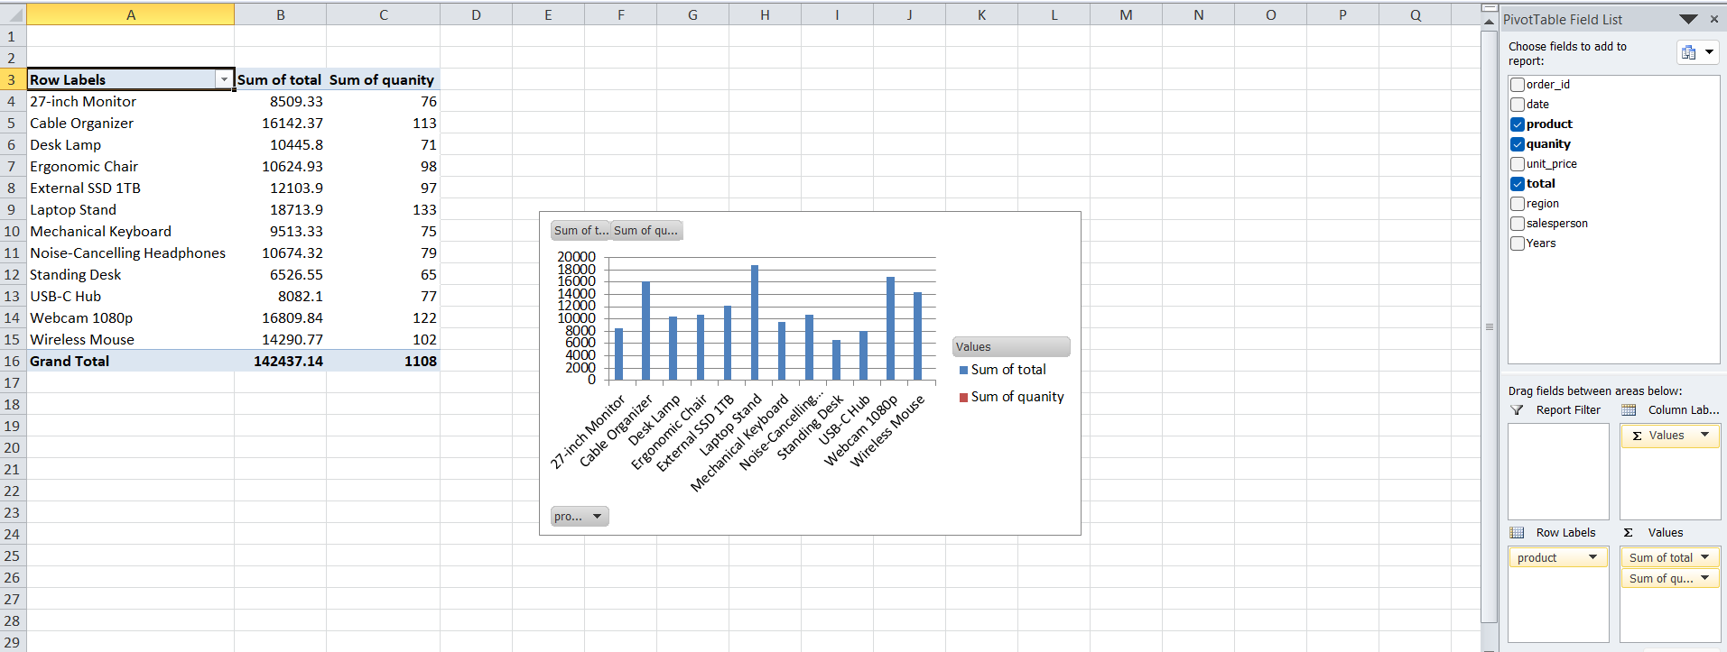
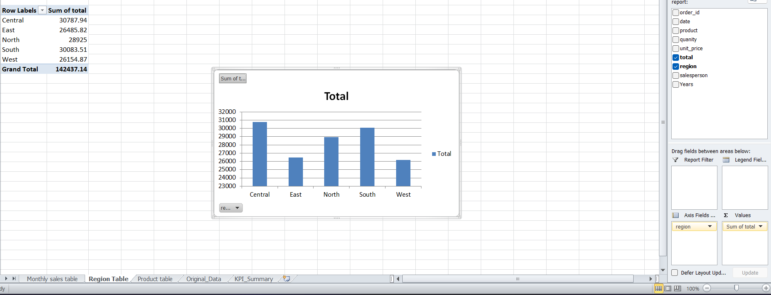
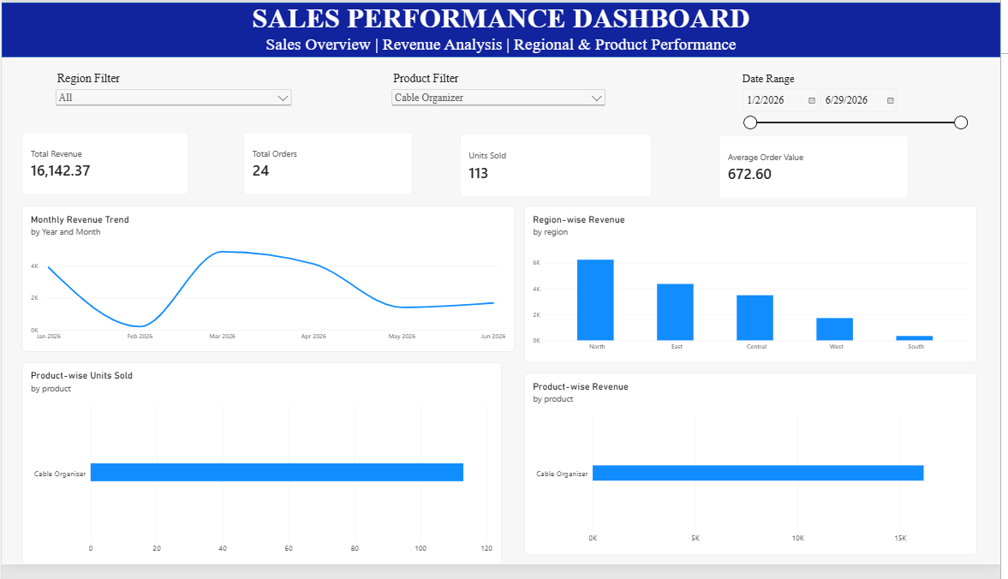
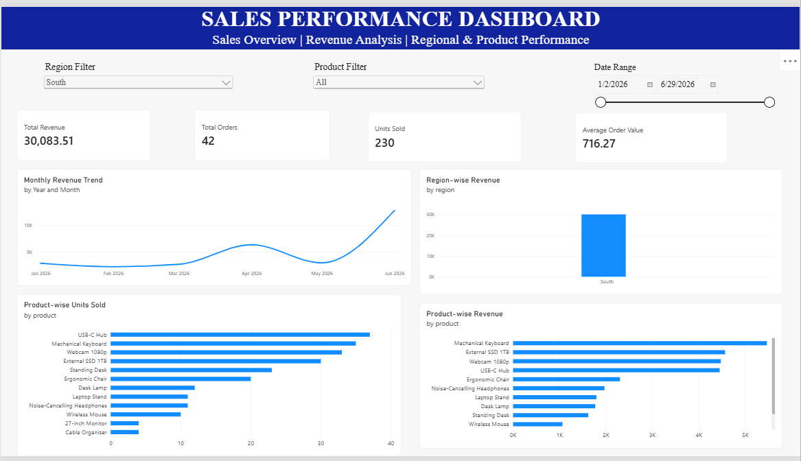
Step 6: Executive Summary
Prepared an executive summary to communicate the main sales performance observations supported by the available data.
Step 7: Testing and Validation
Compared Power BI KPI values with Excel summaries, tested interactive filters, and captured screenshots as supporting evidence.
Step 8: Final Documentation
Organised the project files, prepared the README and requirements documentation, reviewed the presentation, and prepared the final project package.

10. WEEK-BY-WEEK PROJECT PLAN
Week 1 – Research and Planning
- Understand the business problem.
- Identify stakeholders and project objectives.
- Inspect the available dataset.
- Define KPIs and project requirements.
- Prepare the project folder structure.
Week 2 – Core Implementation
- Clean and validate the dataset using Excel.
- Calculate important KPIs.
- Create PivotTables and summaries.
- Prepare the Power BI data model and initial visuals.
Week 3 – Analysis and Refinement
- Complete dashboard visuals and slicers.
- Prepare the executive summary.
- Review sales insights.
- Test calculations and interactive filters.
Week 4 – Quality and Submission
- Complete validation evidence.
- Document project limitations.
- Finalise the README and requirements document.
- Review the final presentation.
- Organise project files and prepare portfolio and viva materials.

11. PROJECT DELIVERABLES
The final project package contains the following deliverables:
1. Dataset Folder
- Original_Data.csv
- Cleaned_data.xlsx
2. Power BI Folder
- Sales_performance_Dashboard.pbix
- Executive Summary
3. Documentation Folder
- README
- Requirements and Implementation Document
- Project Requirements Document
4. Presentation Folder
- Sales Performance Dashboard Presentation
5. Screenshots Folder
- Data validation screenshots.
- KPI summary screenshot.
- Dashboard screenshots.
- Revenue analysis screenshots.
- Product analysis screenshots.
- Slicer and filter testing screenshots.
These deliverables provide the working files, analysis, documentation, validation evidence, and presentation required to review the project.

12. EXPECTED FINAL OUTPUT
The expected final output is a complete, organised, and presentation-ready Sales Performance Dashboard project package.
The project demonstrates the process of transforming raw sales data into meaningful business information using Excel and Power BI.
The final package includes the original and cleaned datasets, interactive dashboard, executive summary, documentation, validation evidence, and presentation.

13. ACCEPTANCE CRITERIA
The project is considered ready for submission when the following conditions are verified:
- The project objective, stakeholder, scope, inputs, outputs, and limitations are documented.
- The original dataset and cleaned workbook are maintained separately.
- Data-quality checks and sales calculation validation are documented.
- Power BI KPI values match the Excel summary.
- Monthly revenue, product performance, and regional performance are represented in the dashboard.
- Region, Product, and Date Range slicers work correctly.
- The executive summary presents observations supported by the dataset.
- Screenshots provide evidence of cleaning, validation, KPI summaries, dashboard visuals, and filter testing.
- README, requirements document, Power BI file, dataset, presentation, and evidence are organised properly.
- Known issues and unavailable measures, including conversion rate and profit, are clearly disclosed.

14. EVALUATION RUBRIC AND SELF-REVIEW
The project can be reviewed using the evaluation criteria provided in the internship guidelines.
Evaluation Criteria:
- Requirements and Domain Understanding – 15 Marks
- Technical / Professional Execution – 25 Marks
- Quality, Accuracy and Validation – 20 Marks
- Problem-Solving and Independence – 15 Marks
- Documentation and Reproducibility – 10 Marks
- Presentation and Communication – 10 Marks
- Creativity and Improvement Thinking – 5 Marks
Total: 100 Marks
Self-Review:
The project includes data preparation, KPI calculations, dashboard development, validation, documentation, and presentation. The final self-review score should be assigned only after checking the completed project evidence against each evaluation criterion.

15. PORTFOLIO VALUE
Portfolio Project Title:
Sales Performance Dashboard | Excel and Power BI
Project Description:
Developed an interactive Sales Performance Dashboard using Microsoft Excel and Power BI. Cleaned and validated 240 sales records covering January to June 2026, calculated key sales performance indicators, and analysed monthly revenue, product-wise, and region-wise performance.
Created an interactive dashboard with Region, Product, and Date Range filters, along with an executive summary to communicate business observations.
Portfolio Presentation:
The project can be presented through:
- A resume project description.
- A GitHub repository containing permitted project files.
- A professional LinkedIn project post.
- Selected dashboard screenshots.
- A short explanation of the business problem, implementation, results, and limitations.
Before publishing, confirm that the dataset is permitted for public sharing and remove any confidential information. A GitHub or portfolio link can be added once the repository is created.

16. VIVA PREPARATION
The following questions are useful for explaining the project during a viva or project evaluation.
1. What business problem does your dashboard solve, and who is the primary stakeholder?
2. What was the most important technical or analytical decision you made during the project, and why?
3. How did you validate the source data, calculations, and dashboard KPI values?
4. What edge cases, limitations, or risks did you identify, and how did you handle them?
5. What changes would you make if the dataset increased to ten times its current size?
6. How would you explain the dashboard's key findings to a non-technical stakeholder?
7. Which part of the project required the most independent problem-solving, and what did you learn?
The answers should be prepared separately using the actual implementation, tools, calculations, and decisions made during the project.

17. ADVANCED CHALLENGE AND FUTURE IMPROVEMENTS
The advanced challenge is an optional extension of the core project. It focuses on identifying possible improvements that could make the dashboard more useful and suitable for future business requirements.
Possible Future Improvements:
- Add a data refresh and monitoring checklist to track data freshness and dashboard accuracy.
- Include additional stakeholder requirements and test more edge cases when new data becomes available.
- Automate repetitive data-cleaning or refresh activities and document the time saved.
- Include website visits and lead information to support conversion-rate analysis.
- Include cost and expense information to support profit and margin analysis.
- Prepare a production-readiness roadmap covering scheduled refresh, access control, data-quality monitoring, and user feedback.
Current Status:
These improvements are proposed future enhancements and are not part of the completed implementation unless they are separately developed and tested.

