DATABASE MANAGEMENT SYSTEM
ASSIGNMENT SESSION – 6

Que-1 Create a SQL query using GROUP BY to show the total number of orders placed by each user in an 'orders' table, displaying user_id and order_count.
SELECT user_id COUNT(*) AS order_count
FROM orders
GROUP BY user_id;
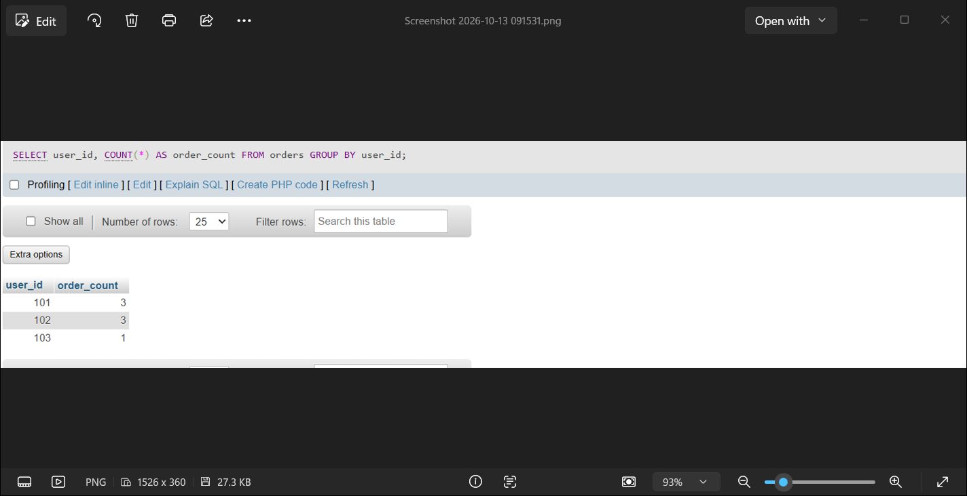

Que-2 Write a SQL query to display the names of restaurants from a 'restaurants' table that have received an average rating above 4.0, using GROUP BY and HAVING.
SELECT name, AVG(rating) AS average_rating
FROM restaurant GROUP BY name
HAVING AVG(rating)>4.0;
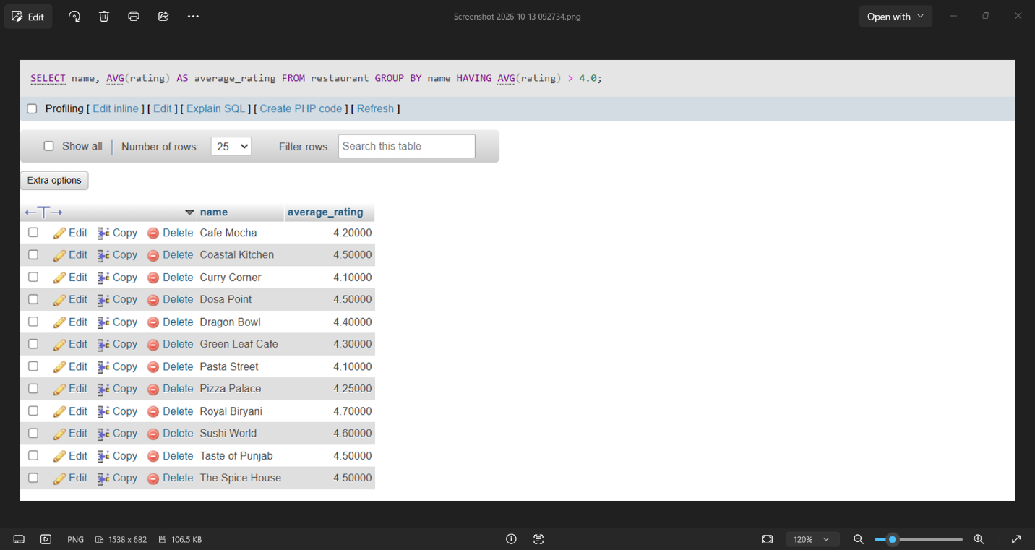

Que – 3 Suppose you have a 'payments' table with columns user_id, amount, and payment_date. Write a subquery to find user_ids who have made a single payment above ₹2000 in any transaction.
SELECT user_id FROM payments
WHERE user_id IN (SELECT user_id
FROM payment
WHERE amount>2000);
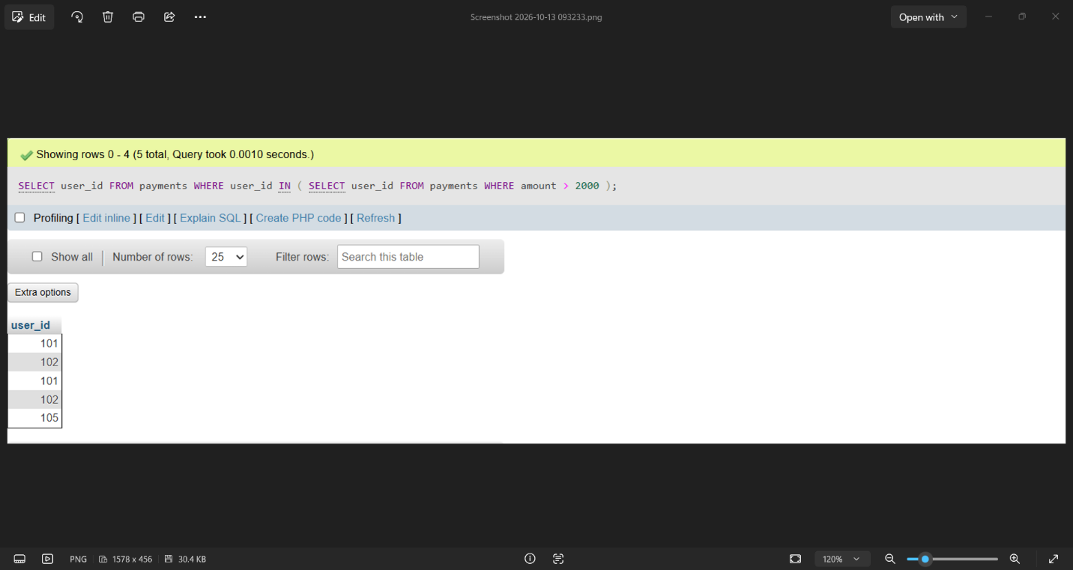

Que-4 Using a nested subquery, display the names of movies from a 'movies' table that have a higher average rating than the overall average rating of all movies.<br><br><em><strong>Hint:</strong> Use a subquery to calculate the overall average rating, then compare each movie's average rating against it in the main query.</em>
SELECT name
FROM movies
WHERE rating > (SELECT AVG(rating) FROM movies);
