DATABASE MANAGEMENT SYSTEM

ASSIGNMENT SESSION – 1

Que-1 Install MySQL Workbench on your computer, connect to the local MySQL server, and take a screenshot of the default databases shown in the Schemas panel.
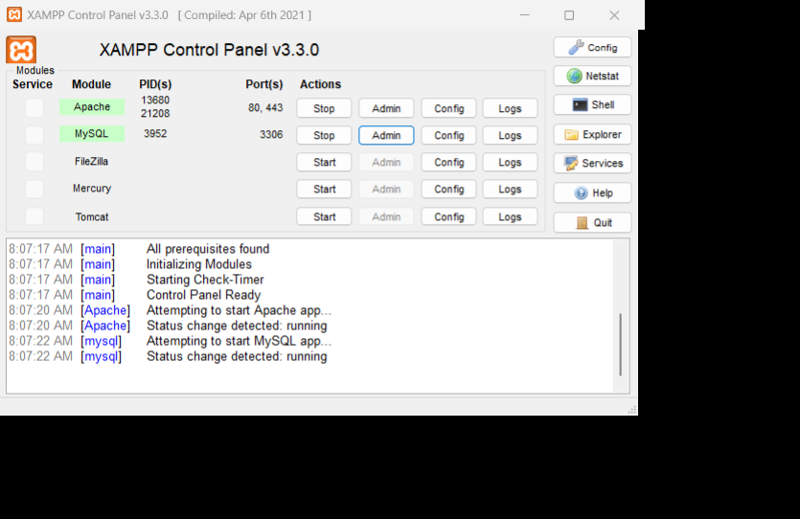

Que -2 Create a new database called InstaClone in MySQL Workbench, then create a table named Users with columns: user_id (INT, primary key), username (VARCHAR), email (VARCHAR), and followers_count (INT).
CREATE DATABASE InstaClone;

USE InstaClone;

CREATE TABLE Users (
user_id INT PRIMARY KEY,
username VARCHAR(255),
email VARCHAR(255),
followers_count INT
);

Que-3 Insert 3 sample users into the Users table you created, using realistic Instagram-style usernames and follower counts.
INSERT INTO Users (user_id, username, email, followers_count)
VALUES
(1, 'travelwithriya', 'riya@example.com', 12500),
(2, 'techwitharjun', 'arjun@example.com', 8700),
(3, 'foodie_ishita', 'ishita@example.com', 21300);

Que -4 Create another table in the InstaClone database called Posts with columns: post_id (INT, primary key), user_id (INT), caption (VARCHAR), and post_date (DATE). Add a foreign key from Posts.user_id to Users.user_id to establish a relationship.
USE InstaClone;

CREATE TABLE Posts (
post_id INT PRIMARY KEY,
user_id INT,
caption VARCHAR(255),
post_date DATE,
FOREIGN KEY (user_id) REFERENCES Users(user_id)
);

Que -5 Write a short comparison (3-4 lines each) of MySQL, PostgreSQL, Oracle, and SQLite, focusing on where each one is commonly used (for example: web apps, mobile apps, enterprise systems, etc.).
MySQL
MySQL is widely used for web applications and websites, especially with PHP, Python, and JavaScript-based systems.
It is popular because it is easy to use, reliable, and has strong community support.
It is commonly used for applications ranging from small websites to large-scale web platforms.
PostgreSQL
PostgreSQL is an advanced open-source database commonly used for web applications, data analytics, and complex systems.
It provides strong support for complex queries, transactions, and large datasets.
It is popular in modern backend applications and data-intensive projects.
Oracle
Oracle Database is mainly used in large enterprise systems, including banking, finance, telecommunications, and government organizations.
It is designed for high performance, security, scalability, and large amounts of business data.
It is especially common where reliability and advanced enterprise features are important.
SQLite
SQLite is a lightweight, serverless database commonly used in mobile apps, desktop applications, and embedded systems.
It stores the entire database in a single file and does not require a separate database server.
It is widely used in applications such as Android/iOS apps and small local applications.

