DATABASE MANAGEMENT SYSTEM
ASSIGNMENT SESSION – 7

Que-1 Create a table called Restaurant with columns: id, name, location, and cuisine. Apply NOT NULL constraint to name and location, and make id the PRIMARY KEY.
CREATE TABLE Restaurant (
id INT PRIMARY KEY,
name VARCHAR(100) NOT NULL,
location VARCHAR(255) NOT NULL,
cuisine VARCHAR(100)
);
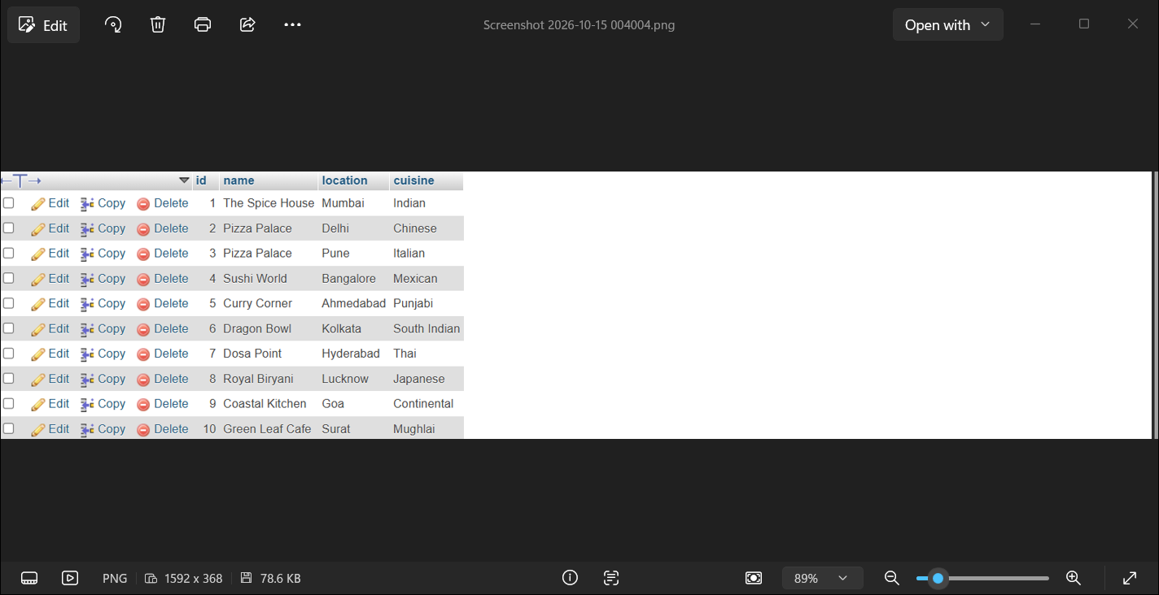

Que-2 Create a table called FoodOrder with columns: order_id, restaurant_id, user_id, and order_total. Set order_id as PRIMARY KEY, and add a FOREIGN KEY constraint on restaurant_id referencing Restaurant(id).
CREATE TABLE FoodOrder (
order_id INT PRIMARY KEY,
restaurant_id INT,
user_id INT,
order_total DECIMAL(10,2),
FOREIGN KEY (restaurant_id) REFERENCES Restaurant(id)
);
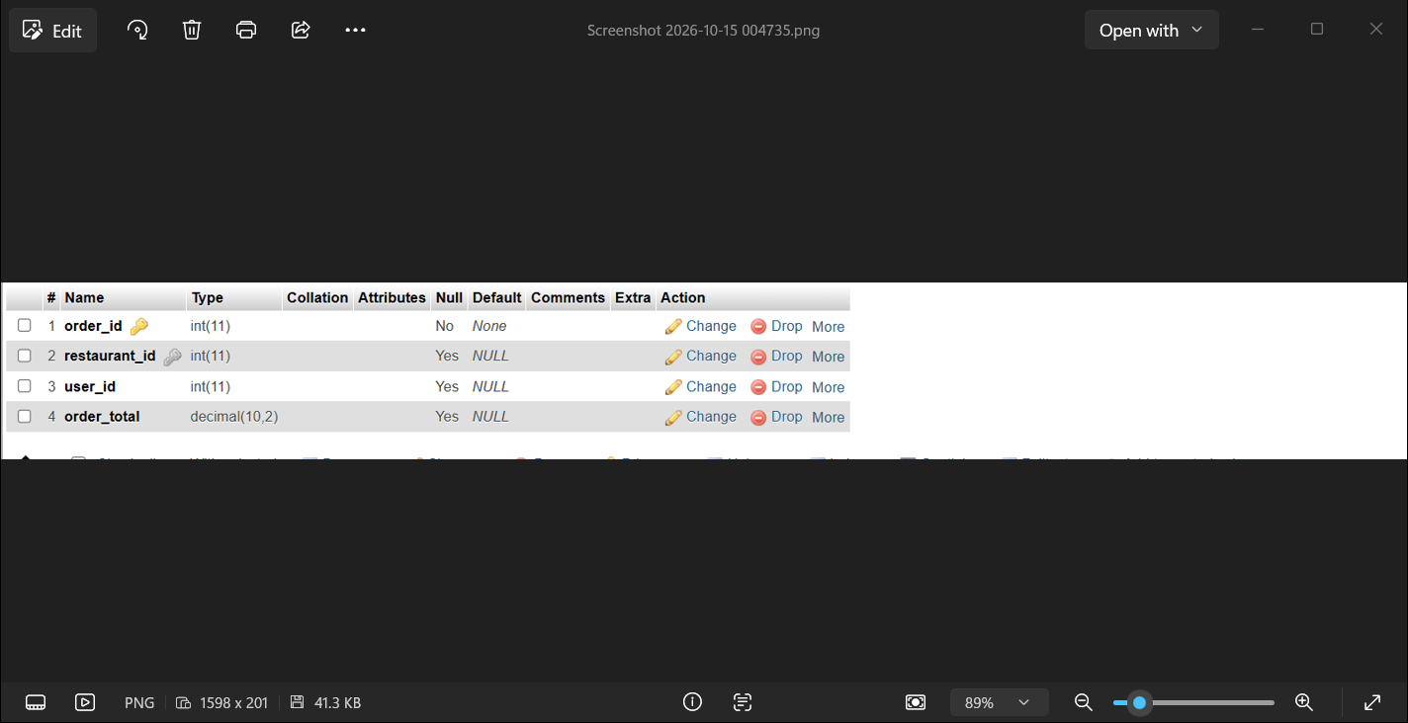

Que-3 Insert 6 rows into a table called SpotifyUser with columns: user_id, username, email, and subscription_type. Ensure that username is UNIQUE and email is NOT NULL.<br><br><em><strong>Hint:</strong> Use the UNIQUE and NOT NULL constraints when creating the table.</em>
CREATE TABLE SpotifyUser (
user_id INT PRIMARY KEY,
username VARCHAR(100) UNIQUE,
email VARCHAR(150) NOT NULL,
subscription_type VARCHAR(50)
);
INSERT INTO SpotifyUser
(user_id, username, email, subscription_type)
VALUES
(1, 'rahul123', 'rahul@gmail.com', 'Premium'),
(2, 'priya456', 'priya@gmail.com', 'Free'),
(3, 'amit789', 'amit@gmail.com', 'Premium'),
(4, 'neha321', 'neha@gmail.com', 'Student'),
(5, 'rohan654', 'rohan@gmail.com', 'Free'),
(6, 'sneha987', 'sneha@gmail.com', 'Premium’);
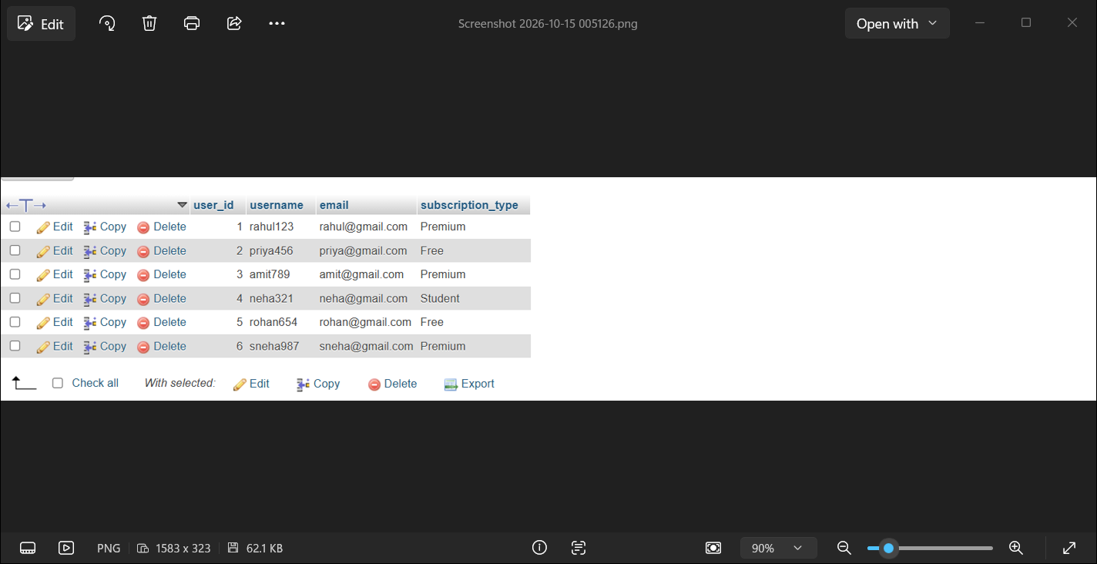

Que-4 Create a VIEW named TopSpendersView that shows usernames and order_total from a FoodOrder table where order_total is greater than 1000.
CREATE VIEW TopSpendersView AS
SELECT s.username, f.order_total
FROM restaurent_management_system.FoodOrder AS f
JOIN music_playlist.SpotifyUser AS s
ON f.user_id = s.user_id
WHERE f.order_total > 1000;


Que-5 Write a SQL query to list all users from the TopSpendersView who have spent more than 2000, sorted by order_total descending.<br><br><em><strong>Constraint:</strong> Only use the TopSpendersView for your query, not the original FoodOrder table.</em>
SELECT *FROM TopSpendersView
WHERE order_total > 2000
ORDER BY order_total DESC;
