CSS

ASSIGNMENT SESSION – 8

Que-1 <p>Add the viewport meta tag `<meta name="viewport" content="width=device-width, initial-scale=1">` to 'index.html' of 'college-fest-page', open the page in the DevTools device toolbar at 360px wide, and save a screenshot named 'before_responsive.png' of how it looks before any media queries. Hint: Press Ctrl+Shift+M in DevTools, choose Responsive and type the width. If you missed Session 7, first build a fest page with three pass cards in a flex row and an 8-tile grid.</p>
OUTPUT:

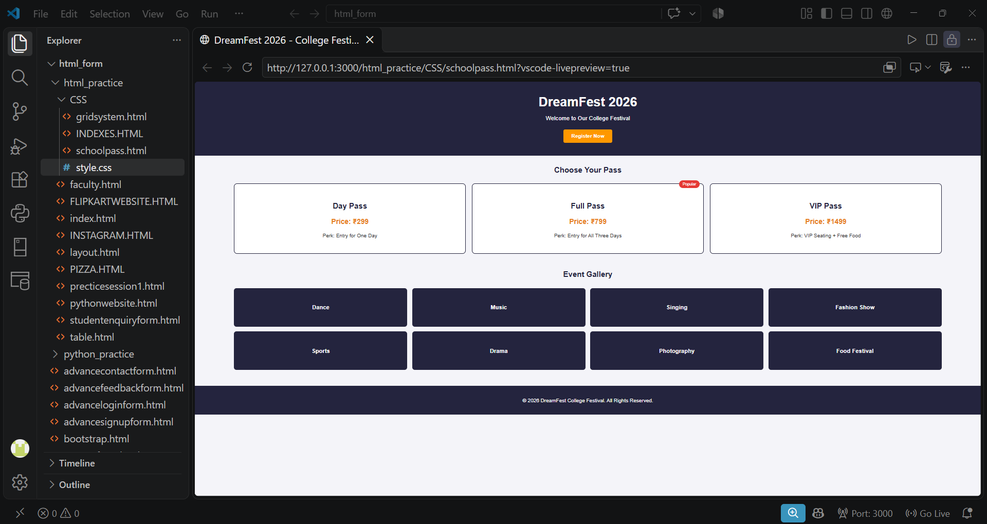

Que-2 <p>Add a media query for max-width: 768px in 'style.css' that stacks the pass cards in one column, stacks the header's title above its nav, and shows the gallery as 2 columns and 4 rows. Hint: A flex row stacks when you set flex-direction: column on its container. Constraint: Use max-width queries only, so the desktop styles stay as the base.</p>
HTML: <!DOCTYPE html>
<html lang="en">

<head>
<meta charset="UTF-8">
<meta name="viewport" content="width=device-width, initial-scale=1.0">

<title>DreamFest 2026 - College Festival</title>

<link rel="stylesheet" href="style.css">
</head>

<body>

<!-- HEADER -->
<header>
<h1>DreamFest 2026</h1>
<p>Welcome to Our College Festival</p>
<a href="#" class="register-btn">Register Now</a>
</header>

<main>

<!-- PASS SECTION -->
<section class="pass-section">

<h2>Choose Your Pass</h2>

<article class="pass-container">

<div class="pass">
<h3>Day Pass</h3>
<p class="price">Price: ₹299</p>
<p>Perk: Entry for One Day</p>
</div>

<div class="pass">
<span class="popular">Popular</span>
<h3>Full Pass</h3>
<p class="price">Price: ₹799</p>
<p>Perk: Entry for All Three Days</p>
</div>

<div class="pass">
<h3>VIP Pass</h3>
<p class="price">Price: ₹1499</p>
<p>Perk: VIP Seating + Free Food</p>
</div>

</article>

</section>

<!-- EVENT GALLERY -->
<section class="gallery-section">

<h2>Event Gallery</h2>

<div class="gallery">

<div class="gallery-item">Dance</div>
<div class="gallery-item">Music</div>
<div class="gallery-item">Singing</div>
<div class="gallery-item">Fashion Show</div>
<div class="gallery-item">Sports</div>
<div class="gallery-item">Drama</div>
<div class="gallery-item">Photography</div>
<div class="gallery-item">Food Festival</div>

</div>

</section>

</main>

<!-- FOOTER -->
<footer>
<p>© 2026 DreamFest College Festival. All Rights Reserved.</p>
</footer>

</body>

</html>

CSS: @media screen and (max-width: 768px) {

body {
background-color: lightyellow !important;
}

.pass-container {
display: flex !important;
flex-direction: column !important;
}

.pass {
width: 100% !important;
}

.gallery {
display: grid !important;
grid-template-columns: repeat(2, 1fr) !important;
grid-template-rows: repeat(4, 120px) !important;
}

header {
display: flex;
flex-direction: column;
align-items: center;
}

}body {
background-color: yellow !important;
}

Que-3 <p>Add a second media query for max-width: 480px that reduces the h1 to 28px, sets the main padding to 12px and shows the gallery as 1 column and 8 rows. Constraint: Put only the rules that change at this width inside the query; do not repeat the 768px rules.</p>
/* EXTRA SMALL MOBILE SCREEN */

@media (max-width: 480px) {

/* Heading Size */
h1 {
font-size: 28px;
}

/* Main Section Padding */
main {
padding: 12px;
}

/* Gallery - 1 Column and 8 Rows */
.gallery {
grid-template-columns: 1fr;
grid-template-rows: repeat(8, 120px);
}

}

Que-4 <p>Finish by testing the page at 360px, 768px and 1200px in the DevTools device toolbar, fixing anything that makes a horizontal scrollbar appear, then save 'after_responsive.png' at 360px and push everything to 'college-fest-page'. Hint: A horizontal scrollbar means some element is wider than the screen; hover elements in the Elements panel to find it, and `max-width: 100%` stops images overflowing.</p>
/* Prevent Horizontal Overflow */

* {
box-sizing: border-box;
}

html, body {
max-width: 100%;
overflow-x: hidden;
}

img {
max-width: 100%;
height: auto;
}

