HTML

ASSIGNMENT SESSION-3

Que-1 <p>Create 'enquiry.html' in your 'tuition-class-site' folder with the same boilerplate as 'index.html' and a form using `method="get"` with four fields: student name (text), parent email (email), parent phone (tel) and age (number), each with a label connected by for and id. Hint: If you missed Session 2, first make 'index.html' with only the boilerplate and one h1. Constraint: Clicking each label must move the cursor into its field.</p>
<!DOCTYPE html>
<html lang="en">
<head>
<meta charset="UTF-8">
<meta name="viewport" content="width=device-width, initial-scale=1.0">
<title>Student Enquiry Form</title>
<align="center">
</head>
<body>

<h1>Student Enquiry Form</h1>

<form method="get">

<label for="student_name">Student Name:</label>
<input type="text" id="student_name" name="student_name">
<br><br>

<label for="parent_email">Parent Email:</label>
<input type="email" id="parent_email" name="parent_email">
<br><br>

<label for="parent_phone">Parent Phone:</label>
<input type="tel" id="parent_phone" name="parent_phone">
<br><br>

<label for="age">Student Age:</label>
<input type="number" id="age" name="age">
<br><br>

<input type="submit" value="Submit Enquiry">

</form>

</body>
</html>
OUTPUT: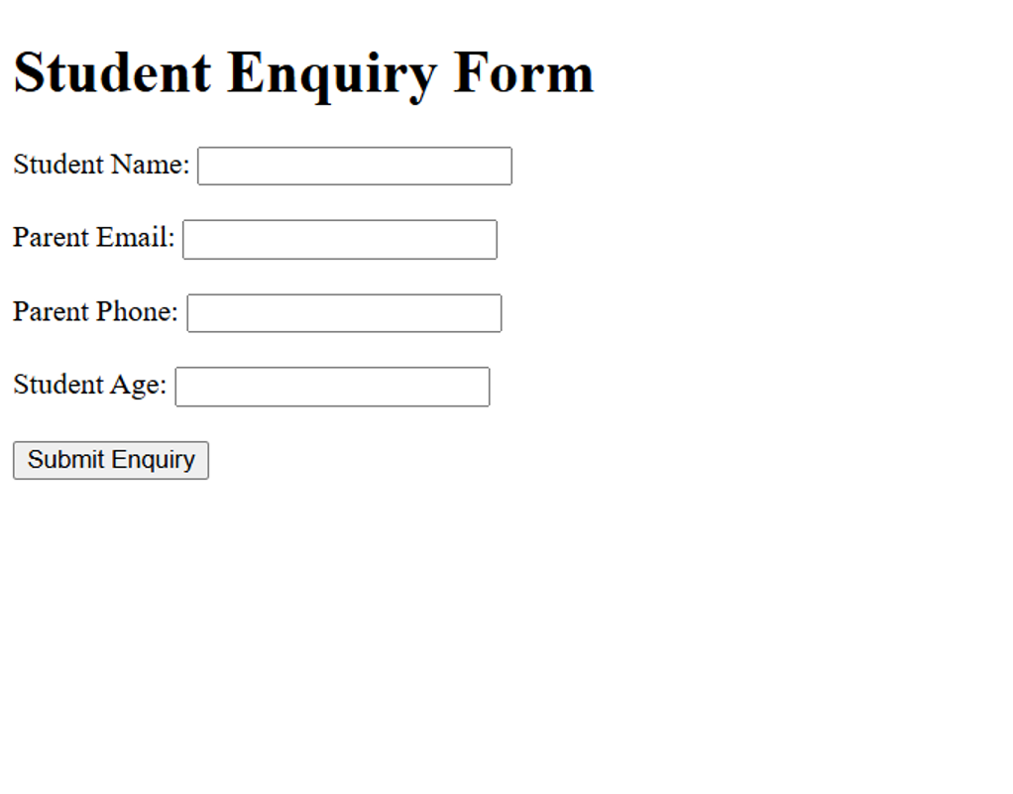
Que-2 <p>Extend 'enquiry.html' with a select named 'subject' whose options are the five subjects from your 'index.html', two radio buttons named 'mode' (Online and Offline), and a textarea named 'message' that is 4 rows tall and 40 columns wide. Hint: Radio buttons act as one group only when they share the same name value. Constraint: The select must start with an empty-value option reading 'Choose a subject'.</p>

<!DOCTYPE html>
<html lang="en">
<head>
<meta charset="UTF-8">
<meta name="viewport" content="width=device-width, initial-scale=1.0">
<title>Student Enquiry Form</title>
</head>
<body>

<h1 style="text-align: center;">Student Enquiry Form</h1>

<form method="get" style="text-align: center;">

<label for="student_name">Student Name:</label>
<input type="text" id="student_name" name="student_name">
<br><br>

<label for="parent_email">Parent Email:</label>
<input type="email" id="parent_email" name="parent_email">
<br><br>

<label for="parent_phone">Parent Phone:</label>
<input type="tel" id="parent_phone" name="parent_phone">
<br><br>

<label for="age">Student Age:</label>
<input type="number" id="age" name="age">
<br><br>

<label for="subject">Choose Subject:</label>
<select id="subject" name="subject">
<option value="">Choose a subject</option>
<option value="Mathematics">Mathematics</option>
<option value="Science">Science</option>
<option value="English">English</option>
<option value="Social Studies">Social Studies</option>
<option value="Computer Science">Computer Science</option>
</select>
<br><br>

<label>Class Mode:</label>

<input type="radio" id="online" name="mode" value="Online">
<label for="online">Online</label>

<input type="radio" id="offline" name="mode" value="Offline">
<label for="offline">Offline</label>
<br><br>

<label for="message">Your Message:</label>
<br><br>

<textarea id="message" name="message" rows="4" cols="40"></textarea>
<br><br>

<input type="submit" value="Submit Enquiry">

</form>

</body>
</html>
OUTPUT: 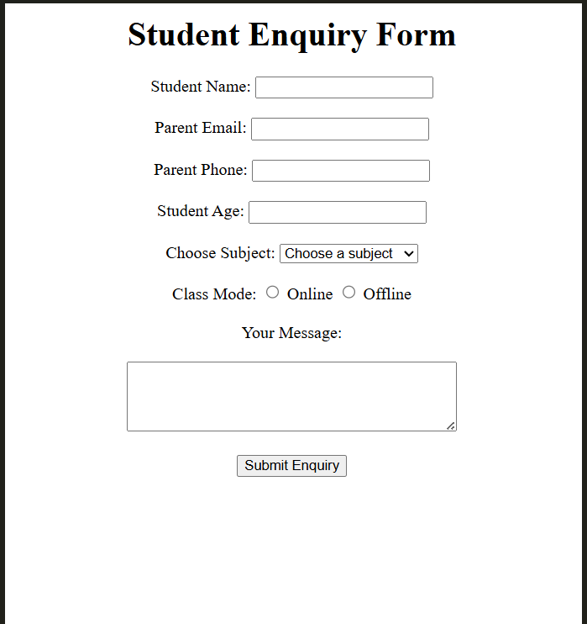

Que-3 <p>Add validation attributes to 'enquiry.html' so the browser blocks submission unless the name has at least 3 characters, the email is valid, the phone is exactly 10 digits, the age is between 5 and 18, and a subject is chosen. Test with an empty form, an age of 25 and a phone of 98765. Hint: `pattern="[0-9]{10}"` accepts exactly ten digits; add a title attribute to show your own error hint. Constraint: Use HTML attributes only; write no JavaScript.</p>

<!DOCTYPE html>
<html lang="en">
<head>
<meta charset="UTF-8">
<meta name="viewport" content="width=device-width, initial-scale=1.0">
<title>Student Enquiry Form</title>
</head>
<body>

<h1 style="text-align: center;">Student Enquiry Form</h1>

<form method="get" style="text-align: center;">

<label for="student_name">Student Name:</label>
<input type="text"
id="student_name"
name="student_name"
minlength="3"
required
title="Name must contain at least 3 characters">
<br><br>

<label for="parent_email">Parent Email:</label>
<input type="email"
id="parent_email"
name="parent_email"
required>
<br><br>

<label for="parent_phone">Parent Phone:</label>
<input type="tel"
id="parent_phone"
name="parent_phone"
pattern="[0-9]{10}"
required
title="Please enter exactly 10 digits">
<br><br>

<label for="age">Student Age:</label>
<input type="number"
id="age"
name="age"
min="5"
max="18"
required>
<br><br>

<label for="subject">Choose Subject:</label>

<select id="subject" name="subject" required>
<option value="">Choose a subject</option>
<option value="Mathematics">Mathematics</option>
<option value="Science">Science</option>
<option value="English">English</option>
<option value="Social Studies">Social Studies</option>
<option value="Computer Science">Computer Science</option>
</select>

<br><br>

<label>Class Mode:</label>

<input type="radio" id="online" name="mode" value="Online">
<label for="online">Online</label>

<input type="radio" id="offline" name="mode" value="Offline">
<label for="offline">Offline</label>

<br><br>

<label for="message">Your Message:</label>
<br><br>

<textarea id="message" name="message" rows="4" cols="40"></textarea>

<br><br>

<input type="submit" value="Submit Enquiry">

</form>

</body>
</html>

Que-4 <p>Finish 'enquiry.html' by adding a submit button and a reset button, then fill the form with a fictional student and a made-up 10-digit phone number, submit it, and save a screenshot named 'enquiry_submitted.png' showing the address bar. Commit and push to 'tuition-class-site'. Hint: With method get the values appear after a ? in the address bar, but only fields that have a name attribute are sent. Constraint: Do not use a real person's name or phone number.</p>

<!DOCTYPE html>
<html lang="en">
<head>
<meta charset="UTF-8">
<meta name="viewport" content="width=device-width, initial-scale=1.0">
<title>Student Enquiry Form</title>
</head>
<body>

<h1 style="text-align: center;">Student Enquiry Form</h1>

<form method="get" style="text-align: center;">

<label for="student_name">Student Name:</label>
<input type="text" id="student_name" name="student_name"
minlength="3" required
title="Name must contain at least 3 characters">
<br><br>

<label for="parent_email">Parent Email:</label>
<input type="email" id="parent_email" name="parent_email" required>
<br><br>

<label for="parent_phone">Parent Phone:</label>
<input type="tel" id="parent_phone" name="parent_phone"
pattern="[0-9]{10}" required
title="Please enter exactly 10 digits">
<br><br>

<label for="age">Student Age:</label>
<input type="number" id="age" name="age"
min="5" max="18" required>
<br><br>

<label for="subject">Choose Subject:</label>
<select id="subject" name="subject" required>
<option value="">Choose a subject</option>
<option value="Mathematics">Mathematics</option>
<option value="Science">Science</option>
<option value="English">English</option>
<option value="Social Studies">Social Studies</option>
<option value="Computer Science">Computer Science</option>
</select>
<br><br>

<label>Class Mode:</label>
<input type="radio" id="online" name="mode" value="Online">
<label for="online">Online</label>

<input type="radio" id="offline" name="mode" value="Offline">
<label for="offline">Offline</label>
<br><br>

<label for="message">Your Message:</label>
<br><br>
<textarea id="message" name="message"
rows="4" cols="40"></textarea>
<br><br>

<button type="submit">Submit Enquiry</button>
<button type="reset">Reset Form</button>

</form>

</body>
</html>

