PYTHON

ASSIGNMENT SESSION – 1

Que-1 Install Python (latest version) and VS Code on your computer, then take a screenshot of both the Python installation confirmation and the VS Code welcome screen.
Python latest version:-
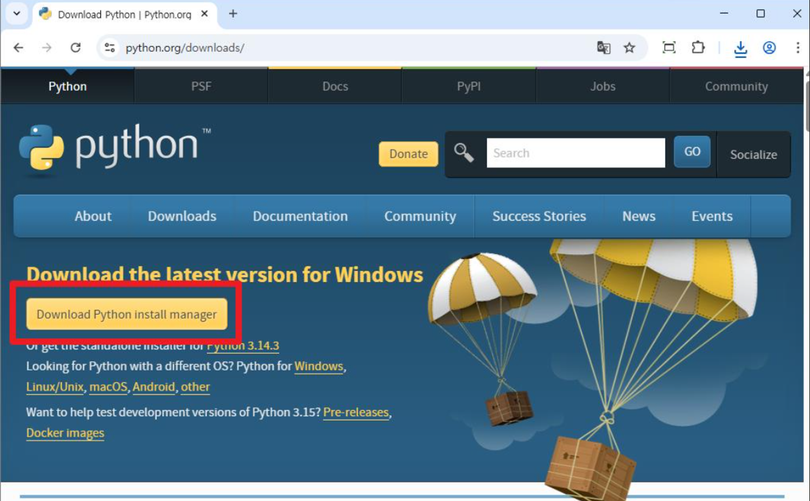

Vs code welcome screen:-
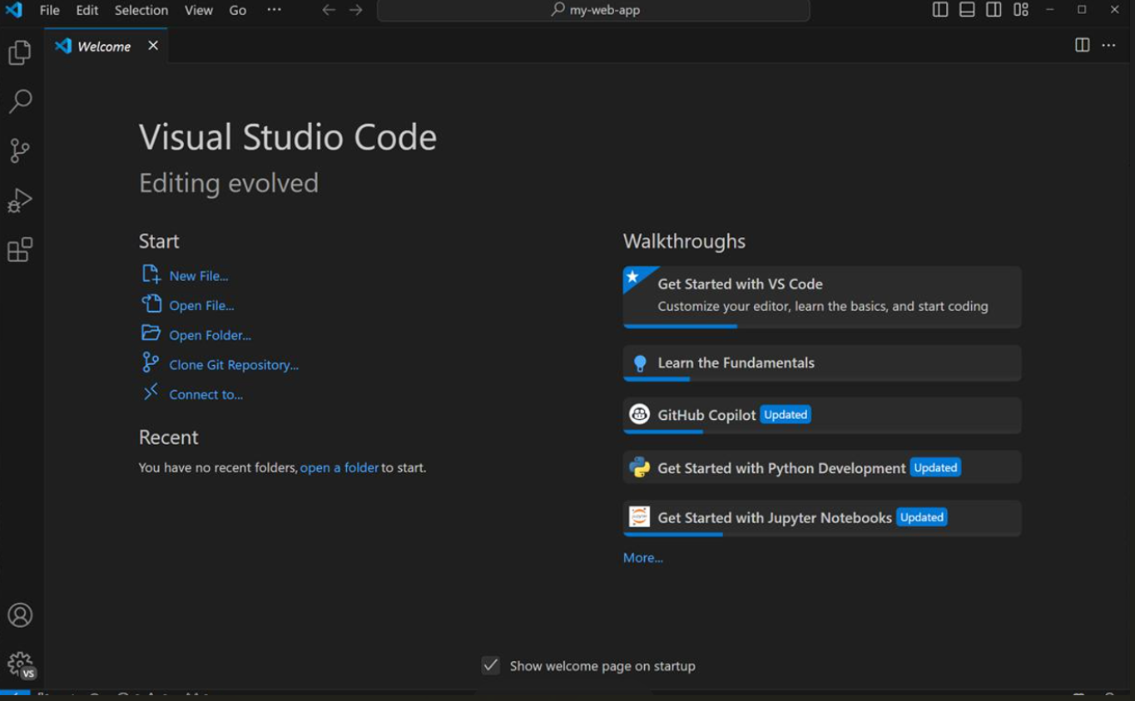

Que-2 Create a new Python file named hello_instagram.py in VS Code and write code to print 'Hello, Instagram World!' to the terminal.
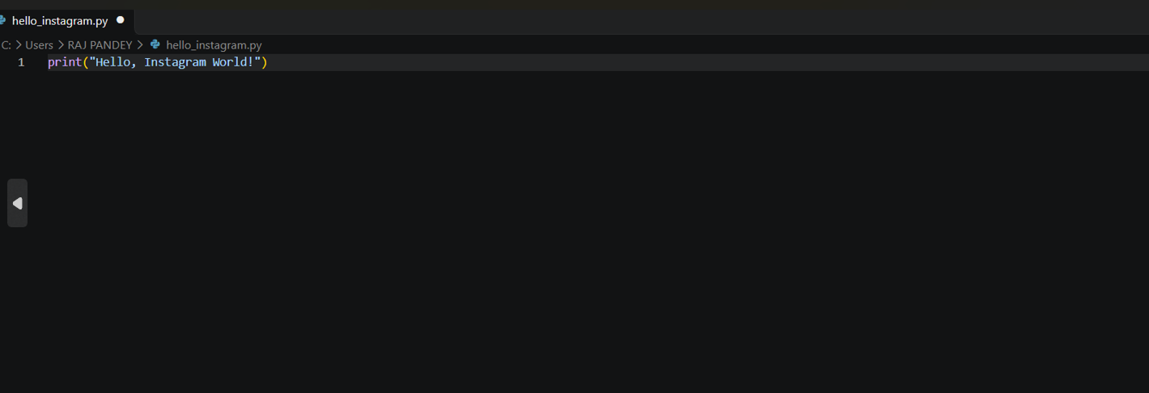

Que-3 Write a Python script called app_use_cases.py that prints three real-life apps you use daily and, for each, prints one way Python could be used in their backend or data analysis.
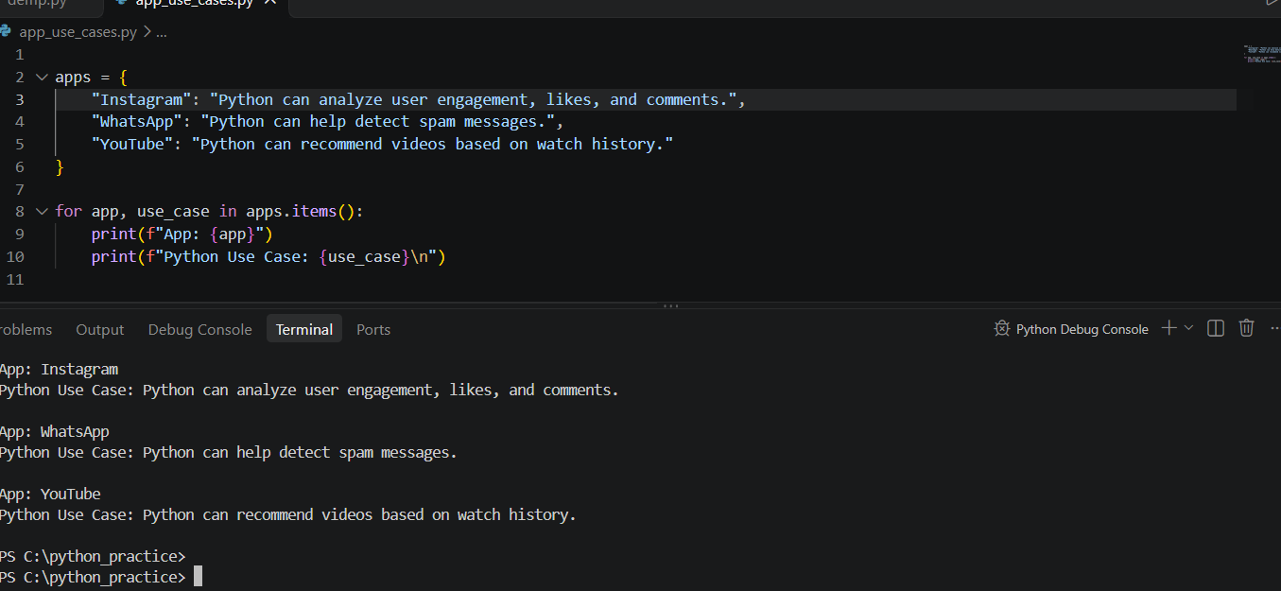
Que-4 Modify your hello_instagram.py script to print the Python version currently running your script.<br><br><em><strong>Hint:</strong> Use the sys module and sys.version.</em>

import sys

print("Hello, Instagram World!")
print("Python version:", sys.version)

Que-5 Explain the difference between how Python executes code versus how C or Java executes code, using your own words and a simple example for each.
Main Difference:
Feature | Python | C | Java
Execution | Through an interpreter | Compile first, then run | Bytecode, then JVM
Output File | Usually does not require a separate executable | Native executable | .class bytecode file
Typical Workflow | python file.py | Compile, then run the executable | Compile, then run using the JVM
Python example: print("Hello World!")
C EXAMPLE:
#include <stdio.h>
int main() {
printf("Hello World!\n");
return 0;
}
Java example:
class Hello {
public static void main(String[] args) {
System.out.println("Hello World!");
}
}

