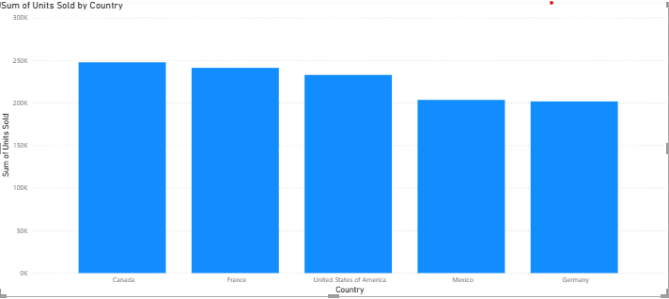

**CHART TYPE:** String

**X-AXIS:** Country

**Y-AXIS:** Sum of units sold

**INSIGHT**

* The chart shows a descending order of unit sold by a country.
* Canda has the highest number of unit sales.
* Germany has the lowest sale
* Germany and Mexico show similar sales.
* All countries have sales over 200K units