BACKEND PROJECT DOCUMENTATION
AI WeatherWise
Weather that talks back: live forecasts, explained in plain language and powered by Google Gemini AI.
Node.js • Express.js • MongoDB • JWT • Google Gemini

What is inside
The story behind the project, its architecture and data model, step-by-step setup, the backend code layout, database design, and live API test results. Diagrams, code screenshots and API test results from the project appear in each section.

1. Project Overview
AI WeatherWise is a RESTful backend that turns raw weather numbers into advice people can act on. It fetches live conditions, stores each user’s favourite cities in MongoDB, and asks Google Gemini AI to describe the weather in plain language and suggest what to wear or do.
Security is built in from the first request: passwords are hashed with bcrypt, sessions use JWT tokens, and incoming data is sanitised. If no external API key is configured, a fallback mode keeps every endpoint working with sample data, so the project can be demonstrated anywhere.

At a glance
Area | Choice | Purpose
Runtime | Node.js | Runs the server and business logic
Framework | Express.js | Routing, middleware and JSON handling
Database | MongoDB + Mongoose | Stores users and saved locations with schema validation
Security | JWT + bcryptjs | Token-based login and hashed passwords
AI | Google Gemini AI | Weather summaries and recommendations
Weather data | OpenWeatherMap | Current temperature, humidity, wind and conditions
Testing | Postman | Manual verification of every endpoint

The story: meet Alex
Alex travels constantly. Every new city means checking a weather app, guessing what to pack and starting from scratch again. Alex wants one place that remembers the cities, explains the forecast in a sentence, and says what to do about it.
Alex’s problems  - Too many cities to keep track of.  - Raw numbers, but no advice on clothing or activities.  - Data without a plain-language summary.  - No safe way to sync preferences across devices. | What WeatherWise does  - Saves favourite cities per account (full CRUD).  - Fetches live weather for any city.  - Asks Gemini for a summary and practical tips.  - Protects everything behind secure login.

Who uses it
Registered user  Saves cities, checks live weather and requests AI insights. | Admin / developer  Watches API health, manages accounts and verifies the weather and AI integrations. | Public visitor  Reads current weather through open endpoints without creating an account.

Outcome
People spend less time decoding numbers and more time acting on them. Mongoose schemas keep the data consistent, and Gemini adds context-aware advice on top of live conditions.

Requirements

Software
Tool | Version | Why it is needed
Operating system | Windows 10/11, macOS or Linux | Cross-platform development
Node.js | v16 or above | Runs the server
npm | v8 or above | Installs and manages dependencies
MongoDB | Local or Atlas | Stores users and locations
Google Gemini AI SDK | @google/generative-ai / @google/genai | Connects to Google Gemini for AI insights
Postman | Latest | Tests the API endpoints
VS Code | Or any IDE | Writing and running the code

Hardware
Component | Minimum | Recommended
Processor | Intel Core i5 (8th Gen) / Ryzen 5 | Same or better
RAM | 8 GB | 16 GB, for MongoDB and the server running together
Storage | 1 GB free | 1 GB free

Epic 1: Project Architecture
WeatherWise follows the MVC pattern so that routing, logic and data never get tangled. Requests enter through the Express gateway, pass JWT verification when a route is private, and are handled by controllers. Controllers call the weather and AI services, and models read and write MongoDB.
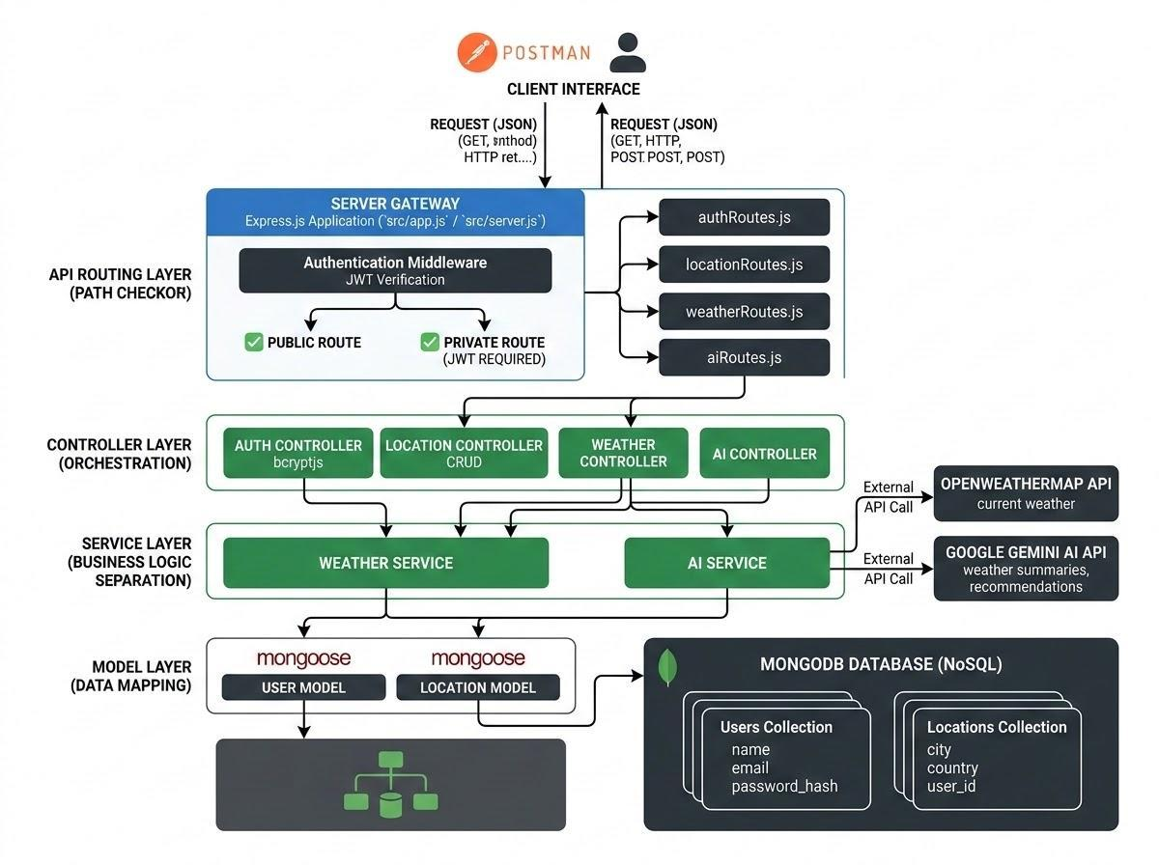
Figure 1: Overall system architecture

The layers
Layer | What lives here | Job
Client | Postman or any front end | Sends JSON requests and reads responses
Gateway | Express app, CORS, JWT middleware | Maps HTTP methods, parses JSON, guards private routes
Routes | auth, location, weather, ai | Connects each URL path to its controller
Controllers | One per route group | Validates input and orchestrates the work
Services | Weather service, AI service | Calls OpenWeatherMap and Gemini
Models | User, Location (Mongoose) | Defines schemas and talks to MongoDB

Data model
Two collections carry the core data. One user can save many locations, and each location points back to its owner.

Figure 2: Entity-relationship diagram

User
Field | Type | Rules
_id | ObjectId | Primary key
name | String | Required, trimmed
email | String | Required, unique, lowercase, must match an email pattern
password | String | Required, at least 6 characters, stored hashed
createdAt / updatedAt | Date | Added automatically by timestamps

Location
Field | Type | Rules
_id | ObjectId | Primary key
user | ObjectId | Reference to the owning User, required
city | String | Required, trimmed
country | String | Required, trimmed
createdAt / updatedAt | Date | Added automatically by timestamps

Relationship
User to Location is one-to-many. A compound unique index on user, city and country stops anyone from saving the same city twice.

Roles and responsibilities
Role | Responsibilities
Admin | Manage accounts (create, delete, suspend); watch API health and logs; keep the database healthy.
Registered user | Maintain a list of favourite cities; request live weather; ask Gemini for summaries and recommendations; manage own profile and credentials.

Key features
- Secure access: JWT verification blocks unauthorised requests to private routes.
- Saved cities: Full create, read, update and delete for each user’s favourites.
- AI insights: Natural-language summaries and clothing or activity tips from Gemini.
- Fallback mode: Sample weather and advice keep the API usable without external keys.
- Input sanitisation: Protects against XSS and NoSQL injection.
- Central error handling: One consistent error format across the API.

User journey
- Register or log in and receive a JWT.
- Save a favourite city.
- Fetch the current weather for that city.
- Ask Gemini for a summary and recommendations based on those numbers.
- The server checks the token on every private call and returns the result.

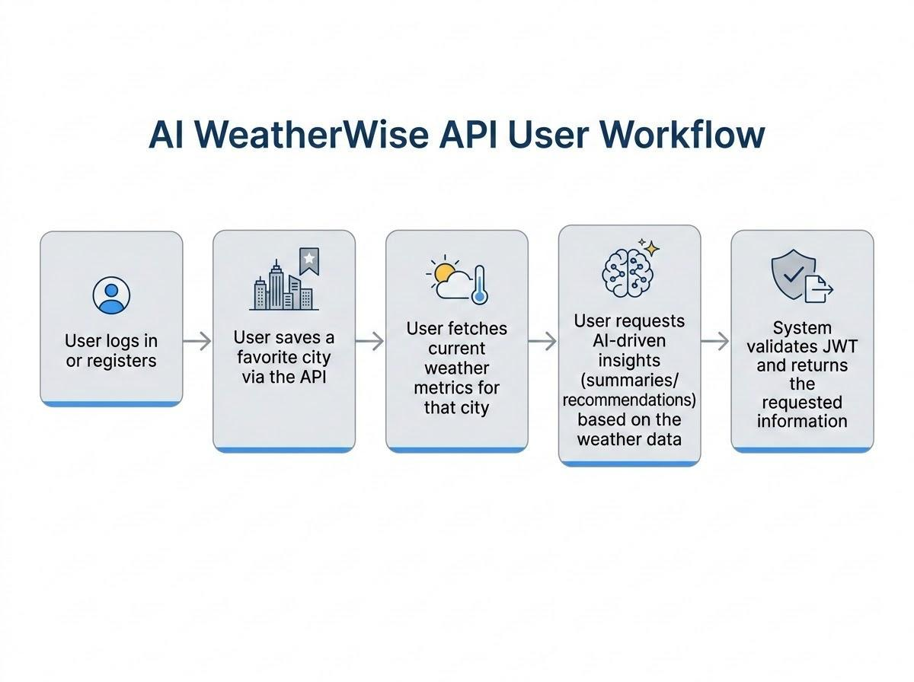
Figure 3: User workflow

MVC in this project

Figure 4: MVC pattern
Model  Mongoose schemas define fields, defaults and indexes, and validate data before it is saved. | View (routes)  This is a headless API, so the view layer is the routing layer that maps each path to a controller. | Controller  Receives the request, checks it, delegates to models and services, and returns JSON.

Epic 2: Project Setup and Configuration

Step 1: Create the project
- Create a folder named AI Weatherwise.
- Open it in Visual Studio Code.
- Open the integrated terminal and run the commands below.

Step 2: Initialise and install
Create the package file:
$ npm init -y

Install the runtime dependencies:
$ npm install express mongoose bcryptjs jsonwebtoken cors dotenv multer @google/genai

Install Nodemon so the server restarts on every change:
$ npm install --save-dev nodemon

Package | Role
express | Web framework and routing
mongoose | MongoDB object modelling
bcryptjs | Password hashing
jsonwebtoken | Creates and verifies JWT tokens
cors | Cross-origin request handling
dotenv | Loads values from the .env file
multer | File upload handling
@google/genai | Google Gemini AI client
nodemon | Auto-restart during development

Step 3: Files and folders
Create these files in the project root: index.js, .env, package.json and .gitignore. Then build the src folder with controllers, middleware, models, routes and utils inside it.
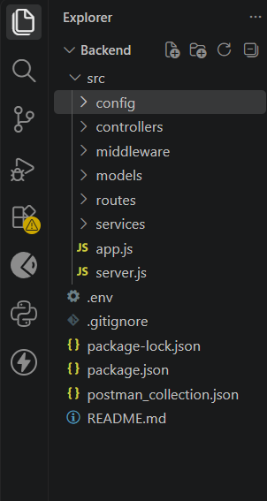
Figure 5: Initial folder structure in VS Code

Step 4: Environment variables
Create a .env file in the project root with these values:
Variable | Example value | Meaning
PORT | 5001 | Port the server listens on (Postman uses http://localhost:5001)
MONGO_URI | your_mongodb_connection_string | Database connection string
JWT_SECRET | your_jwt_secret | Secret used to sign tokens
GEMINI_API_KEY | your_gemini_api_key | Key for the Google Gemini service

Keep secrets safe
Add .env to .gitignore so keys are never pushed to GitHub. The server runs on port 5001 as set in .env, so every Postman URL starts with http://localhost:5001. The 5000 in index.js is only a fallback used when PORT is missing.

Epic 3: Backend Development
The backend is split into small modules so each file has one clear responsibility. This keeps the code easy to read, test and extend. It exposes secure REST APIs for authentication, saved locations, live weather and AI-generated recommendations.

Folder structure
––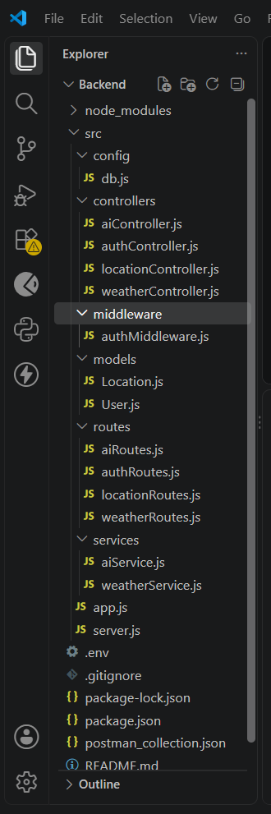
Figure 6: Backend structure in VS Code
Folder / file | Responsibility
config/db.js | Connects to MongoDB
controllers/ | authController, locationController, weatherController, aiController
middleware/authMiddleware.js | Verifies the JWT on private routes
models/ | User.js and Location.js Mongoose schemas
routes/ | authRoutes, locationRoutes, weatherRoutes, aiRoutes
services/ | Weather and AI service logic
app.js / server.js | Express setup and server start-up
postman_collection.json | Ready-made API tests

Application entry point
The entry file loads environment variables, sets up middleware, connects to MongoDB and registers the routes. The server only starts listening after the database connection succeeds; if the connection fails, the process exits with an error message.
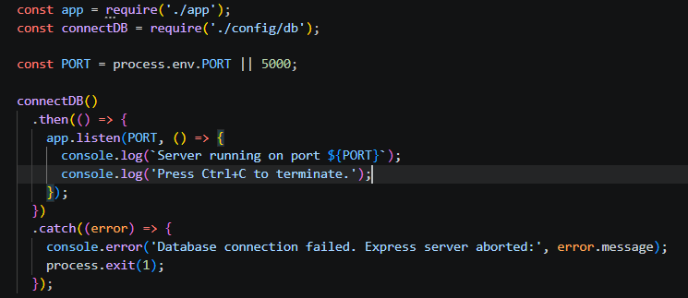
Figure 7: Entry point code

Epic 4: Database Configuration

MongoDB set-up checklist
- Install Mongoose in the project.
$ npm install mongoose

- Write the database connection module.
- Define the User and Location schemas and models.

Connect first, serve later
The database must be connected before the server accepts any request. That is why the app starts listening only inside the success handler of the connection call.

Location schema
Each saved city stores the city, the country and a reference to its owner. The unique index prevents duplicates for the same user.
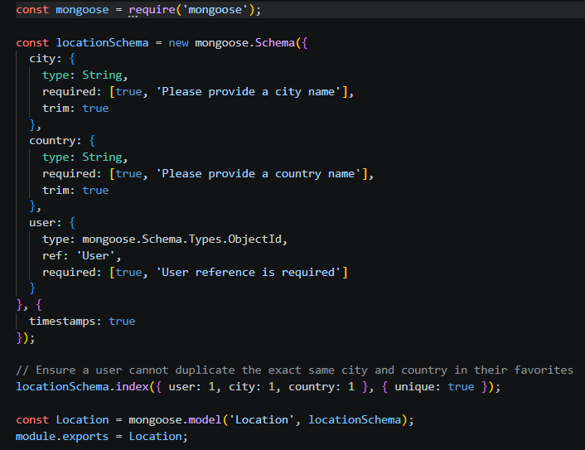
Figure 8: Location schema code

User schema
Users have a name, a unique lowercase email checked against a pattern, and a password of at least six characters.
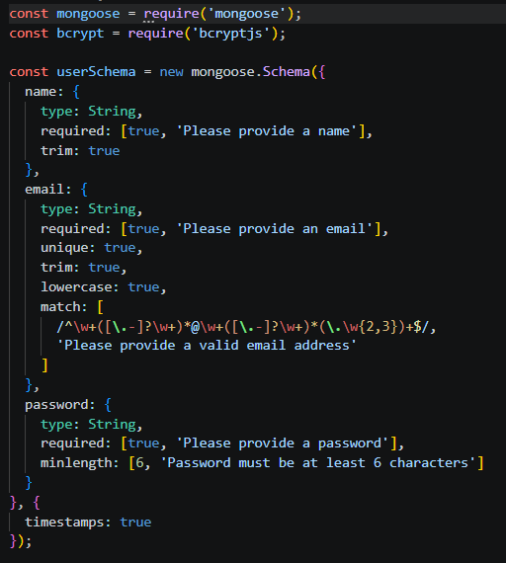
Figure 9: User schema code

Database connection
This module opens the Mongoose connection using MONGO_URI, or falls back to a local MongoDB instance when it is missing.
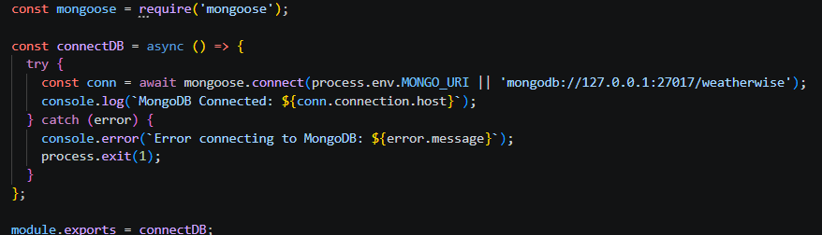
Figure 10: Database connection code

Epic 5: Project Execution and Testing
Before running, make sure MongoDB is up and the .env file is filled in. Then install everything and start the server:
$ npm install

On success the terminal confirms the database connection and the server begins listening on port 5001. Test with Postman or Thunder Client using the base URL http://localhost:5001.

Endpoints tested
Endpoint | Method | Purpose | Sample result
/api/auth/register | POST | Create an account | 201 Created + token
/api/auth/login | POST | Log in | 200 OK + token
/api/weather/:city | GET | Current weather for a city | 200 OK + metrics
/api/ai/weather-recommendation | POST | AI advice from weather values | 200 OK + recommendation

1. Register
Send name, email and password. The API answers with the new user and a JWT.
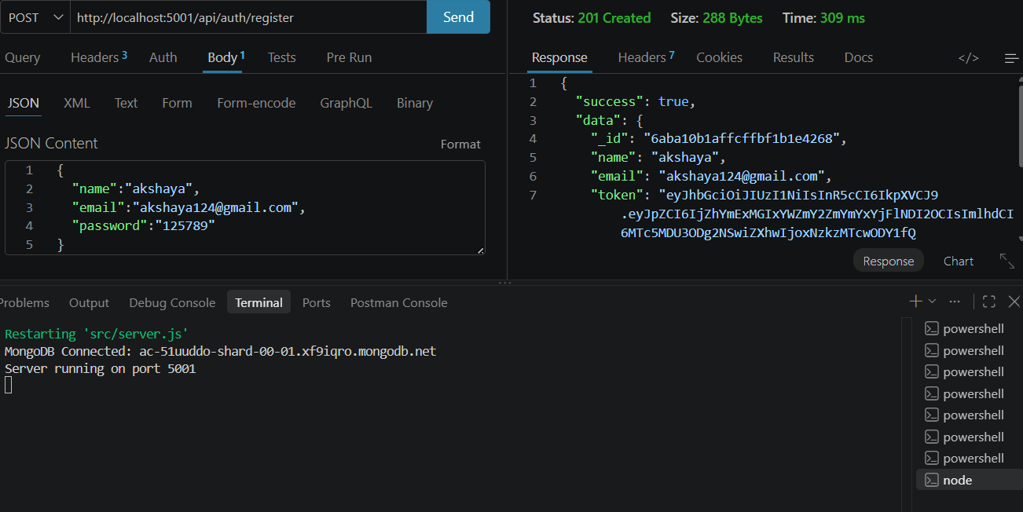
Figure 11: Register request and response

2. Login
Send email and password to receive a fresh token.
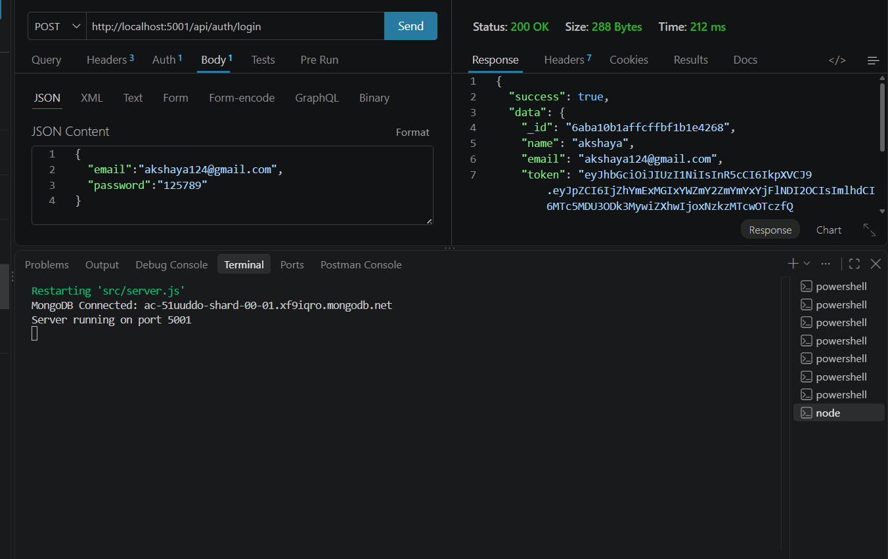
Figure 12: Login request and response

3. Weather
Request a city such as Bangalore. The response includes temperature, humidity, wind speed and condition. A mock flag shows when fallback data was used.
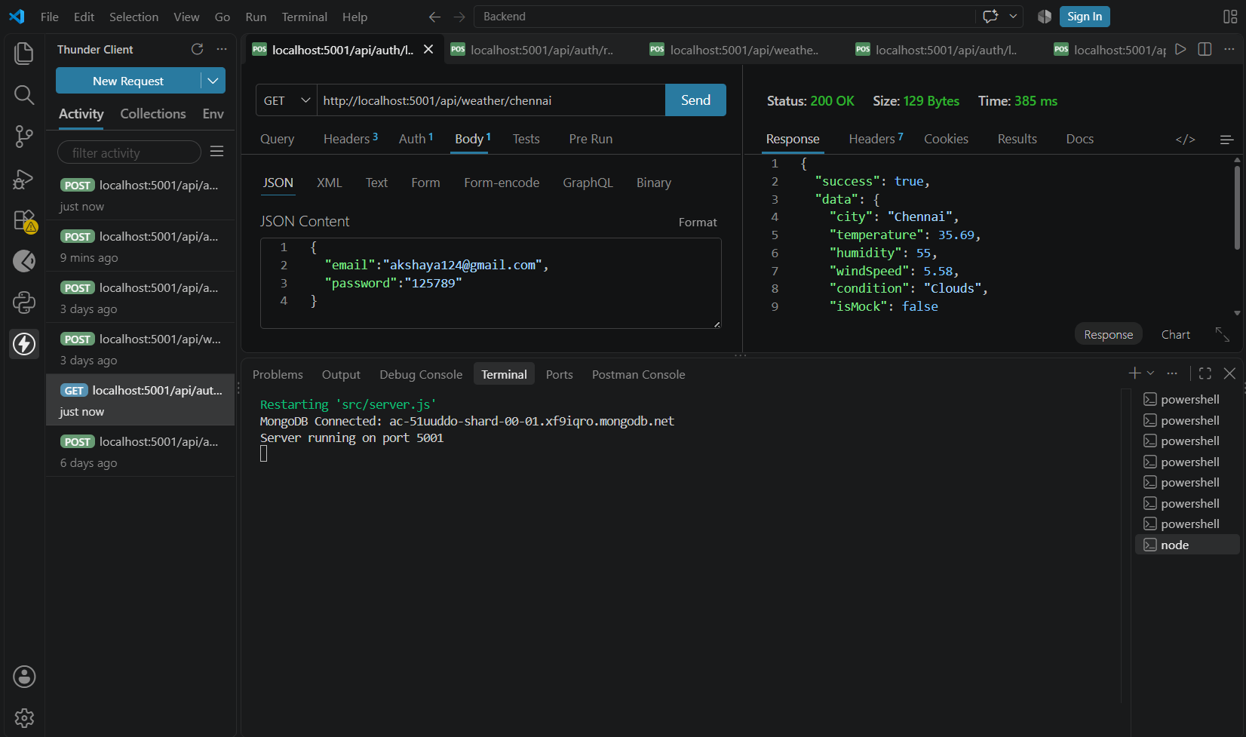
Figure 13: Weather request and response

4. AI recommendation
Send the city, temperature, humidity and condition. Gemini (or the fallback) returns a short piece of advice.
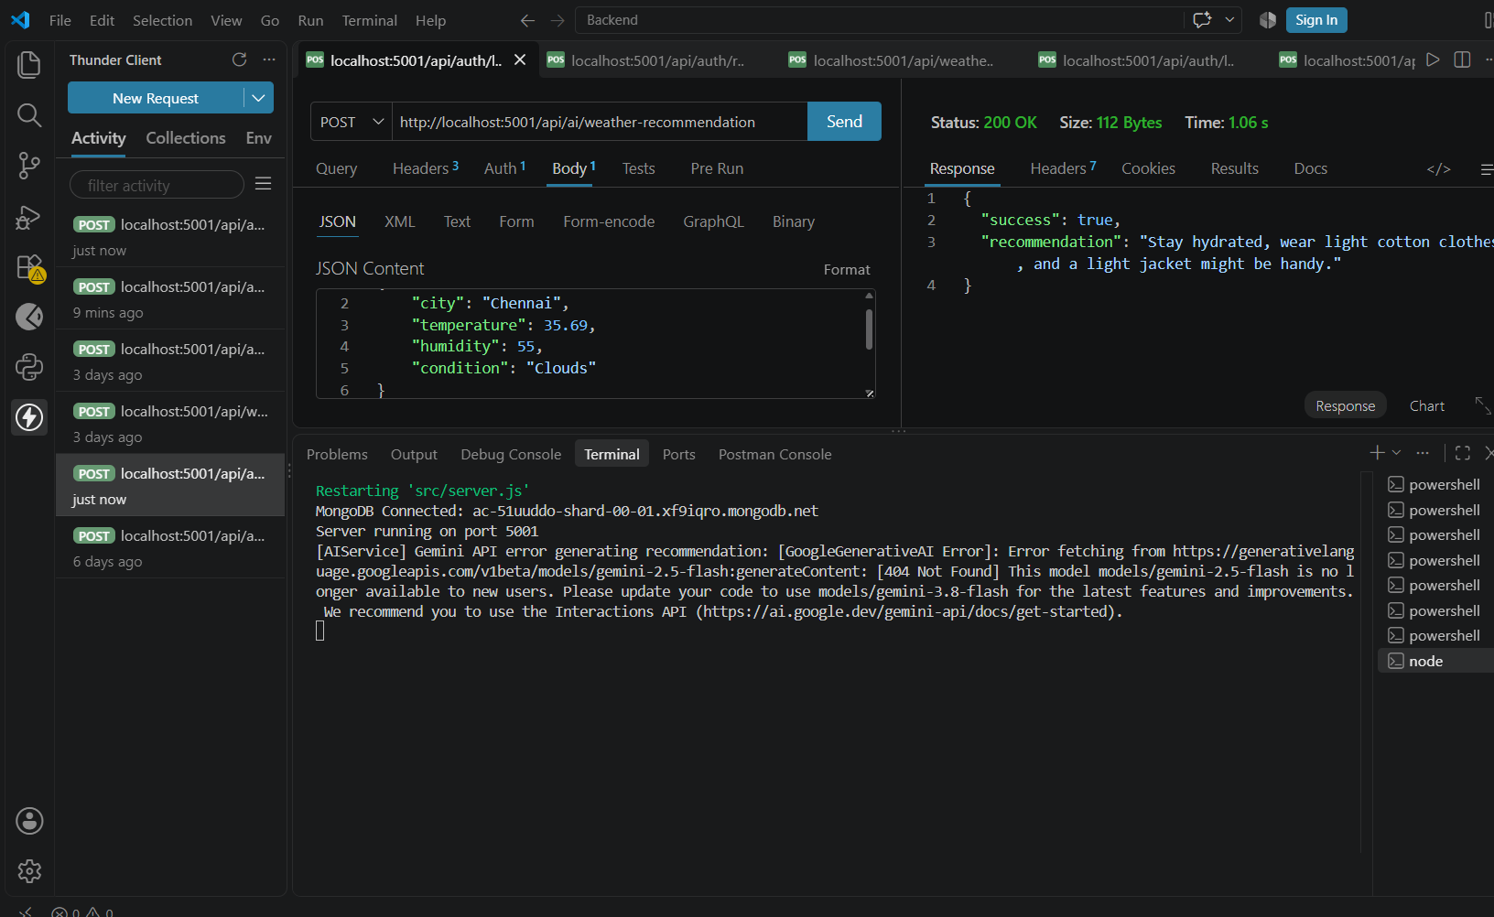

Demo video link : https://drive.google.com/file/d/15kvZAKOaFlpxJS1gDWpsVS993VHJ64Ou/view?usp=sharing

Code : https://drive.google.com/drive/folders/16m-J3FVibkjYID7vueN7jGzucJvgFS57?usp=sharing

