PROJECT REPORT
AI-POWERED STUDENT PERFORMANCE
ANALYSIS AND PREDICTION

Submitted in partial fulfilment of the requirements for the
AICTE–IBM SkillsBuild Data Analytics with AI Internship 2026

Submitted by
REKHA J
Master of Computer Applications (MCA)

Institution: DAYANANDA SAGAR UNIVERSITY
Department: MASTER OF COMPUTER APPLICATIONS
Internship Period: 17TH AUG- 21ST SEP

Academic Year 2026

CERTIFICATE
This is to certify that the project report entitled “AI-Powered Student Performance Analysis and Prediction” is prepared by Rekha J, a student of the Master of Computer Applications (MCA) programme, as part of the AICTE–IBM SkillsBuild Data Analytics with AI Internship 2026.
The work described in this report concerns exploratory analysis of student mathematics performance data and the development of a Random Forest classification model using Python and scikit-learn.
This certificate is to be completed and signed by the authorised institution / internship supervisor.

Project Guide / Mentor | Head of Department | Institution Seal
Name: __________________  Signature: ______________ | Name: __________________  Signature: ______________

Date: __________________________ Place: __________________________

DECLARATION
I, Rekha J, hereby declare that this project report titled “AI-Powered Student Performance Analysis and Prediction” is prepared for my AICTE–IBM SkillsBuild Data Analytics with AI Internship 2026. The report documents the work represented in my submitted Jupyter Notebook. Dataset details and evaluation figures are reported from the notebook outputs available at the time of preparation. Any institution-specific information, signatures, and internship dates must be completed accurately before submission.
Signature: ______________________ Date: ______________________

ACKNOWLEDGEMENT
I express my sincere gratitude to the AICTE–IBM SkillsBuild programme for the opportunity to develop practical skills in data analytics and artificial intelligence. I thank my institution, faculty members, and internship mentor for their guidance and encouragement. I also acknowledge the developers and maintainers of the student performance dataset and the open-source Python ecosystem, including Pandas, NumPy, Matplotlib, Seaborn, and scikit-learn, which supported this project.

ABSTRACT
This project applies exploratory data analysis and supervised machine learning to a student mathematics performance dataset. The dataset contains 395 student records and 33 original attributes. The analysis examines final mathematics grades and the relationship between study-time categories and grades. A binary target, at_risk, is defined as 1 when the final grade (G3) is below 10 and 0 otherwise. Five input features—studytime, failures, absences, G1, and G2—are used to train a Random Forest classifier. An 80:20 stratified train–test split and a fixed random seed of 42 are used. The saved notebook reports 91.14% test accuracy. For the at-risk class, precision is 0.85, recall is 0.88, and F1-score is 0.87; the confusion matrix is [[49, 4], [3, 23]]. The project illustrates a practical machine-learning workflow while recognising that model predictions are estimates and should not be used as the sole basis for educational decisions.

KEYWORDS
Student performance, data analytics, machine learning, Random Forest, classification, exploratory data analysis, Python, academic support

TABLE OF CONTENTS
- 1. Introduction
- 2. Problem Statement
- 3. Aim and Objectives
- 4. Scope and Significance
- 5. Dataset Description
- 6. Tools and Technologies
- 7. System Requirements
- 8. Methodology
- 9. Exploratory Data Analysis
- 10. Model Development
- 11. Results and Discussion
- 12. Sample Prediction
- 13. Limitations
- 14. Ethical Considerations
- 15. Future Enhancements
- 16. Conclusion
- References
- Appendix A: How to Run the Project
- Appendix B: Important Code Logic
- Appendix C: Submission Checklist
Note: Update page numbers automatically in Microsoft Word if a page-numbered contents page is required. The final pagination may change after adding institution details or screenshots.

LIST OF FIGURES
- Figure 1. Project workflow
- Figure 2. Confusion matrix from the saved notebook
- Figure 3. Model evaluation metrics

LIST OF TABLES
- Table 1. Dataset summary
- Table 2. Selected model features
- Table 3. Model configuration
- Table 4. Classification report
- Table 5. Confusion matrix interpretation

1. INTRODUCTION
Educational institutions collect academic information such as assessment grades, attendance, study habits, and prior failures. Analysing these records can help reveal patterns that may be useful when planning student support. Data analytics provides methods for summarising and visualising these records, while machine learning can learn patterns from labelled examples and produce predictions for new records.
This project, “AI-Powered Student Performance Analysis and Prediction,” uses a mathematics student-performance dataset. Python libraries are used to inspect the data, visualise grade distributions, define a binary performance category, train a Random Forest classifier, and evaluate its predictions on a held-out test set.
The term “at risk” in this report refers only to the project's operational definition: a final mathematics grade G3 below 10. It is not a judgement of a student's overall ability, potential, character, or future achievement.

1.1 Background
Machine learning classification maps input attributes to a discrete label. In this project the two labels are 0 (not flagged by the defined threshold) and 1 (potentially needing additional academic support). The model uses earlier grades and selected contextual features as predictors.

1.2 Motivation
The motivation is to demonstrate an end-to-end data analytics workflow: acquiring data, checking its quality, performing exploratory analysis, preparing a target variable, fitting a classifier, and interpreting evaluation measures.

2. PROBLEM STATEMENT
Student outcomes can vary with study time, earlier assessment results, previous failures, and absences. Reviewing many records manually may make it difficult to identify recurring patterns. The project therefore investigates whether a supervised classification model can distinguish records according to a predefined final-grade threshold using selected input features.
The task is a small educational prototype. It does not establish causation, diagnose the reasons for academic performance, or demonstrate that the model is ready for use in a real school.

3. AIM AND OBJECTIVES
Aim: To analyse student mathematics performance data and develop a machine-learning classifier that flags records according to a project-defined final-grade threshold.
- Load and inspect the student performance dataset using Pandas.
- Summarise data types, missing values, duplicate rows, and descriptive statistics.
- Visualise the distribution of final mathematics grades.
- Explore final grades across study-time categories.
- Create the binary at_risk target from G3.
- Train a Random Forest classifier using selected features.
- Evaluate predictions with accuracy, precision, recall, F1-score, and a confusion matrix.
- Run a sample prediction and explain the output responsibly.

4. SCOPE AND SIGNIFICANCE

4.1 Scope
The implemented work focuses on mathematics performance records. It includes exploratory visualisations, binary classification, test-set evaluation, and one illustrative sample prediction. The model uses five features and a fixed 80:20 stratified split.

4.2 Significance
The project provides hands-on practice with data loading, data-quality checks, visualisation, feature selection, model training, and evaluation. It demonstrates how analytical outputs can be communicated in a structured report.

4.3 Out of scope
The notebook does not establish a deployed application, a school intervention process, a causal study, or a validated decision-support system. It does not compare the final performance of multiple model families, despite importing a Logistic Regression class in the initial setup.

5. DATASET DESCRIPTION
The notebook loads a comma-separated text file using semicolon delimiters from the following URL:
https://huggingface.co/datasets/DElmazi/Student_Performance/resolve/main/student-mat.csv
The file is read with pandas.read_csv(url, sep=';'). The notebook reports 395 rows and 33 columns before creating the target variable. After adding at_risk, the dataset contains 34 columns.
Item | Description
Records | 395 student records
Original attributes | 33 columns
Target-added columns | 34 columns after adding at_risk
Outcome grade | G3, final mathematics grade on a 0–20 scale
Target definition | at_risk = 1 if G3 < 10; otherwise 0
Missing values | The saved notebook reports zero missing values in all 33 original columns
Duplicate rows | The saved notebook reports zero duplicate rows
Data types | 16 integer columns and 17 object columns before adding target, as reported by df.info()

5.1 Selected attributes
Feature | Meaning in this project
studytime | Study-time category, coded from 1 (lowest) to 4 (highest) in the plot labels
failures | Number of previous class failures recorded in the dataset
absences | Recorded number of absences
G1 | First-period grade
G2 | Second-period grade
G3 | Final mathematics grade; used to create the target label

The target threshold is project-defined and should not be interpreted as a universal definition of student risk. The exact dataset URL should be checked and retained in the final submission.

6. TOOLS AND TECHNOLOGIES
Tool / Library | Purpose
Python | Programming language for analysis and model development
Pandas | Reading, organising, inspecting, and selecting tabular data
NumPy | Numerical computing support
Matplotlib | Plot creation
Seaborn | Statistical visualisation
scikit-learn | Train–test split, Random Forest, prediction, and evaluation metrics
Jupyter Notebook / Google Colab | Interactive environment for running code and reviewing outputs
Hugging Face dataset URL | Location from which the notebook loads the dataset

7. SYSTEM REQUIREMENTS

7.1 Hardware
A standard laptop or desktop capable of running Python and a Jupyter environment is sufficient for this dataset. No specialised GPU is required for the Random Forest model used here.

7.2 Software
Python 3, Jupyter Notebook or Google Colab, and the libraries listed in requirements.txt are required. Internet access is needed when loading the dataset directly from the URL.
The uploaded requirements.txt lists: pandas, numpy, matplotlib, seaborn, scikit-learn, and jupyter.

8. METHODOLOGY
The project follows a sequential workflow from data acquisition to prediction. The figure below summarises the implemented stages.
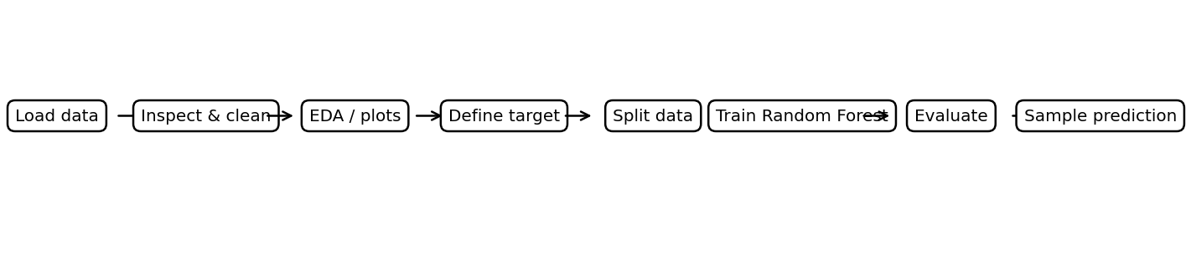
Figure 1. Project workflow based on the submitted notebook.

8.1 Data acquisition
The notebook reads the student mathematics data from the specified Hugging Face URL using Pandas and a semicolon separator.

8.2 Data inspection
The notebook displays the first rows, dataset dimensions, column data types, missing-value counts, duplicate-row count, and descriptive statistics. The saved output reports no missing values and no duplicate rows.

8.3 Exploratory data analysis
A count plot is created for the at_risk target. A histogram with a kernel density estimate displays the distribution of G3. A box plot compares G3 across study-time categories.

8.4 Target engineering
The target is constructed using the expression df['at_risk'] = (df['G3'] < 10).astype(int). Thus records with G3 below 10 receive label 1, while records with G3 equal to or above 10 receive label 0.

8.5 Feature selection
The classifier uses studytime, failures, absences, G1, and G2 as inputs. G3 is not included as an input because it directly defines the target label.

8.6 Train–test split
The dataset is split using train_test_split with test_size=0.2, random_state=42, and stratify=y. This holds out 20% of records for testing while preserving the target-class proportions as closely as possible.

8.7 Model training
A RandomForestClassifier is created with n_estimators=100, random_state=42, and class_weight='balanced'. The model is fitted on the training features and labels.

8.8 Model evaluation
The notebook calculates accuracy, a classification report, and a confusion matrix on the test set. The evaluation output is reproduced in Section 11.

9. EXPLORATORY DATA ANALYSIS

9.1 Dataset structure and quality
The loaded dataset contains 395 records and 33 original attributes. The quality checks in the saved notebook report no missing values and zero duplicate rows. The original columns comprise numerical and categorical fields.

9.2 Final mathematics grade distribution
The notebook creates a histogram of G3 using 11 bins and overlays a kernel density estimate. The plot is intended to show how final grades are distributed across the observed range. Because the notebook output saved in the provided file does not preserve the underlying plot values as text, this report does not claim a specific peak, skew, or modal grade.

9.3 Study time and final grade
A box plot compares G3 across the four study-time categories. It supports visual comparison of medians, spread, and possible outliers between categories. The plot alone cannot establish that study time causes a particular grade.

9.4 Performance categories
The notebook creates a count plot for the binary at_risk label. The category 1 indicates G3 below 10; category 0 indicates G3 of 10 or above. The exact overall class counts are not included in the saved text output, so they are not reproduced here.

10. MODEL DEVELOPMENT

10.1 Algorithm: Random Forest
A Random Forest is an ensemble learning method that combines predictions from multiple decision trees. Each tree is trained using a randomised sample of the training data and feature selection at splits; the classifier aggregates tree outputs to assign a class. This can model nonlinear relationships and interactions among input variables.

10.2 Model configuration
Parameter | Value | Role
n_estimators | 100 | Number of trees in the forest
random_state | 42 | Makes the randomised model setup reproducible
class_weight | balanced | Adjusts class weights inversely to class frequencies
test_size | 0.2 | 20% of records held out for testing
stratify | y | Maintains approximate class proportions across splits

10.3 Feature rationale
studytime represents a study-habit category; failures captures prior failures; absences captures attendance-related information; G1 and G2 provide earlier grade information. These variables are selected in the notebook and are used as the complete feature set for the final model.

10.4 Reproducibility
The fixed random_state values in the split and classifier help reproduce the same randomised procedure when the same data and software behaviour are used. The dataset is fetched from a remote URL, so exact reproducibility also depends on the dataset version remaining unchanged.

11. RESULTS AND DISCUSSION

11.1 Accuracy
The saved notebook reports a test accuracy of 91.14%. Accuracy is the proportion of all test records whose predicted class matches the actual class. Accuracy should be interpreted alongside class-specific precision and recall, especially when the classes are imbalanced.

11.2 Classification report
Class | Precision | Recall | F1-score | Support
0 — not flagged | 0.94 | 0.92 | 0.93 | 53
1 — potentially needs support | 0.85 | 0.88 | 0.87 | 26
Macro average | 0.90 | 0.90 | 0.90 | 79
Weighted average | 0.91 | 0.91 | 0.91 | 79

For class 1, precision of 0.85 means that 85% of the records predicted as class 1 in the test set were class 1. Recall of 0.88 means that the model identified 88% of actual class-1 records in the test set. The F1-score of 0.87 is the harmonic mean of precision and recall. These figures describe this test split and do not guarantee performance on future or different populations.

11.3 Confusion matrix
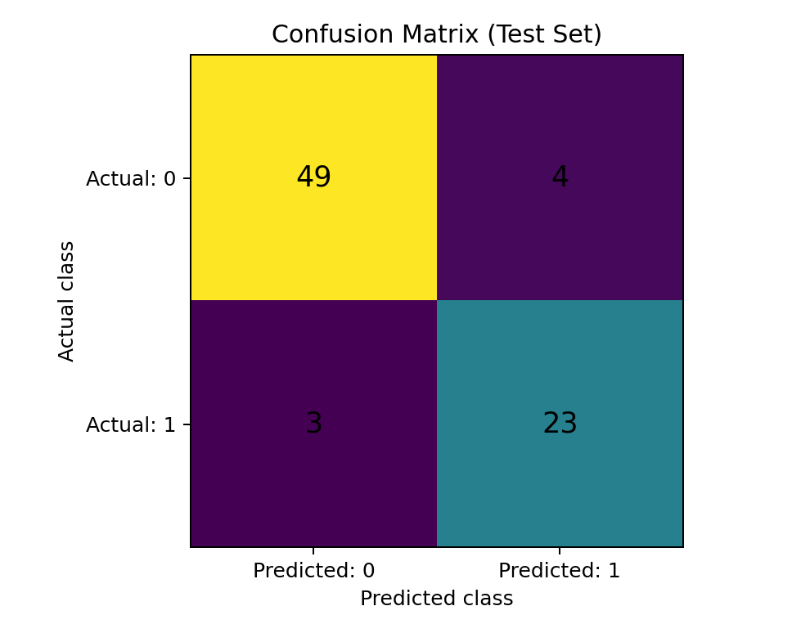
Figure 2. Confusion matrix reproduced from the notebook output.
 | Predicted 0 | Predicted 1
Actual 0 | 49 — true negatives | 4 — false positives
Actual 1 | 3 — false negatives | 23 — true positives

The matrix indicates 49 class-0 records correctly classified as class 0, four class-0 records incorrectly predicted as class 1, three class-1 records incorrectly predicted as class 0, and 23 class-1 records correctly predicted as class 1. In an educational-support context, false negatives deserve particular attention because they are records labelled at risk by the threshold but not flagged by the model.

11.4 Metric visualisation
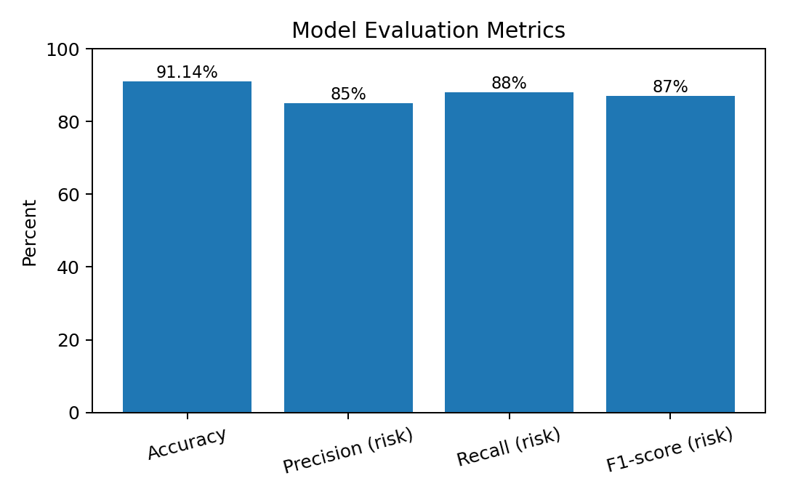
Figure 3. Accuracy and class-1 metrics from the notebook. Class-specific precision, recall, and F1-score are rounded to whole percentages for this visual summary.

11.5 Discussion
The saved test results suggest that the model performed well on the held-out records from this particular split. The class-1 recall of 0.88 indicates that most of the test records meeting the project's at-risk definition were identified, while three such records were missed. These results are a useful prototype evaluation, not evidence of general effectiveness in another institution or cohort.

12. SAMPLE PREDICTION
The notebook constructs one sample record with the following feature values:
Feature | Sample value
studytime | 2
failures | 0
absences | 4
G1 | 12
G2 | 13

The saved notebook output is: “Prediction: Student is not flagged as at risk.” It also reports an estimated risk probability of 0.0%. This probability is the model's output for the class-1 estimate for this sample; it should not be interpreted as a calibrated real-world probability of academic failure.

12.1 Interpretation
For this example, the trained classifier assigns class 0 under the selected features and learned trees. A single sample demonstrates the prediction pipeline but does not validate the model's suitability for making decisions about actual students.

13. LIMITATIONS
- The dataset has 395 records and may not represent students from other schools, regions, subjects, or time periods.
- The at_risk label is defined by a single grade threshold (G3 < 10); different educational contexts may use different thresholds or multiple indicators.
- The notebook reports one train–test split. Cross-validation and testing on an external dataset are not included.
- The saved notebook does not report hyperparameter tuning or comparison of multiple trained models.
- The sample prediction probability is not shown to be calibrated.
- Grade and attendance data may contain contextual factors that are not captured by the selected five features.
- Visual relationships are descriptive and do not establish causation.
- The data are fetched from a remote URL, so changes to the hosted file could affect reproducibility.

14. ETHICAL CONSIDERATIONS
A student-risk prediction should be treated as a prompt for supportive review, not as a final judgement. Students should not be labelled or penalised solely on the basis of a model output. Any real-world use would require privacy protection, informed governance, evaluation for bias across relevant groups, transparent communication, human oversight, and a process for correcting inaccurate records.
The project-defined at_risk label is a threshold-based category, not a measure of a student's worth or long-term potential. Any future implementation should minimise access to personal data and should explain how predictions are used.

15. FUTURE ENHANCEMENTS
- Add cross-validation to estimate performance across multiple data splits.
- Evaluate a second held-out or external dataset to examine generalisation.
- Compare Random Forest with baseline and alternative classifiers using the same split protocol.
- Report class balance and include precision–recall curves and ROC-AUC where appropriate.
- Use feature-importance analysis or explainability methods to understand model behaviour, while avoiding causal claims.
- Calibrate predicted probabilities before interpreting them as probabilities.
- Document the exact dataset version and save a local copy or checksum for reproducibility.
- Add a simple user interface only after model validation and privacy requirements are addressed.
- Review possible bias and fairness across groups before any practical use.

16. CONCLUSION
This project demonstrates an end-to-end student performance analysis workflow using Python. The notebook loads 395 records with 33 original attributes, checks data quality, visualises final grades and study-time categories, defines an at_risk target using G3 < 10, and trains a Random Forest classifier using studytime, failures, absences, G1, and G2. The saved notebook reports 91.14% test accuracy, with class-1 precision of 0.85, recall of 0.88, and F1-score of 0.87.
The work fulfils its practical objective of demonstrating exploratory data analysis and binary classification. Further validation, responsible governance, and human review would be necessary before considering any real-world educational use.

REFERENCES
- DElmazi. Student Performance dataset, student-mat.csv. Hugging Face Datasets. https://huggingface.co/datasets/DElmazi/Student_Performance/resolve/main/student-mat.csv (accessed for the notebook; verify the current URL and dataset provenance before submission).
- McKinney, W. pandas documentation. https://pandas.pydata.org/docs/
- NumPy Developers. NumPy documentation. https://numpy.org/doc/
- Matplotlib Development Team. Matplotlib documentation. https://matplotlib.org/stable/
- Seaborn Development Team. Seaborn documentation. https://seaborn.pydata.org/
- scikit-learn Developers. scikit-learn documentation, RandomForestClassifier and model evaluation. https://scikit-learn.org/stable/

APPENDIX A: HOW TO RUN THE PROJECT
- Install Python 3 or open Google Colab.
- Install the libraries listed in requirements.txt (for example, run pip install -r requirements.txt in a suitable environment).
- Open RekhaJ_student_performance_analysis.ipynb.ipynb in Jupyter Notebook or upload it to Google Colab.
- Ensure the environment has internet access because the notebook reads the dataset from a remote URL.
- Run the notebook cells in order.
- Review the dataset checks, plots, classification report, confusion matrix, and sample prediction.

APPENDIX B: IMPORTANT CODE LOGIC
Target creation:
df['at_risk'] = (df['G3'] < 10).astype(int)
Feature selection:
X = df[['studytime', 'failures', 'absences', 'G1', 'G2']]
y = df['at_risk']
Train–test split:
train_test_split(X, y, test_size=0.2, random_state=42, stratify=y)
Classifier:
RandomForestClassifier(n_estimators=100, random_state=42, class_weight='balanced')

APPENDIX C: SUBMISSION CHECKLIST
- ☐ Replace the institution, department, guide, and internship-date placeholders on the cover page.
- ☐ Confirm whether your college requires a prescribed certificate, declaration, or formatting template.
- ☐ Add the actual internship completion certificate if required; this report does not replace an official certificate.
- ☐ Verify the dataset citation and add any source details required by your supervisor.
- ☐ Open the report in Word and update the table of contents and page numbers after final formatting.
- ☐ Check that the final report matches your actual notebook and your institution's academic integrity rules.

