Pavel Timchenko

5/31/2021

IT FDN 110A SPR21

Assignment 08

<https://github.com/rekit88/IntroToProg-Python-Mod08.git>

# **ASSIGNMENT 8**

## **Overview:**

In this assignment we have to create a python script in which we would use classes, objects, constructors, properties methods, attributes etc. Following document will be divided on five segments: class Product, class FileProcessor, class Io, Main body of the script and results.

## **Class Product**

In this class initially we create an objects, by using constractor with local variables. Then we add “properties” to those objects, by using getter and setter elements. In this case I created a “check” feature to which type of data user may enter. (Figure 1.)

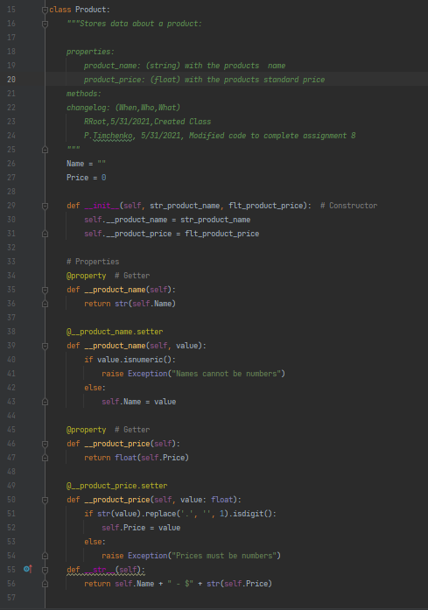

Figure 1.

## **Class FileProcessor**

In this class we perform reading data from file and saving data to file. (Figure 2.)

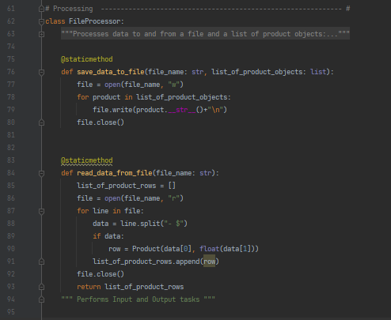

Figure 2.

## **Class IO**

This class responsible for presenting an interaction menu for user. (Figure 3.)

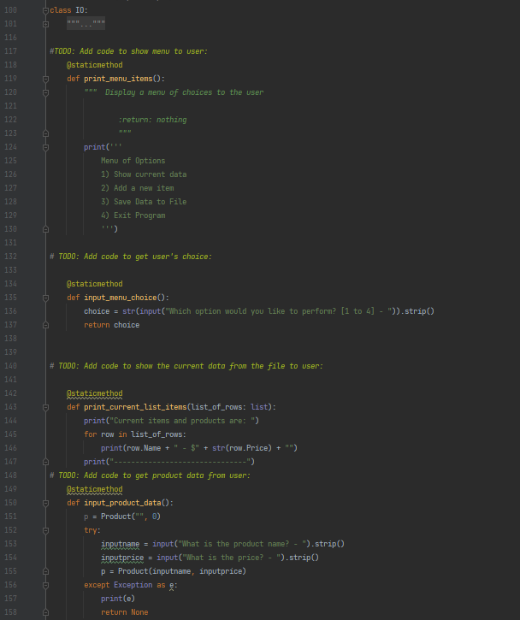

Figure 3.

## **Main body of the script**

This is the last section of this script. In some way this can be called main “engine” of the script, which is bounded to all other classes, combines them in order, and makes the script to work in a way the user chooses. (Figure 4.)

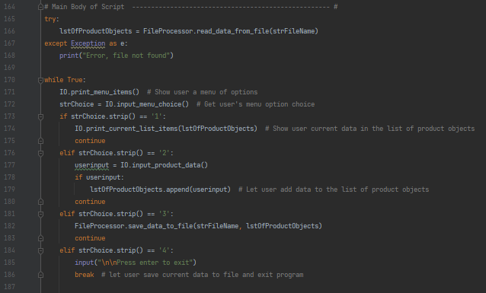

Figure 4.

## **Result**

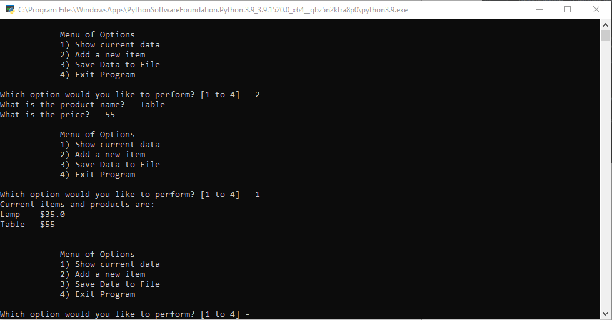

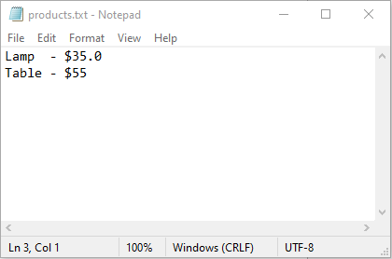

## **Summary**

By using new knowledge of classes, objects, constructors, properties methods, and others, I created a script which perform as was assign. All this information was very helpful in organizing my code.