Continuous risk-based predictive approaches to treatment effect heterogeneity: A simulation study

**Objective:** Baseline risk is an important determinant of the absolute effect of a treatment for an individual patient. We aimed to compare different risk-based methods for predicting individualized treatment effects with simulations of the RCT setting. **Study Design** and Setting: We sampled patients from a superpopulation with diverse assumptions for a baseline prognostic index of risk (PI), and for the shape of the interaction between the PI and treatment (no, linear or quadratic interaction). In each sample, we fitted different models for predicting absolute benefit: a model with the PI and a constant relative treatment effect and models including an interaction of treatment assignment with the PI, with 4 quarters of the PI, and with nonlinear transformations of the PI (restricted cubic splines with 3, 4 and 5 knots). We also used an adaptive model selection approach based on Akaike’s Information Criterion. We evaluated predictive performance in the superpopulation using root mean squared error and measures of discrimination and calibration for benefit. Starting from a base case scenario (sample size 4,250, treatment odds ratio 0.8, AUC of the PI 0.75), we varied the sample size, the strength of the treatment effect, and the discriminative ability of the PI. **Results:** Models including a linear interaction of the PI with treatment had (close to?) optimal performance under most simulation scenarios. More flexible models with restricted cubic splines required larger sample sizes and higher AUC of the PI to outperform the linear model. The adaptive approach performed similarly to the best-performing method in each scenario. **Conclusion:** Under most circumstances, a model with a linear interaction of the PI with treatment is better able to predict absolute treatment benefit.

# 1 Introduction

Predictive approaches for assessing heterogeneity of treatment effects (HTE) aim at the development of models predicting either individualized effects or which of two (or more) treatments is better for an individual [1]. In prior work, we divided such methods in three broader categories based on the reference class used for defining patient similarity when making individualized predictions or recommendations [2]. Risk-modeling approaches use prediction of baseline risk as the reference; treatment effect modeling approaches also model treatment-covariate interactions, in addition to risk factors; optimal treatment regime approaches focus on developing treatment assignment rules and therefore rely heavily on modeling treatment effect modifiers.

Risk-modeling approaches to predictive HTE analyses provide a viable option in the absence of well-established treatment effect modifiers [3,4]. In simulations, modeling of effect modifiers, i.e. treatment-covariate interactions, often led to miscalibrated predictions of benefit, while risk-based methods proved quite robust [5]. Most often, risk-modeling approaches are carried out in two steps: first a risk prediction model is developed externally or internally on the entire RCT population, “blinded” to treatment; then the RCT population is stratified using this prediction model to evaluate risk-based treatment effect variation [6]. However, even though estimates at the risk subgroup level may be accurate, these estimated do not apply to individual patients, especially for patients with predicted risk at the boundaries of the risk intervals. Hence, the risk-stratified approach is useful for exploring and presenting HTE, but is not useful for supporting treatment decisions for individual patients.

To individualize treatment effects, the recent PATH statement suggested various risk-based models including a prognostic index of baseline risk (PI) and treatment assignment [cite PATH !!]. We aimed to summarize and compare different risk-based models for predicting individualized treatment effects. We simulated RCT settings to compare the performance of these models under different assumptions of the relationship between baseline risk and treatment. We illustrated the different models by a case study of predicting individualized effects of tissue plasminogen activator (tPA) versus streptokinase treatment in patients with an acute myocardial infarction (MI).

# 2 Methods

## 2.1 Simulation scenarios

In the simulated datasets based treatment was allocated at random using a 50:50 split. For each patient we simulated baseline covariates, where and . Outcomes for patients in the control arm were generated from a logistic regression model including all baseline covariates. Coefficient values were such, so that the prediction model had an AUC of and an event rate of in the control arm was achieved. Under the base case scenario, outcomes in the treatment arm were created using the same logistic regression model, including a constant treatment odds ratio (OR) of . The generated samples of the base case scenario had sample size of 4,250 ( power for the detection of an unadjusted OR of ).

We evaluated the effect of sample size considering additional scenarios with sample sizes of 1,064 and 17,000. We also evaluated the effect of prediction performance, adjusting the baseline covariate coefficients, so that AUC values of and were achieved when validating in a simulated dataset of 500,000 patients.

We simulated binary outcomes in the control arm using true probabilities , where . In the treatment arm outcomes where generated with probabilities with

where the coefficients and along with the centering constant were set for each simulation scenario. In this way we were able to assess a wide variety of scenarios, ranging from true constant relative treatment effects to moderate and strong linear and quadratic deviations. We also considered scenarios with treatment-covariate interactions. These scenarios include 4 weak interactions (), 4 strong interactions (), and 2 weak and 2 strong interactions. Combining all these different settings resulted in a simulation study of scenarios. The exact settings for each scenario are available in the supplementary material.

## 2.2 Individualized risk-based benefit predictions

All methods assume that a risk prediction model is available and can be used to assign individualized risk predictions. For the simulations we developed the prediction models internally and blinded to treatment using logistic regression including main effects for all baseline covariates and treatment. Risk predictions on individuals were made setting treatment to .

The *stratified HTE method* has been suggested as an alternative to traditional subgroup analyses. Patients are stratified into equally-sized risk strata—in this case based on risk quartiles. Absolute effects are estimated using the differences in event rates between treatments within risk quarters. We considered this approach as a reference, expecting it to perform worse than the other candidates, as its objective is not individualized benefit prediction.

Another approach would be to assume *constant relative treatment effect* (OR) is constant. In that case, absolute benefit is estimated from . This is the method usually considered when performing risk-based assessment of treatment effect heterogeneity in RCT data.

A different approach fits a logistic regression using treatment, the prognostic index and their interaction. In this case absolute benefit is estimated from . We will refer to this method as the *linear interaction* approach.

Finally, we used *restricted cubic splines* (RCS) to relax the linearity assumption on the effect of the linear predictor [7]. We compared the results for 3, 4 and 5 knots when fitting the splines to introduce increasing flexibility to the methods considered.

## 2.3 Evaluation metrics

For evaluating the prediction error of the considered methods we used root mean squared error (RMSE), since both the true and the predicted benefits are known, given that this is a simulation study. More specifically, we calculated RMSE from

We also compared the discriminative ability of the methods under study. We assessed discrimination using the c-for-benefit statistic described in [8]. Patients in each treatment arm are ranked based on their predicted benefit and then are matched 1:1, dropping patients in the larger treatment arm without a pair. We define *observed* pair-specific treatment benefit as the difference of observed outcomes between the untreated and the treated patient of each pair. Pair-specific *predicted* benefit is defined as the average of predicted benefits within each pair. Then, c-for-benefit is defined as the probability that from two randomly chosen matched patient pairs with unequal observed benefit, the pair with greater observed benefit also has a higher predicted benefit.

We evaluated calibration in a similar manner, using the integrated calibration index (ICI) for benefit [9]. After creating pairs based on predicted benefit, observed benefits are regressed on the predicted benefits using a locally weighted scatterplot smoother (loess). The ICI is the average absolute difference between predicted and smooth observed benefit. Values closer to represent better calibration.

# 3 Results

## 3.1 Simulations

The model including a constant relative treatment effect had the lowest median RMSE in scenarios with a true constant relative treatment effect (OR = 0.8, N = 4,250 and AUC = 0.75) or moderate relative deviations were considered (Figure ; Panel A). However, when we considered strong linear and quadratic deviations from a constant relative treatment effect the linear interaction model performed best (Figure ; Panels B and C). Only in the case of strong quadratic deviations models including RCS (3 knots) performed equally well to the linear interaction method. Increasing the number of knots in RCS resulted in higher error rates across all scenarios. The adaptive approach performed very similarly to the best performing model in each scenario.

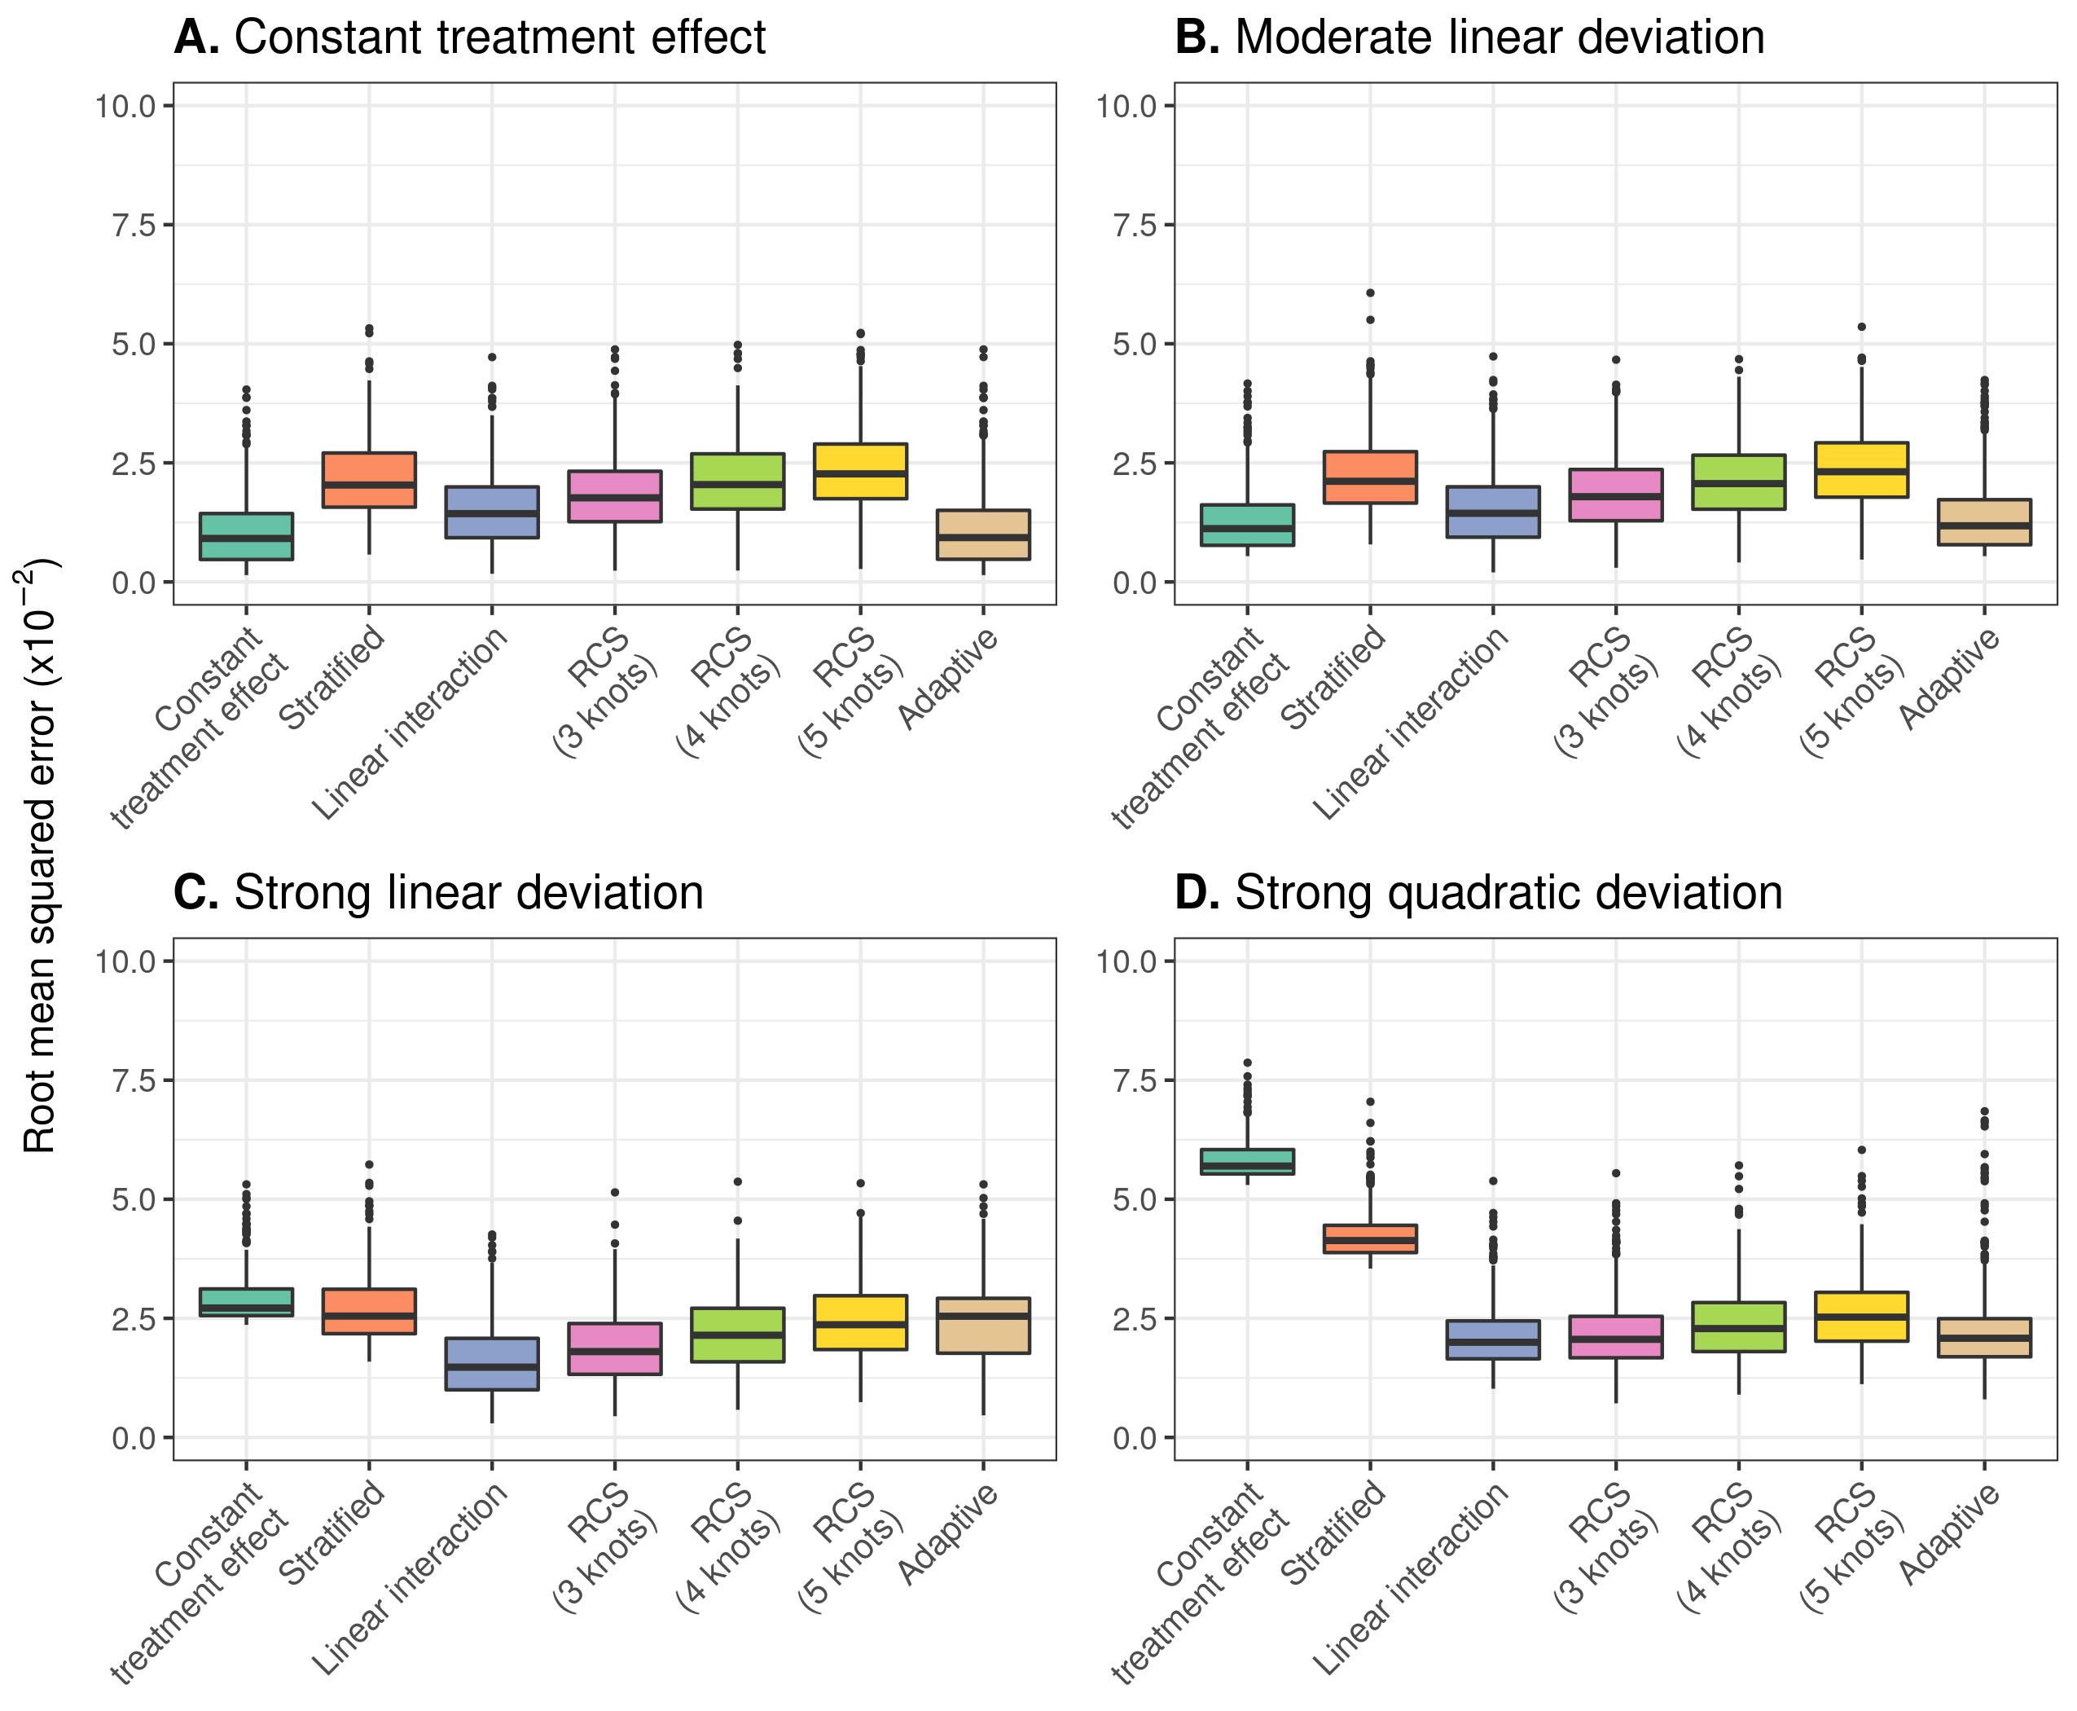

Figure 3.1: RMSE of the considered methods across 500 replications calculated in a simulated superpopulation of size 500,000. presents the results of the scenario with true constant relative treatment effect, with a true prediction AUC of 0.75 and sample size of 4250; presents the results under moderate linear deviations from constant treatment effects; presents the results for strong linear deviations from constant relative treatment effects; presents the results for strong quadratic deviations from constant relative treatment effects.

When we increased the sample size (N = 17,000), the model including a constant relative treatment effect had the lowest RMSE under the assumption of true constant relative treatment effects (Figure ; Panel A). Contrary to previous results with smaller sample sizes, when introducing moderate and strong linear deviations the linear interaction model performed best, outperforming the constant treatment effect model (Figure ; Panels B and C). However, the linear interaction model was outperformed by the more flexible RCS models (3 knots) in the case of strong quadratic deviations. Again, the increased flexibility of RCS smoothing with higher number of knots resulted in overfitting and worse performance (Figure ; Panel D).

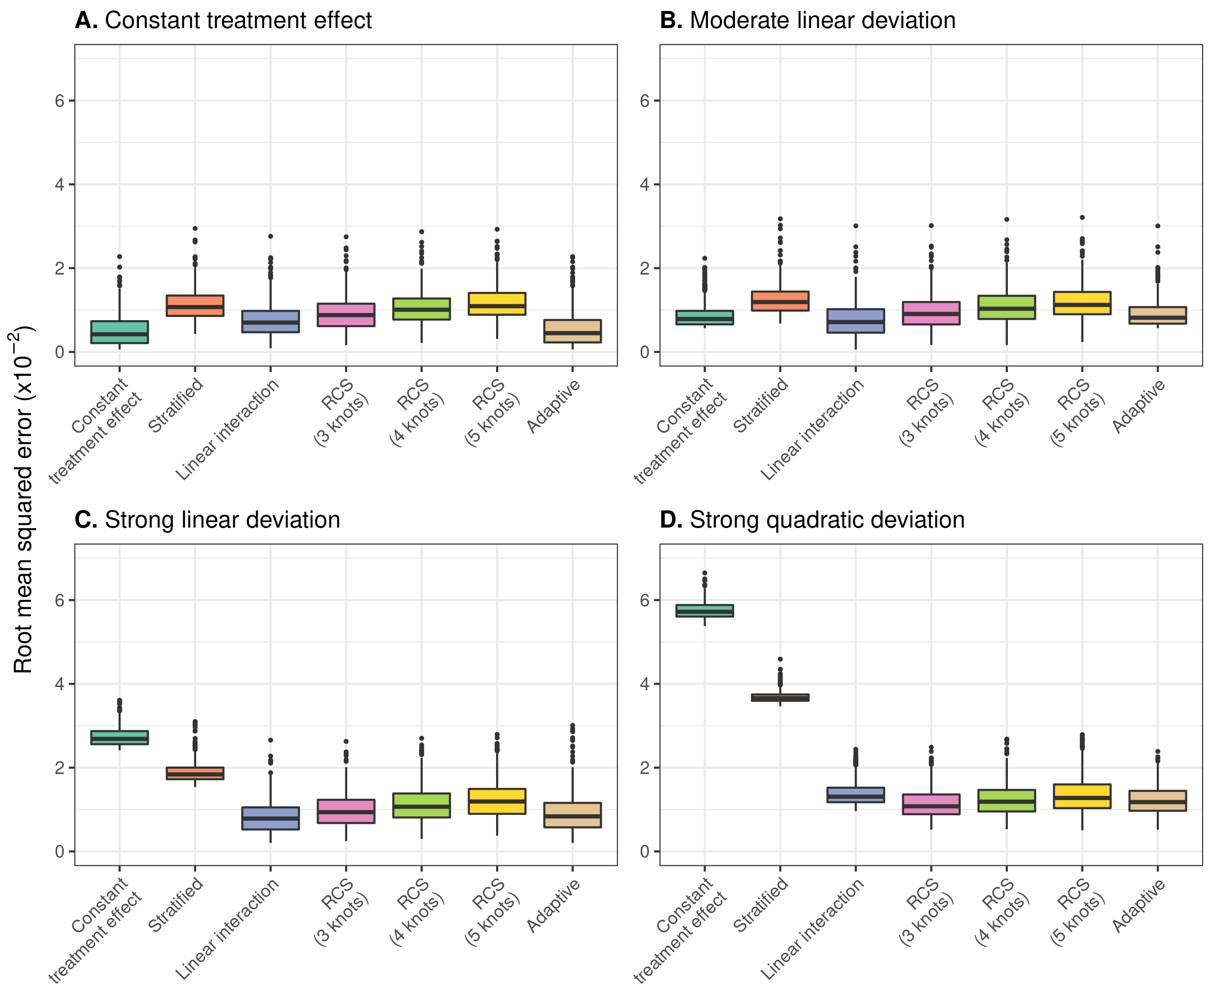

Figure 3.2: RMSE of the considered methods across 500 replications calculated in a simulated sample of size 500,000. presents the results under the base case scenario of true constant relative treatment effect, with a true prediction AUC of 0.75 and sample size of 17,000; presents the results under moderate linear deviations from constant treatment effects; presents the results for strong linear deviations from constant relative treatment effects; presents the results for strong quadratic deviations constant relative treatment effects.

When we increased the true prediction AUC to 0.85, models including RCS smoothing had the lowest RMSE in the presence of strong quadratic deviations from the base case of true constant relative treatment effects (Figure ; Panel D). However, with milder deviations, the linear interaction model had the lowest RMSE with the RCS smoothing methods (3 knots) being a close second (Figure ; Panels B and C). Increasing the number of knots of RCS smoothing resulted in increased RMSE, which was less pronounced in the case of strong quadratic deviations.

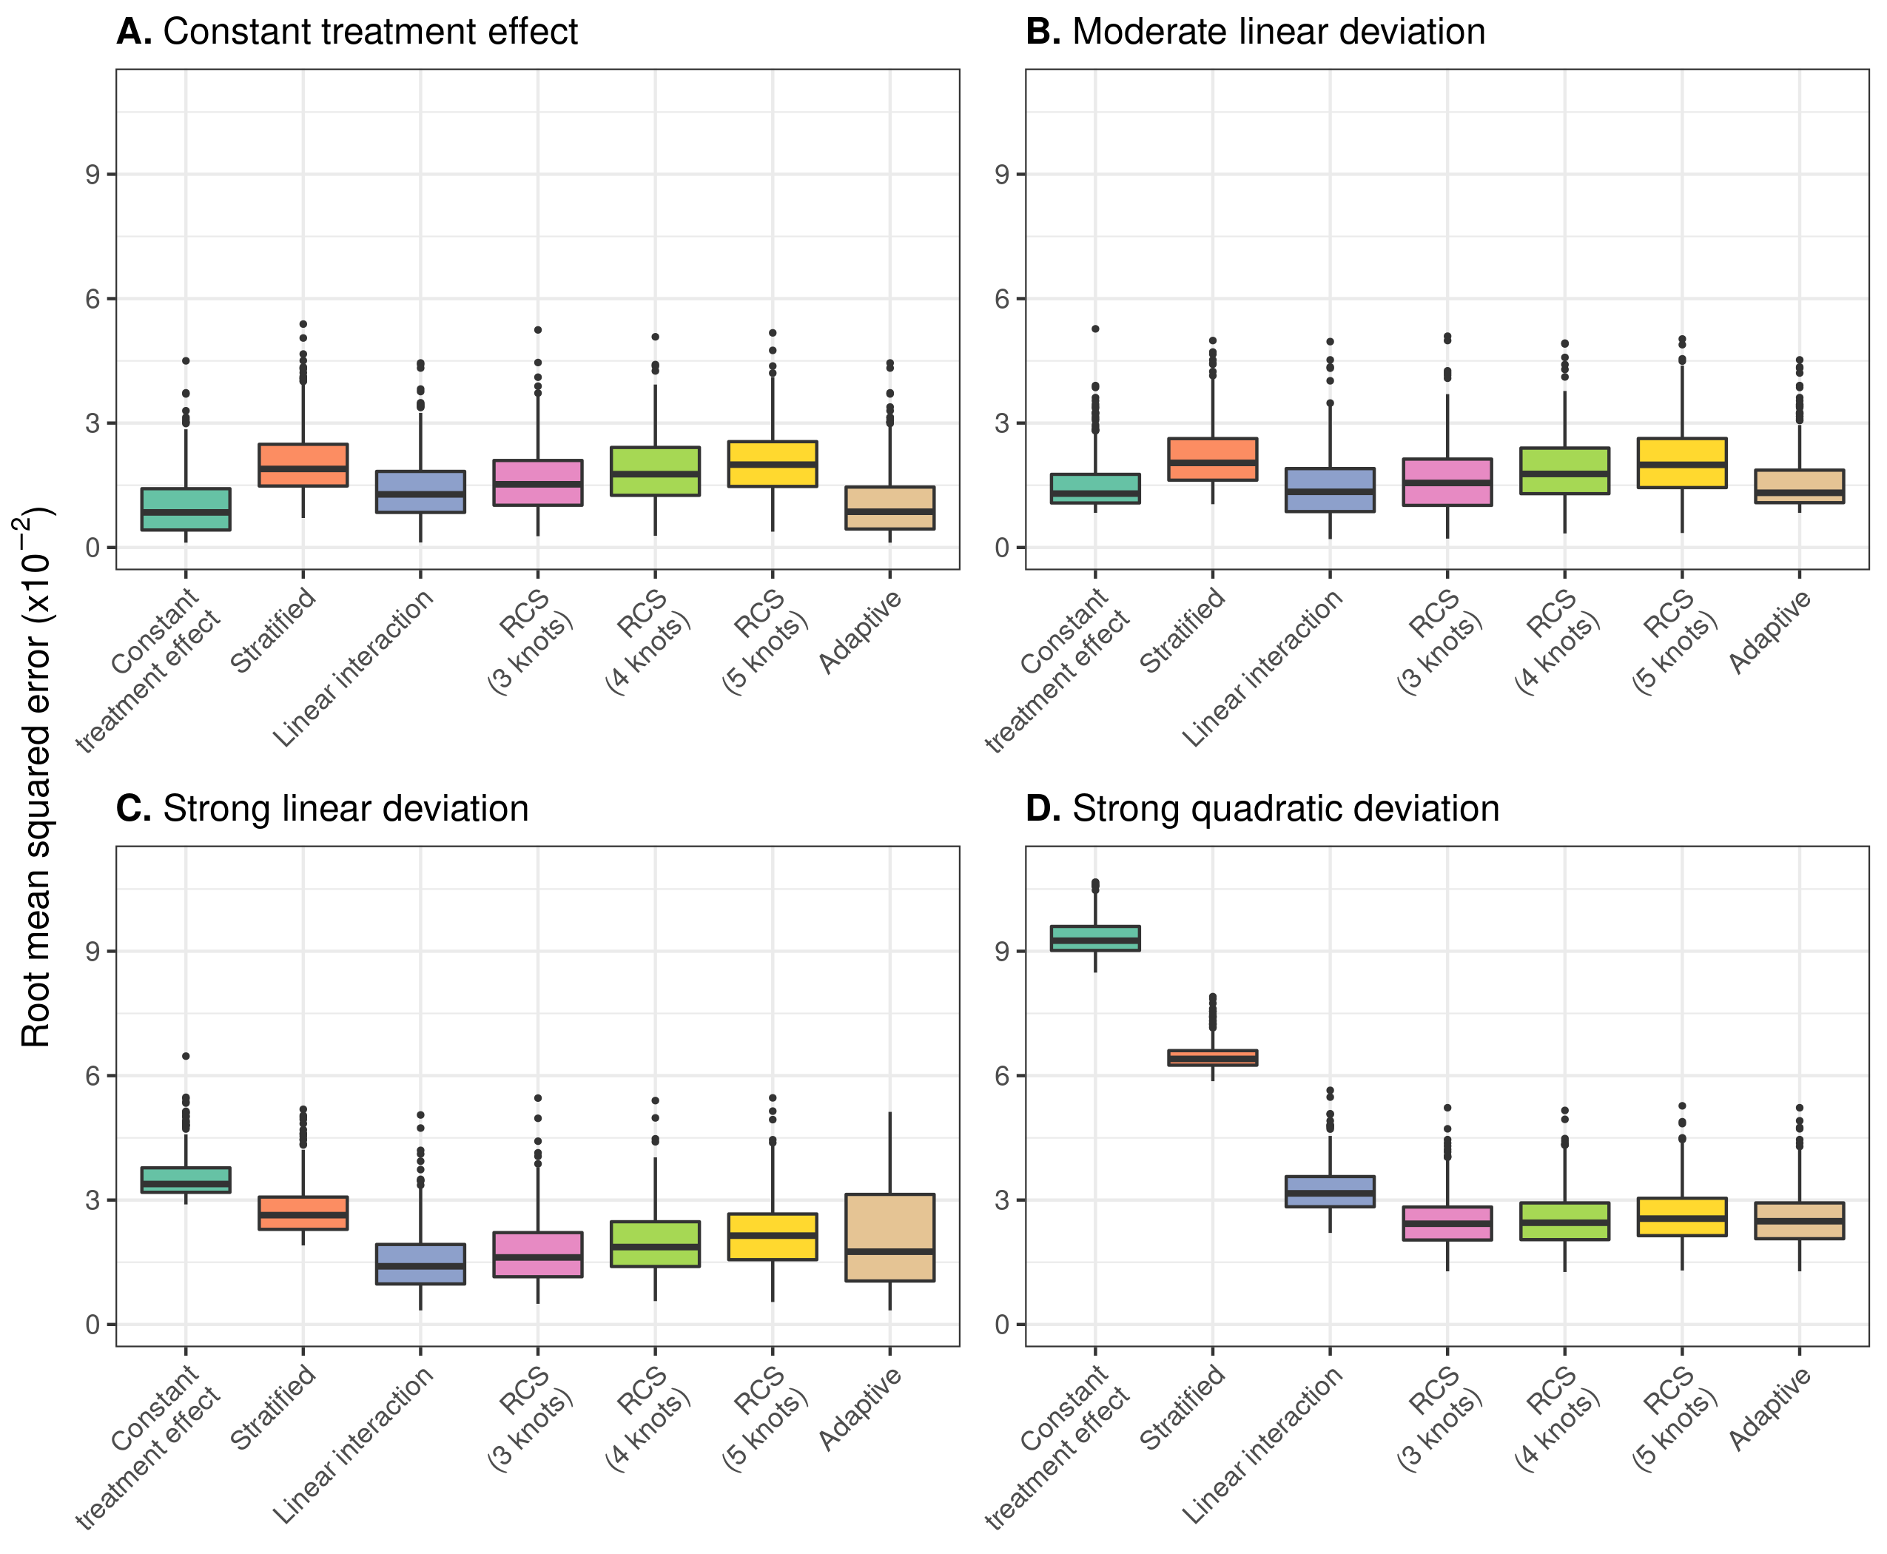

Figure 3.3: RMSE of the considered methods across 500 replications calculated in a simulated sample of size 500,000. presents the results under the base case scenario of true constant relative treatment effect, with a true prediction AUC of 0.85 and sample size of 4,250; presents the results under moderate linear deviations from constant treatment effects, while holding true prediction AUC and sample size constant; presents the results for strong linear deviations from constant relative treatment effects; presents the results for strong quadratic deviations from constant relative treatment effects.

The constant effects model, the linear interaction model and models with RCS smoothing (3 knots) had the highest median c-for-benefit in the base case scenario and the scenarios where linear and quadratic deviations were considered. The constant treatment effect model and the linear interaction model tended to present much lower variability compared to all other approaches (Figure ). We also observed an increasing trend of discrimination for benefit variability and decreasing median values with increasing number of restricted cubic spline knots in all scenarios.

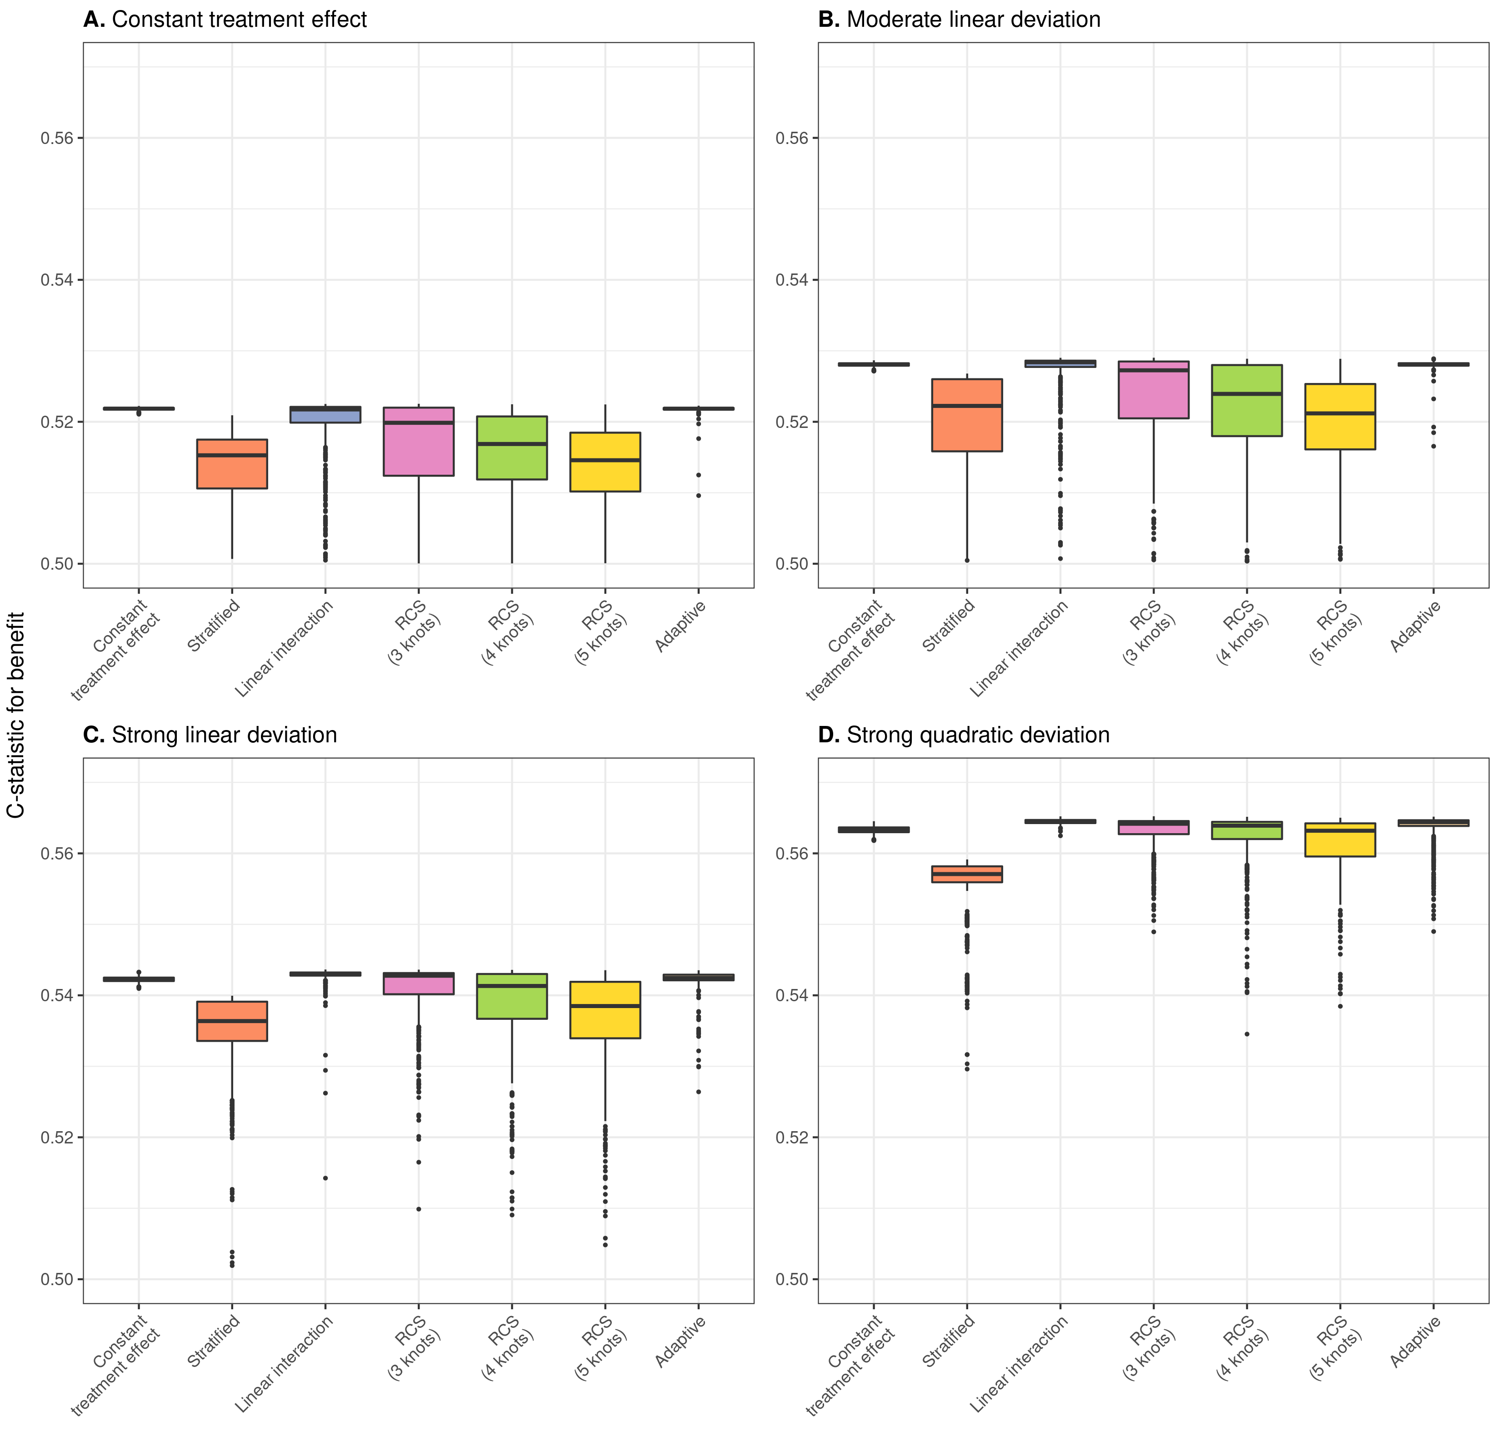

Figure 3.4: Discrimination for benefit of the considered methods across 500 replications calculated in a simulated sample of size 500,000. presents the results under the base case scenario of true constant relative treatment effect, with a true prediction AUC of 0.75 and sample size of 4250; presents the results under moderate linear deviations from constant treatment effects; presents the results for strong linear deviations from constant relative treatment effects; presents the results for strong quadratic deviations from constant relative treatment effects.

When focusing on calibration, the linear interaction model had the lowest median ICI for benefit in the majority of scenarios except for the scenarios where no or moderate linear deviations from the base case were considered. In that case constant treatment effect models demonstrated the best performance, very comparable to the linear interaction model’s performance, nonetheless (Figure ). However, under strong linear or quadratic deviations, the constant treatment effect model was very poorly calibrated (Figure ; Panels C and D).

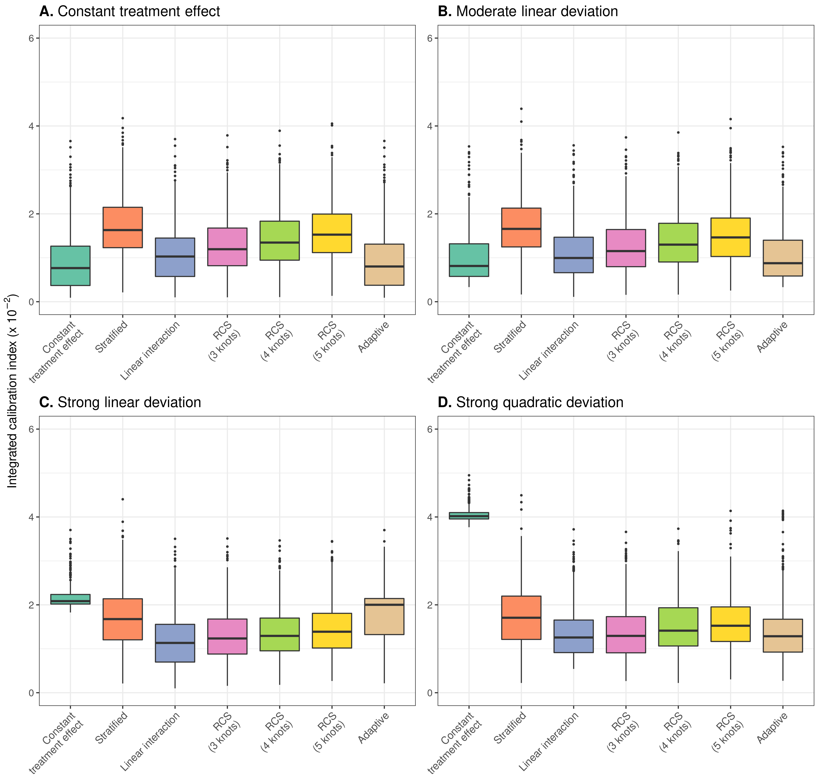

Figure 3.5: Calibration for benefit of the considered methods across 500 replications calculated in a simulated sample of size 500,000. presents the results under the base case scenario of true constant relative treatment effect, with a true prediction AUC of 0.75 and sample size of 4250; presents the results under moderate linear deviations from constant treatment effectst; presents the results for strong linear deviations from of constant relative treatment effects; presents the results for strong quadratic deviations from constant relative treatment effects.

## 3.2 Case study

We demonstrate the different methods for individualizing treatment benefits using data from 30,510 patients with an acute myocardial infarction (MI) included in the GUSTO-I trial. 10,348 patients were randomized to tissue plasminogen activator (tPA) treatment and 20,162 were randomized to streptokinase. The outcome of interest was 30-day mortality, recorded for all patients.

In line with previous analyses [10,11], we fitted a logistic regression model with 6 baseline covariates, i.e. age, Killip class, systolic blood pressure, heart rate, an indicator of previous MI, and the location of MI, to predict 30-day mortality risk. A constant effect of treatment was included in the model. When deriving risk predictions for individuals we set the treatment indicator to 0. More information on model development can be found in the supplement.

We used the risk linear predictor to fit the the proposed methods under study for individualizing absolute benefit predictions. All methods had quite comparable results, in the sense that we predicted increasing benefits for patients with higher baseline risk predictions. In terms of c-for-benefit (validated internally) all models had quite comparable performance ranging from 0.519 (RCS smoothing with 3 knots) to 0.542 (RCS smoothing with 4 knots). Similar conclusions could be drawn in terms of ICI-for-benefit which ranged from 0.0039 (linear interaction approach) to 0.0053 (RCS smoothing with 4 knots).

The adaptive approach picked the model with RCS smoothing with 4 knots, which had quite comparable performance to the smooth fit with 5 knots. However, for lower baseline risk these 2 models predicted implausible benefits and maybe should be avoided when applying such models in practice. The linear interaction model and the model with RCS smoothing (3 knots) made very similar predictions and also followed quite closely the evolution of the stratified estimates. In this case, we observed that even using a simple model with a constant relative treatment effect can result in very similar benefit predictions as other more complex approaches.

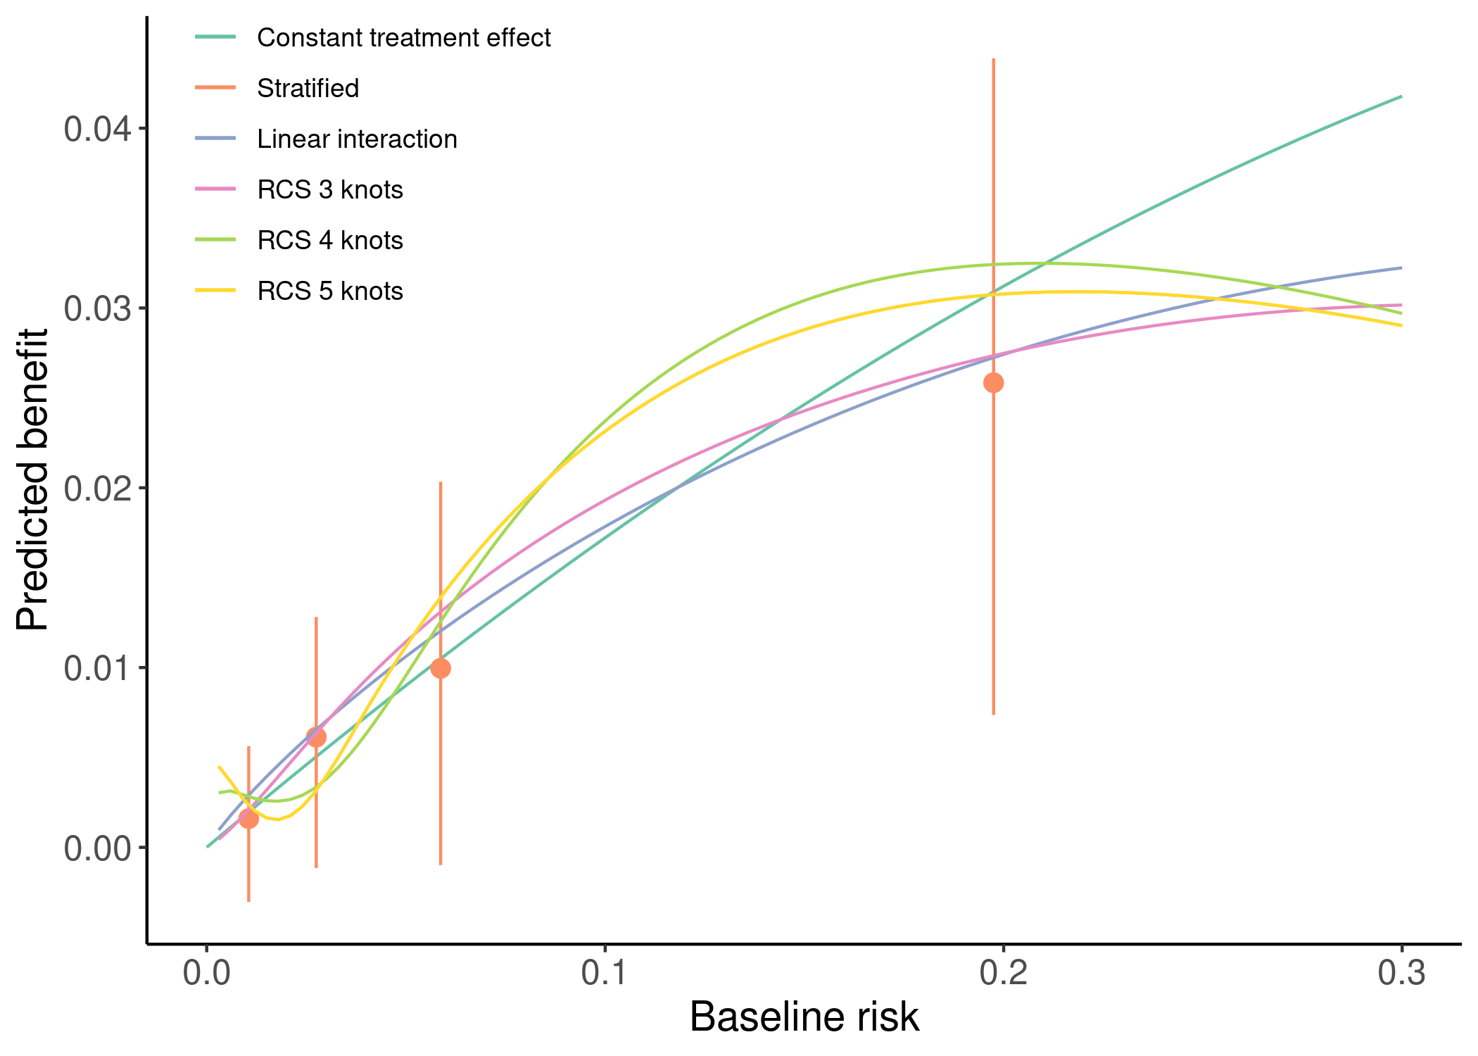

Figure 3.6: Individualized absolute benefit predictions based on baseline risk when using a constantn treatment effect approach, a linear interaction approach and RCS smoothing using 3,4 and 5 knots. Risk stratified estimates of absolute benefit are presented within quartiles of baseline risk as reference.

# 4 Discussion

The linear interaction model proved to be superior to alternative approaches when predicting risk-based treatment benefit under a wide range of scenarios. It generally had lower mean squared error, lower e-for-benefit and higher c-for-benefit with lower variability across simulation replications. Models including restricted cubic splines with 3 knots only outperformed the linear interaction model in the presence of strong quadratic deviations from a constant relative treatment effect.

Including restricted cubic splines with 4 or 5 knots proved to be too flexible, as indicated by higher RMSE, increased variability of discrimination for benefit and worse calibration of benefit predictions. Even with larger sample sizes and strong quadratic deviations from the base case scenario of constant relative treatment effects, these more flexible restricted cubic splines did not outperform the simpler RCS with 3 knots. These more flexible approaches may only be helpful if we expect more extreme patterns of heterogeneous treatment effects.

The constant treatment effect model, despite having adequate performance in the presence of weak treatment effect heterogeneity on the relative scale, quickly broke down with stronger deviations from constant relative treatment effects. In these cases, the stratified approach generally had lower error rates compared to the constant treatment effect model. In concept, the stratified approach lies between the constant effects model and smoother approaches, only assuming constant treatment effects within strata of predicted risk and, therefore, is more sensitive to treatment effect heterogeneity. Stepwise treatment benefit estimates are very useful for demonstrating treatment effect heterogeneity – because estimating treatment effect requires groups of patients rather than individual patients –but are not helpful for making individualized absolute benefit predictions.

Increasing the discriminative ability of the risk model – by increasing the predictor coefficients of the true risk model – reduced RMSE for all methods, similar to increasing the sample size. This increase in discriminative ability translates in higher variability of predicted risks, which, in turn, allows the considered methods to better follow the evolution of treatment benefit. As expected, the increase in discriminative ability of the risk model also led to higher values of c-for-benefit. Even though risk model performance is very important for the ability of risk-based methods to predict treatment benefit, prediction model development was outside the scope of this work and has already been studied extensively [5,12,13].

Risk-based approaches to predictive HTE estimate treatment benefit as a function of baseline risk. A limitation of our study is that we assumed treatment benefit to be a function of baseline risk in the majority of the simulation scenarios. Nevertheless, our main conclusions did not change when we generated individual treatment-covariate interactions (supplementary table/figure x). Future simulation studies could explore the effect of more extensive deviations from risk-based treatment effects.

Recent years have seen an increased interest in predictive HTE approaches focusing on individualized benefit predictions. In our simulations we only focused on risk-based methods, using baseline risk as a reference in a two-stage approach to individualizing benefit predictions. However, there is a plethora of different methods, ranging from treatment effect modeling to tree-based approaches available in more recent literature [14–16]. Simulations are also needed to assess relative performance and define the settings where these break down or outperform each other.

In conclusion, when comparing different risk-based approaches to predict individualizing benefit a models including a linear treatment interaction with the prognostic performed best in a wide range of scenarios. More flexible models with restricted cubic splines required larger sample sizes and higher AUC of the PI to outperform the linear model. An adaptive approach, selecting the model with optimal AIC, had satisfactory performance.

# 5 References

[1] Varadhan R, Segal JB, Boyd CM, Wu AW, Weiss CO. A framework for the analysis of heterogeneity of treatment effect in patient-centered outcomes research. Journal of Clinical Epidemiology 2013;66:818–25. <https://doi.org/10.1016/j.jclinepi.2013.02.009>.

[2] Rekkas A, Paulus JK, Raman G, Wong JB, Steyerberg EW, Rijnbeek PR, et al. Predictive approaches to heterogeneous treatment effects: A scoping review. BMC Medical Research Methodology 2020;20. <https://doi.org/10.1186/s12874-020-01145-1>.

[3] Kent DM, Paulus JK, Klaveren D van, D’Agostino R, Goodman S, Hayward R, et al. The predictive approaches to treatment effect heterogeneity (PATH) statement. Annals of Internal Medicine 2019;172:35. <https://doi.org/10.7326/m18-3667>.

[4] Kent DM, Klaveren D van, Paulus JK, D’Agostino R, Goodman S, Hayward R, et al. The predictive approaches to treatment effect heterogeneity (PATH) statement: Explanation and elaboration. Annals of Internal Medicine 2019;172:W1. <https://doi.org/10.7326/m18-3668>.

[5] Klaveren D van, Balan TA, Steyerberg EW, Kent DM. Models with interactions overestimated heterogeneity of treatment effects and were prone to treatment mistargeting. Journal of Clinical Epidemiology 2019;114:72–83. <https://doi.org/10.1016/j.jclinepi.2019.05.029>.

[6] Kent DM, Rothwell PM, Ioannidis JP, Altman DG, Hayward RA. Assessing and reporting heterogeneity in treatment effects in clinical trials: A proposal. Trials 2010;11. <https://doi.org/10.1186/1745-6215-11-85>.

[7] Harrell FE, Lee KL, Pollock BG. Regression models in clinical studies: Determining relationships between predictors and response. JNCI Journal of the National Cancer Institute 1988;80:1198–202. <https://doi.org/10.1093/jnci/80.15.1198>.

[8] Klaveren D van, Steyerberg EW, Serruys PW, Kent DM. The proposed “concordance-statistic for benefit” provided a useful metric when modeling heterogeneous treatment effects. Journal of Clinical Epidemiology 2018;94:59–68. <https://doi.org/10.1016/j.jclinepi.2017.10.021>.

[9] Austin PC, Steyerberg EW. The integrated calibration index (ICI) and related metrics for quantifying the calibration of logistic regression models. Statistics in Medicine 2019;38:4051–65. <https://doi.org/10.1002/sim.8281>.

[10] Califf RM, Woodlief LH, Harrell FE, Lee KL, White HD, Guerci A, et al. Selection of thrombolytic therapy for individual patients: Development of a clinical model. American Heart Journal 1997;133:630–9. <https://doi.org/10.1016/s0002-8703(97)70164-9>.

[11] Steyerberg EW, Bossuyt PMM, Lee KL. Clinical trials in acute myocardial infarction: Should we adjust for baseline characteristics? American Heart Journal 2000;139:745–51. <https://doi.org/10.1016/s0002-8703(00)90001-2>.

[12] Burke JF, Hayward RA, Nelson JP, Kent DM. Using internally developed risk models to assess heterogeneity in treatment effects in clinical trials. Circulation: Cardiovascular Quality and Outcomes 2014;7:163–9. <https://doi.org/10.1161/circoutcomes.113.000497>.

[13] Abadie A, Chingos MM, West MR. Endogenous stratification in randomized experiments. The Review of Economics and Statistics 2018;100:567–80. <https://doi.org/10.1162/rest_a_00732>.

[14] Athey S, Tibshirani J, Wager S. Generalized random forests. The Annals of Statistics 2019;47. <https://doi.org/10.1214/18-aos1709>.

[15] Lu M, Sadiq S, Feaster DJ, Ishwaran H. Estimating individual treatment effect in observational data using random forest methods. Journal of Computational and Graphical Statistics 2018;27:209–19. <https://doi.org/10.1080/10618600.2017.1356325>.

[16] Wager S, Athey S. Estimation and inference of heterogeneous treatment effects using random forests. Journal of the American Statistical Association 2018;113:1228–42. <https://doi.org/10.1080/01621459.2017.1319839>.