Linear interaction of treatment with baseline risk was sufficient for predicting individualized benefit

**Objective:** To compare different risk-based methods predicting individualized treatment effects in RCT simulations. **Study Design and Setting:** We simulated data using diverse assumptions for a baseline prognostic index of risk (PI) and the shape of its intereraction with treatment (none, linear or quadratic). In each sample we predicted absolute benefit using: models with the PI and a constant relative treatment effect; models including an interaction of treatment with the PI; stratification in quarters of the PI; nonlinear transformations of the PI (restricted cubic splines with 3, 4 and 5 knots); an adaptive approach using Akaike’s Information Criterion. We evaluated predictive performance using root mean squared error and measures of discrimination and calibration for benefit. Starting from a base case scenario (sample size 4,250, treatment odds ratio 0.8, AUC of the PI 0.75), we varied the sample size, the treatment effect strength, and the PI’s discriminative ability. **Results:** Models including a PI by treatment interaction performed better under most simulation settings. Flexible models required larger sample sizes and higher AUC of the PI to outperform the linear interaction model. The adaptive approach performed similarly to the best-performing method in most scenarios. **Conclusion:** Under most circumstances, a model with a linear interaction of the PI with treatment is the optimal risk-based approach to predicting absolute treatment benefit.

# 1 Introduction

Predictive approaches for assessing heterogeneity of treatment effects (HTE) aim at the development of models predicting either individualized effects or which of two (or more) treatments is better for an individual [1]. In prior work, we divided such methods in three broader categories based on the reference class used for defining patient similarity when making individualized predictions or recommendations [2]. Risk-modeling approaches use prediction of baseline risk as the reference; treatment effect modeling approaches also model treatment-covariate interactions, in addition to risk factors; optimal treatment regime approaches focus on developing treatment assignment rules and therefore rely heavily on modeling treatment effect modifiers.

Risk-modeling approaches to predictive HTE analyses provide a viable option in the absence of well-established treatment effect modifiers [3,4]. In simulations, modeling of effect modifiers, i.e. treatment-covariate interactions, often led to miscalibrated predictions of benefit, while risk-based methods proved quite robust [5]. Most often, risk-modeling approaches are carried out in two steps: first a risk prediction model is developed externally or internally on the entire RCT population, “blinded” to treatment; then the RCT population is stratified using this prediction model to evaluate risk-based treatment effect variation [6]. However, even though estimates at the risk subgroup level may be accurate, these estimates do not apply to individual patients, especially for patients with predicted risk at the boundaries of the risk intervals. Hence, the risk-stratified approach is useful for exploring and presenting HTE, but is not useful for supporting treatment decisions for individual patients.

To individualize treatment effects, the recent PATH statement suggested various risk-based models including a prognostic index of baseline risk (PI) and treatment assignment [3,4]. We aimed to summarize and compare different risk-based models for predicting individualized treatment effects. We simulated RCT settings to compare the performance of these models under different assumptions of the relationship between baseline risk and treatment. We illustrated the different models by a case study of predicting individualized effects of tissue plasminogen activator (tPA) versus streptokinase treatment in patients with an acute myocardial infarction (MI).

# 2 Methods

## 2.1 Simulation scenarios

For each patient we generated 8 baseline covariates here and . Treatment was allocated using a 50:50 split. Outcomes for patients in the control arm were generated from a logistic regression model including all baseline covariates. In the base case scenario coefficient values were such, that the AUC of the logistic regression model was and the event rate in the control arm was .

While binary outcomes in the control arm were generated from Bernoulli variables with true probabilities , the outcomes in the treatment arm were based on true probabilities , with

The coefficients and along with the centering constant were set for each simulation scenario to mimic a wide variety scenarios, ranging from true constant relative treatment effect () to moderate and strong linear () and quadratic deviations. We also considered scenarios with treatment-covariate interactions. These scenarios included 4 weak interactions (), 4 strong interactions (), and 2 weak and 2 strong interactions.

The sample size of the base case scenario was set to 4,250 ( power for the detection of a marginal OR of 0.8). We evaluated the effect of smaller or larger sample sizes of 1,064 and 17,000, respectively. We also evaluated the effect of worse or better discriminative ability for risk, adjusting the baseline covariate coefficients, such that the AUC of the regression model in the control arm was 0.65 and 0.85 respectively.

Combining all these settings resulted in a simulation study of 66 scenarios (exact settings in the supplementary material).

## 2.2 Individualized risk-based benefit predictions

All methods assume that a risk prediction model is available to assign risk predictions to individual patients. For the simulations we developed a prediction model internally, using logistic regression including main effects for all baseline covariates and treatment assignment. Risk predictions for individual patients were based on treatment assignment to the control arm, that is setting treatment assignment to 0.

A *stratified HTE method* has been suggested as an alternative to traditional subgroup analyses. Patients are stratified into equally-sized risk strata—in this case based on risk quartiles. Absolute treatment effects within risk strata are estimated by the difference in event rate between patients in the control arm and patients in the treated arm. We considered this approach as a reference, expecting it to perform worse than the other candidates, as its objective is not to individualize benefit prediction.

Second, we considered a model which assumes *constant relative treatment effect* (constant OR). Hence, absolute benefit is predicted from .

Third, we considered a logistic regression model including treatment, the prognostic index, and their linear interaction. Absolute benefit is then estimated from . We will refer to this method as the *linear interaction* approach.

Fourth, we used *restricted cubic splines* (RCS) to relax the linearity assumption on the effect of the linear predictor [7]. We considered splines with 3, 4 and 5 knots to compare models with different levels of flexibility.

Finally, we considered an adaptive approach using Akaike’s Information Criterion (AIC) for model selection. The candidate models were: a constant treatment effect model, a model with a linear interaction with treatment and RCS models with 3, 4 and 5 knots.

## 2.3 Evaluation metrics

We evaluated the predictive accuracy of the considered methods by the root mean squared error (RMSE):

We compared the discriminative ability of the methods under study using c-for-benefit [8]. The c-for-benefit represents the probability that from two randomly chosen matched patient pairs with unequal observed benefit, the pair with greater observed benefit also has a higher predicted benefit. To be able to calculate observed benefit, patients in each treatment arm are ranked based on their predicted benefit and then matched 1:1 across treatment arms. *Observed* treatment benefit is defined as the difference of observed outcomes between the untreated and the treated patient of each matched patient pair. *Predicted* benefit is defined as the average of predicted benefit within each matched patient pair.

We evaluated calibration in a similar manner, using the integrated calibration index (ICI) for benefit [9]. The observed benefits are regressed on the predicted benefits using a locally weighted scatterplot smoother (loess). The ICI-for-benefit is the average absolute difference between predicted and smooth observed benefit. Values closer to represent better calibration.

# 3 Results

## 3.1 Simulations

The model including a constant relative treatment effect had the lowest median RMSE in scenarios with a true constant relative treatment effect (OR = 0.8, N = 4,250 and AUC = 0.75) or with moderate relative deviations (Figure ; Panel A). However, when we considered strong linear and quadratic deviations from a constant relative treatment effect the linear interaction model performed best (Figure ; Panels B and C). Only in the case of strong quadratic deviations models including RCS (3 knots) performed equally well to the linear interaction method. Increasing the number of knots in RCS resulted in higher RMSE across all scenarios. The adaptive approach performed very similarly to the best performing model in each scenario.

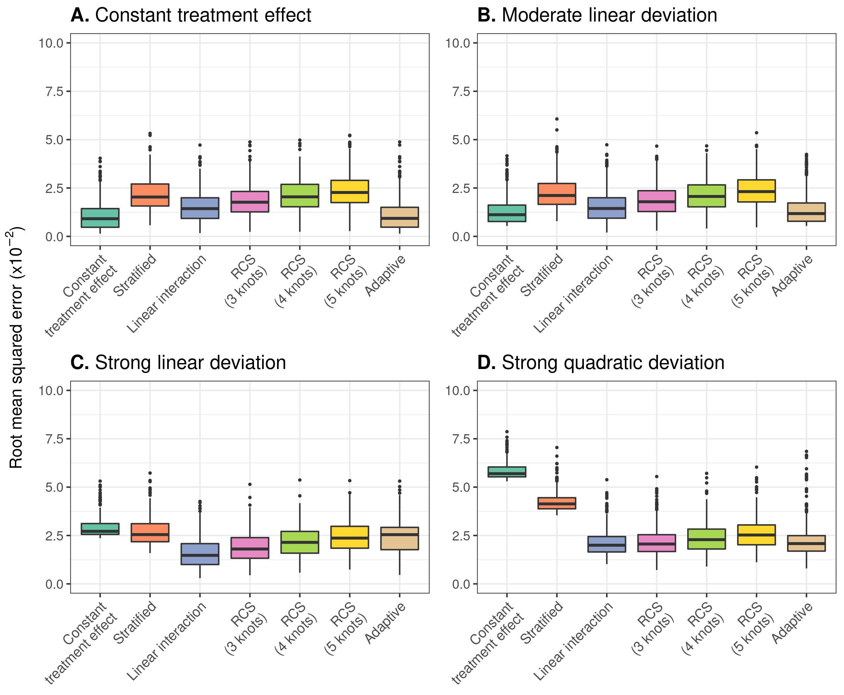

Figure 3.1: RMSE of the considered methods across 500 replications calculated in a simulated superpopulation of size 500,000. The scenario with true constant relative treatment effect had a true prediction AUC of 0.75 and sample size of 4250. Results are presented under moderate linear, strong linear, and strong quadratic deviations from constant relative treatment effects.

When we increased the sample size (N = 17,000), the model including a constant relative treatment effect had the lowest RMSE under the assumption of true constant relative treatment effects (Figure ; Panel A). However, when introducing moderate and strong linear deviations the linear interaction model outperformed the constant treatment effect model (Figure ; Panels B and C). Furthermore, the linear interaction model was outperformed by the more flexible RCS models (3 knots) in the case of strong quadratic deviations. Again, the increased flexibility of RCS smoothing with higher number of knots resulted in overfitting and worse predictive accuracy (Figure ; Panel D).

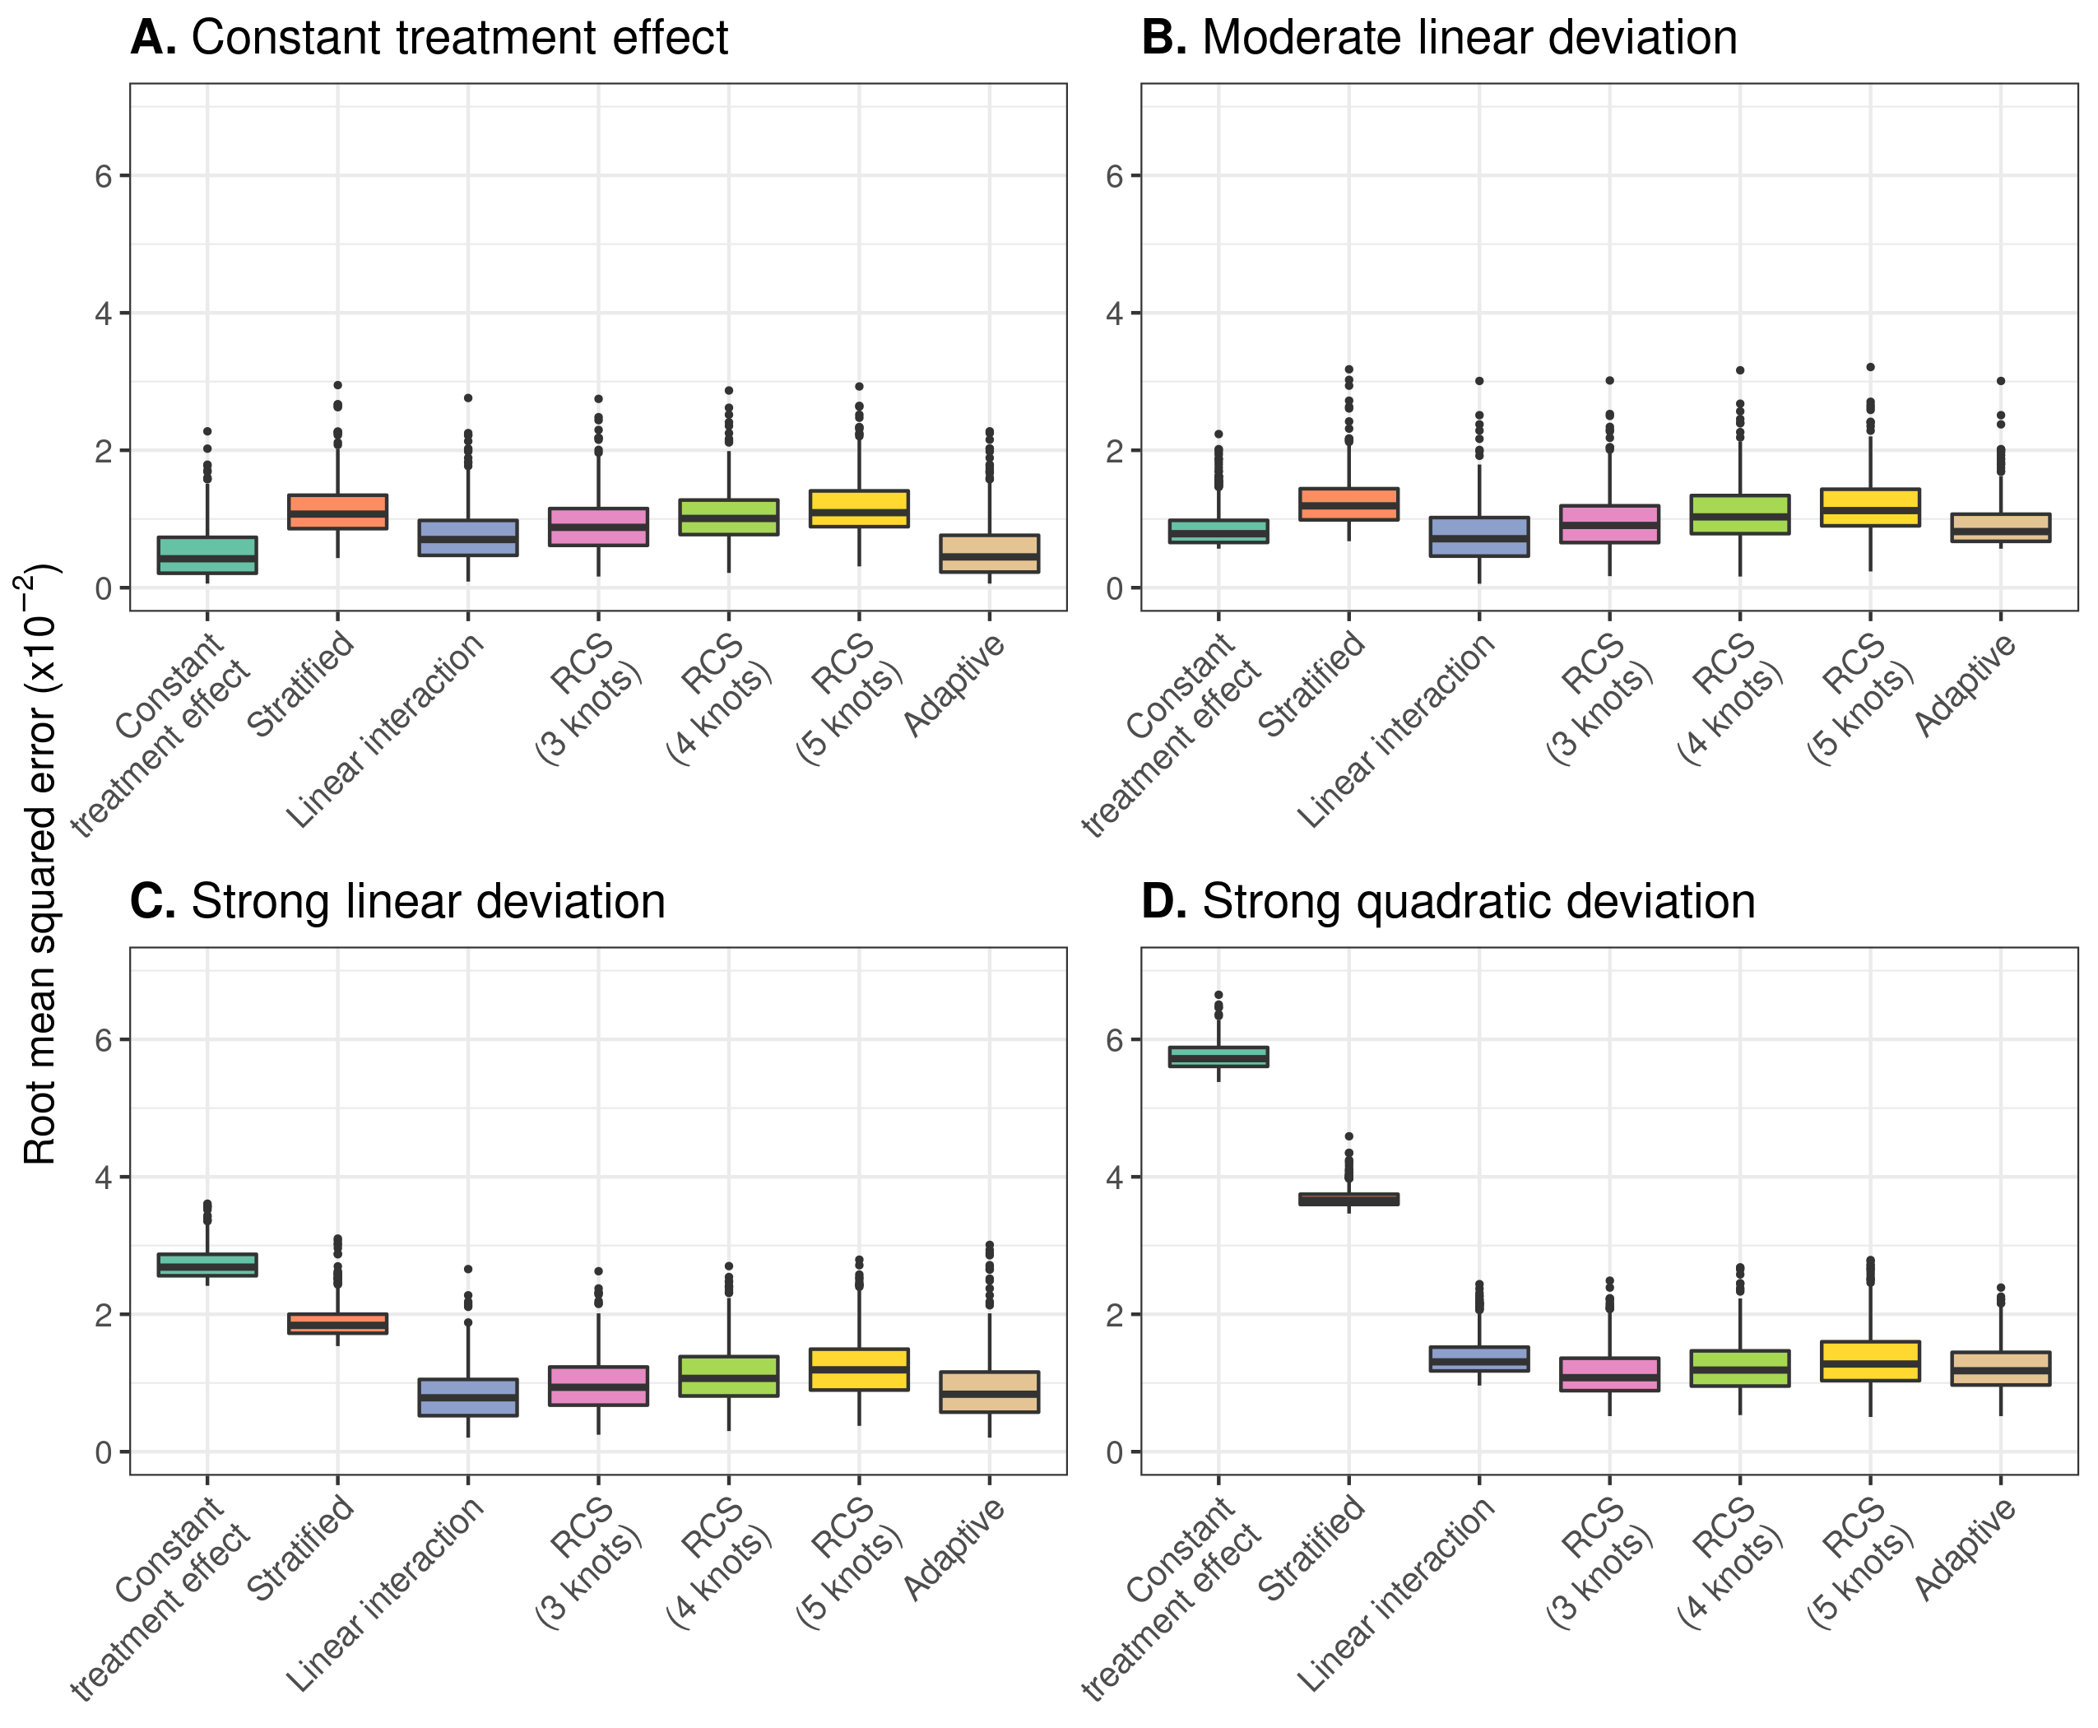

Figure 3.2: RMSE of the considered methods across 500 replications calculated in a simulated sample of size 500,000. Sample size 17,000 rather than 4250 in Figure

When we increased the AUC of the true prediction model to 0.85, models including RCS smoothing had the lowest RMSE in the presence of strong quadratic deviations from the base case of true constant relative treatment effects (Figure ; Panel D). However, with milder deviations, the linear interaction model had the lowest RMSE with the RCS smoothing methods (3 knots) being a close second (Figure ; Panels B and C). Increasing the number of knots of RCS smoothing resulted in increased RMSE, which was less pronounced in the case of strong quadratic deviations.

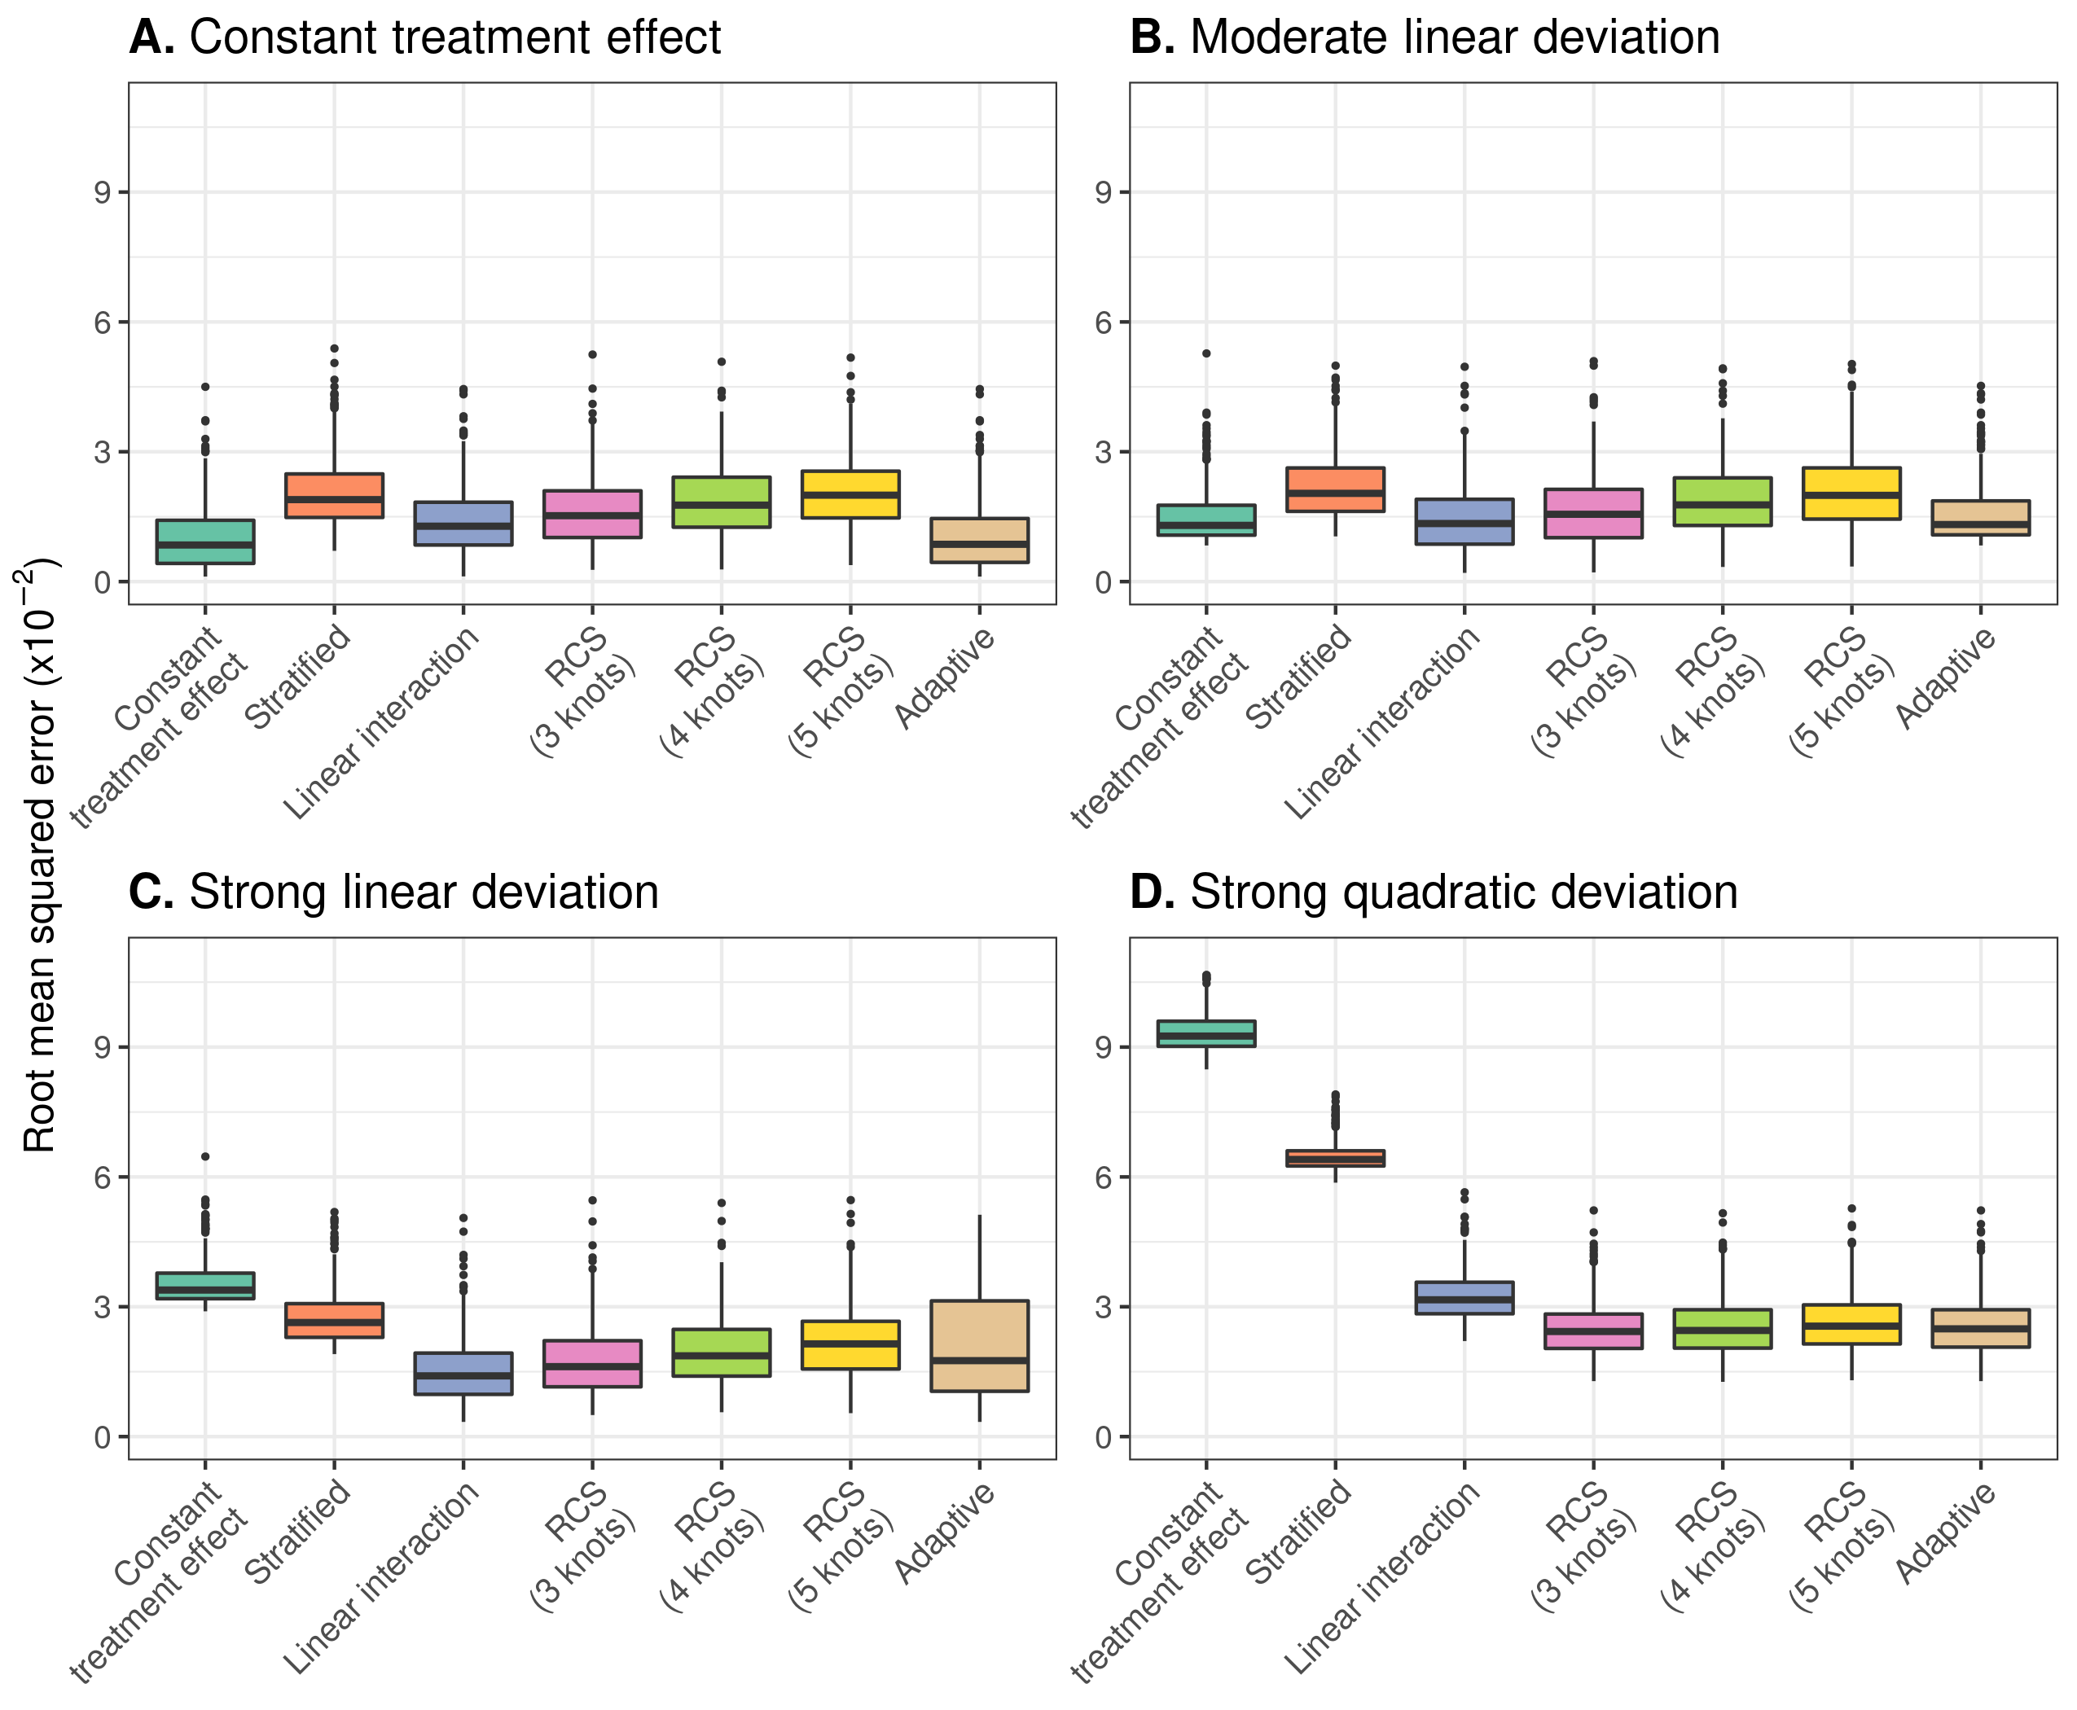

Figure 3.3: RMSE of the considered methods across 500 replications calculated in a simulated sample of size 500,000. True prediction AUC of 0.85 and sample size of 4,250.

The constant effects model, the linear interaction model and models with RCS smoothing (3 knots) had the highest median c-for-benefit in the base case scenario and the scenarios where linear and quadratic deviations were considered. The constant treatment effect model and the linear interaction model tended to present much lower variability compared to all other approaches (Figure ). With increasing number of RCS knots, we observed decreasing median values and increasing variability of the c-for-benefit in all scenarios.

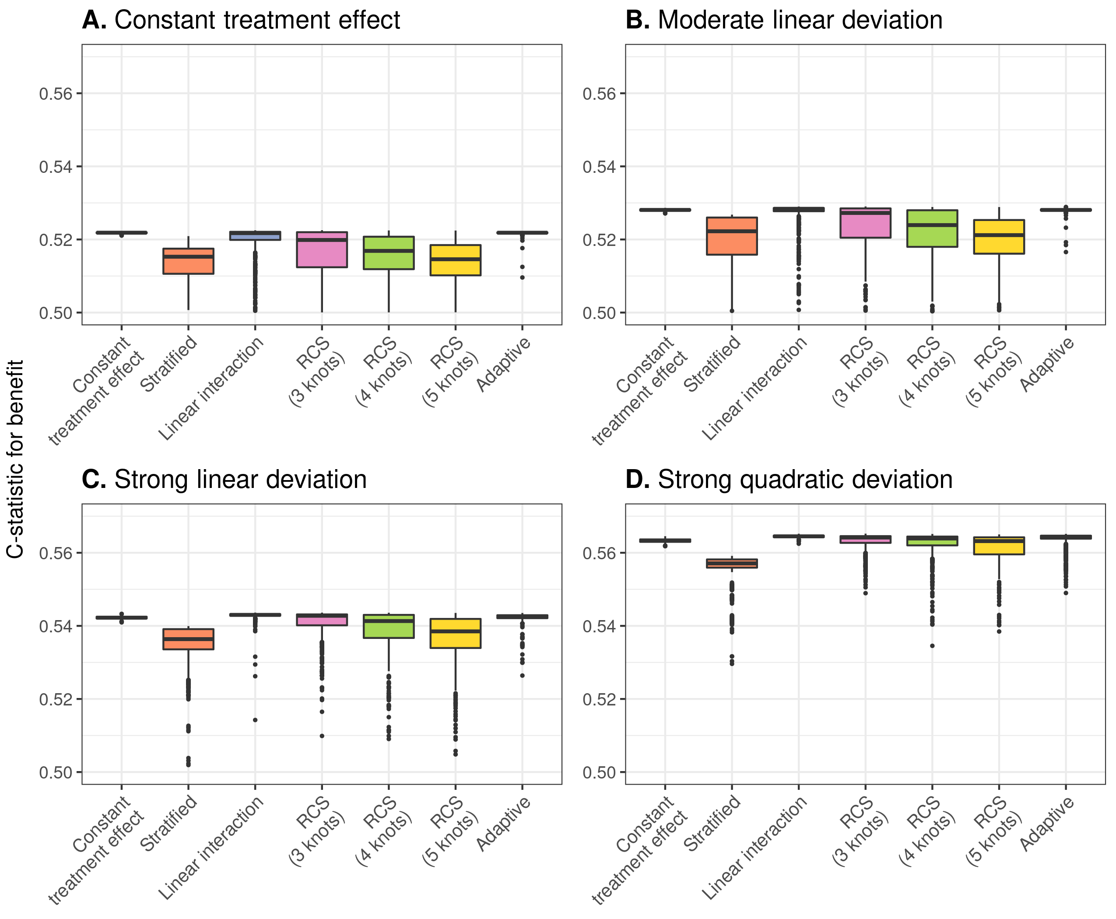

Figure 3.4: Discrimination for benefit of the considered methods across 500 replications calculated in a simulated sample of size 500,000. True prediction AUC of 0.75 and sample size of 4,250.

As for calibration, the linear interaction model had the lowest median ICI-for-benefit in the majority of scenarios except for the scenarios where no or moderate linear deviations from the base case were considered. In that case constant treatment effect models demonstrated optimal calibration, very comparable to the linear interaction model’s performance, nonetheless (Figure ). With strong linear or quadratic deviations, the constant treatment effect model was poorly calibrated (Figure ; Panels C and D).

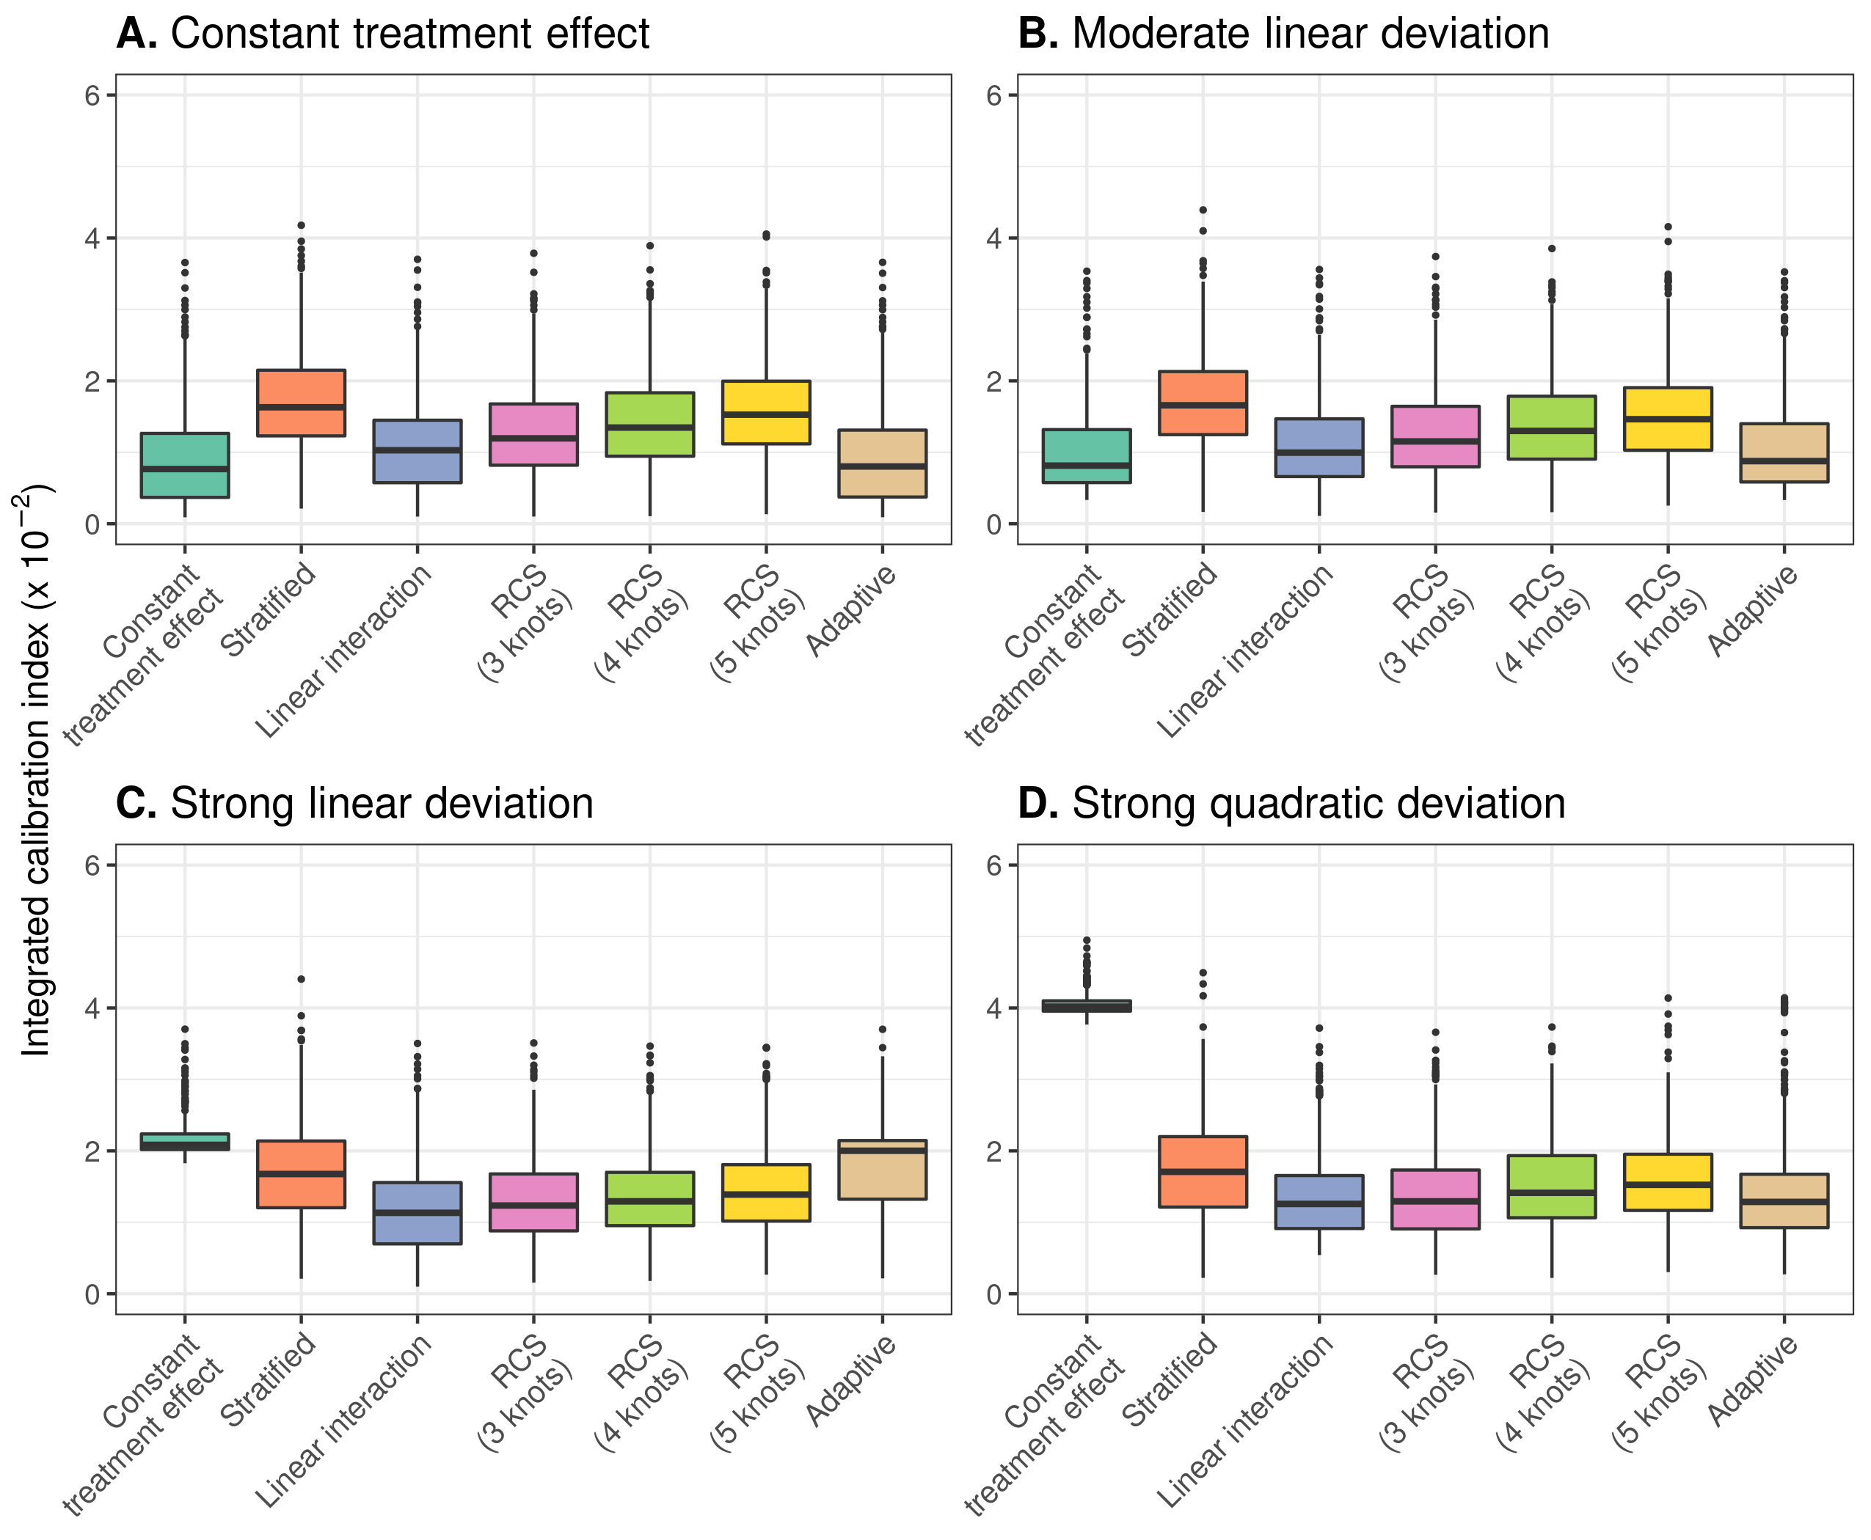

Figure 3.5: Calibration for benefit of the considered methods across 500 replications calculated in a simulated sample of size 500,000. True prediction AUC of 0.75 and sample size of 4,250.

## 3.2 Case study

We demonstrate the different methods for individualizing treatment benefits using data from 30,510 patients with an acute myocardial infarction (MI) included in the GUSTO-I trial. 10,348 patients were randomized to tissue plasminogen activator (tPA) treatment and 20,162 were randomized to streptokinase. The outcome of interest was 30-day mortality, recorded for all patients.

In line with previous analyses [10,11], we fitted a logistic regression model with 6 baseline covariates, i.e. age, Killip class, systolic blood pressure, heart rate, an indicator of previous MI, and the location of MI, to predict 30-day mortality risk. A constant effect of treatment was included in the model. When deriving risk predictions for individuals we set the treatment indicator to 0. More information on model development can be found in the supplement.

We used the risk linear predictor to fit the proposed methods under study for individualizing absolute benefit predictions. All methods predicted increasing benefits for patients with higher baseline risk predictions, but the fitted patterns were clearly different. The adaptive approach selected the model with RCS smoothing with 4 knots. However, for very low baseline risk this model predicted decreasing benefit with increasing risk may be somewhat too flexible. The more robust models, the linear interaction model or the model with RCS smoothing (3 knots), gave very similar benefit predictions, followed the evolution of the stratified estimates very closely and may therefore be preferable for use in clinical practice. The linear interaction model had somewhat lower AIC compared to the model with RCS smoothing (3 knots), slightly better cross-validated discrimination (c-for-benefit 0.526 vs 0.525) and quite similar cross-validated calibration (ICI-for benefit 0.0115 vs 0.0117).

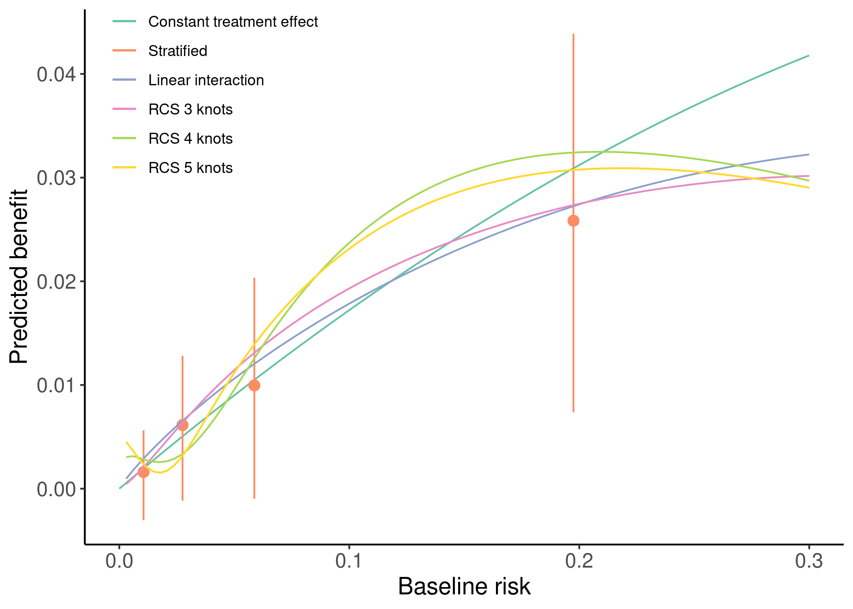

Figure 3.6: Individualized absolute benefit predictions based on baseline risk when using a constantn treatment effect approach, a linear interaction approach and RCS smoothing using 3,4 and 5 knots. Risk stratified estimates of absolute benefit are presented within quartiles of baseline risk as reference.

# 4 Discussion

The linear interaction model proved to be superior to alternative approaches when predicting risk-based treatment benefit under a wide range of scenarios. It generally had lower mean squared error, lower e-for-benefit and higher c-for-benefit with lower variability across simulation replications. Models including restricted cubic splines with 3 knots only outperformed the linear interaction model in the presence of strong quadratic deviations from a constant relative treatment effect.

Models including restricted cubic splines with 4 or 5 knots proved to be too flexible, as indicated by higher RMSE, increased variability of discrimination for benefit and worse calibration of benefit predictions. Even with larger sample sizes and strong quadratic deviations from the base case scenario of constant relative treatment effects, these more flexible restricted cubic splines did not outperform the simpler RCS with 3 knots. These approaches may only be helpful if we expect more extreme patterns of heterogeneous treatment effects compared to the quadratic deviations considered here.

The constant treatment effect model, despite having adequate performance in the presence of weak treatment effect heterogeneity on the relative scale, quickly broke down with stronger deviations from constant relative treatment effects. In these cases, the stratified approach generally had lower error rates compared to the constant treatment effect model. Stepwise treatment benefit estimates are very useful for demonstrating treatment effect heterogeneity–because estimating treatment effect requires groups of patients rather than individual patients–but are not helpful for making individualized absolute benefit predictions.

Increasing the discriminative ability of the risk model–by increasing the predictor coefficients of the true risk model–reduced RMSE for all methods. This increase in discriminative ability translates in higher variability of predicted risks, which, in turn, allows the considered methods to better capture absolute treatment benefits. As a consequence, the increase in discriminative ability of the risk model also led to higher values of c-for-benefit. Even though risk model performance is very important for the ability of risk-based methods to predict treatment benefit, prediction model development was outside the scope of this work and has already been studied extensively [5,12,13].

The adaptive approach had adequate performance, following closely the performance of the “true” model in most scenarios. However, with smaller sample sizes it tended to “miss” the treatment-risk interactions and selected simpler models. This resulted in increased RMSE variability in these scenarios, especially in the case of true strong linear deviations from the base case scenario. This tendency was mitigated when the discriminative ability of the prediction model was higher. Therefore, in the case of smaller sample sizes and/or poorly discriminating prediction models, the simpler linear interaction model is a safer choice for predicting absolute benefits.

Risk-based approaches to predictive HTE estimate treatment benefit as a function of baseline risk. A limitation of our study is that we assumed treatment benefit to be a function of baseline risk in the majority of the simulation scenarios. Nevertheless, our main conclusions did not change when we generated individual treatment-covariate interactions (supplementary table/figure x). Future simulation studies could explore the effect of more extensive deviations from risk-based treatment effects.

Recent years have seen an increased interest in predictive HTE approaches focusing on individualized benefit predictions. In our simulations we only focused on risk-based methods, using baseline risk as a reference in a two-stage approach to individualizing benefit predictions. However, there is a plethora of different methods, ranging from treatment effect modeling to tree-based approaches available in more recent literature [14–16]. Simulations are also needed to assess relative performance and define the settings where these break down or outperform each other.

In conclusion, when comparing different risk-based approaches to predicting individualized treatment benefit, a model including a linear treatment interaction with the prognostic index performed best in a wide range of scenarios. More flexible models with restricted cubic splines required larger sample sizes and higher AUC of the prognostic index to outperform the linear interaction model. An adaptive approach, selecting the model with the optimal AIC, had comparable performance to the best performing approach in most of the scenarios.

# 5 References

[1] Varadhan R, Segal JB, Boyd CM, Wu AW, Weiss CO. A framework for the analysis of heterogeneity of treatment effect in patient-centered outcomes research. Journal of Clinical Epidemiology 2013;66:818–25. <https://doi.org/10.1016/j.jclinepi.2013.02.009>.

[2] Rekkas A, Paulus JK, Raman G, Wong JB, Steyerberg EW, Rijnbeek PR, et al. Predictive approaches to heterogeneous treatment effects: A scoping review. BMC Medical Research Methodology 2020;20. <https://doi.org/10.1186/s12874-020-01145-1>.

[3] Kent DM, Paulus JK, Klaveren D van, D’Agostino R, Goodman S, Hayward R, et al. The predictive approaches to treatment effect heterogeneity (PATH) statement. Annals of Internal Medicine 2019;172:35. <https://doi.org/10.7326/m18-3667>.

[4] Kent DM, Klaveren D van, Paulus JK, D’Agostino R, Goodman S, Hayward R, et al. The predictive approaches to treatment effect heterogeneity (PATH) statement: Explanation and elaboration. Annals of Internal Medicine 2019;172:W1. <https://doi.org/10.7326/m18-3668>.

[5] Klaveren D van, Balan TA, Steyerberg EW, Kent DM. Models with interactions overestimated heterogeneity of treatment effects and were prone to treatment mistargeting. Journal of Clinical Epidemiology 2019;114:72–83. <https://doi.org/10.1016/j.jclinepi.2019.05.029>.

[6] Kent DM, Rothwell PM, Ioannidis JP, Altman DG, Hayward RA. Assessing and reporting heterogeneity in treatment effects in clinical trials: A proposal. Trials 2010;11. <https://doi.org/10.1186/1745-6215-11-85>.

[7] Harrell FE, Lee KL, Pollock BG. Regression models in clinical studies: Determining relationships between predictors and response. JNCI Journal of the National Cancer Institute 1988;80:1198–202. <https://doi.org/10.1093/jnci/80.15.1198>.

[8] Klaveren D van, Steyerberg EW, Serruys PW, Kent DM. The proposed “concordance-statistic for benefit” provided a useful metric when modeling heterogeneous treatment effects. Journal of Clinical Epidemiology 2018;94:59–68. <https://doi.org/10.1016/j.jclinepi.2017.10.021>.

[9] Austin PC, Steyerberg EW. The integrated calibration index (ICI) and related metrics for quantifying the calibration of logistic regression models. Statistics in Medicine 2019;38:4051–65. <https://doi.org/10.1002/sim.8281>.

[10] Califf RM, Woodlief LH, Harrell FE, Lee KL, White HD, Guerci A, et al. Selection of thrombolytic therapy for individual patients: Development of a clinical model. American Heart Journal 1997;133:630–9. <https://doi.org/10.1016/s0002-8703(97)70164-9>.

[11] Steyerberg EW, Bossuyt PMM, Lee KL. Clinical trials in acute myocardial infarction: Should we adjust for baseline characteristics? American Heart Journal 2000;139:745–51. <https://doi.org/10.1016/s0002-8703(00)90001-2>.

[12] Burke JF, Hayward RA, Nelson JP, Kent DM. Using internally developed risk models to assess heterogeneity in treatment effects in clinical trials. Circulation: Cardiovascular Quality and Outcomes 2014;7:163–9. <https://doi.org/10.1161/circoutcomes.113.000497>.

[13] Abadie A, Chingos MM, West MR. Endogenous stratification in randomized experiments. The Review of Economics and Statistics 2018;100:567–80. <https://doi.org/10.1162/rest_a_00732>.

[14] Athey S, Tibshirani J, Wager S. Generalized random forests. The Annals of Statistics 2019;47. <https://doi.org/10.1214/18-aos1709>.

[15] Lu M, Sadiq S, Feaster DJ, Ishwaran H. Estimating individual treatment effect in observational data using random forest methods. Journal of Computational and Graphical Statistics 2018;27:209–19. <https://doi.org/10.1080/10618600.2017.1356325>.

[16] Wager S, Athey S. Estimation and inference of heterogeneous treatment effects using random forests. Journal of the American Statistical Association 2018;113:1228–42. <https://doi.org/10.1080/01621459.2017.1319839>.