STAT 653 Finals
Mani Rekha
May 15, 2019

1 What is a tokenizer?
Answer: One common task in NLP is tokenization. Tokenization is the process of breaking the set of words or text into single words called tokens. These token are then used for as input for other types of analysis or tasks like to determine correlation between words, frequency of words, computing the TF-IDF etc. Some of the commonly used tokenizers are unnest_tokens in tidytext package, and tokens in quanteda package.

2 What is the formula for calculating the TF-IDF? Explain the two part of the calculation. What is the advantage of using the TF-IDF over just using word counts?
Answer:
Term Frequency:
TF(t,d) = 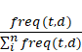
freq(t,d) - count of the instances of the term t in document d.
TF(t,d) - proportion of the count of term t in document d.
n – no of distinct terms in the document d

Inverse Document Frequency:
IDF(t) = 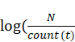)
N – count of distinct document in the corpus
Count(t) – count of documents in the corpus in which terms t is present.

Term Frequency-Inverse Document Frequency (TF-IDF)
TF-IDF = TF(t,d) * IDF(t)
Advantage of TF-IDF over word count: TF-IDF approach is used to find signature words in the document. Using word count or Bag of model approach, we may have the high term frequency word but it does not necessarily mean that word is important. TF-IDF quantifies the word based on both term frequency and inverse document frequency which enables to find out the so called important words that further leads us into topic modeling.

3 Read the excellent blog post from the Demonstration of tidytext using Darwin’s “On the Origin of Species”. Run all of the code in this blog post in your R Notebook and explain each step presented. Discuss any differences you see in the sentiment analysis performed using different lexicons.
Answer: NRC seems to have much higher positivity scores than the 2 other lexicons. 2)Both AFINN and Bing et al. show strong negativity for chapter 3.

# load all the required packages
library(tidytext)
library(dplyr)
library(readr)
library(ggplot2)
library(tidyr)
library(stringr)
library(purrr)
library(hrbrthemes)
library(gutenbergr)
# Data Extraction
# Find the "Origin" in the list of books made available by the Gutenberg Project, by using str_detect from stringr to find potential matches
res <- gutenberg_works(str_detect(title, regex("on the origin of species", ignore_case = TRUE)))
# Take a look at the titles containing the string"On the origin of species"
res %>% select(title)
## # A tibble: 3 x 1
## title
## <chr>
## 1 "On the Origin of Species By Means of Natural Selection\r\nOr, the Prese~
## 2 "A Critical Examination of the Position of Mr. Darwin's Work, \"On the O~
## 3 "On the Origin of Species by Means of Natural Selection\r\nor the Preser~
# Look for the gutenberg ID
res %>% select(gutenberg_id)
## # A tibble: 3 x 1
## gutenberg_id
## <int>
## 1 1228
## 2 2926
## 3 22764
# Notice there are 3 books that contains "on the origin of species" in the title. It looks like there is the 1st edition (what we want), a book about "the origin of species", and the 6th edition also by Darwin.
# Download the 1st edition using gutenberg ID
ofs_full <- gutenberg_download(1228)
# Text mining and EDA
# 1 Remove the preface
grep("INTRODUCTION\\.", ofs_full$text)
## [1] 49 275
# It occurs in 2 places: once in the table of contents, and once as the title of the introductory chapter. There are a couple of white spaces in front of the word in the table of contents
# So lets modify our regular expression by adding a ^ in front of it to specify the line has to exactly start with the word "INTRODUCTION":
grep("^INTRODUCTION\\.", ofs_full$text)
## [1] 275
# We get single match now which is what we are looking for.
# Lets use the same approach to find the line "Index"
grep("^INDEX\\.", ofs_full$text)
## [1] 14214
# Again we get a single match, and where we expect it to be. So now we know how to extract the boundaries of the actual text for the book.
ofs <- ofs_full %>% slice(grep("^INTRODUCTION\\.", text):(grep("^INDEX\\.", text))-1)
# 2 Chapter limits detection
grep("^[0-9]+\\.", ofs$text, value=TRUE)
## [1] "1. VARIATION UNDER DOMESTICATION."
## [2] "2. VARIATION UNDER NATURE."
## [3] "3. STRUGGLE FOR EXISTENCE."
## [4] "4."
## [5] "5. LAWS OF VARIATION."
## [6] "6. DIFFICULTIES ON THEORY."
## [7] "7. INSTINCT."
## [8] "8. HYBRIDISM."
## [9] "9. ON THE IMPERFECTION OF THE GEOLOGICAL RECORD."
## [10] "10. ON THE GEOLOGICAL SUCCESSION OF ORGANIC BEINGS."
## [11] "11. GEOGRAPHICAL DISTRIBUTION."
## [12] "12. GEOGRAPHICAL DISTRIBUTION--continued."
## [13] "13. MUTUAL AFFINITIES OF ORGANIC BEINGS: MORPHOLOGY:"
## [14] "14. RECAPITULATION AND CONCLUSION."
# Looks like we get all the chapter boundaries almost correctly. The only hiccup is for Chapter 4 where the title is on a different line from the number. For the purpose of this demonstration, we are going to leave it as is.
# 3 Blank lines
# find blank lines
head(nzchar(ofs$text))
## [1] FALSE TRUE FALSE TRUE TRUE TRUE
# Putting all the above steps together
ofs <- ofs_full %>%
slice(grep("^INTRODUCTION\\.", text):(grep("^INDEX\\.", text))-1) %>%
filter(nzchar(text)) %>%
mutate(linenumber = row_number(),
chapter = cumsum(grepl("^[0-9]+\\.", text)))
# Prep the text for analysis
# Tokenize text
ofs_tidy <- ofs %>%
unnest_tokens(word, text)
# remove stop words
data("stop_words")
ofs_tidy <- ofs_tidy %>%
anti_join(stop_words)
# Find the most commonly occuring words
ofs_tidy %>%
count(word, sort=TRUE) %>%
top_n(15) %>%
mutate(word = reorder(word, n)) %>%
ggplot(aes(x = word, y = n)) +
geom_col() +
xlab(NULL) +
coord_flip() +
theme_ipsum_rc()
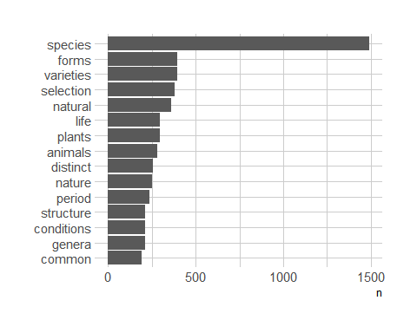
# Clearly species is the most commonly occuring word followed by forms, varieties, selection.
# Tokenize using Bigrams
ofs_bigram <- ofs %>%
unnest_tokens(bigram, text, token="ngrams", n=2)
# Seperate the words into word1 and word2 to remove stop words
ofs_separated <- ofs_bigram %>%
separate(bigram, c("word1", "word2"), sep =" ")
ofs_filtered <- ofs_separated %>%
filter(!word1 %in% stop_words$word,
!word2 %in% stop_words$word) %>%
filter(nchar(word1)>3) %>%
filter(nchar(word2)>3) %>%
unite(bigram, word1, word2, sep = " ")
# visualize the bigrams
ofs_filtered %>%
count(bigram, sort=TRUE) %>%
top_n(15) %>%
mutate(bigram = reorder(bigram, n)) %>%
ggplot(aes(x=bigram, y=n)) +
geom_col() +
coord_flip() +
theme_ipsum_rc()
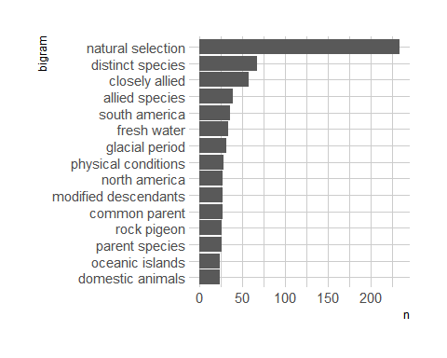
# Natural Selection is by far the most commonly occuring word. Let us Interpret some patterns
# closely allied, allied species - indicates the closely related species
# north america, south america - Observations are mainly from these regions
# common parent, parent species - shows the role of inheritance
# Other words like distinct species, environment conditions like fresh water and glacial period also made it to the top 15 list
# Sentiment Analysis using pre-defined dictionary (afinn, bing, nrc)
afinn <- ofs_tidy %>% inner_join(get_sentiments("afinn")) %>% group_by(chapter, index = linenumber %/% 80) %>% summarize(sentiment = sum(score)) %>% mutate(method = "AFINN")
bing_and_nrc <- bind_rows(ofs_tidy %>%
inner_join(get_sentiments("bing")) %>%
mutate(method = "Bing et al."),
ofs_tidy %>%
inner_join(get_sentiments("nrc") %>%
filter(sentiment %in% c("positive", "negative"))) %>%
mutate(method = "NRC")) %>%
count(method, index = linenumber %/% 80, chapter, sentiment) %>%
spread(sentiment, n, fill = 0) %>%
mutate(sentiment = positive - negative)
bind_rows(afinn, bing_and_nrc) %>%
ggplot(aes(index, sentiment, fill = as.factor(chapter))) +
geom_col() +
facet_wrap(~ method, ncol = 1, scales = "free_y") +
theme_ipsum_rc() +
scale_fill_discrete(name="", labels=c("Introduction",
paste("Chapter", 1:14)))
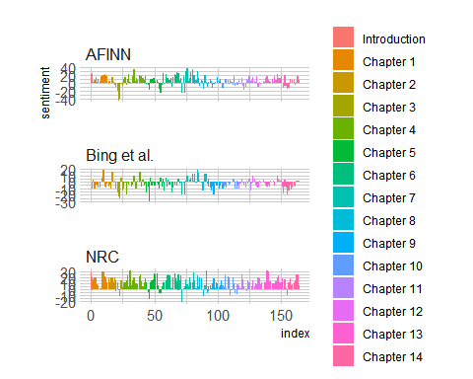
# notice a few things: 1) NRC seems to have much higher positivity scores than the 2 other lexicons. 2)Both AFINN and Bing et al. show strong negativity for chapter 3.
# let's look at the most distinctive words in the conclusion compared to the rest of the book.
# For this, we'll use the log odds ratio for each word that occur at least 10 times. We'll select the 15 most distinctive words from the entire book compared to the final chapter.
word_ratios <- ofs_tidy %>%
group_by(conclusion = chapter == 14) %>%
count(word, conclusion) %>%
filter(n >= 10) %>%
ungroup() %>%
spread(conclusion, n, fill = 0) %>%
rename(conclusion = `TRUE`, restofbook = `FALSE`) %>%
mutate_if(is.numeric, funs((. + 1)/sum(. +1))) %>%
mutate(logratio = log(conclusion/restofbook)) %>%
arrange(desc(logratio))
word_ratios %>%
mutate(abslogratio = abs(logratio)) %>%
group_by(logratio < 0) %>%
top_n(15, abslogratio) %>%
ungroup() %>%
mutate(word = reorder(word, logratio)) %>%
ggplot(aes(word, logratio, fill = logratio < 0)) +
geom_col() +
coord_flip() +
ylab("log odds (Chapter 14/Rest of Book)") +
scale_fill_discrete(name = "", labels = c("Chapter 14", "Rest of Book")) +
theme_ipsum_rc()
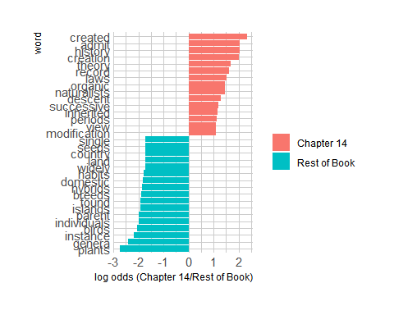
# It seems clear that the words chosen by Darwin in the conclusion are more abstract ("theory", "laws", "view") than in the rest of the book.
# Evolution is supposed to commonly occuring word in a book like this however it does not seem to appear. The book does ends with the word "evolved". Let's double check, by looking for words that starts with "evol"
ofs_tidy %>% filter(str_detect(word, "^evol"))
## # A tibble: 1 x 4
## gutenberg_id linenumber chapter word
## <int> <int> <int> <chr>
## 1 1228 13138 14 evolved
# Indeed, the word "evolved" only occurs once in the book, and in the Chapter 14
max(ofs_tidy$linenumber)
## [1] 13138
# This is indeed short text analysis. According to author, we can do more analysis than this.
# this provides quick overview of the environment, packages used for this session
sessionInfo()
## R version 3.6.0 (2019-04-26)
## Platform: x86_64-w64-mingw32/x64 (64-bit)
## Running under: Windows 10 x64 (build 17134)
##
## Matrix products: default
##
## locale:
## [1] LC_COLLATE=English_United States.1252
## [2] LC_CTYPE=English_United States.1252
## [3] LC_MONETARY=English_United States.1252
## [4] LC_NUMERIC=C
## [5] LC_TIME=English_United States.1252
##
## attached base packages:
## [1] stats graphics grDevices utils datasets methods base
##
## other attached packages:
## [1] gutenbergr_0.1.4 hrbrthemes_0.6.0 purrr_0.3.2 stringr_1.4.0
## [5] tidyr_0.8.3 ggplot2_3.1.1 readr_1.3.1 dplyr_0.8.0.1
## [9] tidytext_0.2.0
##
## loaded via a namespace (and not attached):
## [1] tidyselect_0.2.5 xfun_0.6 lattice_0.20-38
## [4] colorspace_1.4-1 generics_0.0.2 htmltools_0.3.6
## [7] SnowballC_0.6.0 yaml_2.2.0 utf8_1.1.4
## [10] rlang_0.3.4 pillar_1.3.1 glue_1.3.1
## [13] withr_2.1.2 gdtools_0.1.8 plyr_1.8.4
## [16] munsell_0.5.0 gtable_0.3.0 evaluate_0.13
## [19] labeling_0.3 knitr_1.22 extrafont_0.17
## [22] curl_3.3 fansi_0.4.0 triebeard_0.3.0
## [25] urltools_1.7.3 Rttf2pt1_1.3.7 broom_0.5.2
## [28] tokenizers_0.2.1 Rcpp_1.0.1 backports_1.1.4
## [31] scales_1.0.0 hms_0.4.2 digest_0.6.18
## [34] stringi_1.4.3 grid_3.6.0 cli_1.1.0
## [37] tools_3.6.0 magrittr_1.5 lazyeval_0.2.2
## [40] tibble_2.1.1 janeaustenr_0.1.5 crayon_1.3.4
## [43] extrafontdb_1.0 pkgconfig_2.0.2 Matrix_1.2-17
## [46] assertthat_0.2.1 rmarkdown_1.12 rstudioapi_0.10
## [49] R6_2.4.0 nlme_3.1-139 compiler_3.6.0

4 Read the excellent blog post by Julia Silge GENDER ROLES WITH TEXT MINING AND N-GRAMS. Run all of the code in this blog post in your R Notebook and explain each step presented. What are the differences discovered in gender roles between the authors? Would this analysis be possible without using bigrams?
Answer –
- In Jane Austen’s novel, Women do things like remember, read, feel, resolve, long, hear, dare, and cry. Men, on the other hand, in these novels do things like stop, take, reply, come, marry, and know.
- Eliot’s works are quite similar to Austen’s based on the verbs associated with men and women. In Eliot’s novel, Women read, run, need, marry, and look while men leave, mean, tell, know, and call. The verbs associated with women are more connected to emotion or feelings while the verbs associated with men are more connected to action or speaking.
- Jane Eyre novel seems slightly different compared to other 2 novels. The words in Jane Eyre are more likely to appear after “she” are not particularly feelings-oriented. Women in this novel do things like look, tell, open, and do while men stop, smile and pause. - I dont think it is possible to do gender analysis without using Bigrams.

# load all the library
library(tidyverse)
library(tidytext)
library(janeaustenr)
# Tokenize using bigrams
austen_bigrams <- austen_books() %>% unnest_tokens(bigram, text, token = "ngrams", n = 2)
austen_bigrams
## # A tibble: 725,049 x 2
## book bigram
## <fct> <chr>
## 1 Sense & Sensibility sense and
## 2 Sense & Sensibility and sensibility
## 3 Sense & Sensibility sensibility by
## 4 Sense & Sensibility by jane
## 5 Sense & Sensibility jane austen
## 6 Sense & Sensibility austen 1811
## 7 Sense & Sensibility 1811 chapter
## 8 Sense & Sensibility chapter 1
## 9 Sense & Sensibility 1 the
## 10 Sense & Sensibility the family
## # ... with 725,039 more rows
# let's just look for bigrams that start with "she" and "he"
pronouns <- c("he", "she")
# Count the words w/ he and she terms
bigram_counts <- austen_bigrams %>%
count(bigram, sort = TRUE) %>%
separate(bigram, c("word1", "word2"), sep = " ") %>%
filter(word1 %in% pronouns) %>%
count(word1, word2, wt = n, sort = TRUE) %>%
rename(total = n)
bigram_counts
## # A tibble: 1,571 x 3
## word1 word2 total
## <chr> <chr> <int>
## 1 she had 1472
## 2 she was 1377
## 3 he had 1023
## 4 he was 889
## 5 she could 817
## 6 he is 399
## 7 she would 383
## 8 she is 330
## 9 he could 307
## 10 he would 264
## # ... with 1,561 more rows
# These are the most common bigrams that start with "he" and "she" in Jane Austen's works. Notice that there are more mentions of women than men here. This makes sense as Jane Austen's novels have protagonists who are women. The most common bigrams look pretty similar between the male and female characters in Austen's works.
# Let's calculate a log odds ratio so we can find the words (hopefully mostly verbs) that exhibit the biggest differences between relative use for "she" and "he".
word_ratios <- bigram_counts %>%
group_by(word2) %>%
filter(sum(total) > 10) %>%
ungroup() %>%
spread(word1, total, fill = 0) %>%
mutate_if(is.numeric, funs((. + 1) / sum(. + 1))) %>%
mutate(logratio = log2(she / he)) %>%
arrange(desc(logratio))
# Take a look at the words following she and he in Jane austen novels
word_ratios %>% arrange(abs(logratio))
## # A tibble: 164 x 4
## word2 he she logratio
## <chr> <dbl> <dbl> <dbl>
## 1 always 0.00185 0.00190 0.0379
## 2 loves 0.000923 0.000892 -0.0495
## 3 too 0.000923 0.000892 -0.0495
## 4 when 0.000923 0.000892 -0.0495
## 5 acknowledged 0.00108 0.00112 0.0500
## 6 remained 0.00108 0.00112 0.0500
## 7 had 0.158 0.164 0.0600
## 8 paused 0.00138 0.00145 0.0659
## 9 would 0.0408 0.0428 0.0705
## 10 turned 0.00308 0.00323 0.0715
## # ... with 154 more rows
# These words, like "always" and "loves", are about as likely to come after the word "she" as the word "he".
# Now let's look at the words that exhibit the largest differences in appearing after "she" compared to "he".
word_ratios %>%
mutate(abslogratio = abs(logratio)) %>%
group_by(logratio < 0) %>%
top_n(15, abslogratio) %>%
ungroup() %>%
mutate(word = reorder(word2, logratio)) %>%
ggplot(aes(word, logratio, color = logratio < 0)) +
geom_segment(aes(x = word, xend = word,
y = 0, yend = logratio),
size = 1.1, alpha = 0.6) +
geom_point(size = 3.5) +
coord_flip() +
labs(x = NULL,
y = "Relative appearance after 'she' compared to 'he'",
title = "Words paired with 'he' and 'she' in Jane Austen's novels",
subtitle = "Women remember, read, and feel while men stop, take, and reply") +
scale_color_discrete(name = "", labels = c("More 'she'", "More 'he'")) +
scale_y_continuous(breaks = seq(-3, 3),
labels = c("0.125x", "0.25x", "0.5x",
"Same", "2x", "4x", "8x"))
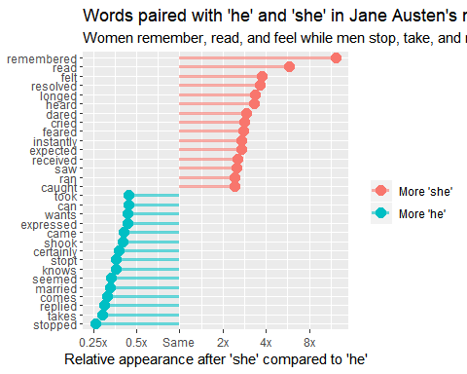
# Clearly Women in Austen's novels do things like remember, read, feel, resolve, long, hear, dare, and cry. Men, on the other hand, in these novels do things like stop, take, reply, come, marry, and know.
# Lets take a look at different novel now
# George Eliot and n-grams
eliot <- gutenberg_download(c(145, 550, 6688),mirror = "http://mirrors.xmission.com/gutenberg/")
# Lets calculate the log odds ratios for each word that comes after "he" and "she" in these novels of George Eliot.
eliot_ratios <- eliot %>%
unnest_tokens(bigram, text, token = "ngrams", n = 2) %>%
count(bigram, sort = TRUE) %>%
ungroup() %>%
separate(bigram, c("word1", "word2"), sep = " ") %>%
filter(word1 %in% pronouns) %>%
count(word1, word2, wt = n, sort = TRUE) %>%
rename(total = n) %>%
group_by(word2) %>%
filter(sum(total) > 10) %>%
ungroup() %>%
spread(word1, total, fill = 0) %>%
mutate_if(is.numeric, funs((. + 1) / sum(. + 1))) %>%
mutate(logratio = log2(she / he)) %>%
arrange(desc(logratio))
eliot_ratios %>%
mutate(abslogratio = abs(logratio)) %>%
group_by(logratio < 0) %>%
top_n(15, abslogratio) %>%
ungroup() %>%
mutate(word = reorder(word2, logratio)) %>%
ggplot(aes(word, logratio, color = logratio < 0)) +
geom_segment(aes(x = word, xend = word,
y = 0, yend = logratio),
size = 1.1, alpha = 0.6) +
geom_point(size = 3.5) +
coord_flip() +
labs(x = NULL,
y = "Relative appearance after 'she' compared to 'he'",
title = "Words paired with 'he' and 'she' in George Eliot's novels",
subtitle = "Women read, run, and need while men leave, mean, and tell") +
scale_color_discrete(name = "", labels = c("More 'she'", "More 'he'")) +
scale_y_continuous(breaks = seq(-5, 5),
labels = c("0.03125x", "0.0625x", "0.125x", "0.25x", "0.5x",
"Same", "2x", "4x", "8x", "16x", "32x"))
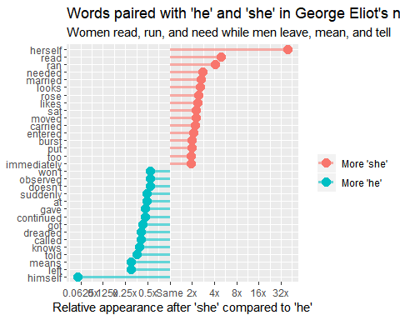
# overall there are quite similar ideas behind the verbs for women and men in Eliot's works as Austen's. Women read, run, need, marry, and look while men leave, mean, tell, know, and call. The verbs associated with women are more connected to emotion or feelings while the verbs associated with men are more connected to action or speaking.
# Finally, let's look at one more novel.
# Jane Eyre and n-grams
eyre <- gutenberg_download(1260,mirror = "http://mirrors.xmission.com/gutenberg/")
eyre_ratios <- eyre %>%
unnest_tokens(bigram, text, token = "ngrams", n = 2) %>%
count(bigram, sort = TRUE) %>%
ungroup() %>%
separate(bigram, c("word1", "word2"), sep = " ") %>%
filter(word1 %in% pronouns) %>%
count(word1, word2, wt = n, sort = TRUE) %>%
rename(total = n) %>%
group_by(word2) %>%
filter(sum(total) > 5) %>%
ungroup() %>%
spread(word1, total, fill = 0) %>%
mutate_if(is.numeric, funs((. + 1) / sum(. + 1))) %>%
mutate(logratio = log2(she / he)) %>%
arrange(desc(logratio))
eyre_ratios %>%
mutate(abslogratio = abs(logratio)) %>%
group_by(logratio < 0) %>%
top_n(15, abslogratio) %>%
ungroup() %>%
mutate(word = reorder(word2, logratio)) %>%
ggplot(aes(word, logratio, color = logratio < 0)) +
geom_segment(aes(x = word, xend = word,
y = 0, yend = logratio),
size = 1.1, alpha = 0.6) +
geom_point(size = 3.5) +
coord_flip() +
labs(x = NULL,
y = "Relative appearance after 'she' compared to 'he'",
title = "Words paired with 'he' and 'she' in Jane Eyre",
subtitle = "Women look, tell, and open while men stop, smile, and pause") +
scale_color_discrete(name = "", labels = c("More 'she'", "More 'he'")) +
scale_y_continuous(breaks = seq(-3, 3),
labels = c("0.125x", "0.25x", "0.5x",
"Same", "2x", "4x", "8x"))
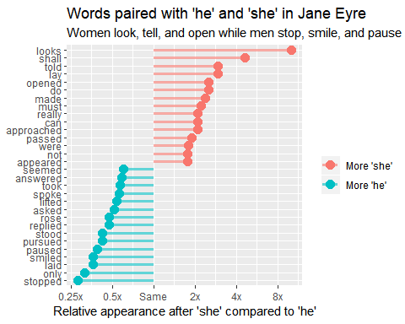
# Indeed, the words that are more likely to appear after "she" are not particularly feelings-oriented; women in this novel do things like look, tell, open, and do.

