STAT 653 Project
Rekha Mani
5/4/2019

The goal of this project is to perform lyric analysis on the Billboard data set obtained from Kaggle. The author who posted this data set in the Kaggle has combined songs from 50 years of Billboard Year-End Hot 100 (1965-2015) into one dataset for analysis. This data set features 5100 observations with features-rank (1-00), song, artist, year, lyrics, and source.
After doing lot of research on text analysis and with so many questions in mind, I decided to follow the below steps to get an insight into the data.
I Text Mining and Exploratory analysis
II Sentiment Analysis
III Topic modeling using LDA (Latent Dirichlet Allocation) approach

I Text Mining and Exploratory Analysis:
First and foremost step in text mining is extracting the text data and the popular method for obtaining data for text mining is using rvest package to scrape the content from the web. Since the data was already available from Kaggle, I did not spend much time on data extraction however it did require some basic cleaning.
As part of text mining and exploratory analysis, performed the following tasks
- Load all the required library
- Read the data
- Basic cleaning to replace contractions, remove numbers, punctuations, and special characters.
- Added new field called Decade to group the years to view song trends over the years.
- Tokenization to break out the lyrics into individual words
- Count and visualize (using Bar graph, wordcloud) the most commonly used words in lyrics
- Visualize trending words over the years

# Includes all the library
library(tidytext) # text mining
library(tidyverse)# data manipulation
library(quanteda) # data cleaning
library(textclean)
library(ggplot2)
library(wordcloud)
library(wordcloud2)
library(igraph)
library(ggraph)
library(widyr)
library(tm)
library(topicmodels)
library(ggrepel)
# import dataset
song_lyrics<-read_csv("C:/Rekha/Personal/NLP/billboard_lyrics_1964-2015.csv")
## Parsed with column specification:
## cols(
## Rank = col_double(),
## Song = col_character(),
## Artist = col_character(),
## Year = col_double(),
## Lyrics = col_character()
## )
dim(song_lyrics)
## [1] 5100 5
colnames(song_lyrics)
## [1] "Rank" "Song" "Artist" "Year" "Lyrics"
# replace contractions
fix_contractions<-function(doc)
{
doc<-gsub("aint", "are not", doc)
doc<-gsub("dont", "do not", doc)
doc<-gsub("youve","you have",doc)
doc<-gsub("wont","will not",doc)
doc<-gsub("wanna","want to", doc)
doc<-gsub("gonna","going to", doc)
doc<-gsub("wouldnt","would not", doc)
doc<-gsub("shouldnt","should not",doc)
doc<-gsub("thats","that is", doc)
doc<-gsub("hows","how is", doc)
doc<-gsub("youre","you are",doc)
doc<-gsub("youll","you will",doc)
return(doc)
}
song_lyrics$Lyrics<-sapply(song_lyrics$Lyrics,fix_contractions)
# remove special char
removeSpecialChars <- function(x) gsub("[^a-zA-Z0-9]", " ", x)
song_lyrics$Lyrics<-sapply(song_lyrics$Lyrics,removeSpecialChars)
# remove numbers
removenumbers<-function(num) gsub("[0-9]","",num)
song_lyrics$Lyrics<-sapply(song_lyrics$Lyrics,removenumbers)
# remove underscore
remove_underscore<-function(text) gsub("[_]"," ",text)
song_lyrics$Lyrics<-sapply(song_lyrics$Lyrics,remove_underscore)
# Create new field called decade to group the years to view song trends over the years
song_lyrics<- song_lyrics %>% mutate(decade=
ifelse(Year %in% 1965:1969, "1960s",
ifelse(Year %in% 1970:1979,"1970s",
ifelse(Year %in% 1980:1989,"1980s",
ifelse(Year %in% 1990:1999,"1990s",
ifelse(Year %in% 2000:2009, "2000s",
ifelse(Year %in% 2010:2015,"2010s",
"NA")))))))
dim(song_lyrics)
## [1] 5100 6
# Tokenize
song_lyrics_token<-song_lyrics %>% unnest_tokens(word,Lyrics)
song_lyrics_filtered<-song_lyrics_token %>% anti_join(stop_words) %>% distinct() %>% filter(nchar(word)>3)
## Joining, by = "word"
# count most common words
song_lyrics_filtered %>% count(word,sort = TRUE)
## # A tibble: 39,551 x 2
## word n
## <chr> <int>
## 1 love 2723
## 2 time 1975
## 3 baby 1860
## 4 yeah 1481
## 5 feel 1427
## 6 night 1259
## 7 girl 1245
## 8 heart 1165
## 9 life 1141
## 10 eyes 913
## # ... with 39,541 more rows
# visualize most common words
song_lyrics_filtered %>% count(word,sort = TRUE) %>% filter(n>500) %>% mutate(word=reorder(word,n)) %>% ggplot(aes(word,n)) + geom_col() +
labs(title="Most common words in Billboard songs from 1965 - 2015") + xlab(NULL) + ylab(NULL) + coord_flip()
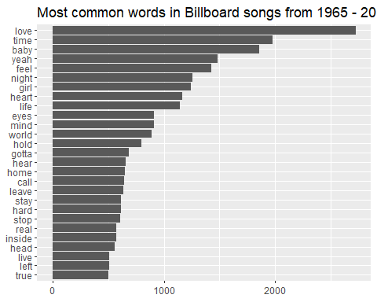
Love seems to be most common topic. Lets go ahead and visualize most common words using wordcloud
# visualize most common words using wordcloud
song_lyrics_count<-song_lyrics_filtered %>% count(word,sort = TRUE)
wordcloud2(song_lyrics_count[1:300, ], size = .5)
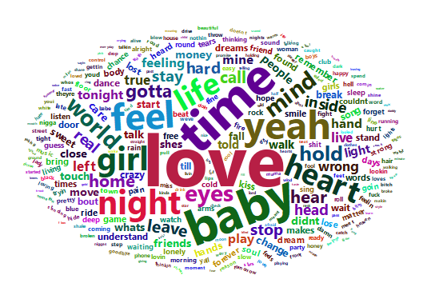
# so far, we have seen top words across all the songs. Let us see trending words
trending_words<-song_lyrics_filtered %>% group_by(decade) %>% count(word,decade,sort=TRUE) %>% slice(seq_len(8)) %>% ungroup() %>% arrange(decade,n) %>% mutate(row=row_number())
trending_words
## # A tibble: 48 x 4
## decade word n row
## <chr> <chr> <int> <int>
## 1 1960s feel 85 1
## 2 1960s mind 91 2
## 3 1960s heart 93 3
## 4 1960s girl 100 4
## 5 1960s yeah 100 5
## 6 1960s time 135 6
## 7 1960s baby 148 7
## 8 1960s love 240 8
## 9 1970s mind 158 9
## 10 1970s life 170 10
## # ... with 38 more rows
trending_words %>% ggplot(aes(row,n,fill=decade)) + geom_col(show.legend = NULL) + facet_wrap(~decade,scales = "free") + coord_flip() + scale_x_continuous(breaks=trending_words$row,labels = trending_words$word)
## Warning: `show.legend` must be a logical vector.
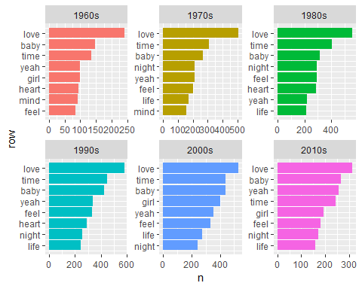
Clearly love, time and baby are trending words.
The method we have seen so far looks at the entire dataset but it has not addressed how to quantify just how important various terms are in the document with respect to the entire collection. We have looked at term frequency and removed stop words but this is not sophisticated approach. Let us use TF-IDF approach to examine the words over the time.
tfidf_words_decade<-song_lyrics %>% unnest_tokens(word,Lyrics) %>% distinct() %>% filter(nchar(word)>3) %>% count(word,decade, sort=TRUE) %>% ungroup() %>% bind_tf_idf(word,decade,n) %>% arrange(desc(tf_idf))
tfidf_words_decade
## # A tibble: 68,304 x 6
## word decade n tf idf tf_idf
## <chr> <chr> <int> <dbl> <dbl> <dbl>
## 1 nigga 2000s 123 0.00122 0.693 0.000847
## 2 nigga 2010s 57 0.00105 0.693 0.000726
## 3 shit 2010s 84 0.00154 0.405 0.000626
## 4 niggas 2010s 49 0.000900 0.693 0.000624
## 5 shit 2000s 143 0.00142 0.405 0.000576
## 6 imma 2010s 45 0.000827 0.693 0.000573
## 7 fuck 2010s 73 0.00134 0.405 0.000544
## 8 niggas 2000s 73 0.000725 0.693 0.000503
## 9 byjamesg 2010s 24 0.000441 1.10 0.000484
## 10 bitches 2010s 37 0.000680 0.693 0.000471
## # ... with 68,294 more rows
# top 8 words for each year
top_tfidf_words_decade<-tfidf_words_decade %>% group_by(decade) %>% slice(seq_len(8)) %>% ungroup() %>% arrange(decade,tf_idf) %>% mutate(row=row_number())
top_tfidf_words_decade
## # A tibble: 48 x 7
## word decade n tf idf tf_idf row
## <chr> <chr> <int> <dbl> <dbl> <dbl> <int>
## 1 apples 1960s 2 0.0000836 1.79 0.000150 1
## 2 evry 1960s 9 0.000376 0.405 0.000153 2
## 3 sally 1960s 6 0.000251 0.693 0.000174 3
## 4 contentment 1960s 3 0.000125 1.79 0.000225 4
## 5 deceived 1960s 3 0.000125 1.79 0.000225 5
## 6 moonbeams 1960s 3 0.000125 1.79 0.000225 6
## 7 miscellaneous 1960s 32 0.00134 0.182 0.000244 7
## 8 shingaling 1960s 4 0.000167 1.79 0.000300 8
## 9 ageless 1970s 3 0.0000572 1.79 0.000103 9
## 10 bayou 1970s 3 0.0000572 1.79 0.000103 10
## # ... with 38 more rows
# visualize TF-IDF
top_tfidf_words_decade %>% ggplot(aes(row,tf_idf,fill=decade)) + geom_col(show.legend = NULL) + labs(x=NULL , y = "TF-IDF" , title = "Important words using TF-IDF over years") + facet_wrap(~decade,ncol=3, nrow=2, scales = "free") + scale_x_continuous(breaks=top_tfidf_words_decade$row,labels = top_tfidf_words_decade$word) + coord_flip()
## Warning: `show.legend` must be a logical vector.
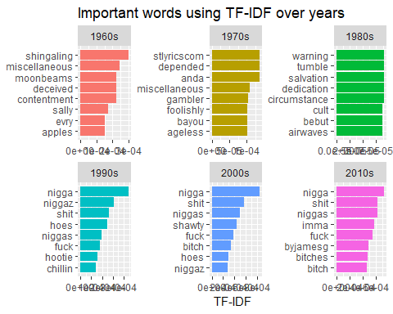
Notice the trending words or most commonly used words like love, time, baby, girl are no longer prevalent. This shows completely different set of words which gives some idea about other common words used in songs over the years. Wow! You can see that we are getting into deeper level of insight now.

II Sentiment Analysis
In this section, we will
- Explore the predefined sentiment lexicons (nrc, bing, afinn) and their word counts.
- Identify how many words from the lyrics exist in the lexicons.
- Look at the specific words and word forms.

# explore sentiment lexicons and word count
new_sentiments<-sentiments %>% filter(lexicon != "loughran") %>% mutate(sentiment=ifelse(lexicon == "AFINN" & score > 0, "positive", ifelse(lexicon == "AFINN" & score < 0, "Negative", sentiment))) %>% group_by(lexicon) %>% mutate(words_in_lexicon=n_distinct(word)) %>% ungroup()
new_sentiments %>% group_by(lexicon, sentiment, words_in_lexicon) %>% summarise(distinct_words=n_distinct(word)) %>% ungroup() %>% spread(sentiment, distinct_words)
## # A tibble: 3 x 14
## lexicon words_in_lexicon anger anticipation disgust fear joy negative
## <chr> <int> <int> <int> <int> <int> <int> <int>
## 1 AFINN 2476 NA NA NA NA NA NA
## 2 bing 6785 NA NA NA NA NA 4782
## 3 nrc 6468 1247 839 1058 1476 689 3324
## # ... with 6 more variables: Negative <int>, positive <int>,
## # sadness <int>, surprise <int>, trust <int>, `<NA>` <int>
This table givs us an idea of size and structure of each lexicon.
In order to determine which lexicon is more applicable to the lyrics, let us take a look at the match ratio of words that are common to both lexicon and lyrics
song_lyrics_filtered %>% mutate(distinct_words_in_lyrics=n_distinct(word)) %>% inner_join(new_sentiments) %>% group_by(lexicon, distinct_words_in_lyrics,words_in_lexicon) %>% summarize(lex_match_words=n_distinct(word)) %>% ungroup() %>% mutate(match_ratio=lex_match_words/distinct_words_in_lyrics) %>% select(lexicon,lex_match_words,distinct_words_in_lyrics,match_ratio)
## Joining, by = "word"
## # A tibble: 3 x 4
## lexicon lex_match_words distinct_words_in_lyrics match_ratio
## <chr> <int> <int> <dbl>
## 1 AFINN 1275 39551 0.0322
## 2 bing 2214 39551 0.0560
## 3 nrc 2918 39551 0.0738
NRC lexicon has more distinct words from the lyrics when compared to bing and AFINN. Also, notice the match ratio is very low. No lexicon could have all the words nor should they. Many words are considered as neutral and would not have an associated sentiment.
Now that we have fundamental understanding of lexicon, lets apply this knowledge to do sentiment analysis
lyrics_bing<-song_lyrics_filtered %>% inner_join(get_sentiments("bing"))
## Joining, by = "word"
lyrics_nrc<-song_lyrics_filtered %>% inner_join(get_sentiments("nrc"))
## Joining, by = "word"
Since words can appear in multiple categories in NRC, such as Negative/Fear or Positive/Joy, we will also create a subset without the positive and negative categories to use later on.
lyrics_nrc_sub<-song_lyrics_filtered %>% inner_join(get_sentiments("nrc")) %>% filter(!sentiment %in% c('positive','negative'))
## Joining, by = "word"
# lets start by graphing the nrc sentiment analysis of the entire dataset
nrc_plot<-lyrics_nrc %>% group_by(sentiment) %>% summarise(word_count=n()) %>% ungroup() %>% mutate(sentiment=reorder(sentiment, word_count)) %>% ggplot(aes(sentiment,word_count)) + geom_col() + ggtitle("NRC sentiment") + coord_flip()
nrc_plot
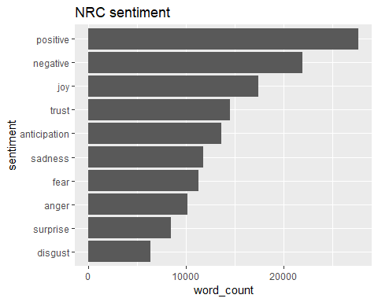
It appears that NRC strongly favors positive. But the question is are all the words with sentiment of disgust/anger also in the negative category as well? It may be worth checking out.
# Now lets take a look at bing sentiment
bing_plot<-lyrics_bing %>% group_by(sentiment) %>% summarise(word_count=n()) %>% ungroup() %>% mutate(sentiment=reorder(sentiment, word_count)) %>% ggplot(aes(sentiment,word_count)) + geom_col() + ggtitle("Bing Sentiment") + coord_flip()
bing_plot
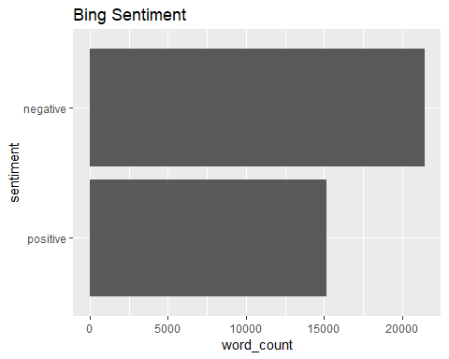
There appears to be more words with negative sentiment than positive sentiment.
So far we have been looking into single words and did sentiment analysis on single words. If love is common word, what if there are preceding or following words like ‘not’ then our analysis is wrong. Looking at single words sometimes could be misleading. So now it is the time to look at bigrams or word pairs.
# Tokenise using ngrams/bigram
lyrics_bigrams<-song_lyrics %>% unnest_tokens(bigram,Lyrics,token="ngrams",n=2)
lyrics_bigrams_seperated<-lyrics_bigrams %>% separate(bigram, c("word1", "word2"), sep = " ")
bigrams_filtered<-lyrics_bigrams_seperated %>% filter(!word1 %in% stop_words$word) %>% filter(!word2 %in% stop_words$word)
# since there are more repeated words in the song, lets do some filtering
glimpse(bigrams_filtered)
## Observations: 177,329
## Variables: 7
## $ Rank <dbl> 1, 1, 1, 1, 1, 1, 1, 1, 1, 1, 1, 1, 1, 1, 1, 1, 1, 1, 1...
## $ Song <chr> "bad day", "bad day", "bad day", "bad day", "bad day", ...
## $ Artist <chr> "daniel powter", "daniel powter", "daniel powter", "dan...
## $ Year <dbl> 2006, 2006, 2006, 2006, 2006, 2006, 2006, 2006, 2006, 2...
## $ decade <chr> "2000s", "2000s", "2000s", "2000s", "2000s", "2000s", "...
## $ word1 <chr> "blue", "skys", "carrying", "carrying", "bad", "sad", "...
## $ word2 <chr> "skys", "faded", "onstand", "oncause", "day", "song", "...
bigram_decade <- bigrams_filtered %>% filter(word1 != word2) %>% unite(bigram, word1, word2, sep=" ") %>% inner_join(song_lyrics) %>% count(bigram,decade, sort=TRUE) %>% group_by(decade) %>% slice(seq_len(7)) %>% ungroup() %>% arrange(decade,n) %>% mutate(row=row_number())
## Joining, by = c("Rank", "Song", "Artist", "Year", "decade")
# visualize the bigram
bigram_decade %>% ggplot(aes(row, n, fill = decade)) + geom_col(show.legend = FALSE) + facet_wrap(~decade, scales = "free") + scale_x_continuous(breaks = bigram_decade$row, labels = bigram_decade$bigram) + coord_flip()
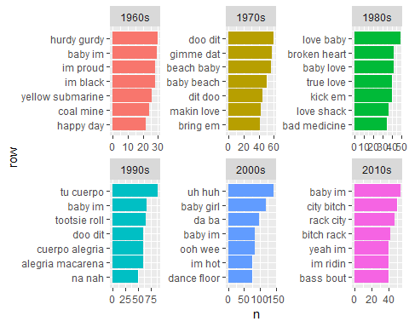
Using bigrams, you can almost see the common phrases shift from Love, dance, sex and rap style songs.
This time, we will use AFINN lexicon to perform sentiment analysis on word pairs and take look at how often sentiment associated words are preceded by “not” or other negating words
AFINN<-get_sentiments("afinn")
not_words<-lyrics_bigrams_seperated %>% filter(word1=="not") %>% inner_join(AFINN, by=c(word2="word")) %>% count(word2, score, sort = TRUE) %>% ungroup()
not_words %>% mutate(contribution=n*score) %>% arrange(desc(abs(contribution))) %>% head(20) %>% mutate(word2=reorder(word2,contribution)) %>% ggplot(aes(word2, n*score, fill = n*score>0)) + geom_col(show.legend = FALSE) + xlab("Words preceded by \"not\"") + ylab("Sentiment score * Number of Occurrences") + ggtitle("Sentiment of Words Preceded by Not") + coord_flip()
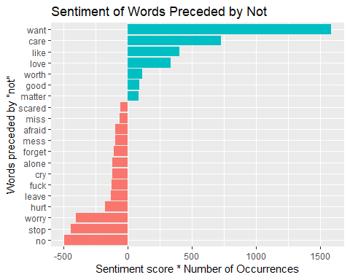
Note the words like care, love, good is given a false positive sentiment because the word “not” is often ignored during the single word analysis
negation_words<-c("not","no","never","without")
negation_bigrams<-lyrics_bigrams_seperated %>% filter(word1 %in% negation_words) %>% inner_join(AFINN, by = c(word2="word")) %>%
count(word1,word2,score,sort=TRUE) %>% mutate(contribution=n*score) %>% arrange(desc(abs(contribution))) %>% group_by(word1) %>% slice(seq_len(20)) %>% arrange(word1, desc(contribution)) %>% ungroup()
negation_bigrams
## # A tibble: 74 x 5
## word1 word2 score n contribution
## <chr> <chr> <int> <int> <int>
## 1 never want 1 94 94
## 2 never love 3 26 78
## 3 never win 4 17 68
## 4 never loved 3 13 39
## 5 never satisfied 2 11 22
## 6 never trust 1 9 9
## 7 never true 2 4 8
## 8 never cry -1 8 -8
## 9 never broke -1 9 -9
## 10 never miss -2 5 -10
## # ... with 64 more rows
bigram_graph<-negation_bigrams %>% graph_from_data_frame()
set.seed(123)
a<-grid::arrow(type = "closed", length = unit(.15,"inches"))
ggraph(bigram_graph, layout = "fr") + geom_edge_link(alpha=.25) + geom_edge_density(aes(fill=score)) + geom_node_point(color = "purple1", size = 1) + geom_node_text(aes(label = name), repel = TRUE) + theme_void() + theme(legend.position = "none",plot.title = element_text(hjust = 0.5)) + ggtitle("Negation Bigram Network")
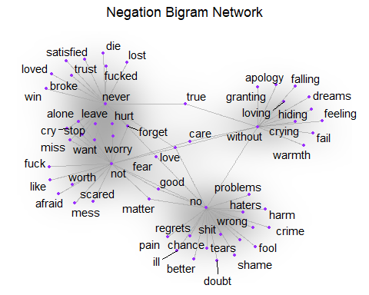
Here you can see the word pairs associated with negation words. So if our analysis is based on the unigrams, then “alone” comes back as negative however the bigram “not alone” will have reverse effect. Also, look at other words like “never loved” and “not good”
Now let us take a look at the pairwise correlation.
# Use the pairwiser_count() function from widyr package to identify co-occurence of events. That is, we count the number of times each pair of words appear together within a song.
pwc<-song_lyrics_filtered %>% filter(n()>=20) %>% pairwise_count(word, Song, sort=TRUE) %>% filter(item1 %in% c("love", "care", "hurt","crazy")) %>% group_by(item1) %>% slice(seq_len(7)) %>% ungroup() %>% mutate(row=-row_number())
pwc %>%
ggplot(aes(row, n, fill = item1)) +
geom_bar(stat = "identity", show.legend = FALSE) +
facet_wrap(~item1, scales = "free") +
scale_x_continuous( breaks = pwc$row, labels = pwc$item2) +
xlab(NULL) + ylab(NULL) +
ggtitle("Pairwise Counts") +
coord_flip()
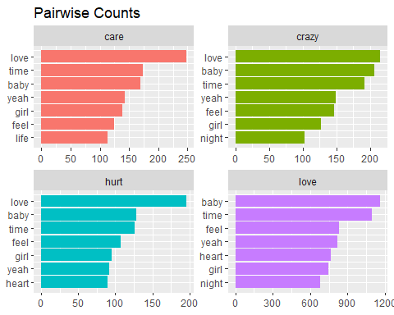
# Lets now compare it to pairwise correlation
song_lyrics_filtered %>% group_by(word) %>% filter(n()>=20) %>% pairwise_cor(word, Song, sort = TRUE) %>% filter(item1 %in% c("love", "care", "hurt","crazy")) %>% group_by(item1) %>% top_n(7) %>% ungroup() %>% mutate(item2=reorder(item2, correlation)) %>% ggplot(aes(item2, correlation, fill = item1)) + geom_bar(stat = 'identity',show.legend = FALSE) + facet_wrap(~item1, scales = 'free') + xlab(NULL) + ylab(NULL) +
ggtitle("Pairwise Correlation") + coord_flip()
## Selecting by correlation
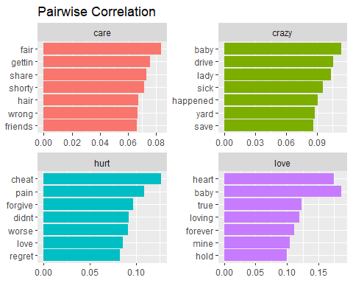
It is interesting to see how the words are correlated differently when compared to their paired counts. Looking at the results, we begin to see that some themes emerge just for four words. This leads us to topic modeling.

III Topic modeling using LDA approach
In this section, we will create subset of our original data set so it contains lyrics from eight artist rather than using entire dataset. To make it interesting, I have added some book authors to the dataset. This dataset contains a wide variety of artists ranging from beatles (pop), jay-z(rap) and johnny-cash(country). These artists were chosen because they were ranked as most prolific in their respective genre.
all_sources_tidy_balanced<-read_csv("C:/Rekha/Personal/NLP/all_sources_tidy_balanced.csv")
## Warning: Missing column names filled in: 'X1' [1]
## Parsed with column specification:
## cols(
## X1 = col_double(),
## document = col_character(),
## source = col_character(),
## genre = col_character(),
## word = col_character()
## )
# Lets examine the data
all_sources_tidy_balanced %>% group_by(source) %>% mutate(word_count=n(),source_document_count=n_distinct(document)) %>% select(source, genre, word_count, source_document_count) %>% distinct() %>% ungroup()
## # A tibble: 12 x 4
## source genre word_count source_document_count
## <chr> <chr> <int> <int>
## 1 amy-grant christian 10698 219
## 2 beatles pop-rock 10698 222
## 3 chris-tomlin christian 10698 217
## 4 eminem hip-hop-rap 10698 221
## 5 icebergs earth_science 10698 217
## 6 jay-z hip-hop-rap 10698 209
## 7 johnny-cash country 10698 222
## 8 machine_learning data_science 10698 212
## 9 machine_learning_r machine_learning 10698 219
## 10 michael-jackson pop-rock 10698 222
## 11 prince pop-rock 10698 222
## 12 sports_nutrition sports_nutrition 10698 212
# lets do some quick cleaning before we proceed
all_sources_tidy_balanced<-all_sources_tidy_balanced %>% mutate(source = ifelse(source=="machine_learning","m_learn",ifelse(source=="machine_learning_r","m_learn_r",ifelse(source=="michael_jackson","mi_jackson",ifelse(source=="sports_nutrition","nutrition",source))))) %>% mutate(genre = ifelse(genre == "machine_learning", "m_learn",ifelse(genre == "sports_nutrition", "nutrition", genre)))
# create DTM and set the variables
all_sources_dtm_balanced<-all_sources_tidy_balanced %>% count(document,word,sort = TRUE) %>% ungroup() %>% cast_dtm(document,word,n)
source_dtm <- all_sources_dtm_balanced
source_tidy <- all_sources_tidy_balanced
# Fit the model and identify the themes
K<-8
num_words<-10
seed<-1234
lda<-LDA(source_dtm, k=8, method = "GIBBS", control = list(seed = seed))
lda
## A LDA_Gibbs topic model with 8 topics.
song_topics<-tidy(lda, matrix = "beta")
song_topics
## # A tibble: 142,136 x 3
## topic term beta
## <int> <chr> <dbl>
## 1 1 nah 0.00000464
## 2 2 nah 0.00000590
## 3 3 nah 0.00000552
## 4 4 nah 0.00000554
## 5 5 nah 0.0106
## 6 6 nah 0.00000626
## 7 7 nah 0.00000616
## 8 8 nah 0.00000562
## 9 1 god 0.00000464
## 10 2 god 0.00000590
## # ... with 142,126 more rows
# Note this has turned into one-topic-per-term-per-row format. For each combination, the model computes the probability of that term being generated from that topic.
song_top_terms<-song_topics %>% group_by(topic) %>% top_n(10, beta) %>% ungroup() %>% arrange(topic, -beta)
song_top_terms %>% ggplot(aes(term, beta, fill = factor(topic))) + geom_col(show.legend = FALSE) + facet_wrap(~topic, scales = 'free') + coord_flip()
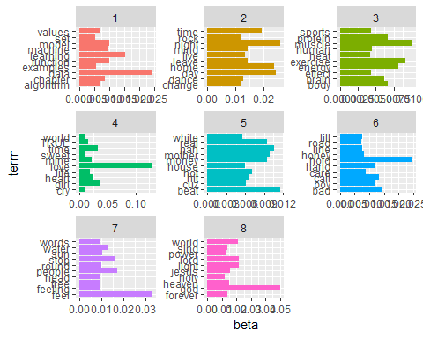
We can interpret the results as follows
#Topic One - machine learning and data science
#Topic Two - pop/rock
#Topic Three - sports nutrition
# Four - country
#Topic Five - hip-hop-rap
#Topic Six - country or pop-rock
#Topic Seven - icebergs, earth science
#Topic Eight - religious
# This function can be used to show genre and source by passing type
top_items_per_topic<-function(lda_model,source_tidy,type)
{
#get the tidy version by passing gamma for the per document per topic prob
document_lda_gamma<-tidy(lda_model,matrix="gamma") %>%
inner_join(source_tidy) %>%
select(document,gamma,source,genre,topic) %>%
distinct() %>%
# group so that we can get sum per topic/source
group_by(source,topic) %>%
arrange(desc(gamma)) %>%
#create the sum of all document gamma vals per topic/source
mutate(topic_sum=sum(gamma)) %>%
select(topic,topic_sum,source,genre) %>%
distinct() %>%
ungroup() %>%
# type will be either source or genre
group_by(source, genre) %>%
#get the highest topic_sum per type
top_n(1, topic_sum) %>%
mutate(row = row_number()) %>%
mutate(label = ifelse(type == "source", source, genre),title = ifelse(type == "source", "Recommended Writers Per Topic","Genres Per Topic")) %>%
ungroup() %>%
mutate(topic = paste("Topic", topic, sep = " ")) %>%
select(label, topic, title)
document_lda_gamma %>% ggplot(aes(1,1,label = label, fill= factor(topic))) + geom_point(color = "transparent") +
geom_label_repel(nudge_x=.2,direction="y",box.padding=0.1,segment.color='transparent',size=3) + facet_grid(~topic) +
xlab(NULL) + ylab(NULL) +
ggtitle(document_lda_gamma$title) +
coord_flip()
}
top_items_per_topic(lda, source_tidy, "source")
## Joining, by = "document"
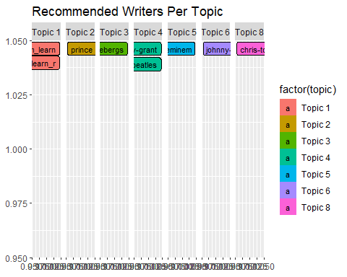
We may not be familiar with these artist. So let us try replacing the artist with genre and see the outcome.
top_items_per_topic(lda, source_tidy, "genre")
## Joining, by = "document"
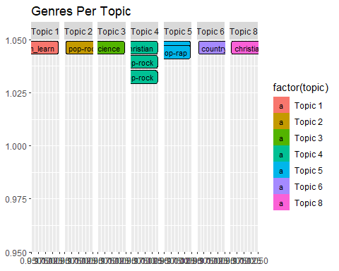
The hip-hop-rap artists are grouped together; the Christian artists are together; two of the pop-rock artists are together, and each book has its own topic! It's amazing to see that unsupervised learning can produce results like this (recognizing different genres) based entirely on text.

Conclusion:
As you can see, we used data from lyrics and nonfiction books to identify themes, classify individual documents into the most likely topics, and identify similar writers based on thematic content. Thus, we were able to build a simple recommendation system based on text and labeled writers. We can further go ahead and predict how the songs in future would look like based on the lyrics using the algorithms such as Random Forest, Decision trees, Naïve Bayes and XGBoost.

