

Functional Safety Concept Lane Assistance

**Document Version: 1.0**

**Template Version 1.0, Released on 2017-06-21**



# 

# Document history

|  |  |  |  |
| --- | --- | --- | --- |
| Date | Version | Editor | Description |
| 24.5.2018 | 1.0 | Arindam Baidya | First Attempt |
|  |  |  |  |
|  |  |  |  |
|  |  |  |  |
|  |  |  |  |

# Table of Contents

Document history

Table of Contents

Purpose of the Functional Safety Concept

Inputs to the Functional Safety Analysis

Safety goals from the Hazard Analysis and Risk Assessment

Preliminary Architecture

Description of architecture elements

Functional Safety Concept

Functional Safety Analysis

Functional Safety Requirements

Refinement of the System Architecture

Allocation of Functional Safety Requirements to Architecture Elements

Warning and Degradation Concept

# 

# Purpose of the Functional Safety Concept

Functional safety concept is looking at the item from a higher level, without going into technical details. The purpose of functional safety concept is to avoid accidents by reducing risks to acceptable levels.

# Inputs to the Functional Safety Concept

## Safety goals from the Hazard Analysis and Risk Assessment

|  |  |
| --- | --- |
| **ID** | **Safety Goal** |
| Safety_Goal_01 | The oscillating steering torque from the Lane Departure Warning function shall be limited. |
| Safety_Goal_02 | The Lane Keeping Assistance function shall be time limited and additional steering torque shall end after a given time interval so that the driver cannot misuse the system for autonomous driving. |
| Safety_Goal_03 | The Lane Departure Warning function shall be deactivated when the camera sensor or any other sensors start malfunctioning. |
| Safety_Goal_04 | Lane Keeping Assistance has to be sensible to different coloring of lane lines, and reliably detect and react on merging lanes in advance |

## Preliminary Architecture

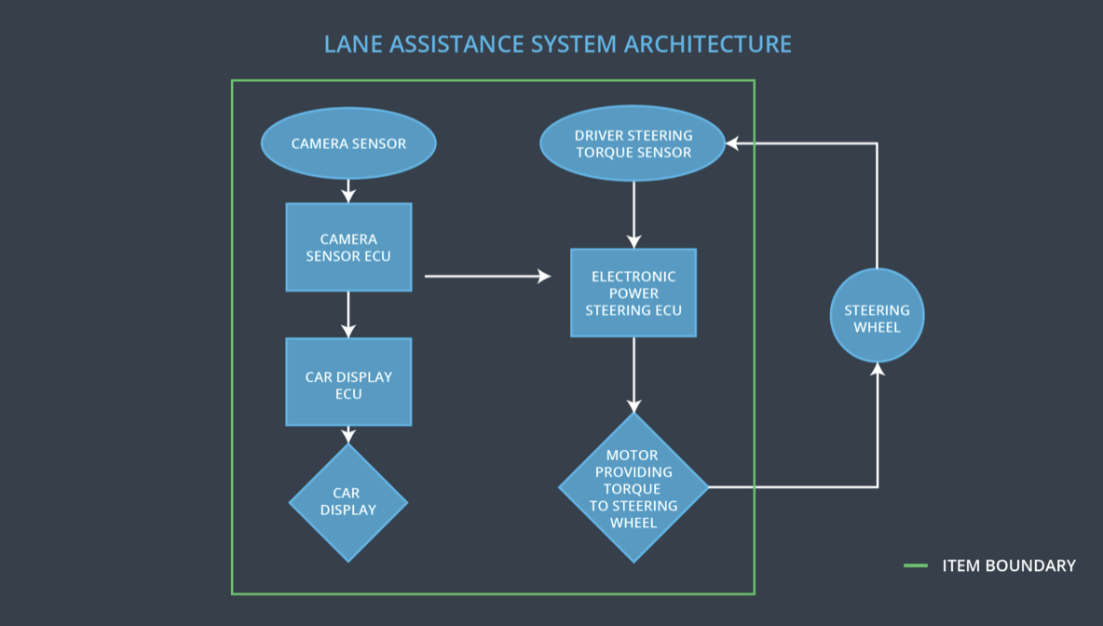

### 

### Description of architecture elements

|  |  |
| --- | --- |
| **Element** | **Description** |
| Camera Sensor | Captures images from the road and provide them to Camera Sensor ECU |
| Camera Sensor ECU | Analyses lane line position from the camera images and generates a torque request to the Electronic Power Steering ECU. |
| Car Display | Displays warning, feedback and Lane Departure Assistance status to the driver |
| Car Display ECU | Drive the Car Display component to show the Lane Keep Assistance warning and Lane Departure Assistance status |
| Driver Steering Torque Sensor | Measure and deliver the steering torque intensity provided by the driver to Electronic Power Steering ECU |
| Electronic Power Steering ECU | Use the information received from Camera Sensor ECU and Driver Steering Torque Sensor and torque requested by the LKA and LDW and computes the necessary torque to be applied by the Motor actuator |
| Motor | Receives final torque to be calculated by Electronic Power Steering ECU and applies it to the steering wheel. |

# Functional Safety Concept

The functional safety concept consists of:

* Functional safety analysis
* Functional safety requirements
* Functional safety architecture
* Warning and degradation concept

## Functional Safety Analysis

|  |  |  |  |
| --- | --- | --- | --- |
| **Malfunction ID** | **Main Function of the Item Related to Safety Goal Violations** | **Guidewords (NO, WRONG, EARLY, LATE, MORE, LESS)** | **Resulting Malfunction** |
| Malfunction_01 | Lane Departure Warning (LDW) function shall apply an oscillating steering torque to provide the driver a haptic feedback | MORE | The lane departure warning  function applies an oscillating  torque with very high torque  amplitude (above limit) |
| Malfunction_02 | Lane Departure Warning (LDW) function shall apply an oscillating steering torque to provide the driver a haptic feedback | MORE | The lane departure warning function applies an oscillating torque with very high torque frequency (above limit) |
| Malfunction_03 | Lane Keeping Assistance (LKA) function shall apply the steering torque when active in order to stay in ego lane | NO | The lane keeping assistance function is not limited in time duration which leads to misuse as an autonomous driving function. |
| Malfunction_04 | The Lane Departure Warning function shall deactivate when the camera sensor or any other sensors start malfunctioning. | WRONG | The Lane Departure Warning function starts reacting randomly when the camera sensor or any other sensors start malfunctioning. |
| Malfunction_05 | Lane Keeping Assistance  (LKA) function shall apply the steering torque when active in order to stay in  ego lane | WRONG | Camera sensor does not  detect yellow lanes of  construction site and therefore does not detect lane merging situations correctly. While Keeping the lane LKA introduces lane merging without further precautions. |

## Functional Safety Requirements

Lane Departure Warning (LDW) Requirements:

|  |  |  |  |  |
| --- | --- | --- | --- | --- |
| **ID** | **Functional Safety Requirement** | **ASIL** | **Fault Tolerant Time Interval** | **Safe State** |
| Functional  Safety  Requirement  01-01 | The EPS ECU shall ensure that the lane departure warning torque amplitude is below is Max_Torque_Amplitude | C | 50ms | Lane Assistant  functionality off |
| Functional  Safety  Requirement  01-02 | The EPS ECU shall ensure that the lane departure warning torque frequency is below is Max_Torque_Frequency | C | 50ms | Lane Assistant  functionality off |
| Functional  Safety  Requirement  01-03 | The LDW function shall be deactivated when the camera sensor or any other sensor starts malfunctioning. | C | 10ms | LDW Function is deactivated |

Lane Departure Warning (LDW) Verification and Validation Acceptance Criteria:

|  |  |  |
| --- | --- | --- |
| **ID** | **Validation Acceptance**  **Criteria and Method** | **Verification Acceptance**  **Criteria and Method** |
| Functional  Safety  Requirement  01-01 | Test how drivers react to different torque  amplitudes to prove that an appropriate  value was chosen. | Verify that system turns off if LDW ever exceeds Max_Torque_Amplitude. |
| Functional  Safety  Requirement  01-02 | Test how drivers react to different torque frequencies to prove that an appropriate value was chosen. | Verify that system turns off if LDW ever exceeds Max_Torque_Frequency. |
| Functional  Safety  Requirement  01-03 | Validate Lane Departure Warning is off when the camera sensor or any other sensor is malfunctioning. | Verify the LDW is never on when camera sensor or any other sensors is malfunctioning. |

Lane Keeping Assistance (LKA) Requirements:

|  |  |  |  |  |
| --- | --- | --- | --- | --- |
| **ID** | **Functional Safety Requirement** | **ASIL** | **Fault Tolerant Time Interval** | **Safe State** |
| Functional  Safety  Requirement  02-01 | The EPS ECU shall ensure that the lane keeping assistance torque is applied for only Max_Duration. | B | 500ms | Lane Assistant functionality off |
| Functional Safety Requirement 02-02 | The camera sensor ECU shall not request torque if Laneline_Is_Yellow is stated true by camera sensor ECU. | D | 30ms | Lane Assistant functionality off |

Lane Keeping Assistance (LKA) Verification and Validation Acceptance Criteria:

|  |  |  |
| --- | --- | --- |
| **ID** | **Validation Acceptance**  **Criteria and Method** | **Verification Acceptance**  **Criteria and Method** |
| Functional  Safety  Requirement  02-01 | Test and validate that the Max_Duration chosen really dissuades drivers from taking their hands off the wheel. | Verify that system turns off if LKA ever exceeds MAX_DURATION. |
| Functional Safety Requirement 02-02 | Test and validate that Laneline_Is_Yellow is stated correctly, if  lanelines turn yellow. | Verify that system turns off if Lane_Not_Found is true. |

## Refinement of the System Architecture

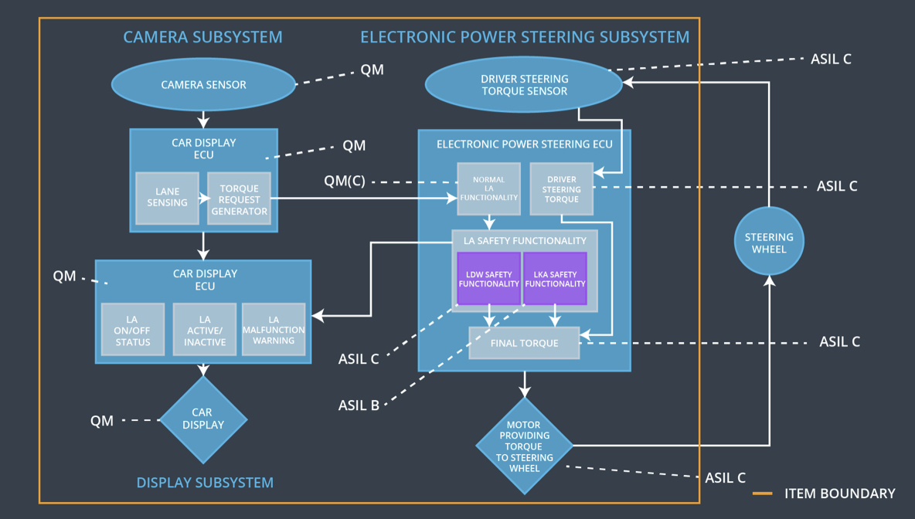

## Allocation of Functional Safety Requirements to Architecture Elements

|  |  |  |  |  |
| --- | --- | --- | --- | --- |
| **ID** | **Functional Safety Requirement** | **Electronic Power Steering ECU** | **Camera ECU** | **Car Display ECU** |
| Functional  Safety  Requirement  01-01 | The electronic power steering  ECU shall ensure that the lane  departure oscillating torque  amplitude is below  Max_Torque_Amplitude | **x** |  |  |
| Functional  Safety  Requirement  01-02 | The electronic power steering ECU shall ensure that the lane departure oscillating torque frequency is below Max_Torque_Frequency | **x** |  |  |
| Functional  Safety  Requirement  01-03 | The Lane Departure Warning function shall be deactivated when the Electronic Power Steering ECU detects camera sensor or any other sensor has started malfunctioning | **x** |  |  |
| Functional  Safety  Requirement  02-01 | The electronic power steering ECU shall ensure that the lane keeping assistance torque is applied for only Max_Duration. | **x** |  |  |
| Functional  Safety  Requirement  02-02 | The electronic power steering ECU shall ensure that lane keeping assistance torque is zero if camera sensor ECU states Laneline_Is_Yellow is true | **x** |  |  |

## Warning and Degradation Concept

|  |  |  |  |  |
| --- | --- | --- | --- | --- |
| **ID** | **Degradation Mode** | **Trigger for Degradation Mode** | **Safe State invoked?** | **Driver Warning** |
| WDC-01 | Turn off Lane Assistant functionality | Malfunction_01 | Yes | Lane Departure Warning Malfunction Warning on Car Display |
| WDC-02 | Turn off Lane Assistant functionality | Malfunction_02 | Yes | Lane Departure Warning Malfunction Warning on Car Display |
| WDC-03 | Turn off Lane Assistant functionality | Malfunction_03 | Yes | Lane Keeping Assistance Malfunction Warning on Car Display |
| WDC-04 | Turn off Lane Assistant functionality | Malfunction_04 | Yes | Lane Departure Warning Malfunction Warning on Car Display |
| WDC-05 | Turn off Lane Assistant functionality | Malfunction_05 | Yes | Lane Keeping Assistance Malfunction Warning on Car Display |