**Outline**

Whenever we create a webpage, we must make sure that the content inside it is readable. This can be done by adding content in the form of tables and lists. This lesson will introduce you to some advanced HTML elements to add more features to your webpage like - hyperlinks, tables, and lists.

**Overview**

**Topics introduced**

* Attributes
* Hyperlinks in HTML
* Tables in HTML
* Lists in HTML

**Topics in Detail -**

**Attributes**

Attributes can be used in any HTML element.

Attributes provide more information about elements that is not provided by the element itself.

The start tag is always used to specify attributes.

Attributes are typically represented by name/value pairs, such as **name="value."**

You will get to see more about attributes in different elements in HTML.

**Hyperlinks in HTML**

Links can be found on nearly every web page. Users can navigate from page to page by clicking on links.

Hyperlinks are HTML links. You can navigate to another document by clicking on a link. A text, image, or any other HTML element can be used as a link.

A hyperlink is defined by the HTML **“<a>”** tag. The syntax is as follows:

**<a href="url"> text </a>**

**The href attribute is used to specify the destination of the link.**

The text is the part that the reader will see. By clicking on this text, the reader will be directed to the specified URL address.

**Example -**

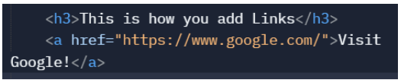

**Output -**

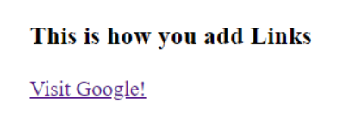

**Tables in HTML**

HTML tables allow users to enter data like text, images, links, videos, etc. Into rows and columns of the cells.

For creating tables, we make use of the **<table>** tag.

There are two parts of the table, namely:

1. Columns
2. Rows

We create a table row-wise. We first code for the first row, then the second, and so on.

The **<tr>** tag is used to create table rows and the **<td>** tag is used to create data cells. The elements under **<td>** are regular and left aligned by default.**<th>** tag is used for table header row.

**Example -**

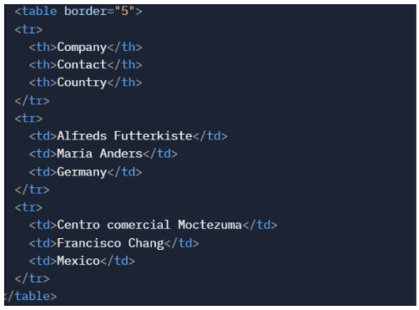

**Output -**

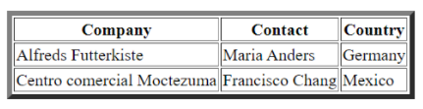

**Lists in HTML**

HTML lists are used to present lists of information in a well-formed and semantic way. There are three different types of lists in HTML, and each one has a specific purpose and meaning.

* Ordered List
* Unordered List
* Description list

**1. Ordered List**

An ordered list can be created using the <ol> element, and each list item starts with the <li> element. Ordered lists are used in cases when the order of the List's items is important. Ordered lists use numbers to mark each item of the list.

**2. Unordered List**

An unordered list created using the <ul> element, and each list item starts with the <li> element. Unordered lists use bullets to mark each item of the list.

**3. Description list**

The description list is created using the <dl> element. The <dl> element is used in conjunction with the <dt> element which specifies a term, and the <dd> element which specifies the term's definition.

**Example -**

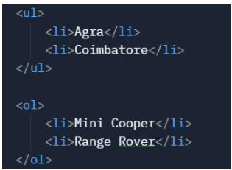

**Output -**

