Principal Researcher Report: How to Build Practical, Proof-of-Skill Learning Loops
Prepared for: solve.education | Focus: Clear Business English, Domain-Agnostic V1 Framework, Practical Hiring Evidence
Document Style: 12pt Standard Typography, Simple Clean Layout, Local Embedded Screenshots

1. Executive Summary & Core Strategy
The Shift from Daily Attendance to Real Skill Proof: Most popular learning apps (like Duolingo, DataCamp, or standard Khan Academy) make money when users open the app every day and keep paying for subscriptions. Because of this, their designs reward attendance and effort—like earning daily streaks, points, or badges simply for clicking through lessons. In a 'learn-to-hire' platform where employers need to trust a candidate's real capabilities, rewarding attendance without proof of actual skill is dangerous because it gives learners false confidence and ruins employer trust.
Our Practical Build Plan for Release 1: solve.education should take the best, easiest-to-use parts of top apps—like simple goal search and interactive split-screen workspaces—and combine them with strict accuracy checks and clear, instant error feedback. Most importantly, instead of requiring technical or programming courses at launch, solve.education will start as a universal practice platform. Whether learners are practicing business reasoning, financial analysis, data literacy, or professional communication, the platform will record their real problem-solving steps so employers can verify what they can actually do.

2. The 6-Step Practical Learning & Verification Loop
Step # | Step Name | How It Helps the Learner & Builds Employer Trust
01. ACTIVATE | Guided Easy Start | Removes confusion by asking learners what career goal they want to achieve, then immediately giving them one clear, right-sized practice task with a simple explanation of why it matters.
02. PRACTICE | Interactive Workspace | Places the learner directly into a clean split-screen workspace (such as a structured spreadsheet modeler, logic table, or interactive case solver) where they actively build solutions instead of just watching videos or reading text.
03. RECOVER | Step-by-Step Hints When Stuck | Prevents learners from quitting when a problem gets tough by offering helpful hints one step at a time. This gives them just enough support to keep moving forward without giving away the final answer.
04. CORRECT | Instant Clear Feedback on Mistakes | Turns errors into teaching moments. When a learner gets something wrong, the system instantly shows a clear, plain-language rule explaining how to fix it, and requires them to try again until they get it right.
05. PROVE | Strict Accuracy Advancement Gate | Ensures that moving up to 'Proficient' or 'Mastered' requires high accuracy with very few mistakes. If a learner makes too many errors, they must restart with new practice problems so they actually learn the material instead of guessing.
06. RETURN | Contextual Recap on Return | Welcomes learners back with a quick recap of what they learned in their last session ('Here is where you left off...'), focusing entirely on verified skill progress rather than arbitrary points or leaderboards.

3. Detailed Analysis of 12 Competitor Features (Plain English & Practical Takeaways)

3.1 Brilliant — Smart Search & Goal Recommender
Platform & Step: Brilliant | Loop Step: Step 01: Activate (Priority P1)
How It Works in Competitor Apps: A simple search bar on the home screen asking learners what they want to achieve. When they type a goal, an AI assistant recommends one specific starting lesson and gives a short plain-language explanation of why that lesson fits ('Taking the First Steps').
Why It Helps Learners Succeed: When beginners face hundreds of course options, they often feel overwhelmed and freeze up. Giving them exactly one recommended starting task—with a clear explanation of why it will help them—builds trust and gets them started immediately.
Potential Risks & Drawbacks: If the recommendations are generic (pointing everyone to the same basic course regardless of what they typed), users will feel ignored. Also, putting too many icons or buttons inside the search bar can confuse first-time visitors.
Practical Takeaway for solve.education: For solve.education, use a simple goal input field that routes new learners directly to their first practical diagnostic check, explaining clearly why that specific check matches their career goal.
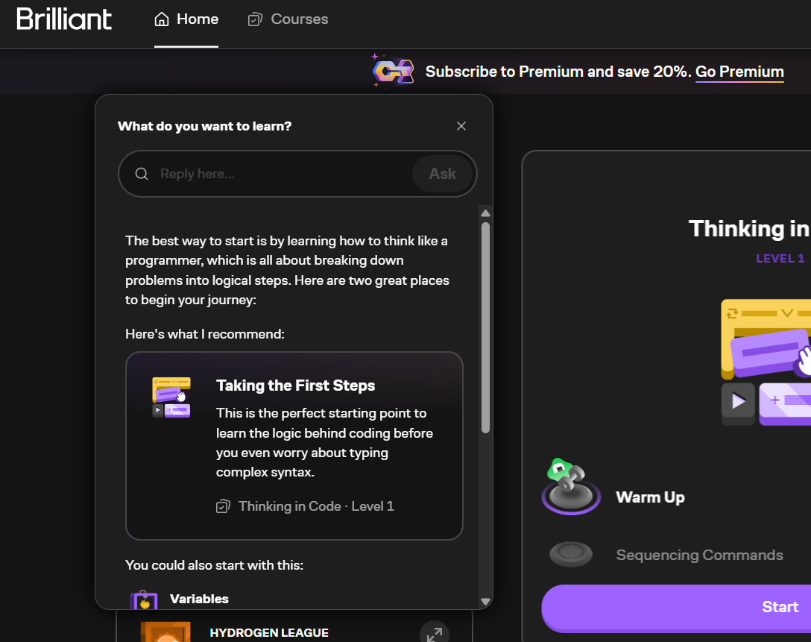
Figure: Brilliant's Smart Search recommending a starting topic with a clear plain-language explanation.

3.2 Brilliant — In-Course Assistant (Koji)
Platform & Step: Brilliant | Loop Step: Step 03: Recover (Priority P1)
How It Works in Competitor Apps: An interactive character sitting beside the lesson text that offers friendly hints and answers questions via typed chat or voice when a learner feels stuck.
Why It Helps Learners Succeed: Many struggling learners hesitate to click a standard 'Help' button because they feel embarrassed. A friendly, proactive assistant that asks 'Would you like a quick hint?' lowers the barrier to asking for help right when the learner needs it most.
Potential Risks & Drawbacks: In the free version, the assistant cuts off right when the problem gets hard, popping up a paywall to force users to upgrade. Additionally, on mobile phone screens, the chat panel takes up too much room and covers the main problem.
Practical Takeaway for solve.education: In solve.education, use a focused learning assistant that asks guiding questions ('What happens to the total if we increase this number?') to help learners think through the problem. Never allow the assistant to output complete ready-made answers.
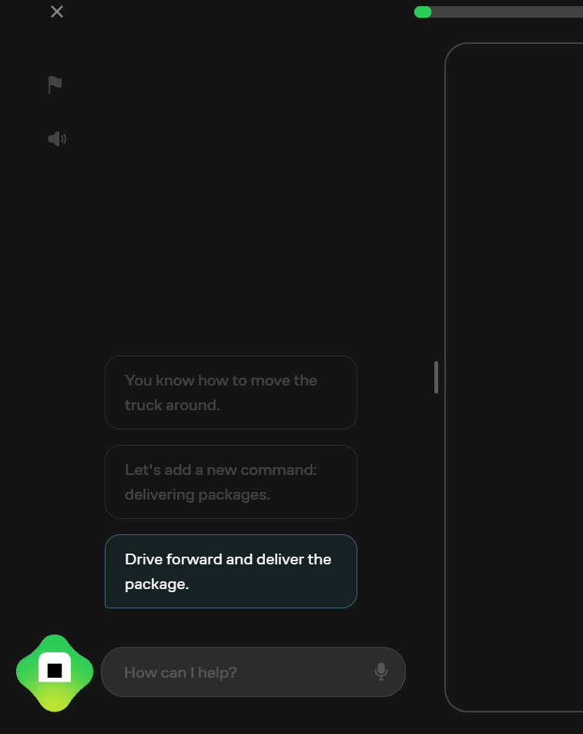
Figure: Brilliant's Koji assistant offering conversational hints alongside the practice task.

3.3 Brilliant — Interactive Drag-and-Drop Logic Blocks
Platform & Step: Brilliant | Loop Step: Step 02: Practice (Priority P1)
How It Works in Competitor Apps: Instead of answering multiple-choice questions, learners drag visual command blocks into the right order to make a truck move across a grid and deliver a package. A prominent 'Start over' button makes trying again quick and easy.
Why It Helps Learners Succeed: Letting learners arrange visual blocks allows them to focus purely on problem-solving logic and step-by-step ordering without worrying about exact formatting errors. Seeing the truck move gives them immediate visual feedback on whether their logic worked.
Potential Risks & Drawbacks: While visual block dragging is great for beginners, learners often struggle later when they have to solve open-ended problems without guided blocks. Dragging blocks proves you can recognize order, but not always that you can solve problems from scratch.
Practical Takeaway for solve.education: In solve.education, use interactive drag-and-order tasks for initial diagnostic warm-ups across any subject, but always require learners to complete an unassisted open-ended task before awarding formal skill certification.
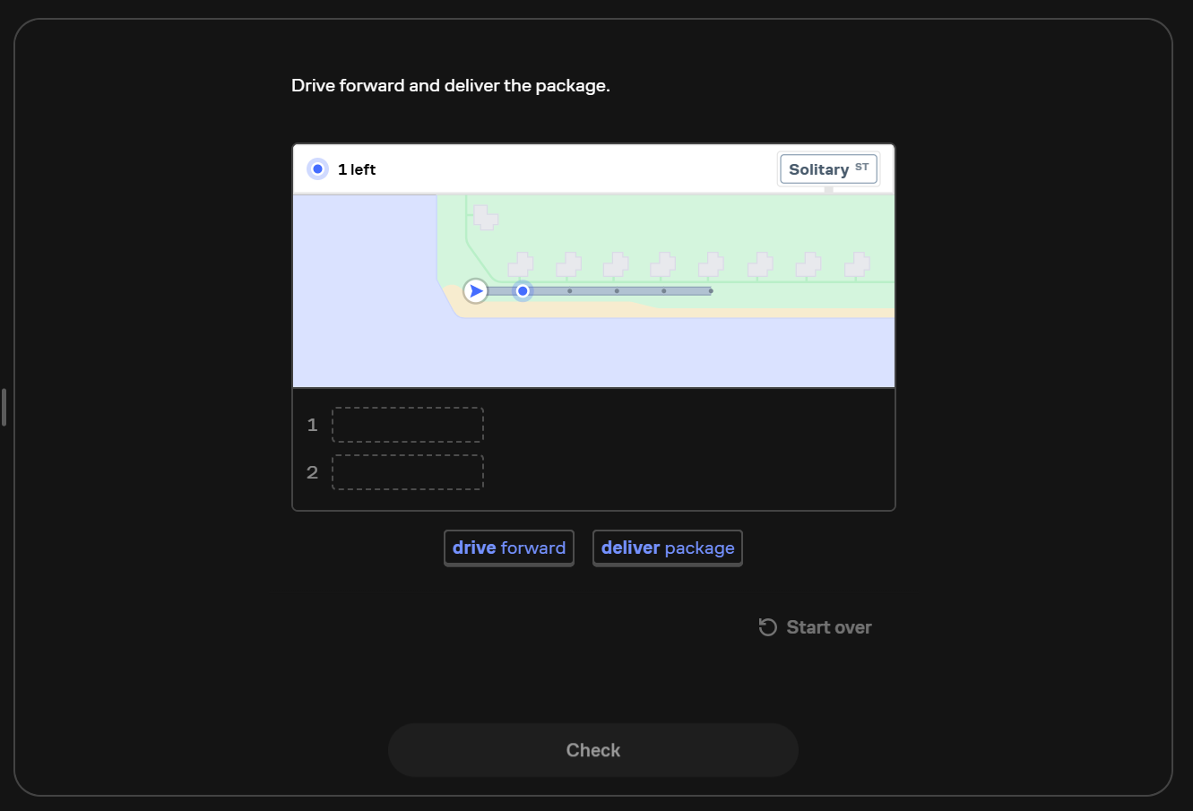
Figure: Brilliant's interactive drag-and-drop block canvas with real-time visual feedback.

3.4 DataCamp — Split-Screen Interactive Workspace
Platform & Step: DataCamp | Loop Step: Step 02: Practice (Priority P0 Core Feature)
How It Works in Competitor Apps: A clean split-screen layout where instructions sit on the left, and a working interactive practice tool sits on the right. When the learner clicks 'Submit', their work is graded instantly inside the browser with zero setup required.
Why It Helps Learners Succeed: This is the gold standard for hands-on practice. By giving learners a working environment right inside their browser, they spend 100% of their time solving the problem instead of wasting hours installing software or setting up tools.
Potential Risks & Drawbacks: If problems only ask learners to fill in one blank word (`____`), students often guess the missing word without understanding the full problem.
Practical Takeaway for solve.education: Make this split-screen interactive workspace our core practice surface (`FR2`). Whether learners are filling out financial tables, analyzing business data, or solving practical case studies, let them do real work with zero setup friction.
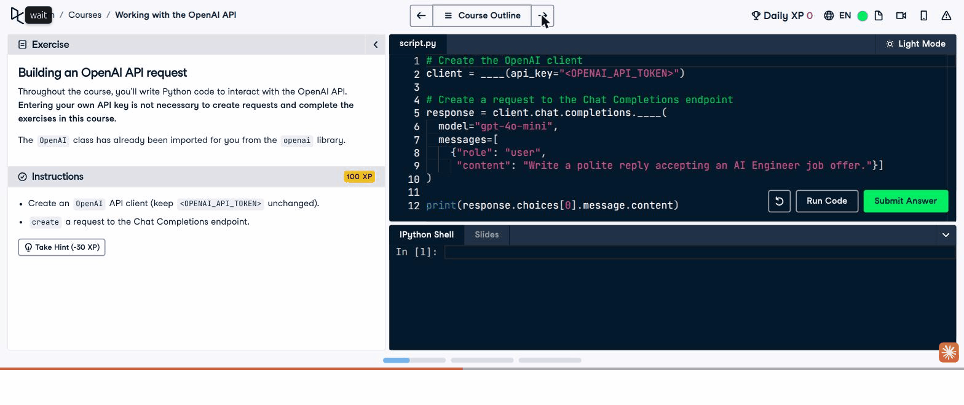
Figure: DataCamp's split-screen layout pairing clear instructions with a working practice workspace.

3.5 DataCamp — Hint Panel with Effort Cost
Platform & Step: DataCamp | Loop Step: Step 03: Recover (Priority P1)
How It Works in Competitor Apps: When a learner gets stuck, they can click 'Take Hint' (which costs 30 points) for a helpful tip, or 'Show Answer' (which costs 70 points) to see the full solution and forfeit their reward for that exercise.
Why It Helps Learners Succeed: Attaching a small point cost to hints makes learners stop and think carefully before asking for help. This encourages them to make an honest attempt on their own first, which leads to much better memory retention.
Potential Risks & Drawbacks: If points feel meaningless to learners, they will click 'Show Answer' immediately just to rush through the lesson without learning.
Practical Takeaway for solve.education: In solve.education, never deduct arbitrary points. Instead, simply record in the verified audit trail whether the learner solved the task independently or needed hints (`Scaffolded Mastery` vs. `Independent Mastery`).
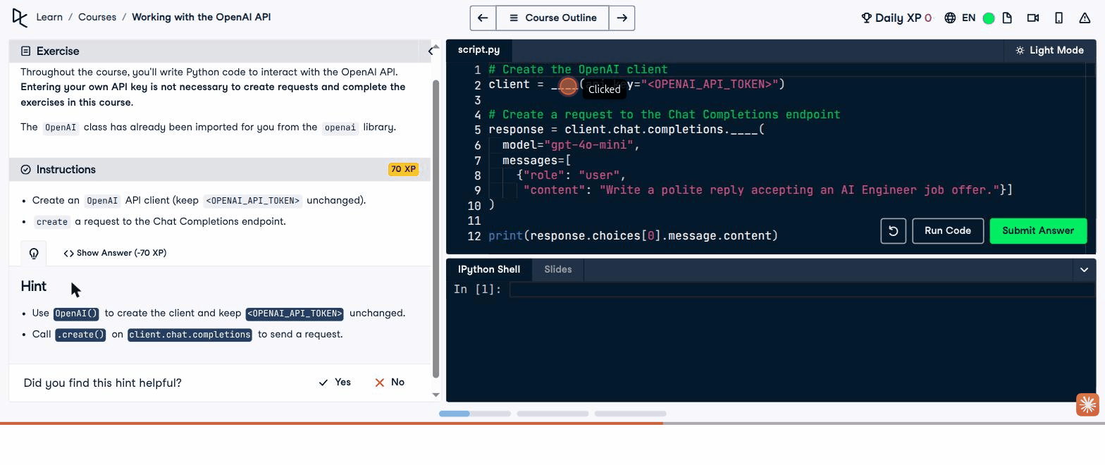
Figure: DataCamp's hint panel showing exact point costs before revealing step-by-step guidance.

3.6 DataCamp — Session Recap & Peer Leaderboards
Platform & Step: DataCamp | Loop Step: Step 06: Return (Priority P2 Monitor)
How It Works in Competitor Apps: When learners return after a day away, a pop-up window summarizes what they practiced last time. The platform also uses daily streaks and weekly competitive leaderboards where users rank against others by total points.
Why It Helps Learners Succeed: Reminding learners what they did yesterday helps refresh their memory and makes picking up where they left off much easier. Streaks give people a daily habit goal to keep them coming back.
Potential Risks & Drawbacks: Public leaderboards often discourage learners who fall behind. Furthermore, competitive ranking encourages people to repeat super-easy lessons over and over just to earn points without learning new skills.
Practical Takeaway for solve.education: Keep the helpful recap feature (`FR7`) to remind learners what they worked on last time, but completely remove public point leaderboards. Instead, show learners a personal chart tracking how their own real-world skills have grown.
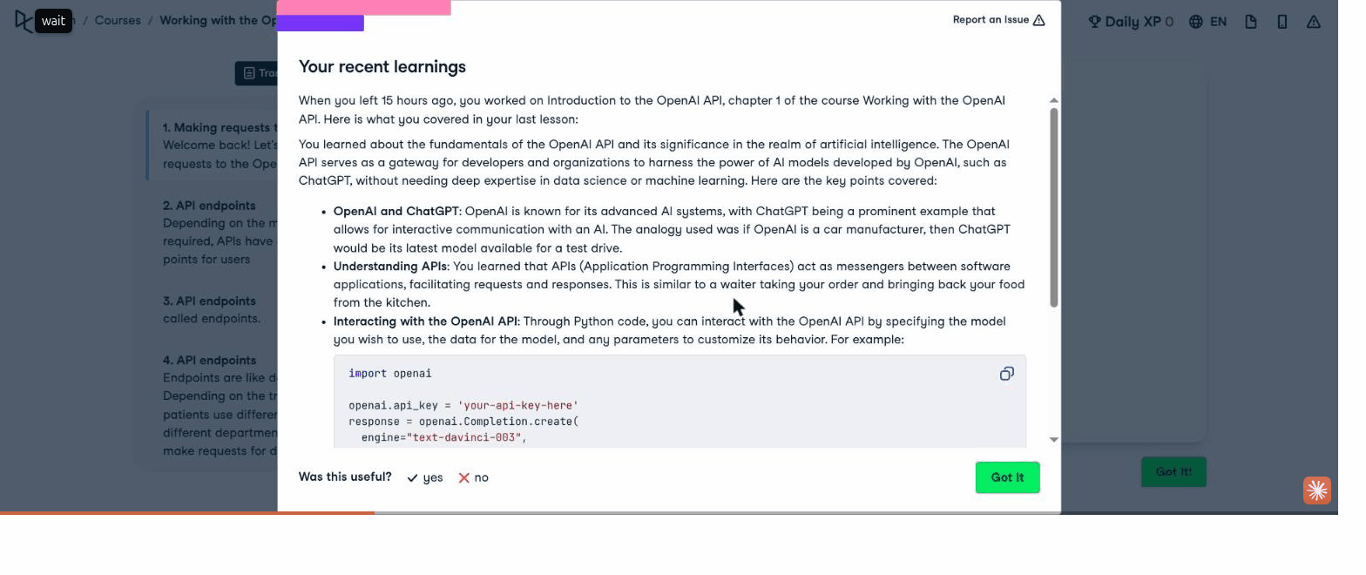
Figure: DataCamp's welcome-back recap summarizing specific topics covered prior to session close.

3.7 Busuu — Quick Tasks with Instant Rule Explanations
Platform & Step: Busuu | Loop Step: Step 04: Correct (Priority P0 Core Feature)
How It Works in Competitor Apps: Short bite-sized exercises where submitting a wrong answer immediately highlights the mistake in red and slides up an easy-to-read explanation box showing the exact rule and correct example.
Why It Helps Learners Succeed: This is one of the most effective teaching methods across all benchmarked apps. Instead of just marking an answer 'Wrong', the platform uses that exact moment of attention to clearly teach the underlying rule right when the learner cares most.
Potential Risks & Drawbacks: If learners can simply click 'Continue' to skip past the explanation in half a second without reading it, they won't absorb the lesson.
Practical Takeaway for solve.education: Build instant Diagnostic Rule Panels (`FR3`) for every error across all subjects. When a learner makes a mistake, explain the exact causal rule clearly, and require them to try again and fix it before they can advance.
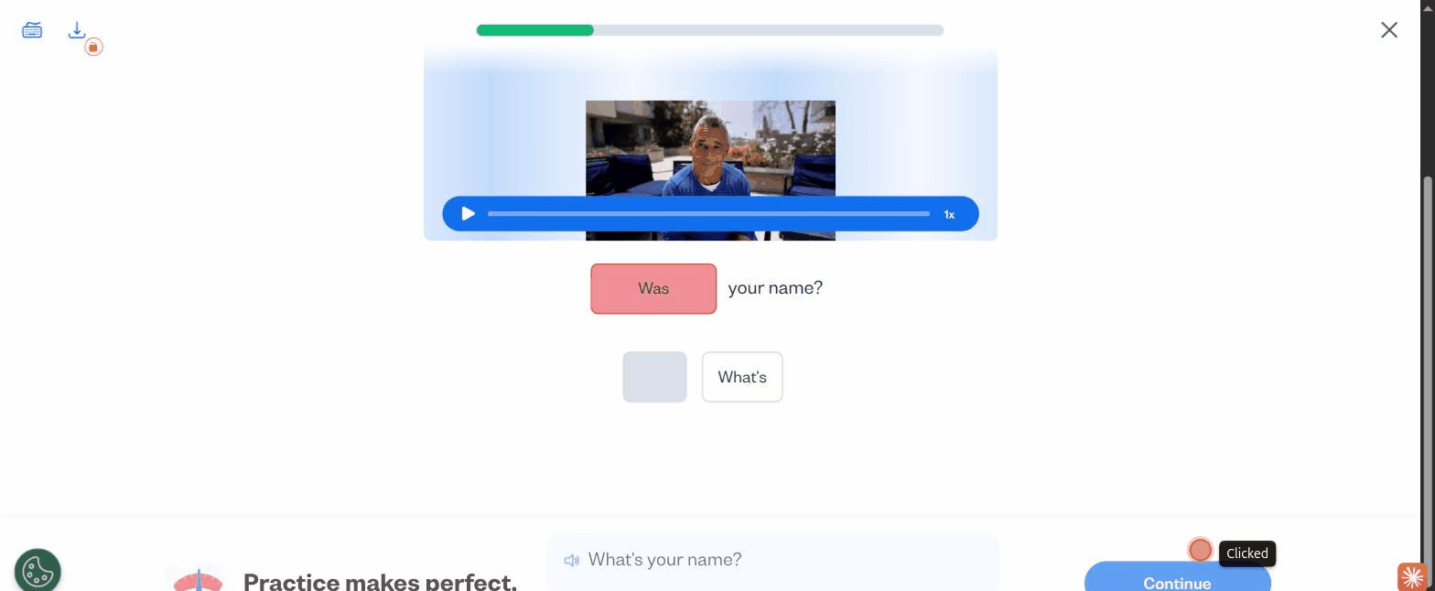
Figure: Busuu's instant explanation panel clarifying the exact rule right after an incorrect attempt.

3.8 Busuu — Community Peer Review & Feedback Feed
Platform & Step: Busuu | Loop Step: Step 06: Return & Proof (Priority P2)
How It Works in Competitor Apps: A social community feed where learners submit open-ended practice prompts and receive written corrections and feedback from more experienced speakers in the community.
Why It Helps Learners Succeed: Automated grading tools can't easily judge whether open-ended communication or strategic business answers sound natural and professional. Having real human peers review submissions provides personalized, authentic feedback that makes learners eager to return and check their reviews.
Potential Risks & Drawbacks: If there aren't enough active reviewers, learners might wait 2 or 3 days for feedback—by which time they've forgotten the exercise. Also, untrained peers sometimes give confusing or incorrect advice.
Practical Takeaway for solve.education: In solve.education, build a **Verified Expert Review Queue (`FR8`)**. Instead of using unverified casual peers, allow verified alumni, mentors, or employer evaluators to review and grade open-ended capstone projects against clear checklists.
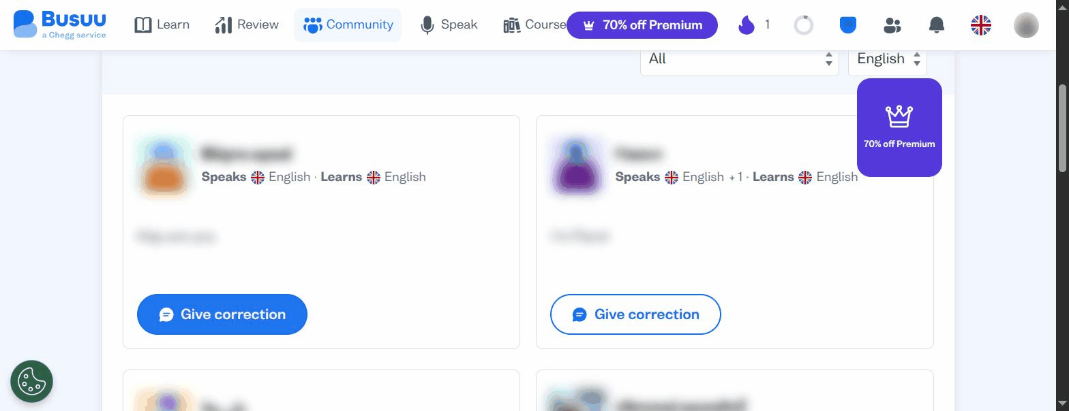
Figure: Busuu's community feedback feed where peers review and correct open-ended submissions.

3.9 Khan Academy — Clear 5-Level Mastery Status Grid
Platform & Step: Khan Academy | Loop Step: Step 05: Prove (Priority P0 Core Feature)
How It Works in Competitor Apps: Instead of just showing a percentage completion bar, every single skill is tracked across five clear levels (`Not Started` -> `Attempted` -> `Familiar` -> `Proficient` -> `Mastered`), displayed visually as colored blocks in a clean grid.
Why It Helps Learners Succeed: This is the clearest way to separate 'hours spent' from 'actual competence'. By showing learners and employers exactly which skills are at `Familiar` level and which are truly `Mastered`, everyone focuses on achieving high accuracy and real capability.
Potential Risks & Drawbacks: If the practice questions are too simple or repetitive, earning 'Proficient' only proves the learner memorized the test questions, not that they can apply the skill in a real job.
Practical Takeaway for solve.education: Adopt this exact 5-level mastery grid (`FR5`) for solve.education. Display this clear, honest status grid directly on the learner's verified profile so employers can see exact skill levels at a glance.
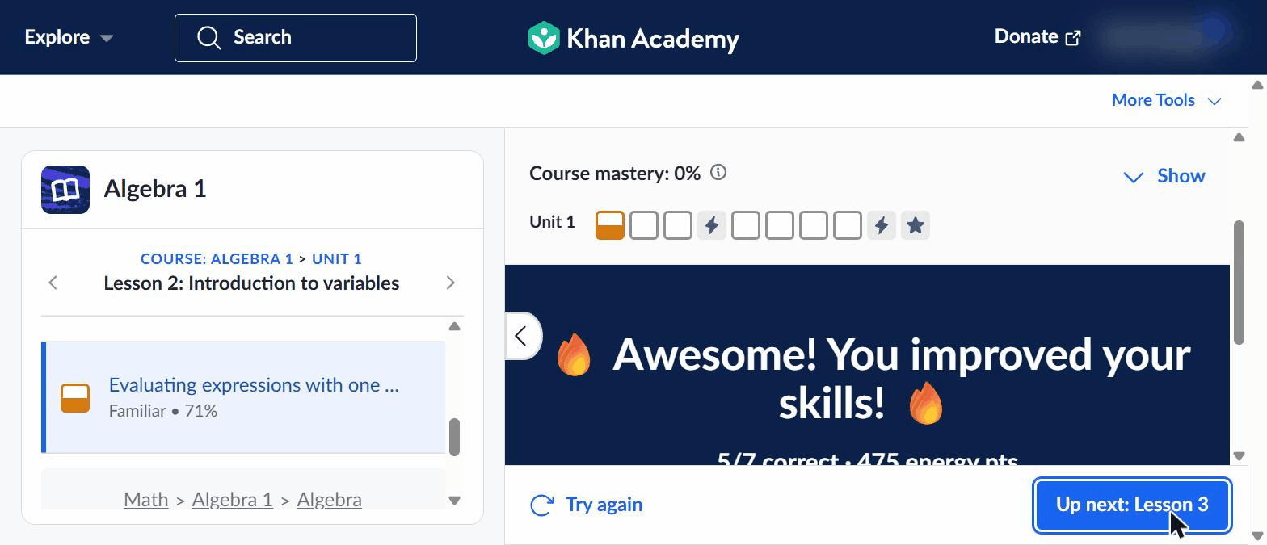
Figure: Khan Academy's clean colored grid displaying exact mastery levels earned for each skill.

3.10 Khan Academy — Strict Accuracy Check (The Two-Mistake Limit)
Platform & Step: Khan Academy | Loop Step: Step 05: Prove (Priority P0 Core Feature)
How It Works in Competitor Apps: When a learner is completing a 7-question mastery check, the platform allows at most one mistake. If they make a second mistake, a message pops up explaining that 'Proficient' status is no longer reachable on this attempt, prompting them to start over.
Why It Helps Learners Succeed: This is the single most important rule for stopping users from guessing or limping through exercises just to earn a badge. By enforcing that 'Proficient' requires very high accuracy, the badge remains credible and meaningful.
Potential Risks & Drawbacks: On complex multi-step problems, a minor formatting typo on Question 6 can trigger the mistake limit and frustrate learners if minor typos aren't forgiven.
Practical Takeaway for solve.education: Enforce strict Accuracy Advancement Gates (`FR5`) across all verification checks. Exceeding 1 mistake caps the award at `Familiar`. To earn `Proficient`, learners must restart with a fresh set of practice problems.
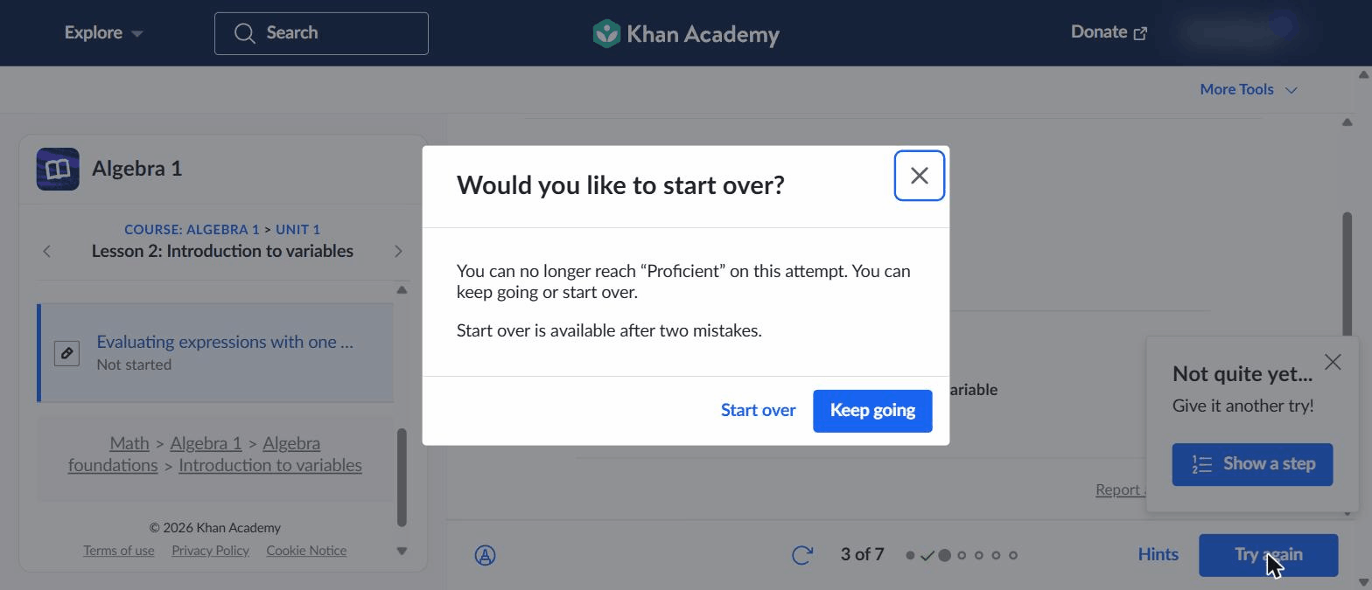
Figure: Khan Academy's alert informing the user that 2 errors require starting fresh to earn Proficient status.

3.11 Khan Academy — Step-by-Step Hints & Quick Video Drawer
Platform & Step: Khan Academy | Loop Step: Step 03: Recover (Priority P1)
How It Works in Competitor Apps: When an answer is wrong, the platform gently encourages another try (`Not quite yet... give it another try`) and lets learners open a step-by-step hint guide (`1 of 4 hints`) or watch a short 2-minute video right inside the problem box.
Why It Helps Learners Succeed: Breaking down a tough problem into 4 simple steps prevents learners from feeling stuck while encouraging them to keep trying. Keeping the video right inside the problem box prevents them from getting lost across different screens.
Potential Risks & Drawbacks: Some learners click through all 4 hints quickly just to see the final answer without actually reading or understanding the steps.
Practical Takeaway for solve.education: Use step-by-step hint guides (`FR4`). However, whenever a learner clicks all the way to the final hint, automatically generate a fresh practice problem that they must solve without hints to prove they understand.
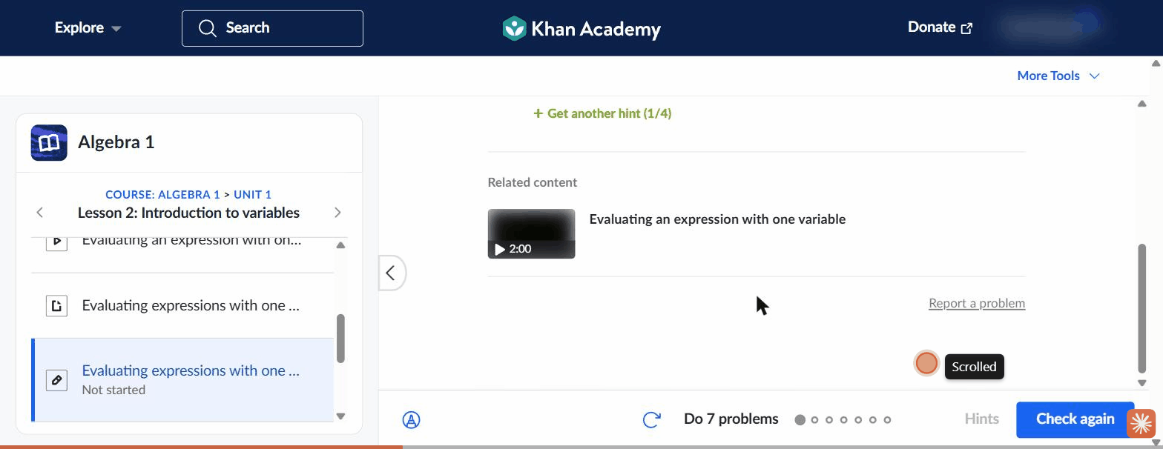
Figure: Khan Academy's step-by-step hint guide and embedded video drawer inside the practice task.

3.12 Khan Academy — End-of-Lesson Summary & 'Up Next' Prompt
Platform & Step: Khan Academy | Loop Step: Step 06: Return (Priority P1)
How It Works in Competitor Apps: When an exercise finishes, a clean summary card shows exactly how much their skills improved (`Familiar -> Proficient • 71%`), celebrates their effort, and gives one prominent 'Up next' button to jump straight into the next lesson.
Why It Helps Learners Succeed: Showing learners concrete proof that their real skills improved makes them feel proud and motivated. A single 'Up next' button captures that positive momentum and encourages them to complete one more task right away.
Potential Risks & Drawbacks: If the summary emphasizes arbitrary points over real skill improvements, learners may focus on collecting points rather than building competence.
Practical Takeaway for solve.education: Design our End-of-Task Summaries (`FR7`) to lead 100% with verified skill growth (`Skill Level Updated -> Proof Recorded`), omitting arbitrary points entirely.

Figure: Khan Academy's summary screen celebrating skill growth and offering a quick forward prompt.

4. Summary Table of Feature Priorities & Practical Value
Feature Name | Platform | Loop Step | Value for Proving Job Skills | solve.education Priority
Smart Search Recommender | Brilliant | Activate | Good for getting started easily | P1 Build Prototype
In-Course Assistant (Koji) | Brilliant | Recover | Helpful if restricted from giving answers | P1 Build Prototype
Drag-and-Drop Logic Blocks | Brilliant | Practice | Good for warm-ups; not enough alone | P1 Adapt Now
Split-Screen Workspace | DataCamp | Practice | Highest (Hands-on practical work) | P0 Core Feature
Hint Panel with Effort Cost | DataCamp | Recover | High (Encourages independent effort) | P1 Build Prototype
Recap & Leaderboards | DataCamp | Return | Recap is great; Leaderboards distract | P2 Use Recap Only
Instant Rule Explanations | Busuu | Correct | Highest (Teaches exact rules instantly) | P0 Core Feature
Community Peer Review | Busuu | Return | Great when reviewed by verified experts | P2 Advanced Build
5-Level Mastery Status Grid | Khan Academy | Prove | Highest (Shows exact skill status clearly) | P0 Core Feature
Strict Accuracy Check (Gate) | Khan Academy | Prove | Highest (Prevents guessing/grinding) | P0 Core Feature
Step-by-Step Hints & Video | Khan Academy | Recover | High (Unblocks learners without frustration) | P1 Adapt Now
End-of-Lesson Growth Summary | Khan Academy | Return | High (Shows real skill progress) | P1 Adapt Now

5. Clear Product Feature Requirements (FR1–FR8)
Requirement ID | Feature Title | What the System Does (Plain English) | Key Data & Proof Recorded
FR1 | Goal-to-Task Router | System asks learners what career or skill goal they want, then immediately launches their first right-sized practice task with a simple explanation. | Tracked: Selected goal ID, recommended task ID, and time taken to start
FR2 | Split-Screen Practice Workspace | System provides a clean split-screen workspace (such as a data table or case solver) where learners do hands-on practice right in their browser with zero setup. | Tracked: Task ID, time spent, errors detected, and final verification score
FR3 | Instant Explanation Panel | When a learner makes a mistake, system pops up a clear plain-language rule explaining what went wrong and requires them to fix it before moving forward. | Tracked: Rule ID, error type, time taken to fix, and whether retry succeeded
FR4 | Step-by-Step Hint Guides | System offers progressive hints when learners ask for help. Every hint used is logged carefully to distinguish independent solves from assisted solves. | Tracked: Task ID, hint level used, total hints opened, and subsequent accuracy
FR5 | Strict Accuracy Limit | System requires high accuracy (allowing at most 1 mistake per check). If more errors occur, system requires learners to restart with fresh practice problems. | Tracked: Skill ID, error count, and whether restart was triggered
FR6 | Verified Skill Audit Trail | System aggregates all practice runs, hint counts, accuracy scores, and timestamps into a verified digital skill record that employers can check and trust. | Tracked: Learner ID, completed skills list, verification check status, and employer view link
FR7 | Welcome-Back Progress Recap | System welcomes returning learners with a brief recap of what they learned last time, and shows summary screens highlighting true skill growth. | Tracked: Hours since last session, concepts reviewed, and time to continue
FR8 | Verified Expert Review Queue | System allows verified mentors, alumni, or employer evaluators to review and grade open-ended capstone projects against clear checklists. | Tracked: Submission ID, evaluator ID, rubric checklist scores, and feedback comments

6. Practical Testing Plan (Ensuring Features Actually Work)
Test ID | What We Are Testing & Why | Who We Test With | Success Target (What We Want to See) | Safety Check (What We Must Watch Out For)
Test 01 | Does our split-screen workspace help learners retain skills better than watching videos first? | 400 beginners across data and business reasoning topics | Learners score at least 25% higher on independent problem-solving tests 2 days later. | Make sure learners aren't just guessing or rushing through without understanding.
Test 02 | Does explaining exact rules instantly upon error reduce repeat mistakes compared to standard right/wrong marks? | 600 active learners | Learners fix their mistakes and score 35% higher on their next attempt. | Ensure the explanation pop-ups don't frustrate users enough to make them quit.
Test 03 | Does requiring strict accuracy (allowing only 1 mistake) accurately predict how well candidates perform in real job interviews? | 300 advanced candidates | High correlation (>65% match) between earning our 'Proficient' badge and passing employer skill screens. | Watch for users getting overly frustrated if they have to restart after a typo.
Test 04 | Does showing a 'welcome back' recap help returning users pick up right where they left off faster than a standard home dashboard? | 800 returning learners | Learners return 15% more often and start their next task 30 seconds faster. | Ensure learners aren't just repeating super-easy warm-up tasks to look active.

