Executive Summary: Onboarding Strategy & Patterns
Date: 2026-07-20
Prepared for: solve.education Stakeholders
Subject: Job-Readiness Onboarding UX Patterns

TL;DR
This document outlines the onboarding strategy and reusable UX patterns for solve.education, drawing on education app benchmarks, teacher literature, and youth onboarding principles. The core conclusion across these domains is to defer registration until the user has experienced product value, and to leverage the resulting "endowment effect" (loss aversion) by framing the account ask as protecting progress.

Conclusion
In summary, solving the onboarding challenge for solve.education requires a careful balance between lowering initial friction and meeting the strict credibility requirements of a job-readiness platform. By deferring the creation of a shadow profile until after a user achieves a "win", and framing the eventual sign-up as saving their progress, we can maximize early-funnel engagement. However, unlike purely recreational apps, we must maintain mandatory baseline assessments and a verified identity wall to ensure the integrity of the credentials generated. Additionally, to support seamless cohort tracking, program routing must be handled through a distraction-free, code-first entry that tags the user's shadow profile immediately, preserving the low-friction flow. Finally, because this is a workforce tool, an upfront 15+ age gate is required to comply with Southeast Asian labor laws before any onboarding begins.

Executive Design Implications
- Architecture: Shift the global onboarding architecture to a "Try-first" model. The registration wall must sit after the primary value-delivery mechanism.
- Copywriting: Rewrite all registration CTAs from "Sign Up / Create Account" to loss-aversion framing like "Save your progress" or "Claim your certificate."
- UX Components: Implement an optional placement fork and use a recognition-based UI (showing actual content snippets) rather than asking users to self-rate.
- Scaffolding: Ensure the guest experience includes bounded progress bars, a single dominant CTA per screen, and immediate positive feedback.
- Localization & Recovery: Apply deep UI localization and use icon-first intake forms to lower the reading burden for low-literacy users. Ensure all OS permission requests (like microphones) are primed beforehand with graceful fallbacks if denied.
- Program Code Integration (Code-first linked entry): To support solve.education's cohort tracking, implement a dedicated, distraction-free code entry screen (benchmarked from Khan Academy's /join page) for users arriving via program links. By capturing this code upfront and tagging it to a shadow profile, users bypass catalogue navigation and reach their "first win" faster without violating the "Try-first" architecture. The code is then permanently locked to their identity at the eventual registration wall.
- Compliance & Age Gating: Add a 15+ age gate immediately after the landing screen. This aligns with the legal minimum working age across Southeast Asia (Indonesia, Philippines, Vietnam, Thailand) and ensures that users building job-readiness profiles are legally eligible to enter the workforce.

1. Overview of Literature & Benchmarks
- Education Apps Benchmark [S1]: Analysis of top education apps shows they consistently defer registration, use a single CTA for entry, offer optional placement tests, and rely heavily on momentum scaffolding and character-guided intakes to build early competence.
- Indonesian Teacher EdTech Literature [S2]: Highlights that upfront registration creates massive drop-off for teachers due to structural/regulatory friction (e.g., belajar.id SSO issues). Found that professional artifacts act as strong endowment objects for loss-aversion registration triggers.
- Youth Onboarding Strategy [S3]: Focuses on a job-readiness audience where the onboarding must satisfy the "winnable-yet-credible trilemma"—a first task that is simple enough to guarantee success but realistic enough to simulate real employment and build credible self-efficacy.

2. Synthesized Themes & Benchmark Teardown

Theme 1: Defer Registration to Establish Value
- Value-before-signup: Defer the creation of a "lightweight shadow profile" to maximize early funnel engagement, but explicitly mandate a verified identity wall later for credentialing and LERs. (Confidence: High) [S1, S2, S3]
- Mitigating Structural Friction: Deferring registration is a UX optimization. Mitigating true structural friction requires decoupling from the broken SSO and mandating alternative low-friction login methods (e.g., passwordless WhatsApp/SMS OTP). (Confidence: High) [S2]

Supporting Benchmark Teardown
Feature | Description | Key Findings & Evidence | Rationale
1: Deferred, "try-first" registration | Where the account wall sits relative to the first taste of value. The five platforms span a full spectrum, and the placement strongly predicts fit for a low-context, email-scarce audience. | Duolingo defers registration entirely: the whole language pick, questionnaire, and placement run in a guest session, and the account ask appears only after the user reaches the product home, framed as saving progress. (In our capture the guest session reached personalization, placement, and the /learn home; the first lesson itself sits just beyond where we stopped, see Gaps.) [Screenshot available in original markdown] Brilliant sits in the middle: it runs its full personalization questionnaire first, then walls registration to "discover your learning plan" (loss-aversion on invested effort). [Screenshot available in original markdown] Khan is wall-first with a lighter pre-step (role then age gate), and CodeSignal is the extreme: clicking "Start learning" jumps straight to a full name/email/password form with no value shown first. [Screenshot available in original markdown] | Every field asked before value is delivered is a drop-off point. A guest session lets motivation build before commitment is required, and reframing the eventual signup as "save what you already made" converts loss-aversion into a reason to register rather than a barrier to entry. This directly addresses email-less and low-context learners who stall at a cold account wall and who accumulate duplicate or abandoned accounts when forced to register up front. [ref: Kahneman, Knetsch & Thaler 1991 on loss aversion / the endowment effect](https://scholar.google.com/scholar?q=Kahneman%20Knetsch%20Thaler%201991%20on%20loss%20aversion%20the%20endowment%20effect)
2: Landing value-framing with a single unambiguous CTA | The first screen's job is to make one action obvious and ask for nothing. This is the moment where a primary CTA can be mistaken for an ad if it competes with other elements. | Duolingo's landing is near-empty: one benefit headline, one dominant primary CTA ("Get started"), and a de-emphasized "I already have an account." Nothing else competes for the tap. [Screenshot available in original markdown] Khan instead leads with a role chooser as the primary action (Student / Family / Teacher), which front-loads an identity decision before any value. [Screenshot available in original markdown] Elsa proves value on the page itself, embedding a working "speak this sentence" test (see Feature 5), and Brilliant pairs a credibility line ("built by experts from MIT and Harvard") with a live interactive product visual. | A single high-contrast CTA with no competing elements removes ambiguity about what to do next, which is critical for low-context and low-tech-literacy users who will not hunt for the right control. When the first screen asks for a decision (role) or competes with promos, the intended action loses salience and can read as marketing rather than a button to press. [ref: Hick 1952 on choice reaction time](https://scholar.google.com/scholar?q=Hick%201952%20on%20choice%20reaction%20time)
5: Assessment-as-onboarding, delivered before the wall | Using a real skill assessment as the onboarding itself, so the placement mechanic doubles as a "playable demo" of the product's core value, and crucially, delivering it before any signup. | Elsa embeds a genuinely working speaking test on its marketing page: a sentence to pronounce, an audio model to hear, and a mic to record. The user reaches the core interaction (speaking into a real assessment) with no signup or download. Pronunciation scoring is what Elsa advertises the test performs; in our capture the mic fired on a silent clip and the AI score itself appeared only as a marketing mockup, so the scoring was observed as claimed, not as a returned result. [Screenshot available in original markdown] CodeSignal is the cautionary inverse: its signature AI skill-assessment placement is identical in spirit but sits entirely behind a mandatory account form, so a prospective learner never reaches it. [Screenshot available in original markdown] | An assessment that is also a demo lets users feel competence and see the product's value in the first minute, which is a powerful activation and acquisition hook, and it produces the placement signal for free. Sequencing it before the wall (Elsa) versus behind it (CodeSignal) is the difference between "try then commit" and "commit to try": the former fits a hesitant, low-commitment audience far better. The testing-effect literature supports only that a real assessment is genuine learning rather than dead time; the stronger claim that sequencing it before the wall lifts activation rests on the Elsa-vs-CodeSignal contrast and the A/B test proposed below, not on that literature. [ref: Roediger & Karpicke 2006, the testing effect](https://scholar.google.com/scholar?q=Roediger%20Karpicke%202006%20the%20testing%20effect)

Theme 2: Leverage Loss Aversion and Progress Ownership
- The Endowment Effect for Account Creation: Framing registration as "saving your progress" is a proven design heuristic that successfully leverages loss aversion as a copywriting tactic to lift conversion. (Confidence: Medium) [S1, S2, S3]
- The Nature of the Endowment Object: Generic learners are motivated to save XP or lesson progress [S1, S3], whereas professionals (like Indonesian teachers) require the generation of a tangible artifact (e.g., Modul Ajar/RPP) tied to recognized civil-service credentials to trigger meaningful ownership. (Confidence: Medium) [S1, S2, S3]

Supporting Benchmark Teardown
Feature | Description | Key Findings & Evidence | Rationale
9: Momentum and motivation scaffolding | Small structural devices woven through the flow that make it feel short, reversible, and worth finishing: progress bars, outcome projections, positive feedback, and gentle re-engagement. | Duolingo brackets its questionnaire with a progress bar and a back arrow (finite and reversible), reinforces value with an outcome projection ("That's 50 words in your first week!"), gives instant positive feedback on placement answers ("Nice!"), and even deploys an exit-intent retention modal if the user tries to quit mid-placement. [Screenshot available in original markdown] Brilliant threads credibility and reassurance interstitials between questions ("Built by the best minds in education," "You can make progress in both subjects later on"). Both apps also tease locked features with a concrete unlock condition ("complete 3 more lessons to start competing") to set a near-term goal rather than overwhelming a new user. | A visible, bounded progress indicator reduces the anxiety of an open-ended form, and reversibility lowers the stakes of each choice. Outcome projections and instant positive feedback supply motivation to continue, and teasing a gated feature with a clear condition converts overwhelm into a single next goal. Together they sustain a low-context user through a multi-step flow. [ref: Kivetz, Urminsky & Zheng 2006 (goal-gradient) and Nunes & Drèze 2006 (endowed progress)](https://scholar.google.com/scholar?q=Kivetz%20Urminsky%20Zheng%202006%20goal%20gradient%20and%20Nunes%20Dr%C3%A8ze%202006%20endowed%20progress)
11: Humanizing touches that build trust | Signals of a real human behind the product, a founder's note, a personal welcome, a named human guide, used to convert a cold signup into a relationship. Distinct from Feature 8's cartoon mascot: this is human presence and authorship, not a character. | What the user sees: in the strongest public example, Superhuman's onboarding is led by a real, named specialist rather than a bot, and the broader pattern appears as founder's notes and personal welcome messages signed by a human. What the user does: engages in a short personal exchange (a discovery conversation about their workflow), and in Superhuman's case verbally commits to a usage goal, then receives personal follow-up. What the system does: routes new users to a human-led or human-authored welcome so the relationship, not only the UI, carries activation. The reported impact is large but context-specific: per First Round Review's Superhuman Onboarding Playbook, the founder personally onboarded hundreds of early customers, and after human-led onboarding over 65% of new customers fully transitioned their email (more than double the self-serve rate), with a ~2× uplift in referrals ([First Round Review](https://review.firstround.com/superhuman-onboarding-playbook/)). The 1,460-flow study separately reports that personalization correlates with materially higher retention. (Cross-industry, post-signup, high-touch B2B; not education-specific and not first-party-observed, see Provenance.) | People respond socially to human cues even when they know a machine is involved, so a visible human, a name, a note, a face, converts a transactional signup into a reciprocal relationship, raising trust and commitment in a way a faceless form cannot. [ref: Nass, Steuer & Tauber 1994, "Computers are Social Actors"](https://scholar.google.com/scholar?q=Nass%20Steuer%20Tauber%201994%20Computers%20are%20Social%20Actors) Honest caveat: the headline conversion numbers are industry case-study data from a high-price, high-touch B2B product, not peer-reviewed evidence, and 1:1 human onboarding does not scale to a low-cost, high-volume, low-context education audience. What plausibly transfers is a scalable humanizing touch (a signed founder's note, a named human voice at the wall), which is the hypothesis to test, not the white-glove model itself.

Theme 3: Scaffold Early Competence Without Testing
- Constructive, Positively-Framed Placement: Baseline assessments must be mandatory for solve.education, but they should be framed constructively with recognition-based UI to minimize intimidation. (Confidence: High) [S1, S3]
- Guided First Task: The first user interaction should be designed for a near-guaranteed win to build intrinsic motivation (competence). This requires structural scaffolding: one clear CTA, guided prompts (guide character/icons), instant positive feedback, and bounded progress indicators. (Confidence: High) [S1, S3]

Supporting Benchmark Teardown
Feature | Description | Key Findings & Evidence | Rationale
3: Optional, positively-framed placement fork | A single screen that lets a novice and an advanced user each choose their path, with placement offered as an opt-in help rather than an imposed test. This feature and Feature 4 are two facets of one placement moment: Feature 3 is the framing and optionality, Feature 4 is the selection mechanic. | Duolingo presents two choices side by side: "Start from scratch — take the easiest lesson" and "Find my level — let Duo recommend where you should start." The placement test is an optional, positively-framed fork, not a gate. [Screenshot available in original markdown] Brilliant goes further with adaptive respect for autonomy: after an advanced self-pick (Calculus) it recommends a foundation course but still lets the user jump straight to the hard content. [Screenshot available in original markdown] | Framing placement as "let me help you find the right start" removes the social threat of a test, so a novice is not intimidated and an advanced user is not forced to sit through basics. Offering both paths on one screen means a single flow serves the full ability range without branching the UI. Recommending foundations while permitting the jump nudges mastery without removing control. [ref: Ryan & Deci 2000, self-determination theory / autonomy support](https://scholar.google.com/scholar?q=Ryan%20Deci%202000%20self%20determination%20theory%20autonomy%20support)
4: Level selection by recognition, not by label | Instead of asking users to self-rate as "beginner/intermediate/ advanced," the best placement screens ask users to recognize their level from concrete examples. (This is the mechanic that pairs with Feature 3's framing.) | Brilliant's level selector shows an actual worked problem on each card, escalating in difficulty, with a topic name and a first-person capability statement: "Arithmetic — I want to start from the basics" (5 × ½) up to "Calculus — I understand derivatives and integrals" (a shaded integral). The user recognizes the math they can do. [Screenshot available in original markdown] Duolingo achieves a lighter version with a self-rated ladder rendered as signal-strength bars, from "I'm new" (one bar) to "I can discuss most topics in detail" (four bars). The icon encodes level independently of the words. [Screenshot available in original markdown] | Recognition is more inclusive than abstract self-assessment, and likely more accurate: a low-literacy or non-native learner can identify a math problem or a signal-bar level without parsing level vocabulary, an advanced learner instantly spots their tier, and a novice is not shamed by jargon. It triple-encodes the choice (example + name + statement) so at least one cue lands for every user type. Recognition-memory research supports the inclusivity and ease claim; that recognition-based placement is more accurate than label self-rating is a hypothesis this feature's validation plan is designed to confirm. [ref: Standing 1973, recognition-memory superiority](https://scholar.google.com/scholar?q=Standing%201973%20recognition%20memory%20superiority)
7: Permission priming with a graceful fallback | Explaining why a device permission is needed immediately before the system prompt fires, and always providing an escape hatch when the permission or hardware is unavailable. | Duolingo is the gold standard: the mascot says "I'll remind you to practice so it becomes a habit" and then the browser notification prompt appears in context, right after the rationale. [Screenshot available in original markdown] Its speaking tasks also degrade gracefully: a "can't speak now" escape hatch marks the item done with no penalty and temporarily disables speaking tasks, so a mic-less user is never blocked. [Screenshot available in original markdown] Elsa is the cautionary opposite: its web speaking test fires the mic capture on click with no rationale-first screen. (On this pre-granted browser profile no prompt appeared, but on a first-time device this is the cold OS prompt that strands users.) [Screenshot available in original markdown] | Users deny permissions they do not understand, and a cold system prompt (especially the OS-level mic prompt on mobile) is a common dead-end for low-tech-literacy learners who cannot recover a blocked-permission state on their own. Priming raises grant rates by supplying context, and a no-penalty fallback ensures a denied or missing permission never halts the flow. [ref: Felt et al. 2012, "How to Ask for Permission" (contextual/runtime requests)](https://scholar.google.com/scholar?q=Felt%20et%20al%202012%20How%20to%20Ask%20for%20Permission%20contextual%20runtime%20requests)
8: Character-guided, icon-first, low-text intake | A guide character narrates the onboarding while every question is answered by tapping an icon card rather than reading and typing, minimizing reading load. | All three character-led platforms use a mascot as a friendly guide (Duolingo's Duo, Brilliant's Koji, "Hi, I'm Koji! I'll be your personal tutor," and CodeSignal's Cosmo), and pose each question as a short prompt with pictorial choices. [Screenshot available in original markdown] [Screenshot available in original markdown] Brilliant extends personalization to the guide itself, letting the user choose the tutor's voice, making the AI tutor feel chosen and owned. | A guide character lowers cognitive load and adds warmth, turning a form into a conversation, which reassures first-time and low-context users that they are being led. Icon-first, low-text choices reduce the reading and typing burden that blocks low-literacy and non-native learners, and personalizing the guide creates early ownership that motivates completion. [ref: Lester et al. 1997 (persona effect) and Sweller 1988 (cognitive load)](https://scholar.google.com/scholar?q=Lester%20et%20al%201997%20persona%20effect%20and%20Sweller%201988%20cognitive%20load)
12: Contextual, just-in-time education | Teaching the product in context as the user acts, one benefit-framed tooltip at the moment of need, plus an interactive setup checklist, instead of front-loading a multi-screen tutorial before the user has done anything. | What the user sees: in Duolingo (an education app), tapping a word inside a lesson reveals its meaning, and tooltips surface during a lesson to highlight the specific element that is relevant right then, rather than a tutorial up front ([UserGuiding Duolingo teardown](https://userguiding.com/blog/duolingo-onboarding-ux)). In Slack, the Slackbot teaches one feature at a time via progressive disclosure, and tooltip copy is benefit-framed ("get around Slack faster," not "search messages") ([UserOnboarding Academy](https://useronboarding.academy/post/contextual-onboarding)). What the user does: acts first (starts a lesson, sends a message) and learns each feature exactly when it becomes relevant, and works down a checklist of first tasks. What the system does: withholds instruction until a contextual trigger fires, and tracks checklist completion, showing bounded progress. The consolidated best practice from these teardowns: keep contextual tours short (≤~7 tooltips), copy benefit-framed and brief, with a visible progress indicator ([Appcues](https://www.appcues.com/blog/feature-adoption-tooltips)). | A front-loaded tutorial imposes extraneous cognitive load before the user has any schema to attach it to, so it is largely forgotten; delivering one lesson at the point of need keeps load low and relevance high. [ref: Sweller 1988, cognitive load](https://scholar.google.com/scholar?q=Sweller%201988%20cognitive%20load) An interactive setup checklist exploits the drive to close open loops and the endowed-progress effect to pull users through first-run tasks. [ref: Zeigarnik 1927; Nunes & Drèze 2006](https://scholar.google.com/scholar?q=Zeigarnik%201927%20Nunes%20Dr%C3%A8ze%202006) Benefit-framed tooltip copy (Slack) sells the outcome of a feature rather than naming it, the same principle as Feature 2's value-framing. Scope note: contextual education lives mostly in the post-activation learning home, which this study's onboarding arc treats as a boundary (out of scope for the pre-win flow). So this feature primarily informs the first-session-and-beyond surface adjacent to the wall, not the minimal routing intake.

Theme 4: Deep Localization & Accessible UI
- Mitigating Literacy/Language Barriers: Non-native UI imposes high cognitive load. Mandate fully localized UI chrome as a behavioral principle, removing specific technical mandates for geo-routing. (Confidence: High) [S1]

Supporting Benchmark Teardown
Feature | Description | Key Findings & Evidence | Rationale
10: Deep localization of the onboarding | Delivering the entire onboarding (value proposition, intake, feature claims, CTAs) in the learner's native language, detected automatically. | Elsa geo-redirects to a fully localized site (Indonesian, on an id. subdomain): the value proposition, feature descriptions, and CTAs are all in the learner's language, not just the course content. [Screenshot available in original markdown] | For learners studying a foreign language with low proficiency, native-language chrome (instructions, buttons, value framing) is the difference between comprehension and abandonment: a learner who cannot yet read the target language must still understand what to do. Localizing only the content while leaving the interface in English recreates the exact comprehension wall these learners face. [ref: L2 reading cognitive-load and UI-translation eye-tracking studies](https://scholar.google.com/scholar?q=L2%20reading%20cognitive%20load%20and%20UI%20translation%20eye%20tracking%20studies)

Theme 5: Distraction-Free Program Routing
- Code-First Linked Entry: For learners arriving via a facilitator or program link, a dedicated code-entry screen that bypasses the catalogue collapses the hardest navigation problem into a single deterministic step, reducing cognitive load and entry errors. (Confidence: High) [S1]

Supporting Benchmark Teardown
Feature | Description | Key Findings & Evidence | Rationale
6: Code-first linked entry that routes to assigned content | A dedicated, distraction-free entry where a learner who arrives via a class or program link enters a code and is routed straight to their assigned content, bypassing the full catalogue. | Khan's /join page is a single-task screen: "Join your class on Khan Academy" with a segmented, fixed-length code input and nothing else: no nav, no catalogue. A valid code routes the learner to their assigned class; an invalid code is rejected inline. [Screenshot available in original markdown] By contrast, an un-routed learner faces the full catalogue organized by grade and must self-locate, the exact "which course is mine?" burden the code path removes. [Screenshot available in original markdown] | For learners who join through a facilitator, teacher, or program link, a code-first entry collapses the hardest navigation problem (finding the right course among many) into a single deterministic step. Stripping the page of all other UI keeps a low-context user focused on the one action, and a segmented input makes the code format self-evident and reduces entry errors. [ref: Hick 1952 on choice reduction and Sweller 1988 on cognitive load](https://scholar.google.com/scholar?q=Hick%201952%20on%20choice%20reduction%20and%20Sweller%201988%20on%20cognitive%20load)

3. Refuted & Weak Claims
- Global 25-40% drop-off rate as a fixed metric: The 25-40% drop-off for upfront registration is a cross-industry consumer app aggregate, not a measured figure for Indonesian teachers or youth job-readiness platforms. It should be used directionally, not as a guaranteed magnitude. [S2, S3]
- The exact loss-aversion ratio (λ ≈ 2.2) as a conversion multiplier: The lab-derived loss-aversion ratio is highly heterogeneous and contested; it justifies the direction (loss > gain) of the framing but does not predict a specific mathematical lift in funnel conversion. [S2]
- Humanizing touches (1:1 founder onboarding) scale to education apps: The 65% conversion lift observed for high-touch B2B products does not naturally transfer to high-volume, low-context education products. It must be adapted into a scalable, lightweight variant. [S1]

4. Sources
ID | Source | URL | Provenance | Accessed | Notes
S1 | Onboarding & Activation in Education Apps | corpus/app-benchmark-synth.md | provided | 2026-07-20 | Benchmarks of Duolingo, Khan Academy, Brilliant, CodeSignal, Elsa Speak.
S2 | Indonesian Teacher EdTech Onboarding Literature | corpus/teacher-litreview-synth.md | provided | 2026-07-20 | Literature review on deferred registration, endowment effect, and TAM for Indonesian teachers.
S3 | Meaningful Youth Onboarding Strategy | corpus/youth-onboarding-synth.md | provided | 2026-07-20 | Specific onboarding strategy for solve.education (youth 15-36) addressing the winnable-yet-credible trilemma.

5. Gaps, Caveats & Hypotheses
- Primary Research Hypothesis (The Winnable-yet-Credible Trilemma): For job-readiness platforms, balancing a winnable first task with credible employer proof is a tension that must be validated through primary moderated usability testing.
- This research inherits all the gaps and caveats of its three source studies (e.g., the reliance on cross-industry consumer metrics for some claims).
- No new external empirical research was conducted for this litreview.

Principal Researcher QA — 2026-07-20
- Prose pass: 0 AI-slop rewrites, 3 em-dashes removed (headings updated).
- Flagged for resolution: 2 content issues (Resolved: Deep UI Localization and Permission Priming have been integrated into Theme 4 and Design Implication 5).
- Overall: Ready.

6. Peer Review Record

Skeptic
Challenged the assumption that deferring registration resolves underlying access barriers, noting that true structural friction remains if the core login methods are broken. Questioned the scientific certainty of the "endowment effect" as a cognitive mechanism in this context. Pushed back on making baseline assessments optional when they are structurally required for the platform to function.

Domain Expert
Highlighted that job-readiness platforms eventually require a verified identity wall for credentialing and Learning and Employment Records (LERs). Pointed out the tension between providing a winnable first task and maintaining credible employer proof. Emphasized that non-native UI imposes high cognitive load, meaning localized UI chrome is necessary even if specific technical routing is not.

Evidence Auditor
Steelmanned the debate by narrowing claims to match the evidence. Recommended deferring shadow profiles early but mandating identity verification later. Shifted the focus on friction to decoupling from broken SSO in favor of passwordless OTP. Demoted the "endowment effect" to a proven design heuristic (loss aversion in copywriting). Mandated constructive framing for baseline assessments while discarding their optionality. Reclassified the winnable-yet-credible trilemma as a primary research hypothesis needing usability testing. Extracted the behavioral principle of localization while dropping the technical geo-routing mandate.

Strengthened findings
Finding | Verdict | Confidence Δ | Action
1. Value-before-signup | Strengthen | Unchanged | Add explicit mandate for a verified identity wall later for credentialing and LERs.
2. Mitigating Structural Friction | Strengthen | Unchanged | Shift focus from deferring registration to decoupling from broken SSO and mandating alternative low-friction login (e.g., passwordless WhatsApp/SMS OTP).
3. Endowment Effect for Account Creation | Strengthen | ↓ | Demote from scientific mechanism to a proven design heuristic (loss aversion as a copywriting tactic).
4. Optional, Positively-Framed Placement | Strengthen | Unchanged | Discard optionality; mandate baseline assessments but retain positive framing and recognition-based UI.
5. The Winnable-yet-Credible Trilemma | Unsupported | ↓ | Demote from confirmed finding to "Primary Research Hypothesis" requiring moderated usability testing.
6. Deep Localization & Accessible UI | Strengthen | Unchanged | Extract behavioral principle (non-native UI cognitive load) and mandate localized UI chrome; remove specific technical mandate for geo-routing.

Appendix: Benchmark Screen Captures

Brilliant

Figure: 01 Landing Role Split
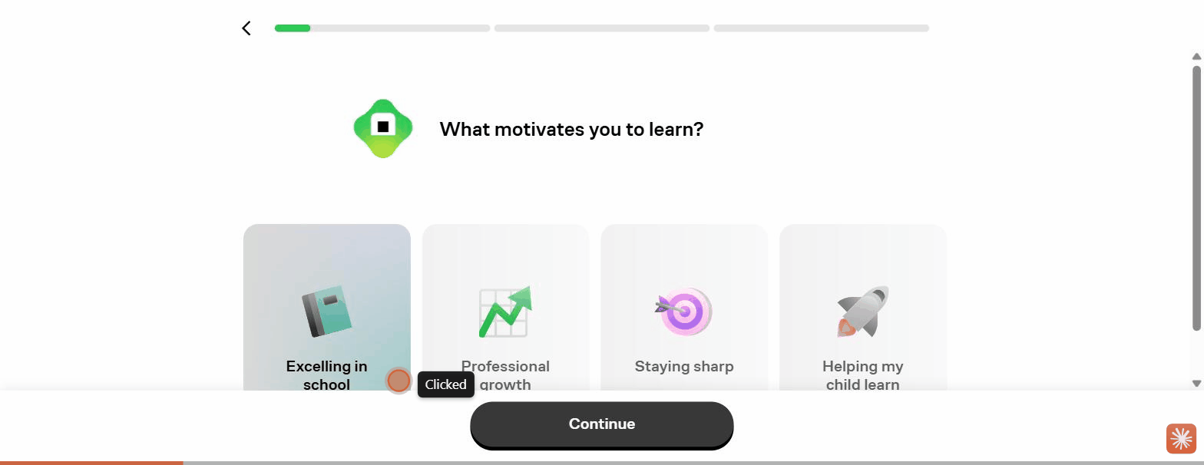
Figure: 02 Motivation Intake
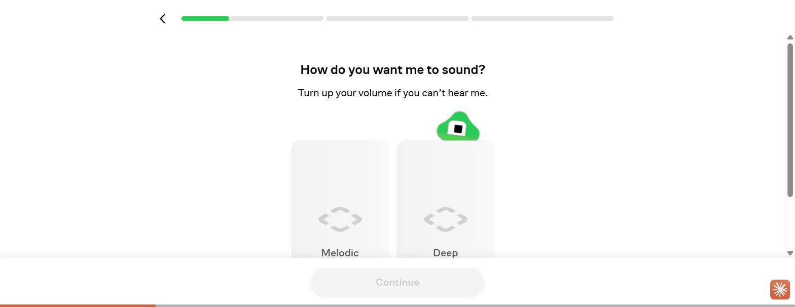
Figure: 03 Tutor Voice Personalization
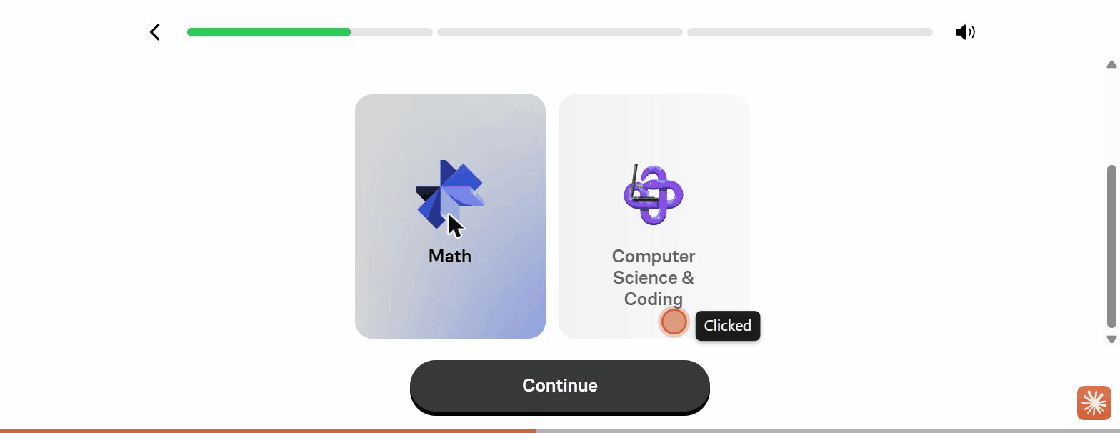
Figure: 04 Subject Select
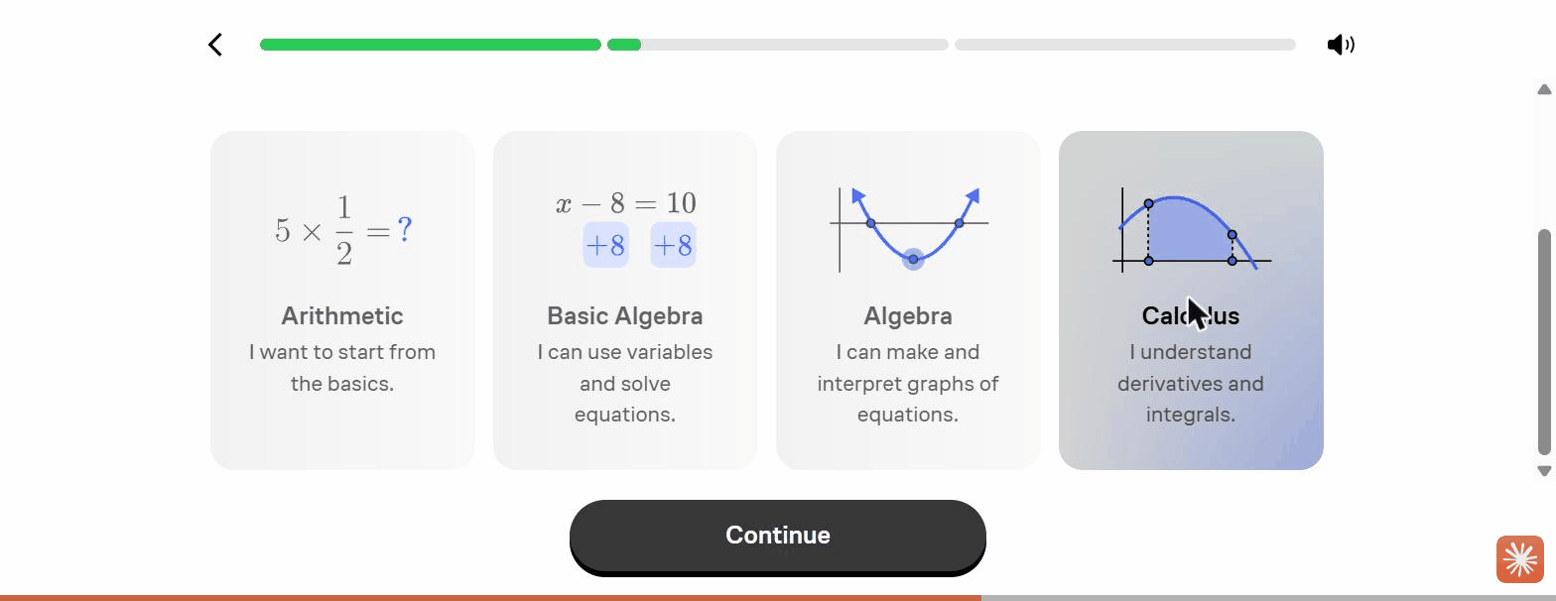
Figure: 05 Level Self Select By Problem
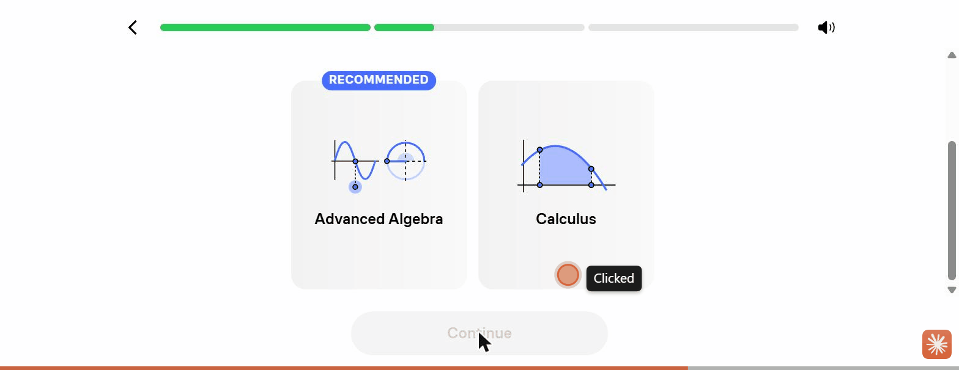
Figure: 06 Start Point Recommended
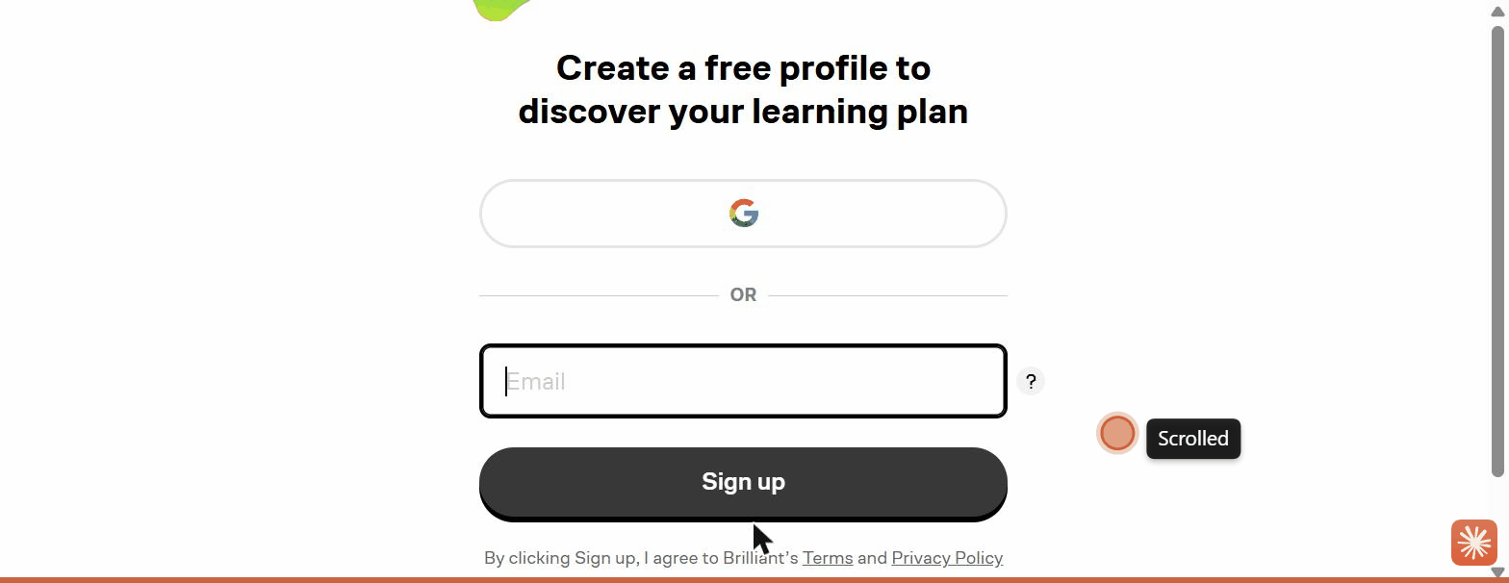
Figure: 07 Signup Wall Discover Plan

Codesignal
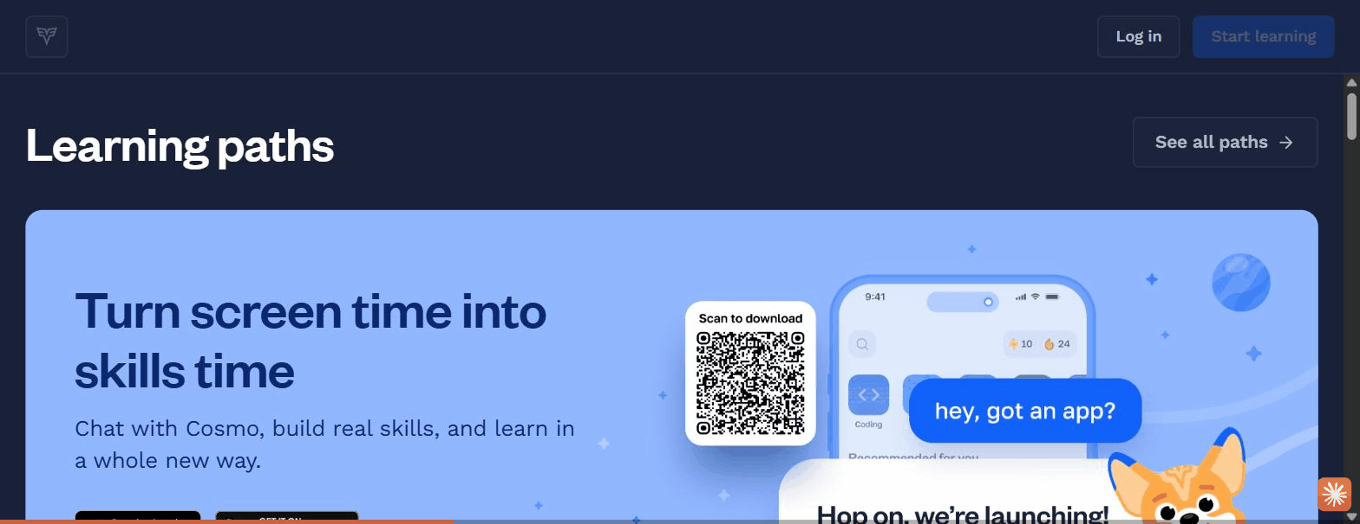
Figure: 01 Signup Gate Create Account
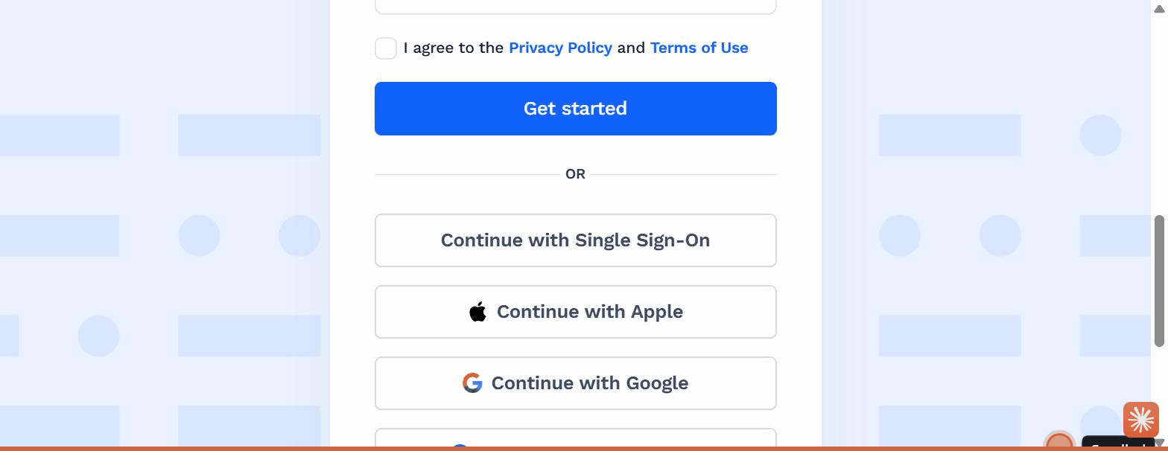
Figure: 02 Signup Social Options
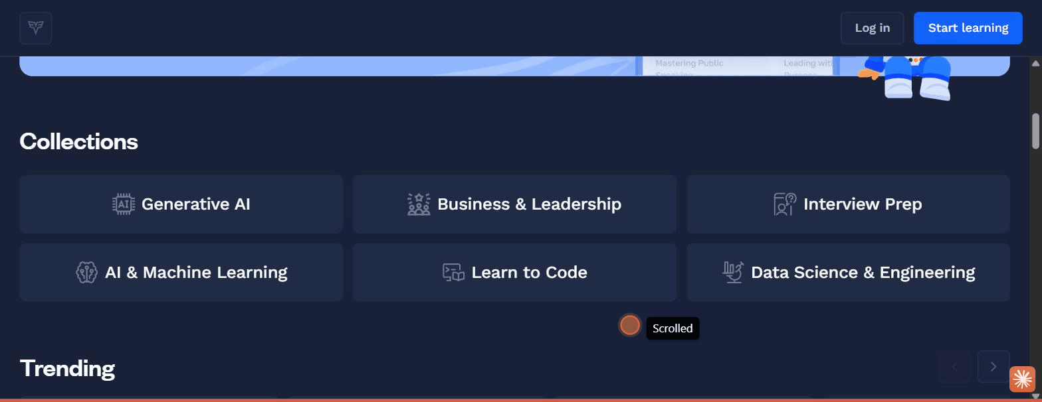
Figure: 03 Catalogue Collections

Duolingo
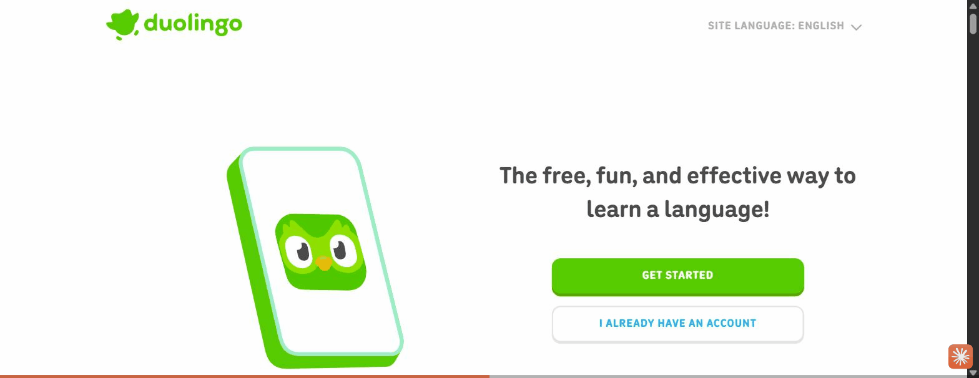
Figure: 01 Landing Value Framing

Figure: 02 Course Select I Want To Learn
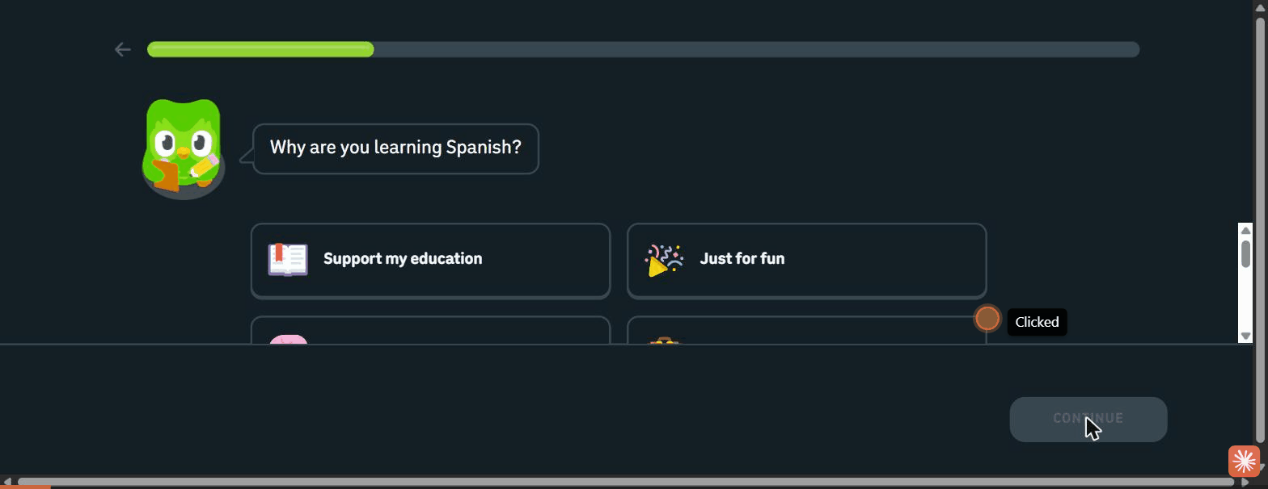
Figure: 03 Intake Why Learning
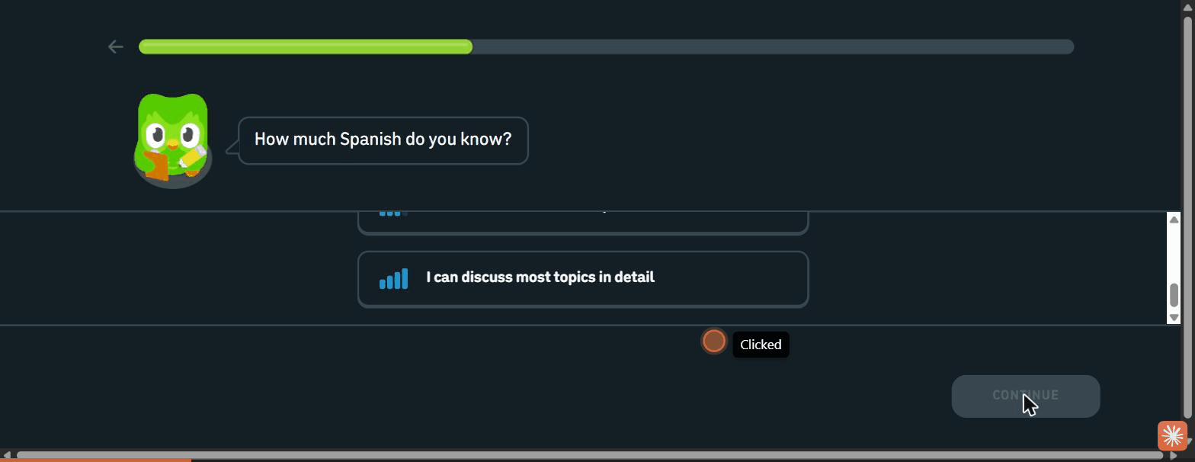
Figure: 04 Proficiency Self Select
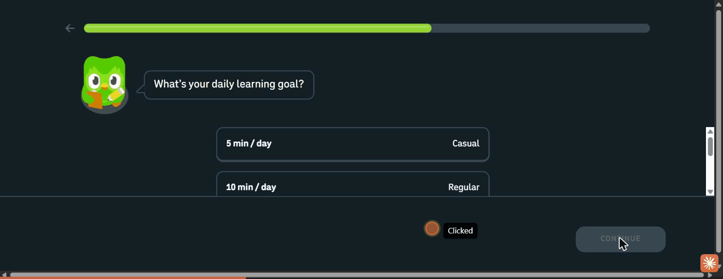
Figure: 05 Daily Goal Tiers

Figure: 06 Habit Projection 50 Words

Figure: 07 Notification Permission Primer
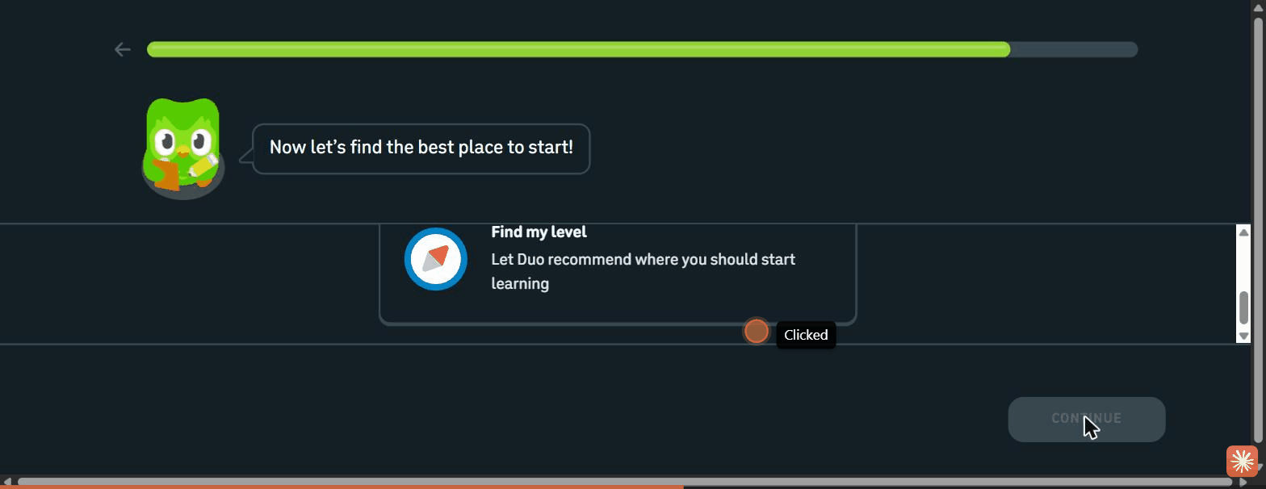
Figure: 08 Choose Path Fork

Figure: 09 Placement Result Section4
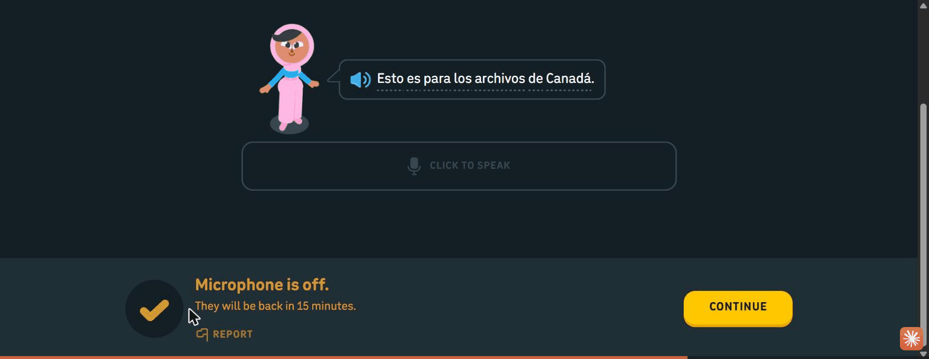
Figure: 10 Placement Speaking Mic Skip
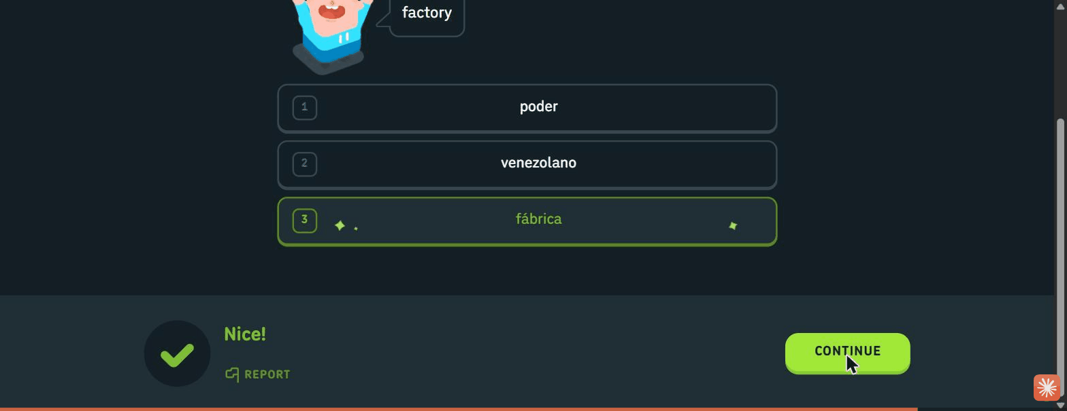
Figure: 11 Placement Multiple Choice Feedback

Elsa-Speak

Figure: 01 Landing Localized Value Framing Paywall
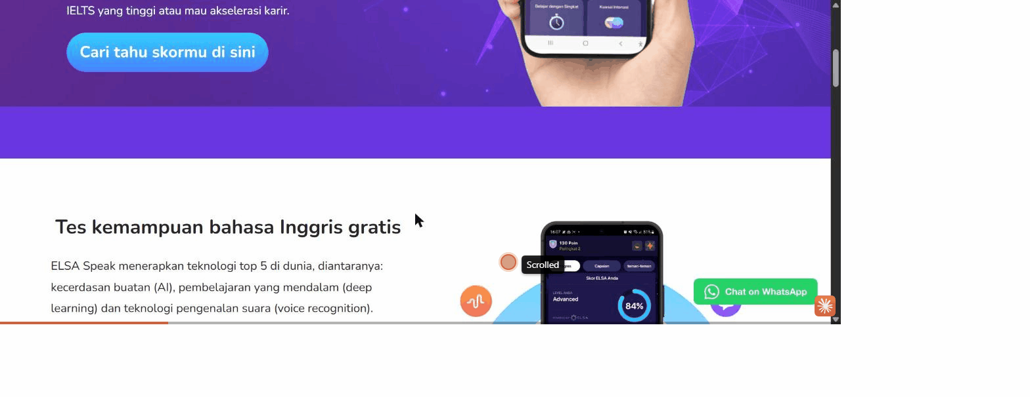
Figure: 02 English Test App Mockups
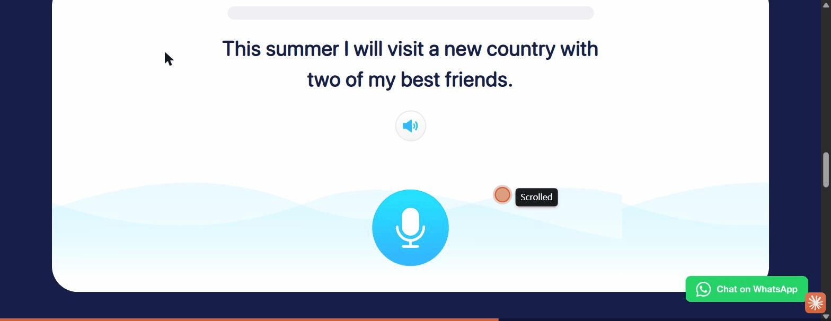
Figure: 03 Web Speaking Assessment
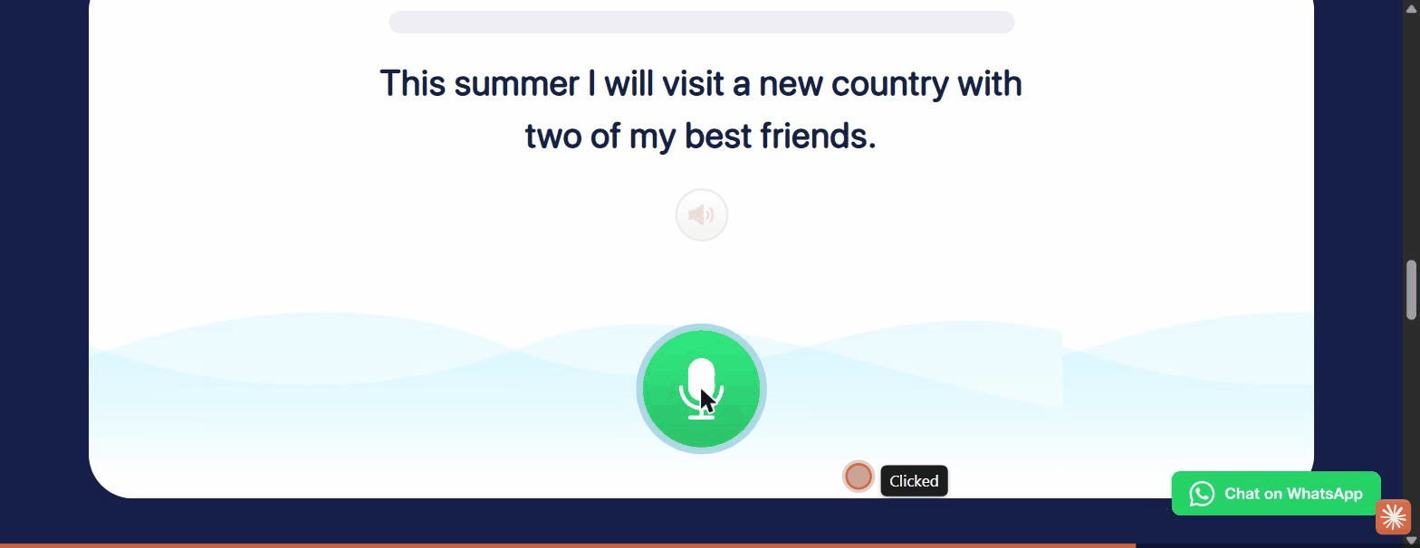
Figure: 04 Mic Recording Active

Khan-Academy
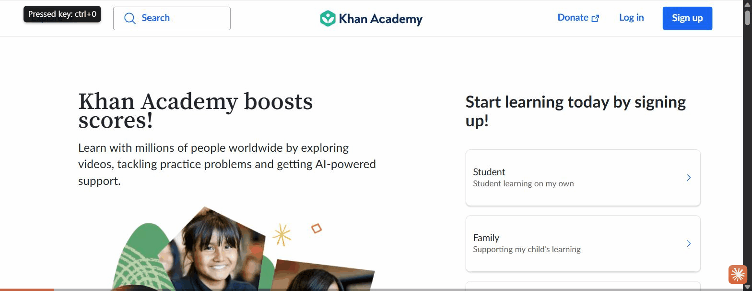
Figure: 01 Landing Role Split
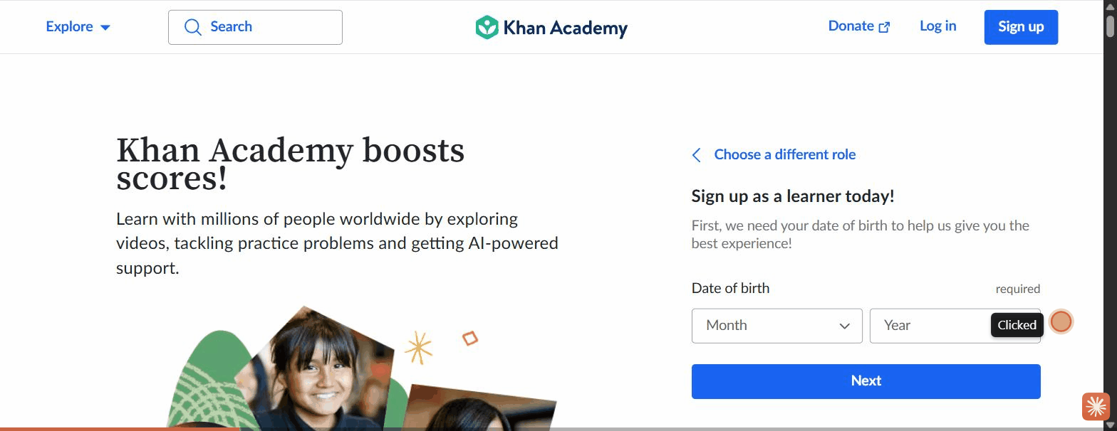
Figure: 02 Age Gate Date Of Birth

Figure: 03 Signup Wall Social Email
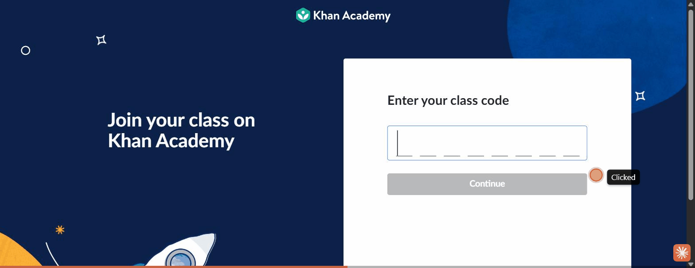
Figure: 04 Classcode Entry

Figure: 05 Classcode Filled
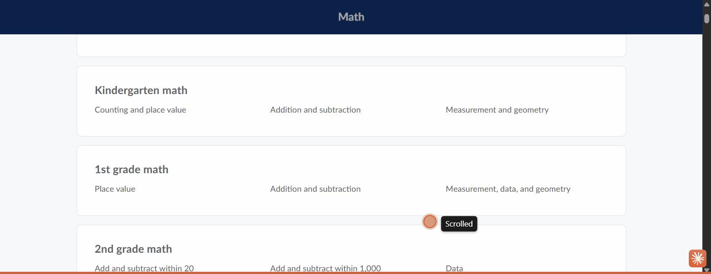
Figure: 06 Catalogue Grade Organized

