Практична робота №1-2

Проектування та програмування експертної системи
Мета:
– Навчитись проектувати та програмно реалізовуввати експертні системи .
– Ознайомитись з теорією штучного інтелекту, способами побудови та
використати при виконанні практичної роботи набуті знання.
– Знати та вміти реалізувати основні складові експертної системи.
Завдання для виконання
Експертна система «Вибір мови програмування».

Порядок виконання:
Роутинг web.php:
Route::resource('tests', TestsController::class);
Route::post('questions/{question}/answer', [QuestionsController::class, 'storeAnswer'])
->name('questions.answer');
Route::resource('questions', QuestionsController::class)
->only(['edit', 'update']);
Route::post('questions/create-empty', [QuestionsController::class, 'createEmpty'])
->name('questions.create-empty');
Route::get('questions/delete/{id}', [QuestionsController::class, 'delete'])
->name('questions.delete');
Route::redirect('/', \route('tests.index'));

Міграції БД:
<?php
use Illuminate\Database\Migrations\Migration;
use Illuminate\Database\Schema\Blueprint;
use Illuminate\Support\Facades\Schema;
class CreateTestsTable extends Migration
{
public function up(): void
{
Schema::create('tests', function (Blueprint $table) {
$table->id();
$table->string('name');
$table->timestamps();
});
}
public function down(): void
{
Schema::dropIfExists('tests');
}
}
<?php
use App\Models\Test;
use Illuminate\Database\Migrations\Migration;
use Illuminate\Database\Schema\Blueprint;
use Illuminate\Support\Facades\Schema;
class CreateQuestionsTable extends Migration
{
public function up(): void
{
Schema::create(
'questions',
function (Blueprint $table) {
$table->id();
$table->foreignIdFor(Test::class)
->references('id')
->on('tests')
->cascadeOnUpdate()
->cascadeOnDelete();
$table->string('text');
$table->bigInteger('significance');
$table->timestamps();
}
);
}
public function down(): void
{
Schema::dropIfExists('questions');
}
}
<?php
use App\Models\Question;
use Illuminate\Database\Migrations\Migration;
use Illuminate\Database\Schema\Blueprint;
use Illuminate\Support\Facades\Schema;
class CreateAnswerOptionsTable extends Migration
{
/**
* Run the migrations.
*
* @return void
*/
public function up()
{
Schema::create(
'answer_options',
function (Blueprint $table) {
$table->id();
$table->foreignIdFor(Question::class)
->references('id')
->on('questions')
->cascadeOnDelete()
->cascadeOnUpdate();
$table->string('content');
$table->timestamps();
}
);
}
/**
* Reverse the migrations.
*
* @return void
*/
public function down()
{
Schema::dropIfExists('answer_options');
}
}
<?php
use App\Models\Test;
use Illuminate\Database\Migrations\Migration;
use Illuminate\Database\Schema\Blueprint;
use Illuminate\Support\Facades\Schema;
class CreateTestSessionsTable extends Migration
{
public function up(): void
{
Schema::create(
'test_sessions',
function (Blueprint $table) {
$table->id();
$table->foreignIdFor(Test::class)
->references('id')
->on('tests')
->cascadeOnUpdate()
->cascadeOnDelete();
$table->timestamps();
}
);
}
public function down(): void
{
Schema::dropIfExists('test_sessions');
}
}
<?php
use App\Models\AnswerOption;
use App\Models\Question;
use App\Models\TestSession;
use Illuminate\Database\Migrations\Migration;
use Illuminate\Database\Schema\Blueprint;
use Illuminate\Support\Facades\Schema;
class CreateSessionAnswersTable extends Migration
{
/**
* Run the migrations.
*
* @return void
*/
public function up(): void
{
Schema::create(
'session_answers',
function (Blueprint $table) {
$table->id();
$table->foreignIdFor(TestSession::class)
->references('id')
->on('test_sessions')
->cascadeOnUpdate()
->cascadeOnDelete();
$table->foreignIdFor(AnswerOption::class)
->references('id')
->on('answer_options')
->cascadeOnUpdate()
->cascadeOnDelete();
$table->timestamps();
}
);
}
/**
* Reverse the migrations.
*
* @return void
*/
public function down(): void
{
Schema::dropIfExists('session_answers');
}
}
<?php
use Illuminate\Database\Migrations\Migration;
use Illuminate\Database\Schema\Blueprint;
use Illuminate\Support\Facades\Schema;
class CreateResultsTable extends Migration
{
/**
* Run the migrations.
*
* @return void
*/
public function up()
{
Schema::create('results', function (Blueprint $table) {
$table->id();
$table->string('lang_name')->unique();
$table->timestamps();
});
}
/**
* Reverse the migrations.
*
* @return void
*/
public function down()
{
Schema::dropIfExists('results');
}
}
<?php
use App\Models\AnswerOption;
use App\Models\Result;
use Illuminate\Database\Migrations\Migration;
use Illuminate\Database\Schema\Blueprint;
use Illuminate\Support\Facades\Schema;
class CreateAnswerResultSignificanceTable extends Migration
{
/**
* Run the migrations.
*
* @return void
*/
public function up(): void
{
Schema::create(
'answer_result_significance',
function (Blueprint $table) {
$table->id();
$table->foreignIdFor(AnswerOption::class)
->references('id')
->on('answer_options')
->cascadeOnUpdate()
->cascadeOnDelete();
$table->foreignIdFor(Result::class)
->references('id')
->on('results')
->cascadeOnUpdate()
->cascadeOnDelete();
$table->unsignedBigInteger('significance');
$table->timestamps();
}
);
}
/**
* Reverse the migrations.
*
* @return void
*/
public function down(): void
{
Schema::dropIfExists('answer_result_significance');
}
}
<?php
use App\Models\Result;
use App\Models\TestSession;
use Illuminate\Database\Migrations\Migration;
use Illuminate\Database\Schema\Blueprint;
use Illuminate\Support\Facades\Schema;
class CreateTestSessionResultsTable extends Migration
{
public function up(): void
{
Schema::create(
'test_session_results',
function (Blueprint $table) {
$table->id();
$table->foreignIdFor(TestSession::class)
->references('id')
->on('test_sessions')
->cascadeOnUpdate()
->cascadeOnDelete();
$table->foreignIdFor(Result::class)
->references('id')
->on('results')
->cascadeOnUpdate()
->cascadeOnDelete();
$table->bigInteger('score');
}
);
}
public function down(): void
{
Schema::dropIfExists('test_session_results');
}
}
<?php
use Illuminate\Database\Migrations\Migration;
use Illuminate\Database\Schema\Blueprint;
use Illuminate\Support\Facades\Schema;
class CreateAnswerLeadsToQuestionTable extends Migration
{
public function up(): void
{
Schema::create(
'answer_leads_to_question',
function (Blueprint $table) {
$table->bigIncrements('id');
$table->foreignId('answer_option_id')
->references('id')
->on('answer_options')
->cascadeOnUpdate()
->cascadeOnDelete();
$table->foreignId('question_id')
->references('id')
->on('questions')
->cascadeOnUpdate()
->cascadeOnDelete();
}
);
}
public function down(): void
{
Schema::dropIfExists('answer_leads_to_question');
}
}
<?php
use Illuminate\Database\Migrations\Migration;
use Illuminate\Database\Schema\Blueprint;
use Illuminate\Support\Facades\Schema;
class CreateSessionQuestionsQueueTable extends Migration
{
public function up()
{
Schema::create(
'session_questions_queue',
function (Blueprint $table) {
$table->bigIncrements('id');
$table->foreignId('test_session_id')
->references('id')
->on('test_sessions')
->cascadeOnUpdate()
->cascadeOnDelete();
$table->foreignId('question_id')
->references('id')
->on('questions')
->cascadeOnUpdate()
->cascadeOnDelete();
}
);
}
public function down()
{
Schema::dropIfExists('session_questions_queue');
}
}
Мігрувавши Базу, створимо моделі:
<?php
namespace App\Models;
use Illuminate\Database\Eloquent\Factories\HasFactory;
use Illuminate\Database\Eloquent\Model;
use Illuminate\Database\Eloquent\Relations\BelongsTo;
use Illuminate\Database\Eloquent\Relations\BelongsToMany;
/**
* App\Models\AnswerOption
*
* @property int $id
* @property int $question_id
* @property string $content
* @property \Illuminate\Support\Carbon|null $created_at
* @property \Illuminate\Support\Carbon|null $updated_at
* @property-read \App\Models\Question $question
* @property-read \Illuminate\Database\Eloquent\Collection|\App\Models\Result[] $results
* @property-read int|null $results_count
* @method static \Illuminate\Database\Eloquent\Builder|AnswerOption newModelQuery()
* @method static \Illuminate\Database\Eloquent\Builder|AnswerOption newQuery()
* @method static \Illuminate\Database\Eloquent\Builder|AnswerOption query()
* @method static \Illuminate\Database\Eloquent\Builder|AnswerOption whereContent($value)
* @method static \Illuminate\Database\Eloquent\Builder|AnswerOption whereCreatedAt($value)
* @method static \Illuminate\Database\Eloquent\Builder|AnswerOption whereId($value)
* @method static \Illuminate\Database\Eloquent\Builder|AnswerOption whereQuestionId($value)
* @method static \Illuminate\Database\Eloquent\Builder|AnswerOption whereUpdatedAt($value)
* @mixin \Eloquent
* @property-read \Illuminate\Database\Eloquent\Collection|\App\Models\Question[] $leadsToQuestion
* @property-read int|null $leads_to_question_count
*/
class AnswerOption extends Model
{
use HasFactory;
public function question(): BelongsTo
{
return $this->belongsTo(Question::class);
}
public function results(): BelongsToMany
{
return $this->belongsToMany(Result::class, 'answer_result_significance')
->using(AnswerResultSignificance::class)
->withPivot('significance');
}
public function leadsToQuestion(): BelongsToMany
{
return $this->belongsToMany(
Question::class,
'answer_leads_to_question',
'answer_option_id',
'question_id'
);
}
}
<?php
namespace App\Models;
use Illuminate\Database\Eloquent\Factories\HasFactory;
use Illuminate\Database\Eloquent\Relations\Pivot;
/**
* App\Models\AnswerResultSignificance
*
* @property int $id
* @property int $answer_option_id
* @property int $result_id
* @property int $significance
* @property \Illuminate\Support\Carbon|null $created_at
* @property \Illuminate\Support\Carbon|null $updated_at
* @method static \Illuminate\Database\Eloquent\Builder|AnswerResultSignificance newModelQuery()
* @method static \Illuminate\Database\Eloquent\Builder|AnswerResultSignificance newQuery()
* @method static \Illuminate\Database\Eloquent\Builder|AnswerResultSignificance query()
* @method static \Illuminate\Database\Eloquent\Builder|AnswerResultSignificance whereAnswerOptionId($value)
* @method static \Illuminate\Database\Eloquent\Builder|AnswerResultSignificance whereCreatedAt($value)
* @method static \Illuminate\Database\Eloquent\Builder|AnswerResultSignificance whereId($value)
* @method static \Illuminate\Database\Eloquent\Builder|AnswerResultSignificance whereResultId($value)
* @method static \Illuminate\Database\Eloquent\Builder|AnswerResultSignificance whereSignificance($value)
* @method static \Illuminate\Database\Eloquent\Builder|AnswerResultSignificance whereUpdatedAt($value)
* @mixin \Eloquent
*/
class AnswerResultSignificance extends Pivot
{
use HasFactory;
protected $table = 'answer_result_significance';
}
<?php
namespace App\Models;
use Illuminate\Database\Eloquent\Builder;
use Illuminate\Database\Eloquent\Factories\HasFactory;
use Illuminate\Database\Eloquent\Model;
use Illuminate\Database\Eloquent\Relations\BelongsTo;
use Illuminate\Database\Eloquent\Relations\BelongsToMany;
use Illuminate\Database\Eloquent\Relations\HasMany;
/**
* App\Models\Question
*
* @property int $id
* @property int $test_id
* @property string $text
* @property int $significance
* @property \Illuminate\Support\Carbon|null $created_at
* @property \Illuminate\Support\Carbon|null $updated_at
* @property-read \Illuminate\Database\Eloquent\Collection|\App\Models\AnswerOption[] $answerOptions
* @property-read int|null $answer_options_count
* @property-read \App\Models\Test $test
* @method static \Illuminate\Database\Eloquent\Builder|Question newModelQuery()
* @method static \Illuminate\Database\Eloquent\Builder|Question newQuery()
* @method static \Illuminate\Database\Eloquent\Builder|Question query()
* @method static \Illuminate\Database\Eloquent\Builder|Question whereCreatedAt($value)
* @method static \Illuminate\Database\Eloquent\Builder|Question whereId($value)
* @method static \Illuminate\Database\Eloquent\Builder|Question whereSignificance($value)
* @method static \Illuminate\Database\Eloquent\Builder|Question whereTestId($value)
* @method static \Illuminate\Database\Eloquent\Builder|Question whereText($value)
* @method static \Illuminate\Database\Eloquent\Builder|Question whereUpdatedAt($value)
* @mixin \Eloquent
* @method static Builder|Question independent()
* @property-read \Illuminate\Database\Eloquent\Collection|\App\Models\AnswerOption[] $couldBeAccessedFromAnswers
* @property-read int|null $could_be_accessed_from_answers_count
*/
class Question extends Model
{
use HasFactory;
protected $fillable = [
'text',
'significance',
];
public function answerOptions(): HasMany
{
return $this->hasMany(AnswerOption::class);
}
/**
* @return BelongsTo|Test
*/
public function test(): BelongsTo
{
return $this->belongsTo(Test::class);
}
public function couldBeAccessedFromAnswers(): BelongsToMany
{
return $this->belongsToMany(
AnswerOption::class,
'answer_leads_to_question',
'question_id',
'answer_option_id',
);
}
/**
* @param \Illuminate\Database\Eloquent\Builder $query
* @return \Illuminate\Database\Eloquent\Builder|self
*/
public function scopeIndependent($query)
{
return $query->whereDoesntHave('couldBeAccessedFromAnswers');
}
}
<?php
namespace App\Models;
use Illuminate\Database\Eloquent\Factories\HasFactory;
use Illuminate\Database\Eloquent\Model;
/**
* App\Models\Result
*
* @property int $id
* @property string $lang_name
* @property \Illuminate\Support\Carbon|null $created_at
* @property \Illuminate\Support\Carbon|null $updated_at
* @method static \Illuminate\Database\Eloquent\Builder|Result newModelQuery()
* @method static \Illuminate\Database\Eloquent\Builder|Result newQuery()
* @method static \Illuminate\Database\Eloquent\Builder|Result query()
* @method static \Illuminate\Database\Eloquent\Builder|Result whereCreatedAt($value)
* @method static \Illuminate\Database\Eloquent\Builder|Result whereId($value)
* @method static \Illuminate\Database\Eloquent\Builder|Result whereLangName($value)
* @method static \Illuminate\Database\Eloquent\Builder|Result whereUpdatedAt($value)
* @mixin \Eloquent
*/
class Result extends Model
{
use HasFactory;
}
<?php
namespace App\Models;
use Illuminate\Database\Eloquent\Factories\HasFactory;
use Illuminate\Database\Eloquent\Model;
/**
* App\Models\SessionAnswer
*
* @property int $id
* @property int $test_session_id
* @property int $answer_option_id
* @property \Illuminate\Support\Carbon|null $created_at
* @property \Illuminate\Support\Carbon|null $updated_at
* @method static \Illuminate\Database\Eloquent\Builder|SessionAnswer newModelQuery()
* @method static \Illuminate\Database\Eloquent\Builder|SessionAnswer newQuery()
* @method static \Illuminate\Database\Eloquent\Builder|SessionAnswer query()
* @method static \Illuminate\Database\Eloquent\Builder|SessionAnswer whereAnswerOptionId($value)
* @method static \Illuminate\Database\Eloquent\Builder|SessionAnswer whereCreatedAt($value)
* @method static \Illuminate\Database\Eloquent\Builder|SessionAnswer whereId($value)
* @method static \Illuminate\Database\Eloquent\Builder|SessionAnswer whereTestSessionId($value)
* @method static \Illuminate\Database\Eloquent\Builder|SessionAnswer whereUpdatedAt($value)
* @mixin \Eloquent
*/
class SessionAnswer extends Model
{
use HasFactory;
}
<?php
namespace App\Models;
use Illuminate\Database\Eloquent\Factories\HasFactory;
use Illuminate\Database\Eloquent\Model;
use Illuminate\Database\Eloquent\Relations\HasMany;
use Illuminate\Database\Eloquent\Relations\HasManyThrough;
use Staudenmeir\EloquentHasManyDeep\HasManyDeep;
use Staudenmeir\EloquentHasManyDeep\HasRelationships;
/**
* App\Models\Test
*
* @property int $id
* @property string $name
* @property \Illuminate\Support\Carbon|null $created_at
* @property \Illuminate\Support\Carbon|null $updated_at
* @property-read \Illuminate\Database\Eloquent\Collection|\App\Models\AnswerOption[] $answerOptions
* @property-read int|null $answer_options_count
* @property-read \Illuminate\Database\Eloquent\Collection|\App\Models\TestSession[] $sessions
* @property-read int|null $sessions_count
* @method static \Illuminate\Database\Eloquent\Builder|Test newModelQuery()
* @method static \Illuminate\Database\Eloquent\Builder|Test newQuery()
* @method static \Illuminate\Database\Eloquent\Builder|Test query()
* @method static \Illuminate\Database\Eloquent\Builder|Test whereCreatedAt($value)
* @method static \Illuminate\Database\Eloquent\Builder|Test whereId($value)
* @method static \Illuminate\Database\Eloquent\Builder|Test whereName($value)
* @method static \Illuminate\Database\Eloquent\Builder|Test whereUpdatedAt($value)
* @mixin \Eloquent
* @property-read \Illuminate\Database\Eloquent\Collection|\App\Models\Question[] $questions
* @property-read int|null $questions_count
*/
class Test extends Model
{
use HasFactory;
use HasRelationships;
public function sessions(): HasMany
{
return $this->hasMany(TestSession::class);
}
public function questions(): HasMany
{
return $this->hasMany(Question::class);
}
public function answerOptions(): HasManyThrough
{
return $this->hasManyThrough(AnswerOption::class, Question::class);
}
public function possibleResults(): HasManyDeep
{
return $this->hasManyDeepFromRelations(
$this->answerOptions(),
(new AnswerOption())->results()
)->distinct();
}
}
<?php
namespace App\Models;
use Illuminate\Database\Eloquent\Builder as EloquentBuilder;
use Illuminate\Database\Eloquent\Collection;
use Illuminate\Database\Eloquent\Factories\HasFactory;
use Illuminate\Database\Eloquent\Model;
use Illuminate\Database\Eloquent\Relations\BelongsToMany;
use Illuminate\Database\Eloquent\Relations\HasMany;
use Staudenmeir\EloquentHasManyDeep\HasManyDeep;
use Staudenmeir\EloquentHasManyDeep\HasRelationships;
/**
* App\Models\TestSession
*
* @property int $id
* @property int $test_id
* @property \Illuminate\Support\Carbon|null $created_at
* @property \Illuminate\Support\Carbon|null $updated_at
* @property-read \Illuminate\Database\Eloquent\Collection|\App\Models\Question[] $answeredQuestions
* @property-read int|null $answered_questions_count
* @property-read mixed $not_answered_questions
* @property-read \Illuminate\Database\Eloquent\Collection|\App\Models\TestSessionResult[] $resultScores
* @property-read int|null $result_scores_count
* @property-read \Illuminate\Database\Eloquent\Collection|\App\Models\Result[] $results
* @property-read int|null $results_count
* @method static EloquentBuilder|TestSession newModelQuery()
* @method static EloquentBuilder|TestSession newQuery()
* @method static EloquentBuilder|TestSession query()
* @method static EloquentBuilder|TestSession whereCreatedAt($value)
* @method static EloquentBuilder|TestSession whereId($value)
* @method static EloquentBuilder|TestSession whereTestId($value)
* @method static EloquentBuilder|TestSession whereUpdatedAt($value)
* @mixin \Eloquent
* @property int|null $last_question_id
* @property-read \Illuminate\Database\Eloquent\Collection|\App\Models\AnswerOption[] $savedAnswers
* @property-read int|null $saved_answers_count
* @method static EloquentBuilder|TestSession whereLastQuestionId($value)
* @property-read \Illuminate\Database\Eloquent\Collection|\App\Models\Question[] $queuedQuestions
* @property-read int|null $queued_questions_count
*/
class TestSession extends Model
{
use HasFactory;
use HasRelationships;
public function savedAnswers(): BelongsToMany
{
return $this->belongsToMany(
AnswerOption::class,
'session_answers',
'test_session_id',
'answer_option_id'
);
}
public function answeredQuestions(): HasManyDeep
{
return $this->hasManyDeepFromRelations(
$this->savedAnswers(),
(new AnswerOption())->question()
);
}
public function results(): BelongsToMany
{
return $this->belongsToMany(Result::class, 'test_session_results')
->using(TestSessionResult::class)
->as('rate')
->withPivot('score');
}
public function getNotAnsweredQuestionsAttribute()
{
return $this->notAnsweredQuestions()->get();
}
public function notAnsweredQuestions()
{
return Question::whereNotIn('id', $this->answeredQuestions->pluck('id'));
}
public function resultScores(): HasMany
{
return $this->hasMany(TestSessionResult::class, 'test_session_id');
}
public function queuedQuestions(): BelongsToMany
{
return $this->belongsToMany(
Question::class,
'session_questions_queue',
'test_session_id',
'question_id'
);
}
public function nextQueueQuestion(): ?Question
{
/** @var Question $next */
$next = $this->queuedQuestions()->first();
return $next;
}
public function removeQuestionFromQueue(Question $question): void
{
$this->queuedQuestions()
->detach($question->id);
}
public function addQuestionsToQueue(Collection $questions): void
{
$this->queuedQuestions()
->attach($questions->pluck('id'));
}
}
<?php
namespace App\Models;
use Eloquent;
use Illuminate\Database\Eloquent\Builder as EloquentBuilder;
use Illuminate\Database\Eloquent\Relations\BelongsTo;
use Illuminate\Database\Eloquent\Relations\Pivot;
/**
* App\Models\TestSessionResult
*
* @method static EloquentBuilder|TestSessionResult newModelQuery()
* @method static EloquentBuilder|TestSessionResult newQuery()
* @method static EloquentBuilder|TestSessionResult query()
* @mixin Eloquent
* @property int $id
* @property int $test_session_id
* @property int $result_id
* @property int $score
* @method static EloquentBuilder|TestSessionResult whereId($value)
* @method static EloquentBuilder|TestSessionResult whereResultId($value)
* @method static EloquentBuilder|TestSessionResult whereScore($value)
* @method static EloquentBuilder|TestSessionResult whereTestSessionId($value)
* @property-read \App\Models\Result $result
*/
class TestSessionResult extends Pivot
{
protected $table = 'test_session_results';
public function result(): BelongsTo
{
return $this->belongsTo(Result::class);
}
}
Засіємо базу даних початковою інформацією:
<?php
namespace Database\Seeders;
use Illuminate\Database\Seeder;
class DatabaseSeeder extends Seeder
{
public function run(): void
{
$this->call(
[
TestSubjectsSeeder::class,
ResultsSeeder::class,
QuestionsSeeder::class,
]
);
}
}
<?php
namespace Database\Seeders;
use App\Models\Test;
use Illuminate\Database\Seeder;
class TestSubjectsSeeder extends Seeder
{
public function run(): void
{
Test::create(
[
'name' => 'Вибір мови програмування'
]
);
}
}
<?php
namespace Database\Seeders;
use App\Models\Result;
use Illuminate\Database\Seeder;
class ResultsSeeder extends Seeder
{
private static function languagesList(): array
{
return [
['lang_name' => 'C'],
['lang_name' => 'C++'],
['lang_name' => 'C#'],
['lang_name' => 'Java'],
['lang_name' => 'JavaScript'],
['lang_name' => 'TypeScript'],
['lang_name' => 'Objective-C'],
['lang_name' => 'PHP'],
['lang_name' => 'Python'],
['lang_name' => 'Ruby'],
['lang_name' => 'Scala'],
['lang_name' => 'Assembler'],
['lang_name' => 'Clojure'],
['lang_name' => 'Delphi'],
['lang_name' => 'Pascal'],
['lang_name' => 'F#'],
['lang_name' => 'Go'],
['lang_name' => 'Haskell'],
['lang_name' => 'Lua'],
['lang_name' => 'Perl'],
['lang_name' => 'Swift'],
['lang_name' => 'Visual Basic'],
];
}
public function run(): void
{
foreach (self::languagesList() as $lang) {
Result::create($lang);
}
}
}
<?php
namespace Database\Seeders;
use App\Models\AnswerOption;
use App\Models\Question;
use App\Models\Result;
use App\Models\Test;
use Illuminate\Database\Seeder;
use Illuminate\Support\Arr;
class QuestionsSeeder extends Seeder
{
private static function neutralAnswerSignificance(): array
{
return form(
[
[
'lang_name' => 'C',
'significance' => 0,
],
[
'lang_name' => 'C++',
'significance' => 0,
],
[
'lang_name' => 'C#',
'significance' => 0,
],
[
'lang_name' => 'Java',
'significance' => 0,
],
[
'lang_name' => 'JavaScript',
'significance' => 0,
],
[
'lang_name' => 'TypeScript',
'significance' => 0,
],
[
'lang_name' => 'Objective-C',
'significance' => 0,
],
[
'lang_name' => 'PHP',
'significance' => 0,
],
[
'lang_name' => 'Python',
'significance' => 0,
],
[
'lang_name' => 'Ruby',
'significance' => 0,
],
[
'lang_name' => 'Scala',
'significance' => 0,
],
[
'lang_name' => 'Assembler',
'significance' => 0,
],
[
'lang_name' => 'Clojure',
'significance' => 0,
],
[
'lang_name' => 'Delphi',
'significance' => 0,
],
[
'lang_name' => 'Pascal',
'significance' => 0,
],
[
'lang_name' => 'F#',
'significance' => 0,
],
[
'lang_name' => 'Go',
'significance' => 0,
],
[
'lang_name' => 'Haskell',
'significance' => 0,
],
[
'lang_name' => 'Lua',
'significance' => 0,
],
[
'lang_name' => 'Perl',
'significance' => 0,
],
[
'lang_name' => 'Swift',
'significance' => 0,
],
[
'lang_name' => 'Visual Basic',
'significance' => 0,
],
],
true
);
}
private static function languagesPopularity(bool $popular): array
{
return form(
[
[
'lang_name' => 'C',
'significance' => 6,
],
[
'lang_name' => 'C++',
'significance' => 6,
],
[
'lang_name' => 'C#',
'significance' => 7,
],
[
'lang_name' => 'Java',
'significance' => 18,
],
[
'lang_name' => 'JavaScript',
'significance' => 8,
],
[
'lang_name' => 'TypeScript',
'significance' => 2,
],
[
'lang_name' => 'Objective-C',
'significance' => 3,
],
[
'lang_name' => 'PHP',
'significance' => 6,
],
[
'lang_name' => 'Python',
'significance' => 32,
],
[
'lang_name' => 'Ruby',
'significance' => 2,
],
[
'lang_name' => 'Scala',
'significance' => 1,
],
[
'lang_name' => 'Assembler',
'significance' => 1,
],
[
'lang_name' => 'Clojure',
'significance' => 0,
],
[
'lang_name' => 'Delphi',
'significance' => 0,
],
[
'lang_name' => 'Pascal',
'significance' => 0,
],
[
'lang_name' => 'F#',
'significance' => 0,
],
[
'lang_name' => 'Go',
'significance' => 2,
],
[
'lang_name' => 'Haskell',
'significance' => 1,
],
[
'lang_name' => 'Lua',
'significance' => 1,
],
[
'lang_name' => 'Perl',
'significance' => 1,
],
[
'lang_name' => 'Swift',
'significance' => 3,
],
[
'lang_name' => 'Visual Basic',
'significance' => 1,
],
],
$popular
);
}
private static function languagesSalary(bool $high): array
{
return form(
[
[
'lang_name' => 'C',
'significance' => 82_523,
],
[
'lang_name' => 'C++',
'significance' => 85_591,
],
[
'lang_name' => 'C#',
'significance' => 68_336,
],
[
'lang_name' => 'Java',
'significance' => 85_609,
],
[
'lang_name' => 'JavaScript',
'significance' => 82_564,
],
[
'lang_name' => 'TypeScript',
'significance' => 88_433,
],
[
'lang_name' => 'Objective-C',
'significance' => 102_173,
],
[
'lang_name' => 'PHP',
'significance' => 70_272,
],
[
'lang_name' => 'Python',
'significance' => 91_098,
],
[
'lang_name' => 'Ruby',
'significance' => 96_775,
],
[
'lang_name' => 'Scala',
'significance' => 115_827,
],
[
'lang_name' => 'Assembler',
'significance' => 35_150,
],
[
'lang_name' => 'Clojure',
'significance' => 104_148,
],
[
'lang_name' => 'Delphi',
'significance' => 51_545,
],
[
'lang_name' => 'Pascal',
'significance' => 63_419,
],
[
'lang_name' => 'F#',
'significance' => 98_285,
],
[
'lang_name' => 'Go',
'significance' => 116_313,
],
[
'lang_name' => 'Haskell',
'significance' => 123_585,
],
[
'lang_name' => 'Lua',
'significance' => 73_427,
],
[
'lang_name' => 'Perl',
'significance' => 93_753,
],
[
'lang_name' => 'Swift',
'significance' => 97_206,
],
[
'lang_name' => 'Visual Basic',
'significance' => 70_727,
],
],
$high
);
}
private static function languagesLowLevel(bool $lowLevel): array
{
return form(
[
[
'lang_name' => 'C',
'significance' => 90,
],
[
'lang_name' => 'C++',
'significance' => 85,
],
[
'lang_name' => 'C#',
'significance' => 30,
],
[
'lang_name' => 'Java',
'significance' => 30,
],
[
'lang_name' => 'JavaScript',
'significance' => 10,
],
[
'lang_name' => 'TypeScript',
'significance' => 13,
],
[
'lang_name' => 'Objective-C',
'significance' => 70,
],
[
'lang_name' => 'PHP',
'significance' => 18,
],
[
'lang_name' => 'Python',
'significance' => 8,
],
[
'lang_name' => 'Ruby',
'significance' => 13,
],
[
'lang_name' => 'Scala',
'significance' => 21,
],
[
'lang_name' => 'Assembler',
'significance' => 100,
],
[
'lang_name' => 'Clojure',
'significance' => 73,
],
[
'lang_name' => 'Delphi',
'significance' => 41,
],
[
'lang_name' => 'Pascal',
'significance' => 48,
],
[
'lang_name' => 'F#',
'significance' => 32,
],
[
'lang_name' => 'Go',
'significance' => 14,
],
[
'lang_name' => 'Haskell',
'significance' => 17,
],
[
'lang_name' => 'Lua',
'significance' => 43,
],
[
'lang_name' => 'Perl',
'significance' => 16,
],
[
'lang_name' => 'Swift',
'significance' => 50,
],
[
'lang_name' => 'Visual Basic',
'significance' => 68,
],
],
$lowLevel
);
}
private static function languagesRecent(bool $old): array
{
return form(
[
[
'lang_name' => 'C',
'significance' => 1972,
],
[
'lang_name' => 'C++',
'significance' => 1998,
],
[
'lang_name' => 'C#',
'significance' => 2000,
],
[
'lang_name' => 'Java',
'significance' => 1995,
],
[
'lang_name' => 'JavaScript',
'significance' => 1995,
],
[
'lang_name' => 'TypeScript',
'significance' => 2012,
],
[
'lang_name' => 'Objective-C',
'significance' => 1980,
],
[
'lang_name' => 'PHP',
'significance' => 1994,
],
[
'lang_name' => 'Python',
'significance' => 1989,
],
[
'lang_name' => 'Ruby',
'significance' => 1990,
],
[
'lang_name' => 'Scala',
'significance' => 2004,
],
[
'lang_name' => 'Assembler',
'significance' => 1948,
],
[
'lang_name' => 'Clojure',
'significance' => 2005,
],
[
'lang_name' => 'Delphi',
'significance' => 1995,
],
[
'lang_name' => 'Pascal',
'significance' => 1970,
],
[
'lang_name' => 'F#',
'significance' => 2005,
],
[
'lang_name' => 'Go',
'significance' => 2009,
],
[
'lang_name' => 'Haskell',
'significance' => 1990,
],
[
'lang_name' => 'Lua',
'significance' => 1993,
],
[
'lang_name' => 'Perl',
'significance' => 1987,
],
[
'lang_name' => 'Swift',
'significance' => 2014,
],
[
'lang_name' => 'Visual Basic',
'significance' => 1991,
],
],
$old
);
}
private static function languagesFunctional(bool $functional): array
{
return form(
[
[
'lang_name' => 'C',
'significance' => 10,
],
[
'lang_name' => 'C++',
'significance' => 20,
],
[
'lang_name' => 'C#',
'significance' => 15,
],
[
'lang_name' => 'Java',
'significance' => 15,
],
[
'lang_name' => 'JavaScript',
'significance' => 80,
],
[
'lang_name' => 'TypeScript',
'significance' => 85,
],
[
'lang_name' => 'Objective-C',
'significance' => 10,
],
[
'lang_name' => 'PHP',
'significance' => 75,
],
[
'lang_name' => 'Python',
'significance' => 75,
],
[
'lang_name' => 'Ruby',
'significance' => 73,
],
[
'lang_name' => 'Scala',
'significance' => 92,
],
[
'lang_name' => 'Assembler',
'significance' => 0,
],
[
'lang_name' => 'Clojure',
'significance' => 100,
],
[
'lang_name' => 'Delphi',
'significance' => 0,
],
[
'lang_name' => 'Pascal',
'significance' => 13,
],
[
'lang_name' => 'F#',
'significance' => 87,
],
[
'lang_name' => 'Go',
'significance' => 94,
],
[
'lang_name' => 'Haskell',
'significance' => 95,
],
[
'lang_name' => 'Lua',
'significance' => 13,
],
[
'lang_name' => 'Perl',
'significance' => 70,
],
[
'lang_name' => 'Swift',
'significance' => 98,
],
[
'lang_name' => 'Visual Basic',
'significance' => 10,
],
],
$functional
);
}
private static function languagesOOP(bool $oop): array
{
return form(
[
[
'lang_name' => 'C',
'significance' => 8,
],
[
'lang_name' => 'C++',
'significance' => 60,
],
[
'lang_name' => 'C#',
'significance' => 97,
],
[
'lang_name' => 'Java',
'significance' => 100,
],
[
'lang_name' => 'JavaScript',
'significance' => 60,
],
[
'lang_name' => 'TypeScript',
'significance' => 94,
],
[
'lang_name' => 'Objective-C',
'significance' => 83,
],
[
'lang_name' => 'PHP',
'significance' => 93,
],
[
'lang_name' => 'Python',
'significance' => 82,
],
[
'lang_name' => 'Ruby',
'significance' => 80,
],
[
'lang_name' => 'Scala',
'significance' => 82,
],
[
'lang_name' => 'Assembler',
'significance' => 0,
],
[
'lang_name' => 'Clojure',
'significance' => 7,
],
[
'lang_name' => 'Delphi',
'significance' => 15,
],
[
'lang_name' => 'Pascal',
'significance' => 0,
],
[
'lang_name' => 'F#',
'significance' => 87,
],
[
'lang_name' => 'Go',
'significance' => 50,
],
[
'lang_name' => 'Haskell',
'significance' => 24,
],
[
'lang_name' => 'Lua',
'significance' => 8,
],
[
'lang_name' => 'Perl',
'significance' => 70,
],
[
'lang_name' => 'Swift',
'significance' => 95,
],
[
'lang_name' => 'Visual Basic',
'significance' => 83,
],
],
$oop
);
}
private static function languagesForDesktopDev(bool $desktopDev): array
{
return form(
[
[
'lang_name' => 'C',
'significance' => 50,
],
[
'lang_name' => 'C++',
'significance' => 90,
],
[
'lang_name' => 'C#',
'significance' => 100,
],
[
'lang_name' => 'Java',
'significance' => 95,
],
[
'lang_name' => 'JavaScript',
'significance' => 2,
],
[
'lang_name' => 'TypeScript',
'significance' => 2,
],
[
'lang_name' => 'Objective-C',
'significance' => 95,
],
[
'lang_name' => 'PHP',
'significance' => 30,
],
[
'lang_name' => 'Python',
'significance' => 80,
],
[
'lang_name' => 'Ruby',
'significance' => 20,
],
[
'lang_name' => 'Scala',
'significance' => 10,
],
[
'lang_name' => 'Assembler',
'significance' => 7,
],
[
'lang_name' => 'Clojure',
'significance' => 5,
],
[
'lang_name' => 'Delphi',
'significance' => 60,
],
[
'lang_name' => 'Pascal',
'significance' => 10,
],
[
'lang_name' => 'F#',
'significance' => 80,
],
[
'lang_name' => 'Go',
'significance' => 5,
],
[
'lang_name' => 'Haskell',
'significance' => 20,
],
[
'lang_name' => 'Lua',
'significance' => 20,
],
[
'lang_name' => 'Perl',
'significance' => 20,
],
[
'lang_name' => 'Swift',
'significance' => 100,
],
[
'lang_name' => 'Visual Basic',
'significance' => 60,
],
],
$desktopDev
);
}
private static function languagesForWebDev(bool $siteDev): array
{
return form(
[
[
'lang_name' => 'C',
'significance' => 1,
],
[
'lang_name' => 'C++',
'significance' => 3,
],
[
'lang_name' => 'C#',
'significance' => 67,
],
[
'lang_name' => 'Java',
'significance' => 70,
],
[
'lang_name' => 'JavaScript',
'significance' => 100,
],
[
'lang_name' => 'TypeScript',
'significance' => 90,
],
[
'lang_name' => 'Objective-C',
'significance' => 3,
],
[
'lang_name' => 'PHP',
'significance' => 100,
],
[
'lang_name' => 'Python',
'significance' => 80,
],
[
'lang_name' => 'Ruby',
'significance' => 73,
],
[
'lang_name' => 'Scala',
'significance' => 69,
],
[
'lang_name' => 'Assembler',
'significance' => 1,
],
[
'lang_name' => 'Clojure',
'significance' => 4,
],
[
'lang_name' => 'Delphi',
'significance' => 3,
],
[
'lang_name' => 'Pascal',
'significance' => 1,
],
[
'lang_name' => 'F#',
'significance' => 15,
],
[
'lang_name' => 'Go',
'significance' => 60,
],
[
'lang_name' => 'Haskell',
'significance' => 53,
],
[
'lang_name' => 'Lua',
'significance' => 12,
],
[
'lang_name' => 'Perl',
'significance' => 60,
],
[
'lang_name' => 'Swift',
'significance' => 43,
],
[
'lang_name' => 'Visual Basic',
'significance' => 5,
],
],
$siteDev
);
}
private static function languagesWebFrontEnd(bool $front): array
{
return form(
[
[
'lang_name' => 'C',
'significance' => 0,
],
[
'lang_name' => 'C++',
'significance' => 0,
],
[
'lang_name' => 'C#',
'significance' => 0,
],
[
'lang_name' => 'Java',
'significance' => 0,
],
[
'lang_name' => 'JavaScript',
'significance' => 100,
],
[
'lang_name' => 'TypeScript',
'significance' => 150,
],
[
'lang_name' => 'Objective-C',
'significance' => 0,
],
[
'lang_name' => 'PHP',
'significance' => 0,
],
[
'lang_name' => 'Python',
'significance' => 0,
],
[
'lang_name' => 'Ruby',
'significance' => 0,
],
[
'lang_name' => 'Scala',
'significance' => 0,
],
[
'lang_name' => 'Assembler',
'significance' => 0,
],
[
'lang_name' => 'Clojure',
'significance' => 0,
],
[
'lang_name' => 'Delphi',
'significance' => 0,
],
[
'lang_name' => 'Pascal',
'significance' => 0,
],
[
'lang_name' => 'F#',
'significance' => 0,
],
[
'lang_name' => 'Go',
'significance' => 0,
],
[
'lang_name' => 'Haskell',
'significance' => 0,
],
[
'lang_name' => 'Lua',
'significance' => 0,
],
[
'lang_name' => 'Perl',
'significance' => 0,
],
[
'lang_name' => 'Swift',
'significance' => 0,
],
[
'lang_name' => 'Visual Basic',
'significance' => 0,
],
],
$front,
);
}
private static function languagesWebBackEnd(bool $back): array
{
return form(
[
[
'lang_name' => 'C',
'significance' => 1,
],
[
'lang_name' => 'C++',
'significance' => 3,
],
[
'lang_name' => 'C#',
'significance' => 100,
],
[
'lang_name' => 'Java',
'significance' => 100,
],
[
'lang_name' => 'JavaScript',
'significance' => 100,
],
[
'lang_name' => 'TypeScript',
'significance' => 100,
],
[
'lang_name' => 'Objective-C',
'significance' => 3,
],
[
'lang_name' => 'PHP',
'significance' => 200,
],
[
'lang_name' => 'Python',
'significance' => 120,
],
[
'lang_name' => 'Ruby',
'significance' => 70,
],
[
'lang_name' => 'Scala',
'significance' => 90,
],
[
'lang_name' => 'Assembler',
'significance' => 1,
],
[
'lang_name' => 'Clojure',
'significance' => 4,
],
[
'lang_name' => 'Delphi',
'significance' => 3,
],
[
'lang_name' => 'Pascal',
'significance' => 1,
],
[
'lang_name' => 'F#',
'significance' => 15,
],
[
'lang_name' => 'Go',
'significance' => 60,
],
[
'lang_name' => 'Haskell',
'significance' => 50,
],
[
'lang_name' => 'Lua',
'significance' => 12,
],
[
'lang_name' => 'Perl',
'significance' => 60,
],
[
'lang_name' => 'Swift',
'significance' => 43,
],
[
'lang_name' => 'Visual Basic',
'significance' => 5,
],
],
$back
);
}
private static function languagesForMobileDev(bool $mobileDev): array
{
return form(
[
[
'lang_name' => 'C',
'significance' => 0,
],
[
'lang_name' => 'C++',
'significance' => 60,
],
[
'lang_name' => 'C#',
'significance' => 55,
],
[
'lang_name' => 'Java',
'significance' => 100,
],
[
'lang_name' => 'JavaScript',
'significance' => 90,
],
[
'lang_name' => 'TypeScript',
'significance' => 93,
],
[
'lang_name' => 'Objective-C',
'significance' => 40,
],
[
'lang_name' => 'PHP',
'significance' => 70,
],
[
'lang_name' => 'Python',
'significance' => 100,
],
[
'lang_name' => 'Ruby',
'significance' => 85,
],
[
'lang_name' => 'Scala',
'significance' => 90,
],
[
'lang_name' => 'Assembler',
'significance' => 0,
],
[
'lang_name' => 'Clojure',
'significance' => 20,
],
[
'lang_name' => 'Delphi',
'significance' => 5,
],
[
'lang_name' => 'Pascal',
'significance' => 3,
],
[
'lang_name' => 'F#',
'significance' => 7,
],
[
'lang_name' => 'Go',
'significance' => 80,
],
[
'lang_name' => 'Haskell',
'significance' => 50,
],
[
'lang_name' => 'Lua',
'significance' => 2,
],
[
'lang_name' => 'Perl',
'significance' => 15,
],
[
'lang_name' => 'Swift',
'significance' => 95,
],
[
'lang_name' => 'Visual Basic',
'significance' => 5,
],
],
$mobileDev
);
}
private static function questions(): array
{
return [
[
'text' => 'Це має бути популярна мова?',
'significance' => 100000,
'answer_options' => [
[
'content' => 'Так',
'results' => self::languagesPopularity(true),
],
[
'content' => 'Ні',
'results' => self::languagesPopularity(false),
],
[
'content' => 'Не обов\'язково',
'results' => self::neutralAnswerSignificance(),
],
]
],
[
'text' => 'Програмісти на цій мові повинні отримувати високі зарплати?',
'significance' => 100000,
'answer_options' => [
[
'content' => 'Так',
'results' => self::languagesSalary(true),
],
[
'content' => 'Ні',
'results' => self::languagesSalary(false),
],
[
'content' => 'Зарплата - не саме головне',
'results' => self::neutralAnswerSignificance(),
],
]
],
[
'text' => 'Мова повинна бути давно сформована і перевірена роками?',
'significance' => 100000,
'answer_options' => [
[
'content' => 'Так',
'results' => self::languagesRecent(false)
],
[
'content' => 'Ні',
'results' => self::languagesRecent(true)
],
[
'content' => 'Це не є важливим',
'results' => self::neutralAnswerSignificance(),
],
]
],
[
'text' => 'Любите працювати з пам\'яттю комп\'ютера, з операціями процессора? ',
'significance' => 100000,
'answer_options' => [
[
'content' => 'Так',
'results' => self::languagesLowLevel(true),
],
[
'content' => 'Ні',
'results' => self::languagesLowLevel(false),
],
[
'content' => 'Не знаю',
'results' => self::neutralAnswerSignificance(),
],
]
],
[
'text' => 'Мова повинна підтримувати функціональну парадигму?',
'significance' => 100000,
'answer_options' => [
[
'content' => 'Так',
'results' => self::languagesFunctional(true)
],
[
'content' => 'Ні',
'results' => self::languagesFunctional(false)
],
[
'content' => 'Без різниці',
'results' => self::neutralAnswerSignificance(),
],
]
],
[
'text' => 'Мова повинна підтримувати об\'єктно-орієнтовану парадигму?',
'significance' => 100000,
'answer_options' => [
[
'content' => 'Так',
'results' => self::languagesOOP(true)
],
[
'content' => 'Ні',
'results' => self::languagesOOP(false)
],
[
'content' => 'Без різниці',
'results' => self::neutralAnswerSignificance(),
],
]
],
[
'text' => 'Які додатки бажаєте створювати?',
'significance' => 150000,
'answer_options' => [
[
'content' => 'Мобільні',
'results' => self::languagesForMobileDev(true),
],
[
'content' => 'Веб-додатки',
'results' => self::languagesForWebDev(true),
'leadsToQuestionKeys' => [
'web_front',
'web_back',
]
],
[
'content' => 'Десктопні',
'results' => self::languagesForDesktopDev(true),
],
[
'content' => 'Поки що не знаю',
'results' => self::neutralAnswerSignificance(),
],
]
],
'web_front' => [
'text' => 'Бажаєте працювати на Front End?',
'significance' => 150000,
'answer_options' => [
[
'content' => 'Так',
'results' => self::languagesWebFrontEnd(true),
],
[
'content' => 'Ні',
'results' => self::languagesWebFrontEnd(false),
],
[
'content' => 'Поки що не знаю',
'results' => self::neutralAnswerSignificance(),
],
]
],
'web_back' => [
'text' => 'Бажаєте працювати на Back End?',
'significance' => 150000,
'answer_options' => [
[
'content' => 'Так',
'results' => self::languagesWebBackEnd(true),
],
[
'content' => 'Ні',
'results' => self::languagesWebBackEnd(false),
],
[
'content' => 'Поки що не знаю',
'results' => self::neutralAnswerSignificance(),
],
]
],
];
}
public function run(): void
{
$test = Test::findOrFail(1);
$questionsData = self::questions();
foreach ($questionsData as $questionKey => $questionData) {
if (!is_int($questionKey)) {
continue;
}
$this->createQuestion($test, $questionData, $questionsData);
}
}
private function createQuestion(Test $test, array $questionData, array &$questionsData): Question
{
$question = new Question();
$question->text = $questionData['text'];
$question->significance = $questionData['significance'];
$question->test()->associate($test);
$question->save();
foreach ($questionData['answer_options'] as $optionData) {
$option = new AnswerOption();
$option->content = $optionData['content'];
$option->question()->associate($question);
$option->save();
$dependentQuestions = array_map(
fn($qKey) => $this->createQuestion(
$test,
$questionsData[$qKey],
$questionsData
),
$optionData['leadsToQuestionKeys'] ?? []
);
$option->leadsToQuestion()->sync(Arr::pluck($dependentQuestions, 'id'));
foreach ($optionData['results']['languages'] as $resultInfo) {
$result = $this->findResultByName($resultInfo['lang_name']);
$option->results()->attach(
[
$result->id => ['significance' => $resultInfo['significance']]
]
);
}
}
return $question;
}
private function findResultByName(string $name)
{
static $storage = [];
return $storage[$name]
?? ($storage[$name] = Result::whereLangName($name)->firstOrFail());
}
}
function form(array $arr, bool $ver): array
{
$max = array_reduce(
$arr,
static fn($max, $lang) => max($max, $lang['significance']),
0
);
if ($ver) {
return [
'languages' => $arr,
'max_rate' => $max,
];
}
return [
'languages' => array_map(
static function (array $lang) use ($max) {
$lang['significance'] = $max - $lang['significance'];
return $lang;
},
$arr
),
'max_rate' => $max,
];
}
function cut(array $arr): array
{
$min = array_reduce(
$arr,
static fn($max, $lang) => min($max, $lang['significance']),
PHP_INT_MAX,
);
return array_map(
static function (array $lang) use ($min) {
$lang['significance'] -= $min;
return $lang;
},
$arr
);
}
Контроллери:
\App\Http\Controllers\TestsController:
<?php
namespace App\Http\Controllers;
use App\Exceptions\Test\Questions\QuestionsListOver;
use App\Models\Question;
use App\Models\Test;
use App\Models\TestSession;
use App\UseCases\RetrieveNextQuestion;
use App\UseCases\RetrieveTopResults;
use App\UseCases\StartTestSession;
use Illuminate\Http\RedirectResponse;
use Illuminate\Http\Request;
class TestsController extends Controller
{
public function index()
{
return view(
'pages.tests.index',
[
'tests' => Test::all()
]
);
}
public function show(
$testId,
Request $request,
RetrieveNextQuestion $retrieveNextQuestion,
StartTestSession $startSession,
RetrieveTopResults $retrieveTopResults
) {
$testSessionId = $request->query->get('sid');
if (!TestSession::whereId($testSessionId)->exists()) {
$testSession = $startSession($testId);
return $this->startedSessionRedirect($testId, $testSession->id);
}
return $this->displayNextQuestionOrPollResult(
$retrieveNextQuestion,
$testSessionId,
$retrieveTopResults
);
}
public function edit($id)
{
$test = Test::with('questions')->findOrFail($id);
return view('pages.tests.edit', compact('test'));
}
private function startedSessionRedirect($testId, $testSessionId): RedirectResponse
{
return redirect()
->route(
'tests.show',
[
'test' => $testId,
'sid' => $testSessionId,
]
);
}
private function displayPollResult(RetrieveTopResults $retrieveTopResults, int $testSessionId)
{
return view(
'pages.tests.result',
[
'topScores' => $retrieveTopResults($testSessionId, 7)
]
);
}
private function displayQuestion(Question $question, int $testSessionId)
{
return view(
'pages.tests.show',
[
'question' => $question,
'testSessionId' => $testSessionId,
]
);
}
private function retrieveQuestion(RetrieveNextQuestion $retrieveNextQuestion, int $testSessionId): Question
{
$question = $retrieveNextQuestion($testSessionId);
$question->load('answerOptions');
return $question;
}
private function displayNextQuestionOrPollResult(
RetrieveNextQuestion $retrieveNextQuestion,
int $testSessionId,
RetrieveTopResults $retrieveTopResults
) {
try {
$question = $this->retrieveQuestion(
$retrieveNextQuestion,
$testSessionId
);
return $this->displayQuestion(
$question,
$testSessionId
);
} catch (QuestionsListOver $e) {
return $this->displayPollResult(
$retrieveTopResults,
$testSessionId
);
}
}
}
\App\Http\Controllers\QuestionsController:
<?php
namespace App\Http\Controllers;
use App\Models\AnswerOption;
use App\Models\Question;
use App\Models\Result;
use App\Models\Test;
use App\UseCases\AnswerTheQuestion;
use Illuminate\Http\RedirectResponse;
use Illuminate\Http\Request;
final class QuestionsController extends Controller
{
public function storeAnswer($questionId, Request $request, AnswerTheQuestion $answerQuestion): RedirectResponse
{
$testSessionId = $request->input('sid');
$answerId = $request->input('answer');
$answerQuestion($testSessionId, $questionId, $answerId);
return redirect()->back();
}
public function edit($id)
{
/** @var Question $question */
$question = Question::with('answerOptions')->findOrFail($id);
$averageSignificance = $this->averageSignificance($question->test, $question);
$questionsToFollow = Question::all();
return view('pages.questions.edit', compact('question', 'averageSignificance', 'questionsToFollow'));
}
private function averageSignificance(Test $test, $excludeId = 0): int
{
return $test->questions()
->where('id', '<>', $excludeId)
->select(\DB::raw('AVG(significance) as average_significance'))
->first()['average_significance'];
}
public function update($id, Request $request)
{
$question = Question::findOrFail($id);
$question->update($request->input('q'));
foreach ($request->input('ans_opt') as $optionId => $opt) {
$option = AnswerOption::findOrFail($optionId);
$option->content = $opt['content'];
$option->results()->detach();
$option->leadsToQuestion()->sync($opt['leads_to'] ?? []);
foreach ($opt['res'] as $resultId => $significance) {
$option->results()->attach(
$resultId,
[
'significance' => $significance
]
);
}
}
return redirect()->back();
}
public function createEmpty(Request $request)
{
$test_id = $request->test_id;
$test = Test::findOrFail($test_id);
$question = new Question();
$question->text = 'Question text';
$question->test_id = $test_id;
$question->significance = $this->averageSignificance($test);
$question->save();
foreach (
[
[
'content' => 'Так',
'results' => self::neutralAnswerSignificance(),
],
[
'content' => 'Ні',
'results' => self::neutralAnswerSignificance(),
],
[
'content' => 'Поки що не знаю',
'results' => self::neutralAnswerSignificance(),
],
] as $optionData
) {
$option = new AnswerOption();
$option->content = $optionData['content'];
$option->question()->associate($question);
$option->save();
foreach ($optionData['results']['languages'] as $resultInfo) {
$result = Result::whereLangName($resultInfo['lang_name'])->firstOrFail();
$option->results()->attach(
[
$result->id => ['significance' => $resultInfo['significance']]
]
);
}
}
return redirect()->back();
}
public function delete($id)
{
Question::whereId($id)->delete();
return redirect()->back();
}
private static function neutralAnswerSignificance(): array
{
return
[
'languages' => [
[
'lang_name' => 'C',
'significance' => 0,
],
[
'lang_name' => 'C++',
'significance' => 0,
],
[
'lang_name' => 'C#',
'significance' => 0,
],
[
'lang_name' => 'Java',
'significance' => 0,
],
[
'lang_name' => 'JavaScript',
'significance' => 0,
],
[
'lang_name' => 'TypeScript',
'significance' => 0,
],
[
'lang_name' => 'Objective-C',
'significance' => 0,
],
[
'lang_name' => 'PHP',
'significance' => 0,
],
[
'lang_name' => 'Python',
'significance' => 0,
],
[
'lang_name' => 'Ruby',
'significance' => 0,
],
[
'lang_name' => 'Scala',
'significance' => 0,
],
[
'lang_name' => 'Assembler',
'significance' => 0,
],
[
'lang_name' => 'Clojure',
'significance' => 0,
],
[
'lang_name' => 'Delphi',
'significance' => 0,
],
[
'lang_name' => 'Pascal',
'significance' => 0,
],
[
'lang_name' => 'F#',
'significance' => 0,
],
[
'lang_name' => 'Go',
'significance' => 0,
],
[
'lang_name' => 'Haskell',
'significance' => 0,
],
[
'lang_name' => 'Lua',
'significance' => 0,
],
[
'lang_name' => 'Perl',
'significance' => 0,
],
[
'lang_name' => 'Swift',
'significance' => 0,
],
[
'lang_name' => 'Visual Basic',
'significance' => 0,
],
]
];
}
}
Сервісні класи:
<?php
namespace App\UseCases;
use App\Models\Question;
use App\Models\Test;
use App\Models\TestSession;
final class StartTestSession
{
public function __invoke($testId): TestSession
{
/** @var TestSession $testSession */
$test = Test::findOrFail($testId);
$testSession = $test->sessions()->create();
$this->initEmptyResultRates($test, $testSession);
$this->pushIndependentQuestionsIntoSessionQueue($testSession);
return $testSession;
}
private function initEmptyResultRates(Test $test, TestSession $session): void
{
$possibleResultIds = $test->possibleResults->pluck('id')->toArray();
$session->results()->sync(
array_fill_keys(
$possibleResultIds,
['score' => 0]
)
);
}
private function pushIndependentQuestionsIntoSessionQueue(TestSession $session): void
{
$session->queuedQuestions()->sync(
Question::independent()
->orderBy('significance')
->pluck('id')
);
}
}
<?php
namespace App\UseCases;
use App\Exceptions\Test\Questions\QuestionsListOver;
use App\Models\Question;
use App\Models\TestSession;
final class RetrieveNextQuestion
{
private TestSession $testSession;
public function __invoke($sessionId): Question
{
$this->testSession = TestSession::findOrFail($sessionId);
return $this->notNull($this->testSession->nextQueueQuestion());
}
private function notNull($question): Question
{
if ($question === null) {
throw new QuestionsListOver($this->testSession);
}
return $question;
}
}
<?php
namespace App\UseCases;
use App\Models\TestSession;
use App\Models\TestSessionResult;
use Illuminate\Support\Collection;
use Illuminate\Support\Facades\DB;
final class RetrieveTopResults
{
/**
* @param $testSessionId
* @param int|null $limit
* @return TestSessionResult[]|Collection
*/
public function __invoke($testSessionId, int $limit = null): Collection
{
/** @var TestSession $testSession */
$testSession = TestSession::findOrFail($testSessionId);
return $testSession->resultScores()
->addSelect(DB::raw('sum(score) as score_by_result'))
->addSelect('result_id')
->orderByDesc('score_by_result')
->groupBy('result_id')
->limit($limit)
->with('result')
->get();
}
}
<?php
namespace App\UseCases;
use App\Models\AnswerOption;
use App\Models\Question;
use App\Models\Result;
use App\Models\TestSession;
use Illuminate\Support\Collection;
final class AnswerTheQuestion
{
public function __invoke($testSessionId, $questionId, $answerOptionId): void
{
/** @var AnswerOption $selectedAnswerOption */
$testSession = TestSession::findOrFail($testSessionId);
$question = Question::findOrFail($questionId);
$selectedAnswerOption = $question
->answerOptions()
->findOrFail($answerOptionId);
$probableResults = $selectedAnswerOption->results;
$resultsScore = $this->buildResultsScore($probableResults, $question);
$testSession->results()->attach($resultsScore);
$testSession->savedAnswers()->attach($selectedAnswerOption);
$testSession->removeQuestionFromQueue($question);
$testSession->addQuestionsToQueue($selectedAnswerOption->leadsToQuestion);
}
private function buildResultsScore(
Collection $probableResults,
Question $question
): array {
$totalSignificance = $probableResults->reduce(
static fn(int $significance, Result $result) => $significance + $result->pivot->significance,
0
);
$totalSignificance = $totalSignificance ?: INF;
$resultsScore = $probableResults->map(
static fn(Result $result) => $result->pivot->significance / $totalSignificance * $question->significance
);
$resultsScore = array_combine(
$probableResults->pluck('id')->toArray(),
$resultsScore
->map(
static fn(float $score) => ['score' => (int)ceil($score)]
)
->toArray()
);
return $resultsScore;
}
}
Представлення:
resources/views/layouts/main.blade.php:
<!doctype html>
<html lang="en">
<head>
<meta charset="UTF-8">
<meta name="viewport"
content="width=device-width, user-scalable=no, initial-scale=1.0, maximum-scale=1.0, minimum-scale=1.0">
<meta http-equiv="X-UA-Compatible" content="ie=edge">
<title>Document</title>
<link rel="stylesheet" href="https://stackpath.bootstrapcdn.com/bootstrap/4.5.2/css/bootstrap.min.css" integrity="sha384-JcKb8q3iqJ61gNV9KGb8thSsNjpSL0n8PARn9HuZOnIxN0hoP+VmmDGMN5t9UJ0Z" crossorigin="anonymous">
</head>
<body>
<header>
<nav class="navbar navbar-expand-lg navbar-light bg-light mb-3">
<div class="collapse navbar-collapse" id="navbarNav">
<ul class="navbar-nav">
<li class="nav-item">
<a class="nav-link" href="{{ route('tests.index') }}">Головна</a>
</li>
</ul>
</div>
</nav>
</header>
<div class="container-fluid">
<div class="row">
<div class="col-12">
@yield('content')
</div>
</div>
</div>
</body>
</html>
resources/views/pages/tests/index.blade.php:
@extends('layouts.main')
@php
/** @var \App\Models\Test[] $tests */
@endphp
@section('content')
<ul>
@foreach($tests as $test)
<li><a href="{{ route('tests.show', $test->id) }}">{{ $test->name }}</a>
(<a href="{{ route('tests.edit', $test) }}"><small>Редагувати</small></a>)
</li>
@endforeach
</ul>
@endsection
resources/views/pages/tests/show.blade.php:
@extends('layouts.main')
@php
/** @var \App\Models\Question $question */
@endphp
@section('content')
<p>{{ $question->text }}</p>
<form action="{{ route('questions.answer', ['question'=> $question->id]) }}"
method="post">
@csrf
@foreach($question->answerOptions as $answerOption)
<label><input type="radio" name="answer" value="{{ $answerOption->id }}">{{ $answerOption->content }}
</label><br><br>
@endforeach
<input type="hidden" name="sid" value="{{ $testSessionId }}">
<button type="submit" class="btn btn-primary">Далі</button>
</form>
@endsection
resources/views/pages/tests/edit.blade.php:
@extends('layouts.main')
@section('content')
<ul>
@foreach($test->questions as $question)
<li>{{ $question->text }} <a href="{{ route('questions.edit', $question) }}">редаг</a> | <a href="{{ route('questions.delete', $question) }}">видал</a> </li>
@endforeach
</ul>
<form action="{{ route('questions.create-empty') }}" method="post">
@csrf
<input type="hidden" name="test_id" value="{{ $test->id }}">
<button class="btn btn-primary">Create new</button>
</form>
@endsection
resources/views/pages/tests/result.blade.php:
@extends('layouts.main')
@php
/** @var \App\Models\TestSessionResult[] $topScores */
@endphp
@section('content')
<h1>Ваш ідеальний вибір це - {{ \Arr::first($topScores)->result->lang_name }}</h1>
<h2>Також, інші можливі варіанти:</h2>
<ul>
@foreach($topScores as $score)
<li>{{ $score->result->lang_name }}</li>
@endforeach
</ul>
@endsection
resources/views/pages/questions/edit.blade.php:
@extends('layouts.main')
@php
/** @var \App\Models\Question $question */
@endphp
@section('content')
<form action="{{ route('questions.update', $question) }}" method="post">
@csrf
@method('put')
<label class="d-block">
<h3>Питання:</h3>
<textarea name="q[text]" class="d-block">{{ $question->text }}</textarea>
</label>
<br>
<label>
Значимість на загальному фоні питань:
<input type="text" name="q[significance]" value="{{ $question->significance }}">
(Average: {{ $averageSignificance }})
</label>
<br>
<br>
<div>
<h5>Варіанти відповідей:</h5>
<ul class="answerOptions">
@foreach($question->answerOptions as $option)
<li>
<input name="ans_opt[{{$option->id}}][content]" type="text" value="{{ $option->content }}">
<h5>Обраний варіант відповіді призводить до питань:</h5>
<select name="ans_opt[{{$option->id}}][leads_to][]" multiple>
@foreach($questionsToFollow as $question)
<option
value="{{ $question->id }}"
@if($option->leadsToQuestion->contains('id', $question->id)) selected @endif
>
{{ $question->text }}
</option>
@endforeach
</select>
<p>На скільки сильно поточного варіанта відповіді впливає на відповідний результат:</p>
<ul>
@foreach($option->results as $result)
<li>
<label>
<input type="number"
name="ans_opt[{{$option->id}}][res][{{$result->id}}]"
min="0"
value="{{ $result->pivot->significance }}">
{{ $result->lang_name }}
</label>
</li>
@endforeach
</ul>
</li>
@endforeach
</ul>
</div>
<button class="btn btn-secondary mb-4">Зберегти</button>
</form>
@endsection

Документація зі встановлення проекту:
```
composer install
```
```
php artisan key:generate
```
```bash
cp .env.example .env
```
Configure `.env` (name, url, database)
```
php artisan migrate:fresh --seed
```
```
php artisan serve
```
Go to `localhost:8000/tests` or other url, shown in console.

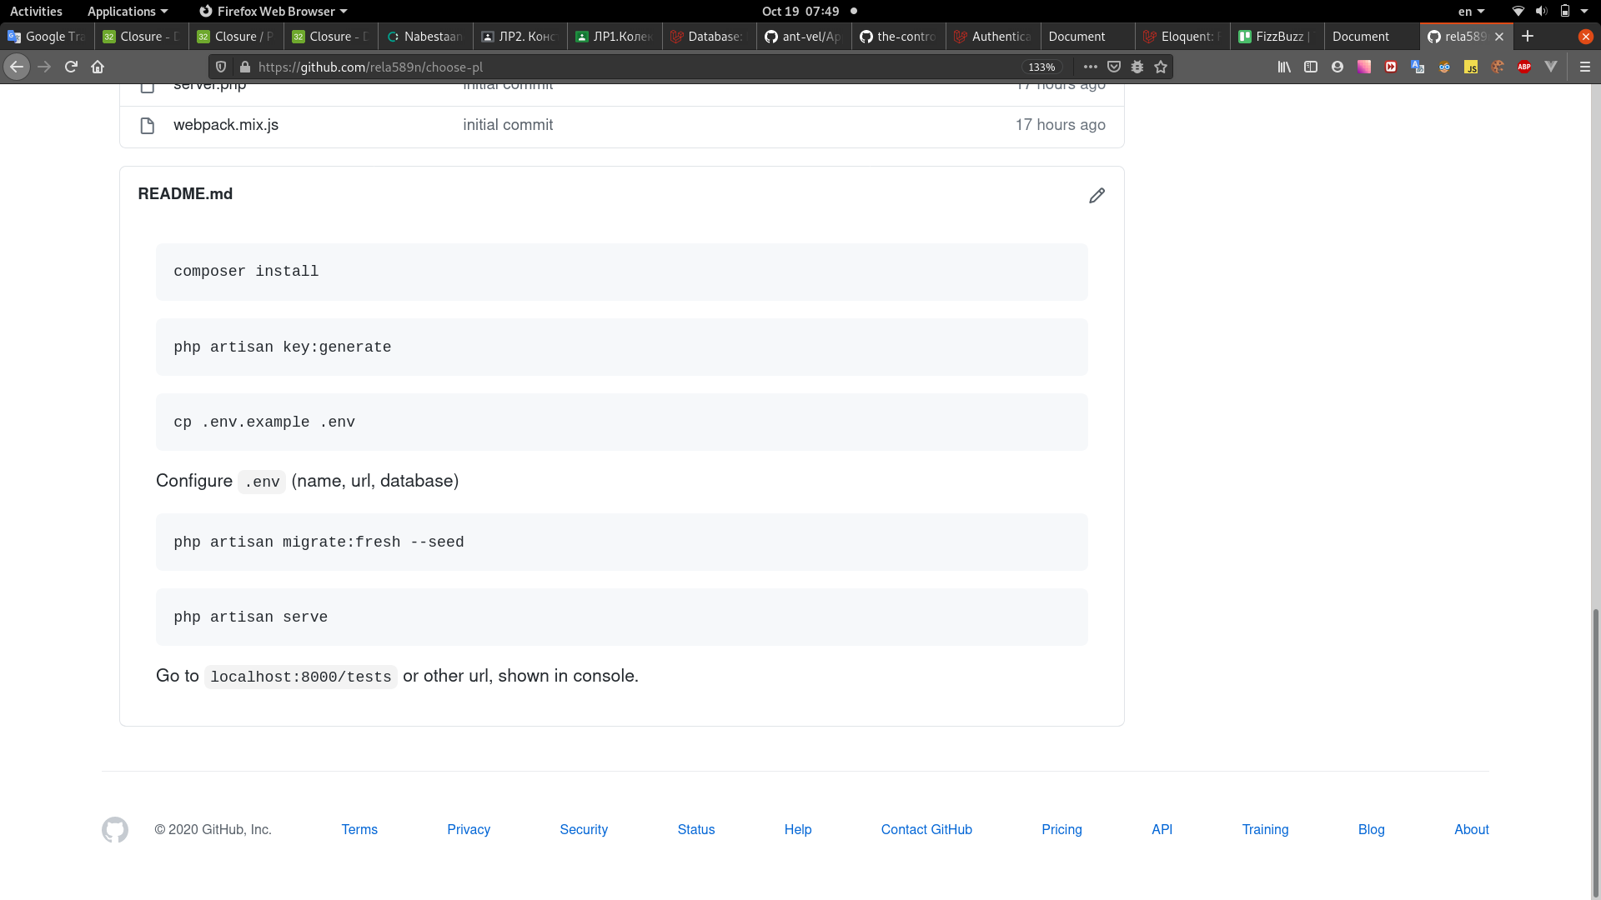
Вигляд експертної системи:
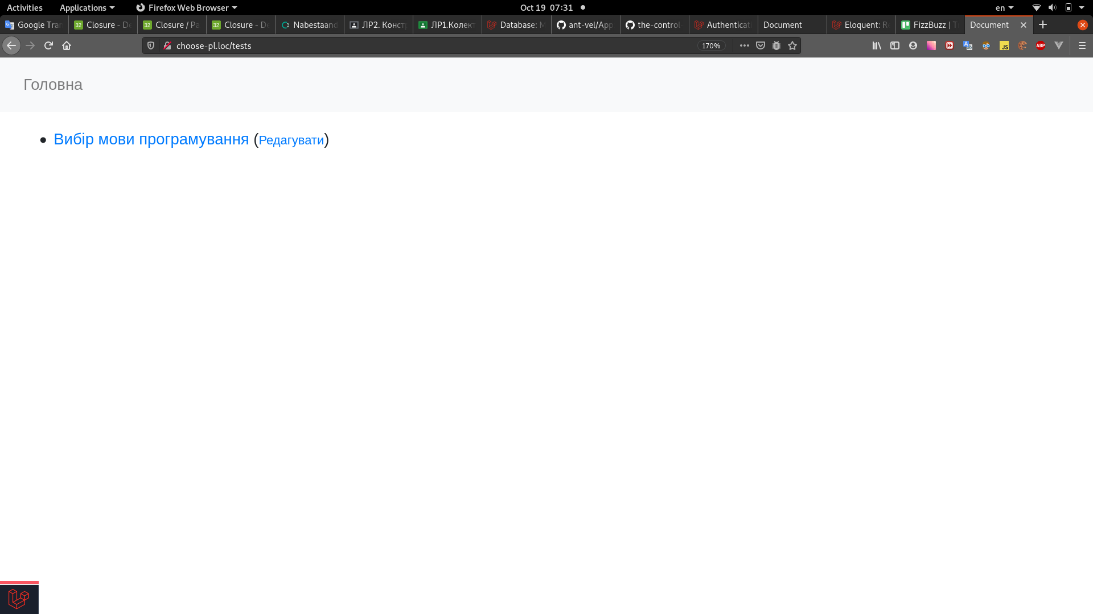

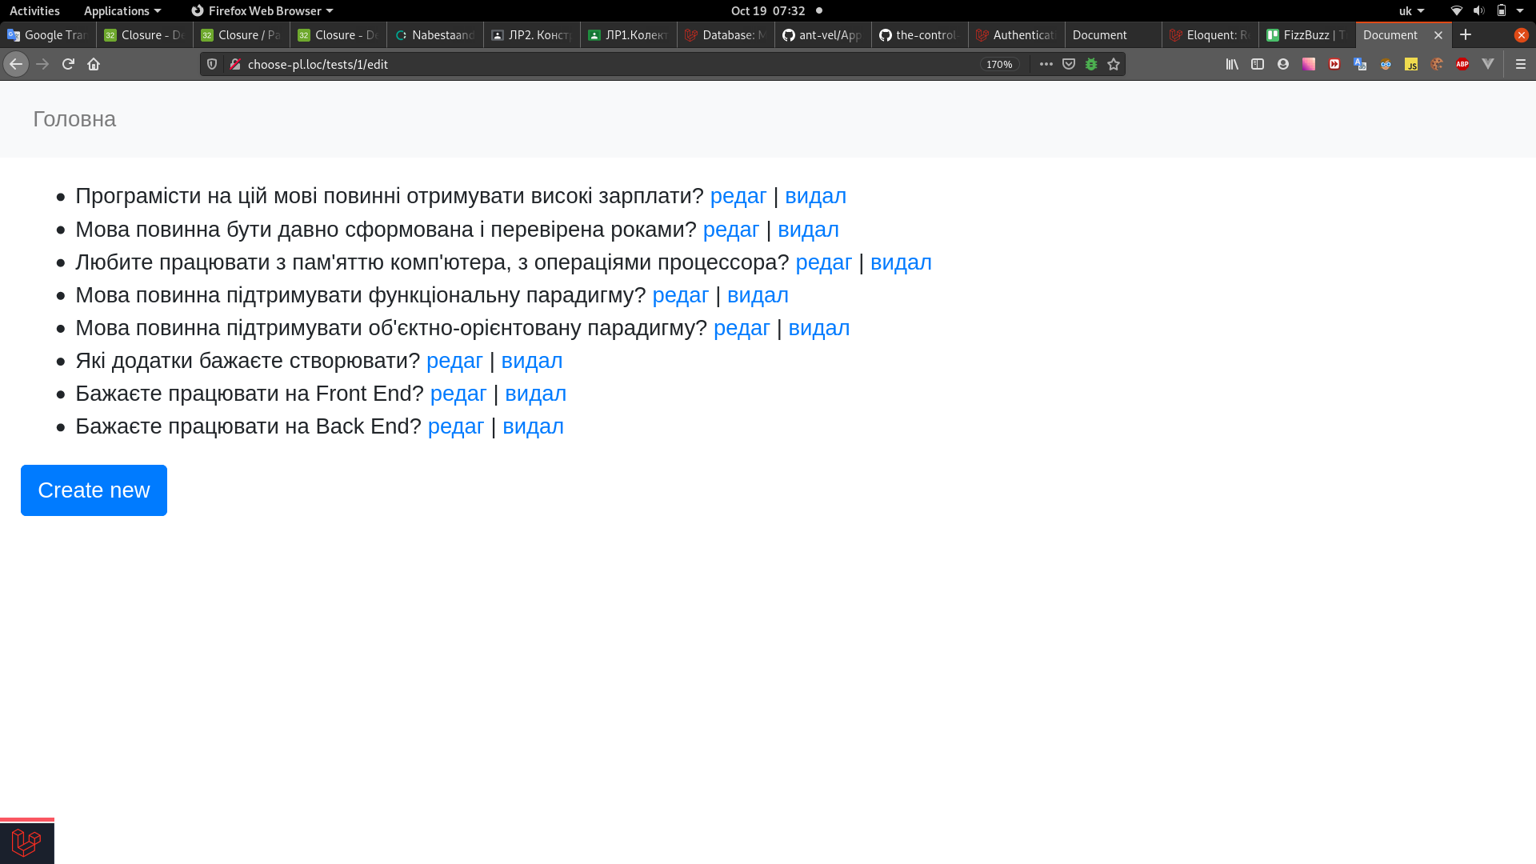

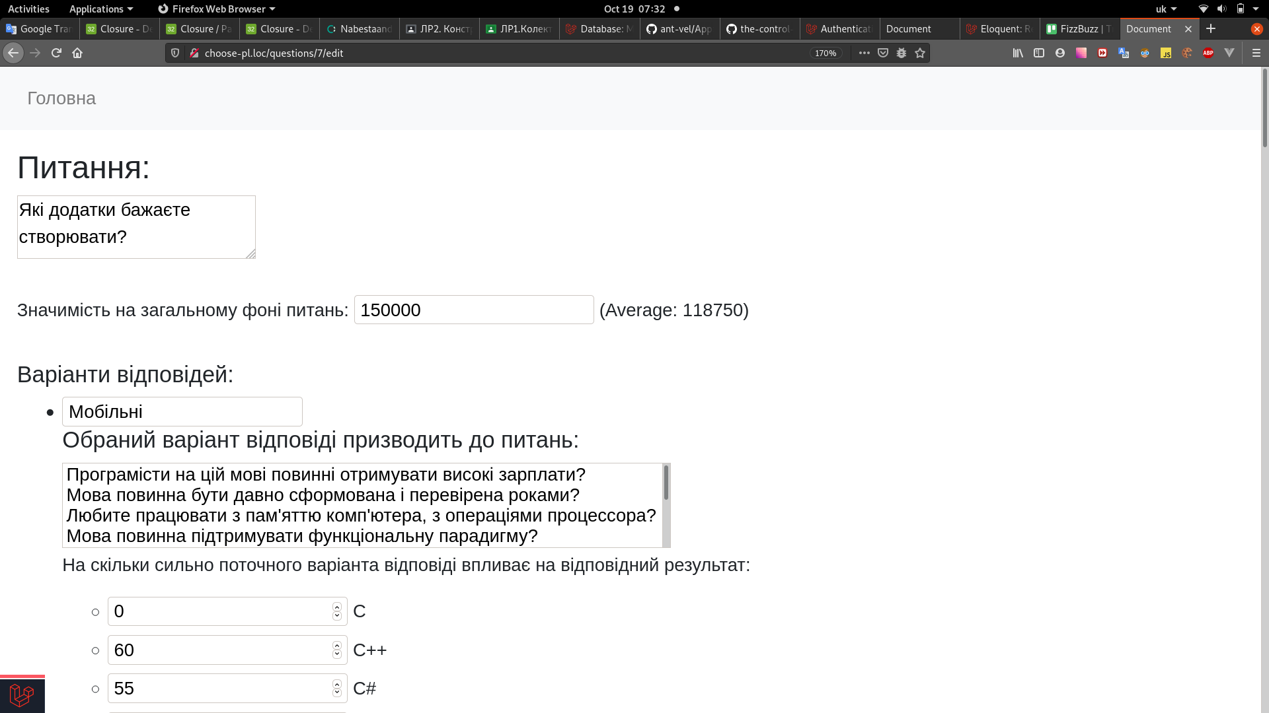

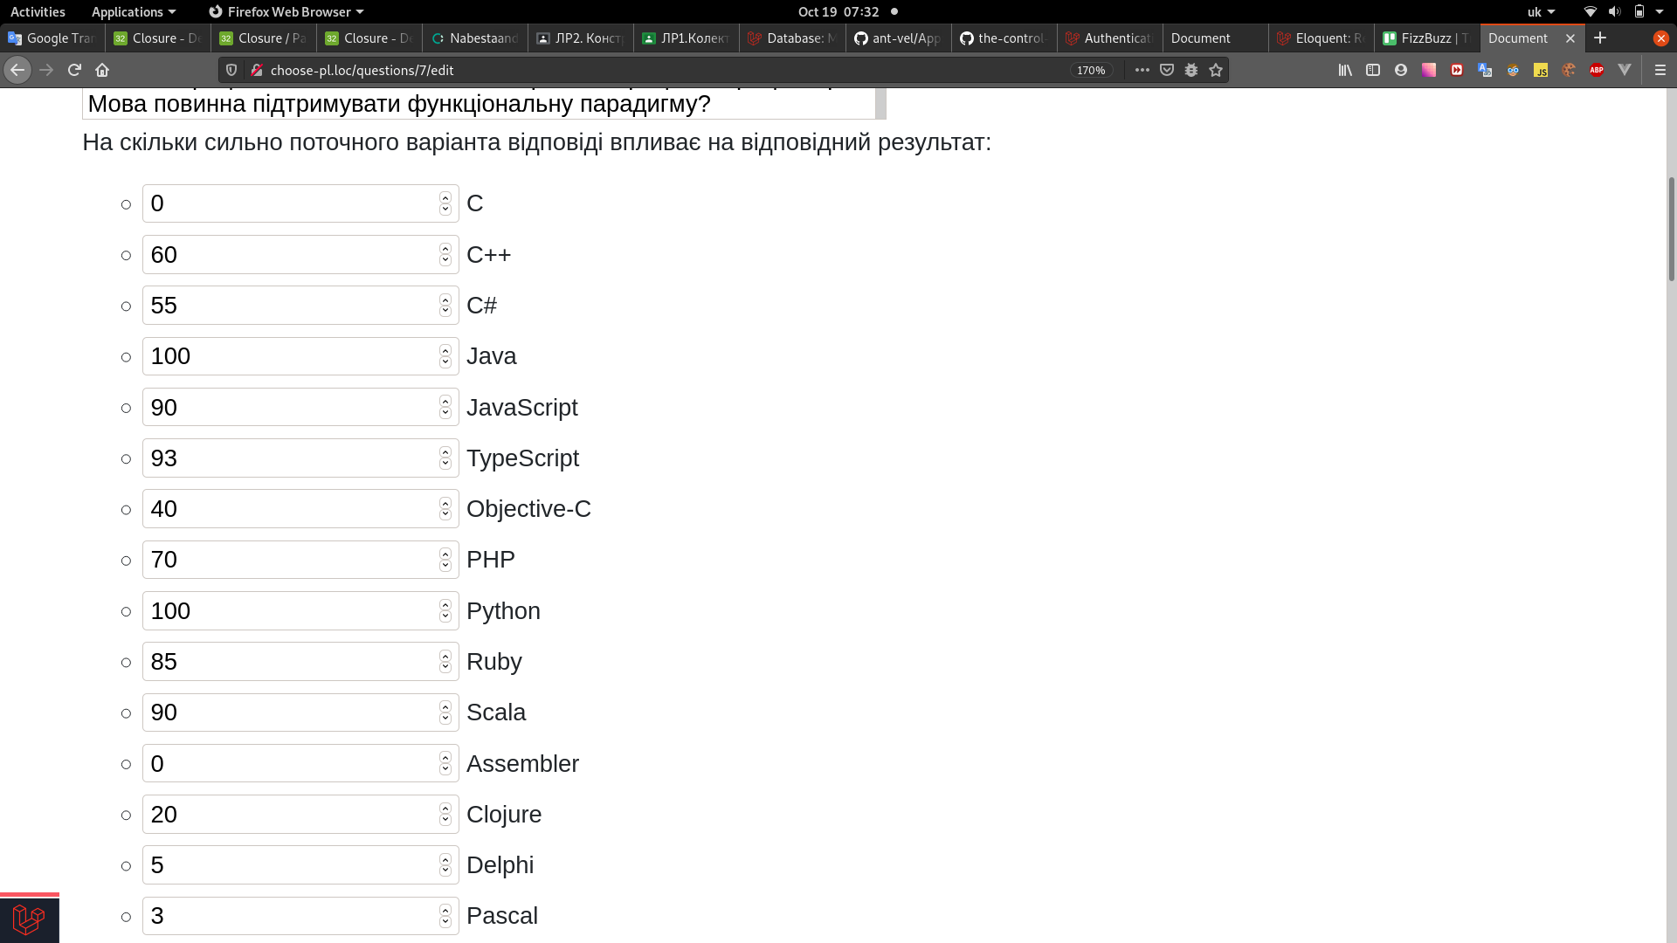

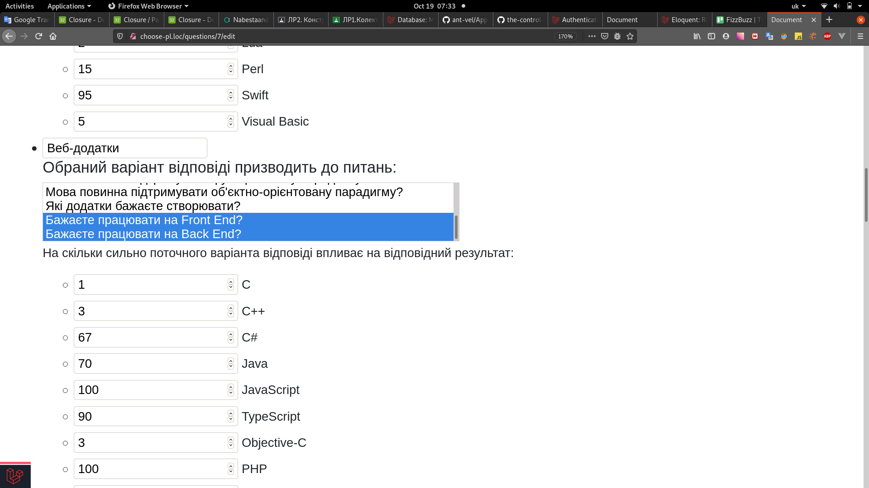

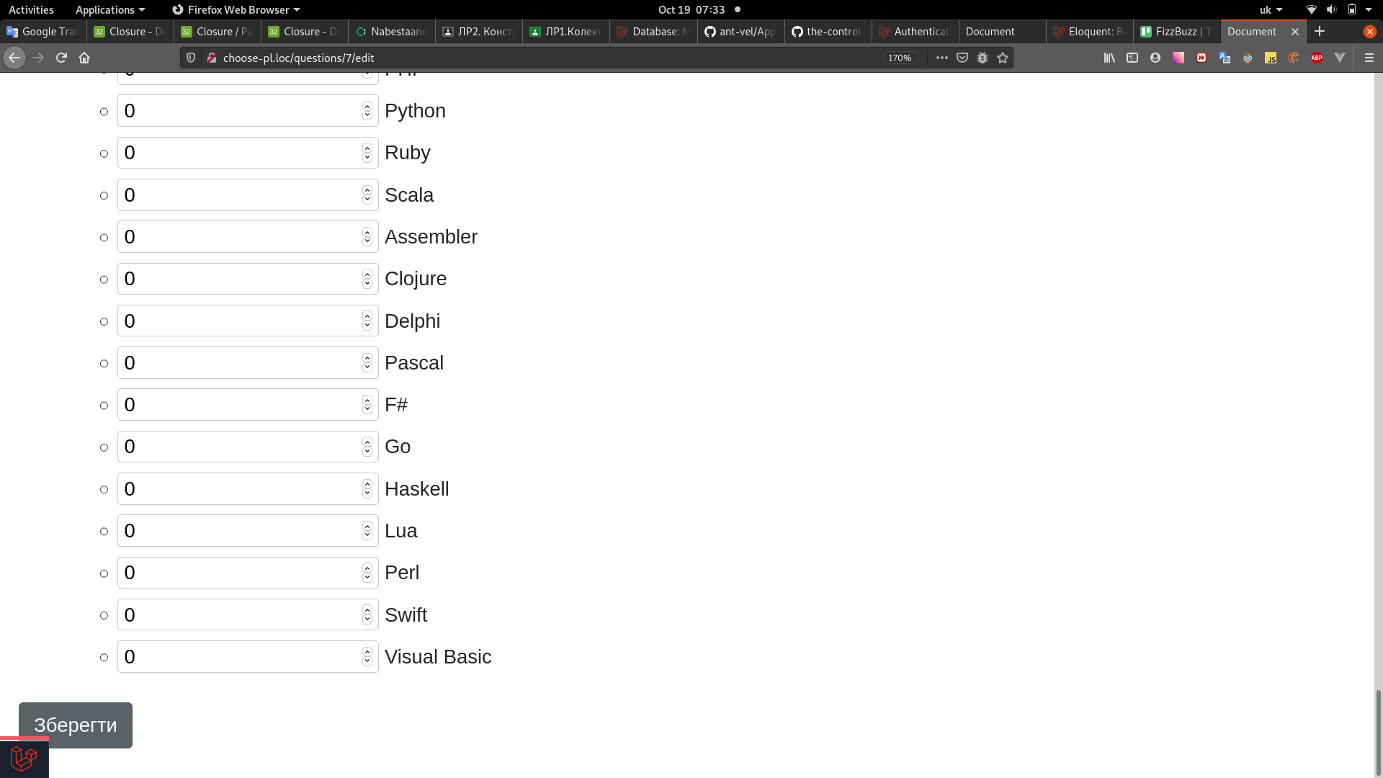

Натиснувши на кнопку “Create New”:

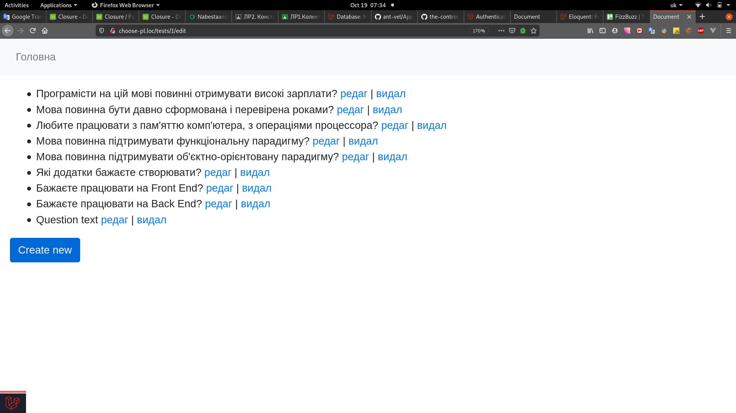

Було створено нове питання, та заповнено нулями всі вихідні результати:
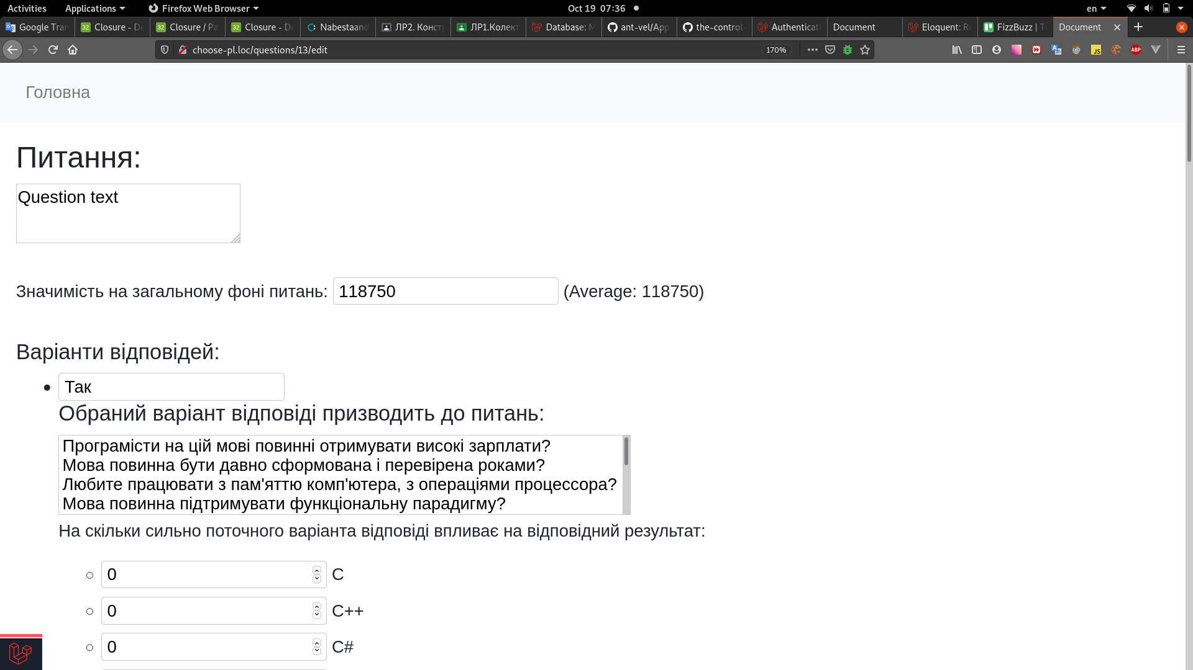

Проходження опитування системою:

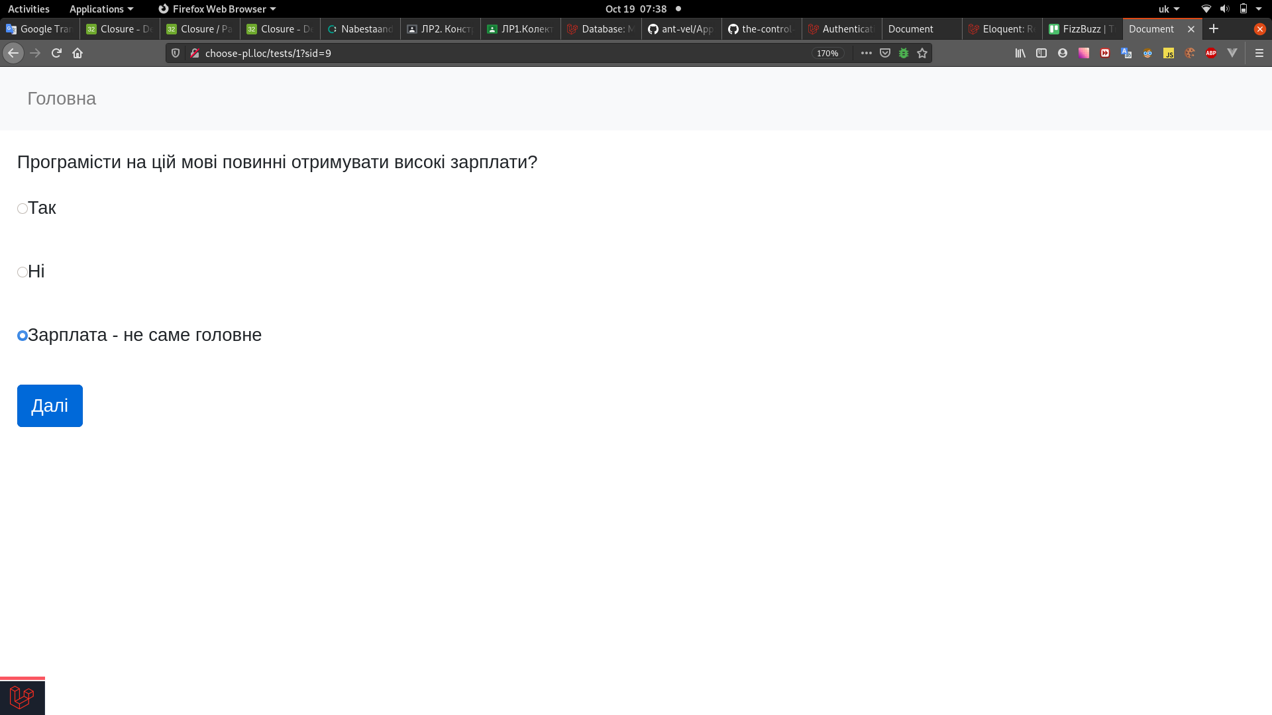

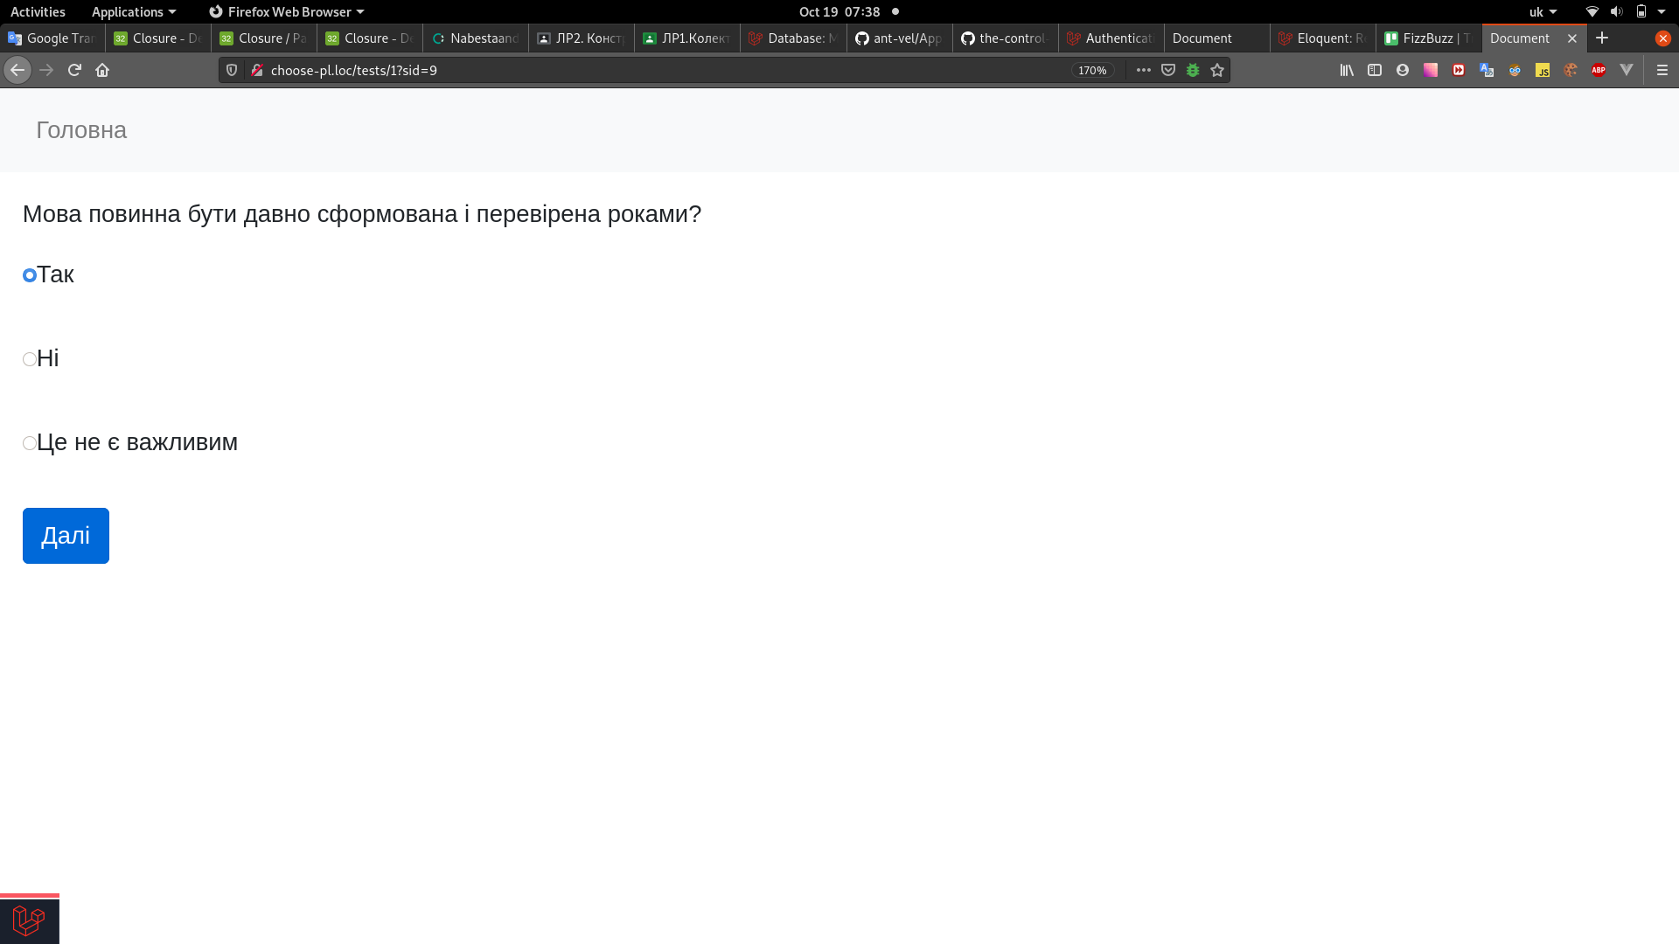

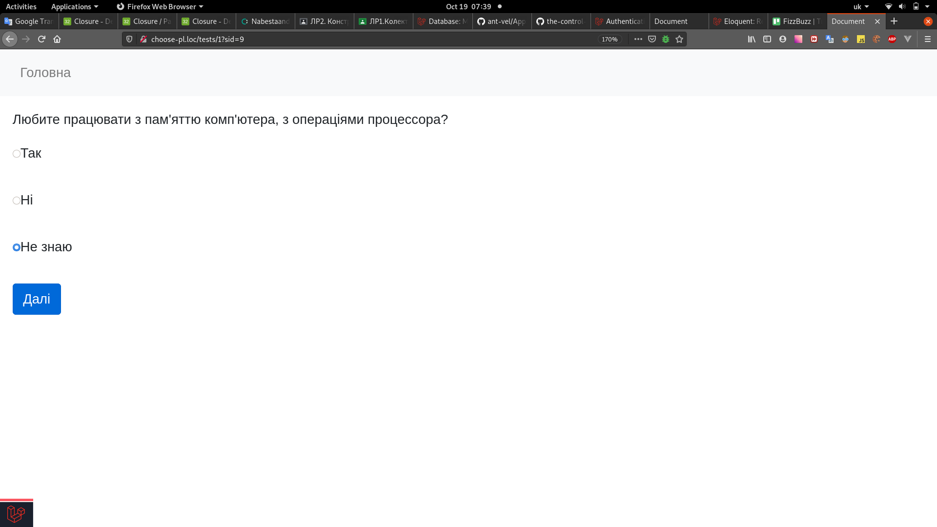

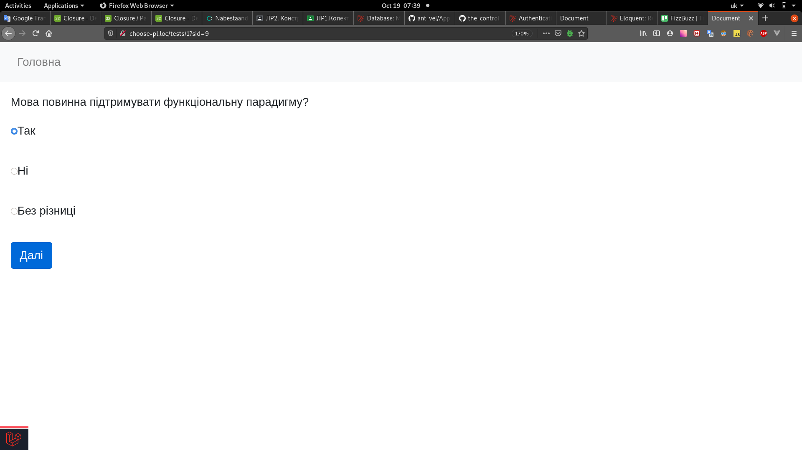

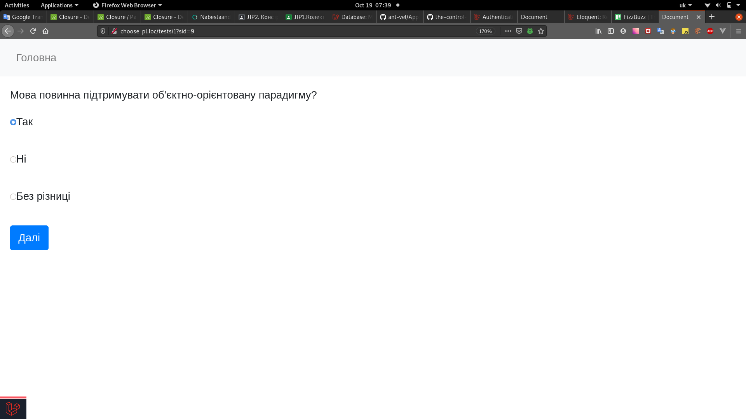

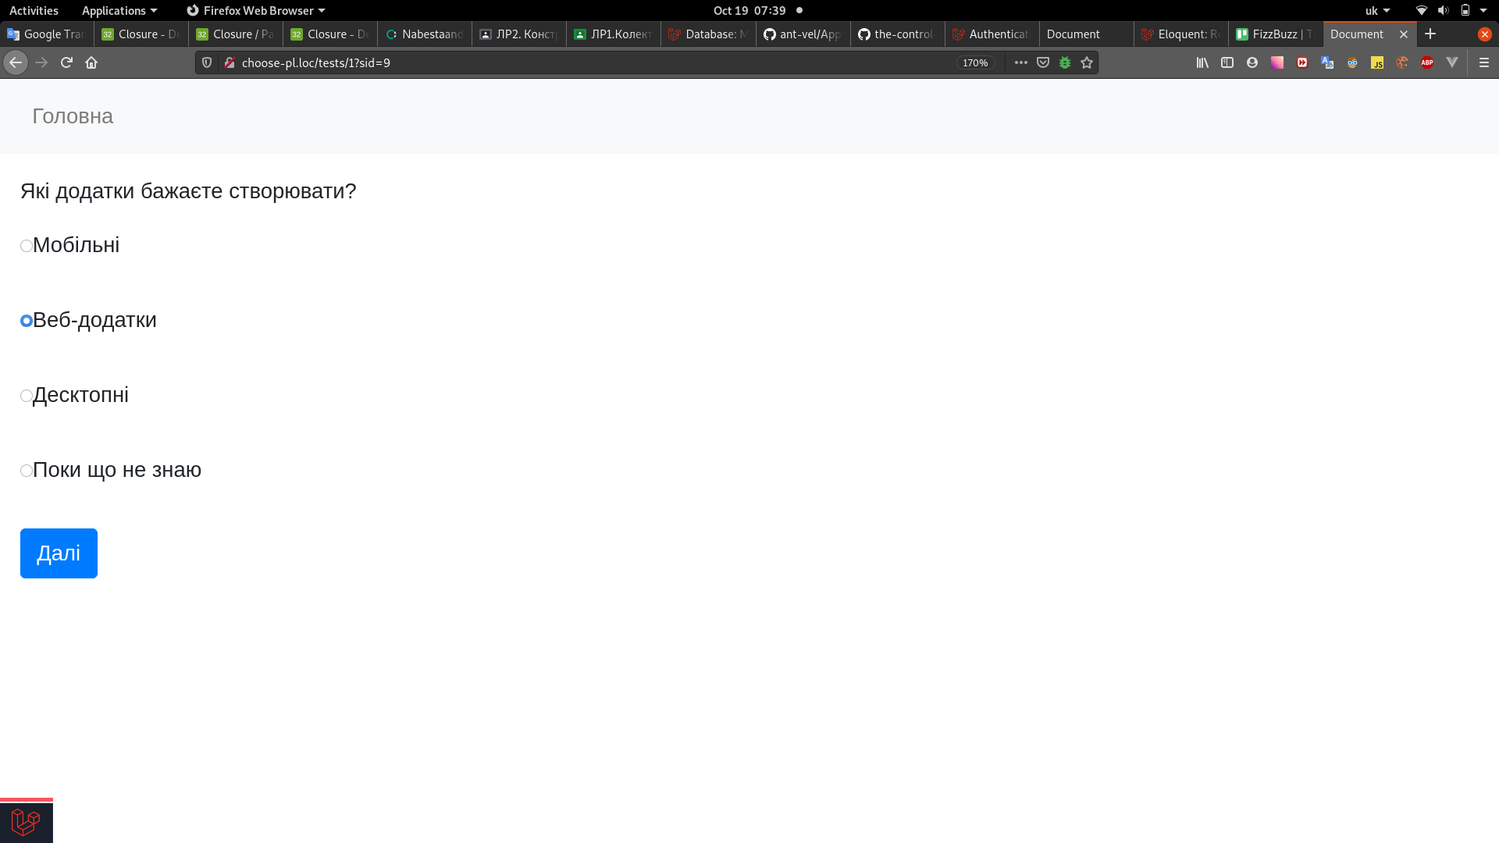

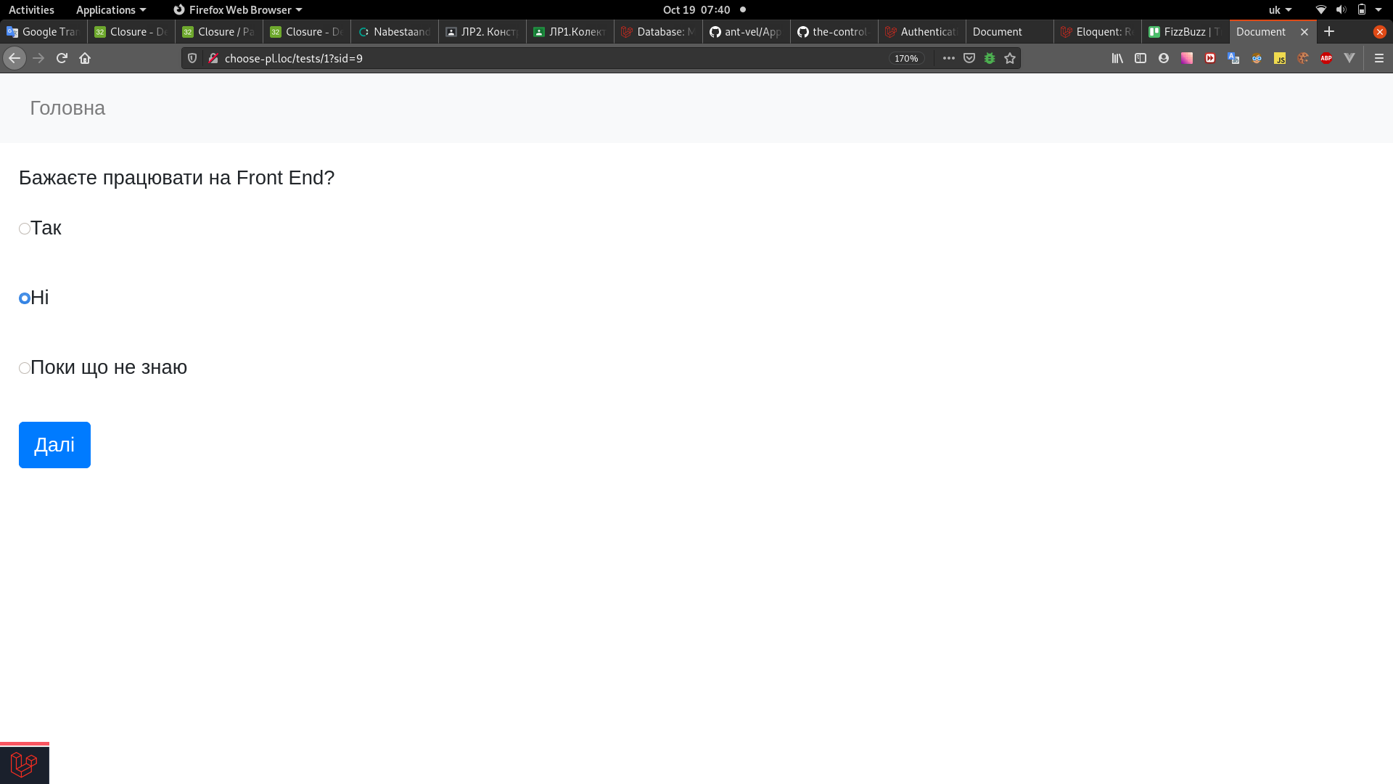

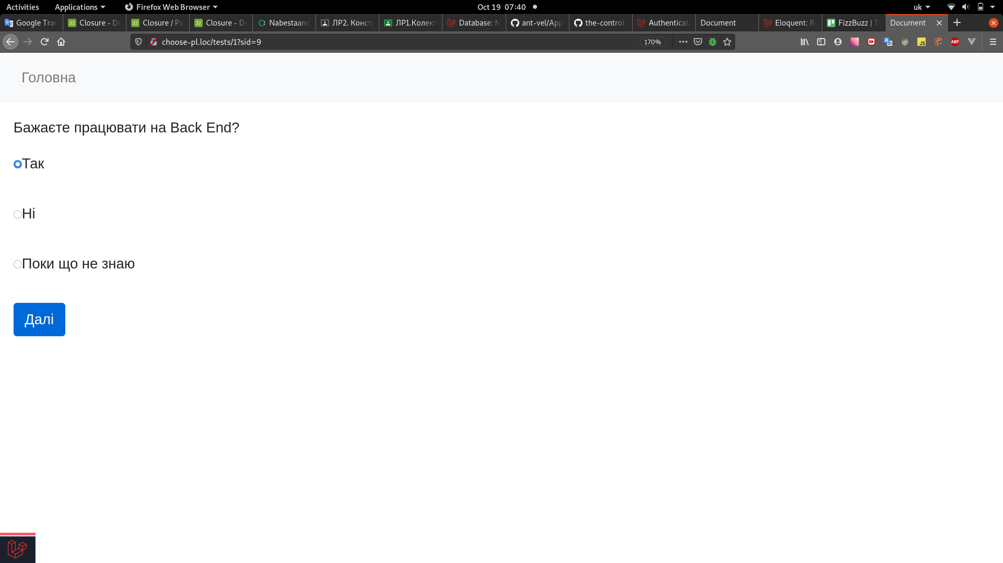

Після завершення черги питань, буде відображено результат:
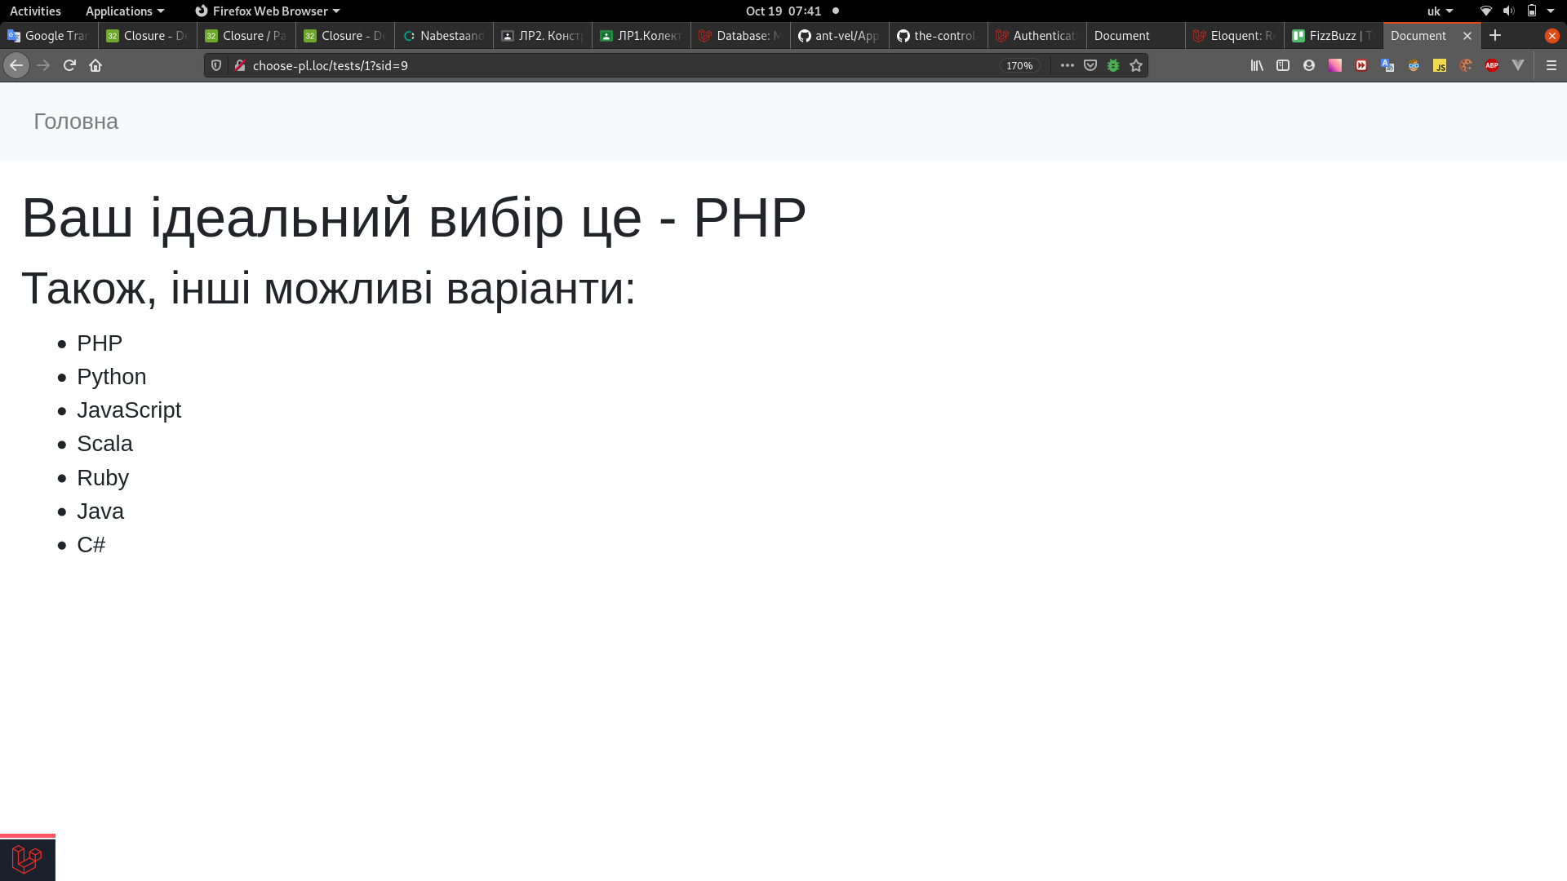

При цьому, якби на питання “Які додатки бажаєте створювати?”, користувач дав відповідь, відмінну від “Веб”, то питання, специфічні для мов веб-програмування, взагалі не були б задані.

Висновок:
На цій лабораторній роботі я навчився проектувати та програмно реалізовуввати експертні системи, ознайомився з теорією штучного інтелекту, способами побудови та використав при виконанні практичної роботи набуті знання; написав документацію для встановлення та запуску створеної експертної системи.

