Практична робота №11

Основи роботи із Vuex
Мета: навчитись працювати з Vuex, розробити інтерфейс для API, розробленого в ЛР8.
Хід роботи:
Завдання
Бюро по працевлаштуванню
Ви працюєте в бюро по працевлаштуванню. Ваше завдання – стеження за фінансовим напрямом роботи компанії.
Діяльність Вашого бюро організована наступним чином: Ваше бюро готове шукати робітників для різних працедавців і вакансії для фахівців різних профілів, які шукають роботу. Якщо є звернення до Вас клієнта-працедавця, його стандартні дані (назва, вид діяльності, адреса, телефон) фіксуються в базі даних. При звертанні до Вас клієнта- претендента, його стандартні дані (прізвище, ім’я, по батькові, кваліфікація, фах, інші дані) також фіксуються в базі даних.
По кожному факту задоволення інтересів обох сторін складається документ. В документі вказується претендент, працедавець, посада і комісійні (прибуток бюро).

Порядок виконання

Створення проекта:

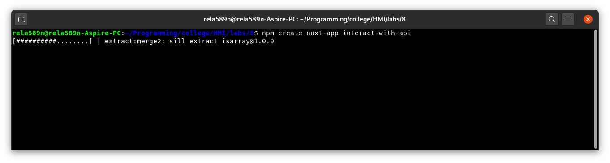

Задаємо параметри проекта:
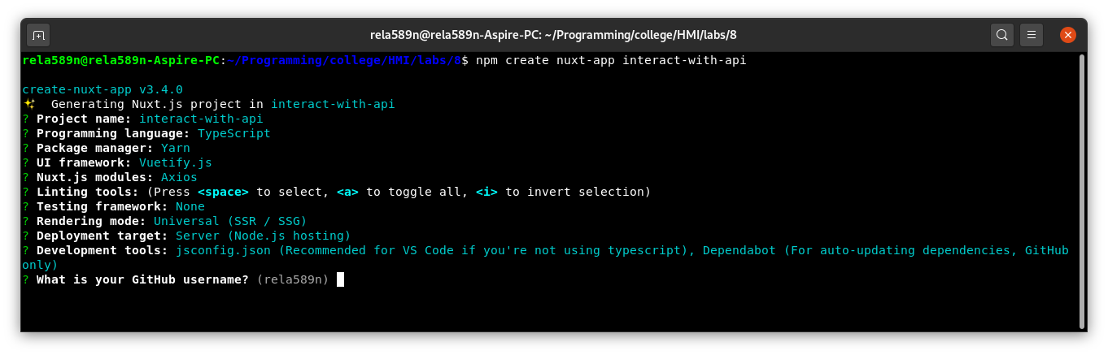

Основні моменти:

Проект буде створено на фреймворкові Nuxt, який базується на Vue
В якості UI-фреймворка буде використано Vuetify.js.
В якості HTTP-клієнта буде використано бібліотеку Axios.
Rendering Mode – SSR.

Запускаємо сервер з апі:
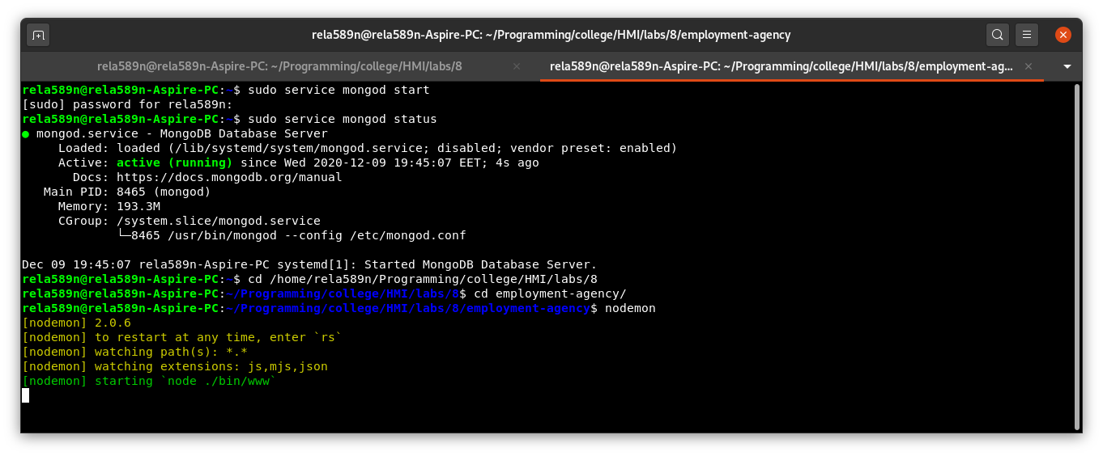
Опишемо конфігурацію для Nuxt ():
nuxt.config.js:
import colors from 'vuetify/es5/util/colors'
export default {
// Global page headers (https://go.nuxtjs.dev/config-head)
head: {
titleTemplate: '%s - interact-with-api',
title: 'interact-with-api',
meta: [
{ charset: 'utf-8' },
{ name: 'viewport', content: 'width=device-width, initial-scale=1' },
{ hid: 'description', name: 'description', content: '' }
],
link: [
{ rel: 'icon', type: 'image/x-icon', href: '/favicon.ico' }
]
},
// Global CSS (https://go.nuxtjs.dev/config-css)
css: [
],
// Plugins to run before rendering page (https://go.nuxtjs.dev/config-plugins)
plugins: [
],
// Auto import components (https://go.nuxtjs.dev/config-components)
components: true,
// Modules for dev and build (recommended) (https://go.nuxtjs.dev/config-modules)
buildModules: [
// https://go.nuxtjs.dev/typescript
'@nuxt/typescript-build',
// https://go.nuxtjs.dev/vuetify
'@nuxtjs/vuetify',
],
// Modules (https://go.nuxtjs.dev/config-modules)
modules: [
// https://go.nuxtjs.dev/axios
'@nuxtjs/axios',
// https://go.nuxtjs.dev/content
'@nuxt/content',
],
// Axios module configuration (https://go.nuxtjs.dev/config-axios)
axios: {},
// Content module configuration (https://go.nuxtjs.dev/config-content)
content: {},
// Vuetify module configuration (https://go.nuxtjs.dev/config-vuetify)
vuetify: {
customVariables: ['~/assets/variables.scss'],
theme: {
dark: true,
themes: {
dark: {
primary: colors.blue.darken2,
accent: colors.grey.darken3,
secondary: colors.amber.darken3,
info: colors.teal.lighten1,
warning: colors.amber.base,
error: colors.deepOrange.accent4,
success: colors.green.accent3
}
}
}
},
publicRuntimeConfig: {
axios: {
baseURL: 'http://localhost:3000/api/',
}
},
// Build Configuration (https://go.nuxtjs.dev/config-build)
build: {
}
}

Тут publicRuntimeConfig вказує на який url мають іти запити з axios.

В tsconfig.json додамо в types також axios:

{
"compilerOptions": {
"target": "ES2018",
"module": "ESNext",
"moduleResolution": "Node",
"lib": [
"ESNext",
"ESNext.AsyncIterable",
"DOM"
],
"esModuleInterop": true,
"allowJs": true,
"sourceMap": true,
"strict": true,
"noEmit": true,
"experimentalDecorators": true,
"baseUrl": ".",
"paths": {
"~/*": [
"./*"
],
"@/*": [
"./*"
]
},
"types": [
"@types/node",
"@nuxt/types",
"@nuxtjs/axios"
]
},
"exclude": [
"node_modules",
".nuxt",
"dist"
]
}

Налаштуємо базовий шаблон layouts/default.vue:
<template>
<v-app dark>
<v-navigation-drawer
v-model="drawer"
:mini-variant="miniVariant"
:clipped="clipped"
fixed
app
>
<v-list>
<v-list-item
v-for="(item, i) in items"
:key="i"
:to="item.to"
router
exact
>
<v-list-item-action>
<v-icon>{{ item.icon }}</v-icon>
</v-list-item-action>
<v-list-item-content>
<v-list-item-title v-text="item.title" />
</v-list-item-content>
</v-list-item>
</v-list>
</v-navigation-drawer>
<v-main>
<v-container>
<nuxt />
</v-container>
</v-main>
<v-navigation-drawer
v-model="rightDrawer"
:right="right"
temporary
fixed
>
<v-list>
<v-list-item @click.native="right = !right">
<v-list-item-action>
<v-icon light>
mdi-repeat
</v-icon>
</v-list-item-action>
<v-list-item-title>Switch drawer (click me)</v-list-item-title>
</v-list-item>
</v-list>
</v-navigation-drawer>
<v-footer
:absolute="!fixed"
app
>
<span>&copy; {{ new Date().getFullYear() }}</span>
</v-footer>
</v-app>
</template>
<script>
export default {
data () {
return {
clipped: false,
drawer: false,
fixed: false,
items: [
{
icon: 'mdi-apps',
title: 'Welcome',
to: '/'
},
{
icon: 'mdi-chart-bubble',
title: 'Inspire',
to: '/inspire'
},
{
icon: 'mdi-chart-bubble',
title: 'Producers',
to: '/producers'
},
{
icon: 'mdi-chart-bubble',
title: 'Employees',
to: '/employees',
},
{
icon: 'mdi-chart-bubble',
title: 'Relations',
to: '/relations',
},
],
miniVariant: false,
right: true,
rightDrawer: false,
title: 'Vuetify.js'
}
}
}
</script>

Сторінка для перегляду/редагування/видалення employees:
pages/employees/index.vue:
<template>
<v-row>
<v-col class="text-center">
<v-data-table
dense
:headers="employeeHeaders"
:items="employees"
item-key="_id"
class="elevation-1"
>
<template v-slot:top>
<v-toolbar
flat
>
<v-toolbar-title>Employees List</v-toolbar-title>
<v-divider
class="mx-4"
inset
vertical
></v-divider>
<v-spacer></v-spacer>
<v-dialog
v-model="showEditDialog"
max-width="500px"
>
<v-card>
<v-card-title>
<span class="headline">Edit item</span>
</v-card-title>
<v-card-text>
<v-container>
<v-row>
<v-col
cols="12"
sm="6"
md="4"
>
<v-text-field
filled
label="First Name"
v-model="editedItem.firstName"
></v-text-field>
</v-col>
<v-col
cols="12"
sm="6"
md="4"
>
<v-text-field
filled
label="Last Name"
v-model="editedItem.lastName"
></v-text-field>
</v-col>
<v-col
cols="12"
sm="6"
md="4"
>
<v-text-field
filled
label="Patronymic"
v-model="editedItem.patronymic"
></v-text-field>
</v-col>
<v-col
cols="12"
sm="6"
md="4"
>
<v-text-field
filled
label="Occupation"
v-model="editedItem.occupation"
></v-text-field>
</v-col>
<v-col
cols="12"
sm="6"
md="4"
>
<v-text-field
filled
label="Phone number"
v-model="editedItem.phone"
></v-text-field>
</v-col>
</v-row>
</v-container>
</v-card-text>
<v-card-actions>
<v-spacer></v-spacer>
<v-btn
color="blue darken-1"
text
@click="cancelEdit"
>
Cancel
</v-btn>
<v-btn
color="blue darken-1"
text
@click="commitEdit"
>
Save
</v-btn>
</v-card-actions>
</v-card>
</v-dialog>
<v-dialog v-model="showDeleteDialog" max-width="500px">
<v-card>
<v-card-title class="headline">Are you sure you want to delete this item?</v-card-title>
<v-card-actions>
<v-spacer></v-spacer>
<v-btn color="blue darken-1" text @click="cancelDelete">Cancel</v-btn>
<v-btn color="blue darken-1" text @click="confirmDelete">OK</v-btn>
<v-spacer></v-spacer>
</v-card-actions>
</v-card>
</v-dialog>
</v-toolbar>
</template>
<template v-slot:item.actions="{ item }">
<v-icon
small
class="mr-2"
@click="editItem(item)"
>
mdi-pencil
</v-icon>
<v-icon
small
@click="deleteItem(item)"
>
mdi-delete
</v-icon>
</template>
</v-data-table>
<v-divider class="mt-4"/>
<v-card-actions>
<v-spacer></v-spacer>
<v-btn
color="success"
depressed
to="/employees/create"
>
Add new
</v-btn>
</v-card-actions>
</v-col>
</v-row>
</template>
<script lang="ts">
import Vue from 'vue';
import {mapActions} from 'vuex';
export default Vue.extend({
components: {},
data: () => ({
employees: [],
editedItem: {
_id: null,
firstName: null,
lastName: null,
patronymic: null,
occupation: null,
phone: null,
},
employeeHeaders: [
{
text: 'First Name',
align: 'left',
value: 'firstName',
},
{
text: 'Last Name',
align: 'left',
value: 'lastName',
},
{
text: 'Patronymic',
align: 'left',
value: 'patronymic',
},
{
text: 'Occupation',
align: 'left',
value: 'occupation',
},
{
text: 'Phone',
align: 'left',
value: 'phone',
},
{
text: 'Actions',
value: 'actions',
sortable: false
},
],
showDeleteDialog: false,
showEditDialog: false,
itemToDeleteId: null,
}),
methods: {
...mapActions({
fetchEmployees: 'employees/fetchEmployees',
deleteEmployee: 'employees/deleteEmployee',
updateEmployee: 'employees/updateEmployee'
}),
editItem(item: object) {
this.editedItem._id = item._id;
this.editedItem.firstName = item.firstName;
this.editedItem.lastName = item.lastName;
this.editedItem.patronymic = item.patronymic;
this.editedItem.occupation = item.occupation;
this.editedItem.phone = item.phone;
this.showEditDialog = true
},
commitEdit() {
this.updateEmployee(this.editedItem);
this.showEditDialog = false
},
cancelEdit() {
this.editedItem._id = null;
this.editedItem.firstName = null;
this.editedItem.lastName = null;
this.editedItem.patronymic = null;
this.editedItem.occupation = null;
this.editedItem.phone = null;
this.showEditDialog = false
},
deleteItem(item: object) {
// this.editedIndex = this.desserts.indexOf(item)
// this.editedItem = Object.assign({}, item)
this.showDeleteDialog = true
this.itemToDeleteId = item._id
},
cancelDelete() {
this.showDeleteDialog = false
this.itemToDeleteId = null
},
confirmDelete() {
this.showDeleteDialog = false
this.deleteEmployee({_id: this.itemToDeleteId});
this.itemToDeleteId = null
},
},
async fetch() {
this.employees = await this.fetchEmployees();
},
mounted() {
}
})
;
</script>

Сторінка для створення нового employee:
pages/employees/create.vue:
<template>
<v-row>
<v-col class="text-center">
<v-card>
<v-toolbar
flat
color="blue-grey"
dark
>
<v-toolbar-title>Add a new Employee</v-toolbar-title>
</v-toolbar>
<v-card-text>
<v-text-field
filled
label="First Name"
v-model="newEmployee.firstName"
></v-text-field>
<v-text-field
filled
label="Last Name"
v-model="newEmployee.lastName"
></v-text-field>
<v-text-field
filled
label="Patronymic"
v-model="newEmployee.patronymic"
></v-text-field>
<v-text-field
filled
label="Occupation"
v-model="newEmployee.occupation"
></v-text-field>
<v-text-field
filled
label="Phone number"
v-model="newEmployee.phone"
></v-text-field>
</v-card-text>
<v-divider></v-divider>
<v-card-actions>
<v-spacer></v-spacer>
<v-btn
color="success"
depressed
@click="addEmployee"
>
Post
</v-btn>
</v-card-actions>
</v-card>
</v-col>
</v-row>
</template>
<script>
import Vue from "vue";
import {mapActions} from "vuex";
export default Vue.extend({
components: {},
data: () => ({
newEmployee: {
firstName: 'First Name',
lastName: 'Last Name',
patronymic: 'Patronymic',
occupation: 'Occupation',
phone: 'Phone',
}
}),
methods: {
...mapActions({
addNewEmployee: 'employees/addNewEmployee',
}),
addEmployee() {
this.addNewEmployee(this.newEmployee);
this.$router.push('/employees');
},
},
});
</script>
<style scoped>
</style>

Сторінка для перегляду/редагування/видалення employers:
pages/producers/index.vue:
<template>
<v-row>
<v-col class="text-center">
<v-data-table
dense
:headers="employerHeaders"
:items="employers"
item-key="_id"
class="elevation-1"
>
<template v-slot:top>
<v-toolbar
flat
>
<v-toolbar-title>Producers List</v-toolbar-title>
<v-divider
class="mx-4"
inset
vertical
></v-divider>
<v-spacer></v-spacer>
<v-dialog
v-model="showEditDialog"
max-width="500px"
>
<v-card>
<v-card-title>
<span class="headline">Edit item</span>
</v-card-title>
<v-card-text>
<v-container>
<v-row>
<v-col
cols="12"
sm="6"
md="4"
>
<v-text-field
v-model="editedItem.name"
label="Name"
></v-text-field>
</v-col>
<v-col
cols="12"
sm="6"
md="4"
>
<v-text-field
v-model="editedItem.occupation"
label="Occupation"
></v-text-field>
</v-col>
<v-col
cols="12"
sm="6"
md="4"
>
<v-text-field
v-model="editedItem.phone"
label="Phone number"
></v-text-field>
</v-col>
<v-col
cols="12"
sm="6"
md="4"
>
<v-text-field
v-model="editedItem.address"
label="Address"
></v-text-field>
</v-col>
</v-row>
</v-container>
</v-card-text>
<v-card-actions>
<v-spacer></v-spacer>
<v-btn
color="blue darken-1"
text
@click="cancelEdit"
>
Cancel
</v-btn>
<v-btn
color="blue darken-1"
text
@click="commitEdit"
>
Save
</v-btn>
</v-card-actions>
</v-card>
</v-dialog>
<v-dialog v-model="showDeleteDialog" max-width="500px">
<v-card>
<v-card-title class="headline">Are you sure you want to delete this item?</v-card-title>
<v-card-actions>
<v-spacer></v-spacer>
<v-btn color="blue darken-1" text @click="cancelDelete">Cancel</v-btn>
<v-btn color="blue darken-1" text @click="confirmDelete">OK</v-btn>
<v-spacer></v-spacer>
</v-card-actions>
</v-card>
</v-dialog>
</v-toolbar>
</template>
<template v-slot:item.actions="{ item }">
<v-icon
small
class="mr-2"
@click="editItem(item)"
>
mdi-pencil
</v-icon>
<v-icon
small
@click="deleteItem(item)"
>
mdi-delete
</v-icon>
</template>
</v-data-table>
<v-divider class="mt-4"/>
<v-card-actions>
<v-spacer></v-spacer>
<v-btn
color="success"
depressed
to="/producers/create"
>
Add new
</v-btn>
</v-card-actions>
</v-col>
</v-row>
</template>
<script lang="ts">
import Vue from 'vue';
import {mapActions} from 'vuex';
export default Vue.extend({
components: {},
data: () => ({
employers: [],
editedItem: {
_id: null,
name: null,
occupation: null,
phone: null,
address: null,
},
employerHeaders: [
{
text: 'Name',
align: 'left',
value: 'name',
},
{
text: 'Occupation',
align: 'left',
value: 'occupation',
},
{
text: 'Phone',
align: 'left',
value: 'phone',
},
{
text: 'Actions',
value: 'actions',
sortable: false
},
],
showDeleteDialog: false,
showEditDialog: false,
itemToDeleteId: null,
}),
methods: {
...mapActions({
fetchProducers: 'producers/fetchProducers',
deleteProducer: 'producers/deleteProducer',
updateProducer: 'producers/updateProducer'
}),
editItem(item: object) {
this.editedItem._id = item._id;
this.editedItem.name = item.name;
this.editedItem.occupation = item.occupation;
this.editedItem.address = item.address;
this.editedItem.phone = item.phone;
this.showEditDialog = true
},
commitEdit() {
this.updateProducer(this.editedItem);
this.showEditDialog = false
},
cancelEdit() {
this.editedItem._id = null;
this.editedItem.name = null;
this.editedItem.occupation = null;
this.editedItem.address = null;
this.editedItem.phone = null;
this.showEditDialog = false
},
deleteItem(item: object) {
// this.editedIndex = this.desserts.indexOf(item)
// this.editedItem = Object.assign({}, item)
this.showDeleteDialog = true
this.itemToDeleteId = item._id
},
cancelDelete() {
this.showDeleteDialog = false
this.itemToDeleteId = null
},
confirmDelete() {
this.showDeleteDialog = false
this.deleteProducer({_id: this.itemToDeleteId});
this.itemToDeleteId = null
},
},
async fetch() {
this.employers = await this.fetchProducers();
},
mounted() {
}
})
;
</script>
Сторінка для створення новго employer:
pages/producers/create.vue:
<template>
<v-row>
<v-col class="text-center">
<v-card>
<v-toolbar
flat
color="blue-grey"
dark
>
<v-toolbar-title>Add a new Producer</v-toolbar-title>
</v-toolbar>
<v-card-text>
<v-text-field
filled
label="Name"
v-model="newProducer.name"
></v-text-field>
<v-text-field
filled
label="Occupation"
v-model="newProducer.occupation"
></v-text-field>
<v-text-field
filled
label="Phone number"
v-model="newProducer.phone"
></v-text-field>
</v-card-text>
<v-divider></v-divider>
<v-card-actions>
<v-spacer></v-spacer>
<v-btn
color="success"
depressed
@click="addProducer"
>
Post
</v-btn>
</v-card-actions>
</v-card>
</v-col>
</v-row>
</template>
<script>
import Vue from "vue";
import {mapActions} from "vuex";
export default Vue.extend({
components: {},
data: () => ({
newProducer: {
name: 'Name',
occupation: 'Occupation',
phone: '+111',
}
}),
methods: {
...mapActions({
addNewProducer: 'producers/addNewProducer',
}),
addProducer() {
this.addNewProducer(this.newProducer);
this.$router.push('/producers');
},
},
});
</script>
<style scoped>
</style>

Сторінка для перегляду контрактів employee – employer:
<template>
<v-row>
<v-col class="text-center">
<v-data-table
dense
:headers="relationHeaders"
:items="relations"
item-key="_id"
class="elevation-1"
>
<template v-slot:top>
<v-toolbar
flat
>
<v-toolbar-title>Relations List</v-toolbar-title>
<v-divider
class="mx-4"
inset
vertical
></v-divider>
<v-spacer></v-spacer>
<v-dialog v-model="showDeleteDialog" max-width="500px">
<v-card>
<v-card-title class="headline">Are you sure you want to delete this item?</v-card-title>
<v-card-actions>
<v-spacer></v-spacer>
<v-btn color="blue darken-1" text @click="cancelDelete">Cancel</v-btn>
<v-btn color="blue darken-1" text @click="confirmDelete">OK</v-btn>
<v-spacer></v-spacer>
</v-card-actions>
</v-card>
</v-dialog>
</v-toolbar>
</template>
<template v-slot:item.actions="{ item }">
<v-icon
small
@click="deleteItem(item)"
>
mdi-delete
</v-icon>
</template>
</v-data-table>
<v-divider class="mt-4"/>
<v-card-actions>
<v-spacer></v-spacer>
<v-btn
color="success"
depressed
to="/relations/create"
>
Add new
</v-btn>
</v-card-actions>
</v-col>
</v-row>
</template>
<script lang="ts">
import Vue from 'vue';
import {mapActions} from 'vuex';
export default Vue.extend({
components: {},
data: () => ({
relations: [],
editedItem: {
_id: null,
},
relationHeaders: [
{
text: 'Employer',
align: 'left',
value: 'employer.name',
},
{
text: 'Employee',
align: 'left',
value: 'employee.full_name',
},
{
text: 'Position',
align: 'left',
value: 'position',
},
{
text: 'Actions',
value: 'actions',
sortable: false
},
],
showDeleteDialog: false,
showEditDialog: false,
itemToDeleteId: null,
}),
methods: {
...mapActions({
fetchRelations: 'relation/fetchRelations',
deleteRelation: 'relation/deleteRelation',
updateRelation: 'relation/updateRelation',
}),
deleteItem(item: object) {
this.showDeleteDialog = true
this.itemToDeleteId = item._id
},
cancelDelete() {
this.showDeleteDialog = false
this.itemToDeleteId = null
},
confirmDelete() {
this.showDeleteDialog = false
this.deleteRelation({_id: this.itemToDeleteId});
this.itemToDeleteId = null
},
},
async fetch() {
this.relations = await this.fetchRelations();
},
mounted() {
// console.log(this.relations);
}
})
;
</script>
Сторінка для створення контракту employee – employer:
pages/relations/create.vue:
<template>
<v-row>
<v-col class="text-center">
<v-card>
<v-toolbar
flat
color="blue-grey"
dark
>
<v-toolbar-title>Add a new relation</v-toolbar-title>
</v-toolbar>
<v-card-text>
<v-col
class="d-flex"
cols="12"
sm="6"
>
<v-select
:items="employees"
item-text="full_name"
item-value="_id"
label="Employee"
v-model="newRelation.employee_id"
>
</v-select>
</v-col>
<v-col
class="d-flex"
cols="12"
sm="6"
>
<v-select
:items="employers"
item-text="name"
item-value="_id"
label="Employer"
v-model="newRelation.employer_id"
>
</v-select>
</v-col>
<v-text-field
label="Position"
v-model="newRelation.position"
></v-text-field>
</v-card-text>
<v-divider></v-divider>
<v-card-actions>
<v-spacer></v-spacer>
<v-btn
color="success"
depressed
@click="addRelation"
>
Post
</v-btn>
</v-card-actions>
</v-card>
</v-col>
</v-row>
</template>
<script>
import Vue from "vue";
import {mapActions} from "vuex";
export default Vue.extend({
components: {},
data: () => ({
employees: [],
employers: [],
newRelation: {
employee_id: null,
employer_id: null,
position: '',
}
}),
methods: {
...mapActions({
fetchProducers: 'producers/fetchProducers',
fetchEmployees: 'employees/fetchEmployees',
addNewRelation: 'relation/addNewRelation',
}),
addRelation() {
this.addNewRelation(this.newRelation);
this.$router.push('/relations');
},
},
async fetch() {
this.employees = await this.fetchEmployees();
this.employers = await this.fetchProducers();
},
});
</script>
<style scoped>
</style>

Vuex сховище для робітників:
store/employees.js:
import Vue from 'vue';
export const state = () => ({
employees: [],
});
export const mutations = {
addEmployeeToArray(state, {newEmployee}) {
state.employees.push(newEmployee);
},
removeById(state, {_id}) {
let index = state.employees.findIndex(p => p._id === _id);
state.employees.splice(index, 1);
},
replaceEmployee(state, {newEmployeeData, id}) {
let index = state.employees.findIndex(x => x._id === id);
console.log(index);
state.employees[index].firstName = newEmployeeData.firstName;
state.employees[index].lastName = newEmployeeData.lastName;
state.employees[index].patronymic = newEmployeeData.patronymic;
state.employees[index].occupation = newEmployeeData.occupation;
state.employees[index].phone = newEmployeeData.phone;
}
}
export const getters = {}
export const actions = {
async addNewEmployee({state, commit, ...others}, newEmployee) {
console.log(others);
let response = await this.$axios.post('/employees', {
firstName: newEmployee.firstName,
lastName: newEmployee.lastName,
patronymic: newEmployee.patronymic,
occupation: newEmployee.occupation,
phone: newEmployee.phone,
});
if (response.status !== 200) {
alert('create error');
return;
}
commit('addEmployeeToArray', {newEmployee: response.data});
},
async deleteEmployee({state, commit, ...others}, {_id}) {
let response = await this.$axios.delete('/employees/' + _id);
console.log(response);
if (response.status !== 200) {
alert('delete error');
return;
}
commit('removeById', {_id});
},
async updateEmployee({state, commit, ...others}, employee) {
let response = await this.$axios.patch('/employees/' + employee._id, employee);
if (response.status !== 200) {
alert('cant update');
return;
}
commit('replaceEmployee', {newEmployeeData: employee, id: employee._id});
},
async fetchEmployees({state}) {
const response = await this.$axios.get('/employees');
Vue.set(state, 'employees', [...response.data]);
return state.employees;
},
};

Vuex сховище для роботодавців:
store/producers.js:

import Vue from 'vue';
export const state = () => ({
producers: [],
});
export const mutations = {
addProducerToArray(state, {newProducer}) {
state.producers.push(newProducer);
},
removeById(state, {_id}) {
let index = state.producers.findIndex(p => p._id === _id);
state.producers.splice(index, 1);
},
replaceProducer(state, {newProducerData, id}) {
let index = state.producers.findIndex(x => x._id === id);
console.log(index);
state.producers[index].name = newProducerData.name;
state.producers[index].patronymic = newProducerData.patronymic;
state.producers[index].occupation = newProducerData.occupation;
state.producers[index].address = newProducerData.address;
state.producers[index].phone = newProducerData.phone;
}
}
export const getters = {
}
export const actions = {
async addNewProducer({state, commit, ...others}, newProducer) {
console.log(others);
let response = await this.$axios.post('/employers', {
name: newProducer.name,
patronymic: newProducer.patronymic,
occupation: newProducer.occupation,
phone: newProducer.phone,
});
if (response.status !== 200) {
alert('create error');
return;
}
commit('addProducerToArray', {newProducer: response.data});
},
async deleteProducer({state, commit, ...others}, {_id}) {
let response = await this.$axios.delete('/employers/' + _id);
console.log(response);
if (response.status !== 200) {
alert('delete error');
return;
}
commit('removeById', {_id});
},
async updateProducer({state, commit, ...others}, producer) {
let response = await this.$axios.patch('/employers/' + producer._id, producer);
if (response.status !== 200) {
alert('cant update');
return;
}
commit('replaceProducer', {newProducerData: producer, id: producer._id});
},
async fetchProducers({state}) {
const response = await this.$axios.get('/employers');
Vue.set(state, 'producers', [...response.data]);
return state.producers;
},
};
Vuex сховище для звязків employee – employer:
store/relation.js:

import Vue from 'vue';
export const state = () => ({
relations: [],
});
export const mutations = {
addRelationToArray(state, {newRelation}) {
const toAdd = {
_id: newRelation._id,
employee_id: newRelation.employee_id,
employer_id: newRelation.employer_id,
position: newRelation.position,
commission: newRelation.commission,
employer: newRelation.employer,
employee: newRelation.employee,
};
toAdd.employee.full_name = toAdd.employee.firstName + " " + toAdd.employee.lastName + " " + toAdd.employee.patronymic;
state.relations.push(toAdd);
},
removeById(state, {_id}) {
let index = state.relations.findIndex(p => p._id === _id);
state.relations.splice(index, 1);
},
replaceRelation(state, {newRelationData, id}) {
let index = state.relations.findIndex(x => x._id === id);
console.log(index);
state.relations[index].employer_name = newRelationData.employer_name;
state.relations[index].employee_name = newRelationData.employee_name;
}
}
export const getters = {}
export const actions = {
async addNewRelation({state, commit, ...others}, newRelation) {
let response = await this.$axios.post('/work-contracts', {
employee_id: newRelation.employee_id,
employer_id: newRelation.employer_id,
position: newRelation.position,
});
if (response.status !== 200) {
alert('create error');
return;
}
commit('addRelationToArray', {newRelation: response.data});
},
async deleteRelation({state, commit, ...others}, {_id}) {
let response = await this.$axios.delete('/work-contracts/' + _id);
console.log(response);
if (response.status !== 200) {
alert('delete error');
return;
}
commit('removeById', {_id});
},
async updateRelation({state, commit, ...others}, relation) {
let response = await this.$axios.patch('/work-contracts/verbose/' + relation._id, relation);
if (response.status !== 200) {
alert('cant update');
return;
}
commit('replaceRelation', {newRelationData: relation, id: relation._id});
},
async fetchRelations({state, commit}) {
const response = await this.$axios.get('/work-contracts/verbose');
Vue.set(state, 'relations', []);
for (let relation of response.data) {
commit('addRelationToArray', {
newRelation: {
_id: relation._id,
employee_id: relation.employee_id,
employer_id: relation.employer_id,
position: relation.position,
commission: relation.commission,
employer: relation.employer[0],
employee: relation.employee[0],
}
});
}
return state.relations;
},
};
Запускаємо nuxt-проект :
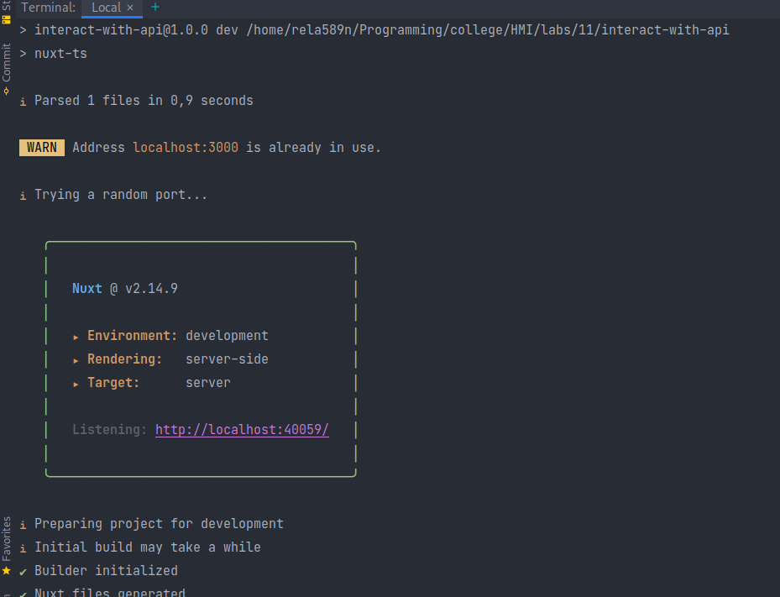
На головній бачимо стандартну сторінку нового проекта:
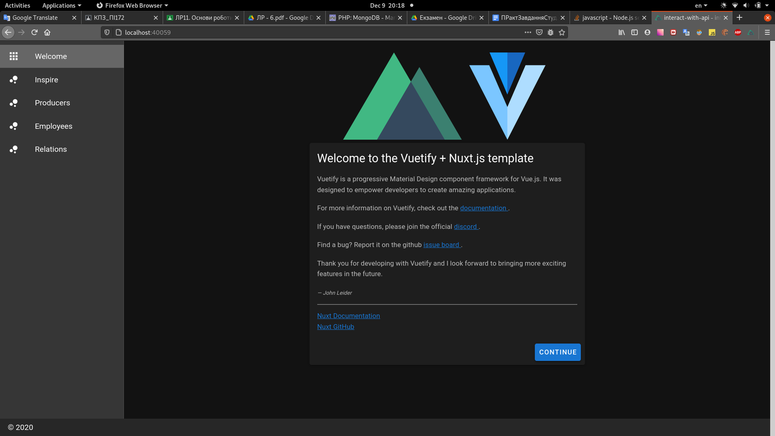

І сторінку “Inspire”:
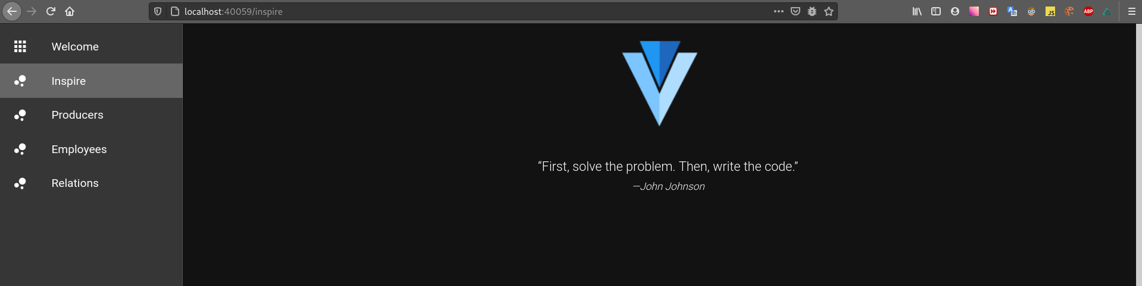

Перейшовши по посиланню “Producers”, можемо бачити список:
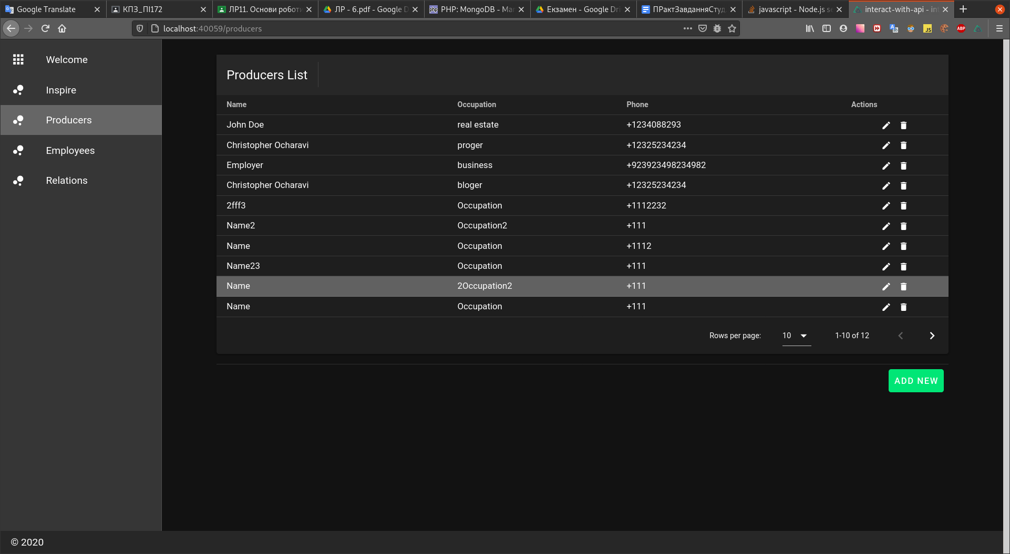
Додамо нового роботодавця:
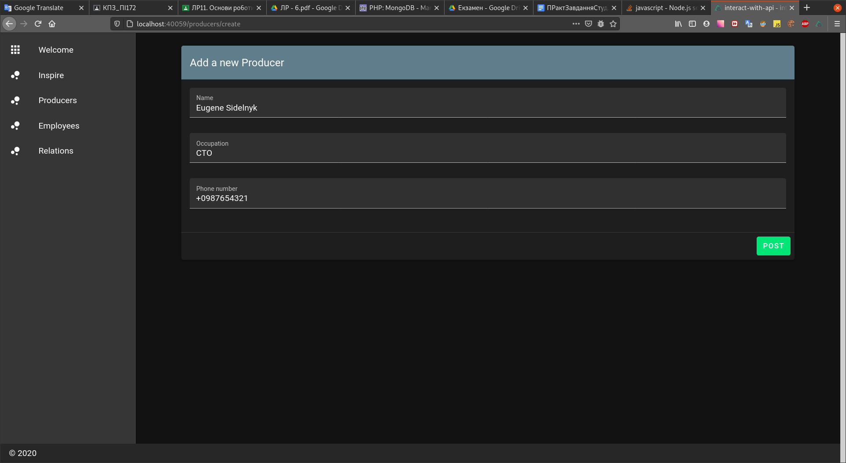
Він відображається з самого низу в таблиці:
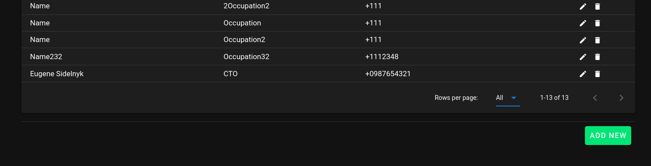

Відредагуємо інформацію якогось роботодавця:
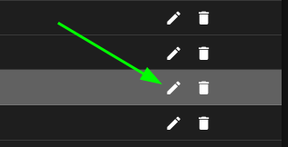

Редагування інформації про роботодавця:
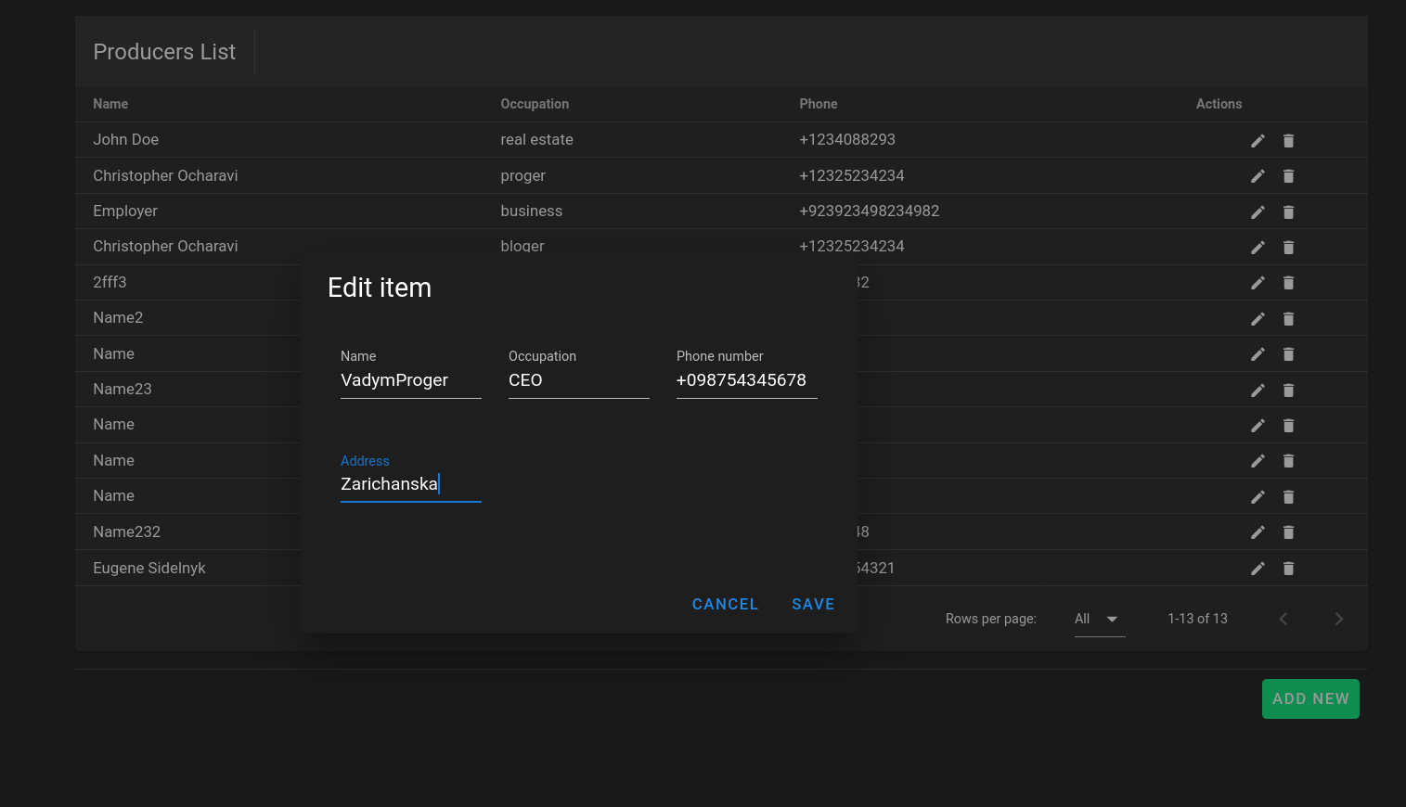
Відредаговано:
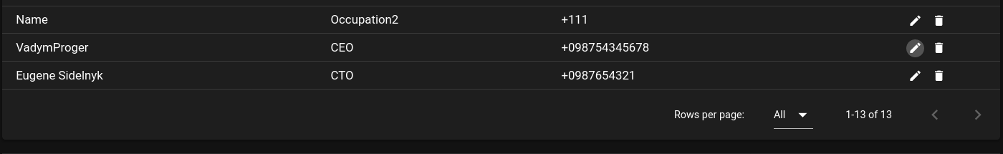
Можна видалити якийсь з записів:
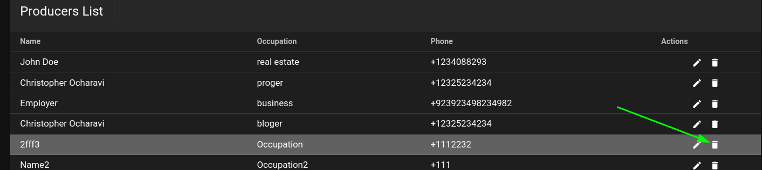
Підтвердження:

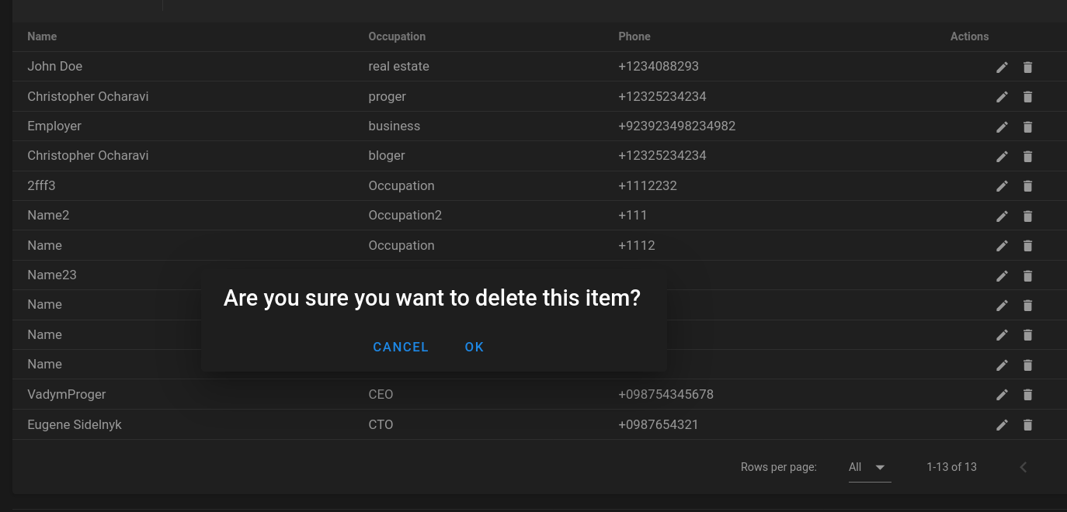
Після видалення:
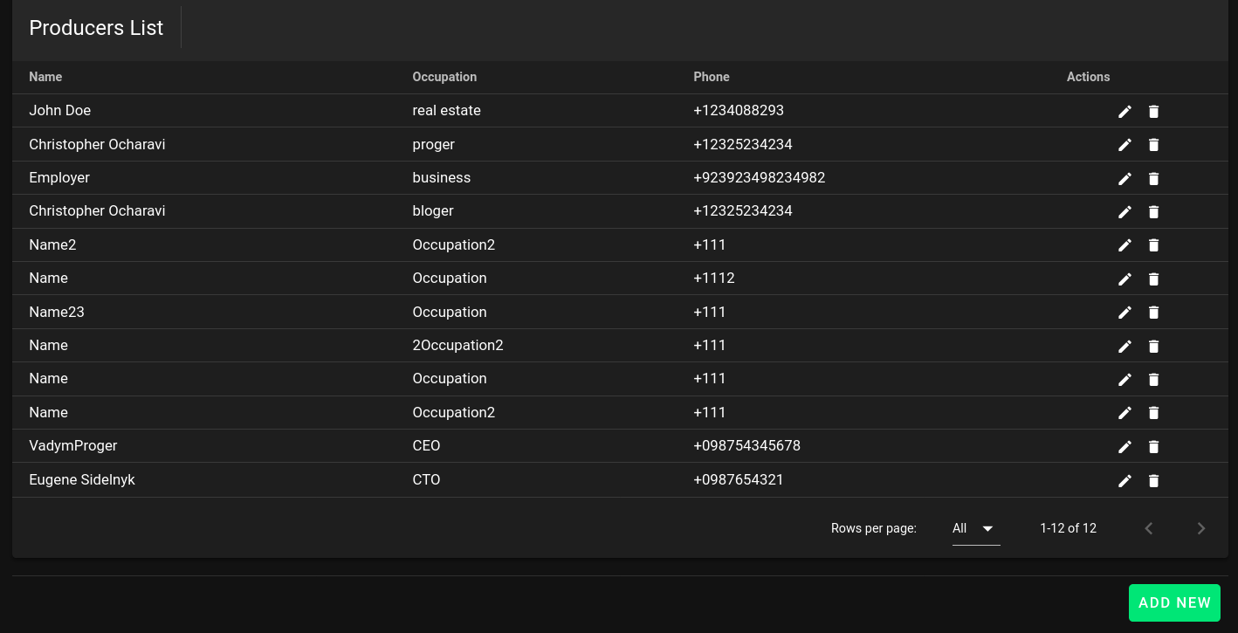

З employees аналогічно:

Список усіх:

Додавання нового:
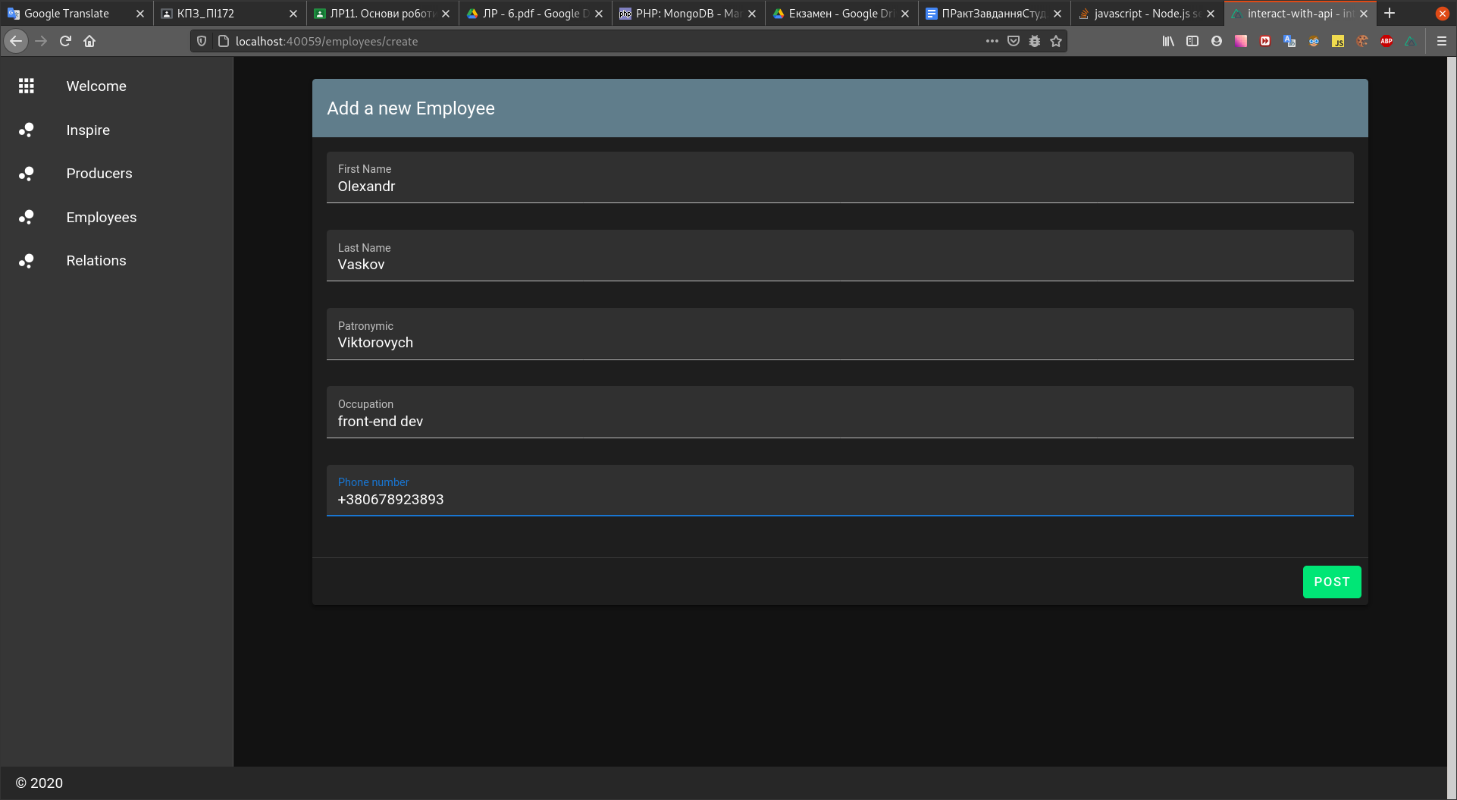

Редагування:
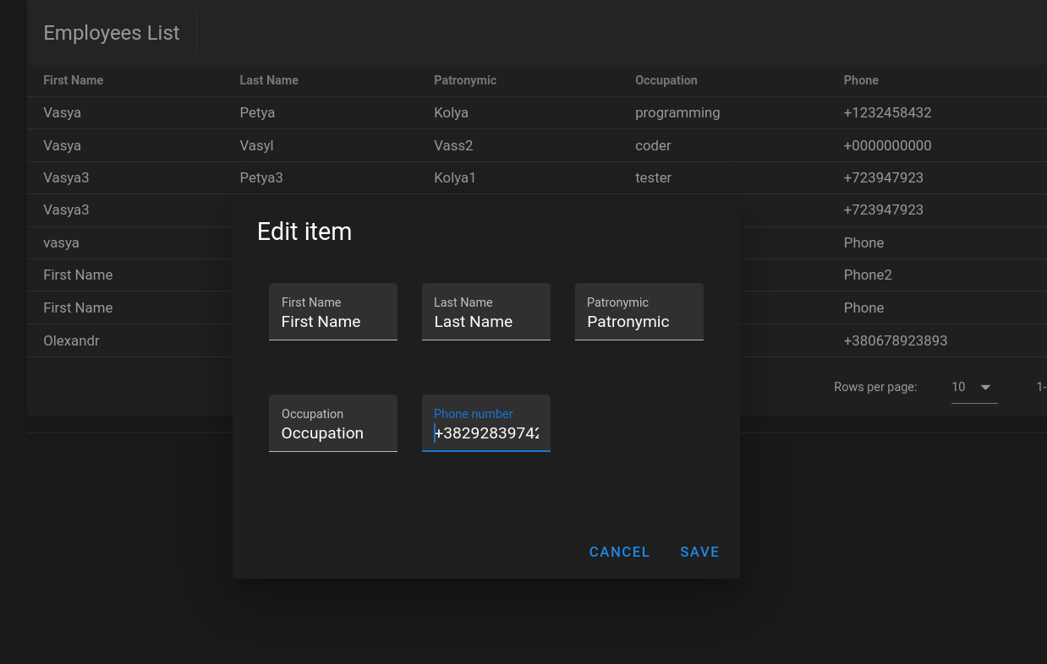
Видалення:
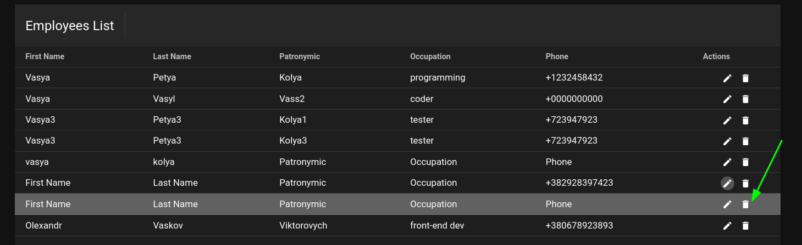
Підтвердження:
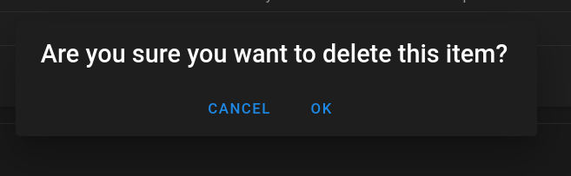

Перейдемо до контрактів.

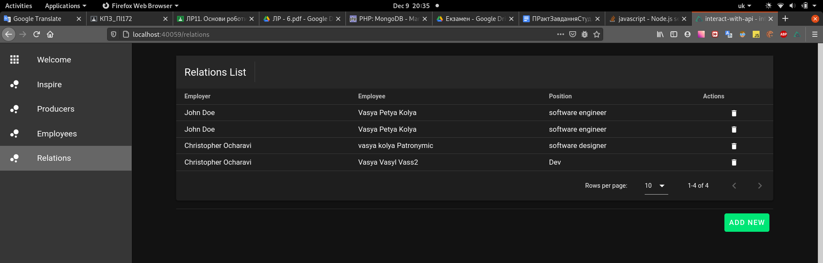

Додаємо новий контракт:

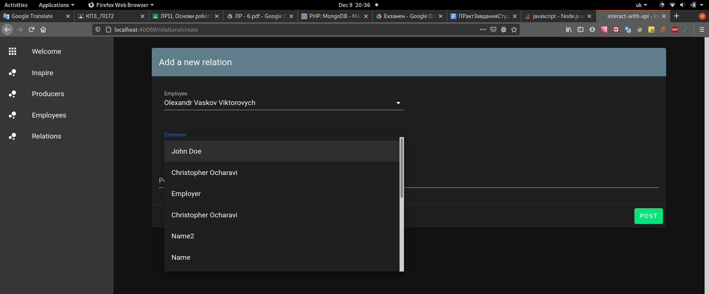

Було додано новий запис:
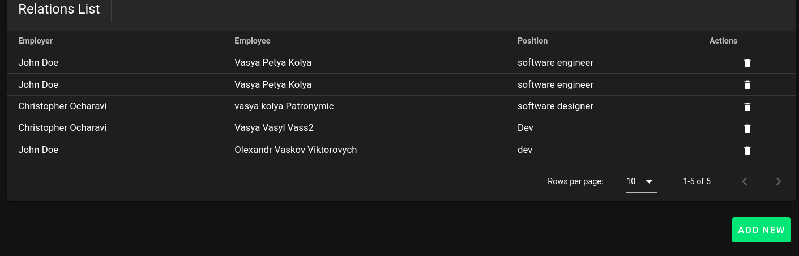

Видалення записа:
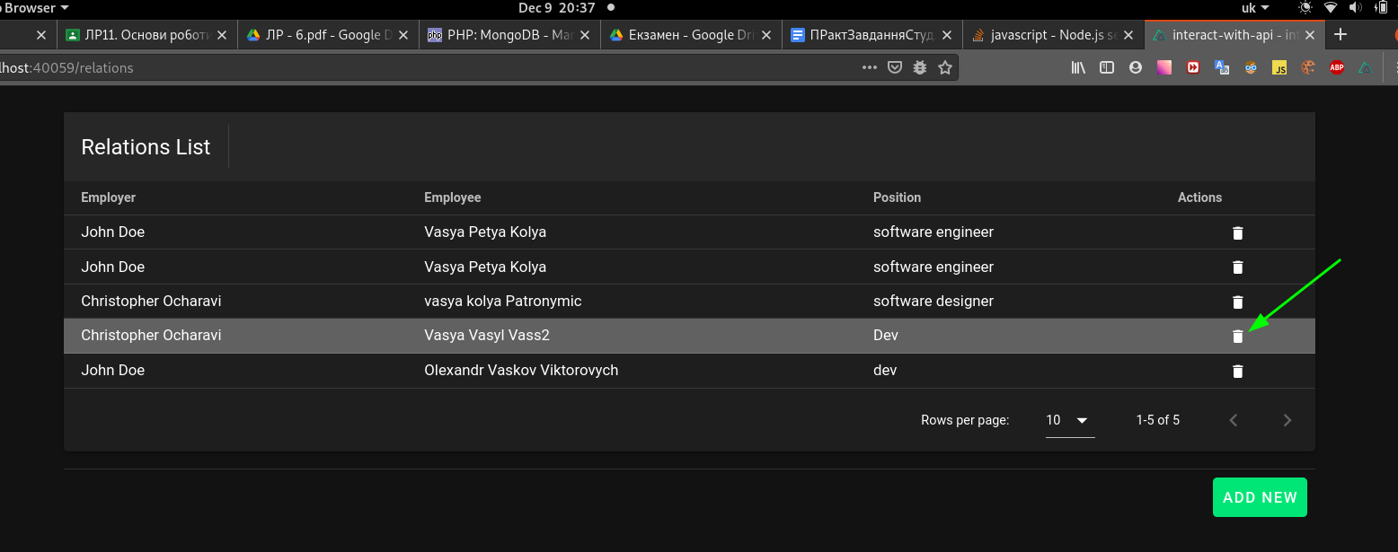

Підтвердження:

Після видалення:
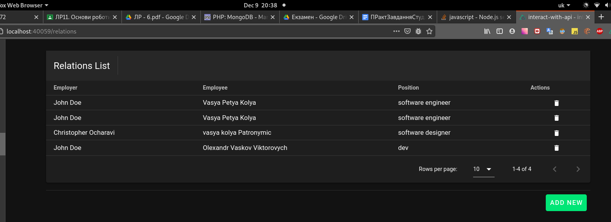

Висновок:
На цій лабораторній роботі я навчився створювати проекти з використанням Nuxt.js, Vuex.js, Vue.js, Axios, Vuetify.js та ін. Технологіями. Було створено проект “Бюро працевлаштування”, що використовує API, створений на попередній ЛР8 для збереження всіх даних.

