Практична робота №9

Основи роботи з бібліотекою React.js
Мета: навчитись створювати проті проекти на React.
Хід роботи:
Завдання

5.1. Відомості про хворих містять дані: прізвище, ім'я, по батькові, рік народження, дата надходження, діагноз, номер палати, дата виписки (якщо хворий виписався).

Порядок виконання

Створимо проект:

npx create-react-app react-first

Точка входу src/index.js:

import React from 'react';
import ReactDOM from 'react-dom';
import './index.css';
import store from "./redux/redux-store";
import App from './App';
import reportWebVitals from './reportWebVitals';
import {BrowserRouter} from "react-router-dom";
import {Provider} from "react-redux";
ReactDOM.render(
<BrowserRouter>
<Provider store={store}>
<App/>
</Provider>
</BrowserRouter>,
document.getElementById('root')
);
// If you want to start measuring performance in your app, pass a function
// to log results (for example: reportWebVitals(console.log))
// or send to an analytics endpoint. Learn more: https://bit.ly/CRA-vitals
reportWebVitals();

Компонент src/App.js:
import React from 'react'
import './App.css';
import Navbar from "./components/Navbar";
import {Route} from "react-router";
import PatientsContainer from "./components/Patients/PatientsContainer";
const App = () => {
return (
<div>
<Navbar/>
<div className='container px-lg-4'>
<Route path={'/'} exact component={PatientsContainer}/>
</div>
</div>
)
};
export default App;

Сховище src/redux/redux-store.js:
import {combineReducers, createStore} from "redux";
import patientsReducer from "./patients-reducer";
let reducers = combineReducers({
patientsPage: patientsReducer
});
let store = createStore(reducers);
window.store = store;
export default store;

Опис змін стану src/redux/patients-reducer.js:
const ADD_PATIENT = 'ADD-PATIENT';
const UPDATE_NEW_NAME_TEXT = 'UPDATE_NEW_NAME_TEXT';
const UPDATE_NEW_SURNAME_TEXT = 'UPDATE_NEW_SURNAME_TEXT';
const UPDATE_NEW_PATRONYMIC_TEXT = 'UPDATE_NEW_PATRONYMIC_TEXT';
const UPDATE_NEW_BIRTHDAY_TEXT = 'UPDATE_NEW_BIRTHDAY_TEXT';
const UPDATE_NEW_DIAGNOSIS_TEXT = 'UPDATE_NEW_DIAGNOSIS_TEXT';
const UPDATE_NEW_ROOM_TEXT = 'UPDATE_NEW_ROOM_TEXT';
const UPDATE_NEW_OUT_TEXT = 'UPDATE_NEW_OUT_TEXT';
let initialState = {
patients: [
{
name: 'Robert',
surname: 'Bob',
patronymic: 'Dooms',
birthday: '12/12/2002',
diagnosis: 'COVID-19',
numberRoom: '2',
dataOut: '12/12/2002'
}
],
newNameText: '',
newSurnameText: '',
newPatronymicText: '',
newBirthdayText: '',
newDiagnosisText: '',
newNumberRoomText: '',
newDataOutText: ''
}
const patientsReducer = (state = initialState, action) => {
switch (action.type) {
case ADD_PATIENT: {
let newPatient = {
name: state.newNameText,
surname: state.newSurnameText,
patronymic: state.newPatronymicText,
birthday: state.newBirthdayText,
diagnosis: state.newDiagnosisText,
numberRoom: state.newNumberRoomText,
dataOut: state.newDataOutText
};
return {
...state,
patients: [...state.patients, newPatient],
newNameText: '',
newSurnameText: '',
newPatronymicText: '',
newBirthdayText: '',
newDiagnosisText: '',
newNumberRoomText: '',
newDataOutText: ''
}
}
case UPDATE_NEW_NAME_TEXT: {
return {
...state,
newNameText: action.newName
}
}
case UPDATE_NEW_SURNAME_TEXT: {
return {
...state,
newSurnameText: action.newSurname
}
}
case UPDATE_NEW_PATRONYMIC_TEXT: {
return {
...state,
newPatronymicText: action.newPatronymic
}
}
case UPDATE_NEW_BIRTHDAY_TEXT: {
return {
...state,
newBirthdayText: action.newBirthday
}
}
case UPDATE_NEW_DIAGNOSIS_TEXT: {
return {
...state,
newDiagnosisText: action.newDiagnosis
}
}
case UPDATE_NEW_ROOM_TEXT: {
return {
...state,
newNumberRoomText: action.newNumberRoom
}
}
case UPDATE_NEW_OUT_TEXT: {
return {
...state,
newDataOutText: action.newDataOut
}
}
default:
return state
}
}
export const addPatientAC = () => ({type: ADD_PATIENT})
export const updateNewNameChangeAC = (text) => ({
type: UPDATE_NEW_NAME_TEXT, newName: text
})
export const updateNewSurnameChangeAC = (text) => ({
type: UPDATE_NEW_SURNAME_TEXT, newSurname: text
})
export const updateNewPatronymicChangeAC = (text) => ({
type: UPDATE_NEW_PATRONYMIC_TEXT, newPatronymic: text
})
export const updateNewBirthdayChangeAC = (text) => ({
type: UPDATE_NEW_BIRTHDAY_TEXT, newBirthday: text
})
export const updateNewDiagnosisChangeAC = (text) => ({
type: UPDATE_NEW_DIAGNOSIS_TEXT, newDiagnosis: text
})
export const updateNewNumberRoomChangeAC = (text) => ({
type: UPDATE_NEW_ROOM_TEXT, newNumberRoom: text
})
export const updateNewDataOutChangeAC = (text) => ({
type: UPDATE_NEW_OUT_TEXT, newDataOut: text
})
export default patientsReducer;

Компонент src/components/Patients/Patients.jsx:
import React from 'react'
import './Patient.css';
const Patient = (props) => {
let addPatient = () => {
props.addPatient();
}
let onNameChange = () => {
let text = newNameElement.current.value;
props.updateNewNameChange(text)
}
let onSurnameChange = () => {
let text = newSurnameElement.current.value;
props.updateNewSurnameChange(text)
}
let onPatronymicChange = () => {
let text = newPatronymicElement.current.value;
props.updateNewPatronymicChange(text)
}
let onBirthdayChange = () => {
let text = newBirthdayElement.current.value;
props.updateNewBirthdayChange(text)
}
let onDiagnosisChange = () => {
let text = newDiagnosisElement.current.value;
props.updateNewDiagnosisChange(text)
}
let onNumberRoomChange = () => {
let text = newNumberRoomElement.current.value;
props.updateNewNumberRoomChange(text)
}
let onDataOutChange = () => {
let text = newDataOutElement.current.value;
props.updateNewDataOutChange(text)
}
let newNameElement = React.createRef();
let newSurnameElement = React.createRef();
let newPatronymicElement = React.createRef();
let newBirthdayElement = React.createRef();
let newDiagnosisElement = React.createRef();
let newNumberRoomElement = React.createRef();
let newDataOutElement = React.createRef();
return (
<div className='text-center'>
{props.patients.map(p => (<div>
<span>
<div className='text'>Ім'я - {p.name}</div>
<div className='text'>Прізвище - {p.surname}</div>
<div className='text'>Фамілія - {p.patronymic}</div>
<div className='text'>Дата народження - {p.birthday}</div>
<div className='text'>Діагноз - {p.diagnosis}</div>
<div className='text'>Номер кімнати - {p.numberRoom}</div>
<div className='text'>Дата випуску - {p.dataOut}</div>
<hr className='line'/>
</span>
</div>))}
<div className='text-padding'>
<input onChange={onNameChange} ref={newNameElement} value={props.newNameText} type="text"
className="text-center" placeholder="Name" aria-label="Username"
aria-describedby="basic-addon1"/>
</div>
<div className='text-padding'>
<input onChange={onSurnameChange} ref={newSurnameElement} value={props.newSurnameText} type="text"
className="text-center" placeholder="Surname" aria-label="Username"
aria-describedby="basic-addon1"/>
</div>
<div className='text-padding'>
<input onChange={onPatronymicChange} ref={newPatronymicElement} value={props.newPatronymicText}
type="text" className="text-center" placeholder="Patronymic" aria-label="Username"
aria-describedby="basic-addon1"/>
</div>
<div className='text-padding'>
<input onChange={onBirthdayChange} ref={newBirthdayElement} value={props.newBirthdayText} type="date"
className="text-center" placeholder="Birthday" aria-label="Username"
aria-describedby="basic-addon1"/>
</div>
<div className='text-padding'>
<input onChange={onDiagnosisChange} ref={newDiagnosisElement} value={props.newDiagnosisText} type="text"
className="text-center" placeholder="Diagnosis" aria-label="Username"
aria-describedby="basic-addon1"/>
</div>
<div className='text-padding'>
<input onChange={onNumberRoomChange} ref={newNumberRoomElement} value={props.newNumberRoomText}
type="text" className="text-center" placeholder="Number Room" aria-label="Username"
aria-describedby="basic-addon1"/>
</div>
<div className='text-padding'>
<input onChange={onDataOutChange} ref={newDataOutElement} value={props.newDataOutText} type="date"
className="text-center" placeholder="Date Out" aria-label="Username"
aria-describedby="basic-addon1"/>
</div>
<button onClick={addPatient} type="button" className="btn btn-outline-primary">Відправити</button>
</div>
)
}
export default Patient;

Контейнер, що зв’язує події та їх обробники (actions)
src/components/Patients/PatientsContainer.jsx:
import React from 'react'
import Patient from "./Patients";
import {connect} from "react-redux";
import {
addPatientAC, updateNewBirthdayChangeAC,
updateNewDataOutChangeAC, updateNewDiagnosisChangeAC,
updateNewNameChangeAC, updateNewNumberRoomChangeAC,
updateNewPatronymicChangeAC, updateNewSurnameChangeAC
} from "../../redux/patients-reducer";
let mapStateToProps = (state) => {
return {
patients: state.patientsPage.patients,
newNameText: state.patientsPage.newNameText,
newSurnameText: state.patientsPage.newSurnameText,
newPatronymicText: state.patientsPage.newPatronymicText,
newBirthdayText: state.patientsPage.newBirthdayText,
newDiagnosisText: state.patientsPage.newDiagnosisText,
newNumberRoomText: state.patientsPage.newNumberRoomText,
newDataOutText: state.patientsPage.newDataOutText
}
}
let mapDispatchToProps = (dispatch) => {
return {
addPatient: () => {
dispatch(addPatientAC())
},
updateNewNameChange: (text) => {
let action = updateNewNameChangeAC(text);
dispatch(action)
},
updateNewSurnameChange: (text) => {
let action = updateNewSurnameChangeAC(text);
dispatch(action)
},
updateNewPatronymicChange: (text) => {
let action = updateNewPatronymicChangeAC(text);
dispatch(action)
},
updateNewBirthdayChange: (text) => {
let action = updateNewBirthdayChangeAC(text);
dispatch(action)
},
updateNewDiagnosisChange: (text) => {
let action = updateNewDiagnosisChangeAC(text);
dispatch(action)
},
updateNewNumberRoomChange: (text) => {
let action = updateNewNumberRoomChangeAC(text);
dispatch(action)
},
updateNewDataOutChange: (text) => {
let action = updateNewDataOutChangeAC(text);
dispatch(action)
}
}
}
export default connect(mapStateToProps, mapDispatchToProps)(Patient);

Запустивши за допомогою `yarn serve`, в браузері можемо бачити наступне:

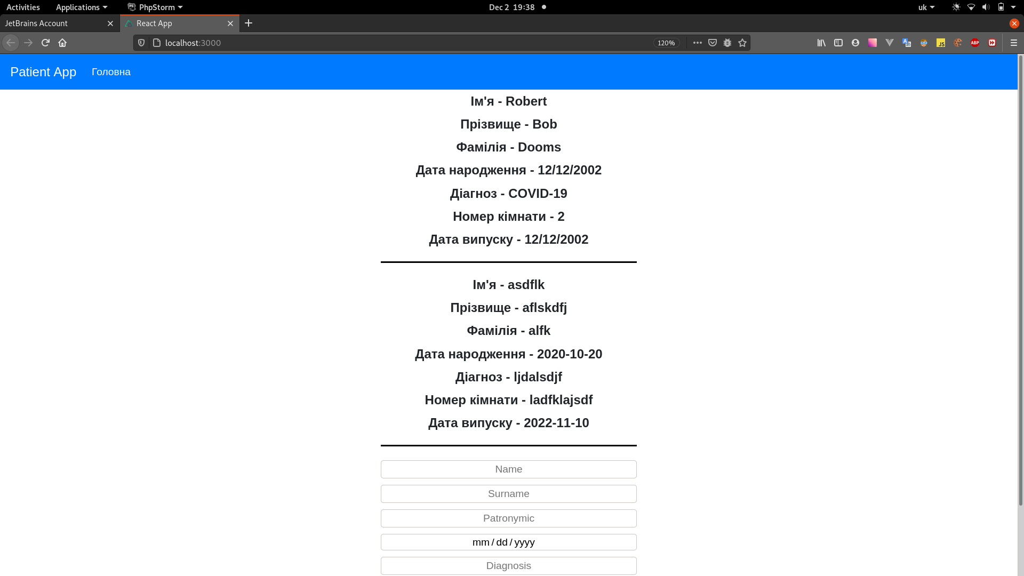

Додамо нового пацієнта:
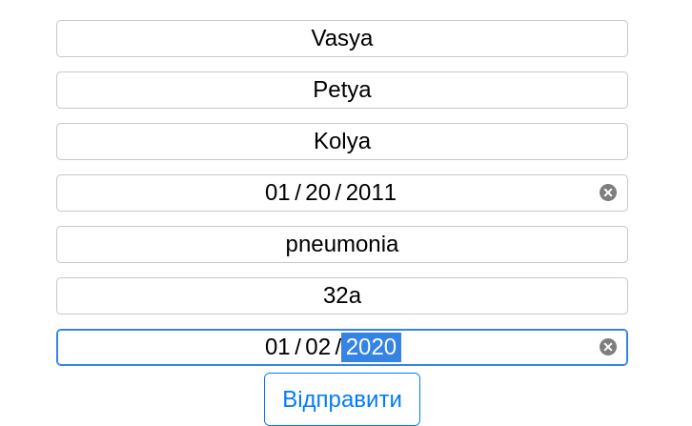

І можемо тепер бачити його в загальному списку:
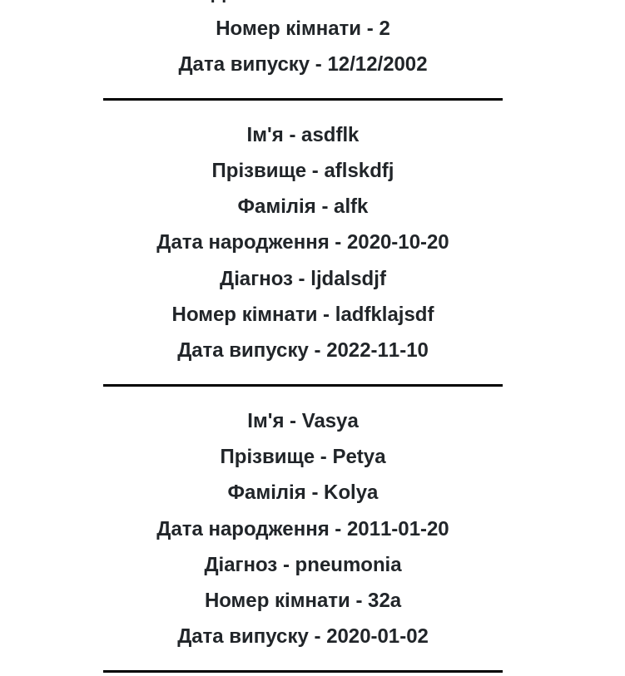

5.2. Плеєр (трек, виконавець, альбом, плейліст)

src/index.js:
import React from 'react';
import ReactDOM from 'react-dom';
import './index.css';
import store from "./redux/redux-store";
import App from './App';
import reportWebVitals from './reportWebVitals';
import {BrowserRouter} from "react-router-dom";
import {Provider} from "react-redux";
ReactDOM.render(
<BrowserRouter>
<Provider store={store}>
<App/>
</Provider>
</BrowserRouter>,
document.getElementById('root')
);
// If you want to start measuring performance in your app, pass a function
// to log results (for example: reportWebVitals(console.log))
// or send to an analytics endpoint. Learn more: https://bit.ly/CRA-vitals
reportWebVitals();
src/App.js:
import React from 'react'
import './App.css';
import Navbar from "./components/Navbar";
import {Route} from "react-router";
import PlaylistsContainer from "./components/Playlists/PlaylistsContainer";
import TracksContainer from "./components/Tracks/TracksContainer";
import AuthorsContainer from "./components/Authors/AuthorsContainer";
const App = () => {
return (
<div>
<Navbar/>
<div className='container px-lg-4'>
<Route path='/playlist' render={() => <PlaylistsContainer/>}/>
<Route path='/tracks' render={() => <TracksContainer/>}/>
<Route path='/author' render={() => <AuthorsContainer/>}/>
</div>
</div>
)
};
export default App;
src/redux/redux-store.js:
import {combineReducers, createStore} from "redux";
import tracksReducer from "./track-reducer";
let reducers = combineReducers({
tracksPage: tracksReducer
});
let store = createStore(reducers);
window.store = store;
export default store;

src/redux/track-reducer.js:
const ADD_TRACK = 'ADD-TRACK';
const UPDATE_NEW_TRACK_TEXT = 'UPDATE-NEW-TRACK-TEXT';
const UPDATE_NEW_AUTHOR_TEXT = 'UPDATE-NEW-AUTHOR-TEXT';
const UPDATE_NEW_URL_TEXT = 'UPDATE-NEW-URL-TEXT';
const UPDATE_NEW_ALBUM_TEXT = 'UPDATE-NEW-ALBUM-TEXT';
const UPDATE_NEW_PLAYLIST_TEXT = 'UPDATE-NEW-PLAYLIST-TEXT';
let initialState = {
tracks: [
{
track: 'new track',
author: 'new Author',
url: 'https://holychords.com/uploads/music/20200701/20200701164535_58.mp3',
album: 'new album',
playlist: 'new playlist'
}
],
newTrackText: '',
newAuthorText: '',
newUrlText: '',
newAlbumText: '',
newPlaylistText: ''
}
const tracksReducer = (state = initialState, action) => {
switch (action.type) {
case ADD_TRACK: {
let newTrack = {
track: state.newTrackText,
author: state.newAuthorText,
url: state.newUrlText,
album: state.newAlbumText,
playlist: state.newPlaylistText
}
return {
...state,
tracks: [...state.tracks, newTrack],
newTrackText: '',
newAuthorText: '',
newUrlText: '',
newAlbumText: '',
newPlaylistText: ''
}
}
case UPDATE_NEW_TRACK_TEXT: {
return {
...state,
newTrackText: action.newTrack
}
}
case UPDATE_NEW_AUTHOR_TEXT: {
return {
...state,
newAuthorText: action.newAuthor
}
}
case UPDATE_NEW_URL_TEXT: {
return {
...state,
newUrlText: action.newUrl
}
}
case UPDATE_NEW_ALBUM_TEXT: {
return {
...state,
newAlbumText: action.newAlbum
}
}
case UPDATE_NEW_PLAYLIST_TEXT: {
return {
...state,
newPlaylistText: action.newPlaylist
}
}
default :
return state
}
}
export const addTracksAC = () => ({type: ADD_TRACK})
export const updateNewTrackChangeAC = (text) => ({
type: UPDATE_NEW_TRACK_TEXT, newTrack: text
})
export const updateNewAuthorChangeAC = (text) => ({
type: UPDATE_NEW_AUTHOR_TEXT, newAuthor: text
})
export const updateNewUrlChangeAC = (text) => ({
type: UPDATE_NEW_URL_TEXT, newUrl: text
})
export const updateNewAlbumChangeAC = (text) => ({
type: UPDATE_NEW_ALBUM_TEXT, newAlbum: text
})
export const updateNewPlaylistChangeAC = (text) => ({
type: UPDATE_NEW_PLAYLIST_TEXT, newPlaylist: text
})
export default tracksReducer;
src/components/Navbar.jsx:
import React from 'react'
import {NavLink} from "react-router-dom";
const Navbar = () => (
<nav className='navbar navbar-dark navbar-expand-lg bg-primary'>
<div className='navbar-brand'>
Music App
</div>
<ul className='navbar-nav'>
<NavLink className='nav-link' to='tracks' exact>Всі треки</NavLink>
<NavLink className='nav-link' to='playlist' exact>Плейлист</NavLink>
<NavLink className='nav-link' to='author' exact>Виконавці</NavLink>
</ul>
</nav>
)
export default Navbar;

src/components/Tracks/Tracks.jsx:
import React from 'react'
import './Tracks.css'
const Tracks = (props) => {
let addTrack = () => {
props.addTrack();
}
let onTrackChange = () => {
let text = newTrackElement.current.value;
props.updateNewTrackChange(text)
}
let onAuthorChange = () => {
let text = newAuthorElement.current.value;
props.updateNewAuthorChange(text)
}
let onUrlChange = () => {
let text = newUrlElement.current.value;
props.updateNewUrlChange(text)
}
let onAlbumChange = () => {
let text = newAlbumElement.current.value;
props.updateNewAlbumChange(text)
}
let onPlaylistChange = () => {
let text = newPlaylistElement.current.value;
props.updateNewPlaylistChange(text)
}
let newTrackElement = React.createRef();
let newAuthorElement = React.createRef();
let newUrlElement = React.createRef();
let newAlbumElement = React.createRef();
let newPlaylistElement = React.createRef();
return (
<div>
<div>{props.tracks.map(t => (<div>
<div className='text'>Трек - {t.track}</div>
<audio controls src={t.url} />
<div className='text'>Посилання - {t.url}</div>
<div className='text'>Альбом - {t.album}</div>
<div className='text'>-----------------------------------</div>
</div>))}</div>
<div className='text-padding'>
<input onChange={onTrackChange} ref={newTrackElement} value={props.newTrackText} type="text"
className="text-center" placeholder="Track" aria-label="Username"
aria-describedby="basic-addon1"/>
</div>
<div className='text-padding'>
<input onChange={onAuthorChange} ref={newAuthorElement} value={props.newAuthorText} type="text"
className="text-center" placeholder="Author" aria-label="Username"
aria-describedby="basic-addon1"/>
</div>
<div className='text-padding'>
<input onChange={onUrlChange} ref={newUrlElement} value={props.newUrlText} type="text"
className="text-center" placeholder="Url" aria-label="Username"
aria-describedby="basic-addon1"/>
</div>
<div className='text-padding'>
<input onChange={onAlbumChange} ref={newAlbumElement} value={props.newAlbumText} type="text"
className="text-center" placeholder="Album" aria-label="Username"
aria-describedby="basic-addon1"/>
</div>
<div className='text-padding'>
<input onChange={onPlaylistChange} ref={newPlaylistElement} value={props.newPlaylistText} type="text"
className="text-center" placeholder="Playlist" aria-label="Username"
aria-describedby="basic-addon1"/>
</div>
<button onClick={addTrack} type="button" className="btn btn-outline-primary">Додати</button>
</div>
)
}
export default Tracks;
src/components/Tracks/TracksContainer.jsx:
import React from 'react'
import {connect} from "react-redux";
import Tracks from "./Tracks";
import {
addTracksAC, updateNewAlbumChangeAC,
updateNewAuthorChangeAC, updateNewPlaylistChangeAC,
updateNewTrackChangeAC, updateNewUrlChangeAC
} from "../../redux/track-reducer";
let mapStateToProps = (state) => {
return {
tracks: state.tracksPage.tracks,
newTrackText: state.tracksPage.newTrackText,
newAuthorText: state.tracksPage.newAuthorText,
newUrlText: state.tracksPage.newUrlText,
newAlbumText: state.tracksPage.newAlbumText,
newPlaylistText: state.tracksPage.newPlaylistText
}
}
let mapDispatchToProps = (dispatch) => {
return {
addTrack: () => {
dispatch(addTracksAC())
},
updateNewTrackChange: (text) => {
let action = updateNewTrackChangeAC(text);
dispatch(action)
},
updateNewAuthorChange: (text) => {
let action = updateNewAuthorChangeAC(text);
dispatch(action)
},
updateNewUrlChange: (text) => {
let action = updateNewUrlChangeAC(text);
dispatch(action)
},
updateNewAlbumChange: (text) => {
let action = updateNewAlbumChangeAC(text);
dispatch(action)
},
updateNewPlaylistChange: (text) => {
let action = updateNewPlaylistChangeAC(text);
dispatch(action)
},
}
}
export default connect(mapStateToProps, mapDispatchToProps)(Tracks);

src/components/Playlists/Playlists.jsx:
import React from 'react'
import './Playlists.css'
const Playlists = (props) => {
return (
<div className='container px-lg-4'>
<strong>Список плейлистів</strong>
{props.tracks.map(p => (<div>
<div className='text'>{p.playlist}</div>
</div>))}
</div>
)
}
export default Playlists;

src/components/Playlists/PlaylistsContainer.jsx:
import React from 'react'
import {connect} from "react-redux";
import Playlists from "./Playlists";
let mapStateToProps = (state) => {
return {
tracks: state.tracksPage.tracks
}
}
let mapDispatchToProps = (dispatch) => {
}
export default connect(mapStateToProps, mapDispatchToProps)(Playlists);

src/components/Authors/Authors.jsx:
import React from 'react'
import './Authors.css'
const Authors = (props) => {
return (
<div className='container px-lg-4'>
<strong>Список авторів</strong>
{props.tracks.map(a => (<div>
<div className='text'>{a.author}</div>
</div>))}
</div>
)
}
export default Authors;

src/components/Authors/AuthorsContainer.jsx:
import React from 'react'
import {connect} from "react-redux";
import Authors from "./Authors";
let mapStateToProps = (state) => {
return {
tracks: state.tracksPage.tracks
}
}
let mapDispatchToProps = (dispatch) => {
}
export default connect(mapStateToProps, mapDispatchToProps)(Authors);

Результати виконання:

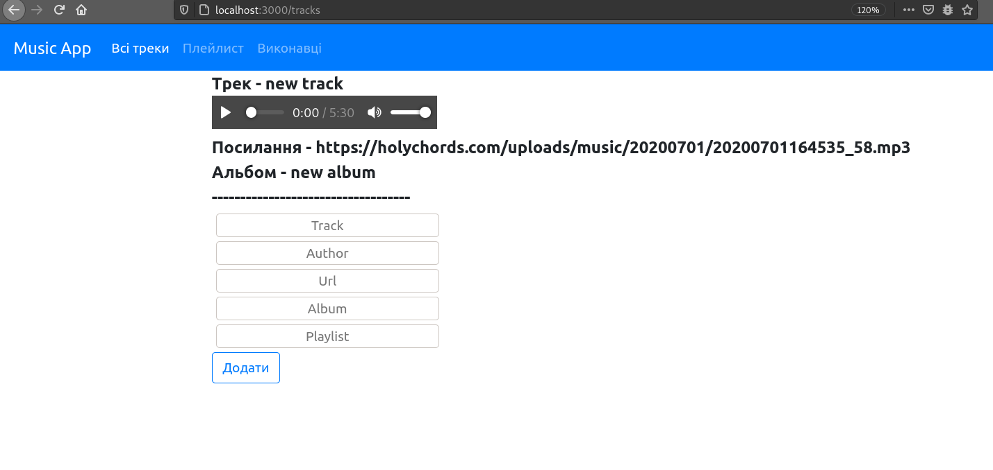

Додамо новий трек:

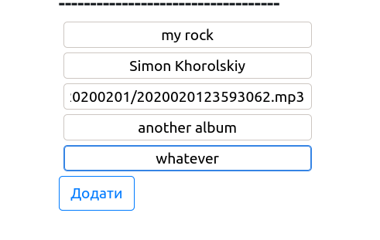

Тепер новий трек відображається в загальному списку:

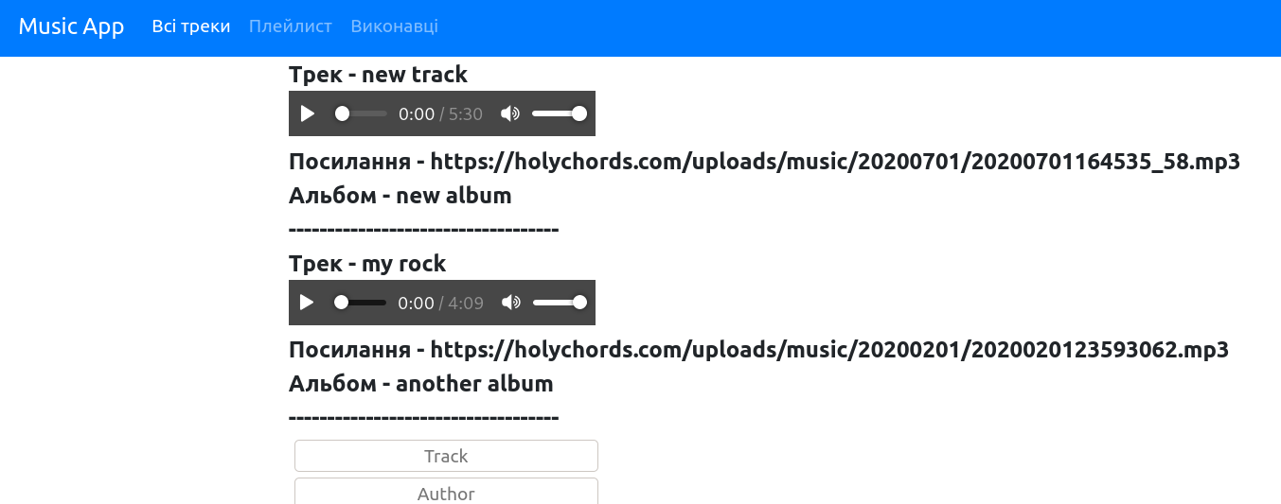
А також, оновлено список плейлистів:

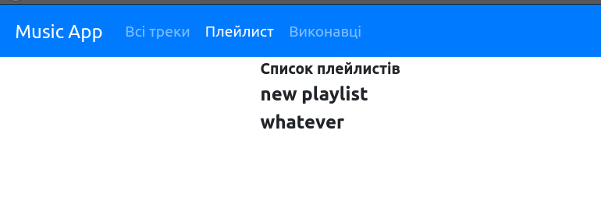
Список виконавців:
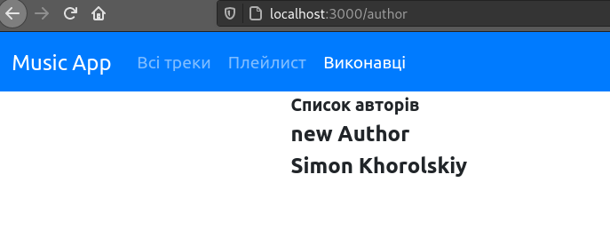

На головній сторінці ми також можемо прослуховувати додані треки:


Висновок:
На цій лабораторній роботі я приблизно зрозумів архітектуру React, розібрався в тому що таке JSX, створив простий проект згідно завдання.

