Лабораторна робота № 2

Тема: Введення в JavaScript розробку. Об'єктно-орієнтоване програмування. Класи.

Варіант №5
1.Відомості про хворих містять дані: прізвище, ім'я, по батькові, рік народження, дата надходження, діагноз, номер палати, дата виписки (якщо хворий виписався). Скласти список хворих, що знаходяться ще в лікарні і розподілити їх по палатах.

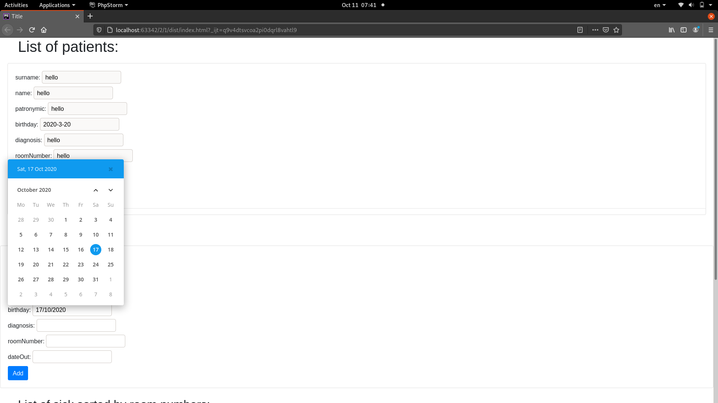

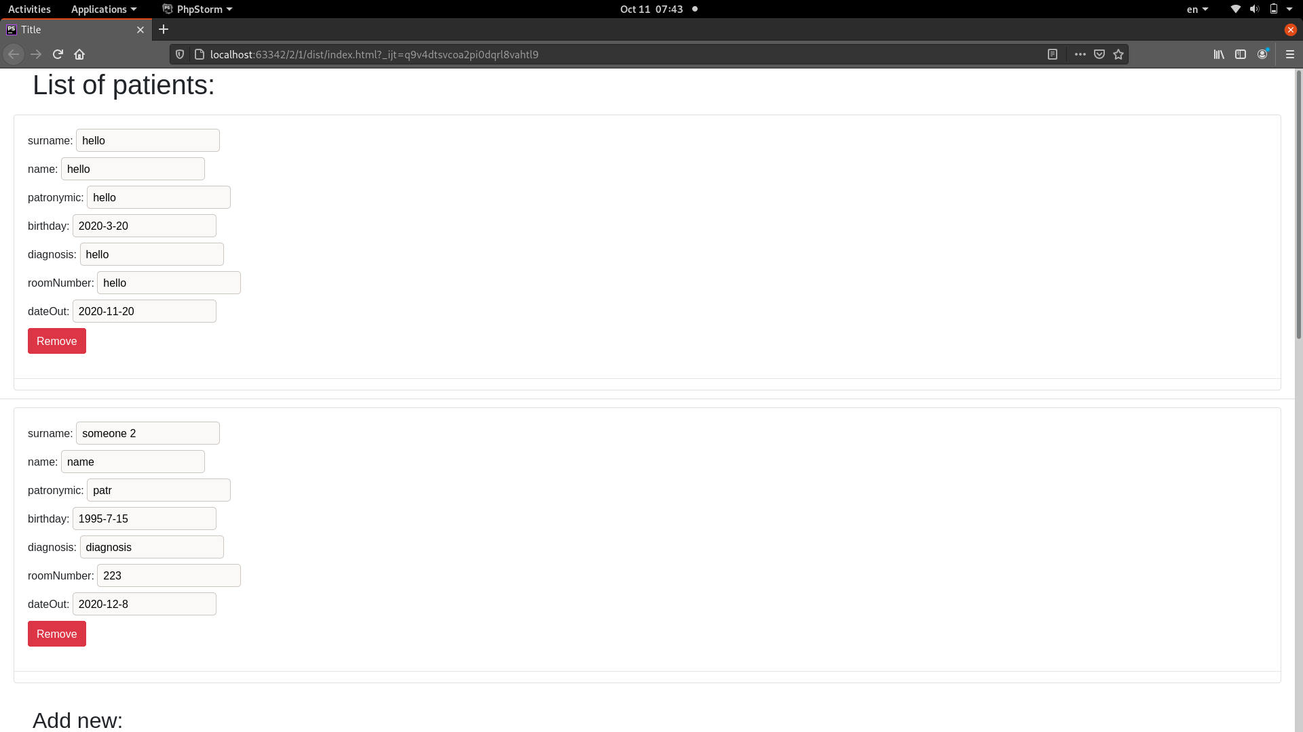

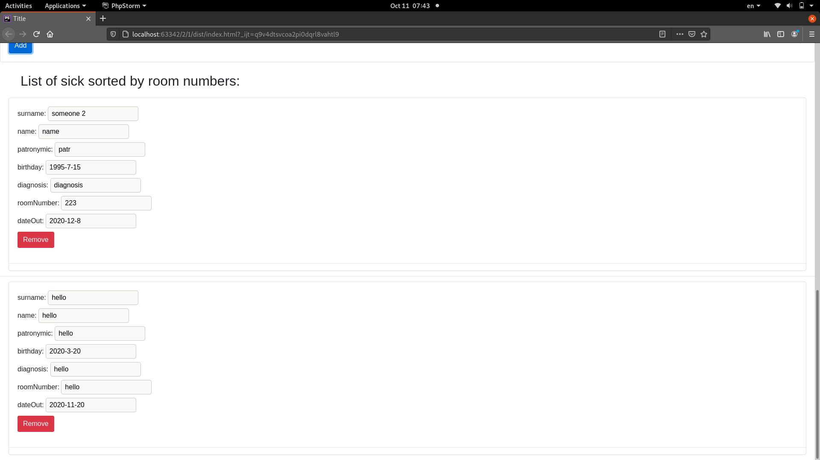

webpack.config.js:
const path = require('path')
const HtmlWebpackPlugin = require('html-webpack-plugin');
const VueLoaderPlugin = require('vue-loader/lib/plugin');
const {CleanWebpackPlugin} = require('clean-webpack-plugin');
module.exports = {
context: path.resolve(__dirname, 'src'),
mode: 'development',
entry: {
main: './index.js',
},
output: {
filename: '[name].[contenthash].js',
path: path.resolve(__dirname, 'dist')
},
plugins: [
new HtmlWebpackPlugin({
template: './index.html',
}),
new CleanWebpackPlugin({}),
new VueLoaderPlugin(),
],
optimization: {
splitChunks: {
chunks: 'all'
}
},
resolve: {
extensions: ['.js', '.vue', '.css']
},
module: {
rules: [
{
test: /\.css$/,
use: [
'style-loader',
'css-loader'
]
},
{
test: /\.vue$/,
loader: 'vue-loader'
},
]
}
}

package.json:
{
"name": "2",
"version": "1.0.0",
"description": "",
"main": "app.js",
"private": true,
"scripts": {
"dev": "webpack --mode=development",
"build": "webpack --mode=production",
"watch": "webpack --mode=development --watch",
"serve": "webpack-dev-server --mode development"
},
"author": "rela589n",
"license": "ISC",
"devDependencies": {
"clean-webpack-plugin": "^3.0.0",
"css-loader": "^4.3.0",
"html-webpack-plugin": "^4.4.1",
"style-loader": "^1.2.1",
"vue-loader": "^15.9.3",
"vue-style-loader": "^4.1.2",
"vue-template-compiler": "^2.6.12",
"webpack": "^4.44.2",
"webpack-cli": "^3.3.12",
"webpack-dev-server": "^3.11.0"
},
"dependencies": {
"vue": "^2.6.12",
"window-date-picker": "^1.0.1"
}
}

index.html:
<!DOCTYPE html>
<html lang="en">
<head>
<meta charset="UTF-8">
<title>Title</title>
<link rel="stylesheet" href="https://stackpath.bootstrapcdn.com/bootstrap/4.5.2/css/bootstrap.min.css">
</head>
<body>
<div id="app"></div>
</body>
</html>

index.js:
import Vue from 'vue';
import App from './App.vue';
new Vue({
el: '#app',
render: h => h(App),
});

App.vue:
<template>
<div id="app">
<h1 class="ml-5">List of patients:</h1>
<ul class="list-group list-group-flush">
<li class="list-group-item" v-for="(patient, index) in patients">
<patient-view :patient="patient" v-on:remove="removePatient(index)"></patient-view>
</li>
<li v-if="patients.length === 0">List is empty</li>
</ul>
<br>
<h2 class="ml-5">Add new:</h2>
<div class="card">
<add-patient-form v-on:submit="addNewPatient"></add-patient-form>
</div>
<br>
<h2 class="ml-5">List of sick sorted by room numbers:</h2>
<ul class="list-group list-group-flush">
<li class="list-group-item" v-for="(patient, index) in sickList">
<patient-view :patient="patient" v-on:remove="removePatient(index)"></patient-view>
</li>
<li v-if="sickList.length === 0">List is empty</li>
</ul>
</div>
</template>
<script>
import {Patient} from "./models/Patient.js";
import PatientView from "./vue-components/patient";
import AddPatientForm from "./vue-components/add-patient-form";
export default {
name: "App",
components: {AddPatientForm, Patient, PatientView},
data: () => ({
patients: [
new Patient(
"hello",
"hello",
"hello",
new Date(
2020,
2,
20
),
"hello",
"hello",
new Date(
2020,
10,
20
),
)
],
}),
methods: {
addNewPatient: function (e, createPatientDto) {
console.log(1);
e.preventDefault();
if (!(createPatientDto.surname && createPatientDto.name && createPatientDto.patronymic && createPatientDto.diagnosis && createPatientDto.roomNumber && createPatientDto.dateOut && createPatientDto.birthday)) {
alert('enter all fields')
return;
}
this.patients.push(
new Patient(
createPatientDto.surname,
createPatientDto.name,
createPatientDto.patronymic,
new Date(
createPatientDto.birthday.year,
createPatientDto.birthday.month,
createPatientDto.birthday.day
),
createPatientDto.diagnosis,
createPatientDto.roomNumber,
new Date(
createPatientDto.dateOut.year,
createPatientDto.dateOut.month,
createPatientDto.dateOut.day
),
)
);
e.target.reset();
Object.getOwnPropertyNames(createPatientDto).forEach(function (prop) {
delete createPatientDto[prop];
});
},
removePatient: function (index) {
this.patients.splice(index, 1);
}
},
computed: {
sickList: function () {
let notReleased = this.patients.filter(p => (new Date().setHours(0, 0, 0, 0)) < p._dateOut);
notReleased.sort((a, b) => a.roomNumber > b.roomNumber ? 1 : -1);
return notReleased;
}
}
}
</script>
<style scoped>
</style>

Patient.js:
export class Patient {
constructor(surname,
name,
patronymic,
birthday,
diagnosis,
roomNumber,
dateOut) {
this.surname = surname;
this.name = name;
this.patronymic = patronymic;
this.diagnosis = diagnosis;
this.roomNumber = roomNumber;
this._birthday = birthday;
this._dateOut = dateOut;
}
get birthday() {
return this._birthday.getFullYear() + "-" + (this._birthday.getMonth() + 1) + "-" + this._birthday.getDate();
}
get dateOut() {
return this._dateOut.getFullYear() + "-" + (this._dateOut.getMonth() + 1) + "-" + this._dateOut.getDate();
}
}

add-patient-form.vue:
<template>
<form class="card-body" @submit="delegateSubmit">
<div class="form-group">
<label class="d-block">surname: <input required type="text" class="surname"
v-model="createPatientDto.surname"></label>
</div>
<label class="d-block">name: <input required type="text" class="name" v-model="createPatientDto.name"></label>
<label class="d-block">patronymic: <input required type="text" class="patronymic"
v-model="createPatientDto.patronymic"></label>
<date-picker title="birthday" v-model="createPatientDto.birthday"></date-picker>
<label class="d-block">diagnosis: <input required type="text" class="diagnosis"
v-model="createPatientDto.diagnosis"></label>
<label class="d-block">roomNumber: <input required type="text" class="roomNumber"
v-model="createPatientDto.roomNumber"></label>
<date-picker title="dateOut" v-model="createPatientDto.dateOut"></date-picker>
<button class="btn btn-primary">Add</button>
</form>
</template>
<script>
import DatePicker from "./date-picker";
export default {
name: "add-patient-form",
components: {DatePicker},
data: function () {
return {
createPatientDto: {}
}
},
methods: {
delegateSubmit: function (e) {
this.$emit('submit', e, this.createPatientDto);
}
}
}
</script>
<style scoped>
</style>

date-picker.vue:
<template>
<div class="date-picker-wrapper">
<label>
{{ title }}:
<input type="text" :value="formatDateValue()" @focusin="openPicker" @input="closePicker">
</label>
<div class="date-picker">
</div>
</div>
</template>
<script>
import WindowDatePicker from 'window-date-picker';
export default {
name: "date-picker",
props: [
'title',
'value',
],
data: function () {
return {
picker: {},
}
},
methods: {
openPicker: function () {
this.picker.open();
},
closePicker: function () {
this.picker.close();
},
reactChange: function () {
this.$emit('input', this.picker.get());
},
formatDateValue: function () {
try {
if (!this.value.day || !this.value.month || !this.value.year) {
return '';
}
} catch (e) {
return '';
}
return `${this.value.day}/${this.value.month}/${this.value.year}`; // "DD/MM/YYYY"
}
},
mounted() {
this.picker = new WindowDatePicker({
el: this.$el.querySelector('.date-picker'),
inputEl: this.$el.querySelector('input'),
dateType: "DD/MM/YYYY",
});
this.picker.el.addEventListener('wdp.change', this.reactChange);
},
}
</script>
<style src="window-date-picker/dist/css/window-date-picker.min.css"></style>

patient.vue:
<template>
<div class="card">
<div class="card-body">
<label class="d-block">surname: <input type="text" readonly class="surname"
v-bind:value="patient.surname"></label>
<label class="d-block">name: <input type="text" readonly class="name"
v-bind:value="patient.name"></label>
<label class="d-block">patronymic: <input type="text" readonly class="patronymic"
v-bind:value="patient.patronymic"></label>
<label class="d-block">birthday: <input type="text" readonly class="birthday"
v-bind:value="patient.birthday"></label>
<label class="d-block">diagnosis: <input type="text" readonly class="diagnosis"
v-bind:value="patient.diagnosis"></label>
<label class="d-block">roomNumber: <input type="text" readonly class="roomNumber"
v-bind:value="patient.roomNumber"></label>
<label class="d-block">dateOut: <input type="text" readonly class="dateOut"
v-bind:value="patient.dateOut"></label>
<button class="btn btn-danger" @click="$emit('remove', patient)">Remove</button>
</div>
<hr>
</div>
</template>
<script>
export default {
props: ['patient'],
}
</script>

2.Плеєр (трек, виконавець, альбом, плейліст)

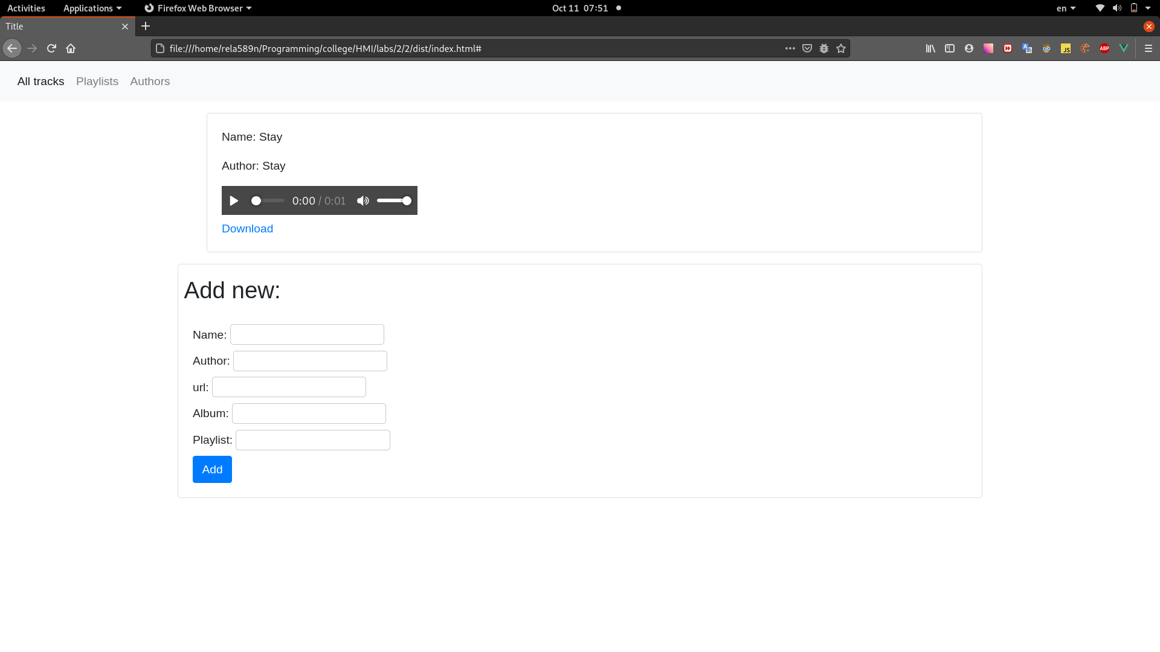

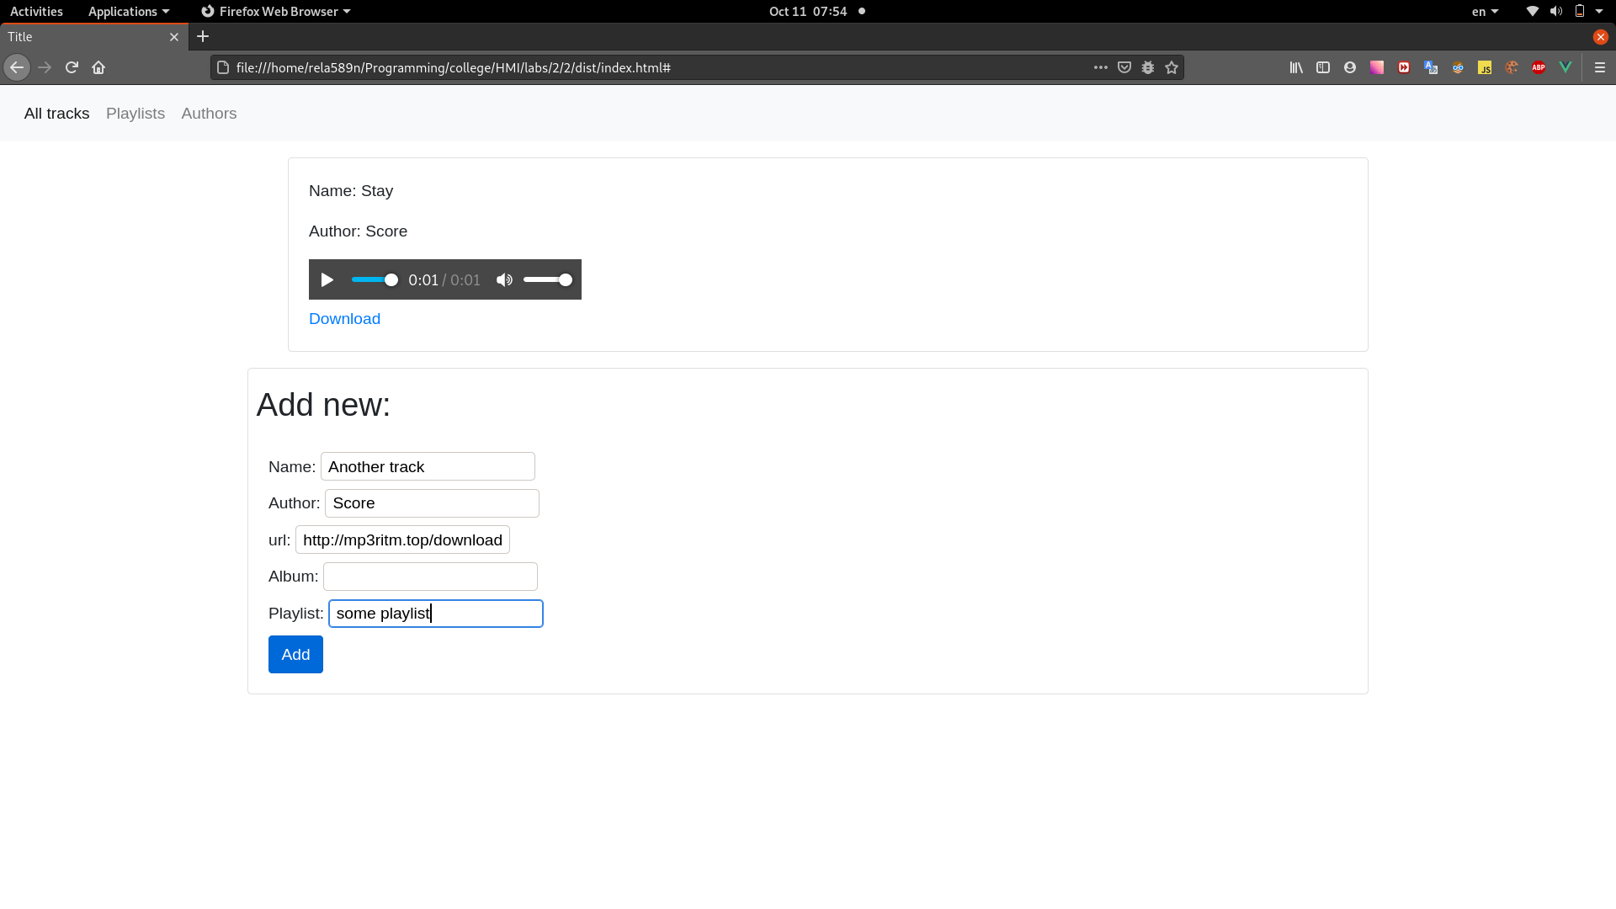

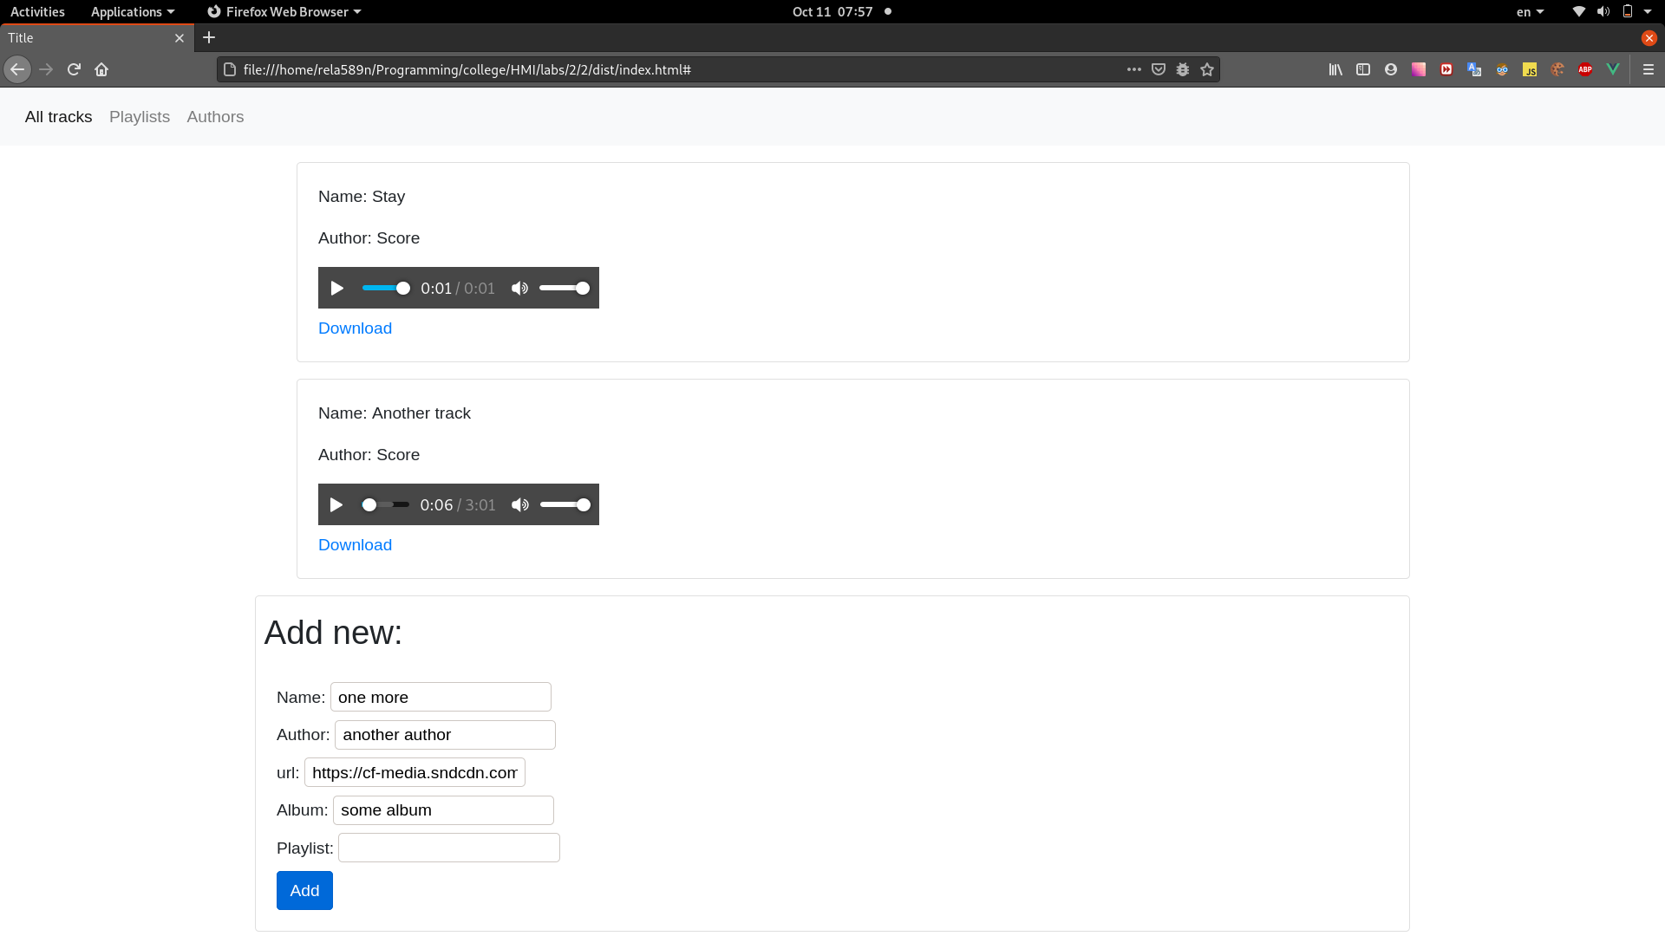

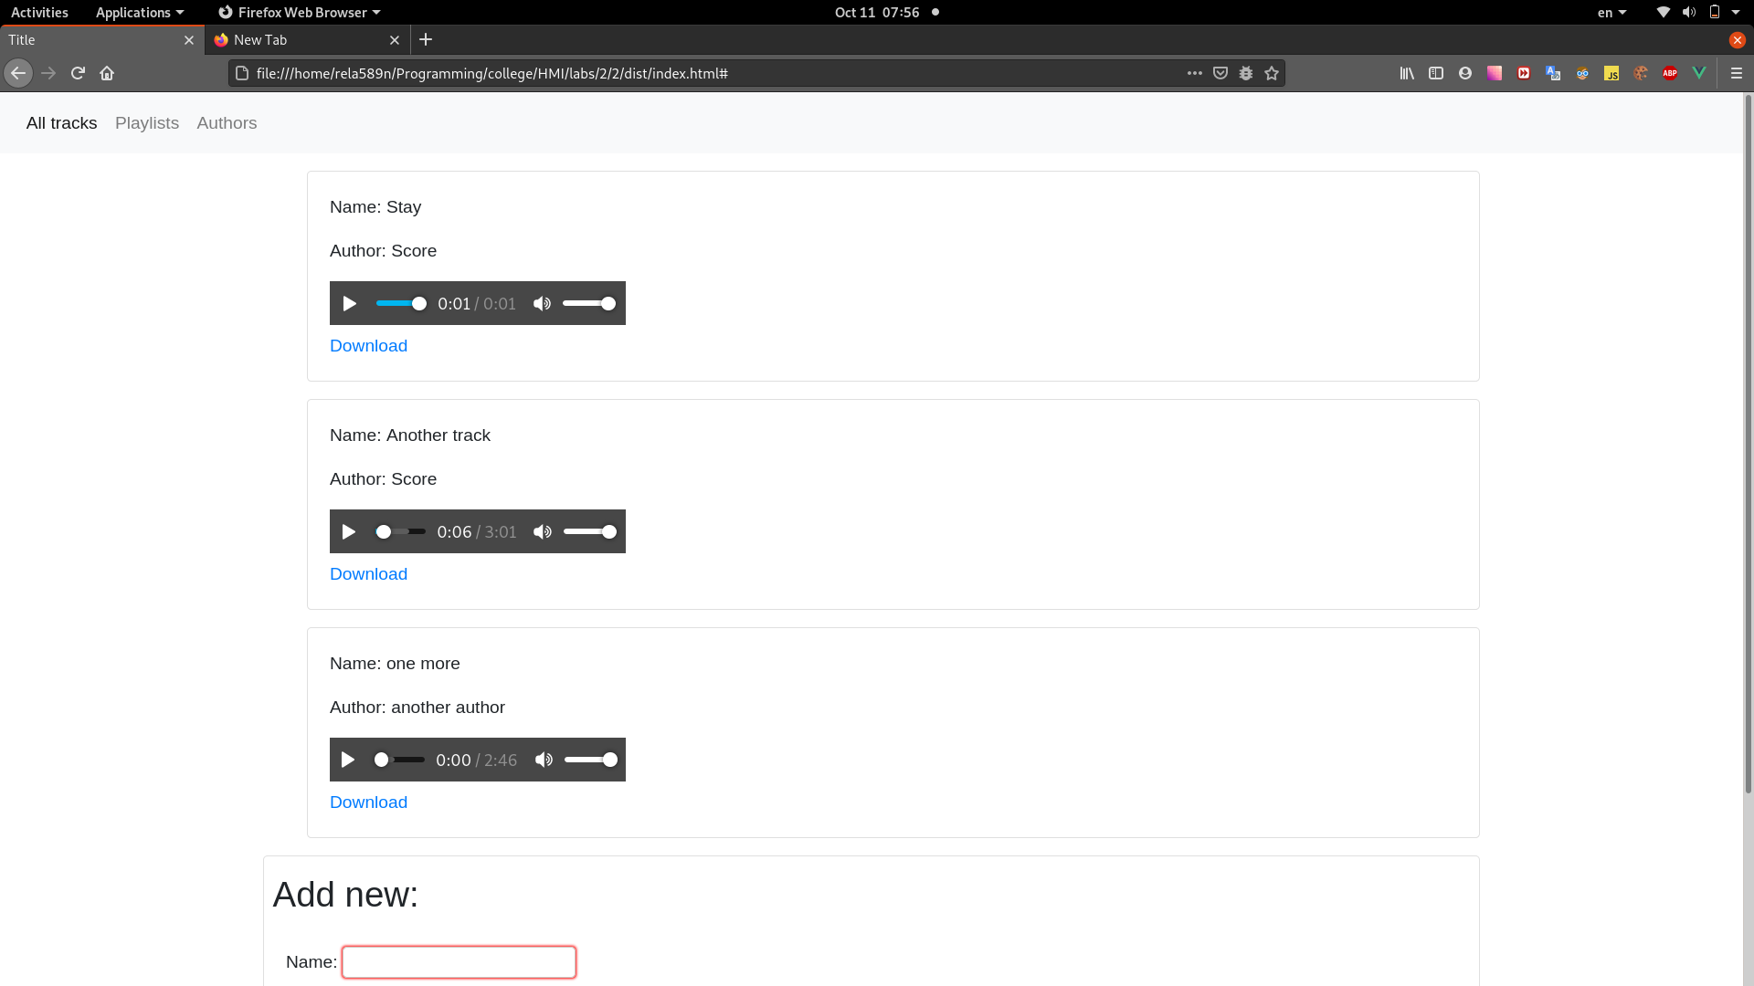

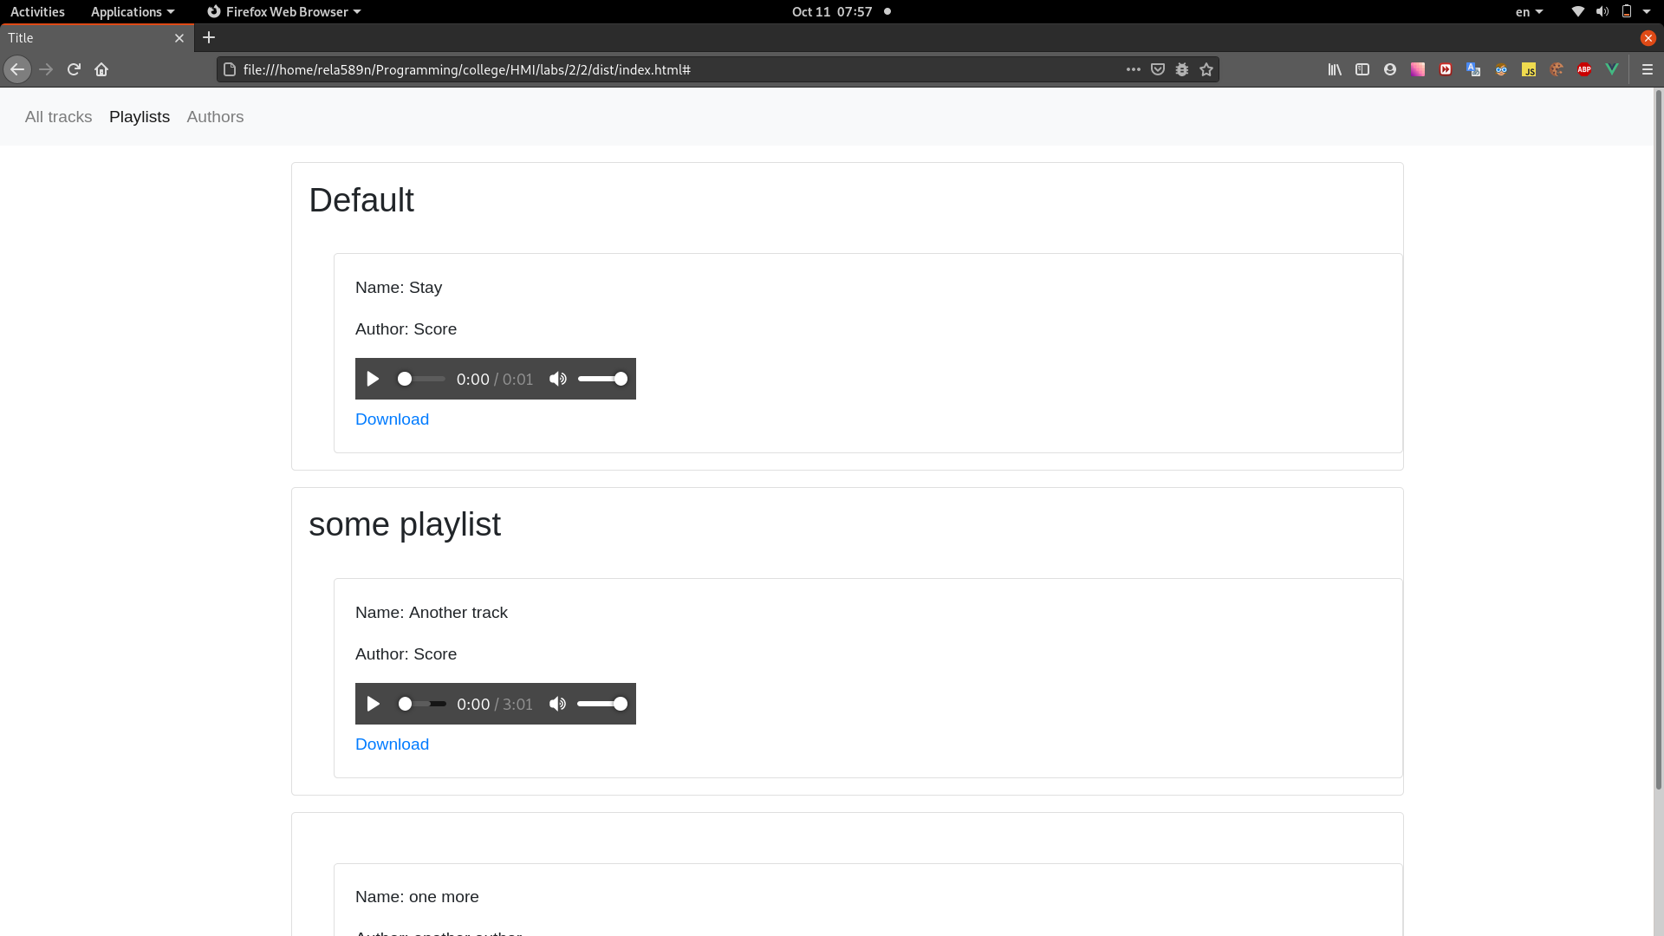

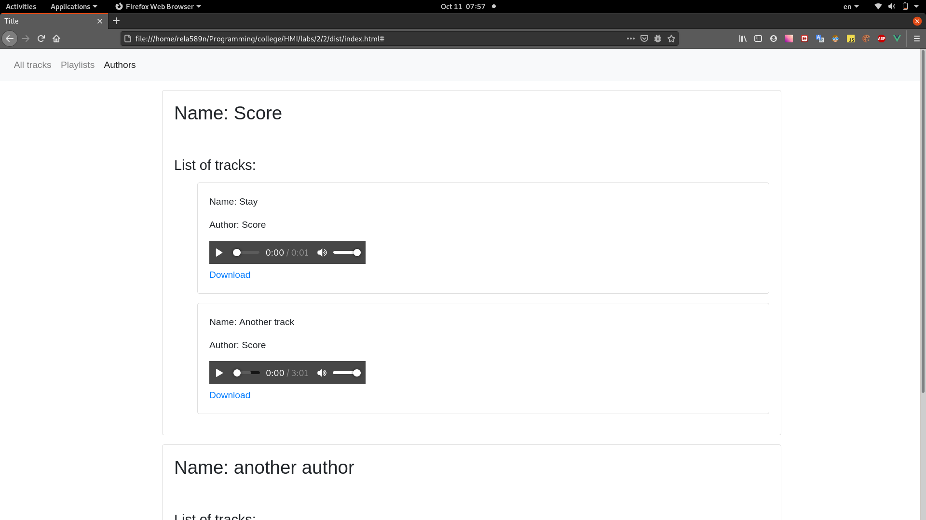

webpack.config.js:
const path = require('path')
const HtmlWebpackPlugin = require('html-webpack-plugin');
const VueLoaderPlugin = require('vue-loader/lib/plugin');
const {CleanWebpackPlugin} = require('clean-webpack-plugin');
module.exports = {
context: path.resolve(__dirname, 'src'),
mode: 'development',
entry: {
main: './index.js',
},
output: {
filename: '[name].[contenthash].js',
path: path.resolve(__dirname, 'dist')
},
plugins: [
new HtmlWebpackPlugin({
template: './index.html',
}),
new CleanWebpackPlugin({}),
new VueLoaderPlugin(),
],
optimization: {
splitChunks: {
chunks: 'all'
}
},
resolve: {
extensions: ['.js', '.vue', '.css']
},
module: {
rules: [
{
test: /\.css$/,
use: [
'style-loader',
'css-loader'
]
},
{
test: /\.vue$/,
loader: 'vue-loader'
},
]
}
}

package.json:
{
"name": "2",
"version": "1.0.0",
"description": "",
"main": "app.js",
"private": true,
"scripts": {
"dev": "webpack --mode=development",
"build": "webpack --mode=production",
"watch": "webpack --mode=development --watch",
"serve": "webpack-dev-server --mode development"
},
"author": "rela589n",
"license": "ISC",
"devDependencies": {
"clean-webpack-plugin": "^3.0.0",
"css-loader": "^4.3.0",
"html-webpack-plugin": "^4.4.1",
"style-loader": "^1.2.1",
"vue-loader": "^15.9.3",
"vue-style-loader": "^4.1.2",
"vue-template-compiler": "^2.6.12",
"webpack": "^4.44.2",
"webpack-cli": "^3.3.12",
"webpack-dev-server": "^3.11.0"
},
"dependencies": {
"uuid": "^8.3.0",
"vue": "^2.6.12",
"window-date-picker": "^1.0.1"
}
}
index.js:
import Vue from 'vue';
import App from './App.vue';
new Vue({
el: '#app',
render: h => h(App),
});

index.html:
<!DOCTYPE html>
<html lang="en">
<head>
<meta charset="UTF-8">
<title>Title</title>
<link rel="stylesheet" href="https://stackpath.bootstrapcdn.com/bootstrap/4.5.2/css/bootstrap.min.css">
</head>
<body>
<div id="app"></div>
</body>
</html>

App.vue:
<template>
<div id="app">
<app-header-menu @select-page="changePage" :current-page="currentPage"></app-header-menu>
<div class="container">
<all-tracks-list v-if="currentPage.is( 'all-tracks-list')" :tracks="tracksList"
v-on:created-new-track="handleTrackDependencies"></all-tracks-list>
<all-playlists-list v-if="currentPage.is( 'all-playlists-list')" :playlists="playlistsList"></all-playlists-list>
<authors-list v-if="currentPage.is( 'authors-list')" :authors="authorsList"></authors-list>
<single-track-page v-if="currentPage.is( 'single-track-page')" :track="selectedTrack"></single-track-page>
</div>
</div>
</template>
<script>
import AllTracksList from "./vue-components/all-tracks-list";
import SingleTrackPage from "./vue-components/single-track-page";
import AuthorsList from "./vue-components/authors-list";
import AllPlaylistsList from "./vue-components/all-playlists-list";
import AppHeaderMenu from "./vue-components/app-header-menu";
import Page from "./ValueObjects/Page.js";
import {Track} from "./models/Track";
import Playlist from "./models/Playlist";
import Author from "./models/Author";
export default {
name: "App",
components: {AppHeaderMenu, AppHeader: AppHeaderMenu, AllPlaylistsList, AuthorsList, SingleTrackPage, AllTracksList},
data: () => ({
currentPage: new Page('all-tracks-list'),
tracksList: [],
playlistsList: [
new Playlist('Default')
],
authorsList: [
new Author('Score')
],
selectedTrack: null,
}),
mounted() {
let playlist = this.playlistsList[0];
let author = this.authorsList[0];
let track = new Track('Stay', author, 'http://cd.textfiles.com/10000gp2/500SNDS/SNORT.WAV', 'don\'t know', playlist);
playlist.tracks.push(track);
author.addTrack(track);
this.tracksList.push(track);
},
methods: {
changePage: function (page) {
this.currentPage = new Page(page);
},
handleTrackDependencies: function (track) {
this.tracksList.push(track);
let author = this.authorsList.find(a => a.name === track.author)
if (author === undefined) {
this.authorsList.push(new Author(track.author, [track]));
}
else {
author.addTrack(track);
}
let playlist = this.playlistsList.find(l => l.name === track.playlist);
if (playlist === undefined) {
this.playlistsList.push(new Playlist(track.playlist, [track]));
}
else {
playlist.tracks.push(track);
}
// http://mp3ritm.top/download.php?id=92389
}
},
}
</script>
<style>
ul {
list-style-type: none;
}
</style>

Author.js:
import { v4 as uuidv4 } from 'uuid';
export default class {
constructor(name, tracks = []) {
this.name = name;
this.tracks= tracks;
this.uuid = uuidv4();
}
toString() {
return this.name;
}
addTrack(track) {
this.tracks.push(track);
}
}

Playlist.js:
import { v4 as uuidv4 } from 'uuid';
export default class {
constructor(name, tracks=[]) {
this.name = name;
this.tracks = tracks;
this.uuid = uuidv4();
}
}

Track.js:
import { v4 as uuidv4 } from 'uuid';
export class Track {
constructor(name, author, url, album, playlist) {
this._name = name;
this._author = author;
this._url = url;
this._album = album;
this._playlist = playlist;
this._uuid = uuidv4();
}
get uuid() {
return this._uuid;
}
get name() {
return this._name;
}
get author() {
return this._author;
}
get url() {
return this._url;
}
get album() {
return this._album;
}
get playlist() {
return this._playlist;
}
}

CreateTrackDtoToTrackTransformer.js:
import {Track} from "../models/Track";
export default class {
static transform(dto) {
return new Track(dto.name, dto.author, dto.url, dto.album, dto.playlist);
}
}

ValueObjects/Page.js:
export default class {
constructor(pageName) {
this.name = pageName;
}
is(pageName) {
return this.name === pageName;
}
}

all-playlists-list.vue:
<template>
<div>
<ul>
<li v-for="palylist in playlists">
<playlist-basic-view :palylist="palylist"></playlist-basic-view>
</li>
<li v-if="playlists.length === 0">There are no playlists</li>
</ul>
</div>
</template>
<script>
import PlaylistBasicView from "./Playlist/playlist-basic-view";
export default {
name: "all-playlists-list",
components: {PlaylistBasicView},
props: ['playlists']
}
</script>
<style scoped>
</style>

all-tracks-list.vue:
<template>
<div>
<ul>
<li v-for="track in tracks">
<track-basic-view :track="track"></track-basic-view>
</li>
</ul>
<new-track-form v-on:submit="addNew"></new-track-form>
</div>
</template>
<script>
import TrackBasicView from "./Track/track-basic-view";
import NewTrackForm from "./new-track-form";
import CreateTrackDtoToTrackTransformer from "../Transformers/CreateTrackDtoToTrackTransformer";
export default {
name: "all-tracks-list",
components: {NewTrackForm, TrackBasicView},
props: ['tracks'],
methods: {
addNew: function (e, createTrackDto) {
e.preventDefault();
let chunk = CreateTrackDtoToTrackTransformer.transform(createTrackDto);
this.$emit('created-new-track', chunk);
}
}
}
</script>
<style scoped>
</style>

app-header-menu.vue:
<template>
<nav class="navbar navbar-expand-lg navbar-light bg-light">
<div class="collapse navbar-collapse" id="navbarNav">
<ul class="navbar-nav">
<li class="nav-item" v-bind:class="{active: currentPage.is( 'all-tracks-list')}">
<a class="nav-link" @click="$emit('select-page', 'all-tracks-list')" href="#">All tracks <span
v-if="currentPage.is( 'all-tracks-list')" class="sr-only">(current)</span></a>
</li>
<li class="nav-item" v-bind:class="{active: currentPage.is( 'all-playlists-list')}">
<a class="nav-link" @click="$emit('select-page', 'all-playlists-list')" href="#">Playlists <span
v-if="currentPage.is( 'all-playlists-list')" class="sr-only">(current)</span></a>
</li>
<li class="nav-item" v-bind:class="{active: currentPage.is( 'authors-list')}">
<a class="nav-link" @click="$emit('select-page', 'authors-list')" href="#">Authors <span
v-if="currentPage.is( 'authors-list')" class="sr-only">(current)</span></a>
</li>
</ul>
</div>
</nav>
</template>
<script>
export default {
name: "app-header-menu",
props: ['currentPage']
}
</script>
<style scoped>
</style>

authors-list.vue:
<template>
<div>
<ul>
<li v-for="author in authors">
<author-basic-view :author="author"></author-basic-view>
</li>
<li v-if="authors.length === 0">There are no authors</li>
</ul>
</div>
</template>
<script>
import AuthorBasicView from "./Author/author-basic-view";
export default {
name: "authors-list",
components: {AuthorBasicView},
props: ['authors'],
}
</script>
<style scoped>
</style>

new-track-form.vue:
<template>
<div class="card">
<h2 class="ml-2 mt-3">Add new:</h2>
<form class="card-body" @submit="delegateSubmit">
<label class="d-block">Name: <input required type="text" v-model="createTrackDto.name"></label>
<label class="d-block">Author: <input required type="text" v-model="createTrackDto.author"></label>
<label class="d-block">url: <input required type="url" v-model="createTrackDto.url"></label>
<label class="d-block">Album: <input type="text" v-model="createTrackDto.album"></label>
<label class="d-block">Playlist: <input type="text" v-model="createTrackDto.playlist"></label>
<button class="btn btn-primary">Add</button>
</form>
</div>
</template>
<script>
export default {
name: "new-track-form",
data: function () {
return {
createTrackDto: {}
};
},
methods: {
delegateSubmit: function(e) {
this.$emit('submit', e, this.createTrackDto);
}
}
}
</script>
<style scoped>
</style>

author-basic-view.vue:
<template>
<div class="card my-3" v-bind:id="author.uuid">
<div class="card-body">
<h2 class="d-block">Name: <span> {{ author.name }} </span></h2>
<br>
<br>
<h4>List of tracks:</h4>
<ul>
<li v-for="track in author.tracks">
<track-basic-view :track="track"></track-basic-view>
</li>
<li v-if="author.tracks.length ===0">Author has no tracks</li>
</ul>
</div>
</div>
</template>
<script>
import TrackBasicView from "../Track/track-basic-view";
export default {
name: "author-basic-view",
components: {TrackBasicView},
props: ['author']
}
</script>
<style scoped>
</style>

playlist-basic-view.vue:
<template>
<div class="card my-3" v-bind:id="palylist.uuid">
<h2 class="m-3"> {{ palylist.name }} </h2>
<ul>
<li v-for="track in palylist.tracks">
<track-basic-view :track="track"></track-basic-view>
</li>
<li v-if="palylist.tracks.length ===0">There are no tracks</li>
</ul>
</div>
</template>
<script>
import TrackBasicView from "../Track/track-basic-view";
export default {
name: "playlist-basic-view",
components: {TrackBasicView},
props: ['palylist']
}
</script>
<style scoped>
</style>

track-basic-view.vue:
<template>
<div class="card my-3" v-bind:id="track.uuid">
<div class="card-body">
<p class="d-block">Name: <span> {{ track.name }} </span></p>
<p class="d-block">Author: <span> {{ track.author }} </span></p>
<audio controls>
<source v-bind:src="track.url">
</audio>
<a class="d-block" target="_blank" v-bind:href="track.url">Download</a>
</div>
</div>
</template>
<script>
export default {
name: "track-basic-view",
props: ['track']
}
</script>
<style scoped>
</style>

