Практична робота №6

Вивчення структурних шаблонів проектування.
Мета: Вивчити структурні шаблони проектування, навчитись застосовувати їх на практиці.
Хід роботи:
Завдання
1. Composite
2. Bridge
3. Proxy

Порядок виконання
1. В даному випадку завдання полягає в тому, щоб спроектувати гру, що містить такі елементи: лучники, лазерні гармати, авіаносці, армії. При тому, потрібно передбачити що в армію можуть входити не тільки звичайні солдати, але й одна армія може включати в себе іншу. Вигляд UM-діаграми для Composite:

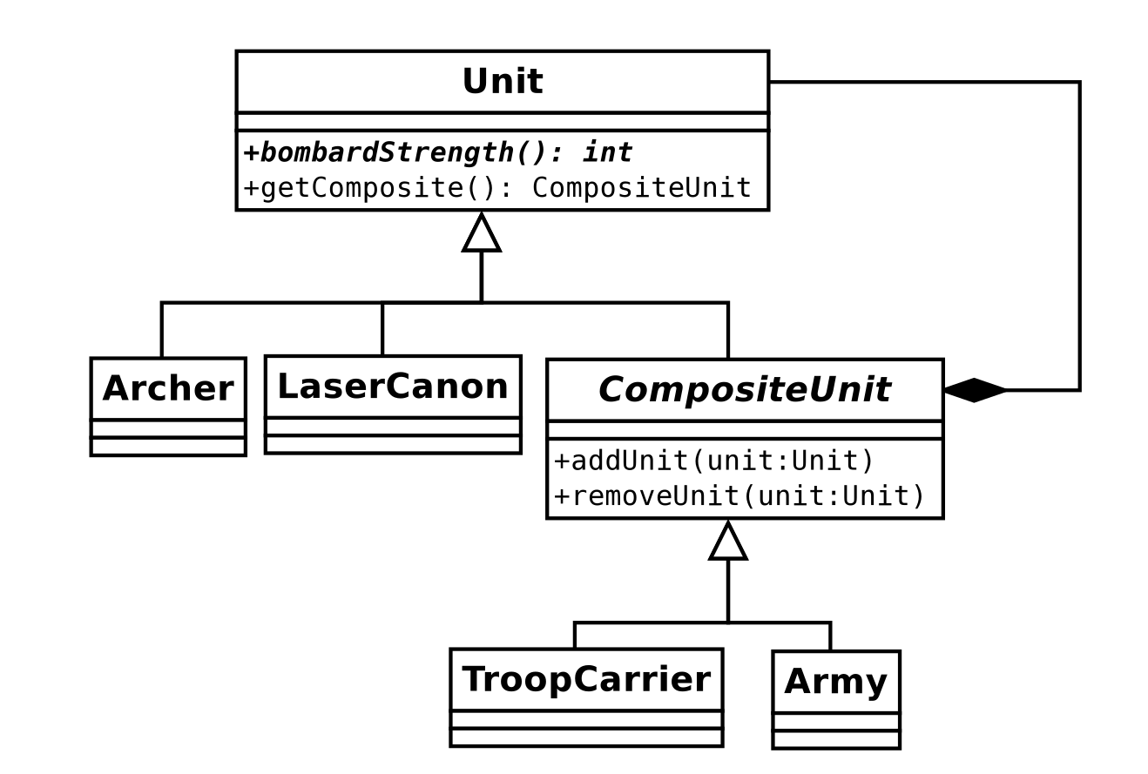

Самий абстрактний модуль src/Entities/Army/Unit.ts:

import {CompositeUnit} from "@/Entities/Army/CompositeUnit";
import {NullCompositeUnit} from "@/Entities/Army/Composite/NullCompositeUnit";
export abstract class Unit {
public abstract bombardStrength(): number;
public abstract defensiveStrength(): number;
public getComposite(): CompositeUnit {
if (this instanceof CompositeUnit) {
return this;
}
// ??? Super expression must either be null or a function
// return NullCompositeUnit.getInstance();
}
}
Абстрактний композитний модуль src/Entities/Army/CompositeUnit.ts:

import {Unit} from "@/Entities/Army/Unit";
export abstract class CompositeUnit extends Unit {
protected nestedUnits: Array<Unit> = [];
public addUnit(unit: Unit) {
this.nestedUnits.push(unit);
}
public removeUnit(unit: Unit) {
this.nestedUnits = this.nestedUnits.filter((u: Unit) => u === unit);
}
}

Одиничні модулі:

src/Entities/Army/Individual/Archer.ts:
import {Unit} from "@/Entities/Army/Unit";
export class Archer extends Unit {
bombardStrength(): number {
return 40;
}
defensiveStrength(): number {
return 35;
}
}
src/Entities/Army/Individual/Cavalry.ts:

import {Unit} from "@/Entities/Army/Unit";
export class Cavalry extends Unit {
bombardStrength(): number {
return 30;
}
defensiveStrength(): number {
return 40;
}
}
src/Entities/Army/Individual/LaserCannon.ts:

import {Unit} from "@/Entities/Army/Unit";
export class LaserCannon extends Unit {
bombardStrength(): number {
return 200;
}
defensiveStrength(): number {
return 20;
}
}
Композитні модулі:
src/Entities/Army/Composite/Army.ts:
import {CompositeUnit} from "@/Entities/Army/CompositeUnit";
import {Unit} from "@/Entities/Army/Unit";
export class Army extends CompositeUnit {
bombardStrength(): number {
return this.nestedUnits.reduce(
(carry: number, unit: Unit) => carry + unit.bombardStrength(),
0
);
}
defensiveStrength(): number {
return this.nestedUnits.reduce(
(carry: number, unit: Unit) => carry + unit.defensiveStrength(),
0
);
}
}
src/Entities/Army/Composite/TroopCarrier.ts:
import {CompositeUnit} from "@/Entities/Army/CompositeUnit";
import {Unit} from "@/Entities/Army/Unit";
import {Archer} from "@/Entities/Army/Individual/Archer";
import {LaserCannon} from "@/Entities/Army/Individual/LaserCannon";
export class TroopCarrier extends CompositeUnit {
addUnit(unit: Archer | LaserCannon) {
super.addUnit(unit);
}
bombardStrength(): number {
const nestedUnitsStrength = this.nestedUnits.reduce(
(carry: number, unit: Unit) => carry + unit.bombardStrength(),
0,
);
return 0.8
* nestedUnitsStrength;
}
defensiveStrength(): number {
const nestedUnitsStrength = this.nestedUnits.reduce(
(carry: number, unit: Unit) => carry + unit.defensiveStrength(),
0
);
return 128
+ nestedUnitsStrength;
}
}

А також null-композитний модуль src/Entities/Army/Composite/NullCompositeUnit.ts:

import {CompositeUnit} from "@/Entities/Army/CompositeUnit";
import {Unit} from "@/Entities/Army/Unit";
export class NullCompositeUnit extends CompositeUnit {
private static instance: NullCompositeUnit|null = null;
private constructor() {
super();
}
public static getInstance(): CompositeUnit {
if (this.instance === null) {
this.instance = new NullCompositeUnit();
}
return this.instance;
}
public addUnit(unit: Unit) {
// ignore
}
public removeUnit(unit: Unit) {
// ignore
}
bombardStrength(): number {
return 0;
}
defensiveStrength(): number {
return 0;
}
}
Компонент App.vue:

<template>
<div id="app">
<img alt="Vue logo" src="./assets/logo.png">
<h1>Check out your console</h1>
</div>
</template>
<script lang="ts">
import Vue from 'vue';
import {Army} from "@/Entities/Army/Composite/Army";
import {Archer} from "@/Entities/Army/Individual/Archer";
import {LaserCannon} from "@/Entities/Army/Individual/LaserCannon";
import {TroopCarrier} from "@/Entities/Army/Composite/TroopCarrier";
import {Cavalry} from "@/Entities/Army/Individual/Cavalry";
import {CompositeUnit} from "@/Entities/Army/CompositeUnit";
export default Vue.extend({
name: 'App',
components: {},
mounted() {
console.log((new Archer()).getComposite())
const mainArmy: CompositeUnit = new Army();
mainArmy.addUnit(new Archer());
mainArmy.addUnit(new Archer());
mainArmy.addUnit(new Cavalry());
mainArmy.addUnit(new LaserCannon());
const subArmy: CompositeUnit = new Army();
subArmy.addUnit(new Archer());
subArmy.addUnit(new Archer());
subArmy.addUnit(new Archer());
mainArmy.addUnit(subArmy);
const troopCarrier: CompositeUnit = new TroopCarrier();
troopCarrier.addUnit(new Archer());
troopCarrier.addUnit(new Archer());
troopCarrier.addUnit(new LaserCannon());
console.log(`[Main] Strength before adding troopCarrier: ${mainArmy.bombardStrength()}`);
console.log(`[Main] Defensive strength before adding troopCarrier: ${mainArmy.defensiveStrength()}`);
subArmy.addUnit(troopCarrier);
console.log(`[Sub] Added troop-carrier`);
console.log(`[Main] Strength after adding troopCarrier: ${mainArmy.bombardStrength()}`)
console.log(`[Main] Defensive strength after adding troopCarrier: ${mainArmy.defensiveStrength()}`);
}
});
</script>
<style>
#app {
font-family: Avenir, Helvetica, Arial, sans-serif;
-webkit-font-smoothing: antialiased;
-moz-osx-font-smoothing: grayscale;
text-align: center;
color: #2c3e50;
margin-top: 60px;
}
</style>

В результаті, в консолі бачимо такий результат:

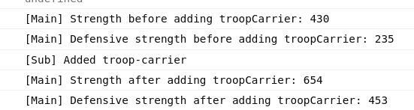

Висновок:
На цій лабораторній роботі я більш повно вивчив породжуючі шаблони проектування, зокрема, абстрактну та прототипну фабрики.

