Лабораторна робота № 4

Тема: Type Script. ООП

Завдання
Переробіть завдання із практичної роботи №2 із JS на TS.

Варіант №5
1.Відомості про хворих містять дані: прізвище, ім'я, по батькові, рік народження, дата надходження, діагноз, номер палати, дата виписки (якщо хворий виписався). Скласти список хворих, що знаходяться ще в лікарні і розподілити їх по палатах.

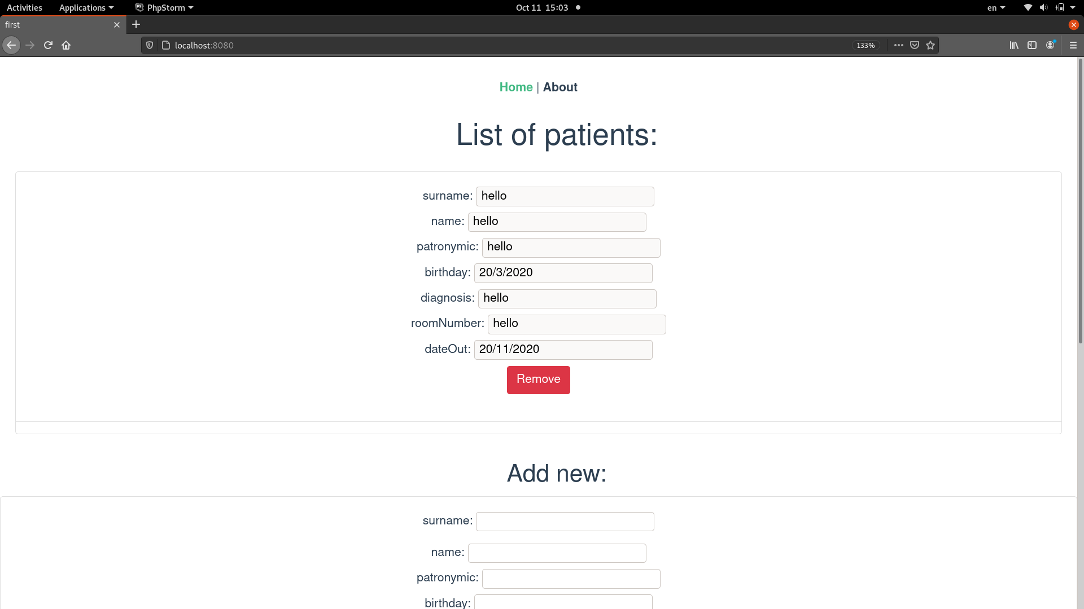

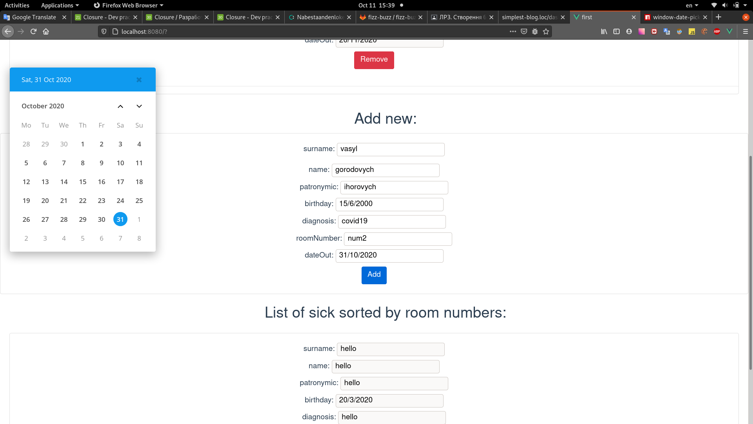

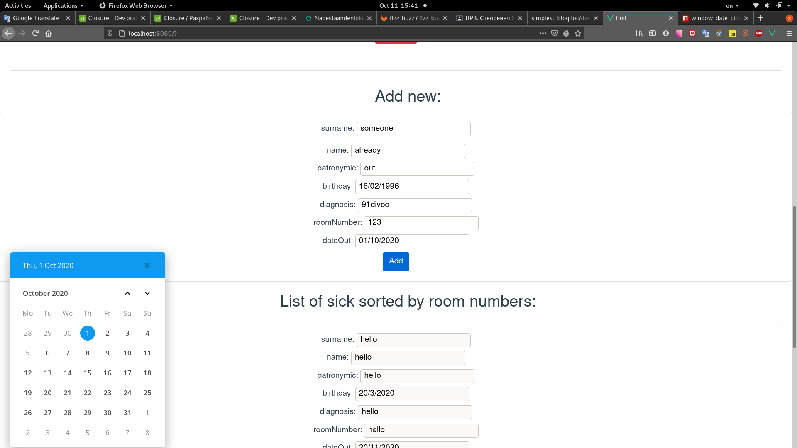

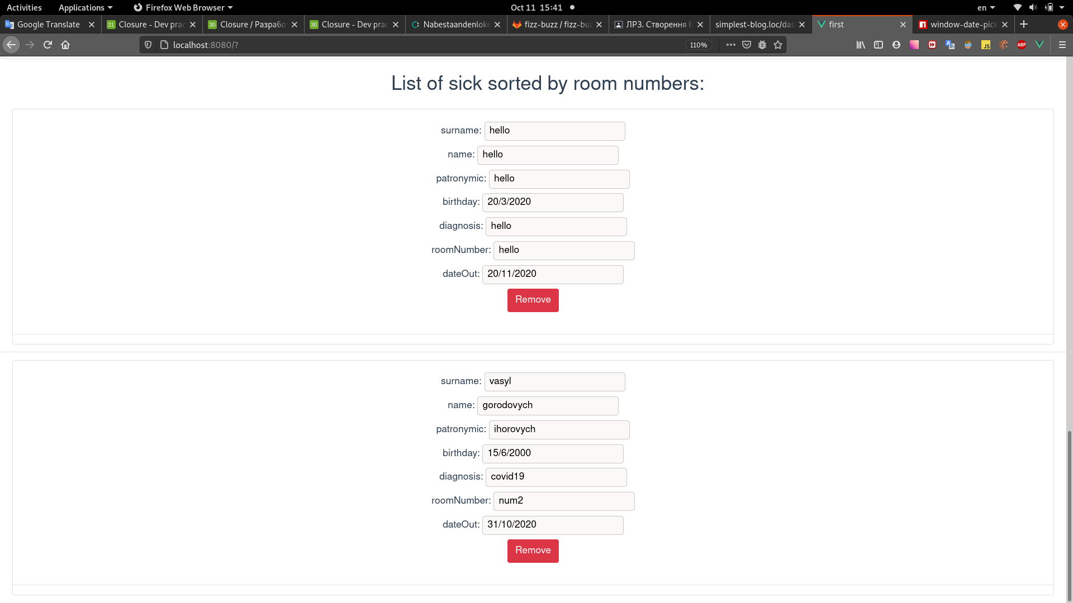

package.json:
{
"name": "first",
"version": "0.1.0",
"private": true,
"scripts": {
"serve": "vue-cli-service serve",
"build": "vue-cli-service build"
},
"dependencies": {
"core-js": "^3.6.5",
"vue": "^2.6.11",
"vue-router": "^3.2.0",
"window-date-picker": "^1.0.1"
},
"devDependencies": {
"@vue/cli-plugin-babel": "~4.5.0",
"@vue/cli-plugin-router": "~4.5.0",
"@vue/cli-plugin-typescript": "~4.5.0",
"@vue/cli-service": "~4.5.0",
"typescript": "~3.9.3",
"vue-template-compiler": "^2.6.11"
}
}
tsconfig.json:
{
"compilerOptions": {
"target": "esnext",
"module": "esnext",
"strict": true,
"jsx": "preserve",
"importHelpers": true,
"moduleResolution": "node",
"skipLibCheck": true,
"esModuleInterop": true,
"allowSyntheticDefaultImports": true,
"sourceMap": true,
"baseUrl": ".",
"types": [
"webpack-env"
],
"paths": {
"@/*": [
"src/*"
]
},
"lib": [
"esnext",
"dom",
"dom.iterable",
"scripthost"
]
},
"include": [
"src/**/*.ts",
"src/**/*.tsx",
"src/**/*.vue",
"tests/**/*.ts",
"tests/**/*.tsx"
],
"exclude": [
"node_modules"
]
}
App.vue:
<template>
<div id="app">
<div id="nav">
<router-link to="/">Home</router-link> |
<router-link to="/about">About</router-link>
</div>
<router-view/>
</div>
</template>
<style>
#app {
font-family: Avenir, Helvetica, Arial, sans-serif;
-webkit-font-smoothing: antialiased;
-moz-osx-font-smoothing: grayscale;
text-align: center;
color: #2c3e50;
}
#nav {
padding: 30px;
}
#nav a {
font-weight: bold;
color: #2c3e50;
}
#nav a.router-link-exact-active {
color: #42b983;
}
</style>

Home.vue:
<template>
<div class="home">
<h1 class="ml-5">List of patients:</h1>
<ul class="list-group list-group-flush">
<li class="list-group-item" v-for="(patient, index) in patients">
<patient-view :patient="patient" v-on:remove="removePatient(index)"></patient-view>
</li>
<li v-if="patients.length === 0">List is empty</li>
</ul>
<br>
<h2 class="ml-5">Add new:</h2>
<div class="card">
<add-patient-form v-on:submit="addNewPatient"></add-patient-form>
</div>
<br>
<h2 class="ml-5">List of sick sorted by room numbers:</h2>
<ul class="list-group list-group-flush">
<li class="list-group-item" v-for="(patient, index) in sickList">
<patient-view :patient="patient" v-on:remove="removePatient(index)"></patient-view>
</li>
<li v-if="sickList.length === 0">List is empty</li>
</ul>
</div>
</template>
<script lang="ts">
import Vue from 'vue';
import AddPatientForm from '@/vue-components/add-patient-form.vue';
import PatientView from "@/vue-components/patient.vue";
import Patient from "@/models/Patient";
import CreatePatientDto from "@/CreatePatientDto";
export default Vue.extend({
name: 'Home',
components: {AddPatientForm, PatientView},
data: () => ({
patients: [
new Patient(
"hello",
"hello",
"hello",
new Date(
2020,
2,
20
),
"hello",
"hello",
new Date(
2020,
10,
20
),
)
],
}),
methods: {
addNewPatient: function (e: any, createPatientDto: CreatePatientDto) {
e.preventDefault();
if (!(createPatientDto.surname
&& createPatientDto.name
&& createPatientDto.patronymic
&& createPatientDto.diagnosis
&& createPatientDto.roomNumber
&& createPatientDto.dateOut
&& createPatientDto.birthday)) {
alert('enter all fields')
return;
}
this.patients.push(
new Patient(
createPatientDto.surname,
createPatientDto.name,
createPatientDto.patronymic,
new Date(
createPatientDto.birthday.year,
createPatientDto.birthday.month - 1,
createPatientDto.birthday.day
),
createPatientDto.diagnosis,
createPatientDto.roomNumber,
new Date(
createPatientDto.dateOut.year,
createPatientDto.dateOut.month - 1,
createPatientDto.dateOut.day
),
)
);
e.target.reset();
createPatientDto.clear()
},
removePatient: function (index: number): void {
this.patients.splice(index, 1);
}
},
computed: {
sickList: function (): Patient[] {
let notReleased: Patient[] = this.patients.filter(
function (p: Patient) {
let date: Date = new Date();
date.setHours(0, 0, 0, 0);
return date < p.rawDateOut;
}
);
notReleased.sort(
(a: Patient, b: Patient) => a.roomNumber > b.roomNumber ? 1 : -1
);
return notReleased;
}
}
});
</script>
<style>
@import "https://stackpath.bootstrapcdn.com/bootstrap/4.5.2/css/bootstrap.min.css";
</style>

main.ts:
import Vue from 'vue'
import App from './App.vue'
import router from './router'
Vue.config.productionTip = false
new Vue({
router,
render: h => h(App)
}).$mount('#app')

Patient.ts:
export default class Patient {
public surname: string;
public name: string;
public patronymic: string;
public diagnosis: string;
public roomNumber: string;
private _birthday: Date;
private _dateOut: Date;
constructor(surname: string,
name: string,
patronymic: string,
birthday: Date,
diagnosis: string,
roomNumber: any,
dateOut: Date) {
this.surname = surname;
this.name = name;
this.patronymic = patronymic;
this.diagnosis = diagnosis;
this.roomNumber = roomNumber;
this._birthday = birthday;
this._dateOut = dateOut;
}
get birthday(): string {
return this._birthday.getDate() + "/" + (this._birthday.getMonth() + 1) + "/" + this._birthday.getFullYear();
}
get dateOut(): string {
return this._dateOut.getDate() + "/" + (this._dateOut.getMonth() + 1) + "/" + this._dateOut.getFullYear();
}
get rawDateOut(): Date {
return new Date(this._dateOut.getTime());
}
}

patient.vue:
<template>
<div class="card">
<div class="card-body">
<label class="d-block">surname: <input type="text" readonly class="surname"
v-bind:value="patient.surname"></label>
<label class="d-block">name: <input type="text" readonly class="name"
v-bind:value="patient.name"></label>
<label class="d-block">patronymic: <input type="text" readonly class="patronymic"
v-bind:value="patient.patronymic"></label>
<label class="d-block">birthday: <input type="text" readonly class="birthday"
v-bind:value="patient.birthday"></label>
<label class="d-block">diagnosis: <input type="text" readonly class="diagnosis"
v-bind:value="patient.diagnosis"></label>
<label class="d-block">roomNumber: <input type="text" readonly class="roomNumber"
v-bind:value="patient.roomNumber"></label>
<label class="d-block">dateOut: <input type="text" readonly class="dateOut"
v-bind:value="patient.dateOut"></label>
<button class="btn btn-danger" @click="$emit('remove', patient)">Remove</button>
</div>
<hr>
</div>
</template>
<script lang="ts">
import Vue from 'vue';
export default Vue.extend({
props: ['patient'],
});
</script>
date-picker.vue:
<template>
<div class="date-picker-wrapper">
<label>
{{ title }}:
<input type="text" :value="formatDateValue()" @focusin="openPicker" @input="closePicker">
</label>
<div class="date-picker">
</div>
</div>
</template>
<script lang="ts">
import WindowDatePicker from 'window-date-picker';
import Vue from "vue";
export default Vue.extend({
name: "date-picker",
props: [
'title',
'value',
],
data: function (): { picker: any } {
return {
picker: null,
}
},
methods: {
openPicker: function (): void {
this.picker.open();
},
closePicker: function (): void {
this.picker.close();
},
reactChange: function (): void {
this.$emit('input', this.picker.get());
},
formatDateValue: function (): string {
try {
if (!this.value.day || !this.value.month || !this.value.year) {
return '';
}
} catch (e) {
return '';
}
return `${this.value.day}/${this.value.month}/${this.value.year}`; // "DD/MM/YYYY"
}
},
mounted() {
this.picker = new WindowDatePicker({
el: this.$el.querySelector('.date-picker'),
inputEl: this.$el.querySelector('input'),
dateType: "DD/MM/YYYY",
});
this.picker.el.addEventListener('wdp.change', this.reactChange);
},
});
</script>
<style src="window-date-picker/dist/css/window-date-picker.min.css"></style>

add-patient-form.vue:
<template>
<form class="card-body" @submit="delegateSubmit">
<div class="form-group">
<label class="d-block">surname: <input required type="text" class="surname"
v-model="createPatientDto.surname"></label>
</div>
<label class="d-block">name: <input required type="text" class="name" v-model="createPatientDto.name"></label>
<label class="d-block">patronymic: <input required type="text" class="patronymic"
v-model="createPatientDto.patronymic"></label>
<DatePicker title="birthday" v-model="createPatientDto.birthday"></DatePicker>
<label class="d-block">diagnosis: <input required type="text" class="diagnosis"
v-model="createPatientDto.diagnosis"></label>
<label class="d-block">roomNumber: <input required type="text" class="roomNumber"
v-model="createPatientDto.roomNumber"></label>
<DatePicker title="dateOut" v-model="createPatientDto.dateOut"></DatePicker>
<button class="btn btn-primary">Add</button>
</form>
</template>
<script type="ts">
import DatePicker from "./date-picker";
import Vue from "vue";
import CreatePatientDto from "@/CreatePatientDto";
export default Vue.extend({
name: "add-patient-form",
components: {DatePicker},
data: function () {
return {
createPatientDto: new CreatePatientDto()
}
},
methods: {
delegateSubmit: function (e) {
this.$emit('submit', e, this.createPatientDto);
}
}
});
</script>
<style scoped>
</style>

2. Плеєр (трек, виконавець, альбом, плейліст)

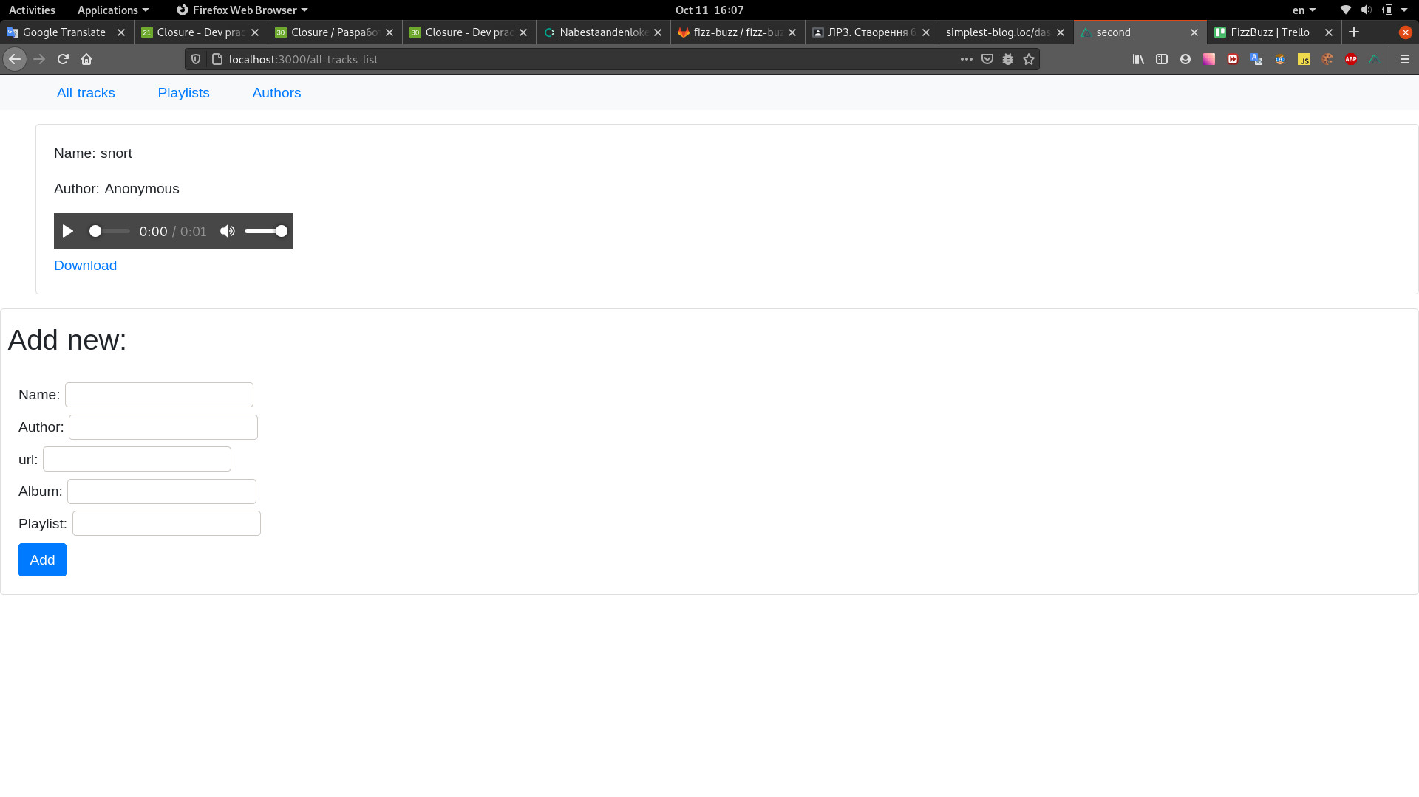

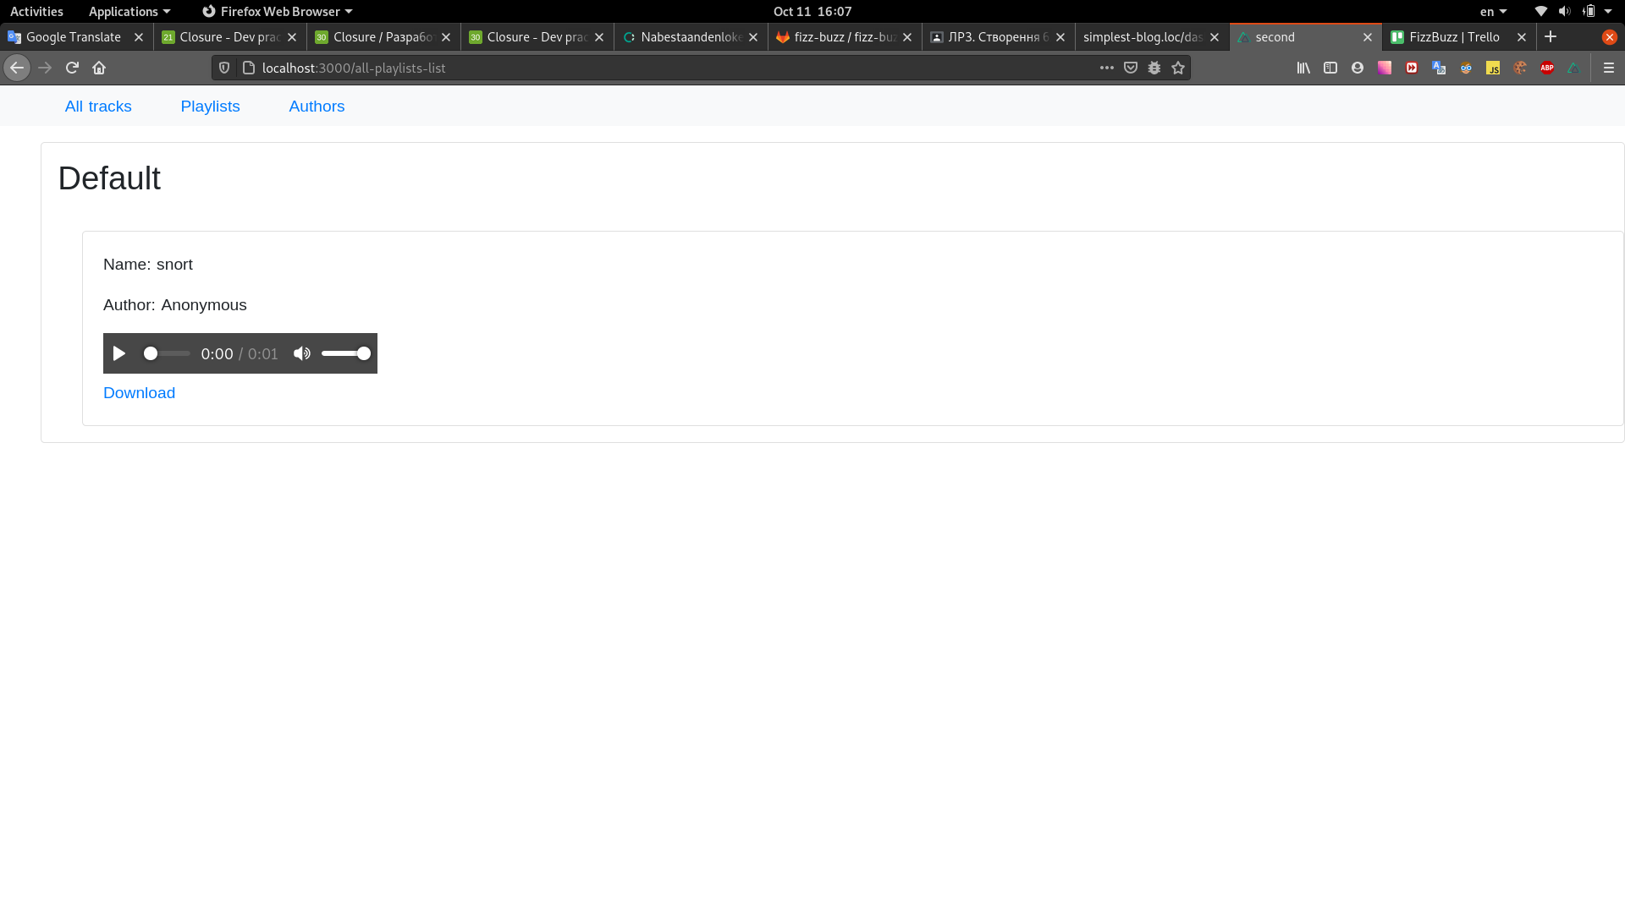

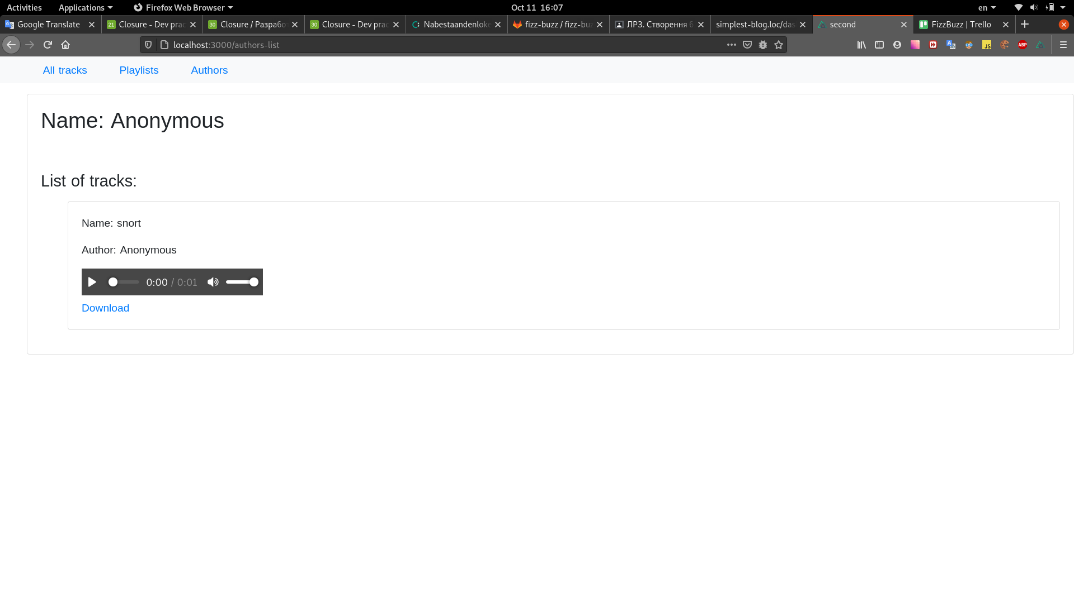

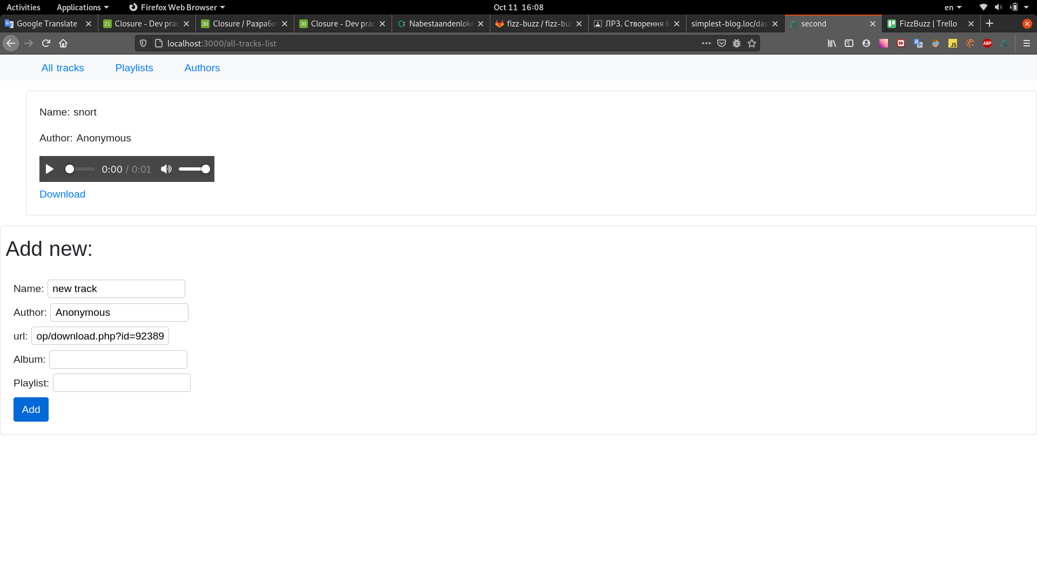

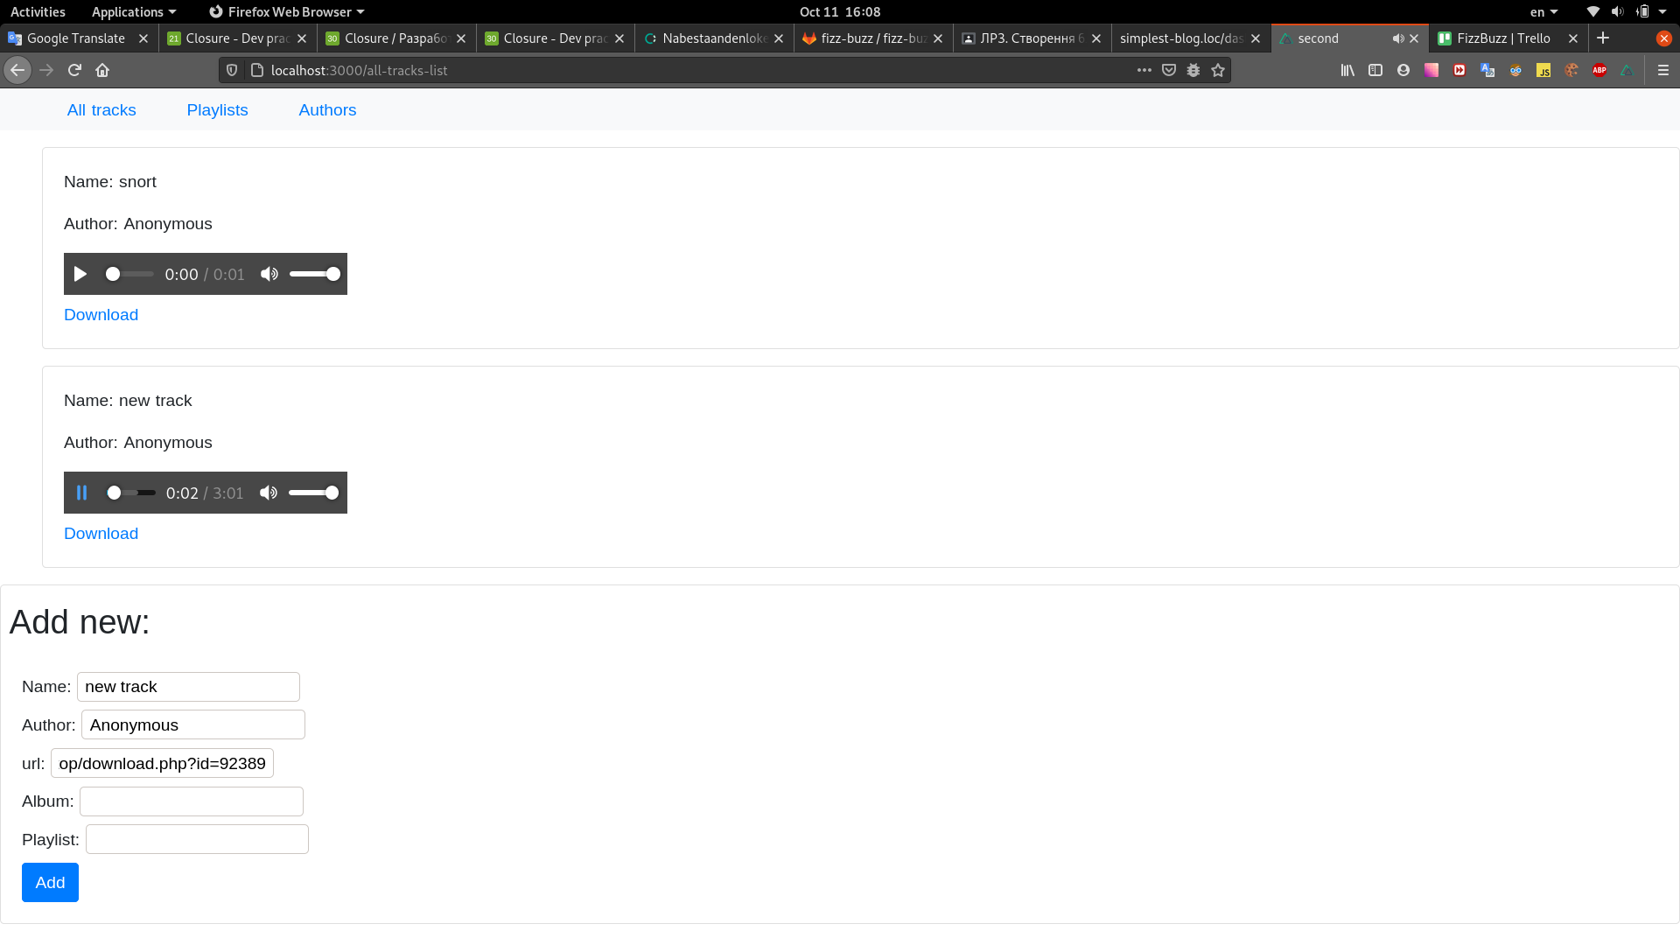
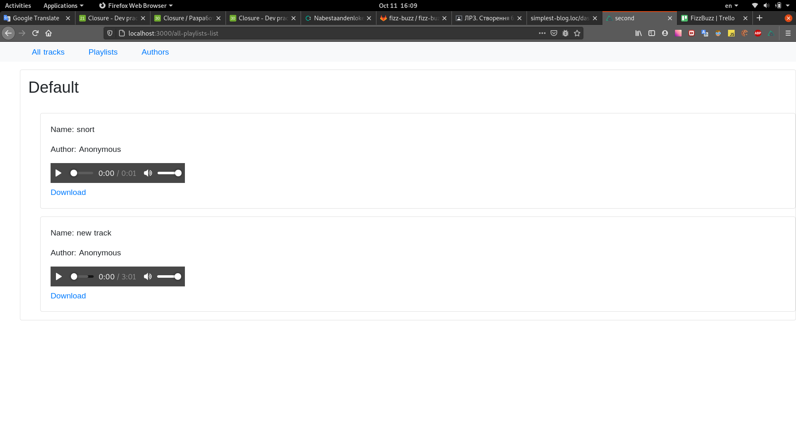
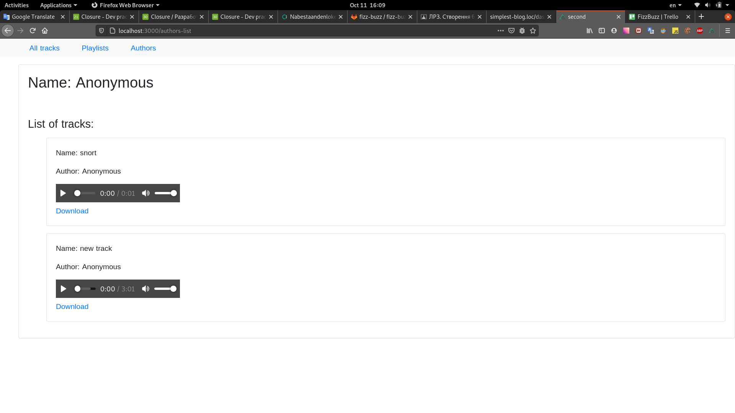

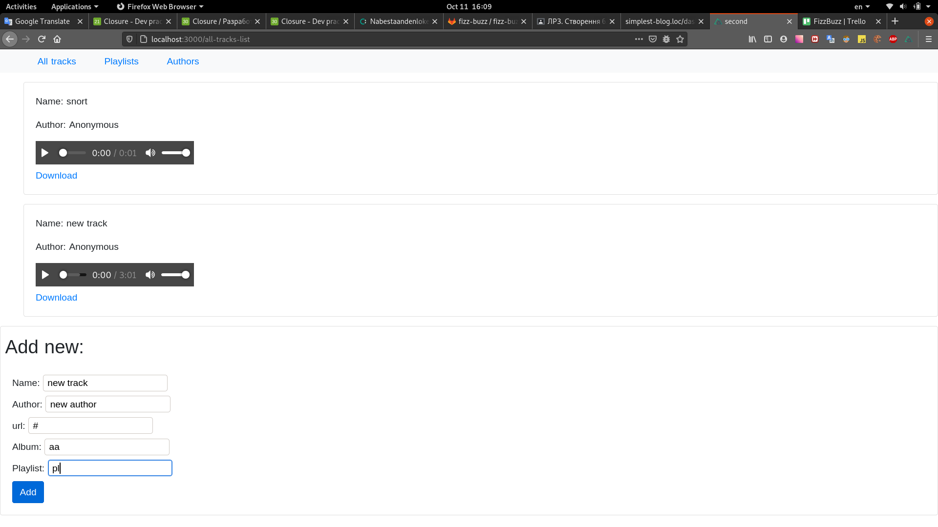

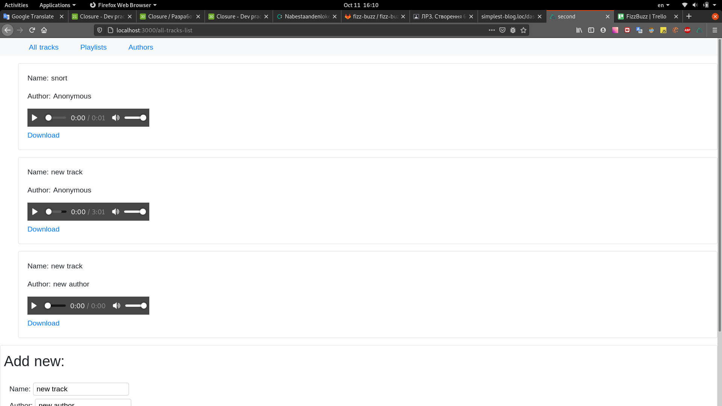

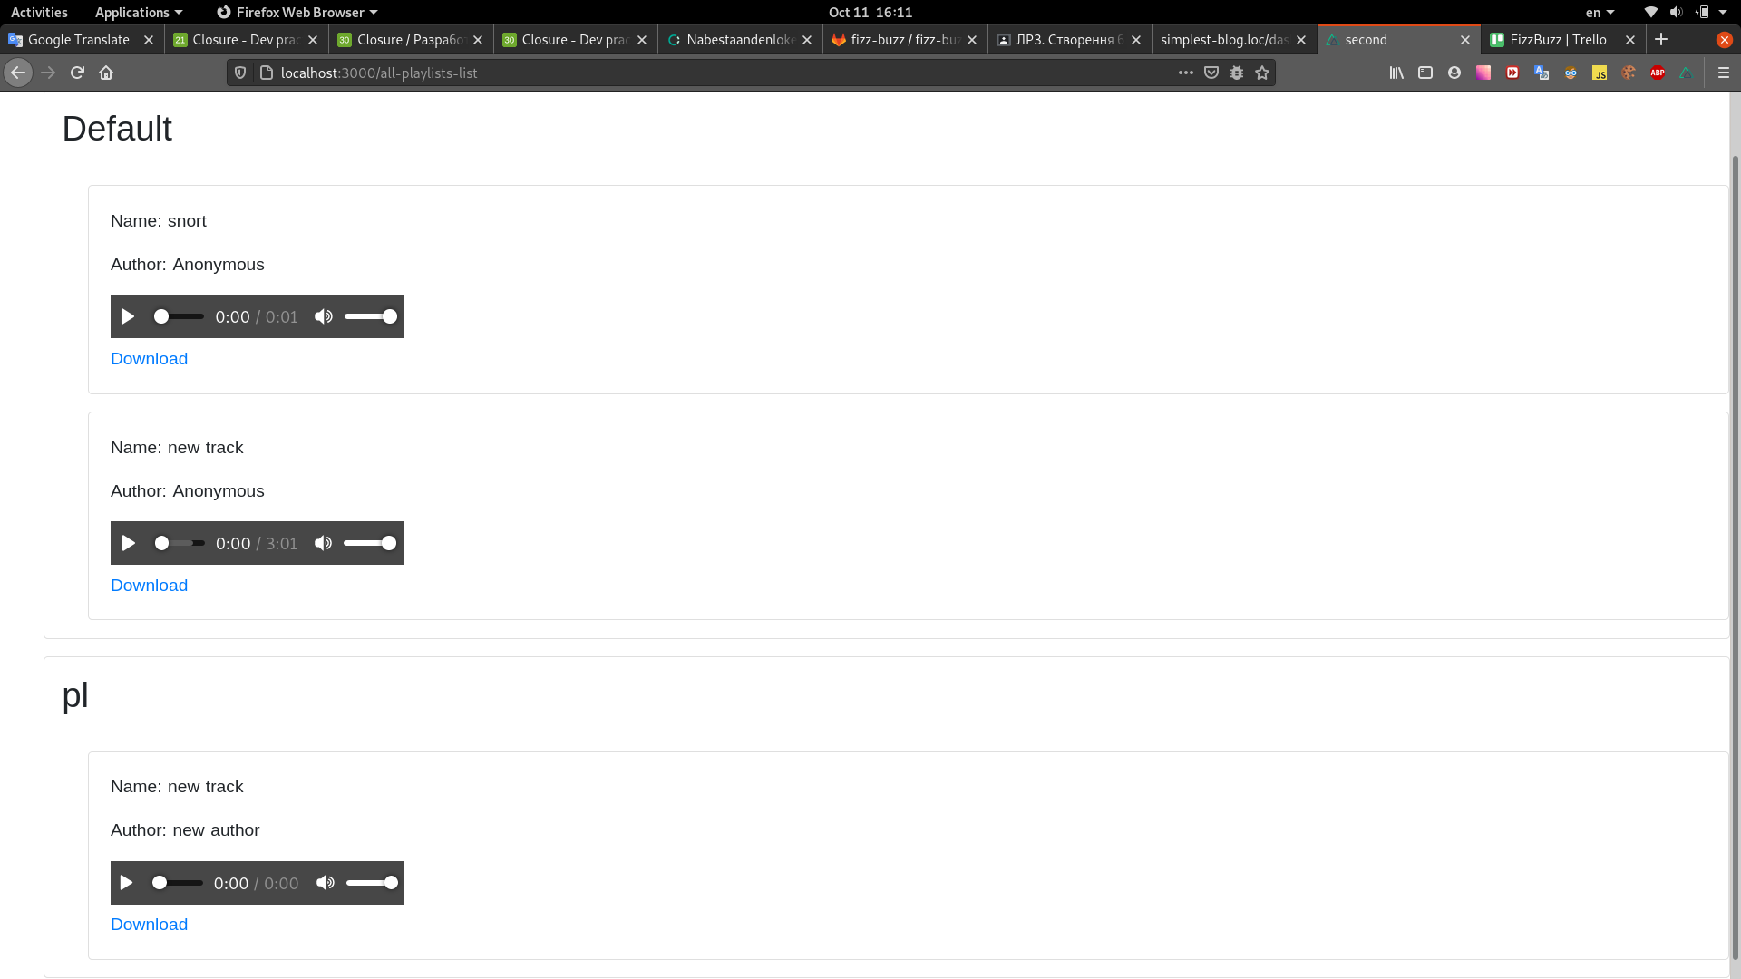

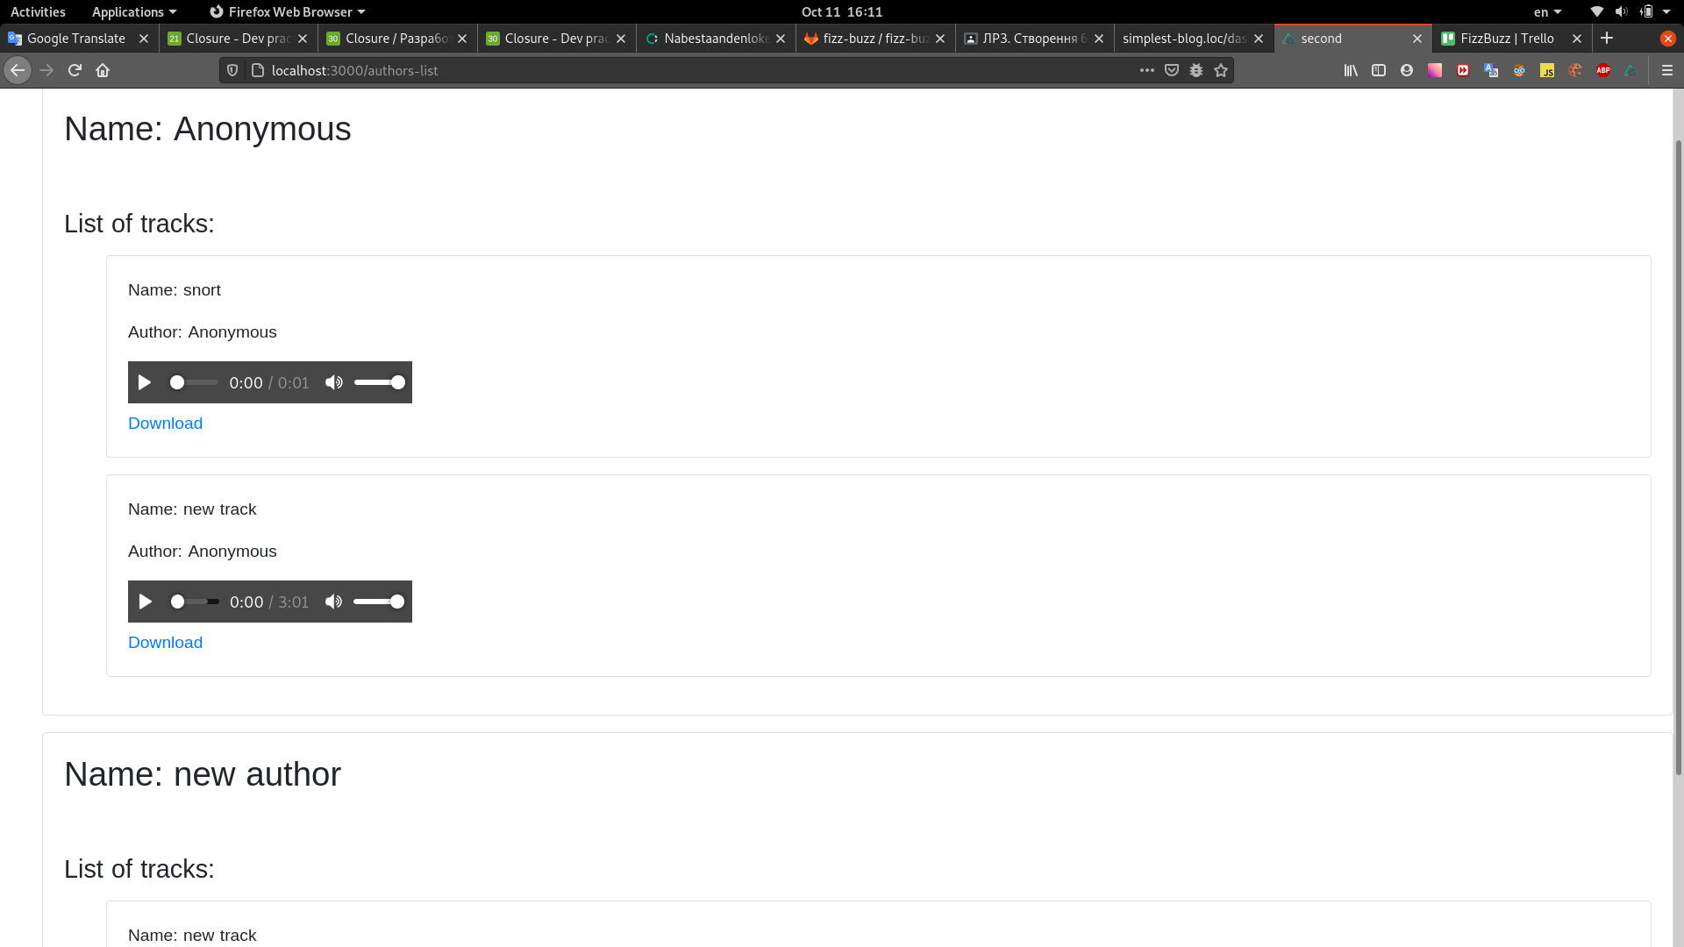

package.json:
{
"name": "second",
"version": "1.0.0",
"private": true,
"scripts": {
"dev": "nuxt-ts",
"build": "nuxt-ts build",
"start": "nuxt-ts start",
"generate": "nuxt-ts generate"
},
"dependencies": {
"@nuxt/typescript-runtime": "^2.0.0",
"@types/uuid": "^8.3.0",
"@vuex-orm/core": "^0.36.3",
"bootstrap": "^4.5.2",
"bootstrap-vue": "^2.17.3",
"core-js": "^3.6.5",
"nuxt": "^2.14.6",
"vue": "^2.6.12",
"window-date-picker": "^1.0.1"
},
"devDependencies": {
"@nuxt/types": "^2.14.6",
"@nuxt/typescript-build": "^2.0.3",
"vuex": "^3.5.1"
}
}

nuxt.config.js:
export default {
// Global page headers (https://go.nuxtjs.dev/config-head)
head: {
title: 'second',
meta: [
{ charset: 'utf-8' },
{ name: 'viewport', content: 'width=device-width, initial-scale=1' },
{ hid: 'description', name: 'description', content: '' }
],
link: [
{ rel: 'icon', type: 'image/x-icon', href: '/favicon.ico' }
]
},
// Global CSS (https://go.nuxtjs.dev/config-css)
css: [
],
// Plugins to run before rendering page (https://go.nuxtjs.dev/config-plugins)
plugins: [
],
// Auto import components (https://go.nuxtjs.dev/config-components)
components: true,
// Modules for dev and build (recommended) (https://go.nuxtjs.dev/config-modules)
buildModules: [
// https://go.nuxtjs.dev/typescript
'@nuxt/typescript-build',
],
// Modules (https://go.nuxtjs.dev/config-modules)
modules: [
// https://go.nuxtjs.dev/bootstrap
'bootstrap-vue/nuxt',
],
// Build Configuration (https://go.nuxtjs.dev/config-build)
build: {
}
}
tsconfig.json:

{
"compilerOptions": {
"target": "ES2018",
"module": "ESNext",
"moduleResolution": "Node",
"lib": [
"ESNext",
"ESNext.AsyncIterable",
"DOM"
],
"esModuleInterop": true,
"allowJs": true,
"sourceMap": true,
"strict": true,
"noEmit": true,
"experimentalDecorators": true,
"baseUrl": ".",
"paths": {
"~/*": [
"./*"
],
"@/*": [
"./*"
]
},
"types": [
"@types/node",
"@nuxt/types"
]
},
"exclude": [
"node_modules",
".nuxt",
"dist"
]
}
store/index.ts:
import VuexORM from '@vuex-orm/core'
import database from '@/database'
import Track from "~/models/Track";
import Author from "~/models/Author";
import {Store} from "vuex";
import Playlist from "~/models/Playlist";
import data from "~/data"
export const plugins = [
VuexORM.install(database)
]
export const mutations = {}
export interface CreateTrackDto {
name: string
author: string
url: string
album: string
playlist: string
}
export const actions = {
nuxtServerInit() {
data()
.then(
data => Track.insert({data})
);
},
async createTrack(context: Store<any>, {dto}: { dto: CreateTrackDto }) {
let author: Author = await context.dispatch('findOrCreateAuthor', {name: dto.author});
let playlist: Playlist = await context.dispatch('findOrCreatePlayList', {name: dto.playlist});
await Track.insert({
data: {
name: dto.name,
author: author,
playlists: [playlist],
album: dto.album,
url: dto.url,
}
})
},
async findOrCreateAuthor(context: Store<any>, {name}: { name: string }) {
let author: Author | null = context.getters.authorByName(name);
if (null === author) {
await Author.insert({
data: {name}
})
return context.getters.authorByName(name)
}
return author;
},
async findOrCreatePlayList(context: Store<any>, {name}: { name: string }){
if (name.length === 0) {
return Playlist
.query()
.where('name', 'Default')
.first();
}
let playlist: Playlist|null = context.getters.playlistByName(name);
if (null === playlist) {
await Playlist.insert({
data: {name}
})
return context.dispatch('findOrCreatePlayList', {name});
}
return playlist;
}
}
export const getters = {
authorByName: (state: any, getters: any) => (name: string) => {
return Author.query()
.where('name', name)
.first();
},
playlistByName: (state: any, getters: any) => (name: string) => {
return Playlist.query()
.where('name', name)
.first()
}
}
database/index.ts:
import {Database} from '@vuex-orm/core'
import Author from "~/models/Author";
import Track from "~/models/Track";
import Playlist from "~/models/Playlist";
import TrackPlaylist from "~/models/TrackPlaylist";
const database = new Database()
database.register(Author)
database.register(Track)
database.register(Playlist)
database.register(TrackPlaylist)
export default database

data/index.ts:
export default async function () {
return [
{
name: 'snort',
url: 'http://cd.textfiles.com/10000gp2/500SNDS/SNORT.WAV',
author_id: 'author-1',
author: {
uuid: 'author-1',
name: 'Anonymous',
},
playlists: [
{
name: 'Default',
}
]
}
];
}

models/Author.ts:
import Track from "~/models/Track"
import {Model} from '@vuex-orm/core'
import {v4 as uuid} from "uuid"
import Fields from "@vuex-orm/core/lib/model/contracts/Fields";
export default class Author extends Model {
static entity: string = 'authors'
static primaryKey = 'uuid'
uuid!: string
name!: string
tracks!: Track[]
static fields(): Fields {
return {
uuid: this.uid(() => uuid()),
name: this.string(''),
tracks: this.hasMany(Track, 'author_id'),
}
}
toString(): string {
return this.name
}
}
models/Playlist.ts:
import {Model} from "@vuex-orm/core"
import Track from "~/models/Track"
import {v4 as uuid} from "uuid"
import TrackPlaylist from "~/models/TrackPlaylist";
import Fields from "@vuex-orm/core/lib/model/contracts/Fields";
export default class Playlist extends Model {
static entity: string = 'playlists'
static primaryKey = 'uuid'
uuid!: string
name!: string
tracks!: Track[]
static fields(): Fields {
return {
uuid: this.uid(() => uuid()),
name: this.string(''),
tracks: this.belongsToMany(Track, TrackPlaylist, 'playlist_id', 'track_id'),
}
}
}

models/Track.ts:
import {Model} from "@vuex-orm/core"
import Author from "~/models/Author"
import Playlist from "~/models/Playlist"
import {v4 as uuid} from "uuid"
import TrackPlaylist from "~/models/TrackPlaylist";
import Fields from "@vuex-orm/core/lib/model/contracts/Fields";
export default class Track extends Model {
static entity: string = 'tracks';
static primaryKey = 'uuid'
uuid!: string
author_id!: string
author!: Author
name!: string
url!: string
album!: string
playlists!: Playlist[]
static fields(): Fields {
return {
uuid: this.uid(() => uuid()),
author_id: this.string(''),
author: this.belongsTo(Author, 'author_id'),
name: this.string(''),
url: this.string(''),
album: this.string(null).nullable(),
playlists: this.belongsToMany(Playlist, TrackPlaylist, 'track_id', 'playlist_id')
}
}
}
models/TrackPlaylist.ts:
import {Model} from "@vuex-orm/core"
import Fields from "@vuex-orm/core/lib/model/contracts/Fields";
export default class TrackPlaylist extends Model {
static entity: string = 'track_playlist'
static primaryKey = ['track_id', 'playlist_id'];
static fields(): Fields {
return {
'track_id': this.string(''),
'playlist_id': this.string(''),
}
}
}
layouts/default.vue:
<template>
<div>
<app-header-menu/>
<Nuxt />
</div>
</template>
<script type="ts">
import Vue from 'vue';
import Menu from '../components/Menu/app-header-menu.vue'
import AppHeaderMenu from "~/components/Menu/app-header-menu.vue";
export default Vue.extend({
components: {AppHeaderMenu, Menu}
})
</script>
<style>
html {
font-family:
'Source Sans Pro',
-apple-system,
BlinkMacSystemFont,
'Segoe UI',
Roboto,
'Helvetica Neue',
Arial,
sans-serif;
font-size: 16px;
word-spacing: 1px;
-ms-text-size-adjust: 100%;
-webkit-text-size-adjust: 100%;
-moz-osx-font-smoothing: grayscale;
-webkit-font-smoothing: antialiased;
box-sizing: border-box;
}
*,
*::before,
*::after {
box-sizing: border-box;
margin: 0;
}
.button--green {
display: inline-block;
border-radius: 4px;
border: 1px solid #3b8070;
color: #3b8070;
text-decoration: none;
padding: 10px 30px;
}
.button--green:hover {
color: #fff;
background-color: #3b8070;
}
.button--grey {
display: inline-block;
border-radius: 4px;
border: 1px solid #35495e;
color: #35495e;
text-decoration: none;
padding: 10px 30px;
margin-left: 15px;
}
.button--grey:hover {
color: #fff;
background-color: #35495e;
}
</style>

author-basic-view.vue:
<template>
<div class="card my-3" v-bind:id="author.uuid">
<div class="card-body">
<h2 class="d-block">Name: <span> {{ author.name }} </span></h2>
<br>
<br>
<h4>List of tracks:</h4>
<ul>
<li v-for="track in author.tracks">
<track-basic-view :track="track"></track-basic-view>
</li>
<li v-if="author.tracks.length ===0">Author has no tracks</li>
</ul>
</div>
</div>
</template>
<script>
import Vue from 'vue'
import TrackBasicView from "../Track/track-basic-view";
export default Vue.extend({
name: "author-basic-view",
components: {TrackBasicView},
props: ['author']
});
</script>
<style scoped>
</style>
playlist-basic-view.vue:
<template>
<div class="card my-3" v-bind:id="playlist.uuid">
<h2 class="m-3"> {{ playlist.name }} </h2>
<ul>
<li v-for="track in playlist.tracks">
<track-basic-view :track="track"></track-basic-view>
</li>
<li v-if="playlist.tracks.length === 0">There are no tracks</li>
</ul>
</div>
</template>
<script>
import Vue from 'vue'
import TrackBasicView from "../Track/track-basic-view";
export default Vue.extend({
name: "playlist-basic-view",
components: {TrackBasicView},
props: ['playlist']
});
</script>
<style scoped>
</style>
new-track-form.vue:
<template>
<div class="card">
<h2 class="ml-2 mt-3">Add new:</h2>
<form class="card-body" @submit.prevent="delegateSubmit">
<label class="d-block">Name: <input required type="text" v-model="createTrackDto.name"></label>
<label class="d-block">Author: <input required type="text" v-model="createTrackDto.author"></label>
<label class="d-block">url: <input required type="text" v-model="createTrackDto.url"></label>
<label class="d-block">Album: <input type="text" v-model="createTrackDto.album"></label>
<label class="d-block">Playlist: <input type="text" v-model="createTrackDto.playlist"></label>
<button class="btn btn-primary">Add</button>
</form>
</div>
</template>
<script lang="ts">
import Vue from 'vue'
import {CreateTrackDto} from "~/store";
export default Vue.extend({
name: "new-track-form",
data: function () {
return {
createTrackDto: <CreateTrackDto>{
name: '' as string,
author: '' as string,
url: '' as string,
album: '' as string,
playlist: '' as string,
}
};
},
methods: {
delegateSubmit: function (e: Event) {
console.warn(this.createTrackDto)
this.$emit('post-track', {dto: this.createTrackDto});
}
}
});
</script>
<style scoped>
</style>
track-basic-view.vue:
<template>
<div class="card my-3" v-bind:id="track.uuid">
<div class="card-body">
<p class="d-block">Name: <span> {{ track.name }} </span></p>
<p class="d-block">Author: <span> {{ track.author }} </span></p>
<audio controls>
<source v-bind:src="track.url">
</audio>
<a class="d-block" target="_blank" v-bind:href="track.url">Download</a>
</div>
</div>
</template>
<script type="ts">
import Vue from 'vue'
export default Vue.extend({
name: "track-basic-view",
props: ['track']
});
</script>
<style scoped>
</style>
app-header-menu.vue:
<template>
<nav class="navbar navbar-expand-lg navbar-light bg-light">
<div class="collapse navbar-collapse" id="navbarNav">
<ul class="navbar-nav">
<li class="nav-item menu-li">
<NuxtLink to="/all-tracks-list">All tracks</NuxtLink>
</li>
<li class="nav-item menu-li">
<NuxtLink to="/all-playlists-list">Playlists</NuxtLink>
</li>
<li class="nav-item menu-li">
<NuxtLink to="/authors-list">Authors</NuxtLink>
</li>
</ul>
</div>
</nav>
</template>
<script>
export default {
name: "app-header-menu",
props: ['currentPage']
}
</script>
<style scoped>
.menu-li {
margin-left: 3rem;
}
</style>
pages/all-playlists-list.vue:
<template>
<div>
<ul>
<li v-for="playlist in allPlaylists">
<playlist-basic-view :playlist="playlist"></playlist-basic-view>
</li>
<li v-if="allPlaylists.length === 0">There are no playlists</li>
</ul>
</div>
</template>
<script>
import Vue from 'vue'
import PlaylistBasicView from "./../components/Playlist/playlist-basic-view";
import Playlist from "@/models/Playlist";
export default Vue.extend({
name: "all-playlists-list",
components: {PlaylistBasicView},
computed: {
allPlaylists() {
return Playlist.query()
.with('tracks.author')
.get();
}
}
})
</script>
<style scoped>
</style>
pages/all-tracks-list.vue:
<template>
<div>
<ul>
<li v-for="track in allTracks">
<track-basic-view :track="track"></track-basic-view>
</li>
</ul>
<new-track-form v-on:post-track="createTrack"></new-track-form>
</div>
</template>
<script type="ts">
import Vue from 'vue'
import TrackBasicView from "@/components/Track/track-basic-view";
import NewTrackForm from "@/components/Track/new-track-form";
import Track from "@/models/Track";
import {mapActions} from "vuex";
export default Vue.extend({
name: "all-tracks-list",
components: {NewTrackForm, TrackBasicView},
methods: {
...mapActions([
'createTrack'
]),
},
computed: {
allTracks() {
return Track.query()
.with('author')
.get()
},
}
})
</script>
<style scoped>
</style>

authors-list.vue:

<template>
<div>
<ul>
<li v-for="author in allAuthors">
<author-basic-view :author="author"></author-basic-view>
</li>
<li v-if="allAuthors.length === 0">There are no authors</li>
</ul>
</div>
</template>
<script>
import Vue from 'vue';
import AuthorBasicView from "@/components/Author/author-basic-view";
import Author from "@/models/Author";
export default Vue.extend({
name: "authors-list",
components: {AuthorBasicView},
computed: {
allAuthors() {
return Author.query()
.with('tracks.author')
.get();
}
}
});
</script>
<style scoped>
</style>

