Практична робота №5

Вивчення породжуючих шаблонів проектування.
Мета: Вивчити породжуючі шаблони проектування, навчитись застосовувати їх на практиці.
Хід роботи:
Завдання
1. Абстрактна фабрика
2. Прототип

Порядок виконання
Потрібно спроектувати гру в якій є 2 типа місцевості – Земля, Марс. В даному випадку місцевість представлена трьома елементами – море, рівнини, ліс. Відобразимо в коді реалізацію абстрактної фабрики:

1. Вигляд UML- діаграми для абстрактної фабрики:

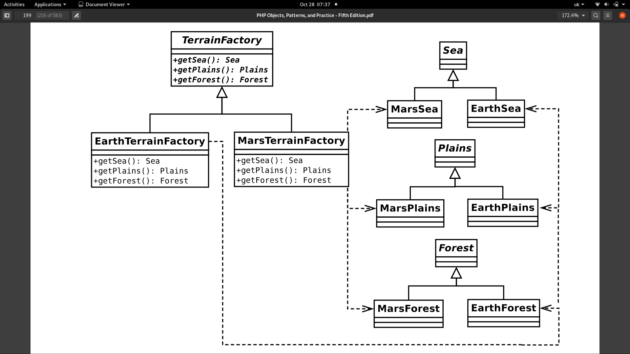

Основна програма src/App.vue:
<template>
<div id="app">
<label>
Select terrain:
<select name="" id="" v-model="terrainType">
<option disabled selected>...</option>
<option value="earth">Earth</option>
<option value="mars">Mars</option>
</select>
</label>
<div>
<br>
<label>
Forest Height
<input readonly type="text" v-bind:value="forest.treesHeight()">
</label>
<br>
<label>
Wind power on the plains:
<input readonly type="text" v-bind:value="plains.windPower()">
</label>
<br>
<label>
Sound of the sea:
<input readonly type="text" v-bind:value="sea.noise()">
</label>
</div>
</div>
</template>
<script lang="ts">
import {Component, Vue} from 'vue-property-decorator';
import HelloWorld from './components/HelloWorld.vue';
import EarthTerrainFactory from "@/Factories/Terrain/EarthTerrainFactory";
import MarsTerrainFactory from "@/Factories/Terrain/MarsTerrainFactory";
import TerrainFactory from "@/Factories/Terrain/TerrainFactory";
import NullTerrainFactory from "@/Factories/Terrain/NullTerrainFactory";
@Component({
components: {
HelloWorld,
},
data: () => ({
terrainType: "",
}),
computed: {
forest() {
return this.terrainFactory.makeForest();
},
sea() {
return this.terrainFactory.makeSea();
},
plains() {
return this.terrainFactory.makePlains(30);
},
terrainFactory(): TerrainFactory {
switch (this.terrainType) {
case "earth":
return new EarthTerrainFactory();
case "mars":
return new MarsTerrainFactory();
default:
return new NullTerrainFactory();
}
}
}
})
export default class App extends Vue {
}
</script>
<style>
#app {
font-family: Avenir, Helvetica, Arial, sans-serif;
-webkit-font-smoothing: antialiased;
-moz-osx-font-smoothing: grayscale;
text-align: center;
color: #2c3e50;
margin-top: 60px;
}
</style>

src/Factories/Terrain/TerrainFactory.ts:
import Sea from "@/Entities/Terrains/Sea/Sea";
import Forest from "@/Entities/Terrains/Forest/Forest";
import Plains from "@/Entities/Terrains/Plains/Plains";
export default interface TerrainFactory {
makeSea(): Sea;
makeForest(): Forest;
makePlains(treesCount: number): Plains;
}
src/Entities/Terrains/Forest/Forest.ts:
export default interface Forest {
treesHeight(): number;
}
src/Entities/Terrains/Plains/Plains.ts:
export default interface Plains {
windPower(): number;
}
src/Entities/Terrains/Sea/Sea.ts:
export default interface Sea {
noise(): string;
}
src/Factories/Terrain/EarthTerrainFactory.ts:
import TerrainFactory from "@/Factories/Terrain/TerrainFactory";
import EarthForest from "@/Entities/Terrains/Forest/EarthForest";
import EarthPlains from "@/Entities/Terrains/Plains/EarthPlains";
import EarthSea from "@/Entities/Terrains/Sea/EarthSea";
export default class EarthTerrainFactory implements TerrainFactory {
makeForest(): EarthForest {
return new EarthForest(1.6);
}
makePlains(treesCount: number): EarthPlains {
return new EarthPlains(treesCount);
}
makeSea(): EarthSea {
return new EarthSea();
}
}

src/Entities/Terrains/Forest/EarthForest.ts:
import Forest from "@/Entities/Terrains/Forest/Forest";
export default class EarthForest implements Forest {
private readonly humidity: number;
constructor(humidity: number) {
this.humidity = humidity;
}
treesHeight(): number {
return this.humidity * 10;
}
}
src/Entities/Terrains/Plains/EarthPlains.ts:
import Plains from "@/Entities/Terrains/Plains/Plains";
export default class EarthPlains implements Plains {
private readonly treesCount: number;
constructor(treesCount: number) {
this.treesCount = treesCount;
}
windPower(): number {
return Math.max(0, 20 - 0.1 * (this.treesCount));
}
}
src/Entities/Terrains/Sea/EarthSea.ts:
import Sea from "@/Entities/Terrains/Sea/Sea";
export default class EarthSea implements Sea {
private message: string = 'Shush! Shush! From earth sea.';
noise(): string {
return this.message;
}
}
src/Factories/Terrain/MarsTerrainFactory.ts:
import TerrainFactory from "./TerrainFactory";
import MarsForest from "../../Entities/Terrains/Forest/MarsForest";
import MarsPlains from "../../Entities/Terrains/Plains/MarsPlains";
import MarsSea from "../../Entities/Terrains/Sea/MarsSea";
export default class MarsTerrainFactory implements TerrainFactory {
makeForest(): MarsForest {
return new MarsForest();
}
makePlains(treesCount: number): MarsPlains {
return new MarsPlains();
}
makeSea(): MarsSea {
return new MarsSea();
}
}

src/Entities/Terrains/Forest/MarsForest.ts:
import Forest from "@/Entities/Terrains/Forest/Forest";
export default class MarsForest implements Forest {
treesHeight(): number {
return 1;
}
}
src/Entities/Terrains/Plains/MarsPlains.ts:
import Plains from "@/Entities/Terrains/Plains/Plains";
export default class MarsPlains implements Plains {
windPower(): number {
return 250;
}
}

src/Entities/Terrains/Sea/MarsSea.ts:
import Sea from "@/Entities/Terrains/Sea/Sea";
export default class MarsSea implements Sea {
private message: string = 'Mars acid!!';
noise(): string {
return this.message;
}
}

Також, потрібно створити реалізації цих класів для випадку пустого значення (паттерн NullObject):

src/Factories/Terrain/NullTerrainFactory.ts:
import TerrainFactory from "@/Factories/Terrain/TerrainFactory";
import Sea from "@/Entities/Terrains/Sea/Sea";
import Forest from "@/Entities/Terrains/Forest/Forest";
import Plains from "@/Entities/Terrains/Plains/Plains";
import NullForest from "@/Entities/Terrains/Forest/NullForest";
import NullPlains from "@/Entities/Terrains/Plains/NullPlains";
import NullSea from "@/Entities/Terrains/Sea/NullSea";
export default class NullTerrainFactory implements TerrainFactory {
makeForest(): Forest {
return new NullForest();
}
makePlains(treesCount: number): Plains {
return new NullPlains();
}
makeSea(): Sea {
return new NullSea();
}
}

src/Entities/Terrains/Forest/NullForest.ts:
import Forest from "@/Entities/Terrains/Forest/Forest";
export default class NullForest implements Forest {
treesHeight(): number {
return 0;
}
}

src/Entities/Terrains/Plains/NullPlains.ts:
import Plains from "@/Entities/Terrains/Plains/Plains";
export default class NullPlains implements Plains {
windPower(): number {
return 0;
}
}

src/Entities/Terrains/Sea/NullSea.ts:
import Sea from "@/Entities/Terrains/Sea/Sea";
export default class NullSea implements Sea {
noise(): string {
return "";
}
}

Запустивши в браузері, можемо бачити поліморфне відображення в залежності від обраного типу:

На самому початку, використовується NullObject:
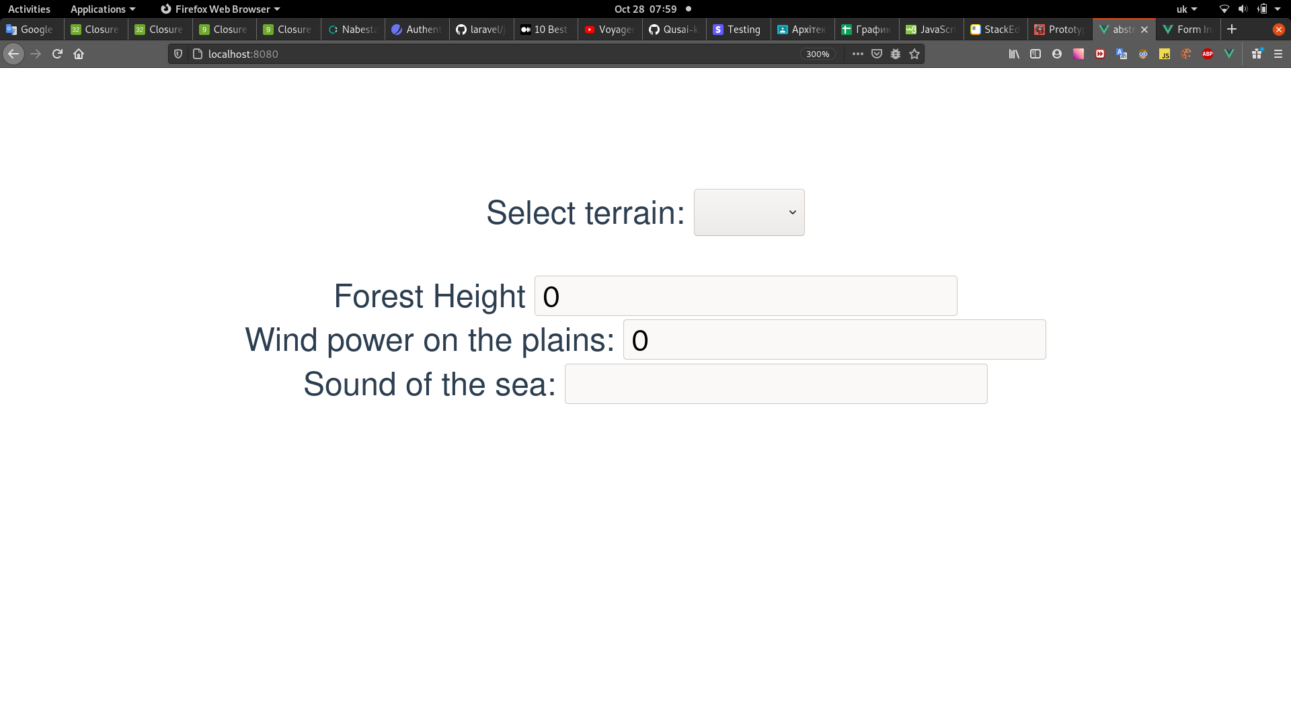

Обравши Земну місцевість:

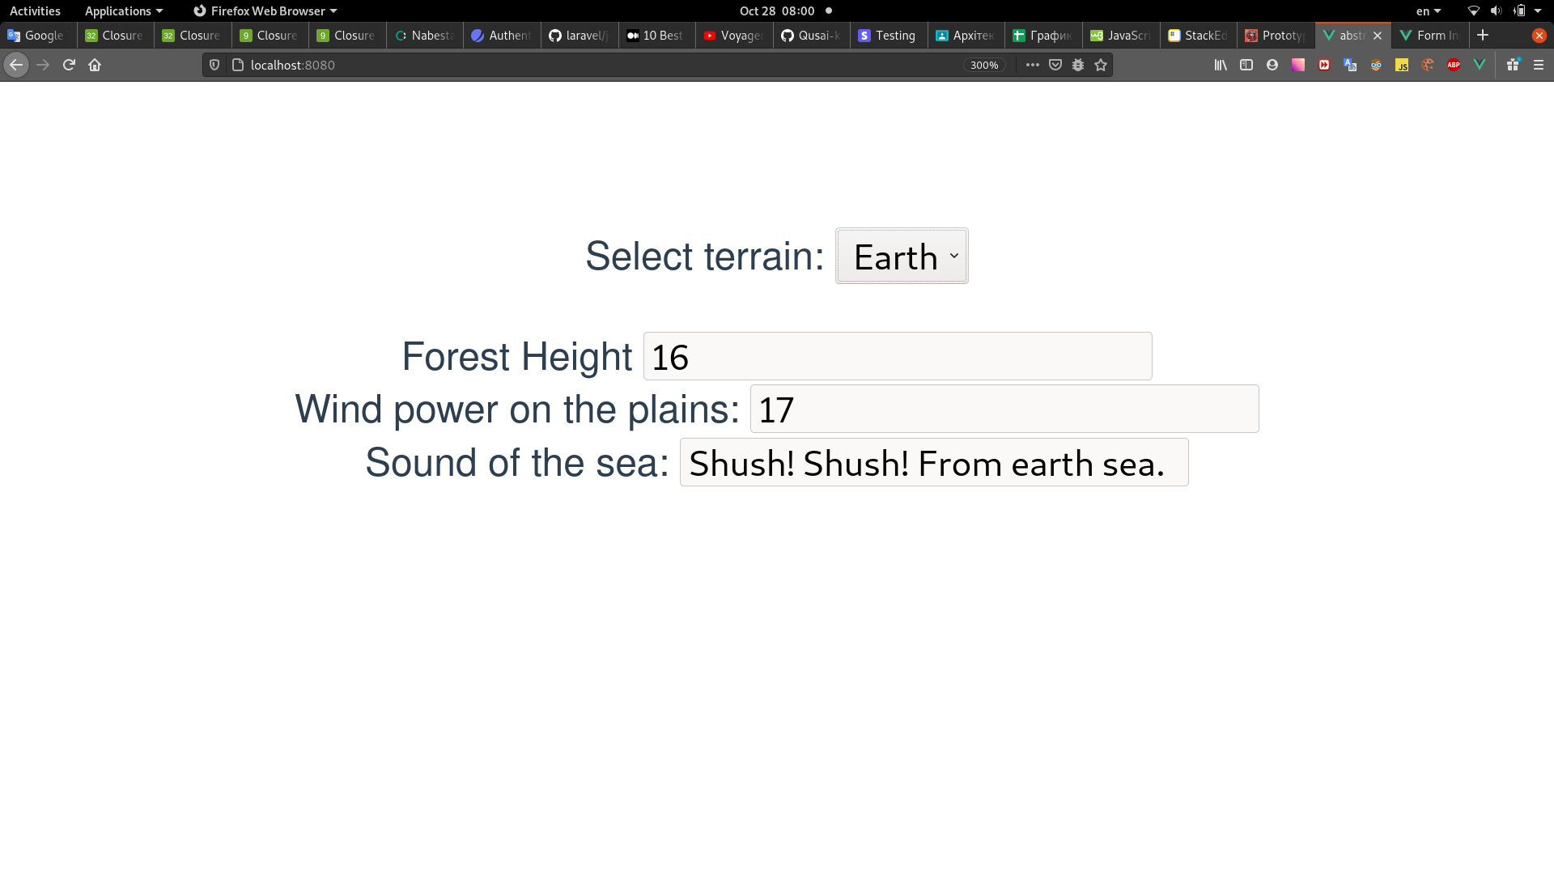

На Марсі:

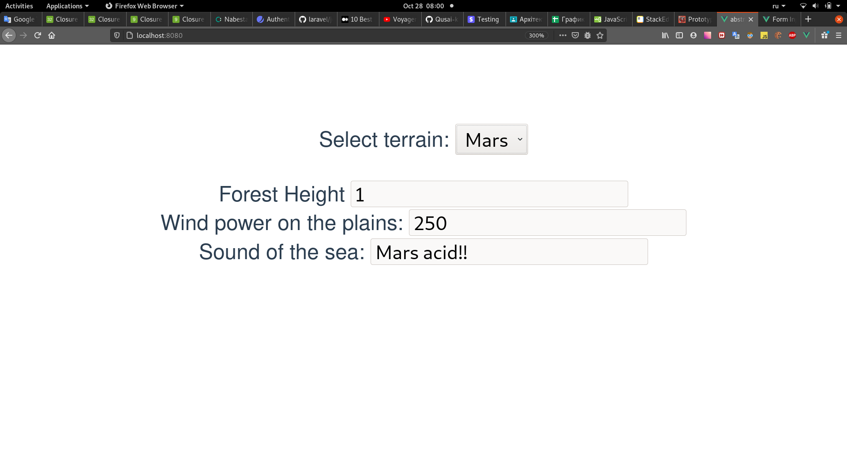

2. Створимо прототипну фабрику.

src/Factories/Terrain/CustomTerrainFactory.ts:

import TerrainFactory from "@/Factories/Terrain/TerrainFactory";
import Forest from "@/Entities/Terrains/Forest/Forest";
import Plains from "@/Entities/Terrains/Plains/Plains";
import Sea from "@/Entities/Terrains/Sea/Sea";
export default class CustomTerrainFactory implements TerrainFactory {
private forestPrototype: Forest;
private plainsPrototype: Plains;
private seaPrototype: Sea;
constructor(forestPrototype: Forest, plainsPrototype: Plains, seaPrototype: Sea) {
this.forestPrototype = forestPrototype;
this.plainsPrototype = plainsPrototype;
this.seaPrototype = seaPrototype;
}
makeForest(): Forest {
return this.forestPrototype.clone();
}
makePlains(treesCount: number = -1): Plains {
return this.plainsPrototype.clone();
}
makeSea(): Sea {
return this.seaPrototype.clone();
}
}
Тепер потрібно реалізувати методи clone на всіх наших цілевих об’єктах:

src/Entities/Terrains/Sea/Sea.ts:
clone(): Sea;

src/Entities/Terrains/Sea/EarthSea.ts:
clone(): Sea {
return new EarthSea();
}

src/Entities/Terrains/Sea/MarsSea.ts:
clone(): Sea {
return new MarsSea();
}

src/Entities/Terrains/Sea/NullSea.ts:

clone(): Sea {
return this;
}

src/Entities/Terrains/Plains/Plains.ts:
clone(): Plains;

src/Entities/Terrains/Plains/EarthPlains.ts:
clone(): Plains {
return new EarthPlains(this.treesCount);
}

src/Entities/Terrains/Plains/MarsPlains.ts:

clone(): Plains {
return new MarsPlains();
}

src/Entities/Terrains/Plains/NullPlains.ts:
clone(): Plains {
return this;
}

src/Entities/Terrains/Forest/Forest.ts:
clone(): Forest;

src/Entities/Terrains/Forest/EarthForest.ts:
clone(): Forest {
return new EarthForest(this.humidity);
}

src/Entities/Terrains/Forest/MarsForest.ts:
clone(): Forest {
return new MarsForest();
}

src/Entities/Terrains/Forest/NullForest.ts:
clone(): Forest {
return this;
}

Також, створимо фабрики для цих об’єктів (щоб потім використати для створення прототипу):

src/Factories/Terrain/Entities/ForestFactory.ts:
import Forest from "@/Entities/Terrains/Forest/Forest";
import EarthForest from "@/Entities/Terrains/Forest/EarthForest";
import MarsForest from "@/Entities/Terrains/Forest/MarsForest";
import NullForest from "@/Entities/Terrains/Forest/NullForest";
export default class ForestFactory {
fabricate(type: string, params: any[]): Forest {
switch (type) {
case 'earth':
// @ts-ignore
return new EarthForest(...params);
case 'mars':
// @ts-ignore
return new MarsForest(...params);
case '':
return new NullForest();
default:
throw new Error(`Type ${type} not found`);
}
}
}
src/Factories/Terrain/Entities/PlainsFactory.ts:

import Plains from "@/Entities/Terrains/Plains/Plains";
import EarthPlains from "@/Entities/Terrains/Plains/EarthPlains";
import MarsForest from "@/Entities/Terrains/Forest/MarsForest";
import MarsPlains from "@/Entities/Terrains/Plains/MarsPlains";
import NullPlains from "@/Entities/Terrains/Plains/NullPlains";
export default class PlainsFactory {
fabricate(type: string, params: any[]): Plains {
switch (type) {
case 'earth':
// @ts-ignore
return new EarthPlains(...params);
case 'mars':
// @ts-ignore
return new MarsPlains(...params);
case '':
return new NullPlains();
default:
throw new Error(`Type ${type} not found`);
}
}
}

src/Factories/Terrain/Entities/SeaFactory.ts:
import EarthSea from "@/Entities/Terrains/Sea/EarthSea";
import MarsSea from "@/Entities/Terrains/Sea/MarsSea";
import NullSea from "@/Entities/Terrains/Sea/NullSea";
export default class SeaFactory {
fabricate(type: string, params: any[]) {
switch (type) {
case 'earth':
// @ts-ignore
return new EarthSea(...params);
case 'mars':
// @ts-ignore
return new MarsSea(...params);
case '':
return new NullSea();
default:
throw new Error(`Type ${type} not found`);
}
}
}
Внесемо відповідні зміни в App.vue:
<template>
<div id="app">
<label>
Select terrain:
<select name="" id="" v-model="terrainType">
<option disabled selected>...</option>
<option value="earth">Earth</option>
<option value="mars">Mars</option>
<option value="custom">Custom</option>
</select>
</label>
<br>
<br>
<div v-if="terrainType === 'custom'">
<label>
Forest type:
<select v-model="customTypeConfig.forest.name">
<option disabled selected>...</option>
<option value="earth">Earth</option>
<option value="mars">Mars</option>
</select>
<label v-if="customTypeConfig.forest.name === 'earth'">
Earth humidity:
<input type="number" min="0" v-model="customTypeConfig.forest.params[0]">
</label>
</label>
<br>
<br>
<label>
Plains type:
<select v-model="customTypeConfig.plains.name">
<option disabled selected>...</option>
<option value="earth">Earth</option>
<option value="mars">Mars</option>
</select>
<label v-if="customTypeConfig.plains.name === 'earth'">
Trees count:
<input type="number" min="0" v-model="customTypeConfig.plains.params[0]">
</label>
</label>
<br>
<br>
<label>
Sea type:
<select v-model="customTypeConfig.sea.name">
<option disabled selected>...</option>
<option value="earth">Earth</option>
<option value="mars">Mars</option>
</select>
</label>
</div>
<div>
<br>
<label>
Forest Height
<input readonly type="text" v-bind:value="forest.treesHeight()">
</label>
<br>
<label>
Wind power on the plains:
<input readonly type="text" v-bind:value="plains.windPower()">
</label>
<br>
<label>
Sound of the sea:
<input readonly type="text" v-bind:value="sea.noise()">
</label>
</div>
</div>
</template>
<script lang="ts">
import {Component, Vue} from 'vue-property-decorator';
import HelloWorld from './components/HelloWorld.vue';
import EarthTerrainFactory from "@/Factories/Terrain/EarthTerrainFactory";
import MarsTerrainFactory from "@/Factories/Terrain/MarsTerrainFactory";
import TerrainFactory from "@/Factories/Terrain/TerrainFactory";
import NullTerrainFactory from "@/Factories/Terrain/NullTerrainFactory";
import CustomTerrainFactory from "@/Factories/Terrain/CustomTerrainFactory";
import ForestFactory from "@/Factories/Terrain/Entities/ForestFactory";
import PlainsFactory from "@/Factories/Terrain/Entities/PlainsFactory";
import SeaFactory from "@/Factories/Terrain/Entities/SeaFactory";
@Component({
components: {
HelloWorld,
},
data: () => ({
terrainType: "",
customTypeConfig: {
forest: {
name: '',
params: [
null
],
},
sea: {
name: '',
params: [],
},
plains: {
name: '',
params: [
null,
],
},
},
}),
computed: {
forest() {
return this.terrainFactory.makeForest();
},
sea() {
return this.terrainFactory.makeSea();
},
plains() {
return this.terrainFactory.makePlains(30);
},
terrainFactory(): TerrainFactory {
switch (this.terrainType) {
case "earth":
return new EarthTerrainFactory();
case "mars":
return new MarsTerrainFactory();
case "custom":
return this.customTerrainFactory;
default:
return new NullTerrainFactory();
}
},
customTerrainFactory(): undefined | null | CustomTerrainFactory {
const config = this.customTypeConfig;
return new CustomTerrainFactory(
this.forestFactory.fabricate(config.forest.name, config.forest.params),
this.plainsFactory.fabricate(config.plains.name, config.plains.params),
this.seaFactory.fabricate(config.sea.name, config.sea.params),
);
},
forestFactory(): ForestFactory {
return new ForestFactory();
},
plainsFactory(): PlainsFactory {
return new PlainsFactory();
},
seaFactory(): SeaFactory {
return new SeaFactory();
},
}
})
export default class App extends Vue {
}
</script>
<style>
#app {
font-family: Avenir, Helvetica, Arial, sans-serif;
-webkit-font-smoothing: antialiased;
-moz-osx-font-smoothing: grayscale;
text-align: center;
color: #2c3e50;
margin-top: 60px;
}
</style>

Тепер, в випадаючому списку обираємо “Custom” та налаштовуємо прототипну фабрику, одразу ж бачачи зміни:
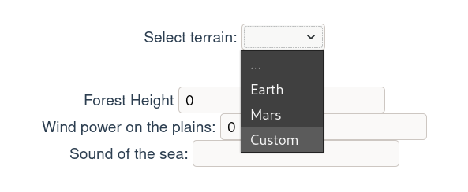
При такому виборі, нам стають доступні налаштування:

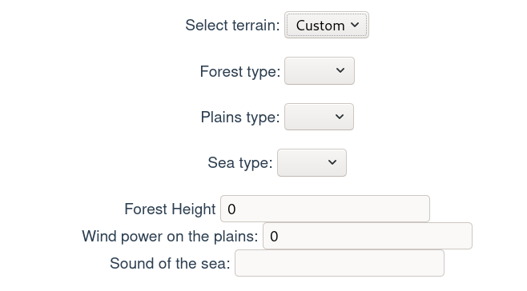

Для параметрів, що потребують налаштування, відкриваються випадаючі списки для їх введення:

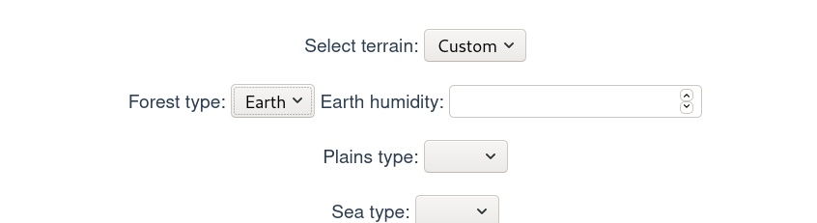

Задавши значення, бачимо як змінився кінцевий результат:

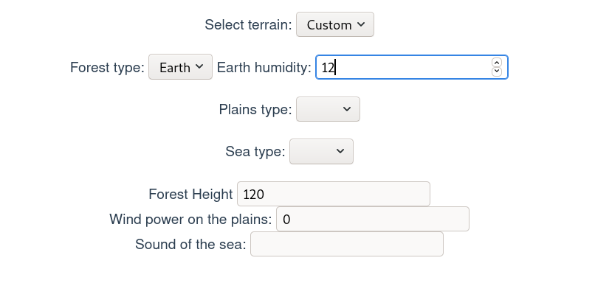

Те ж саме стосується й інших параметрів:
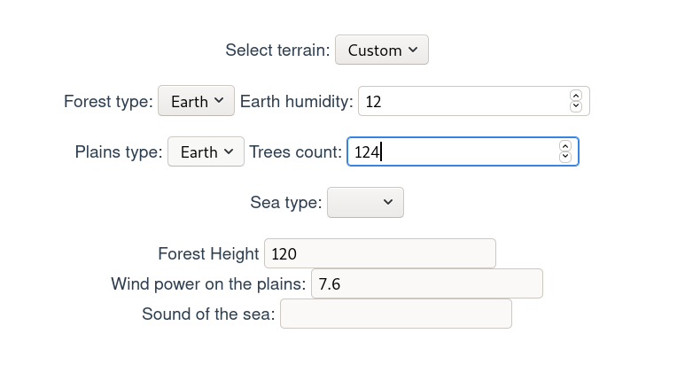

Важливою особливістю прототипної фабрики на відміну від абстрактрої є те, що вона є більш гнучкою. Тобто створення залежить від заложених прототипів об’єктів. В даному випадку, можна створити гібридну місцевість – частково з земними елементами, частково – з марсовими.

До прикладу, можна обрати тип моря від Марсу:

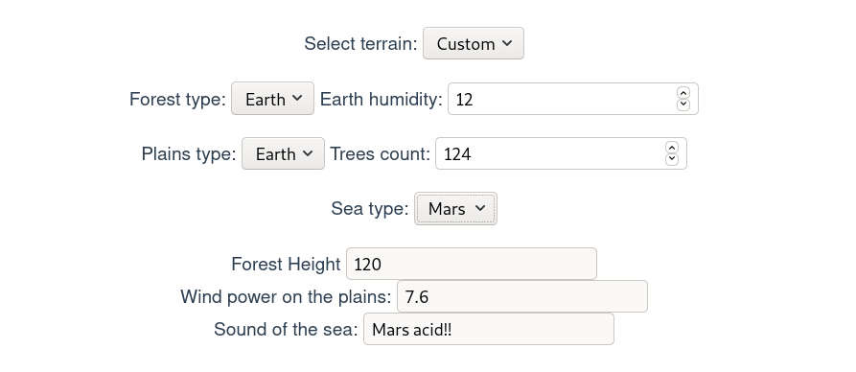

Висновок:
На цій лабораторній роботі я більш повно вивчив породжуючі шаблони проектування, зокрема, абстрактну та прототипну фабрики.

