MeetScribe
Product Requirements Document
v0.1 MVP · April 2026

Product vision
MeetScribe is a free, open source meeting recorder and transcriber that runs entirely in a single HTML file. Users double-click to open it in their browser, record their screen, and get AI-powered transcripts with speaker labels, timestamps, and mixed-language support. No installation, no accounts, no backend servers.

Pain points solved
Pain point | How MeetScribe solves it
Cost | Free and open source. Users bring their own Gemini API key (free tier available). No subscription fees.
Privacy | Zero data leaves the user's machine. No backend, no accounts, no telemetry. Video and transcripts stay in browser memory, gone when the tab closes.
Complexity | One HTML file. Double-click to open. No npm, no Docker, no CLI. Non-developers can use it immediately.
Mixed languages | Supports Chinese/English code-switching and auto-detects language mix. Most tools only handle one language at a time.
Speaker identification | Automatic speaker diarization powered by Gemini. Tells you who said what without manual setup.
Google Meet recording | Google Meet charges for recording on most plans. MeetScribe uses browser screen capture (free) as an alternative.

Architecture
The entire application is a single self-contained HTML file. All logic runs client-side in the browser. The only external call is to the Gemini API for transcription and analysis.

Tech stack
- Screen recording: getDisplayMedia API (screen/window/tab capture) + getUserMedia (microphone mixing)
- Video playback: Native HTML5 <video> element
- Transcription engine: Gemini Flash API (speaker diarization + multilingual, called directly from browser via CORS)
- Chat analysis: Gemini Flash API (transcript passed as context for Q&A)
- Storage: localStorage for API key only. All other data lives in browser memory.

Why Gemini Flash?
Gemini Flash is the only model that simultaneously supports browser-side API calls (CORS), a generous free tier (1,000 requests/day), built-in speaker diarization, and multilingual transcription. Alternatives like Deepgram or AssemblyAI offer better diarization accuracy, but require server-side integration and paid accounts, which conflicts with the "one HTML file, no backend" architecture. For future versions, additional transcription engines can be added as options.

Feature requirements

1. Screen recording
- Click "Record screen" to trigger browser's native screen/window/tab picker
- 3-second countdown after user selects capture source, giving time to switch to meeting window
- Captures system audio (via "Share audio" checkbox in browser dialog) + microphone audio, mixed into a single track
- Live recording timer in the header bar
- "Stop recording" ends capture; video immediately appears in the player

2. Video import and playback
- Drag and drop or file picker for .webm, .mp4, .mkv files
- Video loads instantly (local file, no upload)
- Standard playback controls: play/pause, seek bar, timestamp display

3. AI transcription
- Extracts audio from video in browser using AudioContext
- Splits audio into chunks (~20 min each) for Gemini's context window limit
- Sends audio to Gemini Flash with a prompt requesting: JSON output, speaker labels, timestamps, automatic language detection (English/Chinese/mixed)
- Processing progress shown step-by-step in the right panel (extracting audio, splitting, transcribing chunk N/M, diarization, finalizing)
- Optional subtitle overlay on the video player
- Video remains playable during transcription

4. Transcript panel
- Right-side panel showing transcript segmented by speaker
- Each segment shows: speaker color dot, speaker label, timestamp, transcript text
- Click any segment to jump video to that timestamp
- Current segment highlighted as video plays
- Search bar to filter transcript by keyword

5. Chat analysis
- Second tab in the right panel
- User asks questions about the meeting transcript (e.g., "Summarize key decisions", "What did Speaker 2 say about budget?")
- Sends transcript as context to Gemini; streams response in chat bubble format

6. Export
- Export modal with multi-select options:
  - Transcript as Markdown (speaker labels + timestamps)
  - Transcript as SRT (standard subtitle format)
  - Transcript as JSON (structured data for developers)
  - Video recording (.webm)
  - Chat analysis history

User flow

How a non-developer uses MeetScribe
- Download one file. Go to the GitHub repo, click "Download meetscribe.html". Save it anywhere on your computer.
- Get a free API key. Go to Google AI Studio (aistudio.google.com), sign in with your Google account, click "Create API Key". Copy it.
- Open MeetScribe. Double-click the HTML file. It opens in Chrome. First time: paste your API key when prompted. It saves automatically for next time.
- Record your meeting. Click "Record screen". Choose which screen/window/tab to capture. A 3-second countdown gives you time to switch to your meeting. Click "Stop" when done.
- Get your transcript. Click "Transcribe". Wait a few minutes. The transcript appears on the right with speaker labels and timestamps.
- Ask questions. Switch to the Chat tab. Ask things like "What were the action items?" or "Summarize what John said."
- Export. Click "Export all". Pick what you need (transcript, subtitles, video, chat history). Done.

Wireframes
The complete state flow: Initial → Countdown (3s) → Recording → Video loaded → Processing → Transcript + Chat → Export. Users can also skip to "Video loaded" by dragging in an existing file.

State 1: Initial view
User sees a drop zone for importing existing video, or a "Record screen" button to start capture. API key status shown in the top bar.
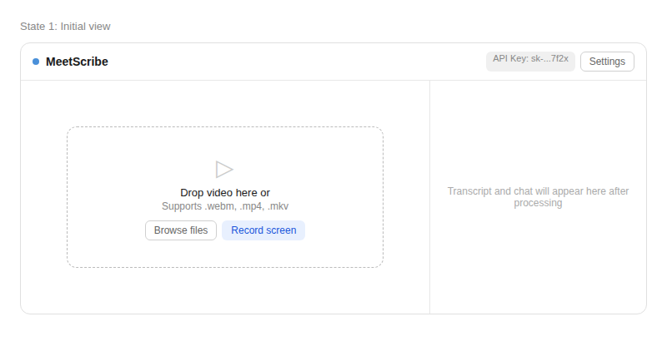

State 2a: Countdown
After the user selects a screen/window/tab, a 3-second countdown begins. This gives the user time to switch to their meeting window before recording starts.
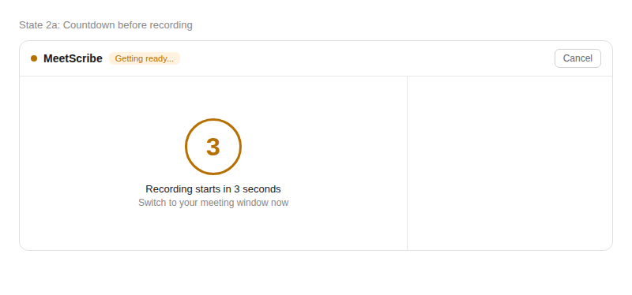

State 2b: Recording
Red indicator and timer in the header. "Stop recording" button prominently displayed. User switches to their meeting; MeetScribe records in the background.
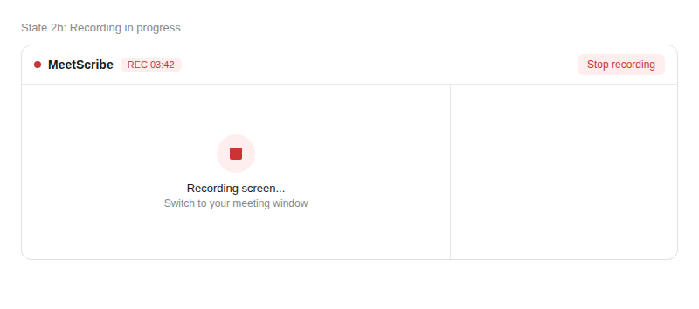

State 3a: Video loaded
Video appears in the player with full playback controls. "Transcribe" button and "Overlay subtitles" checkbox below the player. Right panel shows placeholder waiting for transcription.
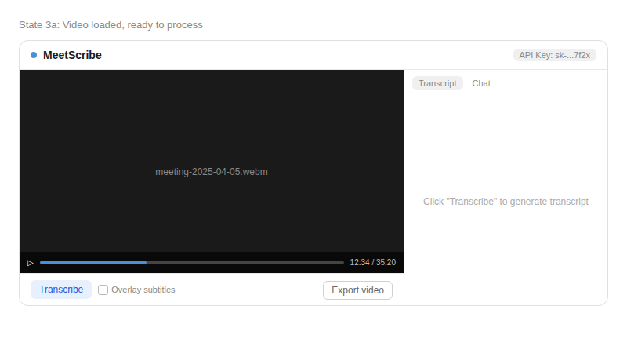

State 3b: Processing
Right panel shows step-by-step progress: extracting audio, splitting chunks, transcribing each chunk, speaker diarization, finalizing. Progress bar and time estimate at the bottom. Video remains playable.
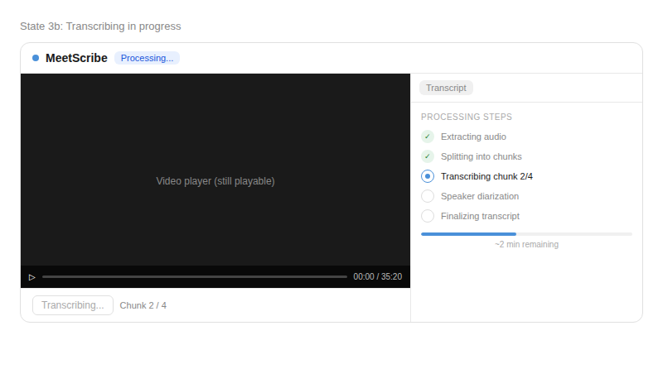

State 4: Transcript complete
Right panel shows transcript segmented by speaker with color-coded labels, timestamps, and Chinese/English mixed text. Current segment highlighted. Subtitle overlay on video. Search bar at the bottom.
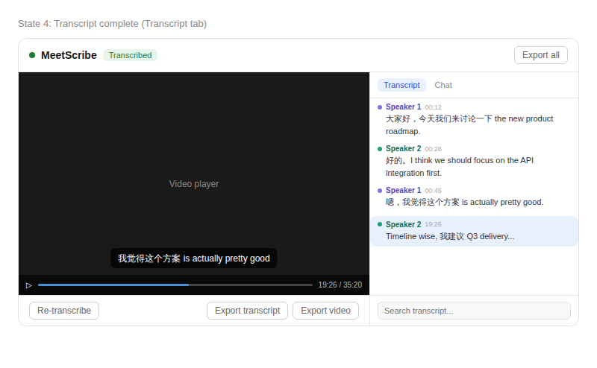

State 4b: Chat tab
User switches to Chat tab. Asks questions about the transcript; Gemini responds with analysis. Chat history persists during the session.
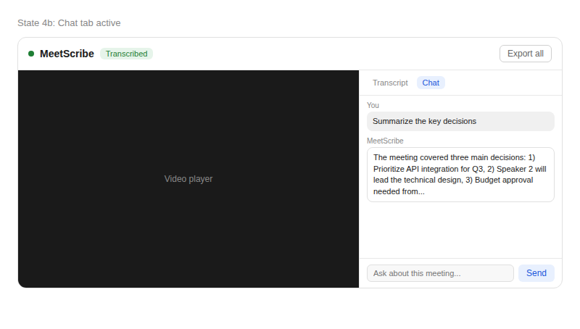

State 5: Export
Modal with multi-select export options: Markdown, SRT subtitles, JSON, video file, and chat history. User selects what they need and clicks "Download selected".
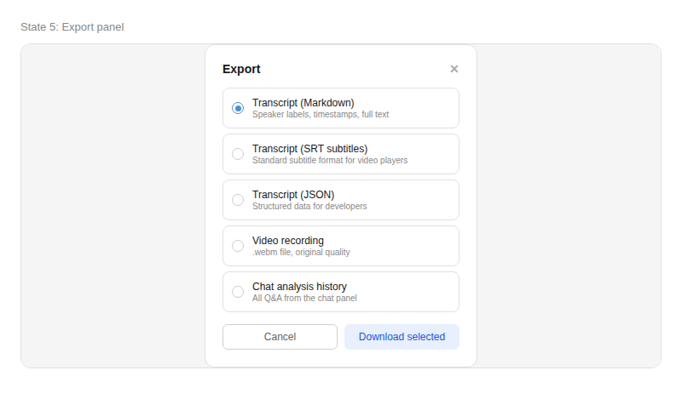

Open source strategy
MeetScribe will be released under the MIT license. The repo will include the single HTML file, a README with setup instructions (get API key, double-click, done), and demo GIFs. The goal is GitHub stars and community reputation, not monetization.
Target audience: developers and non-developers who want free, private meeting transcription. The "one HTML file" angle is the viral hook that differentiates from tools like Otter, tl;dv, and Fireflies.
Future expansion: support additional transcription engines (AssemblyAI, Deepgram) as selectable options; Chrome Web Store extension for tighter Google Meet integration; community-contributed language packs.

