XDG Linux File Picker Mod tutorial
To start with, the server is a regular Python script that you can run anywhere and any way you want. There are two ways to run it:
A. Manual
B. Automatic, using your desktop environment's autorun.

MANUAL METHOD
The picker_server.py file is already waiting for you in your home directory to be run using the terminal:
python3 ~/picker_server.py

AUTOMATIC METHOD
The picker_server.desktop file is in the ~/.config/autostart/ directory, so the next time you log into your account the script should activate automatically if your DE is compliant to XDG standards (you have GNOME, KDE Plasma, or another known environment). It is highly recommended to double-check the file.

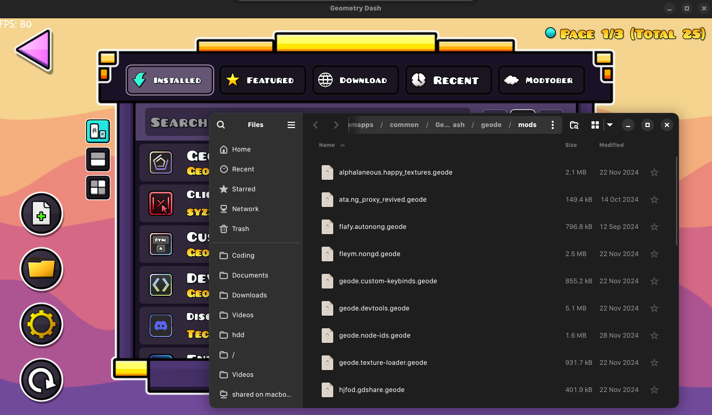
Example of successfully running File Manager (not Wine's one)

