REQUESTOR DETAILS
Fill up all required (*) entry fields. Don’t leave it blank.
Requestor: | Ramil Laude | Ticket Number: | INC0375564
Contact Number: | 09282102572 | Request date: | September 22, 2026
*Actual User & Employee ID: (if the assignee is nonregular /consultant) |  | Contact Number:

*
Assignee

&
Employee ID
:

Complete name w/
(
M
iddle Initial
)

Mariss

Ivy D. Batac

Contact N
umber:

Position:

HR Technology and Analytics
Assistant Manager

*
Division/Dept:

HROD

/
HR TECHNOLOGY AND
ANALYTICS

*
Cost Center:

3
AC2SYS
001

Function:

Office

Field

Both

REQUEST DETAILS

HARDWARE New Upgrade Replacement (Serial no. of old PC______________________________) Indicate quantity in the space provided below.
Desktop ___ Projector____________ Others: Azure App Registration – HR Job Offer Tool
Printer
Laptop ____
Model:___________________

SOFTWARE |  |  | New Renewal |  |  |  | License Type: |  |  |  | Licensed Free  License validity: ___________________
Type of Tool: |  |  | Communication and Collaboration Database Development Tools  Graphics and Multimedia Interactive Media Productivity  Others: __HR Job Offer Tool_________________________
Installer Link:
Non-standard software licenses must be purchased before installation. Indicate how many users in the space provided below.
 |  | Microsoft Office___ |  |  |  | Adobe Photoshop___ |  |  |  | SQL___ |  |  |  | Others:
 |  | Microsoft Project___ |  |  |  | Adobe Acrobat___ |  |  |  | Visual Studio ___ |  |  |  |  |  | _____________
 |  | Microsoft Visio___ |  |  |  | Adobe Flash___ |  |  |  | Power BI___ |  |  |  |  |  | _____________
 |  | Microsoft Access___ |  |  |  | Adobe Creative Cloud___ |  |  |  |  |  |  |  |  |  | _____________

Points to remember when writing your business justification:
- Provide a clear and extensive reason why the software is required and why the pre-installed standard software in your assigned computer do not suffice.
- Provide a brief description of your project initiatives, along with a summary of your business unit's need and technical requirements when applicable.
- Provide the specific integrations to other systems when applicable.

Business  Justification | Business Justification: HR Job Offer Tool Application Registration  The HR Job Offer Tool requires application registration, Microsoft Graph API consent, and access configuration to support HR’s job offer workflow. The requested access will enable organizational sign-in, retrieval of candidate response data from SharePoint, and review of job offer correspondence received by the designated service accounts.  These capabilities will help reduce manual data retrieval and email checking, improve visibility into candidate responses, and support timely follow-up throughout the job offer process.  Justification for Requested Permissions  Permission Business justification  Supports single sign-on by allowing the application to retrieve the signed-in user’s  User.Read basic profile and identify the user within the HR Job Offer Tool.  Enables downloading of the Candidate Responses Excel file from SharePoint so HR can  Files.Read.All use submitted candidate information in the job offer workflow.  Enables reading of emails and replies in the designated service-account mailboxes,  Mail.Read including subjects, recipients, CC, and message content, to support tracking and review of job offer correspondence.  Service Accounts  - HRODJobOffer1@unilab.com.ph  - HRODJobOffer2@unilab.com.ph  The business requirement is limited to the relevant SharePoint candidate response file and the two service-account mailboxes. Access should be configured to the minimum scope necessary, with the permission type and available resource restrictions validated during technical review.  Application and Environment Configuration  The application uses web authentication with the following redirect URIs:  - Production: https://hrjoboffer.unilab.com.ph/signin-oidc  - Quality assurance: https://qas-hrjoboffer.unilab.com.ph/signin-oidc  - Local development: https://localhost:5062/signin-oidc  Approval Requested  Approval is requested for the application registration, required consent, and access configuration to enable these functions. Because the application handles candidate information and email content, access should be restricted to authorized personnel and managed in accordance with organizational security and data privacy requirements.

SUBMITTED BY
  Ramil Laude / Sept. 25, 2026  REQUESTOR /ASSIGNEE  (SIGNATURE OVER PRINTED NAME AND DATE SIGNED) | 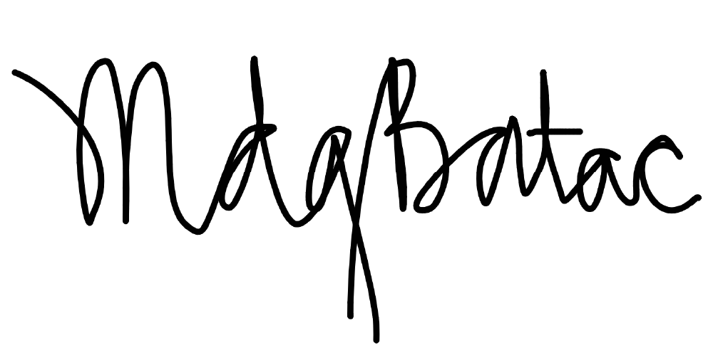  Mariss Ivy Batac / Sept. 25, 2026  COST CENTER OWNER/DIVISION HEAD (SIGNATURE OVER PRINTED NAME AND DATE SIGNED)

For CIT Only: Do not write beyond this point

EVALUATION AND RECOMMENDATION
*Please note that this ITRF is valid up to 3 years until: _______________

CORPORATE INFORMATION TECHNOLOGY
Reviewed by:  AUTHORIZED SIGNATORY ONLY  (SIGNATURE OVER PRINTED NAME AND DATE SIGNED) | Approved by:  AUTHORIZED SIGNATORY ONLY  (SIGNATURE OVER PRINTED NAME AND DATE SIGNED)

