UNI-BOOKS SAMPLE FILE WALKTHROUGH

# First Aid Inventory App.

This walkthrough will give you a quick run-down of the how the First Aid Inventory sample file was created.

To define a UNI-Books file, click the settings button in the top toolbar (right-side).  
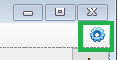

The Data File field tells the UI which data file to connect to. Use this to view the other samples!

If you put a new file name here, a new UNI-Books file will be created.

Entering a password will cause all file saves to be encrypted. When an encrypted UNI-Book is opened the correct password must be provided.

The descriptions tab let you rename the elements in the program UI.

Count – Sets the balance to the entered amount, Increase and Decrease add/subtract from the running balance.

The “Nothing” action does not affect the running balance but can be used as a marker or comment event.

You can enter anything you want in the dropdowns if you do not see the desired valuer listed.

The input tab defines how the event entry dialog behaves.

The lists tab let you set colors and format balance amounts. For money format “$#,###,##0.00”.

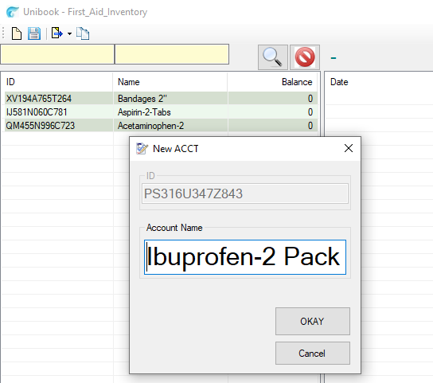

To create new lines/accounts/items, hit the new button:  


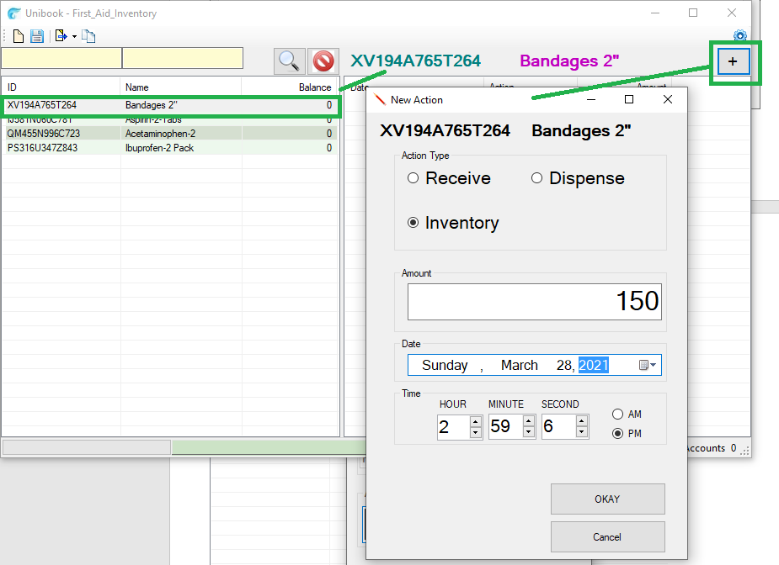

To set/adjust the account balance, click line and then the add button (SEE ABOVE).

Filtering the accounts list

