8/9/2016
Letter of Transmittal

To: | Maryland Transit Administration | Submittal Number | 28
To: | Attn: James Anthony, RE Ancillary Construction (CC: Peter Murphy OE) | Contract Number | T1342
To: | 6 Saint Paul Street, 7th Floor | OFS Number | 0003
To: | Baltimore, MD 21202 | Charge Number 0300-3040
 | Project Name: METRO Old Court Roof Replacement

Subject: | MTA Contractor ID Badge Request

The following items are being sent:
(X) Herewith ( ) Final ( ) Plans ( )MSDS
( ) Under separate Cover ( ) Preliminary (X)Samples ( )Product Data

Quantity |  | Description
5 |  | MTA Contractor ID Badge Request

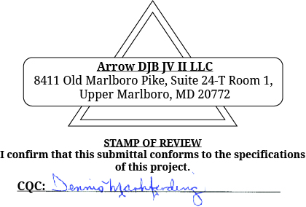
These Items Are Being Sent:

( ) Returned ( ) Approved
( ) Complete & Return ( ) Not approved, resubmit
( ) For your general information/file ( ) Approved as noted
(X) For approval or correction ( ) Bldg. Permit applied for
(X) For your review/comment ( ) For your signature(s)

Sent by: K. Mardis

Please advise Kasay Mardis (Project Manager) of any approvals or deficiencies at km@8aarrow.com or at 202-297-1172

