DEVELOPMENT OF A WEB-BASED MOBILE RESPONSIVE APPLICATION OF A COMMUNITY INFOCENTER

A Thesis
Presented to the Faculty of the College of Science
Technological University of the Philippines
Ayala Boulevard, Manila

By
RON ALLAN R. DEL MUNDO

In Partial Fulfillment of the Requirements for the Degree
Bachelor of Science in Information Technology

August 2025

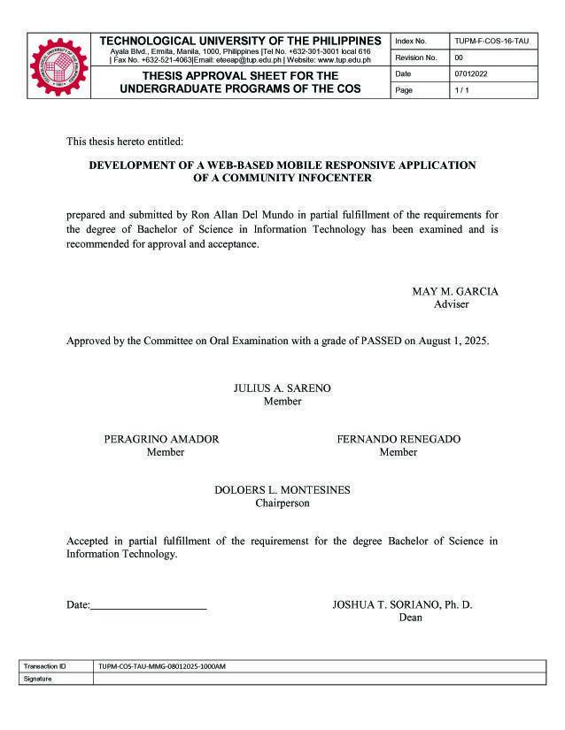
ABSTRACT
This study, titled “Development of a Web-Based Mobile Responsive Application of a Community InfoCenter,” focuses on creating a centralized digital platform for information dissemination and emergency management in Barangay Dampalit, Malabon City—a coastal area highly susceptible to flooding and other natural disasters. The project aims to enhance community preparedness and communication by integrating essential features such as an interactive map of evacuation centers, real-time traffic and utility updates, environmental alerts, and an SMS notification system for emergencies. The system was developed using PHP, CSS, Bootstrap, and JavaScript for the web interface, with MySQL as the database and API integrations for maps, weather, and SMS services. It was hosted on Amazon Web Services (AWS) to ensure accessibility and reliability during crises. Following the ISO 25010 software quality model, the system was evaluated in terms of functionality, usability, compatibility, reliability, maintainability, and portability. Results revealed a grand mean rating of 3.58, interpreted as “Highly Acceptable.” The highest scores were achieved in functional suitability and usability, confirming that the application effectively delivers accurate information and provides a user-friendly experience. The findings conclude that the developed web-based mobile responsive application successfully serves as an information hub that promotes timely, accurate, and accessible communication within the community, especially in times of emergencies. Future enhancements include automating emergency status updates, adding a community feedback feature, and developing a dedicated mobile version for Android and iOS.

ACKNOWLEDGEMENT
Above all, I give thanks to the Lord for his continuous presence, guidance, grace, wisdom and blessing throughout my life and academic journey. He gave me strength in time of doubt and challenges. Without Him, I’m nothing and this achievement would not have been possible without His divine help.

To my Nanay Rosa, my wife Jacq, my daughters Julia and Jodi, my family, my inspiration, thank you for your unconditional love, support and encouragement, their belief in me kept me going even in the most challenging times. To my family: This is a reflection of your love and support.

Special thanks to the esteemed panel and Professor Dolores Montesines, Professor Peragrino Amador, Professor Fernando Renegado, Professor Edward Cruz, Professor Julius Sareno for sharing their expertise, wisdom and patience as they guide me through my research and this had been an enriching learning experience.

To my thesis adviser Professor May Garcia for her invaluable guidance, dedication and support, her insightful feedback, patience and encouragement were instrumental in shaping the direction of my research and helping me overcome challenges along the way.

To Dr. Kevien Cabarrubias-Dela Cruz, Ph.D., Director of the Expanded Tertiary Education, Equivalency and Accreditation Program (ETEEAP) and to my alma mater the Technological University of the Philippines, who accommodate and grant me the opportunity to pursue my studies, complete my academic journey and fulfil my lifelong dream to graduate. It has been an honor to be part of this institution, and I’m truly grateful for the program’s commitment to excellence that helps me reach this very important milestone.

God Bless us all!

TABLE OF CONTENTS
Page
Title Page |  | i
Approval Sheet |  | ii
Abstract |  | iii
Acknowledgement  Table of Contents  List of Tables  List of Figures  List of Appendices |  | iv  v  vii  viii  x
Chapter 1 | THE PROBLEM AND ITS SETTING | 13
 | Background of the Study | 13
 | Objectives of the Study | 16
 | Scope and Limitations of the Study | 17
Chapter 2 | CONCEPTUAL FRAMEWORK | 19
 | Review of Related Literature  Related Studies  Conceptual Model of the Study  Operational Definition of Terms | 19  31  34  35
Chapter 3 | METHODOLOGY | 38
 | Project Design  Project Development  Operation and Testing Procedure  Evaluation Procedure | 38  51  52  59
Chapter 4 | RESULTS AND DISCUSSION | 61
 | Project Description | 61
 | Project Structure | 62
 | Project Capabilities and Limitations | 69
 | Test Result | 70
 | Evaluation Result | 72
Chapter 5 | SUMMARY OF FINDINGS, CONCLUSIONS AND RECOMMENDATIONS | 75
 | Summary of Findings | 75
 | Conclusions | 76
 | Recommendations | 77
REFERENCES |  | 78
RESEARCHER’S PROFILE |  | 110

LIST OF TABLES
Table |  | Page
1 | Functional Testing Procedure | 54
2 | Compatibility Testing Procedure | 57
3 | Usability Testing Procedure | 58
4 | Rating Table | 60
5 | Compatibility Testing Procedure and Result | 70
6 | Usability Testing Procedure and Result | 71
7 | Summary of the evaluation Ratings | 73

LIST OF FIGURES
Figure |  | Page
1 | Damage due to Extreme Events and Disasters (in Billion Php) | 13
2 | Nos. of Incidents & Deaths Due to Natural Extreme Events & Disaster from 2010-19 | 14
3 | Percentage Population of Barangay Dampalit | 14
4 | Map of Dampalit, Malabon City (Google Maps) | 15
5 | Demographic of Dampalit, Malabon City | 20
6 | Software Testing Categories | 29
7 | Software Product Quality | 29
8 | Conceptual Model of the Study | 34
9 | Context Data Flow Diagram | 39
10 | Data Flow Diagram | 40
11 | Use case diagram of the system | 41
12 | Database Design of Community Infocenter part 1 | 41
13 | Database Design of Community Infocenter part 2 | 42
14 | Database Design of Community Infocenter part 3 | 42
15 | System Architecture Diagram | 43
16 | Desktop UI\ Home page | 43
17 | Desktop UI\ Registration page | 44
18 | Desktop UI\ Fire Alert page | 44
19 | Desktop UI\ First Aid Page | 45
20 | Desktop UI\ Flood Alert Page | 45
21 | Desktop UI\ Garbage Collection Page | 46
22 | Desktop UI\ Pharmacy Page | 46
23 | Desktop UI\Shelter Page | 47
24 | Desktop UI\Traffic Advisory Page | 47
25 | Desktop UI\Tsunami Alert Page | 48
26 | Desktop UI\Utilities Page | 48
27 | Desktop UI\Weather Page | 49
28 | Mobile UI\Home | 49
29 | Mobile UI\Menu | 49
30 | Mobile UI\Shelter | 49
31 | Mobile UI\Registration | 50
32 | Mobile UI\SMS Alert | 50
33 | Mobile UI\Pharmacy | 50
34 | Mobile UI\Flood | 50
35 | Mobile UI\Garbage | 50
36 | Mobile UI\Utility Alerts | 50
37 | Mobile UI\Weather | 50
38 | Mobile UI\Fire Alerts | 50
39 | Mobile UI\Tsunami | 50
40 | Iterative Waterfall Model | 50
41 | CMS Administrator Flowchart | 52
42 | User Flowchart | 53
43 | Web Applications Home Page | 61
44 | Shelter Page | 62
45 | Information Board | 63
46 | Traffic update page | 63
47 | Utilities Page | 64
48 | Fire Safety Page | 64
49 | Flood Safety Page | 65
50 | Weather Forecast Page | 65
51 | Registration Page | 66
52 | Subscriber SMS message from the web application | 66
53 | First Aid Page | 66
54 | Report Dashboard – Graphic presentation | 67
55 | Report Dashboard – Report PDF format | 67
56 | Mobile View/ Home | 68
57 | Mobile View/ Menu | 68
58 | Mobile View/ Shelter | 68
59 | Mobile View/ Registration | 68
60 | Mobile View/ SMS Alert | 68
61 | Mobile View/ Pharmacy | 68
62 | Mobile View/ Flood | 69
63 | Mobile View/ Garbage | 69
64 | Mobile View/ Utilities Alerts | 69
65 | Mobile View/ Weather | 69
66 | Mobile View/ Fire Alerts | 69
67 | Mobile View/ Tsunami | 69
68 | Mobile view/Android/ Chrome Browser | 84
69 | Mobile view/Android/ Firefox Browser | 84
70 | Mobile view/iOS/ Safari Browser | 85
71 | Mobile view/iOS/ Chrome Browser | 85
72 | Tablet View/Android/ Chrome Browser- Landscape view | 86
73 | Tablet View/Android/ Chrome Browser- Portrait view | 86
74 | Tablet View/iOS/ Safari Browser- Landscape view | 87
75 | Tablet View/iOS/ Safari Browser- Portrait view | 87
76 | Desktop View/ Chrome Browser | 88
77 | Desktop View/ Edge Browser | 88
78 | Desktop View/ Firefox Browser | 88
79 | SMS Registration UI | 89
80 | Reflected Registration on the CMS | 89
81 | SMS Alert Message | 90
82 | Sent SMS | 90
83 | Screen Responsiveness – Desktop, Laptop, Tablet and Mobile device. | 91

LIST OF APPENDICES
Appendixes |  | Page
A | User Manual | 83
B | Test Result | 84
C | Evaluation Sheet Instrument | 92
D | GANTT Chart | 94
E | Thesis Grammarian Certificate | 95
F | Certificate of Similarity Index using Turnitin URDS | 96
G | Survey Questionnaire and Result Sheet | 97

Chapter 1
THE PROBLEM AND ITS SETTINGS
Background of the Study
Philippines – Country of Natural Calamities
The Philippines is prone to frequent natural calamities. In 2022, the country topped the World Risk Report with a 46.82 world risk index. On average, 20 storms and typhoons enter the Philippine Area of Responsibility (PAR) each year, with about 8 or 9 of them crossing the Philippines.
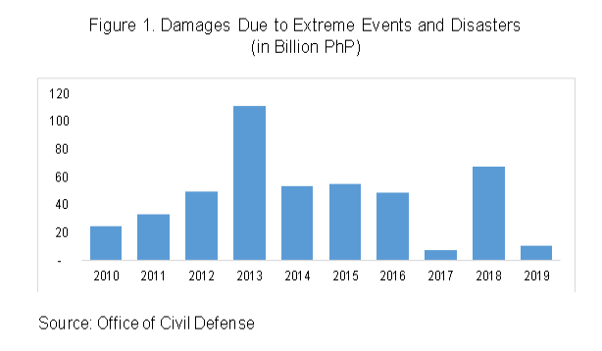
The damages incurred due to natural extreme events and disasters amounted to PhP 463 billion from 2010 to 2019. Agriculture posted the largest share with 62.7 percent or PhP 290 billion followed by infrastructure, and private/communications with 23.0 percent or PhP 106 billion and 14.3 percent or PhP 66 billion respectively.

Figure 1. Damage due to Extreme Events and Disasters (in Billion Php)
Although 2011 recorded the highest number of natural disasters at 367 (Figure 2), the highest number of deaths was recorded in 2013 at 7,056, the year when Typhoon Yolanda hit Luzon, Visayas and Mindanao in November, and a 7.2 magnitude earthquake affected Bohol in October. This was followed by 2011, the year when Tropical Storm Sendong hit the country in December. The Philippines recorded a total of 12,097 deaths from 2010 to 2019.
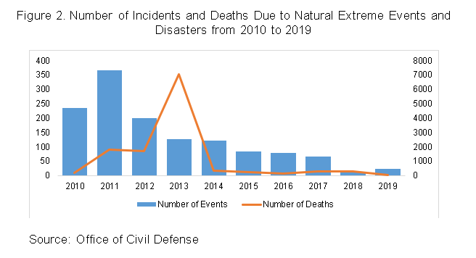

Figure 2. Nos. of Incidents & Deaths Due to Natural Extreme Events & Disaster from 2010-19
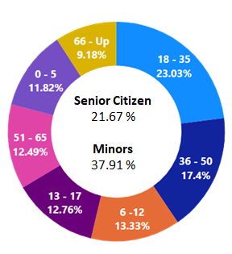
Among the major disasters from 2010 to 2019, meteorological disasters posted the highest number at 120 incidents followed by geophysical disaster and climatological disaster at 16, and 2 incidents respectively. NCR does not spare on this above-mentioned natural occurring calamities which include the city of Malabon.
Figure 3. Percentage Population of Barangay Dampalit
The City of Malabon is one of the most densely populated cities in the Philippines and its low-lying, flat terrain makes it prone to frequent flooding, especially during high tides, heavy rains and when the river and dams overflow. The four cities in CAMANAVA are commonly affected by interconnected rivers, one of which is the Tullahan River.
One of its barangay is Dampalit that belongs to the 1st district of Malabon with the total population of 13,514, which when converted into families has been estimated at 4,000 and 21.67% of the population are senior citizens, while minor is 37.91%. Dampalit is categorized as a coastal barangay covering a total land area of 261.90 hectares that are very prone to weather condition such storm and high tide that may raise the water level and immediately submerged the community with flood water since its surrounded with 2 river system the Batasan River and Muzon river which both lead to the Manila Bay.
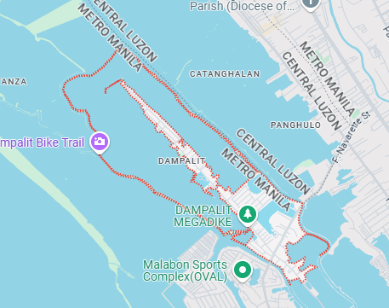

Figure 4. Map of Dampalit, Malabon City (Google Maps)
Despite the effort of the barangay council and different volunteer organizations in the community to inform the resident on the current situation during natural disaster, which is heavily relying on social media and word of mouth to decimate information this is not enough and is very prone to miscommunication and variation of facts or data.
The researcher aimed to develop a centralized web-based platform that serves as an information hub for distributing emergency notifications and safety advisories to the community, with an emphasis on natural disaster scenarios.
Objectives of the Study
The general objective of the study is to develop a centralized hub for emergency management and information dissemination that integrates critical data during crises, thereby ensuring that communities receive timely and accurate updates to guide their decisions and actions in specific emergency situations.
Specifically, it aims to:
- Develop a community infocenter that have the following features:
- Map of emergency evacuation center. Integrated to the application via free API Mapping ensuring live and accurate locations.
- Information board. Contain emergency numbers from different LGUs with copy paste options.
- Real-time traffic. Display certain traffic updates on specific places in the community.
- Utility Services pages. Updates for electricity, water interruptions, and garbage collections.
- Environmental Updates. Page designated specifically for tides, weather conditions, floods, and fire outbreak.
- SMS Alert. SMS Notifications via SMS API for emergencies and information in relation to and limited to utility services and environmental updates. Requires subscription by user.
- Video tutorials Page. Link out to Youtube for a first aid video.
- Reports. For analysis, and interpretation of data.

- To create the system using PHP, CCS, and JavaScript for the Web-based Application and CMS. MySQL for the database, utilizing cloud technology for the servers and API integrations from non-profit institutions for maps and weather data.
- Test and improve the system based on different applicable criteria of ISO 25010 with main focus on the following a. Functionality ensures that the software provides the necessary functions to fulfill user needs and application goals, b. Usability of the application that can work effectively under specified conditions for a specified period of time, and c. Compatibility of the application can be transferred from different hardware and software environments.
- Evaluate the acceptability of the developed community infocenter using the ISO 25010 quality software model.

Scope and Limitations of the Study
The study focused on the design and development of a web-based community infocenter system for Barangay Dampalit, Malabon City, a coastal community with a population of 13,514 and a total land area of 261.90 hectares. Due to its location near the Muzon and Batasan Rivers, which both lead to Manila Bay, the barangay is highly vulnerable to flooding and other water-related hazards.
The application was intended for use by barangay officials and residents within the community. It was designed to be mobile-responsive, providing an optimal user experience across different devices such as desktops, laptops, smartphones, and tablets. Its adaptive design ensures accessibility regardless of screen size or device type.
The application served as a centralized hub for community information, particularly during emergency situations. It will consolidate critical data, announcements, and advisories related to natural disasters and essential community services, ensuring that users receive timely and accurate updates to guide their actions.
Key features of the system include:
- A subscription-based SMS alert mechanism, providing free notifications to residents during emergencies or urgent events such as flooding, high tide, tsunami risks, utility service interruptions, evacuation advisories, and garbage collection schedules.
- User-friendly web interface for both residents and barangay officials.
- Integration of APIs for mapping and SMS services.
- Deployment on AWS Cloud hosting to minimize downtime during power outages or disasters.
The development of the application utilized open-source technologies including PHP, CSS, and JavaScript for the front-end and content management, MySQL for database management, and API integrations for added functionalities.
The study was evaluated by purposively selected respondents composed of residents, barangay officials, and IT experts using the ISO 25010, quality software model.

Chapter 2
CONCEPTUAL FRAMEWORK
This chapter presents a review of related literature and studies underlying the framework of the study. This contains the conceptual model of the study and the operational definition of terms.

Review of related literature
Barangay Dampalit Profile and History
The northern part of Malabon has been called DAMPALIT ever since it became a Barrio. People believe that this name might have been derived from either the Tagalog term: DAANG-PALIIT or MADAHONG PALIIT.
MADAHONG-PALIIT contracted into DAMPALIT was a kind of vegetable plant that grew plentifully in the place especially in the fishponds. Since the abundance of this plant distinguishes it from other places, DAMPALIT might have been the name given to the barrio.
On the other hand, some people believe that DAMPALIT came from DAANG-PALIIT meaning street which tapers towards the end. In this barrio, there is only one street which narrows down to a width of one foot at its ends. This might have been the reason why the barrio was called DAMPALIT.
Barangay DAMPALIT occupies about 16.6% of the entire locality. Fishpond's operations remain the line of business despite the present stature of Malabon which is fast becoming an industrial and commercial community. The Total Land Area (in square hectares): 261.90 hectares.
Demographic Information
AGE | S E X |  | TOTAL
 | Male | Female
1. Children 0 - 5 years old | 801 | 796 | 1597
2. Children 6 -12 years old | 898 | 903 | 1801
3. Children 13 – 17 years old | 892 | 832 | 1724
4. Adult 18-35 years old | 1534 | 1578 | 3112
5. Adult 36-50 years old | 1176 | 1175 | 2351
6. Adult 51-65 years old | 782 | 906 | 1688
7. Adult 66 years old & above | 552 | 689 | 1241

Figure 5. Demographic of Dampalit, Malabon City
Application Standard Requirements
A mobile responsive web application is a website that automatically adjusts its layout, content, and design to fit different screen sizes and devices, such as smartphones, tablets, and desktops. This ensures that users have a smooth and optimal experience regardless of the device they are using. A web application stored on a cloud server and made available over the Internet via a browser interface.
The Community InfoCenter can run different browsers regardless of the device’s operating systems.
Tools for developing the system
Visual Studio Code is a lightweight and powerful source code editor that runs on your desktop and works on Windows. It has built-in support for JavaScript, TypeScript, Node.js.
Visual Studio has different uses and benefits such as:

Collaborate and code remotely
- Fix errors as you code
- Compare changes in your code
PHP (PHP: Hypertext Preprocessor) is a common open-source scripting language popular for web applications. Although it originally stood for “personal home page,” PHP is now a recursive acronym for “hypertext preprocessor,” is fundamentally the tool you use to connect to your database to get information and hand that information over to your web server to be displayed in HTML.

Aspects of PHP set it apart from other languages.
- Scripting languages are interpreted by another program at runtime (no need for compilation). Scripting languages can be interpreted server-side or client-side (in the browser).
- Server-Side: PHP is a server-side scripting language processed by a PHP interpreter on a web server; the result (the output) is sent to the web browser as plain HTML.
- Open-Source: PHP is freely available to download and use.
- Object-Oriented: Object-Oriented Programming (OOP) leverages the concept of “objects” to contain data and functions to help build more complex, reusable web applications. OOP was added to PHP5.
- Fast: PHP uses its memory, minimizing server workload and increasing performance. PHP can be up to 382% faster than Python and 195% faster than Ruby.
- Simple: The PHP syntax is easily understood and learned, whether you’re building from scratch or leveraging existing frameworks or add-ons.
- Well Supported: PHP supports all leading databases (MySQL, SQLite, ODBC) and is compatible with most servers (Apache, IIS, etc.). It is portable across all platforms (Windows, Mac OS, Linux, etc., and can be further supported by PHP frameworks (Laravel, CodeIgniter, Symfony) and many well-stocked and vetted libraries.
PHP is a loosely-typed language that uses eight data types to construct variables (which store data of different types). Unlike other programming languages, PHP is quite relaxed regarding variables, evaluating and guessing the data type. All variables have a dollar sign ($) to start but can be named anything that begins with a letter.
Unlike many programming languages, PHP variables are neither “strong” nor “weak.” Instead, PHP is dynamic and can use strong or weakly typed variables, denoting how strictly or loosely the conversion happens.
CSS or Cascading Style Sheets. CSS, on the other hand, aids in the styling of this material so that it looks to the user as intended. To ensure that webpages are designed appropriately before being reformatted, these languages are maintained distinct (Cox, 2021). This allows the website with an inline, internal or external for style and manipulations of the HTML elements. CSS Syntax consists of Selector, Property and Values, Overrides.
Bootstrap Framework. Bootstrap makes responsive web design a reality. It makes it possible for a web page or app to detect the visitor's screen size and orientation and automatically adapt the display accordingly. The mobile-first approach assumes smartphones, tablets and task-specific mobile apps. Bootstrap addresses the requirements of those technologies in design and includes UI components, layouts, JavaScript tools and the implementation framework.

JavaScript. JavaScript is a logic-based programming language that can be used to change website content and have it respond to user activities in diverse ways (Cox, 2021). Every time a web page does more than just sit there and display static material for you to look at — presenting timely content updates, interactive maps, dynamic 2D/3D visuals, scrolling video jukeboxes, and so on — you can know that JavaScript is involved. It's the third layer of a three-layer cake of standard web technologies, the first two of which (HTML and CSS) have been explored extensively elsewhere in the Learning Area. It allows the website for a powerful and complex logic-based modification of information included, resulting in interactive designs or augmentations (Mozilla, 2021).
MySQL Database Software is a client/server system that consists of a multithreaded SQL server that supports different back ends, several different client programs and libraries, administrative tools, and a wide range of application programming interfaces (APIs).
- Written in C and C++.
- Tested with a broad range of different compilers.
- Works on many different platforms.
- Tested with Purify (a commercial memory leakage detector) as well as
with Valgrind, a GPL tool (https://valgrind.org/).
- Uses multi-layered server design with independent modules.
- Designed to be fully multithreaded using kernel threads, to easily use multiple CPUs if they are available.
- Provides transactional and Non transactional storage engines.
- Designed to make it relatively easy to add other storage engines. This is useful if you want to provide an SQL interface for an in-house database.
- Uses a very fast thread-based memory allocation system.
- Executes very fast joins using an optimized nested-loop join.
- Implements in-memory hash tables, which are used as temporary tables.
- Implements SQL functions using a highly optimized class library that should be as fast as possible. Usually there is no memory allocation at all after query initialization.
- Provides the server as a separate program for use in a client/server networked environment.
Application Programming Interface
APIs are mechanisms that enable two software components to communicate with each other using a set of definitions and protocols. In the context of APIs, the word Application refers to any software with a distinct function. Interface can be thought of as a contract of service between two applications. This contract defines how the two communicate with each other using requests and responses.
For the InfoCenter we are using 3 API for weather, map and SMS integrations.
Cloud Computing
Cloud computing is the on-demand delivery of IT resources over the Internet with pay-as-you-go pricing. Instead of buying, owning, and maintaining physical data centers and servers, you can access technology services, such as computing power, storage, and databases, on an as-needed basis from a cloud provider.
Benefits of cloud computing:
Agility. The cloud gives you easy access to a broad range of technologies so that you can innovate faster and build nearly anything that you can imagine. You can quickly spin up resources as you need them–from infrastructure services, such as compute, storage, and databases, to Internet of Things, machine learning, data lakes and analytics, and much more. You can deploy technology services in a matter of minutes, and get from idea to implementation several orders of magnitude faster than before. This gives you the freedom to experiment, test new ideas to differentiate customer experiences, and transform your business.
Elasticity. With cloud computing, you don’t have to over-provision resources up front to handle peak levels of business activity in the future. Instead, you provision the amount of resources that you actually need. You can scale these resources up or down to instantly grow and shrink capacity as your business needs change.
Cost savings. The cloud allows you to trade fixed expenses (such as data centers and physical servers) for variable expenses, and only pay for IT as you consume it. Plus, the variable expenses are much lower than what you would pay to do it yourself because of the economies of scale.
Deploy globally. With the cloud, you can expand to new geographic regions and deploy globally in minutes. For example, AWS has infrastructure all over the world, so you can deploy your application in multiple physical locations with just a few clicks. Putting applications in closer proximity to end users reduces latency and improves their experience.

Cloud based Server (AWS EC2)
Amazon Elastic Compute Cloud (Amazon EC2) provides on-demand, scalable computing capacity in the Amazon Web Services (AWS) Cloud. Using Amazon EC2 reduces hardware costs so you can develop and deploy applications faster. You can use Amazon EC2 to launch as many or as few virtual servers as you need, configure security and networking, and manage storage. You can add capacity (scale up) to handle compute-heavy tasks, such as monthly or yearly processes, or spikes in website traffic. When usage decreases, you can reduce capacity (scale down) again. An EC2 instance is a virtual server in the AWS Cloud. When you launch an EC2 instance, the instance type that you specify determines the hardware available to your instance. Each instance type offers a different balance of compute, memory, network, and storage resources.
Software Testing
Software testing is a technique for determining if the actual software product meets the expected criteria and ensuring that it is defect-free. It entails the use of manual or automated methods to assess one or more attributes of interest by executing software/system components. In contrast to real requirements, software testing's goal is to find mistakes, gaps, and missing requirements (Hamilton, 2021).

Applications of Software Testing
Software application has various applications in testing the system to identify any gaps and errors in contrary to the actual requirements (Tutorialspoint, 2021):
Cost Effective Development. Early testing saves both time and cost in many aspects, however reducing the cost without testing may result in improper design of a software application rendering the product useless.
Product Improvement. During the Software Development Processes phases, testing is never a time-consuming process. However, diagnosing and fixing the errors identified during proper testing is a time-consuming but productive activity.
Test Automation. Test Automation reduces the testing time, but it is not possible to start test automation at any time during software development. Test automation should be started when the software has been manually tested and is stable to some extent. Moreover, test automation can never be used if requirements keep changing.
Quality Check. Software testing helps in determining the following set of properties of any software such as functionality, reliability, usability, efficiency, maintainability, and portability.
Software testing is classified into three categories namely: Functional testing, Non-Functional testing or Performance testing, and Maintenance testing as shown in Figure # (Hamilton, 2021).

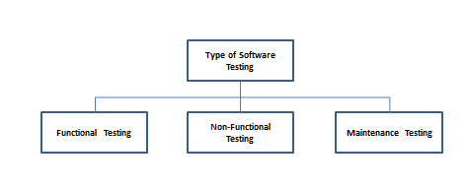
Figure 6. Software Testing Categories
Software Quality Evaluation
ISO 25010, titled “Systems and software engineering – Systems and software Quality Requirements and Evaluation (SQuaRE) – System and software quality models”, is a software quality standard. It describes the models, consisting of characteristics and sub-characteristics, for both software product quality, and software quality in use together with practical guidance on the use of the quality models (Britton, 2021).
The quality model is the cornerstone of a product quality evaluation system. The quality model determines which quality characteristics will be considered when evaluating the properties of a software product (ISO 25000, 2021).

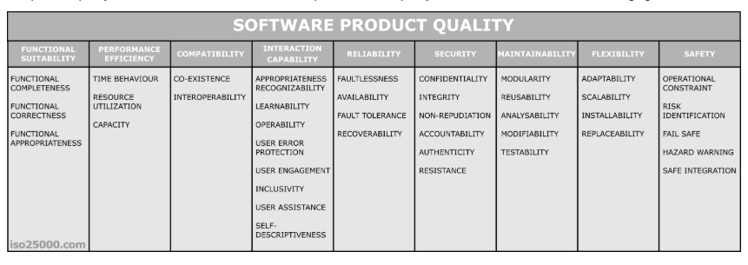
Figure 7. Software Product Quality
The product quality model defined in ISO/IEC 25010 comprises the eight quality characteristics of a system is the degree to which the system satisfies the functionality, performance, compatibility, usability, reliability, security, maintainability, and portability as shown in figure.
Functional Suitability represents the degree to which a product or system provides functions that meet stated and implied needs when used under specified conditions. Functional Suitability is composed of the following sub-characteristics:
- Functional completeness. The degree to which the set of functions covers all the specified tasks and user objectives.
- Functional correctness. The degree to which a product or system provides the correct results with the needed degree of precision.
- Functional appropriateness. The degree to which the functions facilitate the accomplishment of specified tasks and objectives.
Reliability represents the degree to which a system, product or component performs specified functions under specified conditions for a specified period of time. Reliability is composed of the following sub-characteristics:
- Maturity. The degree to which a system, product or component meets needs for reliability under normal operation.
- Availability. The degree to which a system, product or component is operational and accessible when required for use.

- Fault tolerance. The degree to which a system, product or component operates as intended despite the presence of hardware or software faults.
- Recoverability. The degree to which, in the event of an interruption or a failure, a product or system can recover the data directly affected and re-establish the desired state of the system.
Portability represents the degree of effectiveness and efficiency with which a system, product or component can be transferred from one hardware, software or other operational or usage environment to another. Portability is composed of the following sub-characteristics:
- Adaptability. The degree to which a product or system can effectively and efficiently be adapted for different or evolving hardware, software or other operational or usage environments.
- Installability. The degree of effectiveness and efficiency with which a product or system can be successfully installed and/or uninstalled in a specified environment.
- Replaceability. The degree to which a product can replace another specified software product for the same purpose in the same environment.

Related Studies
Author Marquez and Yatco, “A Mobile Application of a Geo-map Informatics Blast for Emergency Response”. The aim is to develop a web-based and mobile application of incident reporting systems in their respective barangay. It states that with the use of the technology it brought a substantial effect on the quality specifically with quick response of the barangay. The use of geolocation helps build up important data information on the administrator side for each report the residents do. In addition, this study can provide a solution in addressing the crime reporting problem in their area. The use of the technology available helps disseminate credible data information to help mitigate crimes.
The “E-Ligtas: A Life-Saving Application Using Fingerprint Biometrics with Analysis for the People Who are in an Emergency”, emphasizes how crimes in every corner of our country are left unreported due to lack of technology used. To address the situation we have, the study developed an application which devised a quick emergency response that can aid users, specifically the citizens of Taguig City, send an alert to the police. The added feature of fingerprint biometrics is used to run the application and inform police stations nearby the user’s location. It is proven in this study that the use of resources such as technology could help individuals make emergency calls much easier.
The E-Ligtas used variations of available APIs and open sources that should still be able to communicate between the mobile users to their police stations record: OneSignal an Application Programming Interface used by the researchers which allows mobile users to enable push notifications including the built-in Samsung Fingerprint Scanner along with sending the notifications to the police. Firebase allows their web application to manage the database and also synchronize the records of its application with its NoSQL database and real-time data gathered.
“AppLERT: A Mobile Application for Incident and Disaster Notification for Metro Manila” by Author Balahadia, Fabito, and Cabatlao, developed a mobile application which serves as a medium that helps users to request for aid from responders. With the help of GPS tracking data, it will help track the location of the user who requested for help and eventually responders would save them from harm. It is clearly expounded in this study that the use of smartphones plays a vital role in our lives today which unexpectedly could help users in times of trouble. The application also utilized a Facebook integration to inform and alert people that a certain incident happened in that area.
The AppLERT performs as built with the help of Android operating system features used for its mobile application to be built based from these components: GPS Global Positioning System uses a navigation for a precise location of its system existing in the current form of a device which uses satellites existing nearby, ground control from stations that used to track signals and the device used to for the location to be pointed. Five main uses of GPS include Location, Navigation, Tracking, Mapping and Timing. AppLERT used a Send Location Module wherein the exact location of the user device will be sent to the connection or its receiver allowing the last details of location in case of losing signal services. Send Report Module was also used by the researchers which allows the user to report with indicated disaster type, description, picture and video of the scene. Camera of smartphones that can capture photos and videos of the current incident and disaster allows an advantage of its smartphone to be used for the proof of incidents. Social Network Interaction Integrated facebook platform was used by the researchers to allow their intended users to be able to cater the wide users of this social media application who will also be able to maximize the advantage of receiving the nearby incident or disasters.
“IReportMo: An Emergency Report Android Mobile Application for Metro Manila” by Author Maghanoy, published in the year 2019, explained how individuals should stay attentive and cautious to whatever situation may happen because life is full of unexpected circumstances. The best way to address this is to maximize whatever available resources we have such as our smartphones. The study developed an application that would help users report incidents. It would serve as a medium to report either crime, accident, fire, or barangay related.
IReportMo application uses a GIS Location based and Google Web Services serves below as a helpful feature for Android Studio using Google Maps integration to share their coordinations to contact number of smartphones. The application also allows users to record the details of existing locations including the time and date.

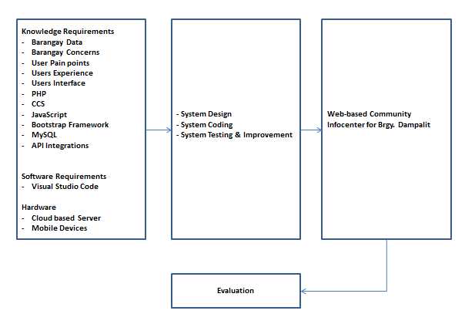
Figure 8. Conceptual Model of the Study

Conceptual Model of the Study
The conceptual model will serve as a blueprint for the project development. The input is split into different categories of knowledge requirements, software requirements and hardware requirements, shown as tools for development. Knowledge requirements contain the studies and concepts about the project that consists of policies, regulations, techniques, and strategies. Software requirements are software technologies needed to develop the software system. Hardware requirements are client devices (mobile phone, laptop) required to operate the system.
The process phase of software development includes system design and analysis, coding, testing, and improvement. This phase involves methods and designs such as diagrams, flowcharts and preliminary models based on the input requirements gathered. To ensure the quality of the software application, ISO 25010 software evaluation instrument tool shall be used to test and evaluate the performance of the system.
The output of the study is to develop a mobile friendly website as a centralized hub for emergency and information broadcast for Barangay Dampalit, Malabon City.
Operational Definition of Terms
In consideration of the clarity and specific meanings of the terminologies used, following definitions are defined for better understanding:
Barangay refers to a small territorial and administrative district forming the most local level of government.
Disaster refers to an event or fact that has unfortunate consequences.
Evacuation Center refers to a temporary, safe place where people can go to seek shelter and receive support when they need to evacuate their homes due to a disaster or emergency.
Utilities Services refers to the essential services needed such as water supply, and electricity.
API refers to Application Programming Interface, a software intermediary that allows two applications to communicate to each other.
PHP refers to Hypertext Preprocessor is a common open-source scripting language popular for web applications.
CCS refers to Cascading Style Sheets aids in the styling of web based materials.
Bootstrap Framework refers to addressing the screen responsiveness of a website.
CMS Content Management System refers to where the content is managed for a specific website.
Database refers to a structured set of data that is typically stored electronically.
MySQL refers to the free ware type of Database.
Javascript refers to a logic-based programming language that can be used to change website content.
Cloud Computing refers to an on-demanded delivery of IT resources over the internet with pay-as-you go pricing.
Cloud based server refers to providing on-demand scalable computing capacity in the cloud.
Mobile application refers to a software program designed to run on mobile devices.
UI refers to User Interface, the point of contact between humans and computers.
UX refers to User Experience refers to the overall experience a user has when interacting with an application.
CTA refers to the Call to Action button is a prompt or directive designed to encourage a user to take a specific action.
SMS refers to Short Message Service, a communication protocol used to send text messages between mobile Phones.
Users refers to individual users of a system that will utilize the application as an information hub in times of disaster and emergency situations.
Dashboard refers to an organized data representation from collected reports.
Emergency refers to a serious, unexpected, and often dangerous situation requiring immediate action.

Chapter 3
METHODOLOGY
This chapter includes the project design, project development, operation, and testing procedure, and the evaluation in procedure of the system.
Project Design
The study developed a web-based Community InfoCenter for Barangay Dampalit to access crucial information within their devices such as a smartphone, laptop, tablet or computer. Aside from this, subscribed users can also receive SMS notifications for alerts on emergency and disaster situations.
Below are the System Architecture Diagram, UI for both desktop and mobile view, user flow, Database diagram, and Use Case Diagram comprise the project design, which depicts and describes the system's flow and design process.
System Design
Context and Top level Data Flow Diagram
Figure 9 illustrates the data flow diagram for Content Management System (CMS) specifically for the Administrator which shows modules presented through the Data Flow Diagram. From there access will proceed to the login of the account and can view, update and edit a page as per required. and the Data flow diagram specifically for the user which shows modules their access to the website information, and options to enroll to the SMS Alert System.

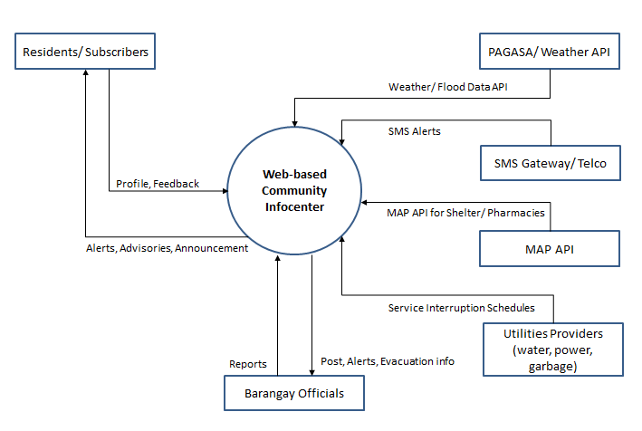
Figure 9. Context Diagram of a developed Web-based Community InfoCenter of
Barangay Dampalit

Figure 10 illustrates the top level data flow diagram for both the user and barangay officials/ administration, which shows modules their access to the website information, and options to enroll to the SMS Alert System.

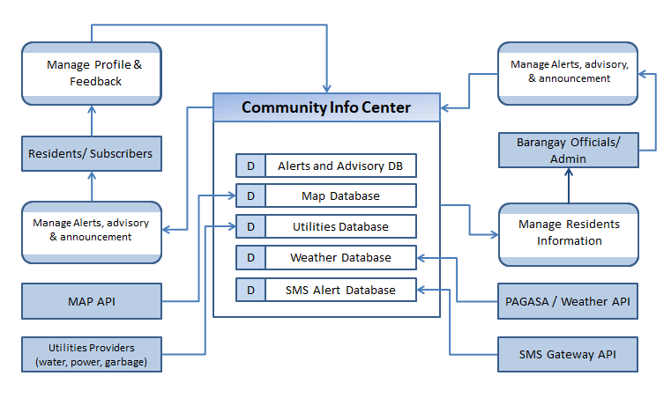
Figure 10. Top Level Data Flow Diagram for the of a developed Web-based Community InfoCenter of Barangay Dampalit

Software Design
The Software Design of the System presents the use case diagram of the system showing the different actions in the system and its interaction with the users. The system is composed of 3 external actors and 6 actions that can be performed in the system. The external actors, who are the users, Barangay admin and System admin, represent the different user access privilege on the system. Each action on the system can only be accessed with the corresponding privilege.

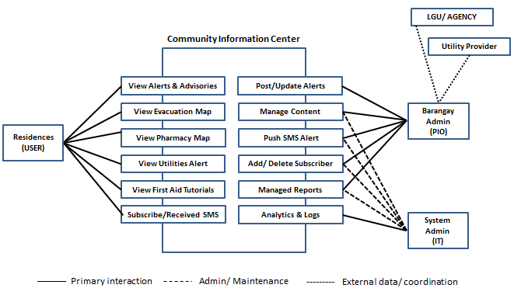

Figure 11. Use case diagram of the system

Database Design
The information maintained in the system is illustrated using the MySQL RDBMS (Relational Database Management System) in Figure 12 to 14. The RDBMS shows the data of the following: administrator, user, and module.

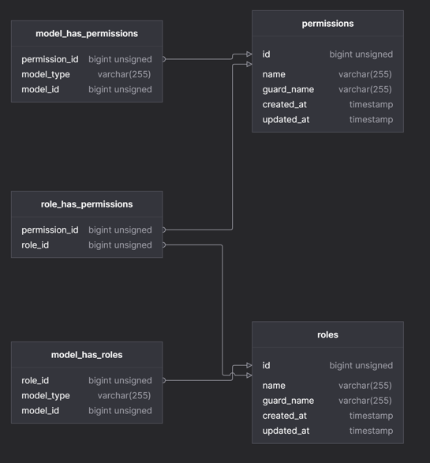
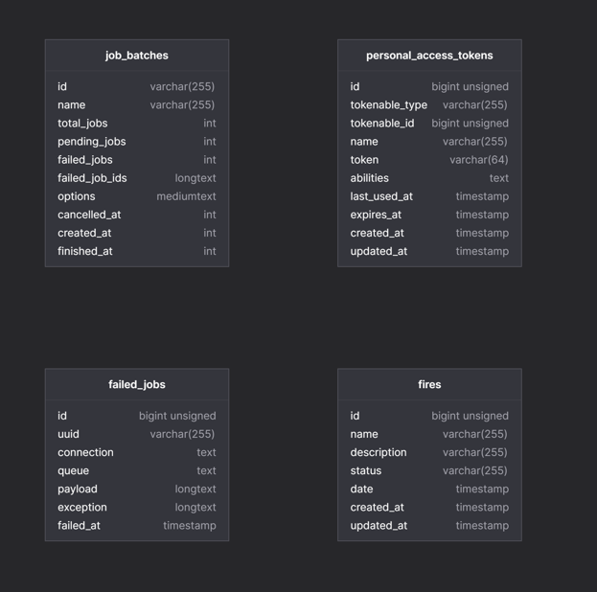
Figure 12. Database Design of Community Infocenter
Figure 13. Database Design of Community Infocenter
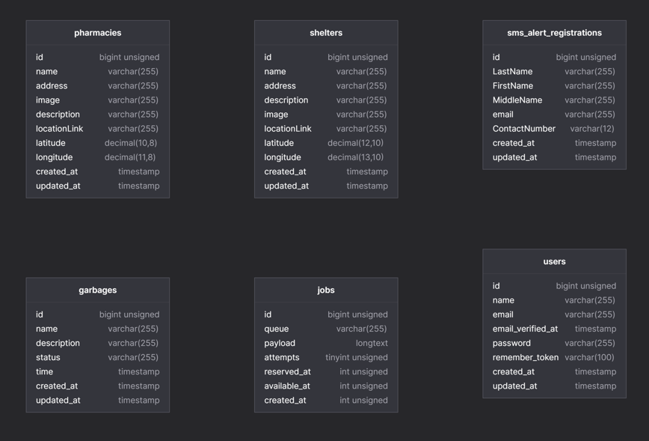
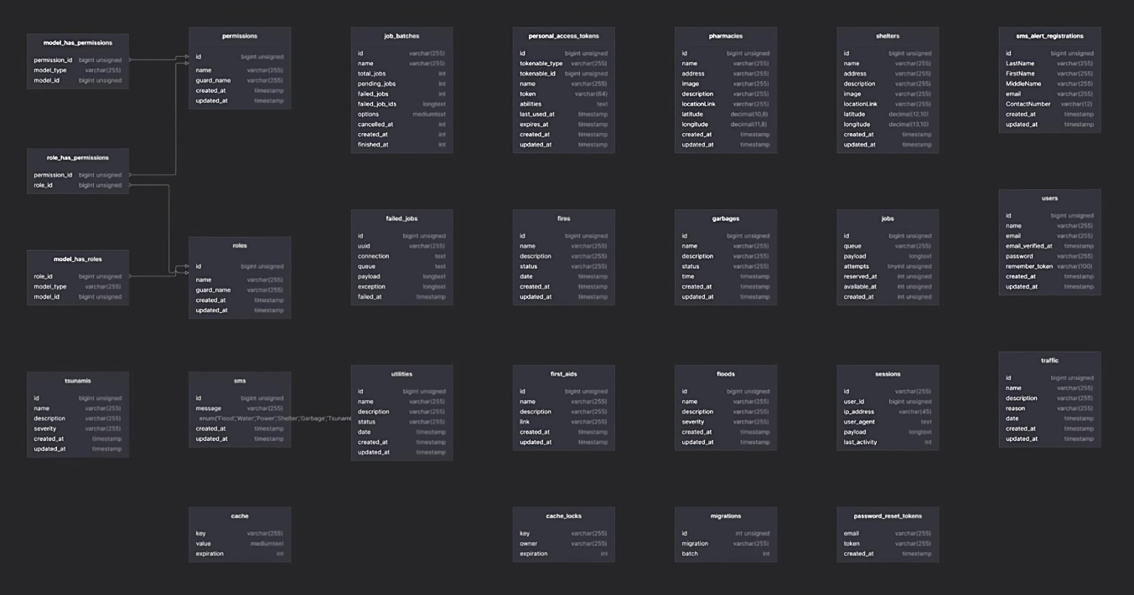
Figure 14. Database Design of Community Infocenter

System architecture
The System Architecture Diagram which displays the communication interface of the system for both the civilian and barangay user, utilizing cloud technology.

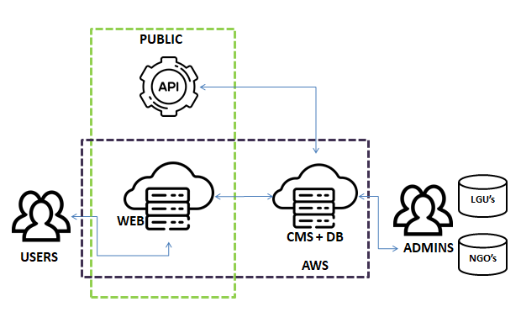

Figure 15. System Architecture Diagram

Desktop UI
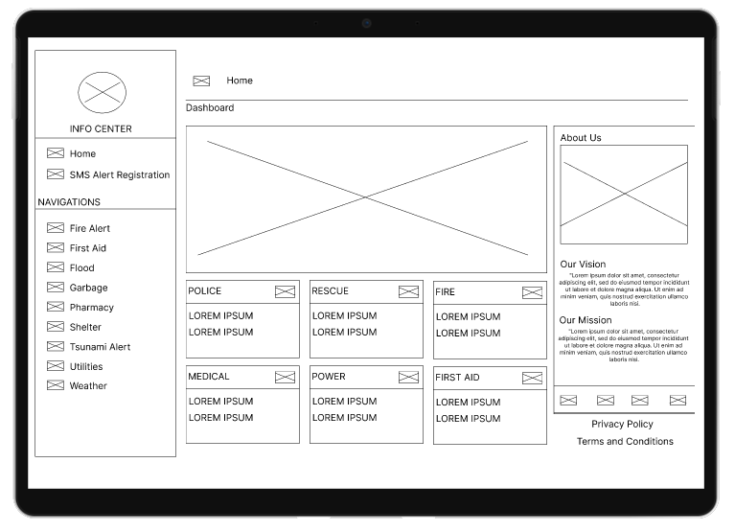  Figure 16. Home Page | Home Page  It serves as an introduction to the website content and purpose, It includes the navigation links, visual elements, Call to action buttons and feature content or sections.
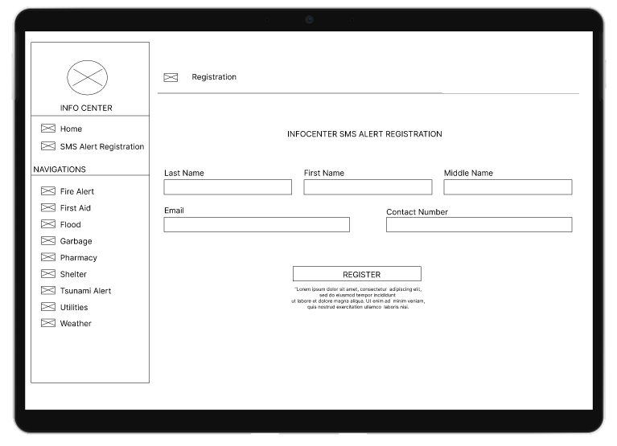  Figure 17. Registration Page | Registration Page  Where users can enroll to the Community SMS service, where subscribers can receive alerts and notification during emergency situations.
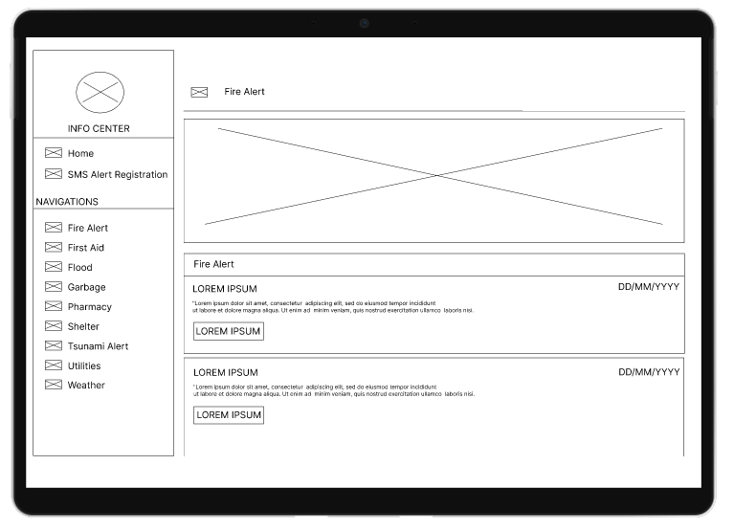 | Fire Alert Page  Display the current situation of a Fire emergency in a certain location.
Figure 18. Fire Alert Page
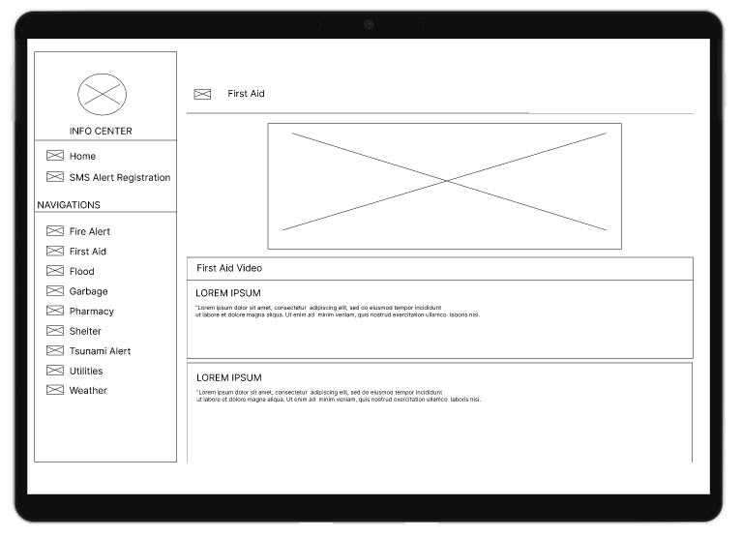  Figure 19. First Aide Page | First Aid Page  Show several first aid videos that may be used in a health emergency.
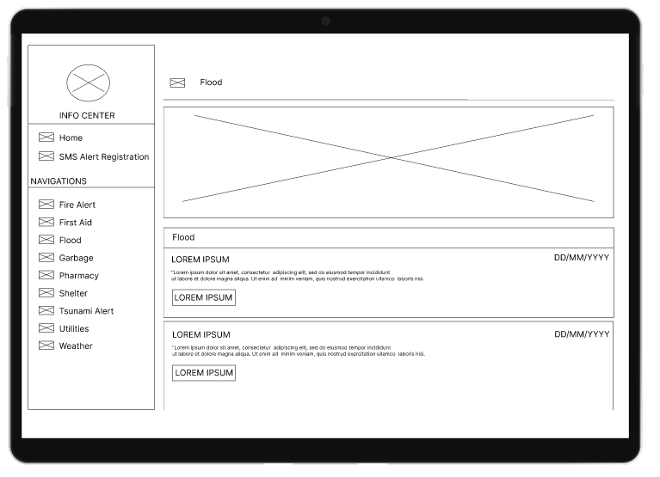  Figure 20. Flood Alert Page | Flood Alert Page  Display the current situation in flooded areas within the community.
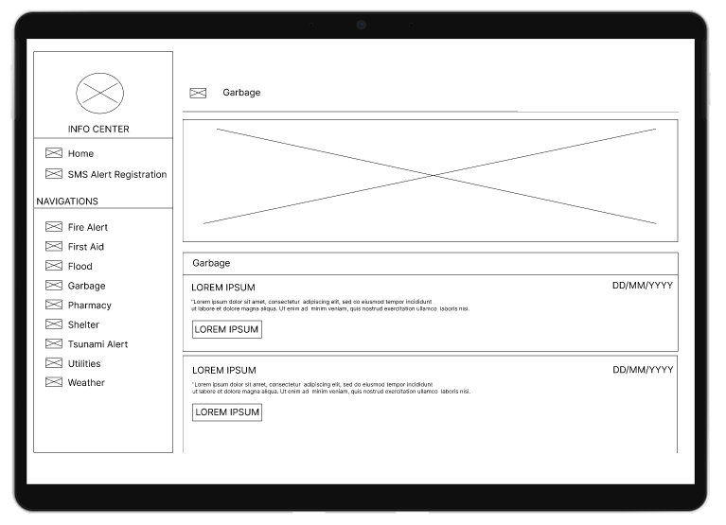  Figure 21. Garbage Collection Page | Garbage Collection  Display the schedule of the garbage collection in certain areas.
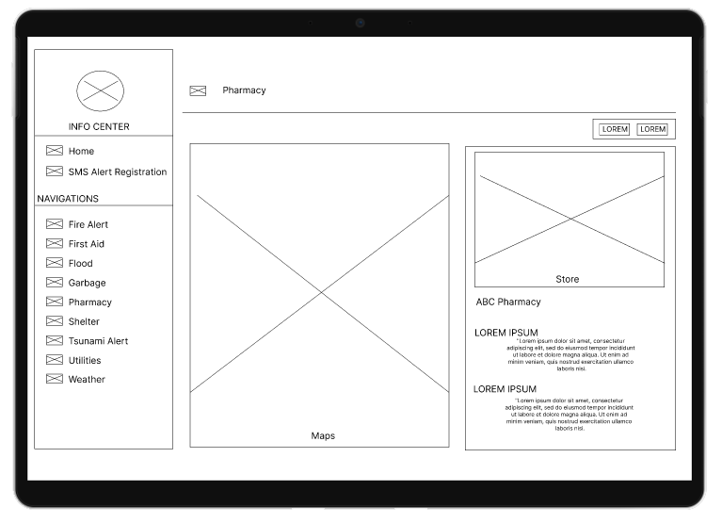  Figure 22. Pharmacy Page | Pharmacy Page  Shows the location of pharmacy on our area
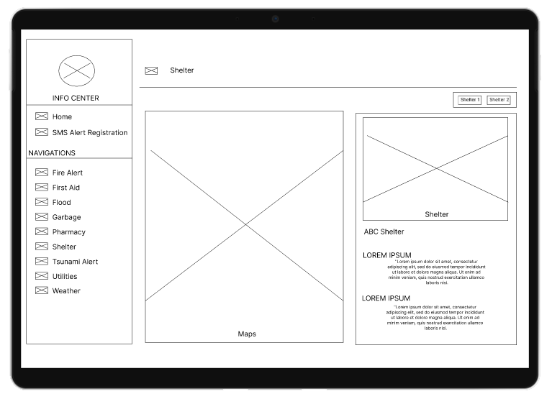  Figure 23. Shelter Page | Shelter Page  Shows the location of the shelter/ evacuation page during floods and calamity.
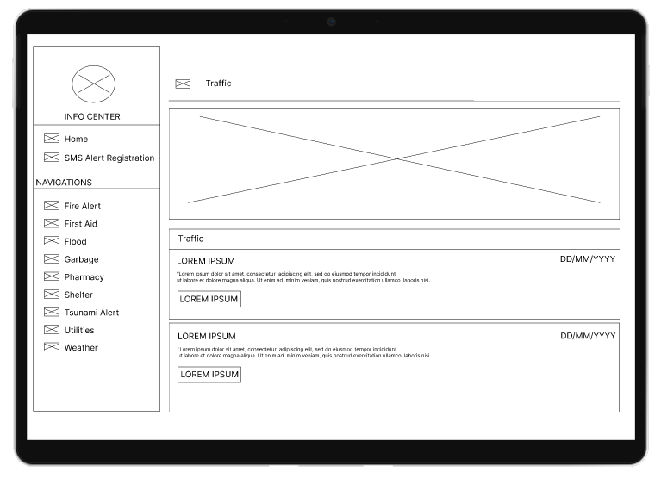  Figure 24. Traffic Advisory Page | Traffic advisory Page  Shows the area where heavy traffic was observed, link on the fb page of the traffic bureau of the city.
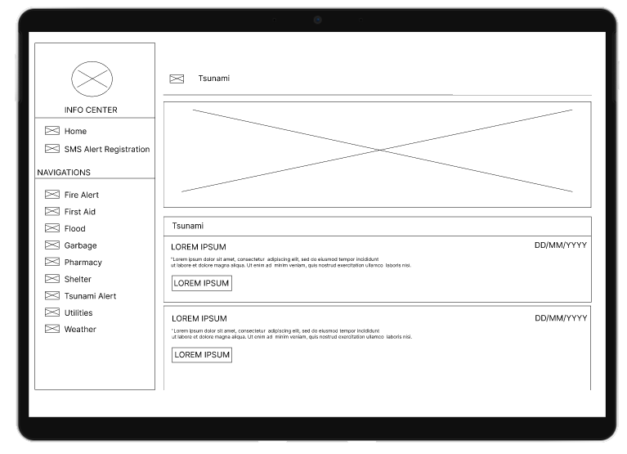  Figure 25. Tsunami Alert Page | Tsunami Alert  Shows the raised Tsunami Alert of the area.
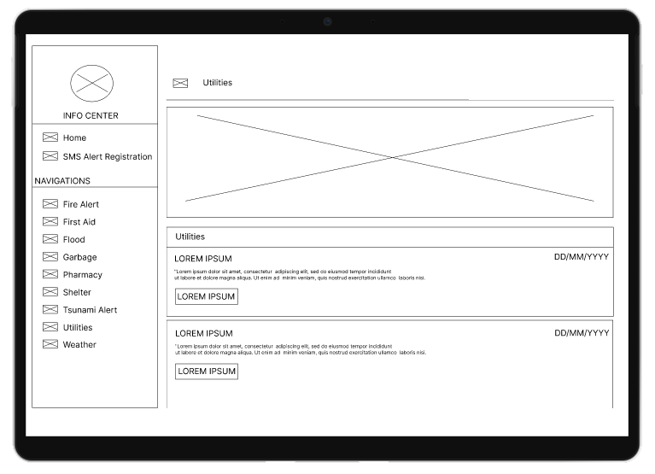  Figure 26. Utilities Page | Utilities Page  Shows the utilities (Power, and water interruptions) with the community.
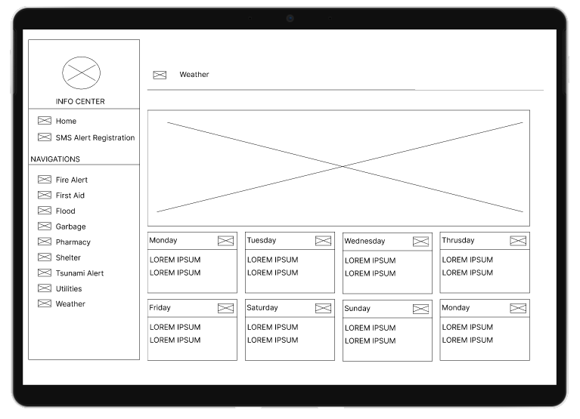  Figure 27. Weather Page | Weather Page  Shows the weather in the Malabon Area.

Mobile UI
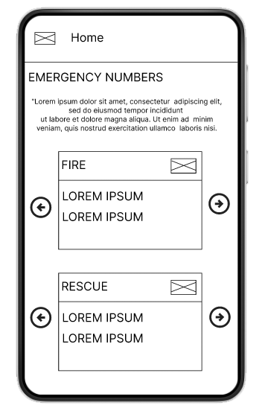  Figure 28. Home | 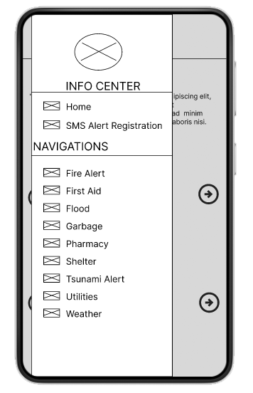  Figure 29. Menu | 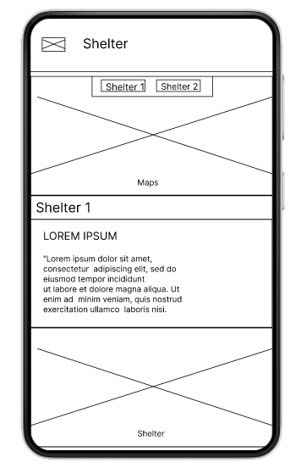  Figure 30. Shelter
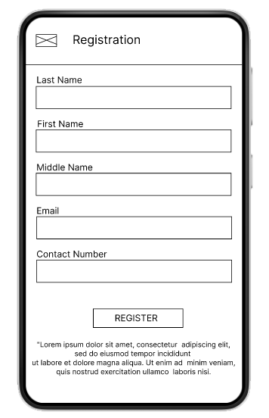  Figure 31. Registration | 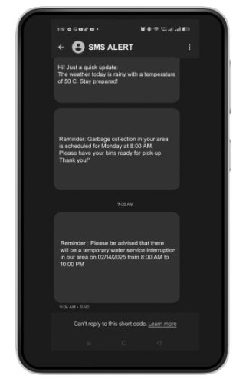  Figure 32. SMS Alert | 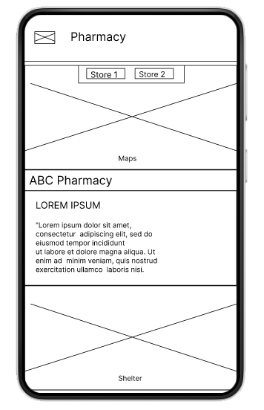  Figure 33. Pharmacy
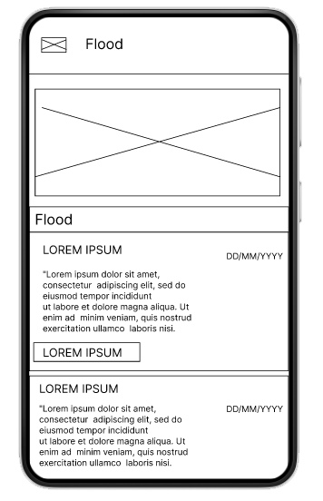  Figure 34. Flood | 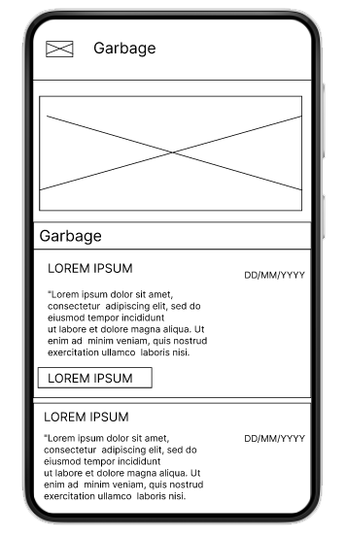  Figure 35. Garbage | 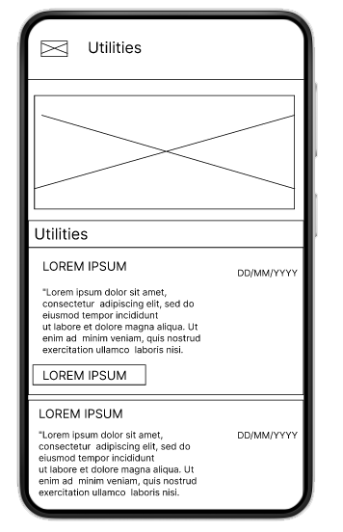  Figure 36. Utility Alerts
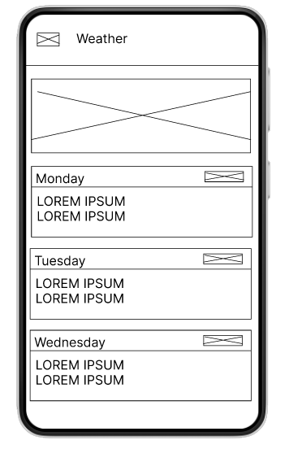  Figure 37. Weather | 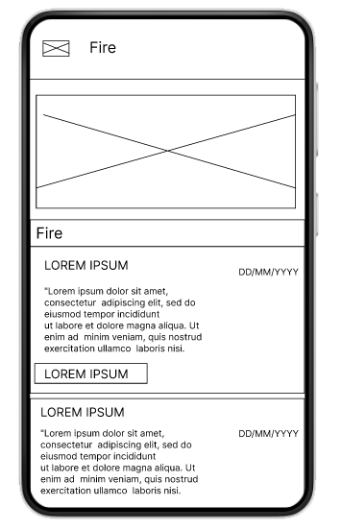  Figure 38. Fire Alerts | 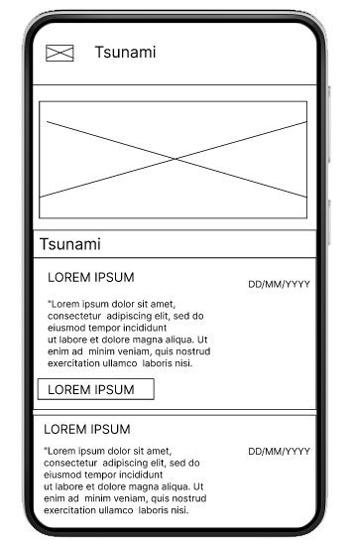  Figure 39. Tsunami
Project Development
The Community Infocenter will be developed using the Iterative Waterfall Model. The feedback paths are provided from every phase to its preceding phase. The model includes the following: Requirement Analysis, System Design, Implementation, Testing, and Maintenance shown in Figure 40.
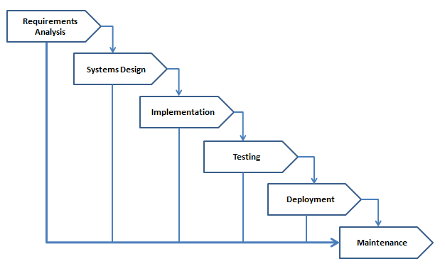

Figure 40. Iterative Waterfall Model

Requirement Analysis. The objectives, goals of Community Infocenter, are to analyze, and compare previous studies, and projects that can be referenced to the proposed project.
System Design. It focused on technological design requirements such as, programming language, equipment, and information sources for the development of the system. It covers the overall look and functionality.
Implementation. The System will be developed using PHP, CCS, Bootstrap, JavaScript and MySQL for the database. It will run via web browsing on desktop and mobile devices.
Testing. The system is subject to Quality Assurance testing in finding any bugs in the system by using different testing procedures. Bug fixes will be done in every phase to ensure smooth flow towards an effective system.
Deployment. The Community Infocenter will be deployed on AWS cloud to ensure high availability and accessibility anytime. It will be web browser based for both User and CMS admin.
Maintenance. To ensure overall system usability it will be subject for systems maintenance on a regular basis.
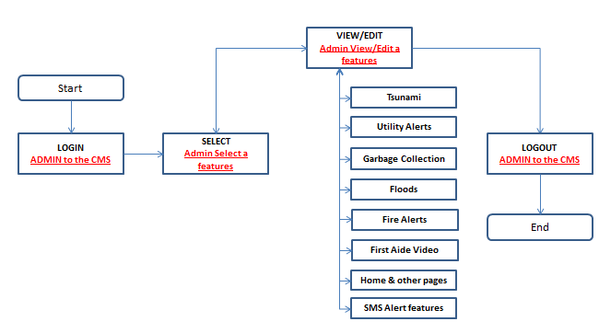
Operation and Testing Procedure
CMS Administrator
Figure 41. CMS Administrator Flowchart
- On the browser, type the address of the content management system.
- Input the admin and password.
- Browse the dashboard
- View or Edit the following features/ page (Tsunami, Utility, Garbage, Floods, Fire Alerts, First Aid Video, SMS Alert, Home and other pages.)
- After the updates, logout on the systems.
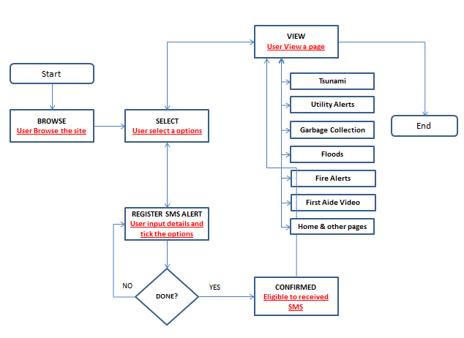
Client/User

Figure 42. User Flowchart
- On the browser, type the address of the community infocenter in a desktop, tablet or mobile browser.
- View any of the following features/ pages (Tsunami, Utility, Gargabage, Floods, Fire Alerts, First Aid Video, SMS Alert, Home and other pages.)
- Optional : User may opt in to register on the SMS alert input, Full Name, Email and Contact number, accept the Terms and Conditions, click “register”.

Functional Testing
This shall be performed to check the features or functionalities of the application. This is to ensure that each software component performs the expected output. The following steps shall be taken for each iteration:
- Distinguish the functions of each software build.
- Create input data based on the specifications of the function.
- Identify the output data based on the specifications of the function.
- Execute the test cases.
- Compare the actual result from the expected result.
- Determine the post condition.
- Evaluate if the test passes or fails.
The following tables show the testing procedures to be conducted on the framework in terms of compatibility and usability. To verify that the web application homepage and all key alert and service features load correctly and function as expected across multiple browsers (Firefox, Chrome, Edge, Safari).
Table 1.
Portability Testing Procedure.
Test Case | Test Types | Steps Undertaken | Types
Homepage load correctly | - Navigate the home page URL | - Search the Application web address  - Browse web app. | Co-existence
Access the Web App from a browser | - Firefox  - Chrome  - Edge  - Safari | - Open a web browser from a PC or MacOS machine and open the URL link into the address bar.  - Press Enter to load the web application. | Co-existence
Access the Fire Alert Features from a browser | - Firefox  - Chrome  - Edge  - Safari | - Browse the web application on the preferred browser  - Select the Fire Alert Features | Co-existence
Access the First Aid Features from a browser | - Firefox  - Chrome  - Edge  - Safari | 1. Browse the web application on the preferred browser  2. Select the First Aid Features | Co-existence
Access the Flood Alert Features from a browser | - Firefox  - Chrome  - Edge  - Safari | 1. Browse the web application on the preferred browser  2. Select the Flood Alert Features | Co-existence
Access the Garbage Collection Features from a browser | - Firefox  - Chrome  - Edge  - Safari | 1. Browse the web application on the preferred browser  2. Select the Garbage Features | Co-existence
Access the Pharmacy Location Features from a browser | - Firefox  - Chrome  - Edge  - Safari | 1. Browse the web application on the preferred browser  2. Select the Pharmacy Features | Co-existence
Access the Shelter Location Features from a browser | - Firefox  - Chrome  - Edge  - Safari | 1. Browse the web application on the preferred browser  2. Select the Shelter Features | Co-existence
Access the Traffic Features from a browser | - Firefox  - Chrome  - Edge  - Safari | 1. Browse the web application on the preferred browser  2. Select the Traffic Features | Co-existence
Access the Tsunami Alert Features from a browser | - Firefox  - Chrome  - Edge  - Safari | 1. Browse the web application on the preferred browser  2. Select the Tsunami Features | Co-existence
Access the Utilities Alert Features from a browser | - Firefox  - Chrome  - Edge  - Safari | 1. Browse the web application on the preferred browser  2. Select the Tsunami Features | Co-existence
Access the Weather Alert Features from a browser | - Firefox  - Chrome  - Edge  - Safari | 1. Browse the web application on the preferred browser  2. Select the Weather Alert | Co-existence
Access the SMS Alert Features from a browser | - Firefox  - Chrome  - Edge  - Safari | 1. Browse the web application on the preferred browser  2. Select the SMS Alert registration  3. Fill up the form  4. Click Register | Co-existence

Compatibility Testing
To confirm that the web application can be accessed seamlessly on both mobile devices (Android and iOS) and desktop browsers (Firefox, Chrome, Edge, Safari).
This shall be conducted to examine the performance of the system under given environmental conditions. The following steps shall be taken for each iteration:
- Run the application repeatedly in several test devices and environments to determine if the system shall provide the same output and results.
- Count the total number of failing cases and the total number of cases under consideration.
- Compute the probability of failure.

Table 2.
Compatibility Testing Procedure.
Test Case | Types | Steps Undertaken | Types
Access the web application via mobile devices | - Android devices  - iOS Devices | Search the  Application  - Browse web app. | Co-existence
Access the Web App from a browser | - Firefox  - Chrome  - Edge  - Safari | - Open a web browser from a PC or MacOS machine and open the URL link into the address bar.  - Press Enter to load the web application. | Co-existence
_______________________________________________________________________

Usability Testing
To ensure that the web application provides an intuitive, accessible, and user-friendly interface across desktop and mobile devices. This shall be performed to verify the adaptability, install acceptance and replaceability of the application. The following steps below shall be taken for each repetition.
- Run the application repeatedly in several test devices and environments to determine if the system shall provide the same output and results.
Table 3.
Usability Testing Procedure.
Test Case | Steps to be Taken | Expected Output | Types
Easy navigation from homepage | - Open Homepage  - Try accessing the main sections. | - Users can reach each section within 1- 2 clicks. | User Interface
Clear and readable content | - Open any content page.  - Check font size, color contrast and spacing | - Text is legible and will structured | Operability
Intuitive Layout | - Browse homepage and other key pages | - User can identify menus, buttons, and key function easily | User interface aesthetics
Mobile usability | - Open site on smart phone.  - Try accessing different page and features | - All content and buttons are accessible and readable on mobile. | Accessibility

Evaluation Procedure
The Evaluation Procedure was analyzed through descriptive and quantitative data. The process used a 4-Point Likert Scale to examine and assume the strength of the responses is linear. Researchers also gathered a survey questionnaire instrument to help count the equivalent number of scores to express how much they agree or disagree with a specific statement as shown below:
The following procedure was followed to evaluate the acceptability of the developed system application :
- Invited 30 randomly selected respondents to serve as evaluator-respondents of the application such as parents, barangay official, senior citizen, bystander.
- Demonstrated the developed system to the respondents and explained the features of it in general and the individual modules.
- The respondents shall also rate the application in terms of the standard evaluation criteria of ISO 25010 using a 4-Point Likert Scale rating system as shown in Table 4
- Evaluators were asked to try evaluating the features of the system.
- After project demonstration, the evaluator respondents were given a questionnaire.
- The accomplished questionnaires were processed, and the data were tabulated in Microsoft Excel to determine the ratings.
- The adjectival ratings for the questionnaire were interpreted using the Numerical Rating Scale below.
Table 4.
4-Point Likert Scale
Numerical Rating | Adjectival Rating
4 | Highly Acceptable
3 | Very Acceptable
2 | Acceptable
1 | Not Acceptable

Chapter 4

RESULTS AND DISCUSSION
This chapter contains the project description, project structure, project capabilities and limitations and results of evaluation for the project.

Project Description
The study developed a web-based and android application designed for community use. The web application which is developed to to assist the community particularly in disaster events.
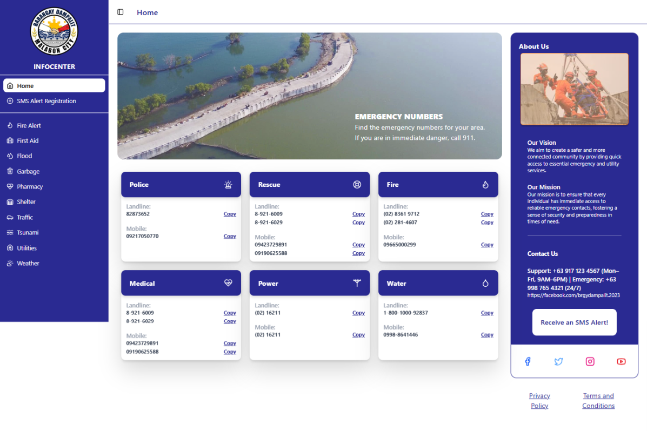
Figure 43. Web Applications Home Page

Project Structure

The web application was designed and developed to be both accessible to mobile and web browsers.
- The Web Application
The web application, shown on Figure 43 is the Home page where features and options are clearly displayed for the user. Here are the major features of the web application:
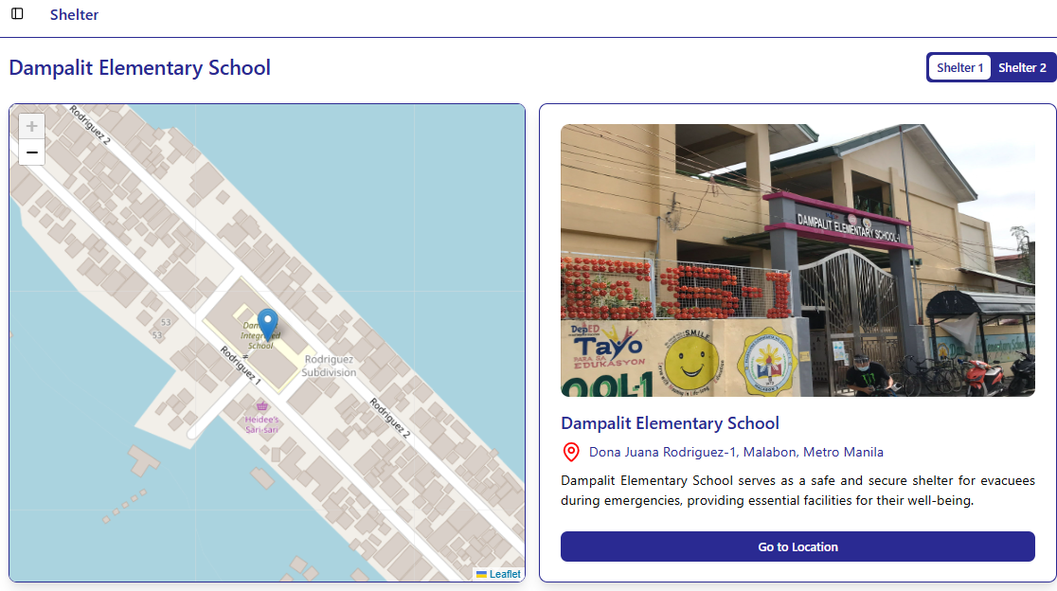
Figures 44. Shelter Page - Map of emergency evacuation center. Integrated to the application via free API Mapping ensuring live and accurate locations.
Figure 44. Shelter Page

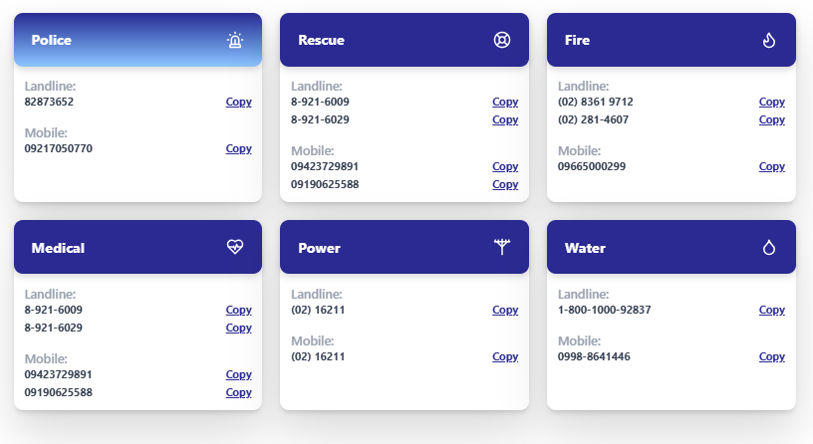
Figure 45. Information board - Contains emergency numbers from different LGUs with copy paste options. Supporting efficient details copying.
Figure 45. Information Board
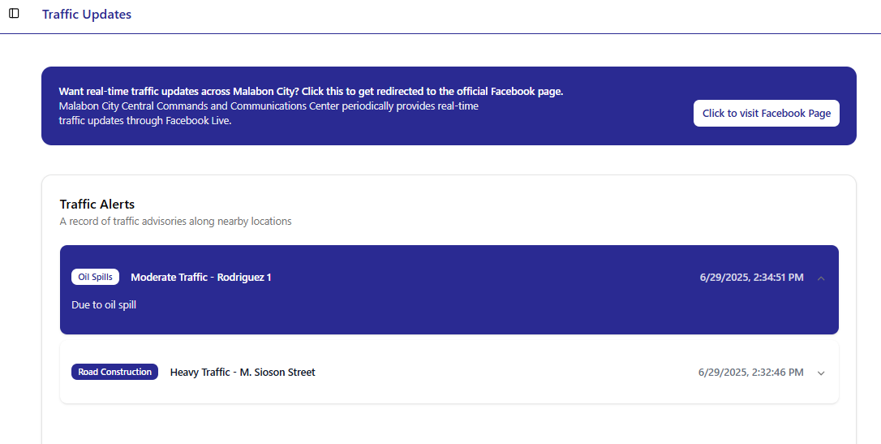
Figure 46. Real-time traffic- Display certain traffic on specific places with the vicinity of the community, informing the residence and help the barangay on traffic monitoring.
Figure 46. Traffic update page
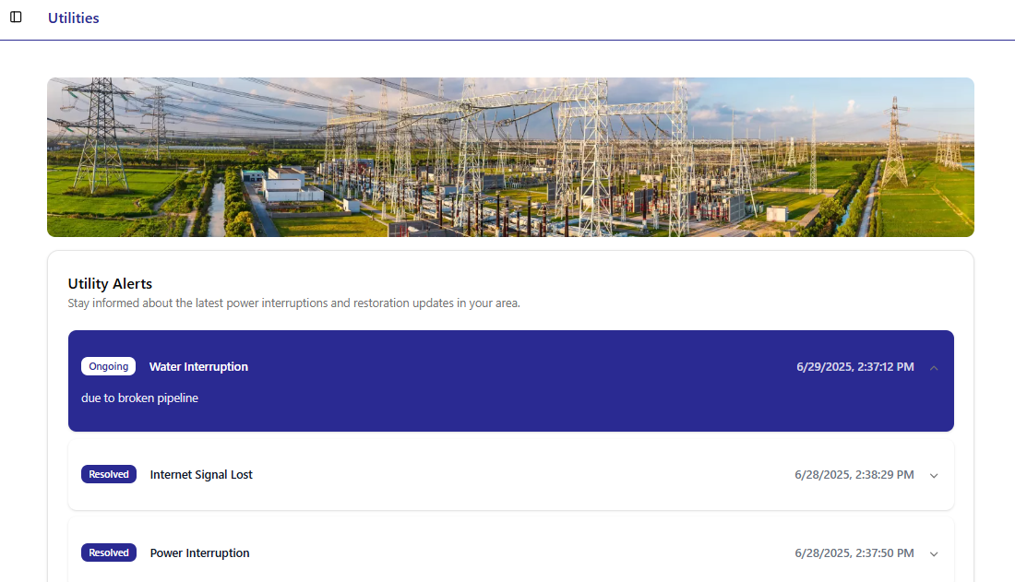
Figure 47. Utility Services pages - Updates for electricity, water interruptions, and garbage collections, will help the residence to plan and take proper action on certain service interruptions.
Figure 47. Utilities Page
Figures 49 to 50. Environmental Updates Page - designated specifically for tides, weather conditions, floods, and fire outbreak, which able to help the community to take planned action on certain situation.
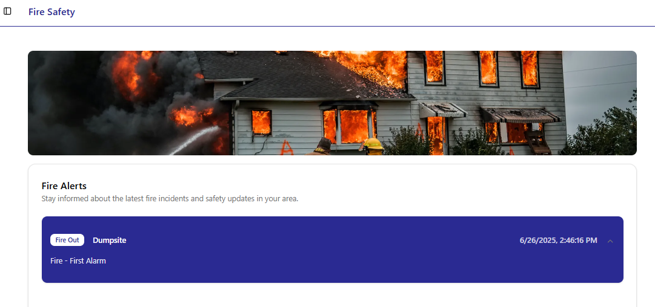
Figure 48. Fire Safety Page
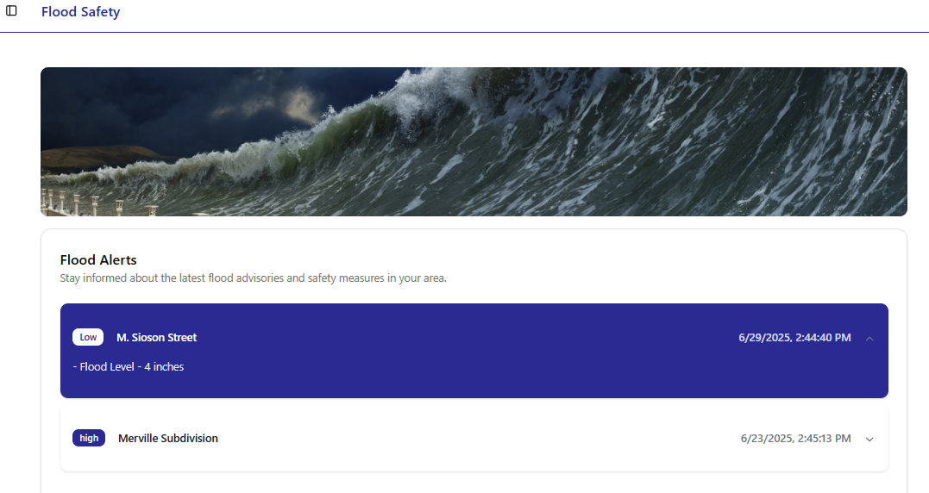

Figure 49. Flood Safety Page
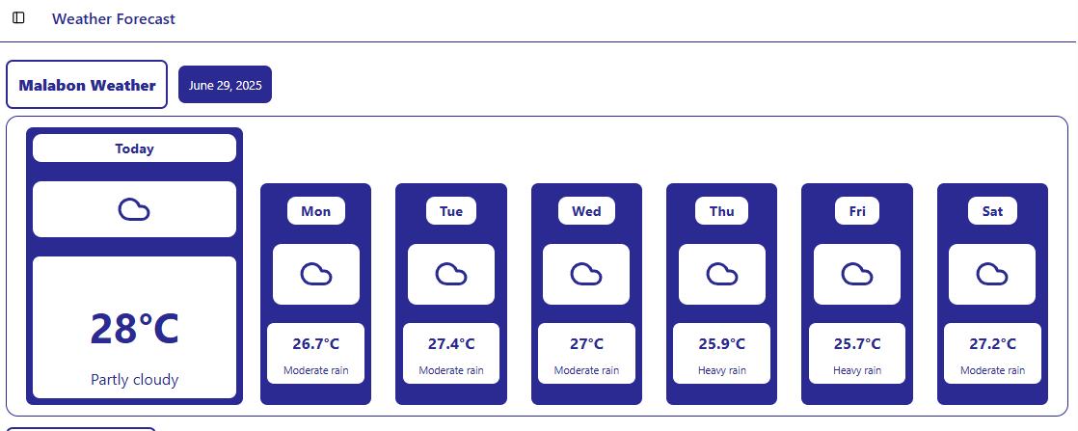
Figure 50. Weather Forecast Page
Figures 51 to 52. SMS Alert - SMS Notifications via SMS API for emergencies and information in relation to and limited to utility services and environmental updates.
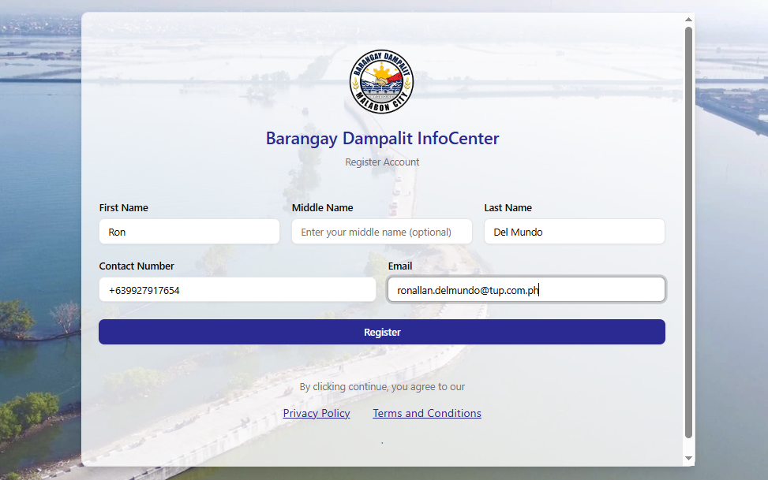
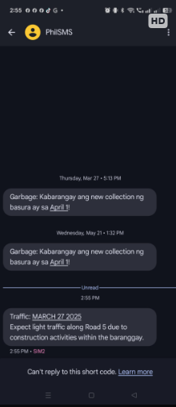

Figure 51. Registration Page Figure 52. Subscriber SMS message from the web application
Figure 53. Video tutorials Page - Link out to Youtube for a first aid video.
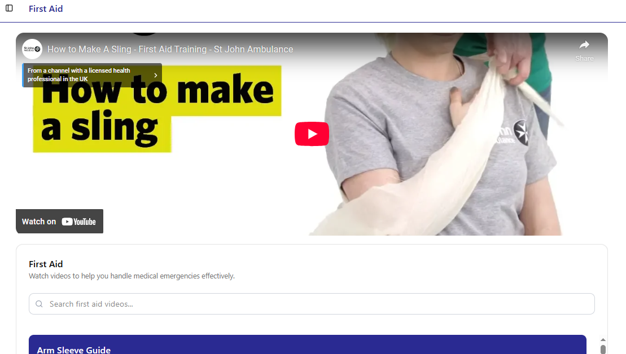

Figure 53. First Aid Page
Figures 54 to 55. Reports - for analysis, and interpretation of data, that able to barangay officials to put upon decision based on the facts, and metrics.
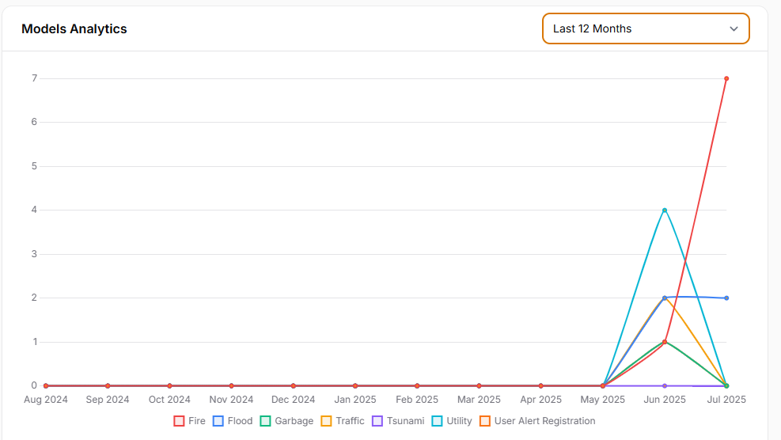

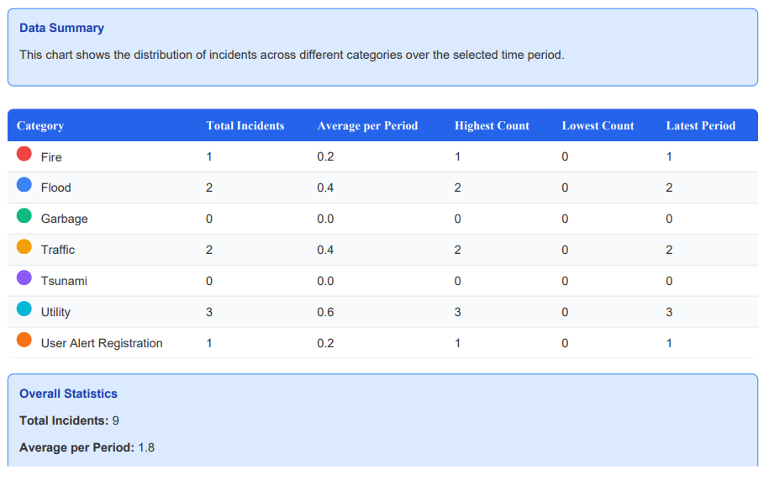
Figure 54. Report Dashboard – Graphic presentation

Figure 55. Report Dashboard – Report PDF format

Mobile View
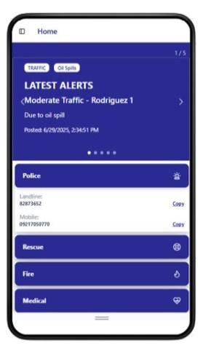  Figure 56. Home | 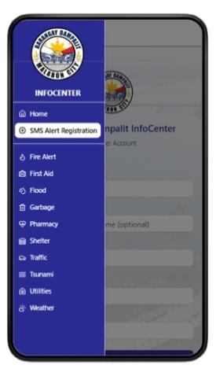  Figure 57. Menu | 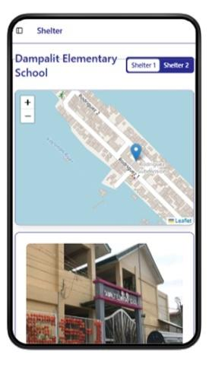  Figure 58. Shelter
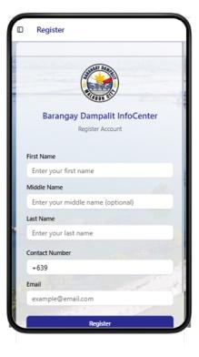  Figure 59. Registration |   Figure 60. SMS Alert | 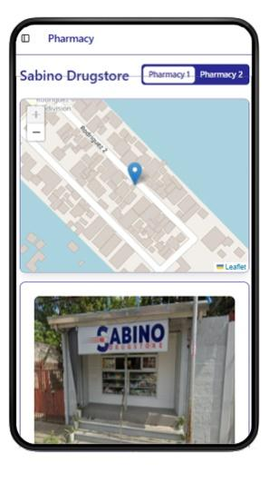  Figure 61. Pharmacy
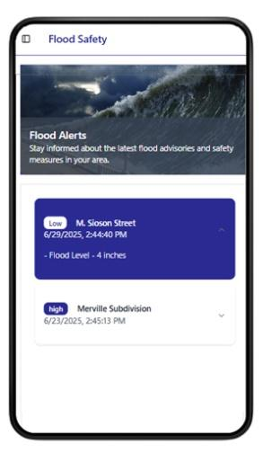  Figure 62. Flood | 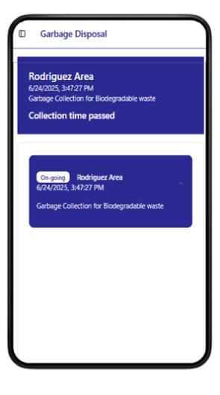  Figure 63. Garbage | 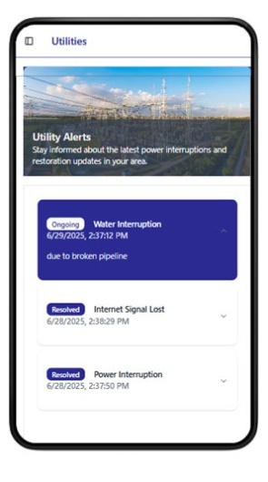  Figure 64. Utility Alerts
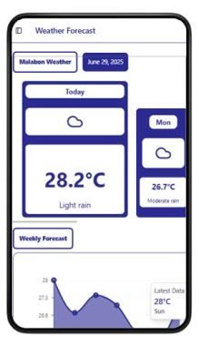  Figure 65. Weather | 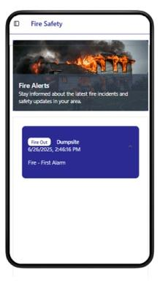  Figure 66. Fire Alerts | 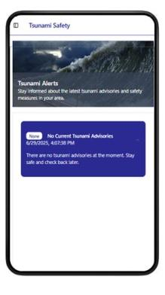  Figure 67. Tsunami

Project Capabilities and Limitations

The following are the capabilities and limitations of the developed web application.
- The web application can load different browsers such as Google, Firefox, and Edge.
- The web application can adjust on different screen sizes from mobile, tablet, laptop and desktop.
- The web application can be highly available since it is stored in the cloud.
- The web application (CMS) had the features to send SMS to subscriber for quick information decimation.
- The web application (CMS) had the report features which give the stakeholder valuable data for disaster and future use.
These following are the limitations of the developed web application.
- The web application needs to be updated by the authorized personnel in the event of a natural disaster.
- The web application needs to be maintained by both stakeholder and technical team.

Tests Results

The web application was created using PHP, CCS, MySQL and hosted in AWS. As such, the web application can run on any web browser on both desktop and mobile devices. The test results on the compatibility and usability of the developed system are presented in the following tables.
Table 5.
Compatibility Testing Procedure.
Test Case | Steps Undertaken | Observed Results
(Co-existence)  Access the Web App from a browser | - Open a web browser from a PC or MacOS machine and open the URL link into the address bar.  - Press Enter to load the web application. | The web application is displayed in the Web Browser.
(Interoperability)  The user can interact with the web application. | - Select an option or feature | The Web application is responsive to the selected feature of the user.
(Co-existence)  The web application works on different devices and OS versions. | - Choose a device with older software versions.  - Choose a device with newer software versions. | The web application is accessible using different version of devices.

Table 6.
Usability Testing Procedure.
Test Case | Steps to be Taken | Expected Output | Results
(Learnability)  User familiarization | - Users select according to their preference. | - User by getting familiarized with the simple UI  - Users with little to no experience can easily understand how to use the web application with its simple search and navigation design. | Viewed and familiarized with the web application features.
(Operability)  Explore the feature of the web application | - Browse the web application  - Select from the features | - The UI design is very easy to navigate  - With a few clicks, select the feature that was accessed by the user. | UX is an industry standard.
(User interface aesthetics)  User interface simple and readable | - Browse the web application  - Select from the features | - The web application text is simple, readable, and clearly visible to the users.  - The icons are natural and consistent with the application.  - Styles and themes are consistent in the entire application. | Dashboard-based web application.
(Accessibility)  Explore the web application | - Browse the web application  - Navigate framework design, button, search, and filter functionality. | - The web application layout is consistent in all version android devices. Logo, title, and search bar are placed and appear in the same relative order and position.  - Interactive elements like buttons are placed where it can easily be reached. | The web application are working different sizes of devices and computers

Evaluation Results

The Web Application was evaluated to determine its acceptability. The respondents consisted of randomly selected IT professionals, IT graduates and Smart Home Automation users which are the actual users. Table 7 shows the summary of ratings.

Table 7.
Summary of evaluation ratings.
Criteria | Mean | Adjectival Rating
- Functional Suitability
- Functional Completeness | 3.78 | Highly Acceptable
- Functional Correctness | 3.89 | Highly Acceptable
- Functional Appropriateness | 3.93 | Highly Acceptable
Sub-Mean | 3.87 | Highly Acceptable
- Performance Efficiency
- Time Behavior | 3.80 | Highly Acceptable
- Resource Utilization | 3.33 | Very Acceptable
Sub-Mean | 3.57 | Highly Acceptable
- Compatibility
- Co-existence | 3.71 | Highly Acceptable
- Interoperability | 3.80 | Highly Acceptable
Sub-Mean | 3.76 | Highly Acceptable
- Usability
- Appropriateness recognizability | 3.80 | Highly Acceptable
- Learnability | 3.87 | Highly Acceptable
- Operability | 3.84 | Highly Acceptable
Sub-Mean | 3.80 | Highly Acceptable
- Reliability
- Availability | 3.71 | Highly Acceptable
- Fault Tolerance | 3.20 | Very Acceptable
Sub-Mean | 3.46 | Highly Acceptable
- Maintainability
- Analyzability | 3.51 | Highly Acceptable
- Modifiability | 3.20 | Very Acceptable
- Testability | 3.29 | Very Acceptable
Sub-Mean | 3.33 | Very Acceptable
- Portability
- Installability | 3.29 | Very Acceptable
Sub-Mean | 3.29 | Very Acceptable
Grand Mean | 3.58 | Highly Acceptable

In table 7, the web application obtained its highest rating under " Functional Suitability" with a mean rating of 3.87 or "Highly Acceptable." This rating indicated that the web application was able to deliver the expected functionalities based on its requirements and delivered the right results.
The Web Application obtained its second highest rating under “Usability” with mean rating of 3.80 or “Highly Acceptable”. This implies that the web application was appropriate for the users' needs and easy to learn, understand, and operate based on its requirements.
The Web Application obtained its lowest rating under "Portability," with a mean rating of 3.29 or "Very Acceptable." This rating could indicate that there could be other features that may be added in the system.
Overall, the framework obtained a mean rating of 3.58 or “Highly Acceptable” which means that the developed “web application” is highly acceptable to its intended stakeholder and conforms to the requirement of its intended use.

Chapter 5

SUMMARY OF FINDINGS, CONCLUSION AND RECOMMENDATION
This chapter presents the summary of findings, the conclusions drawn from the findings, and the corresponding recommendations for further enhancement of the project.

Summary of Findings
Based on the evaluation results, the developed web application entitled “Web-based mobile responsive Application of a community infocenter” can enable users to access crucial information particularly on time of disaster. The following is the summary of findings using the web application:
  - Functional Suitability. The evaluators rated the web application as highly acceptable regarding the application functions, deliverance of correct results, and the accomplishment of the established objectives.
  - Performance Efficiency. The evaluators rated the web application as highly acceptable regarding how the application processes the task and responds according to the established time.
  - Compatibility. The evaluators rated the web application as highly acceptable regarding how the application provides accurate information.
  - Usability. The evaluators rated the web application as highly acceptable regarding how the framework is appropriate for the user's needs, interface and satisfying interactions, accessibility, protection from user errors, and ease of learning, operating, and control.
  - Reliability. The evaluators rated the web application as highly acceptable regarding its functions with hardware faults, interruptions, or failure, and how it works as required during use.
  - Maintainability. The evaluators rated the web application as very acceptable regarding failures, the continued operations even when changes have been made, how a change in component has minimal impact on others, and ease of testing.
  - Portability. The evaluators rated the web application as very acceptable regarding how easily the framework application can be browsed on users' smartphones and run-on computer web browsers.

Conclusions
The following conclusions were derived from the above findings:
  - The web application was successfully designed to have the following features:
    - Allows users to browse an easy to use and understand web application.
    - It works seamlessly across several devices such as mobile, tablet and desktop.
    - Provide fast loading time of pages and features.
    - Ability to scale and handle increase of traffic without major redesign.
    - Work properly on major browsers like Chrome, Firefox, Safari, and Edge with consistent behavior.
  - The developed framework was successfully built using PHP, Visual Studio Code, CCS, MySQL Database, and deployed/hosted to AWS cloud.
  - The test results show that the web application is compatible and usable by the stakeholder requirements, and users.
  - The developed web application was evaluated to be Highly acceptable in terms of Functional Suitability, Performance Efficiency, Compatibility, Usability, Reliability, Maintainability, and Portability.

Recommendations
The following are suggestions for further enhancement of the developed web application.
  - Automation of update status of certain emergencies.
  - Web Application comment section.
  - Mobile version for both android and iOS.

REFERENCES
Electronic Source
City of Malabon Website. City of Malabon Profile Retrieved January 2025, from https://malabon.gov.ph/Home/CityOfMalabon
AMAZON EC2. Why Amazon EC2 2025, Retrieved January 2025 from https://aws.amazon.com/ec2/?nc2=type_a
Open-meteo. Free Weather API 2025, Retrieved January 2025 from https://open-meteo.com/
Agafonkin, Volodymyr. Leaflets 2025, Retrieved January 2025from https://leafletjs.com/
PhilSMS. SMS Gateway API Philippines 2025, Retrieved January 2025 from https://philsms.com/
Sharah Ibrahim. Handa Pilipinas! A hope in a country of natural calamities, Retrieved January 2025, from https://iso25000.com/index.php/en/iso-25000-standards/iso-25010
PSA, Damages Due to Natural Extreme Events and Disasters Amounted to Php 463 Billion January 2025, from https://psa.gov.ph/statistics/environment/peenra/node/163321
Google Maps. Map of Dampalit 2025, Retrieved January 2025 from https://www.google.com/maps/place/Dampalit,+Malabon,+Metro+Manila
Lalit Singla. What is PHP for Web Development and Why Should You use It? January 2025, from https://www.netsolutions.com/insights/what-is-php/
MsSQL. What is MySQL 2024, Retrieved January 2025 from https://dev.mysql.com/doc/refman/8.4/en/what-is-mysql.htmlISO/IEC 25010. Software Data Quality 2024, from https://iso25000.com/index.php/en/iso-25000-standards/iso-25010
Zola, Andrew. Bootstrap January 2025, from https://www.techtarget.com/whatis/definition/bootstrap
ISO/IEC 25010. Software Data Quality 2024, from https://iso25000.com/index.php/en/iso-25000-standards/iso-25010
Britton, J. (2021, May 6). What is ISO 25010? Perforce Software. Retrieved January 5, 2022, from https://www.perforce.com/blog/qac/what-is-iso-25010
Bram, S., & Vestergren , S. (2011). Emergency Response Systems: Concepts, features, evaluation and design. Retrieved January 5, 2022, from https://www.diva-portal.org/smash/get/diva2:507142/FULLTEXT01.pdf
Britton, J. (2021, May 6). What is ISO 25010? Perforce Software. Retrieved January 5, 2022, from https://www.perforce.com/blog/qac/what-is-iso-25010
Chen, R., Sharman, R., Rao, H. R., & Upadhyaya, S. (2007). Design principles for critical incident response systems. Information Systems and e-Business Management, 5(3), 201–227. https://doi.org/10.1007/s10257-007-0046-0
Cox, L. K. (2021, July 21). Web design 101: How HTML, CSS, and JavaScript work. HubSpot Blog. Retrieved January 12, 2022, from https://blog.hubspot.com/marketing/web-design-html-css-javascript
Fabito, B. S., Balahadia, F. F., & Cabatlao, J. D. (2016). AppLERT: A mobile application for incident and disaster notification for metro manila. 2016 IEEE Region 10 Symposium (TENSYMP). https://doi.org/10.1109/tenconspring.2016.7519420
Hamilton, T. (2021, December 11). What is software testing? definition, basics & types in software engineering. Guru99. Retrieved January 11, 2022, from https://www.guru99.com/software-testing-introduction-importance.html
Hamilton, T. (2021, December 25). What is grey box testing? techniques, example. Guru99. Retrieved January 11, 2022, from https://www.guru99.com/grey-box-testing.html
ISO 25000. (2021). ISO 25000 Portal. iso25000.com. Retrieved January 5, 2022, from https://iso25000.com/index.php/en/iso-25000-standards/iso-25010
Maghanoy, J. A. (2019). IREPORTMO: An emergency report Android mobile application for Metro Manila. 2019 IEEE 11th International Conference on Advanced Infocomm Technology (ICAIT). https://doi.org/10.1109/icait.2019.8935906
Mozilla. (2021). What is javascript? - learn web development: MDN. Learn web development | MDN. Retrieved January 12, 2025, from https://developer.mozilla.org/en-US/docs/Learn/JavaScript/First_steps/What_is_JavaScript
Rey, E. W., Arganda, J. M., Juanitas, X. V., & Mañalac, D. L. (2019). E-ligtas. Proceedings of the 2019 5th International Conference on Industrial and Business Engineering. https://doi.org/10.1145/3364335.3364387
Tutorialspoint. (2021). Black box testing. Retrieved January 11, 2025, from https://www.tutorialspoint.com/software_testing_dictionary/black_box_testing.htm
Tutorialspoint. (2021). Software testing tutorial. Retrieved January 11, 2025, from https://www.tutorialspoint.com/software_testing/index.htm
Tutorialspoint. (2021). What is a grey box testing? Retrieved January 11, 2025, from https://www.tutorialspoint.com/what-is-a-grey-box-testing
Tutorialspoint. (2021). White box testing. Retrieved January 11, 2025, from https://www.tutorialspoint.com/software_testing_dictionary/white_box_testing.htm
Yatco, J. V., & Marquez, P. (2019). A mobile application of a geo-map Informatics Blast for Emergency response. International Journal of Simulation: Systems, Science & Technology. https://doi.org/10.5013/ijssst.a.20.s2.17

Appendix A
MANUAL
Administrators
- On the browser, type the address of the content management system.
- Input the admin and password.
- Browse the dashboard
- View or Edit the following features/ page (Tsunami, Utility, Garbage, Floods, Fire Alerts, First Aid Video, SMS Alert, Home and other pages.)
- After the updates, logout on the application.
Users
- On the browser, type the address of the community infocenter in a desktop, tablet or mobile browser.
- View any of the following features/ pages (Tsunami, Utility, Gargabage, Floods, Fire Alerts, First Aid Video, SMS Alert, Home and other pages.)
- Optional : User may opt in to register on the SMS alert input, Full Name, Email and Contact number, accept the Terms and Conditions, click “register”.

Appendix B

COMPATIBILITY TEST RESULTS

Mobile View
Android OS
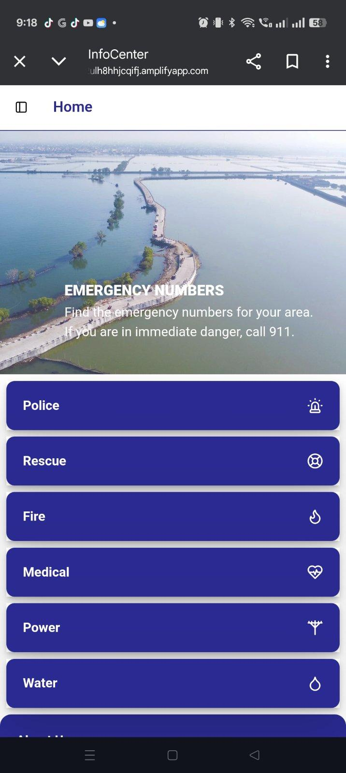 | 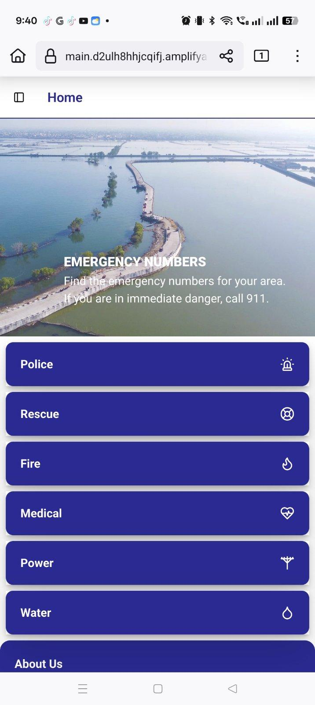
Figure 68. Chrome Browser | Figure 69. Firefox Browser

iOS
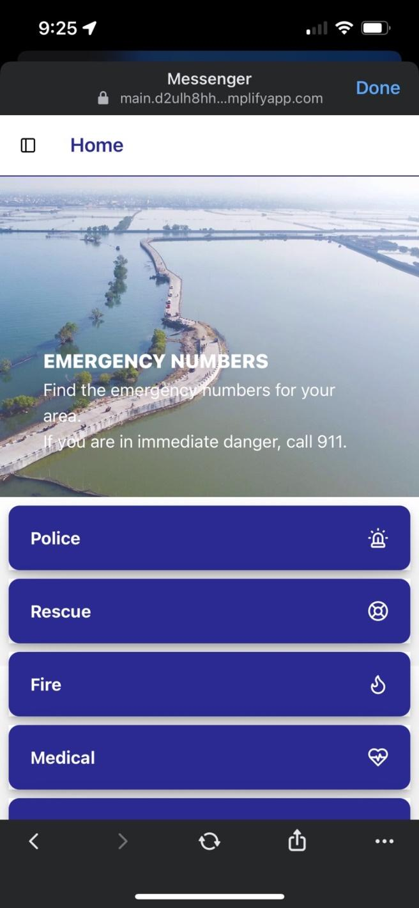 | 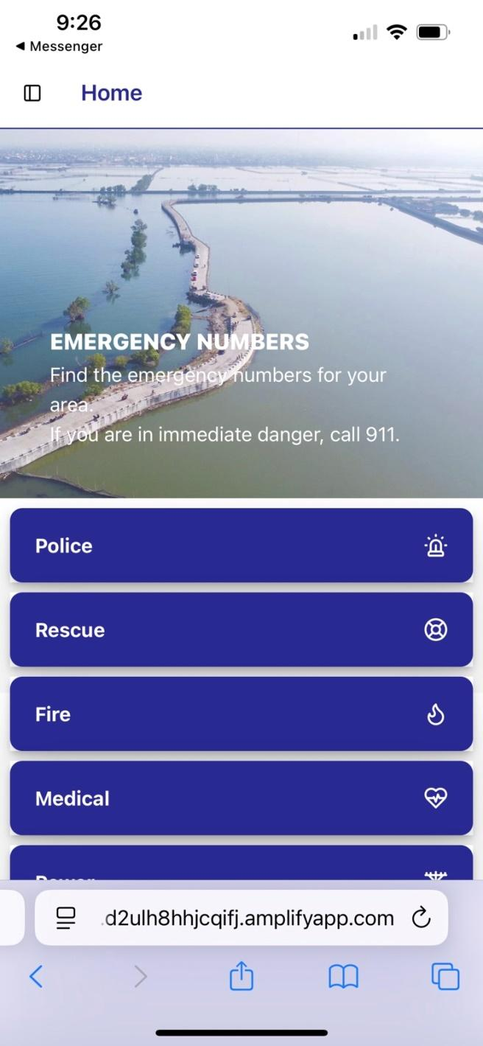
Figure 70. Safari Browser | Figure 71. Chrome Browser

Tablet View
Android OS
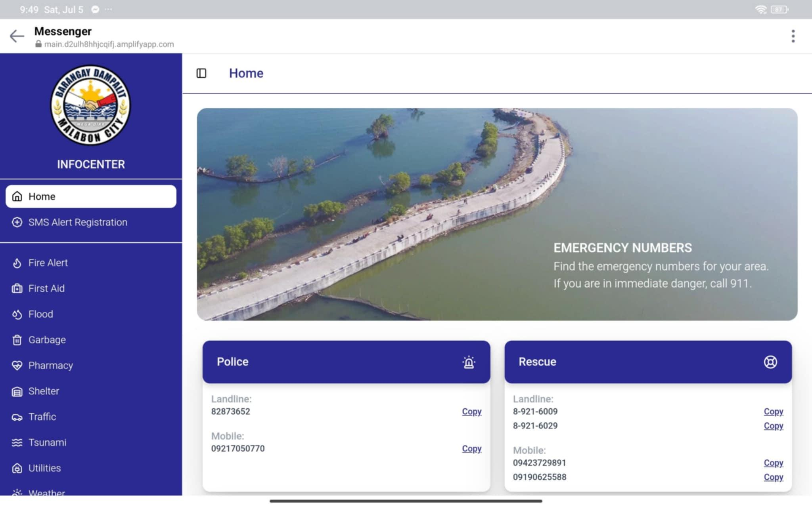
Figure 72. Chrome Browser- Landscape view
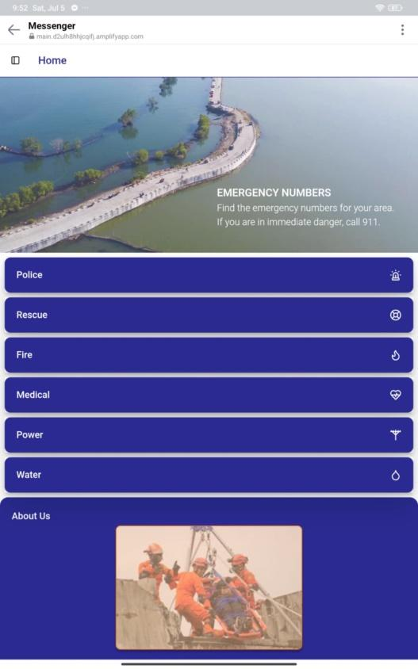
Figure 73. Chrome Browser- Portrait view

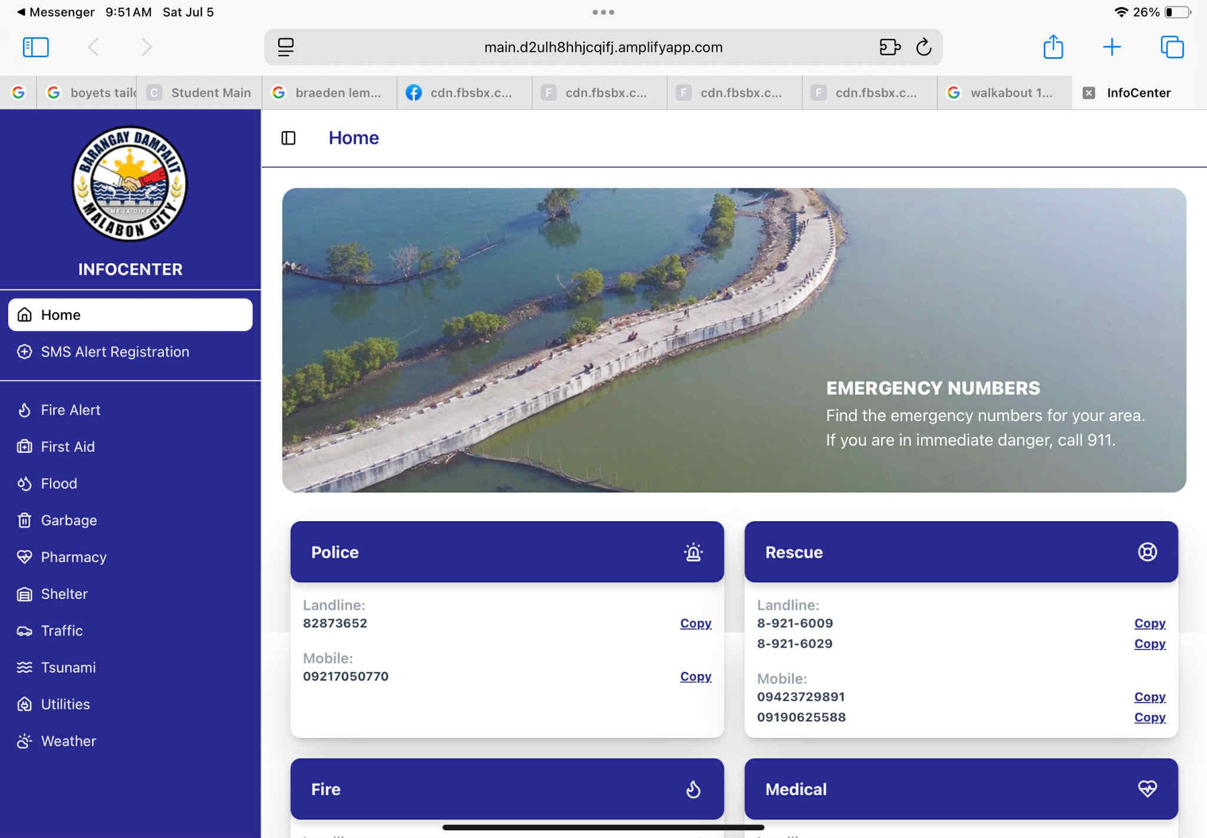
Figure 74. Safari- Landscape view
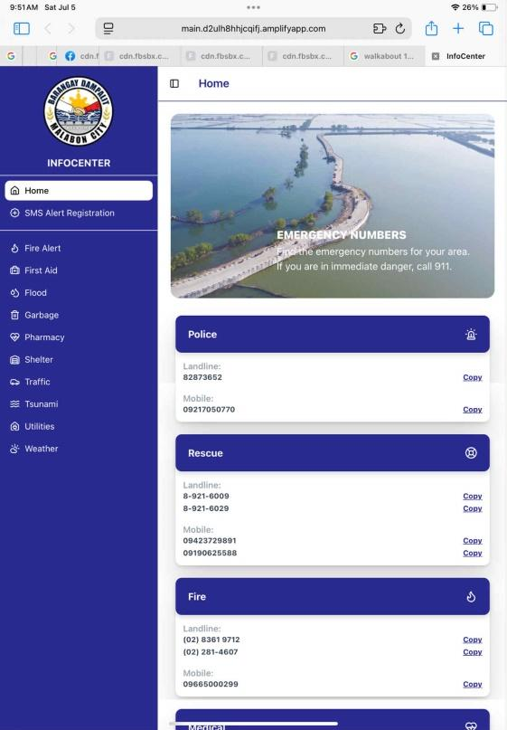
Figure 75. Safari Browser- Portrait view

Desktop View
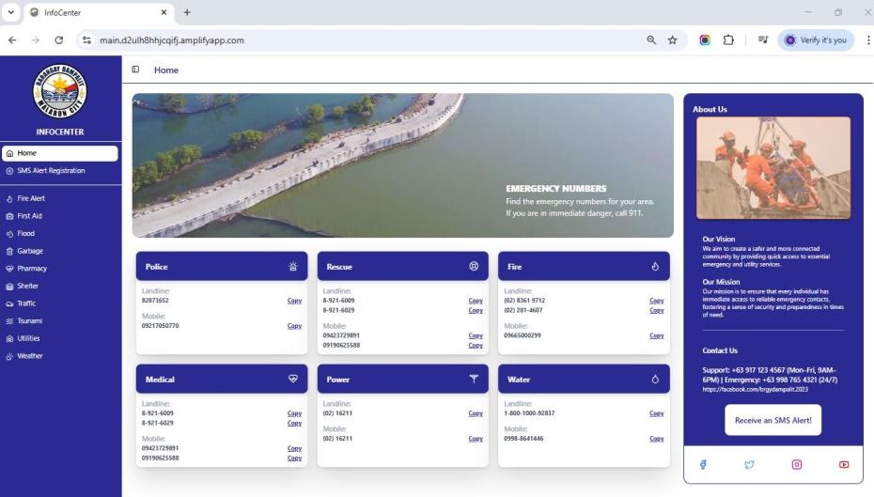
Figure 76. Chrome Browser
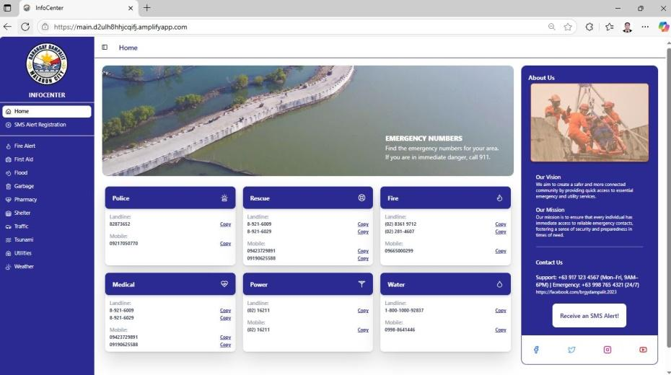
Figure 77. Edge Browser
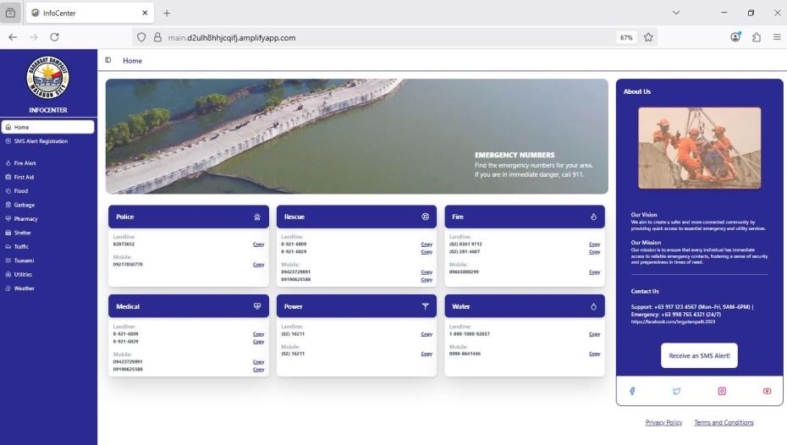
Figure 78. Firefox Browser

USABILITY TEST RESULTS

SMS Registration Feature
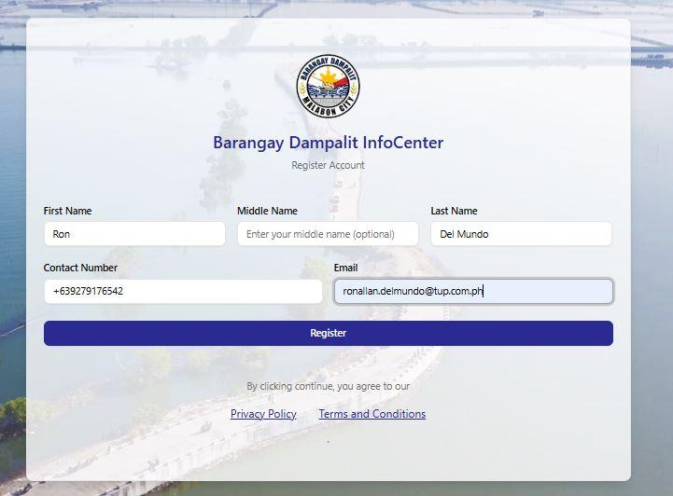
Figure 79. SMS Registration UI
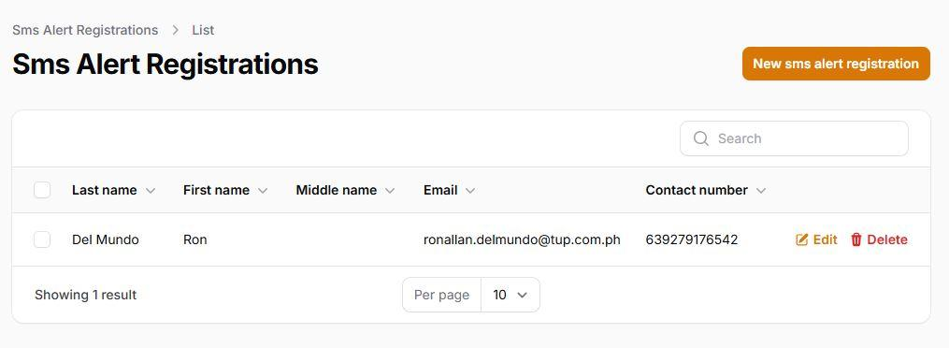
Figure 80. Reflected Registration on the CMS

SMS Alert Features
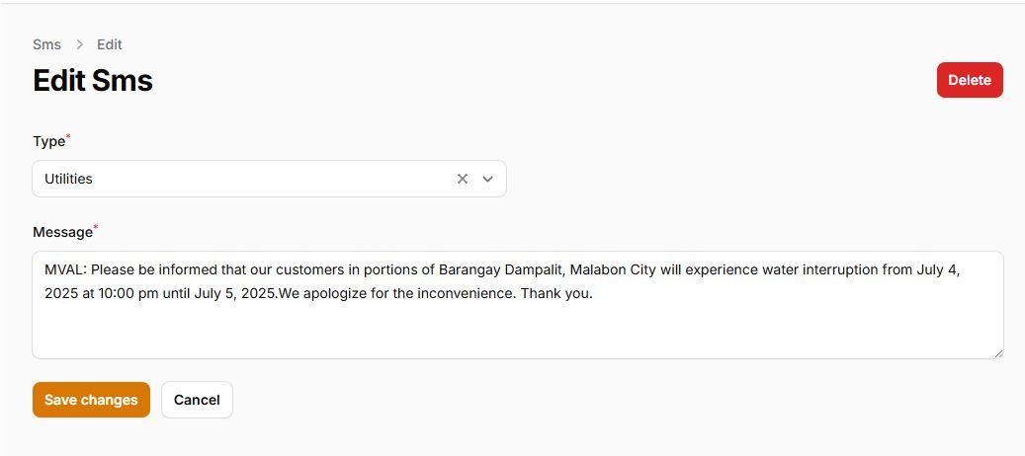
Figure 81. SMS Alert Message
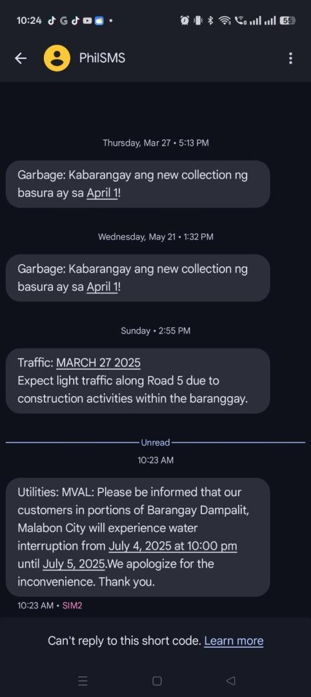
Figure 82. Sent SMS

Screen Responsiveness
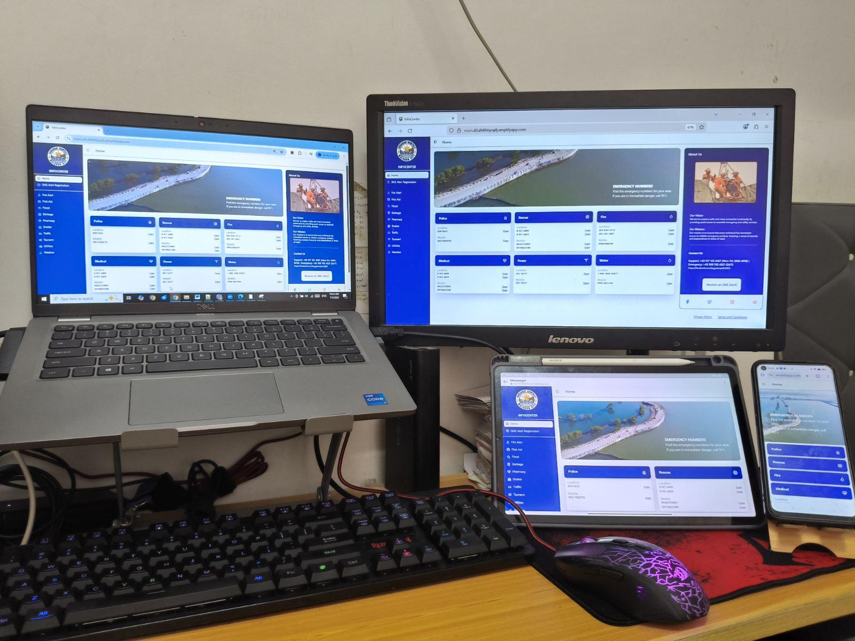
Figure 83. Screen Responsiveness – Desktop, Laptop, Tablet and Mobile device.

Appendix C

SAMPLE EVALUATION SHEET
Technological University of the Philippines
College of Science
Computer Studies Department

Name(Optional):______________________Occupation:__________Date: __________

Direction: Please encircle the appropriate number of your rating to evaluate the project entitled “Development of a web-based mobile responsive application of a community infocenter” using the scale below:
:
4 – Highly Acceptable 3 – Very Acceptable 2 – Acceptable 1 – Not Acceptable

Web Application
Criteria | Rating
- Functionality Suitability
- Functional Completeness. The framework functions complete all the established objectives. | 4 | 3 | 2 | 1
- Functional Correctness. The framework delivers correct results. | 4 | 3 | 2 | 1
- Functional Appropriateness. The framework functions allow the accomplishment of the established objectives. | 4 | 3 | 2 | 1
- Performance Efficiency
- Time Behavior. The framework processes the task and response according to the established time. | 4 | 3 | 2 | 1
- Resource Utilization. The framework utilizes its resources efficiently. | 4 | 3 | 2 | 1
- Compatibility
- Co-existence. The framework can run on the same operating system with the Alexa App. | 4 | 3 | 2 | 1
- Interoperability. The framework can exchange information with the Alexa App. | 4 | 3 | 2 | 1
- Usability
- Appropriateness Recognizability. The framework can be recognized as appropriate for the users' needs. | 4 | 3 | 2 | 1
- Learnability. The effective and efficient usage of the framework is easy to learn. | 4 | 3 | 2 | 1
- Operability. The framework has features that make it easy to operate and control. | 4 | 3 | 2 | 1
- User Error Protection. The framework protects the user from making errors. | 4 | 3 | 2 | 1
- User Interface Aesthetics. The framework interface allows good and satisfying interactions with the users | 4 | 3 | 2 | 1
- Accessibility. The framework can be used by anyone easily. | 4 | 3 | 2 | 1
- Reliability
- Availability. The framework works as required whenever required during the use. | 4 | 3 | 2 | 1
- Fault Tolerance. The framework can resume working in the event of an interruption or a failure. | 4 | 3 | 2 | 1
- Maintainability
- Analyzability. The framework allows easy diagnosis of deficiencies or causes of failures. | 4 | 3 | 2 | 1
- Modifiability. The framework can be effectively modified without creating defects. | 4 | 3 | 2 | 1
- Testability. Test criteria can be created for the Alexa App and performed to know that it meets the given criteria. | 4 | 3 | 2 | 1
- Portability
- Installability. The framework can be installed easily. | 4 | 3 | 2 | 1
Comments/Suggestions:

Appendix D

HIGH LEVEL GANTT CHART
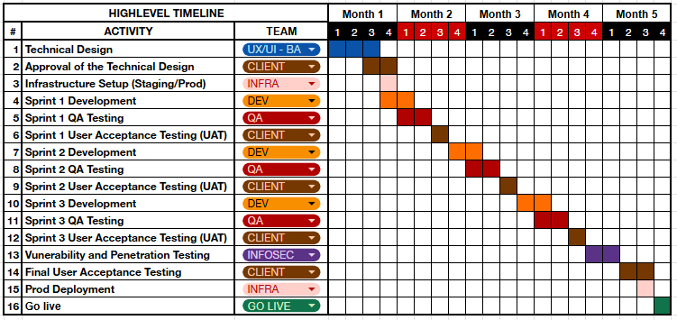

Appendix E

Thesis Grammarian Certificate

Appendix F
Certificate of Similarity Index using Turnitin URDS

Appendix G

EVALUATION SHEET
Technological University of the Philippines
College of Science
Computer Studies Department

Name(Optional):______________________Occupation:__________Date: __________

Direction: Please encircle the appropriate number of your rating to evaluate the project entitled “Development of a web-based mobile responsive application of a community infocenter” using the scale below:

4 – Highly Acceptable 3 – Very Acceptable 2 – Acceptable 1 – Not Acceptable

Web Application
Criteria | Rating
- Functionality Suitability
- Functional Completeness. The framework functions complete all the established objectives. | 4 | 3 | 2 | 1
- Functional Correctness. The framework delivers correct results. | 4 | 3 | 2 | 1
- Functional Appropriateness. The framework functions allow the accomplishment of the established objectives. | 4 | 3 | 2 | 1
- Performance Efficiency
- Time Behavior. The framework processes the task and response according to the established time. | 4 | 3 | 2 | 1
- Resource Utilization. The framework utilizes its resources efficiently. | 4 | 3 | 2 | 1
- Compatibility
- Co-existence. The framework can run on the same operating system with the Alexa App. | 4 | 3 | 2 | 1
- Interoperability. The framework can exchange information with the Alexa App. | 4 | 3 | 2 | 1
- Usability
- Appropriateness Recognizability. The framework can be recognized as appropriate for the users' needs. | 4 | 3 | 2 | 1
- Learnability. The effective and efficient usage of the framework is easy to learn. | 4 | 3 | 2 | 1
- Operability. The framework has features that make it easy to operate and control. | 4 | 3 | 2 | 1
- User Error Protection. The framework protects the user from making errors. | 4 | 3 | 2 | 1
- User Interface Aesthetics. The framework interface allows good and satisfying interactions with the users | 4 | 3 | 2 | 1
- Accessibility. The framework can be used by anyone easily. | 4 | 3 | 2 | 1
- Reliability
- Availability. The framework works as required whenever required during the use. | 4 | 3 | 2 | 1
- Fault Tolerance. The framework can resume working in the event of an interruption or a failure. | 4 | 3 | 2 | 1
- Maintainability
- Analyzability. The framework allows easy diagnosis of deficiencies or causes of failures. | 4 | 3 | 2 | 1
- Modifiability. The framework can be effectively modified without creating defects. | 4 | 3 | 2 | 1
- Testability. Test criteria can be created for the Alexa App and performed to know that it meets the given criteria. | 4 | 3 | 2 | 1
- Portability
- Installability. The framework can be installed easily. | 4 | 3 | 2 | 1
Comments/Suggestions:

EVALUATION SHEET
Technological University of the Philippines
College of Science
Computer Studies Department

Name(Optional):______________________Occupation:__________Date: __________

Direction: Please encircle the appropriate number of your rating to evaluate the project entitled “Development of a web-based mobile responsive application of a community infocenter” using the scale below:
4 – Highly Acceptable 3 – Very Acceptable 2 – Acceptable 1 – Not Acceptable

Web Application
Criteria | Rating
- Functionality Suitability
- Functional Completeness. The framework functions complete all the established objectives. | 4 | 3 | 2 | 1
- Functional Correctness. The framework delivers correct results. | 4 | 3 | 2 | 1
- Functional Appropriateness. The framework functions allow the accomplishment of the established objectives. | 4 | 3 | 2 | 1
- Performance Efficiency
- Time Behavior. The framework processes the task and response according to the established time. | 4 | 3 | 2 | 1
- Resource Utilization. The framework utilizes its resources efficiently. | 4 | 3 | 2 | 1
- Compatibility
- Co-existence. The framework can run on the same operating system with the Alexa App. | 4 | 3 | 2 | 1
- Interoperability. The framework can exchange information with the Alexa App. | 4 | 3 | 2 | 1
- Usability
- Appropriateness Recognizability. The framework can be recognized as appropriate for the users' needs. | 4 | 3 | 2 | 1
- Learnability. The effective and efficient usage of the framework is easy to learn. | 4 | 3 | 2 | 1
- Operability. The framework has features that make it easy to operate and control. | 4 | 3 | 2 | 1
- User Error Protection. The framework protects the user from making errors. | 4 | 3 | 2 | 1
- User Interface Aesthetics. The framework interface allows good and satisfying interactions with the users | 4 | 3 | 2 | 1
- Accessibility. The framework can be used by anyone easily. | 4 | 3 | 2 | 1
- Reliability
- Availability. The framework works as required whenever required during the use. | 4 | 3 | 2 | 1
- Fault Tolerance. The framework can resume working in the event of an interruption or a failure. | 4 | 3 | 2 | 1
- Maintainability
- Analyzability. The framework allows easy diagnosis of deficiencies or causes of failures. | 4 | 3 | 2 | 1
- Modifiability. The framework can be effectively modified without creating defects. | 4 | 3 | 2 | 1
- Testability. Test criteria can be created for the Alexa App and performed to know that it meets the given criteria. | 4 | 3 | 2 | 1
- Portability
- Installability. The framework can be installed easily. | 4 | 3 | 2 | 1
Comments/Suggestions:

EVALUATION SHEET
Technological University of the Philippines
College of Science
Computer Studies Department

Name(Optional):______________________Occupation:__________Date: __________

Direction: Please encircle the appropriate number of your rating to evaluate the project entitled “Development of a web-based mobile responsive application of a community infocenter” using the scale below:
4 – Highly Acceptable 3 – Very Acceptable 2 – Acceptable 1 – Not Acceptable

Web Application
Criteria | Rating
- Functionality Suitability
- Functional Completeness. The framework functions complete all the established objectives. | 4 | 3 | 2 | 1
- Functional Correctness. The framework delivers correct results. | 4 | 3 | 2 | 1
- Functional Appropriateness. The framework functions allow the accomplishment of the established objectives. | 4 | 3 | 2 | 1
- Performance Efficiency
- Time Behavior. The framework processes the task and response according to the established time. | 4 | 3 | 2 | 1
- Resource Utilization. The framework utilizes its resources efficiently. | 4 | 3 | 2 | 1
- Compatibility
- Co-existence. The framework can run on the same operating system with the Alexa App. | 4 | 3 | 2 | 1
- Interoperability. The framework can exchange information with the Alexa App. | 4 | 3 | 2 | 1
- Usability
- Appropriateness Recognizability. The framework can be recognized as appropriate for the users' needs. | 4 | 3 | 2 | 1
- Learnability. The effective and efficient usage of the framework is easy to learn. | 4 | 3 | 2 | 1
- Operability. The framework has features that make it easy to operate and control. | 4 | 3 | 2 | 1
- User Error Protection. The framework protects the user from making errors. | 4 | 3 | 2 | 1
- User Interface Aesthetics. The framework interface allows good and satisfying interactions with the users | 4 | 3 | 2 | 1
- Accessibility. The framework can be used by anyone easily. | 4 | 3 | 2 | 1
- Reliability
- Availability. The framework works as required whenever required during the use. | 4 | 3 | 2 | 1
- Fault Tolerance. The framework can resume working in the event of an interruption or a failure. | 4 | 3 | 2 | 1
- Maintainability
- Analyzability. The framework allows easy diagnosis of deficiencies or causes of failures. | 4 | 3 | 2 | 1
- Modifiability. The framework can be effectively modified without creating defects. | 4 | 3 | 2 | 1
- Testability. Test criteria can be created for the Alexa App and performed to know that it meets the given criteria. | 4 | 3 | 2 | 1
- Portability
- Installability. The framework can be installed easily. | 4 | 3 | 2 | 1
Comments/Suggestions:

EVALUATION SHEET
Technological University of the Philippines
College of Science
Computer Studies Department

Name(Optional):______________________Occupation:__________Date: __________

Direction: Please encircle the appropriate number of your rating to evaluate the project entitled “Development of a web-based mobile responsive application of a community infocenter” using the scale below:
4 – Highly Acceptable 3 – Very Acceptable 2 – Acceptable 1 – Not Acceptable

Web Application
Criteria | Rating
- Functionality Suitability
- Functional Completeness. The framework functions complete all the established objectives. | 4 | 3 | 2 | 1
- Functional Correctness. The framework delivers correct results. | 4 | 3 | 2 | 1
- Functional Appropriateness. The framework functions allow the accomplishment of the established objectives. | 4 | 3 | 2 | 1
- Performance Efficiency
- Time Behavior. The framework processes the task and response according to the established time. | 4 | 3 | 2 | 1
- Resource Utilization. The framework utilizes its resources efficiently. | 4 | 3 | 2 | 1
- Compatibility
- Co-existence. The framework can run on the same operating system with the Alexa App. | 4 | 3 | 2 | 1
- Interoperability. The framework can exchange information with the Alexa App. | 4 | 3 | 2 | 1
- Usability
- Appropriateness Recognizability. The framework can be recognized as appropriate for the users' needs. | 4 | 3 | 2 | 1
- Learnability. The effective and efficient usage of the framework is easy to learn. | 4 | 3 | 2 | 1
- Operability. The framework has features that make it easy to operate and control. | 4 | 3 | 2 | 1
- User Error Protection. The framework protects the user from making errors. | 4 | 3 | 2 | 1
- User Interface Aesthetics. The framework interface allows good and satisfying interactions with the users | 4 | 3 | 2 | 1
- Accessibility. The framework can be used by anyone easily. | 4 | 3 | 2 | 1
- Reliability
- Availability. The framework works as required whenever required during the use. | 4 | 3 | 2 | 1
- Fault Tolerance. The framework can resume working in the event of an interruption or a failure. | 4 | 3 | 2 | 1
- Maintainability
- Analyzability. The framework allows easy diagnosis of deficiencies or causes of failures. | 4 | 3 | 2 | 1
- Modifiability. The framework can be effectively modified without creating defects. | 4 | 3 | 2 | 1
- Testability. Test criteria can be created for the Alexa App and performed to know that it meets the given criteria. | 4 | 3 | 2 | 1
- Portability
- Installability. The framework can be installed easily. | 4 | 3 | 2 | 1
Comments/Suggestions:

EVALUATION SHEET
Technological University of the Philippines
College of Science
Computer Studies Department

Name(Optional):______________________Occupation:__________Date: __________

Direction: Please encircle the appropriate number of your rating to evaluate the project entitled “Development of a web-based mobile responsive application of a community infocenter” using the scale below:
4 – Highly Acceptable 3 – Very Acceptable 2 – Acceptable 1 – Not Acceptable

Web Application
Criteria | Rating
- Functionality Suitability
- Functional Completeness. The framework functions complete all the established objectives. | 4 | 3 | 2 | 1
- Functional Correctness. The framework delivers correct results. | 4 | 3 | 2 | 1
- Functional Appropriateness. The framework functions allow the accomplishment of the established objectives. | 4 | 3 | 2 | 1
- Performance Efficiency
- Time Behavior. The framework processes the task and response according to the established time. | 4 | 3 | 2 | 1
- Resource Utilization. The framework utilizes its resources efficiently. | 4 | 3 | 2 | 1
- Compatibility
- Co-existence. The framework can run on the same operating system with the Alexa App. | 4 | 3 | 2 | 1
- Interoperability. The framework can exchange information with the Alexa App. | 4 | 3 | 2 | 1
- Usability
- Appropriateness Recognizability. The framework can be recognized as appropriate for the users' needs. | 4 | 3 | 2 | 1
- Learnability. The effective and efficient usage of the framework is easy to learn. | 4 | 3 | 2 | 1
- Operability. The framework has features that make it easy to operate and control. | 4 | 3 | 2 | 1
- User Error Protection. The framework protects the user from making errors. | 4 | 3 | 2 | 1
- User Interface Aesthetics. The framework interface allows good and satisfying interactions with the users | 4 | 3 | 2 | 1
- Accessibility. The framework can be used by anyone easily. | 4 | 3 | 2 | 1
- Reliability
- Availability. The framework works as required whenever required during the use. | 4 | 3 | 2 | 1
- Fault Tolerance. The framework can resume working in the event of an interruption or a failure. | 4 | 3 | 2 | 1
- Maintainability
- Analyzability. The framework allows easy diagnosis of deficiencies or causes of failures. | 4 | 3 | 2 | 1
- Modifiability. The framework can be effectively modified without creating defects. | 4 | 3 | 2 | 1
- Testability. Test criteria can be created for the Alexa App and performed to know that it meets the given criteria. | 4 | 3 | 2 | 1
- Portability
- Installability. The framework can be installed easily. | 4 | 3 | 2 | 1
Comments/Suggestions:

EVALUATION SHEET
Technological University of the Philippines
College of Science
Computer Studies Department

Name(Optional):______________________Occupation:__________Date: __________

Direction: Please encircle the appropriate number of your rating to evaluate the project entitled “Development of a web-based mobile responsive application of a community infocenter” using the scale below:
4 – Highly Acceptable 3 – Very Acceptable 2 – Acceptable 1 – Not Acceptable

Web Application
Criteria | Rating
- Functionality Suitability
- Functional Completeness. The framework functions complete all the established objectives. | 4 | 3 | 2 | 1
- Functional Correctness. The framework delivers correct results. | 4 | 3 | 2 | 1
- Functional Appropriateness. The framework functions allow the accomplishment of the established objectives. | 4 | 3 | 2 | 1
- Performance Efficiency
- Time Behavior. The framework processes the task and response according to the established time. | 4 | 3 | 2 | 1
- Resource Utilization. The framework utilizes its resources efficiently. | 4 | 3 | 2 | 1
- Compatibility
- Co-existence. The framework can run on the same operating system with the Alexa App. | 4 | 3 | 2 | 1
- Interoperability. The framework can exchange information with the Alexa App. | 4 | 3 | 2 | 1
- Usability
- Appropriateness Recognizability. The framework can be recognized as appropriate for the users' needs. | 4 | 3 | 2 | 1
- Learnability. The effective and efficient usage of the framework is easy to learn. | 4 | 3 | 2 | 1
- Operability. The framework has features that make it easy to operate and control. | 4 | 3 | 2 | 1
- User Error Protection. The framework protects the user from making errors. | 4 | 3 | 2 | 1
- User Interface Aesthetics. The framework interface allows good and satisfying interactions with the users | 4 | 3 | 2 | 1
- Accessibility. The framework can be used by anyone easily. | 4 | 3 | 2 | 1
- Reliability
- Availability. The framework works as required whenever required during the use. | 4 | 3 | 2 | 1
- Fault Tolerance. The framework can resume working in the event of an interruption or a failure. | 4 | 3 | 2 | 1
- Maintainability
- Analyzability. The framework allows easy diagnosis of deficiencies or causes of failures. | 4 | 3 | 2 | 1
- Modifiability. The framework can be effectively modified without creating defects. | 4 | 3 | 2 | 1
- Testability. Test criteria can be created for the Alexa App and performed to know that it meets the given criteria. | 4 | 3 | 2 | 1
- Portability
- Installability. The framework can be installed easily. | 4 | 3 | 2 | 1
Comments/Suggestions:


RESEARCHER PROFILE
RON ALLAN R. DEL MUNDO
09984751778 delmundo.ra@gmail.com Malabon City

WORK EXPERIENCES
Project Manager
- Serves as Project Manager catering to external clients like corporations, banks, museums, and malls.
- Ongoing / Maintenance Projects – Building automation systems, Artificial Intelligent, Odoo Applications, Movie Ticketing Systems, Corporate Website, E-commerce Website, POS System, mobile application.
- Serves as coordinator to several production teams from both Entertainment, News & Public Affairs Group of GMA Network.
- Responsible for conveying the client technical requirement and deliveries to the internal Team for planning, development, testing and implementation.

Junior Net and System Administrator
- Assisting the team for the pull request of code by the developer to the staging and production server.
- Assisting in internet management using a firewall.
- Assisting on the deployment and configuration of cloud (AWS) and on premise servers.

Senior Technical Support Specialist
- Responsible for the maintenance of the office broadcast and live stream computer.
- Responsible for operating and supporting broadcast PC for News Programs and entertainment.
- Responsible for operating broadcast PC for Chargen implementation on TV Broadcast: PST, Crawler and super imposition graphics.

CAREER MILESTONES
- Lead the Transparency Server Data and Tally Acquisitions Team for Election 2022 and 2025 project for the company.
- Lead the proof of concept in the initial artificial intelligence project.
- Members of the technical team that upgrade the streaming & recording facilities.

.CERTIFICATIONS
- Civil Service Sub Professional Eligible
- Certified Lean Six Sigma Blackbelt.
- Certified Google Project Management
- Certified Google UX Designer
- Certified Google IT Support
- Certified BOSH – Safety Officer 2
SKILLS
- Familiar in using figma for UX design.
- Familiar on Windows, Ubuntu and Mac operating systems.
- Knowledgeable in using Google Workspace.
- Knowledgeable in using Atlassian JIRA Ticketing system & Knowledge Management System.
- Knowledgeable in using Adobe Photoshop and other photo editing software.
- Knowledgeable in configurations, installation of cloud and physical server.
- Knowledgeable in programming languages such as Turbo C, HTML, Javascript and VB 6.0, PHP, and CCS.

