DEVELOPMENT OF TRANSCRIPTIONISTA (TRANSCRIBE,
DATA CAPTURE OPTION TO TEXT APP)

A Thesis Presented to the
Faculty of the College of Science
Technological University of the Philippines
Ayala Boulevard, Manila

By

IGNACIO C. TEODORO, JR

In Partial Fulfillment of the
Requirements for the Degree
Bachelor of Science in Information Systems

January 2026
 | TECHNOLOGICAL UNIVERSITY OF THE PHILIPPINES  Ayala Blvd., Ermita, Manila, 1000, Philippines | Tel No. +632-5301-3001 local 608  Fax No. +632-8521-4063 | Email: cos@tup.edu.ph | Website: www.tup.edu.ph | Index No.
 |  | Revision No.
 | THESIS APPROVAL SHEET FOR THE  UNDERGRADUATE PROGRAMS OF THE COS | Date
 |  | Page

This thesis hereto entitled:

DEVELOPMENT OF TRANSCRIPTIONISTA (TRANSCRIBE, DATA CAPTURE OPTION TO TEXT APP)

prepared and submitted by IGNACIO C. TEODORO, JR in partial fulfillment of the requirements for the degree BACHELOR OF SCIENCE IN INFORMATION SYSTEMS, has been examined and is recommended for approval and acceptance.

PROF. MAY M. GARCIA
Adviser

Approved by the Committee on Oral Examination with a grade of PASSED on January 15, 2026.

PROF. DOLORES L. MONTESINES
Chairperson

PROF. PRISCILLA S. BATOR PROF. AMADOR B. PERAGRINO, JR
Member Member

Accepted in partial fulfillment of the requirements for the degree Bachelor of Science in Information Systems.

Date: DR. JOSHUA T. SORIANO
Dean
Transaction ID Legend: TUPX-AAA (Office Code)-BBB (Type of Transaction)-CCC (Initial of employee)-MMDDYYYY (month day year)-HHMMAM/PM (hourminutesAM/PM)

Transaction ID | TUPM-COS-ETEEAP-KCC-11242025-0851AM
Signature

Abstract

Digitization is essential for organizations that depend on document‑based information, yet delays and transcription errors still hinder productivity. To address inefficiencies in BPO, government, and administrative services, Transcriptionista was developed. This is a cross‑platform application that automates structured text extraction from digital and scanned documents. Transcriptionista combines Textract OCR with Python and Flutter and uses Firestore for secure cloud storage; it processes PDFs, PNGs, JPEGs, and BMPs (including blurred machine‑printed invoices and pay slips), supports configurable field mappings, automated classification, and exports to CSV, JSON, XLS, and TXT. Validation through walkthroughs, UI captures, and structured testing produced accuracy rates of 95% for PDFs and 88% for scanned images, and an ISO 25010 compatibility/usability weighted mean of 3.68 (Highly Acceptable). The project demonstrates a practical, locally adaptable digitization solution that reduces manual bottlenecks and enables institutions to manage business‑critical data more efficiently

Acknowledgement

The completion of this research project marks a significant milestone in my life, and I am profoundly grateful to those who stood by me throughout this journey.
Above all, I return all the glory and praise to our ever-loving God. His sufficient grace was my anchor during the most challenging hours of this research, and His wisdom provided the clarity I needed to persevere.
I extend my heartfelt thanks to my Capstone Adviser, Professor May M. Garcia. Beyond her technical expertise, her mentorship and willingness to share her vast professional knowledge have been instrumental in my development. I am truly grateful for the unparalleled support she provided in navigating the complexities of this project.
Special thanks to the esteemed panel and to my professors, Professor Dolores L. Montesines, Professor Priscilla S. Bator, Professor Peragrino B. Amador Jr., Professor Julius A. Sareno, and Professor Darwin Vargas. Thank you for fostering a culture of learning and for the academic rigor that has prepared me for the professional world.
To our ETEEAP Director, Dr. Kevien Dela Cruz, for your visionary leadership and commitment to academic excellence. Your dedication to maintaining high institutional standards provided the ideal environment for this research to flourish.
I owe my greatest debt of gratitude to my wife, Clarisa, and my children, Isaac, Iris, and Iesha. I thank them for the faithful prayers, enduring grace, and for being the 'why' behind everything I do. This achievement belongs to all of us.

Table of Contents
Page
Title Page i
Approval Sheet ii
Abstract iii
Acknowledgement iv
Table of Contents v
List of Tables vii
List of Figures viii
List of Appendices x

Chapter 1 THE PROBLEM AND ITS SETTINGS 1
Background of the Study 1
Objectives of the Study 4
Scope and Limitations of the Study 5

Chapter 2 CONCEPTUAL FRAMEWORK 7
Review of Related Literature 7
Review of Related Studies 19
Conceptual Model of Study 21
Operational Definition of Terms 48

Chapter 3 METHODOLOGY 49
Project Design 50
Project Development 58
Operation Procedure 60
Testing Procedure 63
Evaluation Procedure 71
Chapter 4 RESULTS AND DISCUSSION 73
Project Description 73
Project Structure 74
Project Capabilities and Limitations 79
Test Result 80
Evaluation Result 87

Chapter 5 SUMMARY OF FINDINGS, CONCLUSIONS, AND
RECOMMENDATIONS 92
Summary of Findings 92
Conclusions 94
Recommendations 96

REFERENCES 99
RESEARCHER’S PROFILE 147

LIST OF TABLES
Table Page
1 Functional Testing Procedure 63
2 Compatibility Testing Procedure 66
3 Usability Testing Procedure 68
4 Range of Weighted Mean Values and their Interpretation 72
5 Text Extraction Accuracy by Document Type 81
6 Compatibility Test Results 82
7 Usability Test Results 83
8 Summary of Evaluation 87

LIST OF FIGURES
Figure Page
1 The Real Cost of Manual Data Entry in Logistics 2
2 Hours spent each day on repetitive computer administration tasks globally 3
3 Business Drivers for Process Automation 14
4 Market forces driving growth of process automation projects 16
5 The State of Process Automation 16
6 Global Optical Character Recognition Market 18
7 Conceptual Model Diagram 22
8 Project Design 44
9 Transcriptionista Process Flow 51
10 PDF’s Popularity 56
11 Agile Development Life Cycle 59
12 Transcriptionista Operation Flow 60
13 Transcriptionista Home Screen 74
14 Document Upload Section 75
15 Input File Preview Section 75
16 Converters Section 76
17 Selective Extract Section 76
18 Edit-Before-Export Section 77
19 Export Section 78
20 Converters Export Options Section 78
21 Generated Output section 79
22 Transcriptionista Home Page 136
23 Register Screen 137
24 Login Screen 137
25 Change Password Screen 138
26 Account Settings Screen 138
27 App Menu Screen 139
28 File Upload Screen 139
29 Input File Preview Screen 140
30 PDF – Image Converter Output Screen 140
31 Extracted Text Screen – Rule Engine 141
32 Document Type Configuration Screen – Rule Engine 141
33 Entity Configuration Screen – Rule Engine 142
34 Field Identifier Configuration Screen – Rule Engine 142
35 Key Fields Screen – Generated Output 143
36 Output Files Screen – Generated Output 143
37 Process Info Screen – Generated Output 144
38 Edit-Before-Export Screen 144
39 Dashboard Screen 145
40 Validation & User Guidance – Invalid user credentials 140
41 Validation & User Guidance– Dynamic Inline validation 146
42 Status-Based Validation Guidance – Setup Readiness Check 146

LIST OF APPENDICES
Appendix Page
A Sample Evaluation Sheet 109
B Survey Questionnaire And Results Sheets 112
C Video Introduction to Transcriptionista 132
D Thesis Grammarian Certification 133
E Certificate of Similarity Index Using Turnitin 135
F Systems Interface Screenshots 136
G Researcher’s Profile 147

Chapter 1

THE PROBLEM AND ITS SETTING

This chapter presents the background of the research, followed by the objectives, scope, and limitations of the study.

Background of the Study

Despite rapid technological advancements, manual data entry remains a widely used practice across many industries worldwide. While familiar and easy to implement, this approach has become increasingly problematic for organizations striving for efficiency, accuracy, and continuous improvement. Manual encoding consumes a significant amount of employee time and is highly susceptible to errors, ultimately slowing down business operations and affecting overall performance.
Several studies have highlighted the inefficiencies associated with manual data entry. According to Mehndiratta (2019), manual encoding is both time-consuming and error-prone, negatively impacting business efficiency, employee productivity, and job satisfaction. Research from Parseur and Smartsheet further revealed that at least one-fourth of employees’ work hours are spent on repetitive manual tasks, including data entry (Gunnoo, 2022; Beloof, n.d.). These repetitive activities limit employees’ ability to focus on more strategic and value-adding work.
In addition to being time-intensive, manual data entry is highly vulnerable to human error. Factors such as fatigue, stress, distractions, and poorly formatted or hard-to-read information significantly increase the likelihood of mistakes (Everything Wrong with Manual Data Entry, n.d.; Haddad, 2021). Studies have estimated that error rates in manual data entry range from 18% to 40%, making human error one of the most persistent challenges in data processing (ImpactMyBiz, 2021). These errors often require rework, leading to wasted time, additional costs, and compromised data accuracy.
The financial implications of manual data entry are equally concerning. On average, a data entry clerk earns approximately USD 15 per hour, and manually encoding a single document takes about 15 minutes, resulting in a base cost of USD 3.75 per document. When error correction is factored in, this cost increases to approximately USD 4.50 per document (Gaur, 2022). Over time, these seemingly small costs accumulate, placing a significant financial burden on organizations that rely heavily on manual processes.
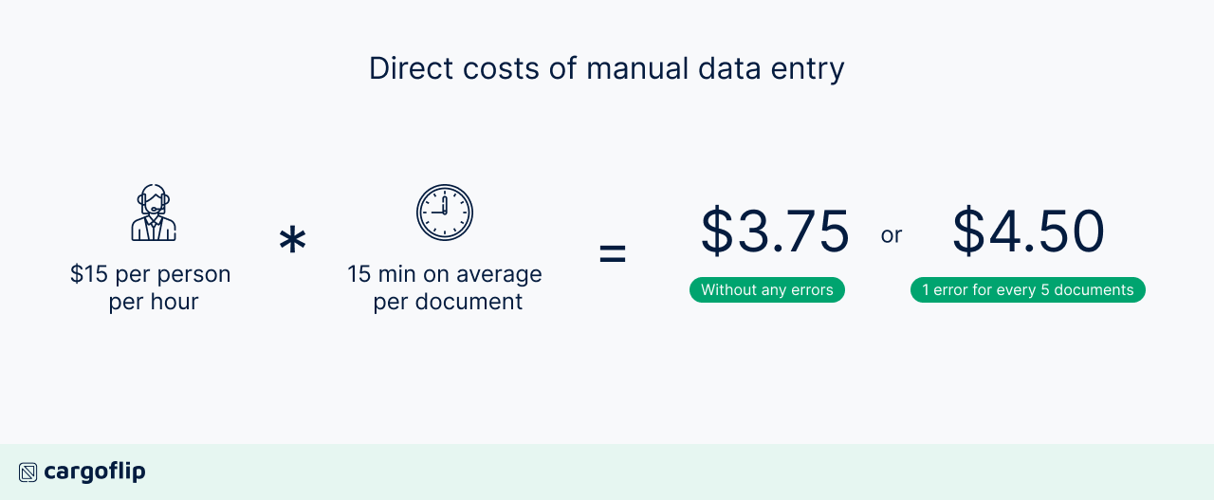
Figure 1: The real cost of manual data entry in logistics (Gaur, 2022)

Manual data entry also has a substantial impact on employee productivity and morale. A study by SoftwareAdvice found that 71% of sales professionals reported losing most of their productive hours to manual data entry tasks (Das, n.d.). Employees spend up to 40% of their time searching for documents and information, with an average of 18 minutes required to locate a single document manually (ImpactMyBiz, 2021). Global surveys further indicate that data entry and data capture are among the most disliked office tasks, contributing to frustration, disengagement, and burnout among employees (Borris, 2020).
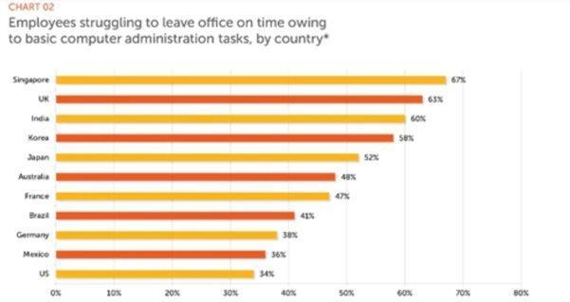
Figure 2: Hours spent each day on repetitive computer administration tasks globally (Alison Borris, 2020)

These persistent challenges have driven organizations to increasingly explore automation solutions. The shift toward process automation has been shown to enhance speed, accuracy, and decision-making while reducing operational costs. This transition accelerated during the COVID-19 pandemic, when 88% of organizations initiated or expanded automation efforts, and 84% increased investments in automation technologies (Camunda, 2020). Employees themselves support this shift, with the majority believing that repetitive administrative tasks should be automated. Industries that rely heavily on paper-based documents—such as finance, logistics, and government—remain particularly affected by manual data entry. Prolonged processing times, high error rates, and employee dissatisfaction continue to challenge these sectors. As emphasized by Automation Anywhere, reducing repetitive tasks is critical to improving productivity and workforce engagement (Tripathi, 2022).
Given these challenges, the researcher was driven by a desire to develop a system that makes document handling easier, faster, and more reliable. By integrating Optical Character Recognition (OCR) and automation technologies, the system, Transcriptionista, aimed to transform physical documents into accurate, machine-readable data while significantly reducing the need for manual encoding. The researcher envisioned this system as a practical response to the everyday difficulties faced by organizations, helping reduce errors, lessen employee workload, and improve overall efficiency and productivity in document-driven processes.

Objectives of the Study

General Objectives
The general objective of this study will be to develop a system that will facilitate automation of basic data transcription workflows, automate the document data capturing process, and reduce the chances of human error in encoding or transcribing different files and documents, which can be used by both private and government sectors in the Philippines.

Specifically, it aims to:
- Design Transcriptionista with the following features:
  - can capture pdf and image documents using OCR.
  - can customize the data field to be read.
  - can export the read data in Excel, CSV, and JSON files.
- Create the Transcriptionista as designed using tools such as Dart and Flutter for a responsive cross-platform experience, integrated Python for backend functionalities, used Firebase for real-time data management, and relied on Visual Studio Code as the development environment, all while ensuring cross-device compatibility with Google services.
- Test and improve the Transcriptionista in terms of reliability and usability
- Evaluate the acceptability of the Transcriptionista using ISO 25010 criteria for a quality software model.

Scope and Limitations of the Study

The study developed a system, Transcriptionista: Transcribe, data capture to text app, an automated data entry solution that reduces the time, errors, and inefficiencies with manual encoding processes.
The study focused on the exploration and application of Optical Character Recognition (OCR) technology for the recognition of machine-printed text. It covered the development of a system that allows users to upload PDF or image-based documents, extract specified data fields, and convert these documents into editable formats. The system supports multiple export options, including Excel, CSV, JSON, and plain text, to accommodate diverse data processing needs. The study also included evaluating the system’s ability to accurately recognize, extract, and transform machine-printed content from scanned or digital documents.
The study covered the exploration of OCR. The developed and tested Transcriptionista in Python using libraries Textract and OpenCV. In addition to core OCR functionality, Transcriptionista used Firebase for cloud-based storage and dynamic document handling during local testing. Transcriptionista only reads and processes machine-printed documents, such as invoices and pay slips, from PDF and image formats like PNG, JPEG, and BMP. The system’s evaluation focused on the effectiveness of its extraction capabilities and export functionality under simulated conditions. Also, batch processing used user‑configured field extraction and export to a more structured data format (CSV, XLS, JSON, and TXT) supported by the system. All features are demonstrated in a local development environment through walkthrough videos.
Despite the advancement of OCR technology, the researcher still identified several limitations:
- The accuracy of OCR output still depends on image clarity, font consistency, and language complexity. Errors may arise from blurred scans, low resolution, or non-standard typography.
- The system does not support handwritten text or cursive fonts.
- Due to unresolved versioning constraints and the testing scope, the demonstration of real-time multi-user authentication and full online functionality did not proceed.
- The implementation of cloud features using Firestore is limited to a controlled local environment.
The study was evaluated by 50 purposively selected respondents to determine the acceptability of Transcriptionista using the ISO 25010.

Chapter 2

CONCEPTUAL FRAMEWORK

This chapter presents a review of related literature, related studies, conceptual model of the study, and operational definitions of terms.

Review of Related Literature

This section presents key concepts and ideas relevant to the topic of the study. It includes discussions on manual data entry and its challenges, process automation, and OCR technology.
It focused on what and how the study could contribute to solving the concerns brought about by manual data entry, as thoroughly described in the previous chapter.
The study employed Optical Character Recognition (OCR) technology to automate the process and mitigate the identified challenges. It further examines the details of OCR technology, including its capabilities and limitations, and discusses how it can be applied to address issues associated with manual data entry. Recent literature on OCR technology and its application to solving manual data entry issues was extensively reviewed.

Manual Data Entry and Its Challenges
Manual data entry is time-consuming and tedious. It significantly affects employee productivity and organizational costs. Das (n.d.) reported that 71% of sales professionals indicated that manual data entry consumed most of their productive working hours. Similarly, employees spend up to 40% of their time searching for documents and information, with an average of 18 minutes required to locate a single document manually (ImpactMyBiz, 2021). Studies indicate that manual data entry is up to 10 times slower than automation. Even a 1% error rate compromises the accuracy of the final documents. Fatigue and inattentiveness are major drivers of error. (Gunnoo, Parseur, 2025)

Automated Data Capture

Automated data capture refers to the process of collecting and converting data from various sources into a usable electronic format for analysis and storage. It refers specifically to the process of scanning physical documents and extracting text from them (What is Data Capture, n.d.).
Before automated data capture can take place, the source material containing the data must be digitized. It includes documents, forms, images, and other physical records that need to be converted into digital format so that they can be read and processed by computers.

Digitization

Digitization is the method of translating document information into a digital format. Digitization nowadays plays a major role in improving not just the quality of work but also its quantity, especially in industries that rely on information from documents. There are growing concerns across sectors about accuracy, timeliness, and productivity issues stemming from manually transcribing data from different document types before it is input to other systems or transferred to other organizations or entities.
Digitization is important for several reasons. First, it enables data to be easily stored, organized, and accessed in digital form. It reduces the need for physical storage space and makes it easier to manage and search for specific information. Second, digitization enables data sharing and collaboration across different locations and devices. It is particularly important in today's global and remote work environment, where team members may be in other parts of the world. Third, digitization can improve the accuracy and speed of data processing.
From a financial perspective, Gaur (2022) highlighted that the cost of manual data entry increases substantially when error correction and reprocessing are considered. Although encoding a single document may appear inexpensive, the accumulated costs over time place a significant burden on organizations, especially those handling large volumes of documents.
Additionally, global surveys identified data entry as one of the most disliked office tasks, often associated with frustration, disengagement, and burnout (Borris, 2020). These findings underscore the need for solutions that reduce repetitive administrative work and improve employee well-being.

Ways to improve manual data entry

There are many solutions available nowadays that can eliminate or perhaps lessen the impact of challenges imposed by manual data entry; some of these are the following:
- Create a Centralized Database. It will make data entry easier, since data is stored and organized in a single place, making it accessible to data entry operators and to agencies that perform data audits. However, this also imposes the following downsides:
  - Security Risks of data stored in one location, and if the database is compromised, all the data is at risk (Difference between Centralized Database and Distributed Database, 2022).
  - It represents a single point of failure for the entire system. If the database goes down or experiences an issue, the whole system may be affected. It can result in lost productivity, data loss, and other issues (How an Active Everywhere Database Accelerates Hybrid Cloud, 2018).
  - Maintaining and upgrading a centralized database can be complex and time-consuming. It can require specialized skills and resources, adding to the system's cost and complexity (Onsman, 2020).
- Synchronize All Data Sources. Data entry providers use this method because it enables them to make real-time changes and updates. By having this capability, they can benefit from having updated data needed by the involved parties.
- Standardize Data Entry Process. Standardizing the data entry process maintains a high level of data accuracy by making it safer, more consistent, and less prone to accuracy issues. However, implementing a standardized data entry process can meet resistance from users accustomed to a different process. It can create a roadblock to adaptation and reduce efficiency in the short term. A standardized data entry process may not be flexible enough to accommodate system changes or evolving business needs. It can create bottlenecks and reduce the organization's ability to respond to changing conditions.
- Audit Data Regularly. Regular auditing of data eventually helps identify areas for improvement in the data entry process. It can also mitigate compliance and security issues. However, regularly auditing data can be expensive, especially for organizations with large volumes of data. It is because it requires significant time and resources to review and verify data, which can add up in terms of labor and software costs. It can also be time-consuming, delaying decision-making and other business activities. It can be particularly a source of issues for companies that need to act quickly on data insights. Auditing data can only identify errors and inconsistencies that are already present. It cannot prevent mistakes from occurring in the first place, which can result in incomplete or inaccurate data capture.
- Data Entry Accuracy Training. Regardless of skill level sets, employees must undergo training and retraining to become familiar with the process and increase their knowledge of data quality. However, data entry accuracy training can be expensive, particularly if it involves hiring external trainers or consultants. In addition, it may require significant time and resources to train employees, thereby increasing labor costs.
- Use Automation for Data Management. In an age where everything seems automated, automating data management is highly recommended to enhance data accuracy and workflow efficiency.
- Outsource Data Entry Service. Data entry outsourcing services can help industries obtain accurate, up-to-date data by leveraging a team of professionals trained to handle these tasks. However, cost is also a factor to consider when outsourcing data entry, especially for small businesses (Challenges Small Businesses Face in Outsourcing Data Entry, n.d.).
However, aside from the downsides of the solutions stated earlier, these available solutions are mostly focused on correction as the primary approach.
When improving data-entry processes, a good rule of thumb is to apply the 1-10-100 Rule for Quality. This concept states that the cost of amending a defect grows by a factor of 10 at each stage of production. The rule states that it costs $1 to fix a defect during the design phase, $10 during the manufacturing phase, and $100 after the product delivery to the customer. This rule looks at the costs associated with prevention, correction, and failure. It also emphasizes that investing in prevention measures makes more sense than investing later to correct issues.
Prevention includes practices, procedures, processes, policies, training, and technology used to do the work right from the beginning (Cudney, 2017).

The Need to Automate Repetitive Tasks.
The use of automation in data processes helps various industries improve their workflows and decision-making.​
​
The move to automate tasks is not just a desire to eliminate repetitive tasks and free up time, but also to improve reliability, if not to eliminate human error from the equation. From the simple to the advanced, there's a whole lot to automate; focusing on the more important things will have a powerful impact on productivity.

Survey results revealed that process automation is a technology that drives business growth and efficiency in near equal measure.
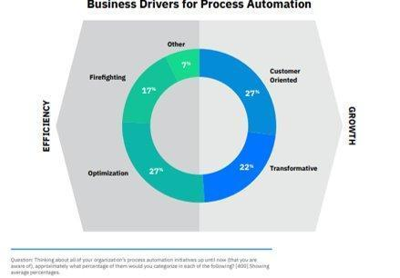
Figure 3: Business Drivers for Automation (camunda.com, 2020).

Due to COVID-19, there’s an increased urgency for process automation initiatives.

One area where manual data entry is particularly prevalent is in the processing of paper-based documents. For example, in the financial services industry, large amounts of invoices, receipts, and other financial documents are processed manually daily. This manual process involves reading the document, transcribing the information into a computer, and then verifying the accuracy of the data. The repetitive, manual nature of this process can lead to burnout, decreased employee productivity, and an increased risk of errors and data loss.
- Employees knew that the shift to automation was their employer's responsibility​.
- The overwhelming majority of 87% office workers expressed an opinion that they want their employers to use automation for manual repetitive tasks. More than half (55%) said they even consider leaving their job if these manual administrative tasks became too high, and 85% would consider working at a company that invests in automation for repetitive administrative tasks.
- In 2019, 550 billion of them circulated, 55 billion electronically, and the rest required manual processing at some level (Tripathi, 2022).
- The research is detailed. The volume of repetitive manual business processes negatively impacted the Worker productivity and morale, said Stephen DeWitt, Chief Strategy Officer at Automation Anywhere. It says that freeing workers to focus more on important tasks is fundamental to the digital workforce. Companies that embrace this immediately will gain a competitive edge in worker productivity and elevate their ability to attract and retain valued employees.
This study highlighted the need to digitize documents for OCR technology and to remove manual and repetitive tasks in the context of the challenges faced by businesses and government offices that rely on manual data entry. By automating this process, businesses and government offices can improve their efficiency, accuracy, and employee satisfaction.
It is where the automated data capture came into light.
As presented in Figures 4 and 5, 88% of IT initiatives have been started or accelerated during this period. While 84% plan to increase investment in process automation.
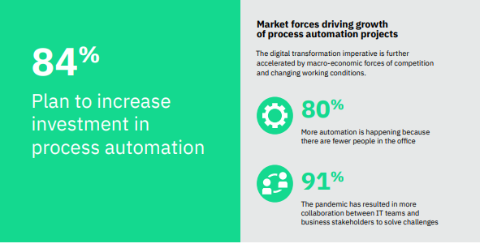
Figure 4: Market forces driving growth of process automation projects (camunda.com, 2020).
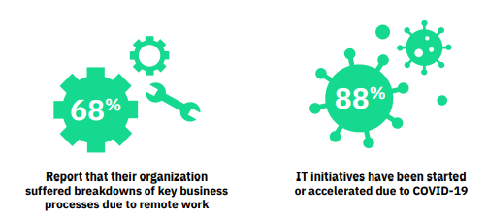
Figure 5: The State of Process Automation (camunda.com, 2020).
Compared to manual data entry, the system not only reduces wasted time but also improves speed and accuracy.

Optical Character Recognition (OCR)

Optical Character Recognition (OCR) is a technology that enables the automatic recognition and conversion of printed text into digital data (Optical character recognition, 2022).
The purpose of OCR is to automate the process of data entry and eliminate the errors and inconsistencies that can arise from manual data entry. By doing so, OCR provides the following benefits:
- Saves time in manual reading and converting printed data to machine-readable form.
- It also minimizes effort in reading and converting different qualities of documents.
- Decreases errors committed during manual reading and conversion
(OCR (optical character recognition), n.d.).

Importance of OCR

OCR (Optical Character Recognition) is the most common method for automated data capture because of its ability to extract data from a wide selection of documents, including those with printed and handwritten text. OCR technology has significantly advanced in recent years, making it a reliable method for automating data capture.
An article in Crown Records Management states that OCR is the most popular technology for automated data extraction (The Past and Future of Optical Character Recognition (OCR) Technology, 2021).

According to a Grand View Research report, the expectation over the next few years is that OCR will be the most widely used technology for automated data capture and reach 10B in market share in the Asia Pacific region alone. Thanks to its ability to extract data from a wide range of documents (Optical Character Recognition Market Size, Share & Trends Analysis Report By Type (Software, Services), By Vertical (BFSI, Retail, Transport And Logistics), By End-use (B2B, B2C), By Region, And Segment Forecasts, 2023 - 2030, 2021).
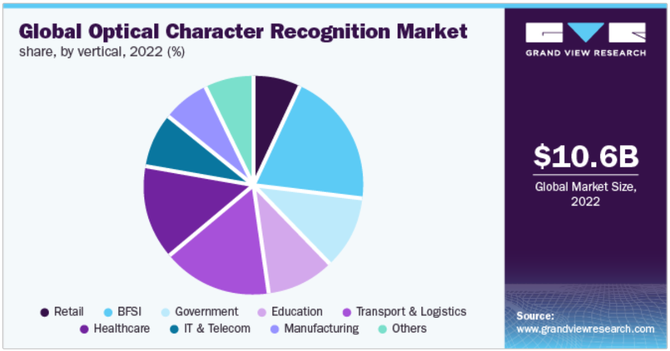
Figure 6: Global Optical Character Recognition Market
A study by MarketsandMarkets found that the OCR market may grow at a Compound Annual Growth Rate (CAGR) of 13.7% between 2018 and 2023, driven by increasing demand for automated data capture solutions. (MarketsAndMarkets, n.d.)

Overall, OCR is the most common method of automated data capture due to its versatility, accuracy, and widespread use across industries.
Optical Character Recognition (OCR) is a key technology used in document digitization and automation. OCR digitizes physical documents, such as PDFs, invoice and receipts, thereby enhancing data accuracy and improving workflow across industries. OCR converts scanned or image-based text into machine-readable digital data, significantly reducing the need for manual encoding. Haddad (2021) noted that OCR improves processing speed and accuracy while minimizing human error in document handling. It is a digital copy machine that utilizes automation to transform a scanned document into machine-readable PDFs that one can edit and share.
OCR technology is widely applied in processing machine-printed documents such as invoices, forms, and payroll records. However, its performance depends on factors such as image resolution, font clarity, and document structure. Despite these limitations, OCR remains one of the most effective tools for automating data extraction from paper-based documents.
The key aspects of OCR technology include examining images for text, printed text in various fonts, and even text within scanned photos.
The application of OCR aligns with the objectives of Transcriptionista, which focuses on extracting specific data fields from PDF and image documents and exporting them into structured formats.

Review of Related Studies

The following are the related studies that inspire the researcher to conduct this study:
- “A Comparative Study of Optical Character Recognition for Printed and Handwritten Tamil Text": This study compares the performance of several OCR systems in recognizing printed Tamil text. The authors found that the OCR system's performance improvement is achievable only through preprocessing techniques and fusion algorithms. (A., 2017)
- "Survey of Post-OCR Processing Approaches": This study surveyed post-OCR processing approaches proposed in the literature. The paper discussed the limitations of OCR systems, which often produce inaccurate results due to factors such as noise, low resolution, and font variability. The paper then presented a comprehensive overview of different techniques proposed to improve OCR accuracy, including:
- Preprocessing techniques such as noise reduction, binarization, skew correction, and layout analysis.
- Error-correction techniques such as dictionary-based, rule-based, and machine-learning-based approaches.
- Post-processing techniques such as language modeling and contextual analysis
- Post-processing techniques such as language modeling and contextual analysis (Thi Tuyet Hai Nguyen, 2021)
"A Detailed Analysis of Optical Character Recognition Technology": This study presented several post-processing techniques to improve OCR accuracy, including language modeling, error correction, and dictionary-based approaches. The authors found that these techniques can significantly improve OCR accuracy, particularly for noisy or degraded text (A Detailed Analysis of Optical Character Recognition Technology, 2016).
- In comparison with the above studies, the present study also focused on addressing the challenges posed by the manual task; however, this study will use automation and configurable algorithms. This configurable algorithmic technique will help the application digitize and extract data without requiring advanced, costly AI or machine learning technologies.

Despite the advancement of OCR technology, the study still identified several limitations as follows:
- The accuracy of OCR output still depends on image clarity, font consistency, and language complexity. Errors may arise from blurred scans, low resolution, or non-standard typography.
- The system does not support handwritten text or cursive fonts.
- Due to unresolved versioning constraints and the testing scope, the demonstration of real-time multi-user authentication and full online functionality did not proceed.
- The implementation of cloud features using Firestore is limited to a controlled local environment.
The study was evaluated by 50 purposively selected respondents to determine the level of acceptability of Transcriptionista using the ISO 25010.

Conceptual Model of Study

The Conceptual Model of the study, as illustrated in Fig. 2, uses an Input-Process-Output diagram to provide an overview of the overall flow and the concept needed to be achieved in this study
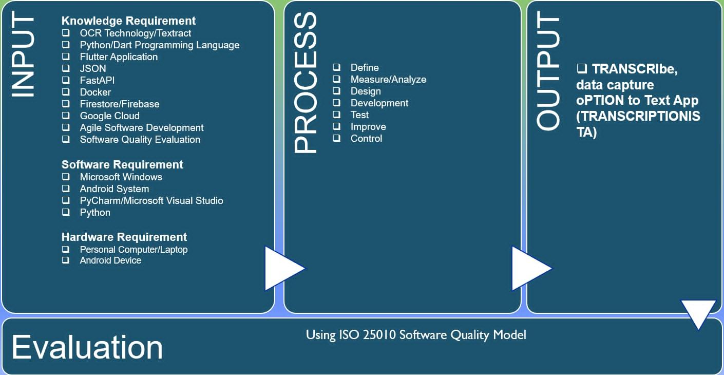
Figure 7: Conceptual Model Diagram

Input

This phase outlines the requirements, including Knowledge, Software, and Hardware, needed to develop the application.

Knowledge Requirements

- The knowledge requirements refer to the expertise and knowledge the researcher needs to conduct the study effectively. Some examples of knowledge requirements that may be necessary for this type of research include the following:

Manual Data Entry Processes

The researcher should have a good understanding of the manual data entry process, including its challenges and the possible types of errors that may commonly occur.

OCR Technology

OCR stands for Optical Character Recognition. It is a technology that converts scanned images or printed documents into editable digital text and stores it electronically. OCR software uses advanced algorithms to identify characters in scanned documents and convert them into machine-readable text.

OCR technology can extract data from a wide range of documents, including invoices, receipts, contracts, and other types of paperwork. It can help organizations automate processes that would otherwise require manual data entry, such as invoice processing, record-keeping, and data entry (What is OCR and OCR technology, 2023).

The researcher should be familiar with OCR technology, including its capabilities, limitations, and applications. This knowledge will help him to identify the potential of OCR technology as a solution to the challenges of manual data entry.

Textractor

This refers to the open-source Python library (amazon-textract-textractor) developed by AWS to simplify working with the Amazon Textract service. The researcher can utilize this library, which acts as a powerful bridge, making the data extraction easier than traditional OCR tools like Tesseract. This library also preserves the hierarchical structure of the document, including tables, multi-column layouts, and nested forms, without the need for manual coordinate mapping.

Dart Programming Language

Google developed Dart in 2011 as a general-purpose programming language designed to be efficient, fast, and easy to use, with a focus on creating high-performance applications across different platforms.
Key features of Dart include:
A modern, object-oriented syntax that is easy to read and write.
Support for asynchronous programming, which allows for efficient handling of input/output (I/O) operations and other tasks.
Built-in support for garbage collection, which helps to manage memory usage and improve performance.
A large standard library with many useful classes and functions for common programming tasks
Compatibility with other programming languages, including JavaScript and C++
Many companies and organizations use Dart for a variety of purposes, including mobile app development, web development, server-side programming, and more (Dart overview, n.d.).

Python

Python is a popular programming language supporting OCR engines and libraries such as Textract, OpenCV, and PyOCR. Python offers an easy-to-learn syntax, a large ecosystem of libraries, and a vast developer community, making it an ideal language for developing OCR-based applications.
Additionally, it offers a wide variety of tools and frameworks for developing and testing OCR-based applications, such as PyTextract and PyOCR. These tools can help researchers and developers improve the accuracy and performance of OCR-based applications.

Therefore, researchers and developers who are developing OCR-based applications may require knowledge and experience with the Python programming language (Python, n.d.).

FlutterFlow/Flutter Application

Flutter is a popular framework for developing both mobile and web applications that can integrate OCR functionality. Google developed Flutter. It is an open-source application development framework. It enables developers to create high-performing cross-platform applications for Android, iOS, and the web.
It provides tools and widgets for developing applications with OCR functionality, including text recognition, image processing, and natural language processing. Flutter also supports plugins and packages for integrating OCR engines and libraries into applications, such as Google's Tesseract OCR engine.
Therefore, understanding Flutter can benefit researchers and developers alike, including those developing OCR-based applications and those interested in developing mobile and web applications with advanced functionality (Build aps for any screen, n.d.).

JSON

JSON stands for JavaScript Object Notation. It is a lightweight data interchange format used to transmit data between server and client in web and mobile apps. It is a human-readable text format that is easy to parse and easy to generate, making it an ideal format for transmitting data between systems.

JSON is useful for representing the OCR engine's output in an OCR-based app. It typically includes the recognized text, its position and size, and any associated metadata, as well as for representing the input data, such as images or documents, that the OCR engine processes.
Therefore, understanding JSON can be beneficial for researchers and developers developing OCR-based applications, as well as for those working with web and mobile applications that use JSON for data transmission (Introducing JSON, n.d.); (Working with JSON, n.d.).

API

An Application Programming Interface (API) is commonly used to integrate OCR engines and libraries into web and mobile applications. An API is a set of protocols and rules which give enablement to different software applications to communicate with each other, allowing developers to access the functionality of OCR engines and their libraries from their own applications.

In OCR-based applications, developers use APIs to transmit data between the OCR engine and the application. It also controls the OCR engine's behavior and accesses its results. For example, an OCR API may accept an image or document as input and return the recognized text, or it may provide additional metadata about the recognized text.

Therefore, understanding APIs can be beneficial for researchers and developers expanding OCR-based applications, as well as for those working with web and mobile applications that use APIs to access external services and functionality (Introduction to web APIs, n.d.).

Docker

Docker is a containerization technology that packages applications with all their dependencies into portable units. This ensures that software runs consistently across different environments, a critical requirement for reproducible research. By isolating applications from underlying system variations, Docker reduces compatibility issues and accelerates deployment (Balasubramanian et al., 2022).

Google Cloud Run

Google Cloud Run is a fully managed serverless platform that executes containerized applications. It automatically scales resources based on demand, eliminating the need for manual infrastructure management. For researchers, this means computational workloads can be deployed quickly and scaled efficiently without specialized DevOps expertise (Google Cloud, n.d.-a).

Agile Software Development

Agile Methodologies are popular software development methodology that emphasizes flexibility, collaboration, and rapid iteration. It is a good fit for complex software development projects with fast-changing requirements, which can be the case for OCR-based applications.

Agile software development methodologies, such as Scrum and Kanban, emphasize continuous delivery and continuous improvement, which can be beneficial for OCR-based applications that require frequent updates. Agile methodologies also emphasize collaboration and communication among team members, which can be useful in OCR-based projects involving multiple stakeholders, including OCR engine developers, front-end developers, and end users.
Therefore, understanding agile software development can be beneficial for researchers and developers developing OCR-based applications, as well as for those who are working on software development projects that require flexibility and collaboration (What is Agile?, n.d.).

Software Quality Evaluation

It is important to ensure that OCR-based applications produce accurate and reliable results. Software quality evaluation involves a set of processes and techniques for measuring and assessing the quality of software products, including OCR-based applications.

Common techniques for software quality evaluation include functional testing, performance testing, and code review. Functional testing assesses the application's features and functionality. Performance testing evaluates an application's speed, scalability, and stability. Code review includes examining the application's code to identify defects and areas for improvement.

Therefore, understanding software quality evaluation can be beneficial for researchers and developers developing OCR-based applications, as well as for those who are working on software development projects that require high-quality software products (Software Engineering Body of Knowledge, n.d.).
  - Statistical and data analysis skills: The researcher should have strong skills in these areas. It will enable him to analyze the data collected during the study and to draw meaningful conclusions from the results.
  - Experience in research design and methodology: The researcher should have experience conducting research studies, designing data-collection instruments, selecting appropriate research methods, and analyzing data.
  - Knowledge of relevant literature: The researcher should have a good understanding of the existing literature on manual data entry, OCR technology, and previous studies on OCR and data entry.
  - Knowledge of domain-specific vocabulary: Depending on the domain the research is focused on, the researcher may need specialized vocabulary or terminology.
  - Overall, these knowledge requirements are essential inputs for developing a robust, effective conceptual model for a research study on using OCR technology to address challenges in manual data entry. By ensuring the researcher has the required knowledge and expertise, the study is more likely to produce valid and reliable results that can advance knowledge in this field.

Software Requirements

Software requirements are an important input requirement. Here are some examples of software requirements for this type of study:

OCR Software (Textract)

One example of OCR software is Textract, which is useful in this study. It is an open-source OCR engine developed in 2005. Google has sponsored this development since 2006 and has used it for OCR tasks in various applications. One advantage of using Textract is its availability and consideration that it is free and open-source software. It is accessible to anyone who wants to use it. Additionally, Textract is also known for its versatility, recognizing text in more than 100 languages, making it an OCR tool for studies involving multilingual data. Another advantage of Textract is its high accuracy in recognizing text, particularly printed text. While its performance with handwriting or other non-standard text can be less reliable, it still provides a good baseline for OCR tasks. Overall, Textract is a popular, widely used OCR tool that can be an effective, cost-efficient solution for an OCR study, addressing challenges in manual data entry. It can be useful for researchers who need to process large amounts of printed text data in multiple languages (G. Singh, 2019; D. Zhong, 2020; Tesseract (software), n.d.).

Microsoft Windows

Microsoft Windows is a widely used operating system that supports OCR software. Many OCR software tools and libraries are available for Windows, such as Tesseract OCR, Microsoft OCR, and Abbyy FineReader.

It also provides a flexible and robust environment for developing and deploying OCR-based applications. The .NET Framework, widely used for developing Windows applications, provides a rich set of libraries and tools for developing OCR applications, including support for image processing, text recognition, and machine learning.
Therefore, understanding Microsoft Windows and its associated software development tools can be beneficial for researchers and developers who are developing OCR-based applications for the Windows platform (tesseract-ocr/tesseract, n.d.); (What is OCR and OCR technology, n.d.)

PyCharm IDE

It is an integrated development environment (IDE) for Python development. PyCharm may be one of the software requirements for this study, as it can use Optical Character Recognition (OCR) to address challenges in manual data entry when the research involves developing OCR-based applications in Python.
PyCharm offers a variety of features such as code completion, debugging, and integration with version control systems. These features can help researchers and developers write, test, and debug code more efficiently, saving time and resources.

Moreover, PyCharm offers integration with various OCR engines and libraries, including Textract, OpenCV, and PyOCR. This integration can simplify the development process and improve the accuracy and performance of the OCR-based applications.

Therefore, researchers and developers developing OCR-based applications using Python may require knowledge and experience with the PyCharm IDE.

- Data management software: Microsoft Excel is a commonly used tool for storing, organizing, and managing data collected during the study. Other examples of data management software include SQL and MongoDB.
- Programming languages: Python is a commonly used programming language for data analysis. Researchers may use Python to develop custom software solutions or to automate data processing tasks.
- Version control systems such as Git help manage changes to software code, while platforms like Google Drive or Dropbox help share project documents with other team members. Overall, these software requirements help ensure that the study is efficient, effective, and produces reliable results. Proper selection of software tools and technologies based on the specific needs of the study helps to solidify understanding of how to use the software effectively.

Hardware Requirements

Personal Computer or laptop

Processor
OCR software requires a powerful processor to process and analyze large amounts of data. A high-end processor with multiple cores, such as an Intel Core i7 or i9, may be required.

Memory (RAM)
OCR software can require significant amounts of memory to process large data files. The recommended RAM is at least 8 GB, but more may be needed depending on the size of the files for processing.

Display
To accurately view and edit data, OCR software requires a high-quality resolution display.

Storage
OCR software requires adequate storage space to store processed data. Depending on the volume of data, an organization may require multiple terabytes of storage capacity.

Scanner or Camera
For physical documents, a high-quality scanner is required to capture clear, high-resolution images. A recommended scanner for OCR should have a minimum of 600 DPI.

Networking
- OCR software may require high-speed network connectivity to enable quick data transfer.

Process

This phase provides a structured, systematic approach to evaluating the effectiveness of OCR technology in automating data entry processes. By following this process, researchers can identify the specific challenges faced in manual data entry, review the relevant literature to gain a deeper understanding of OCR technology, develop research questions or hypotheses, select appropriate research designs and sampling strategies, collect and analyze data using appropriate methods, and draw conclusions and make recommendations based on the findings.
The process also helps ensure that the study researcher conducted a rigorous and transparent study, minimizing the potential for bias or error. By following a structured process, researchers can also ensure their findings are replicable and can inform future research and the implementation of OCR technology in data entry processes.

Define and identify

In the process phase of this research, the initial step is to define and identify the challenges the researcher wants to address. It includes identifying the specific challenges of manual data entry and understanding the potential benefits and limitations of using OCR to address them.

Measure and analyze data

In the process phase of the study, data measurement and analysis are essential for evaluating the OCR system's performance and identifying areas for improvement. It involves collecting and analyzing data related to the accuracy, efficiency, and effectiveness of the OCR system.
Recent studies have shown the various methods for measuring and analyzing data related to OCR systems, such as using confusion matrices, precision and recall metrics, and statistical analysis techniques. A study by Kaur et al. (2021) used precision, recall, and F1 score metrics to evaluate the performance of an OCR system for digitizing Punjabi text. In a study by Bae and Lee (2021), they use confusion matrices to evaluate the accuracy of an OCR system for recognizing Korean characters. A study by Zhang and Purkayastha (2020) demonstrated, through statistical analysis, the effectiveness of an OCR-based data entry system for improving productivity in a manufacturing environment.
These approaches can provide insights into the strengths and weaknesses of the system, helping identify areas for improvement.

Design

The design phase is a critical part of the research process in developing an OCR-based solution to solve challenges in manual data entry. It involves identifying and defining the specific requirements and features that the solution should effectively address the identified challenges.
During this phase, the researcher determined the specific types of input documents that the OCR system would need to process, as well as the expected output formats and quality control measures. The researcher also identified the specific hardware and software requirements for the Transcriptionista system, including any necessary hardware upgrades or modifications.

Other important aspects of the design phase include determining the algorithms to train the Transcriptionista system and identifying the performance metrics and benchmarks to evaluate its effectiveness.
In conclusion, an OCR-based solution such as Transcriptionista can significantly improve the efficiency and accuracy of manual data entry, particularly for input documents like invoices and pay slips. By automating data entry, businesses can reduce the likelihood of errors, minimize manual labor costs, and improve overall productivity.

However, to successfully develop and implement an OCR-based solution, it is important to consider hardware, software, and knowledge requirements carefully, and to properly design and train the OCR system to meet the specific needs and challenges of the target users.

Based on the research conducted, some key recommendations for developing an effective OCR-based solution for data entry include:

- Carefully assess the specific input documents and data fields that need to be processed, as well as the expected output formats and quality control measures.
- Choose a high-quality OCR software, such as TextTract, and ensure it integrates properly with any necessary hardware components.
- Develop a robust training dataset for the OCR system, using a combination of algorithms and manual data entry validation.
- Continuously monitor and evaluate the OCR system's performance, adjusting as needed to maintain effectiveness.
By following these recommendations, businesses and organizations can successfully develop and implement an OCR-based solution. This way, they will improve their data entry processes and realize significant gains in accuracy, efficiency, and cost savings.

Development

This phase includes the following steps: The implementation of the proposed system was considered in this phase. The researcher developed the system using Python and the Textract OCR engine. The system should include modules for preprocessing, OCR, and data entry.
The development phase is a critical stage in the research process as it involves the actual implementation of the proposed solution. It is important to ensure the system is well-designed, tested, and optimized to deliver accurate, efficient results.

Test and Debug

Testing and debugging: After the implementation phase, the researcher must conduct system testing to verify that the system meets the required objectives. Testing on sample datasets to evaluate the accuracy and efficiency of the system, meeting the specified requirements and functions as intended. The test phase involves unit testing, integration testing, system testing, and acceptance testing.

Agile testing methodology can be employed during this phase because it supports iterative and incremental development, enabling continuous testing and feedback. Agile testing focuses on early and frequent testing.

Integration and optimization: Once the system has been tested and validated, it can be integrated into the existing workflow to automate data entry. The next step is to apply the optimization techniques to improve the system's accuracy and efficiency.

Documentation: Proper documentation is essential to help users understand how to use the system and how it works.

Improve

This phase aims to enhance the performance, accuracy, and efficiency of the Transcriptionista System by analyzing test results and identifying areas for improvement in the OCR system. Addressing the identified areas of improvement also requires modifications to the OCR system, fine-tuning of recognition algorithms, or changes to the hardware and software used. The goal of the Improve phase is to optimize the OCR system's performance, ensuring high accuracy and efficiency in automated data entries.

One way to improve the OCR system is to use machine learning algorithms. It enhances recognition accuracy. A study conducted by Kuznetsova et al. (2020) used applied machine learning in improving OCR recognition of handwritten documents. Another approach is to incorporate pre-processing techniques, such as image enhancement or noise reduction, to improve the quality of input images and thus enhance OCR accuracy. A study by Kumar and Ramachandran (2020) used pre-processing techniques to improve OCR accuracy in recognizing text from natural scene images.

Another consideration in the Improved phase is evaluating the overall effectiveness and efficiency of the OCR system in addressing the challenges of manual data entry. It involves comparing the OCR system's performance with the manual data entry process in terms of accuracy, speed, and cost-effectiveness. This evaluation can help identify additional areas for improvement and assess the overall feasibility of using OCR to address the challenges of manual data entry.

In the Improve phase, the following activities were implemented:

- Analyzing test results to identify areas of the system that need improvement
- Gathering feedback from end-users and stakeholders to identify their pain points and areas for improvement
- Implementing improvements to the Transcriptionista system
- Testing the updated system to ensure that the improvements have been effective
- The Improve phase is an iterative process in which changes are made based on feedback and testing results, and the system will require further testing to ensure the improvements have been effective.

Control

This phase involves monitoring and maintaining the system's performance to ensure that it meets the desired objectives and requirements. It includes continuous improvement and system adjustments to ensure sustainability and effectiveness.

During this phase, the system determines its performance and effectiveness in solving manual data entry challenges. The researcher compared the evaluation results with the project objectives to identify any discrepancies and take corrective actions. The control phase also involves establishing a feedback mechanism to collect input from end users and stakeholders. It helps in identifying areas that require improvement.

To ensure the system remains effective and efficient, the researcher needs to implement regular maintenance and upgrades. It improves performance and reliability. This phase also involves establishing policies and procedures for the system's use, including data security and privacy policies.

Output

This block displays the developed app, Transcriptionista, in line with the inputs and processes as described earlier. It also includes recommendations for future research, best practices for using OCR for data entry, and the potential applications of technology in various industries.

The output phase is crucial in communicating the value of the research to stakeholders and the broader community. It provides a basis for decision-making and action, enabling organizations to implement Transcriptionista technology for effective and efficient data entry.

Overall, the output phase of this research aims to provide insights and recommendations to improve data entry processes, increase efficiency, and reduce inaccuracy.

Evaluation

The Evaluation phase, using the ISO 25010 Software Quality Model, determines the system's quality attributes, which include functionality, reliability, usability, performance, security, and lastly, maintainability. It is widely used for international standard recognition in terms of evaluating the app’s software quality requirements.

To evaluate the OCR system developed in this research using ISO 25010, the following steps were conducted:
- Identified the quality attributes relevant to the OCR system, based on the stakeholders' needs and requirements.
- Defined evaluation criteria for each quality attribute in accordance with ISO 25010.
- Evaluated the OCR system against the defined criteria using appropriate evaluation methods, such as testing, inspection, or user feedback.
- Analyzed the evaluation results and identify areas for improvement.
- Took necessary actions to address the identified issues and improve the OCR system's quality.

Project Design

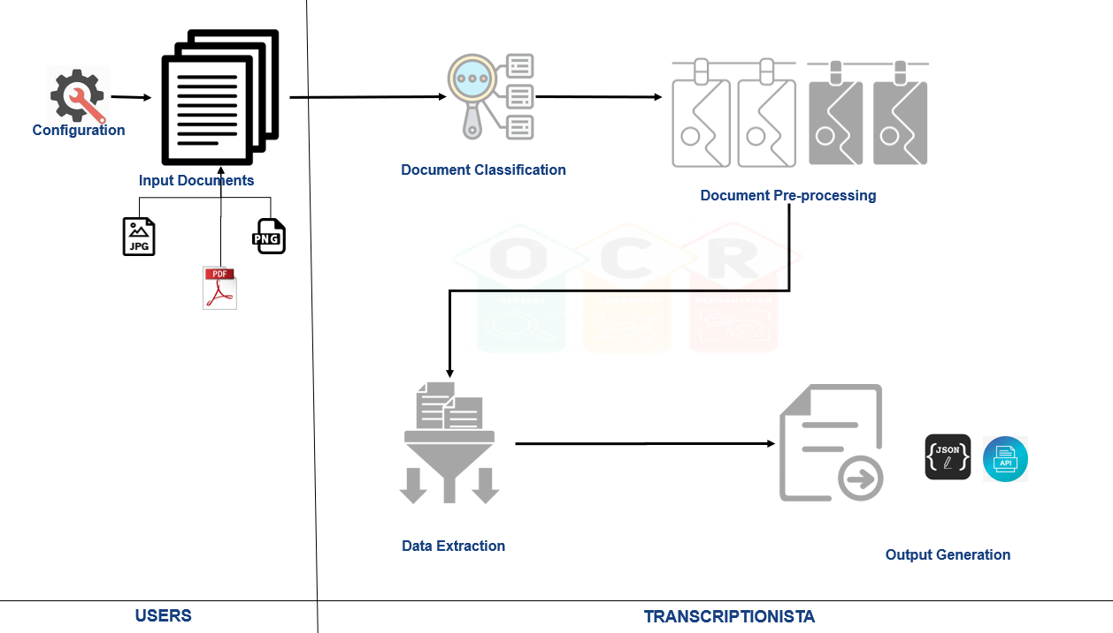
Figure 8: Project Design
The design of the Transcriptionista Application incorporates the following core components to ensure superior functionality and usability:

Configuration

This step in the Transcriptionista Application refers to the process of setting up and customizing the OCR engine to meet the specific requirements of a particular document to be digitized.
By customizing these configuration options, Transcriptionista can be tailored to the specific needs of the user and the application, thereby improving its accuracy and performance.
It includes configuring various parameters, such as the following:

Document Identifier

This parameter determines the type of document the user is using as input to the application. These are the document types that are currently in the scope of the application:
- Invoices
- Payslips
This configuration adds a unique text field in the input document to identify the type of document the application will digitize or transcribe.

Party/Supplier Identifier

For Invoice documents, this refers to the identifier the application uses to determine who issued the invoice. This identifier points to the field on the invoice that contains information about the party or supplier.
For Pay Slips documents, this pertains to the identifier the application uses to determine the field containing the Employee’s Name.

Fields Identifier

These are the identifiers found on the input document that point to the field the Transcriptionist needs to extract for the user.

Fields value format

These are the different field-value formats used by the Transcriptionista app to enhance document extraction.

Refers to the process of scanning or importing the original paper or electronic document into the OCR system. This step is critical, as it sets the stage for subsequent image processing and character recognition.
The OCR system typically accepts a wide range of input formats, including scanned images, PDFs, and other electronic document formats. Once imported, the OCR system performs image processing tasks, such as deskewing, noise removal, and contrast adjustment, to enhance the document image quality. In the Transcriptionista Application, the following document formats will then be a consideration as inputs:
- Document files, such as PDF
- Image files such as JPEG, PNG, BMP

Document Classification

This step in OCR software refers to the process of classifying a document into a predefined category or type based on its content, layout, and structure. This step groups similar documents for further processing or analysis.
Document classification in OCR software typically involves the use of Machine Learning algorithms, such as decision trees, support vector machines, and neural networks. These algorithms are trained on a set of labeled documents to learn the patterns and features that distinguish different document types. Once trained, the classifier automatically categorizes new documents accordingly (Zhi, 2021); (Wang, 2019).
In Transcriptionista, completion is by identifying the elements in the input document that match the values in the Document Identifiers table in the Transcriptionista Rule Engine.

Document Pre-processing

It refers to the set of techniques used to improve the quality of scanned documents before OCR. It includes tasks such as noise removal, contrast enhancement, binarization, skew correction, and despeckling. The goal of document pre-processing is to make the document image more suitable for OCR by removing or reducing any imperfections that may interfere with text recognition (Gomez-Krämer, 2017).

Data Extraction

It refers to the process of extracting relevant data from the digitized text generated by the OCR, by identifying the fields in the input documents that match the field identifiers in the Transcriptionista Rule Engine. Once the identification is determined, Transcriptionista will apply various techniques, such as pattern matching & regular expressions, using the formats included in the Rule Engine. In pattern matching, the Transcriptionista system compares the extracted text with a predefined pattern or format to identify relevant data elements.

Output Generation

It refers to the process of creating a machine-readable, digital output file from a processed document image. In Transcriptionista, the output can be in API or JSON format, making it easily usable and manipulable by other software applications.

Operational Definition of Terms

This section provides clear and specific meanings of key terms as they are used within the context of the study. By defining these concepts operationally, the researcher ensures consistency, avoids ambiguity, and establishes a common understanding for readers. Each term is explained according to how it is applied in the research, rather than relying solely on its general or dictionary definition.

Rule Engine

This mechanism refers to the process by which a user’s understanding of a document and its relevant fields is transformed into a set of instructions that Transcriptionista can execute. In simpler terms, it acts as a bridge between human knowledge and computer logic.
• User Knowledge: The user knows which document is important and which specific fields (e.g., name, date, reference number) need to be extracted.
• Conversion to Logic: That knowledge is then translated into application rules or logic, so the Transcriptionista understands what to look for and how to process it.
• System Utilization: Transcriptionista uses these rules to automatically identify the document, locate the required fields, and extract their values accurately.
• Purpose: This ensures consistency, efficiency, and reduces human error in handling large volumes of documents.
In short, the mechanism enables the application to “think” in terms of the user’s instructions, making the identification and extraction of document fields systematic and repeatable.

Chapter 3

METHODOLOGY

This chapter details the implementation of the Transcriptionista system using the Textract OCR engine and Python. The objective of this chapter is to provide a detailed description of the development process, including both software and hardware requirements, system architecture, and design considerations. Additionally, the chapter illustrates the testing methodology used to evaluate the accuracy and effectiveness of the OCR-based solution.

This chapter presents the design considerations that guided the development phase. These include preprocessing techniques to improve the quality of input data, feature extraction and recognition methods, and error-correction and verification techniques.

Finally, the chapter outlines the testing methodology used to evaluate the OCR-based solution's performance. The testing process includes selecting sample documents, creating a test suite, and assessing the system's accuracy, efficiency, and usability.

Overall, Chapter 3 provides a comprehensive description of the development and testing of the OCR-based solution for manual data entry. It serves as a valuable resource for researchers and practitioners interested in implementing similar systems for their respective applications.

Project Design

The project design phase also includes creating a detailed project plan outlining the activities, milestones, and deliverables for the development and implementation of the OCR system. This plan should take into consideration the potential risks and mitigation strategies.

Furthermore, this chapter outlines key considerations for deploying and implementing the Transcriptionista system. It includes both hardware and software requirements, data processing workflows, and quality control measures. The project design phase is critical to ensure the successful development and implementation of the OCR-based application, serving as a blueprint for the entire project.
Below is the swimlane diagram that shows the expected process flow and functionalities in the Transcriptionista system.

Figure 9: Transcriptionista Process Flow

Configuration. The way to educate the OCR

OCR (Optical Character Recognition) technology has become an essential tool in digitizing printed text and making it available for digital processing. However, OCR systems require configuration and training to accurately recognize and translate printed text into digital data. Here are some reasons why OCR systems need to be configured and educated:

Different fonts and languages: The User must configure the OCR systems to recognize different fonts and languages. Each language and font has unique features for consideration during the OCR process. For example, the User must train OCR to recognize cursive writing or different typefaces, such as bold or italic.

Image quality: The quality of the scanned image can significantly impact the OCR process. For example, blurry or low-resolution images can be challenging for OCR systems to interpret accurately. OCR system configuration is important for handling different image types, such as color, grayscale, and black-and-white.

Document layout: It can also affect OCR accuracy. OCR systems configuration is set-up to recognize different document layouts, such as tables, columns, and lists.

Customization: In some cases, OCR systems need customization to meet a particular requirement for the end user or organization. For example, a financial institution may need to configure an OCR system to recognize particular account numbers or forms (visionify, 2022).
This step in the Transcriptionista Application refers to the process of setting up and customizing the OCR engine to meet the specific requirements of a particular document to be digitized.
By customizing these configuration options, Transcriptionista can be tailored to the specific needs of the user and the application, thereby improving its accuracy and performance.
It includes configuring various parameters, such as the following:

Document Identifier
It is the parameter the application uses to determine the type of document the user is providing. These are the document types that are currently in the scope of the application:
- Invoices
- Payslips
This configuration uses a unique text field in the input document as an identifier, enabling the application to determine whether the type of document is digitized or transcribed.

Party/Supplier Identifier
For Invoice documents, this pertains to the identifier that the user will use so the application can determine who issued the invoice. This identifier points to the field on the invoice that contains information about the party or supplier.
In the case of Pay slips documents, this pertains to the identifier the user will use so the application can determine the field containing the employee’s name.

Fields Identifier
These are the identifiers found in the input documents that point to the field the Transriptionista needs to extract for the user.

Fields value format
These are the different field-value formats the Transcriptionista can use to refine the extracted data further.

Input Documents

Refers to the process of scanning or importing the original paper or electronic document into the OCR system. This step is critical, as it sets the stage for subsequent image processing and character recognition.

OCR systems typically accept a wide range of input formats, including scanned images, PDFs, and other electronic document formats. Once the user successfully imports the document, the OCR system performs image processing tasks, such as deskewing, noise removal, and contrast adjustment, to enhance the document's quality.

I. The inputs to the system

This study focuses on documents circulating worldwide that pose challenges when processed manually. Examples are the following:

I.1 Invoices

Invoices and receipts are the most common document types processed by accounts payable departments. According to a Level Research survey, invoices and receipts account for 83% of the documents processed by accounts payable departments. [1]
Errors in invoice processing can be costly. According to a study by Paystream Advisors, manual invoice processing can cost up to $12.90 per invoice, while automated invoice processing can cost as little as $2.36 per invoice. [2] Additionally, errors in invoice processing can lead to payment delays, missed discounts, and even fraud.
According to the Billentis Report, Vendors sent 55 billion paperless invoices worldwide (Managing IT Vendor Invoices on ServiceNow, n.d.).

I.2 Payslips

As technology advances, so are working habits. According to the Office for National Statistics research, most people access different information on their mobile devices. Also, 11% of employers are now seeking payroll providers that offer portal or smartphone access to payroll information (Gammon, 2019).
Pay slips contain sensitive information that requires accurate processing. Pay slips often contain confidential employee information, such as salary, tax deductions, and benefits. Errors in processing pay slips can result in incorrect payments to employees, leading to compliance issues and legal liabilities for the organization.
Automated data entry using OCR can significantly reduce processing time. According to a case study by ABBYY, a provider of OCR technology, automated invoice processing using OCR reduced processing time by up to 70%. [3] It can allow organizations to process invoices and pay slips more efficiently, freeing up time for other tasks.
The mentioned documents are commonly in PDF format.
According to a Digital Trends article, PDF is the most popular document format because it maintains formatting and security across devices and platforms (Lacoma, 2021). A study by Adobe found that PDF is the most used document file format for both personal and professional use (PDF advantages as the best business document format., n.d.).
An article by PDF Expert explains that PDF is the preferred file format for many businesses because it maintains document formatting and reduces file size (Why it’s Better to Use PDF files instead of Word, Excel or Powerpoint documents, 2018).
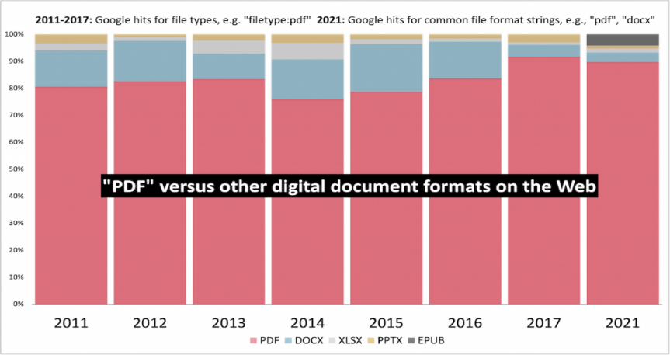
The figure that follows shows the proportion of PDF files as compared to other document formats Google finds online.
Figure 10: PDF’s popularity (Johnson, 2021)

PDF is one of the most widely used document formats worldwide, with an estimated 2.5 trillion PDFs created each year (Source: Adobe).

Document Classification

This step in OCR software refers to the process of automatically categorizing a document into a predefined category or type based on its content, layout, and structure. This step groups similar documents for further processing or analysis.

Document classification in OCR software typically involves machine learning algorithms. Examples of this are decision trees, support vector machines, and neural networks. These algorithms are trained on a set of labeled documents to learn the patterns and features that distinguish different document types. Once trained, the classifier can automatically categorize new documents into their appropriate categories (Zhi, Unsupervised document classification for OCR using clustering and topic modeling. Pattern Recognition Letters, 2021); (Wang, 2019).
In Transcriptionista, it is the process of identifying the elements in the input document that match the values in the Document Identifiers table of the Transcriptionista Rule Engine.

Document Pre-processing

It refers to the set of techniques used to improve the quality of scanned documents before OCR. It includes tasks such as noise removal, contrast enhancement, binarization, skew correction, and despeckling. The goal of document pre-processing is to make the document image more suitable for OCR by removing or reducing any imperfections that may interfere with text recognition (Gomez-Krämer, 2017).

Data Extraction

It refers to the process of extracting relevant data from digitized text generated by OCR. In Transcriptionista, it identifies fields in the input documents that match the field identifiers in the Transcriptionista Rule Engine. Once it identifies the fields for instruction, Transcriptionista will apply various techniques, such as pattern matching & regular expressions, using the formats included in the Rule Engine. In pattern matching, the Transcriptionista system compares the extracted text with a predefined pattern or format to identify relevant data elements.

Output Generation

It refers to the process of creating a machine-readable, digital output file from a processed document image. In Transcriptionista, the output can be in API or JSON format, making it easily usable and manipulable by other software applications.

System Design

The system design phase is a critical stage in software development. It is where the detailed design reflects requirements collected in earlier phases and rigorously aligns with them. The system design phase involves creating detailed technical specifications, defining the system architecture, selecting appropriate hardware and software platforms, and determining the data storage and retrieval mechanisms. This phase also involves identifying and resolving any potential problems or risks that may arise during the development process.

Project Development

The development of this Transcriptionista system follows the Agile Development Cycle, a methodology chosen for its ability to handle evolving requirements and provide a structured yet flexible framework for technical transitions. Since manual data entry workflows often involve nuanced human interactions, an iterative approach allows the development team to refine digital tools based on real-world feedback rather than relying on a rigid, one-time plan.
By adopting this framework, the project prioritizes incremental progress, allowing for the rapid deployment of core functionalities while ensuring the system remains scalable. This approach minimizes risk by identifying integration challenges early -- particularly during the transition from physical records to digital databases-- and ensures that the final product is both technically robust and user-centric.
Figure 11: Agile Development Life Cycle

The following are the stages of the Agile Development Life Cycle:
- Planning – Defining the project vision and breaking tasks into actionable Sprints.
- Requirements Analysis – Identifying essential features to replace manual bottlenecks.
- Design – Developing responsive UI/UX and scalable system architecture.
- Implementation – Incremental coding for mobile and web applications using FlutterFlow.
- Testing – Conducting continuous QA across multiple devices and browsers.
- Deployment – Containerizing the backend via Docker and hosting on Google Cloud Run.
- Maintenance & Continuous Loop – Utilizing feedback-driven improvements to fix bugs and update features.

Operation Procedure
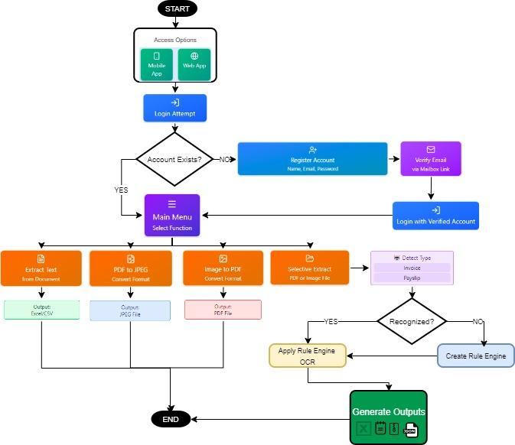
Figure 12: Transcriptionista Operation Flow

Transcriptionista User
- Open the app
  - Users launch browsers on either a computer or a mobile device.
- Attempt to log in
  - The user enters account credentials to sign in.
- Does the account exist?
  - Yes: proceed to step 6.
  - No: go to step 4.
- Register new account
  - The user completes the registration form to create an account.
- Email verification
  - The user receives a verification email and verify his or her address; after verification, return to login.
- Log in with a verified account
  - The user signs in successfully using a verified account.
- Access main menu
  - The user is presented with the main menu and selects a function.
- Choose a function
  - Options include:
  - Extract text from document → produces Doc/CSV output.
  - Convert PDF to JPEG → produces JPG output.
  - Convert image to PDF → produces PDF output.
  - Selective extract from PDF or image → proceed to step 9.
- Selective extraction: detect document type
  - The system analyzes the uploaded PDF or image to determine the document type (for example, invoice or pay slip).
- Document type is recognized?
  - Yes: apply the existing rule engine and OCR pipeline (step 11).
  - No: create or configure a new rule engine for that document type (step 12).
- Apply rule engine and OCR
  - Use OCR to extract text fields according to the rule engine’s mappings and rules.
  - Generate structured outputs based on extracted fields (e.g., JSON, CSV, or document templates).
- Create a rule engine for the unrecognized type
  - Define extraction rules and field mappings for the new document type.
  - Save the rule engine and then run OCR and extraction as in step 11.
- Generate the outputs
  - Return the requested output file(s) to the user (CSV or structured extraction results), JPG, txt, and zip.
- End session or repeat
- Users may perform additional operations from the main menu or log out.

Testing Procedure

Table1:

Functional Testing Procedure

Test Case | Test Types | Steps to be Undertaken | Criteria
Access & Authentication | Entry/Login | 1. The user opened the Web App.  2. The user entered email + password.  3. If the account exists → the Transcriptionista Main Menu is displayed.  4. If not → the user registers, verifies via email, and logs in again. | Functional Suitability – Completeness & Correctness
Document Upload | File Handling | 1. The user uploaded a document (PDF or image).  2. The document was passed to the File Preview Screen for processing. | Reliability – Fault Tolerance & Accuracy
Extract Text from Document | Processing | 1. The system processed the uploaded file.  2. Text was extracted.  3. Output was in Excel/CSV. | Functional Suitability – Accuracy

Convert PDF to JPEG | Conversion | 1. The user selected the conversion option.  2. The system converted PDF to JPEG.  3. Output was in Image File. | Compatibility – Interoperability
Convert Image to PDF | Conversion | 1. The user selected the conversion option.  2. The system converted the Image to PDF.  3. Output was a PDF File. | Compatibility – Co-existence
Selective Extract Doc | Rule Engine | 1. The document was passed to the Rule Engine.  2. The system detected the Invoice type.  3. Headers, values, payment terms, and amounts due were extracted.  4. Output was in CSV/Excel. | Functional Suitability – Accuracy
Selective Extract (Pay slip) | Rule Engine | 1. The document was passed on to Rule Engine.  2. The system detected the Pay slip type.  3. Employee details, salary, deductions, and net pay were extracted.  4. Output was in CSV/Excel. | Co-existence
Selective Extract (Other/Unknown) | Rule Engine | 1. The document was flagged as unclassified.  2. Rule configuration or partial extraction was required.  3. Output was in CSV/Excel. | Co-existence
Export Outputs | Output Handling | 1. The user selected the export format.  2. The system generated the file.  3. Output was in Excel/CSV, PDF, JPEG, or ZIP. | Co-existence

Table 2:

Compatibility Testing Procedure
Test Case | Test Types | Steps to be Undertaken | Criteria
Access the application via mobile devices (Android, iOS) | Device Access | 1. The user opened the browser on the mobile device.  2. The Transcriptionista URL was entered into the address bar.  3. Transcriptionista features (upload, extract, convert) were verified for responsiveness. | Portability – Adaptability & Installability
Access the application via desktop browsers (Firefox, Chrome, Edge, Safari) | Browser Access | 1. A web browser was opened from a PC or Mac OS machine.  2. The URL link was entered into the address bar.  3. Enter was pressed to load the application.  4. The Login using the user's credentials was verified. | Compatibility – Interoperability & Co-existence
Performance under repeated loads | Stress/Performance | 1. The system was loaded repeatedly with multiple files.  2. Response times were measured.  3. Resource utilization was monitored.  4. Outputs were checked for consistency. | Performance Efficiency – Time Behavior & Resource Utilization
Cross-platform consistency | Cross-Environment | 1. The same transcription tasks were executed on mobile and desktop.  2. Outputs were compared for consistency.  3. Any discrepancies were logged. | Reliability – Maturity & Accuracy

Table 3:

Usability Testing Procedure
Test Case | Steps Undertaken | Expected Output | Criteria
Navigation of Main Menu | 1. The user logged in.  2. The main menu was explored.  3. Key functions (upload, extract, convert) were located easily. | The main menu was loaded correctly, and functions were recognizable. | Appropriateness Recognizability
Upload Process Clarity | 1. The user attempted to upload a document.  2. Prompts and instructions were followed.  3. Errors were checked for clarity. | The upload process was clear, with error messages guiding the user. | Learnability & User Error Protection
Output Editing | 1. The user opened the output editor.  2. The user edited the text manually.  3. The system saved changes automatically.  4. Undo/redo functions were tested.  5. The user exported the edited text through CSV and text file download. | The output editor allowed smooth editing, saved changes correctly, and allowed the user to export the edited data. | Operability
Export Options | 1. The user had export format (CSV, TXT, JPG/PNG, ZIP).  2. The system generated the file.  3. The file was downloaded.  4. Accessibility of options was verified. | Export options were accessible, and files were generated correctly. | Accessibility
Interface Design | 1. The user evaluated layout, readability, and design consistency.  2. Icons and labels were checked for clarity.  3. Feedback was collected on satisfaction. | The interface was visually pleasing, consistent, and easy to understand. | User Interface Aesthetics & Satisfaction
Error Handling | 1. The user intentionally logged in using invalid credentials.  2. The system displayed an error message.  3. Recovery instructions were verified. | Errors were handled gracefully with clear recovery instructions. | User Error Protection

Evaluation Procedure

This section describes how the Transcriptionista was evaluated to measure quality, usability, and fit for purpose. A purposive sample of 50 respondents, composed of students, professionals, educators, and office staff, participated. Each respondent observed a short demonstration of the system’s core features—Access, Upload, Extraction, Conversion, Rule Engine, and Export—before completing the evaluation instrument.
- Evaluation framework: Ratings follow the ISO 25010 quality model and focus on five criteria: Functionality, Usability, Reliability, Compatibility, and Portability.
- Instrument: A structured questionnaire delivered via Google Form using a 4‑point Likert scale to avoid neutral responses and encourage decisive feedback.
- Procedure: Demonstration → respondent task or walkthrough → questionnaire completion. Responses were collected electronically and exported for analysis.
- Data processing: Collected responses were compiled in a spreadsheet where weighted means were computed for each criterion to quantify performance.
- Interpretation: Weighted means were mapped to adjectival ratings using the predefined ranges in Table 3.4, enabling clear, comparable judgments across criteria.
This concise, repeatable procedure ensures that evaluation results are grounded in a recognized quality model, reflect the perspectives of representative users, and produce actionable metrics for improving the system.
Table 4 :
Range of Weighted Mean Values and their Interpretation
Scale | Range | Interpretation
4 | 3.26 – 4.00 | Highly Acceptable
3 | 2.51 – 3.25 | Very Acceptable
2 | 1.76 – 2.50 | Acceptable
1 | 1.00 – 1.75 | Not Acceptable

Chapter 4

RESULTS AND DISCUSSION
This chapter presents the data gathered, the analysis, and the interpretation of results. It includes the project description, project structure, capabilities and limitations, test and evaluation results.

Project Description
Transcriptionista was developed as a web-based and mobile-responsive application (as shown in Figure 4.1) to provide an efficient solution for transcription and selective data capture. Transcriptionista was designed to convert various document formats into editable text. It supports streamlined data management and analysis daily. It helps a wide range of users, including professionals, students, and business personnel alike. The application was created to offer users an accurate, reliable, and simplified approach to data manipulation and reporting. It helps them avoid the need for extensive manual effort in their transcription tasks by automating the text extraction process for PDF and image-based files.
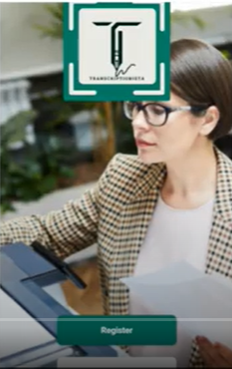
Figure 13: Home Screen
Project Structure
The Transcriptionista application was designed and developed with six primary components to streamline transcription and data capture: Document Upload, Input File Preview, Text Extraction and Converters Option, the Selective Extract option, Edit Before Export Options, and Generated Output Options. Each one contributes to the overall functionality, allowing users to manage various document types with ease.
a. Document Upload
The Document Upload module (as shown in Figure 4.2) allows users to upload files in supported formats such as PDF and image files. This feature lets users import documents into Transcriptionista and generate a transcription with as few clicks.

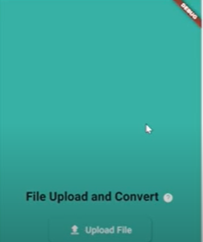
Figure 14: Document Upload Section
b. Input File Preview
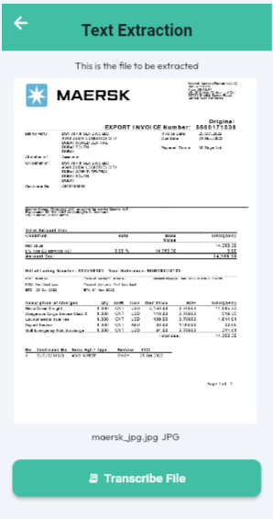
The Input File Preview section (shown in Figure 4.3) provides a preview of the input file to be processed. The users can change the input file if they wish to process other input files before clicking the Transcribe File button.
Figure 15: Input File Preview Section

c. Text Extraction and Converters Option
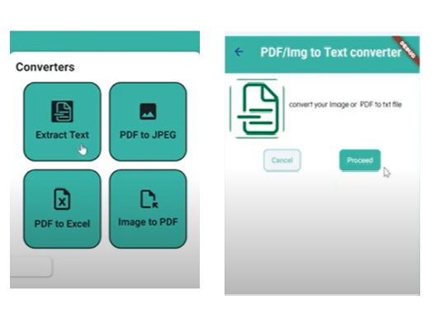
The Text Extraction tab (shown in Figure 4.4) is the core functionality of Transcriptionista. This module extracts text from uploaded documents, converting content into editable, manageable text formats. It has proven to support various document types while maintaining high accuracy in its results. It handles standard fonts and layouts, which deliver reliable transcription results.
Figure 16: Converters Section
d. Selective Extract Option
The Selective Extract Option gives users the ability to extract common or specific fields from a document. This option utilizes the Rule Engine, where users can configure what are the needed fields need to be extracted when Transcriptionista encounters a specific document.
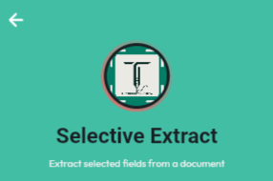
Figure 17: Selective Extract Section
e. Edit-Before-Export Option
The Edit-Before-Export Option gives users the option to edit the Extracted Text and Fields from the Input file before exporting them to a CSV or a text file.
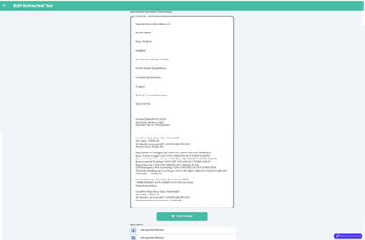
Figure 18: Edit-Before-Export Section

e. Export Options
The Export Options tab (shown in Figures 4.7 and 4.8) enables users to save and export the extracted text in various formats such as CSV, TXT, JSON, and PDF. It allows users to save their transcribed data in the format that best suits their needs, whether for reporting, editing, or data storage.
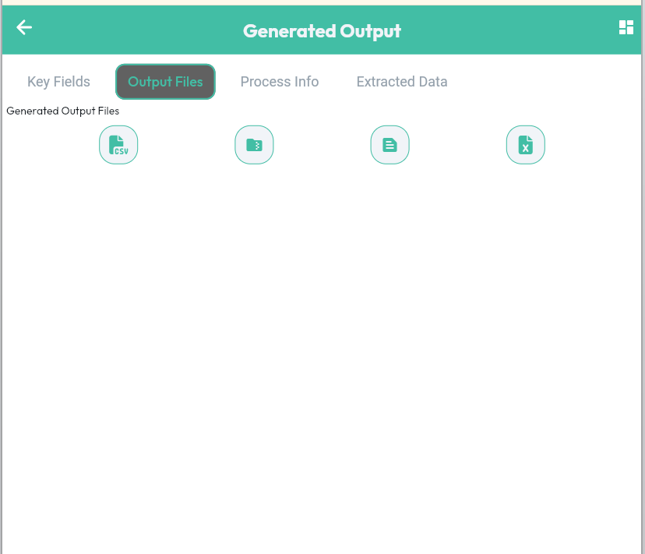
Figure 19: Export Section

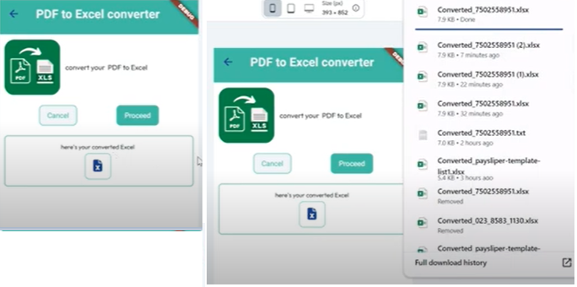
Figure 20: Converters Export Options Section
Once a document is processed, the Generated Output screen is displayed. On this screen, each tab displays relevant information about the extracted data from the document (as shown in Figure 4.9)
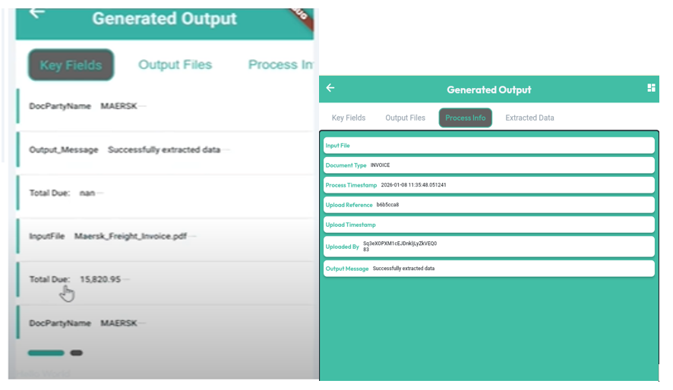
Figure 21: Generated Output section

Project Capabilities and Limitations
Capabilities of Transcriptionista:
The Transcriptionista can efficiently process standard document formats. It also supports both PDF format and image-based files and later converts them into editable text.
- It includes a search-and-filter feature to help users quickly locate and process documents based on criteria such as file type and title.
- The application provides a detailed and organized preview of extracted text to ensure accuracy and achieve satisfaction for the user.
- The interface is intuitive. It ensures ease of use and navigation, with minimal learning required for effective operation.
Limitations of Transcriptionista:
The limitations of the application are as follows:
- The application experiences reduced accuracy when processing complex document layouts, such as multi-column layouts or layouts with images attached to them.
- Documents must use standard fonts and simple layouts to ensure optimal performance. It is observed that intricate or heavily formatted files may affect the accuracy of text extraction.
Test Results
The system used sample datasets to test, including payslips and invoices in various file types to assess accuracy, processing speed, system reliability, and usability.

Data Presentation and Analysis
Test Criteria: The researcher conducted functionality testing. It is to validate the application’s functionality in a local development environment. All evaluation procedures were documented through recorded demonstrations/walkthroughs, ensuring sufficient evidence of the system’s operational capabilities.
Table 4.1 presents the accuracy, processing time, and specific notes on the application’s performance across different document types.

Table 5:
Text Extraction Accuracy by Document Type
Document Type | Accuracy (%) | Average Processing Time (s) | Observations
PDF | 95% | 3.2 | High accuracy with standard fonts
Scanned Images | 88% | 4.6 | Lower accuracy due to OCR limitations

The accuracy rates indicate that the application performs best with DOCX files, followed closely by PDFs, while OCR on scanned images is moderately effective. It highlights a need for further optimization in handling image-based files.
Transcriptionista was developed in Dart and Flutter, ensuring compatibility with both Android and desktop web browsers. The test results summary on the compatibility and usability of the developed system is in the tables that follows.

Table 6:
Compatibility Test Results
Test Case | Steps Shown | Observed Results
(Co-existence) Web App Launches via Browser | The user accessed the app at localhost through the Chrome browser. | The web interface rendered fully and allowed user interaction.
(Co-existence) Consistent Interface Display | The app screens, such as “Upload,” “Extract,” and “Export,” maintained layout consistency across the walkthrough video | Icons, menus, and buttons remained stable and readable throughout
(Interoperability) File Export Feature Displayed | After the user extracted the text and pressed the “Export” button. | The app showed format choices such as CSV and JSON.
(Interoperability) File Upload and Export via Local Development Build | User accessed the web version of Transcriptionista via a development build running on localhost. A document was uploaded, converted by the system, and exported using the visible “Export” button. | The system responded as expected, accepting the upload, processing the content, and providing export formats like CSV, XLS, and JSON.

Table 7:
Usability Test Results
Test Case | Steps Undertaken | Observed Results
(Learnability) Uploading or capturing a document image | 1. Clicked the Selective Extract button  2. Selected a file to be uploaded and processed in the File Upload Menu.  3. Verified the selected file on the File Preview screen.  4. Clicked the Transcribe File button to start the processing. | The file upload, converter, and transcribe functionalities were clear and easy to navigate. Pre-defined actions and settings were consistent across the app. See Appendix G, Figures G6 & G7.
(Operability) Explore the Converter section of Ready-to-Use Converters | 1. Opened Transcriptionista.  2. From the App Menu,  find suitable converters. | The user selected an appropriate converter from the features. See Appendix G, Figure G6.
(User Interface Aesthetics) View Transcriptionista’s Generated Output Screen | 1. Opened Transcriptionista.  2. From the App Menu, used the suitable converters or click the Selective Extract feature.  3. Selected the input file  4. Clicked the process button  5. Transcriptionista performed the corresponding actions (convert or extract)  6. Transcriptionista displayed the generated files and processed information on the Output Files Screen | The Generated Output Screen displayed tabs that contain icons to export generated output files and displayed information about the file extraction. See Appendix G, Figure G15.  On the Dashboard Screen, Transcriptionista also displayed a graph indicating the number of successfully processed and failed files. See Appendix G Figure G18.
(Accessibility) Rule Engine Configuration | 1. User Opened Transcriptionista.  2. From the App Menu, clicked the Selective Extract feature.  3. Selected the input file  4. Clicked the process button  5. Transcriptionista performed the text extraction.  6. Transcriptionista detected that a Rule Engine was needed.  7. User redirected to the Rule Engine Configuration Screen. | Transcriptionista offered easy to use interface to setup or configure the Rule Engine See Appendix G, Figures G10-G13.
(Appropriateness/Recognizability) Select Transcriptionista Converters Based on Users’ Needs | 1. Open Transcriptionista.  2. On the App menu, select an action based on preference or extraction needs. | The app displayed relevant transcription routines, such as Document to Text, Image to Text, and PDF Extraction, based on user preferences. See Appendix G, Figure G6.
(User Error Protection) Display Notification Message | 1. Open Transcriptionista.  2. Navigate through the Login Page  3. Input invalid credentials | The app displayed an error prompt containing the details of the invalid action. See Appendix G, Figure G19.
(User Error Protection)  Configuration Readiness Checklist | 1. User Opened Transcriptionista.  2. From the App Menu, clicked the Selective Extract feature.  3. Selected the input file  4. Clicked the process button  5. Transcriptionista performed the text extraction.  6. Transcriptionista detected that a Rule Engine was needed.  7. User redirected to the Rule Engine Configuration Screen.  8. User was guided on the needed steps to complete the Rule Engine configuration. | The app was able to provide a real-time validation list of prerequisites to prevent execution errors. See Appendix G, Figure G21.

These usability test results demonstrated that Transcriptionista offers a user-friendly interface, seamless accessibility, and robust error handling. It enables users to manage transcription-related duties. As a result, users will then be able to find the right routines with minimal effort.

Evaluation Results
The evaluation results of the application or system were gathered through user feedback, assessing factors such as usability, reliability, and feature functionality. Participants generally reported positive experiences, with comments commending the app's accuracy and ease of use. Suggestions for improvement included support for multi-page document extraction and additional options for handling non-standard document formats. These results confirm that Transcriptionista meets its primary objectives while identifying areas for improvement in future versions.
The researcher evaluated the Transcriptionista framework to assess its acceptability among actual users. The respondents were IT professionals, IT graduates, and users of transcription services. The summary of the evaluation results is in Table 4.4
Table 8:
Summary of Evaluation
Criteria | Weighted Mean | Adjectival Rating
A. Functional Suitability
1. Functional Completeness | 3.73 | Highly Acceptable
2. Functional Correctness | 3.73 | Highly Acceptable
3. Functional Appropriateness | 3.80 | Highly Acceptable
Criteria on Weighted Mean | 3.75 | Highly Acceptable
B. Performance Efficiency
1. Time Behavior | 3.57 | Highly Acceptable
2. Resource Utilization | 3.64 | Highly Acceptable
Criteria on Weighted Mean | 3.60 | Highly Acceptable
C. Compatibility
1. Co-existence | 3.75 | Highly Acceptable
2. Interoperability | 3.66 | Highly Acceptable
Criteria on Weighted Mean | 3.71 | Highly Acceptable
D. Usability
1. Appropriateness Recognizability | 3.68 | Highly Acceptable
2. Learnability | 3.71 | Highly Acceptable
3. Operability | 3.70 | Highly Acceptable
4. User Error Protection | 3.63 | Highly Acceptable
5. User Interface Aesthetics | 3.68 | Highly Acceptable
6. Accessibility | 3.71 | Highly Acceptable
Criteria on Weighted Mean | 3.68 | Highly Acceptable
E. Reliability
1. Availability | 3.63 | Highly Acceptable
2. Fault Tolerance | 3.63 | Highly Acceptable
Criteria on Weighted Mean | 3.63 | Highly Acceptable
F. Maintainability
1. Analyzability | 3.59 | Highly Acceptable
2. Modifiability | 3.71 | Very Acceptable
3. Testability | 3.75 | Highly Acceptable
Criteria on Weighted Mean | 3.68 | Highly Acceptable
G. Portability
1. Install ability | 3.71 | Highly Acceptable
Criteria on Weighted Mean | 3.71 | Highly Acceptable
Grand Mean | 3.68 | Highly Acceptable

As shown in Table 8, the Transcriptionista framework received its highest rating for the "Functional Suitability" criterion, with a weighted mean of 3.75, interpreted as Highly Acceptable. It suggests that Transcriptionista effectively meets user requirements by offering time-saving, cost-efficient, and user-friendly features for transcription tasks and initiatives, reducing the need for extensive manual entry.
The second-highest rating was achieved by both the Portability and Compatibility criteria, with a weighted mean of 3.71, which was also rated as Highly Acceptable. This rating indicates the tool was portable and compatible in many ways.
The lowest rating was obtained by Performance Efficiency, with a weighted mean of 3.60, but still considered as Highly Acceptable. While Transcriptionista performs well in many areas, there is always room for improvement. One of these considerations is enhancing support for both Android and non-Android platforms.
Overall, the Transcriptionista framework received a grand weighted mean of 3.68, described as Highly Acceptable, indicating strong user approval so far. It indicates that the Transcriptionista app, is an effective, user-friendly tool for transcription tasks, especially for beginner users seeking an efficient and effective way to manage their daily transcription workflows.
The system’s functional accuracy, ease of navigation, and modularity were highlighted through the feedback received. Suggestions from users focused on expanding field recognition templates and improving image pre-processing, even for blurred, low-resolution image uploads.
The Transcriptionista demonstrated full functionality during local testing. It validated the core features through test scripts, screen recordings, and walkthroughs successfully. Evaluation metrics support that the project is both technically good and practically useful.

Chapter 5

SUMMARY OF FINDINGS, CONCLUSIONS, AND RECOMMENDATIONS
This chapter includes the summary of findings, the conclusions drawn, and the corresponding recommendations of the study.
Summary of Findings
Transcriptionista was evaluated using the ISO 25010 Software Quality Model Evaluation Survey Form, supported by walkthrough videos, across eight quality attributes. It is required to measure the app's capabilities and ensure it meets the requirements of the organization's needs. Key findings include:
- Functionality Suitability: The application accurately met its intended purpose by performing text extraction and data capture from various formats. Through user feedback, it indicated satisfaction with its transcription capabilities for standard document types (PDF and image files).
- Performance Efficiency: Performance testing demonstrated that Transcriptionista processed the documents with minimal delay during testing. It is with an average processing time of 3.2 seconds for PDFs and 2.8 seconds for image files. However, processing OCR on image-based documents took longer (4.6 seconds) compared to document-based inputs, reflecting room for optimization in handling image files.
- Compatibility: The application supported multiple file formats, including PDF, and image formats. Users also confirmed that Transcriptionista performed effectively across various devices, supporting its cross-platform usability.
- Usability: Transcriptionista received high scores. Users found the interface was straightforward and at the same time intuitive. They appreciated the simple navigation of the app but also suggested minor interface adjustments for enhanced accessibility.
- Reliability: The Transcriptionista system proved stable, though it encountered minimal bugs/crashes during the trial. Its stress test has maintained its functionality even under heavy loads, reflecting strong reliability.
- Security: The Transcriptionista application demonstrated basic security compliance during the demo. It is by implementing secure data-handling processes that adhere to the Data Privacy Act 2010. Users felt confident that the system safeguarded important information. This is a consideration in the future continuous improvements proposal, which includes advanced data encryption and added security.
- Maintainability: The codebase was designed with modularity. It allows easy updates and modifications. However, the project’s maintenance could benefit from improved documentation, which would facilitate future enhancements and debugging.
- Portability: The application was deployable across multiple operating systems, which further enhanced its portability attributes and appeal to a wider range of users based on what is available to them.
Conclusions
From the findings above, the study draws the following conclusions:
- Feature Success: The developed application, Transcriptionista, was successfully designed to integrate a comprehensive set of features to improve the efficiency of transcription and data management processes. The key functionalities include:
  - Document Upload: This important feature of Transcriptionista allows users to upload files in various formats (e.g., PDF and image file) seamlessly, supporting flexibility and ease of access.
  - Text Extraction: This main function of Transcriptionista features the conversion of document content into editable text almost accurately, if not 100%. This makes it highly useful for those needing quick, reliable data capture.
  - Export Options: With a variety of saving formats mentioned earlier, this feature gives users options to export data depending on their specific requirements, which therefore supports facilitating smooth data integration and storage to help them with other tasks.
- Technology Stack and Development Tools: The Transcriptionista app used a robust set of tools and programming libraries, ensuring both performance and functionality are addressed. The Dart programming language and the Flutter framework created a responsive, cross-platform solution to enhance user experience capabilities. Visual Studio Code, on the other hand, served as the primary development environment, offering a flexible, user-friendly coding interface, while the integration of Firebase Database supported real-time data storage and data management. On the other hand, Google services helped ensure the app’s compatibility across devices and platforms.
- Compatibility and Performance: Test results demonstrated the application’s strong compatibility with multiple devices and operating systems. Therefore, it allows it to serve a wide user base. The app proved capable of adapting to different screen sizes and resolutions, maintaining its performance across diverse environments. This compatibility factor underscores Transcriptionista’s versatility and its potential to function seamlessly for a variety of users.
- Evaluation of Key Performance Indicators: The application has proven to be highly acceptable across essential performance indicators, including Functional Suitability, Performance Efficiency, Compatibility, Usability, and Reliability. The positive evaluations in these areas prove that the application is not only functional and efficient but also accessible and dependable. These qualities suggest that Transcriptionista can be a valuable tool for users seeking a reliable, effective transcription and data management solution.
In conclusion, Transcriptionista demonstrates a well-structured application, equipped with a robust set of features that effectively fulfill its intended purpose: providing efficient transcription and data capture solutions. The app has a meaningful contribution to the field of automated transcription by addressing key usability requirements and integrating technologies that support both functionality and compatibility. Its practical design and user-friendly interface make Transcriptionista a significant asset for future individuals and organizations, with potential for further research, enhancements, and broad applicability across diverse user needs.

Recommendations
The following recommendations aim to address identified limitations and enhance Transcriptionista’s quality in alignment with ISO 25010 standards:
- Enhanced OCR Processing
To improve Performance Efficiency for image-based files, incorporate advanced OCR algorithms that better handle complex layouts and non-standard fonts. Machine learning models, such as Textract and Google Vision OCR, could improve accuracy and reduce processing time.
- User Interface Enhancements
The researcher may implement minor usability improvements based on user feedback. For instance, adding accessible tooltips or instructional prompts could improve Usability for first-time users.
- Advanced Security Measures
Strengthen Security by implementing end-to-end encryption for data handling and storage. It would provide enhanced protection for sensitive information, fostering user trust.
- Comprehensive Documentation for Maintainability
Improve Maintainability by expanding the documentation to include details on each module’s functionality and testing procedures. It will aid developers to make updates, debug, or enhance features as needed.
- Expansion of Compatibility
Consider adding support for additional document formats, such as Excel (XLSX) and HTML, which would further enhance compatibility and broaden Transcriptionista's applicability across more use cases.
- User-Centered Testing for Future Enhancements
The researcher will conduct user-centered testing for new features. That is to gauge Usability and Functionality Suitability continuously. Periodic surveys and feedback mechanisms can ensure ongoing alignment with user needs and expectations.

Reflections and Technical Challenges
During the development and testing of Transcriptionista, the researcher encountered several key challenges that provide practical insights and opportunities for growth in system design, deployment strategy, and project planning.
The most significant issue is the inability to proceed with a full public deployment. This is due to unresolved build and versioning conflicts in the development framework. Despite multiple attempts to configure the release environment, incompatibilities between third-party libraries and the Flutter SDK continually prevented a successful production build. As a result, testing was conducted entirely through a local development environment and presented via screen-recorded walkthroughs.
Additionally, the researcher deprioritized the integration with external services (e.g., cloud hosting, QR-based sharing) to focus on the core functionality of file upload, structured text conversion, and local export. While these key features performed reliably, limited time and resources meant that advanced interoperability features, such as multi-user accounts or real-time sync, remained outside the final scope.
From this experience, the researcher learned the following lessons:
- Incremental testing across Flutter versions is a critical consideration to avoid version lock-ins and broken dependencies, late in the development process.
- Clear environment documentation (e.g., OS, SDK, and library versions) is something that needs to be considered to make handoffs and troubleshooting easier to manage in the future.
- Even without public release, a local demonstration can still be as effective to showcase system functionality and user interface design.
- Most importantly, flexibility, persistence, and clear communication with mentors and advisors are essential in adapting to unexpected technical roadblocks.
Overall, the capstone process served not just as a validation of existing skills but also as a platform for a deeper understanding of deployment challenges, product decision-making, and software documentation best practices.

REFERENCES

7 ways manual repetitive tasks are eating into your budget. (2021, December 9). Impact My Biz. https://www.impactmybiz.com/blog/blog-7_ways_repetitive_tasks_tech_budget/
A comparative study of optical character recognition for printed and handwritten Tamil text. (2017). International Journal of Engineering Research and Applications, 56–60. Persia A.
A comparative study of optical character recognition for printed and handwritten Tamil text. (2017). International Journal of Engineering Research and Applications, 7(8), 56–60.
A detailed analysis of optical character recognition technology. (2016). International Journal of Applied Mathematics, Electronics and Computers, 244–249. K. Hamad & M. Kaya.
A detailed analysis of optical character recognition technology. (2016). International Journal of Applied Mathematics, Electronics and Computers, Special Issue, 244–249.
ABBYY. (2021). Invoice processing automation with ABBYY FlexiCapture. https://www.abbyy.com/
Adobe. (n.d.). Why PDF is the best file format for business. Adobe Acrobat Hub. https://www.adobe.com/acrobat/hub/resources/why-pdf-is-best-format-for-business
Agile Alliance. (n.d.). Agile 101. https://www.agilealliance.org/agile101/
Alison Borris. (2020, January 21). Automation Anywhere. https://www.automationanywhere.com/company/press-room/global-research-reveals-world-s-most-hated-office-tasks#:~:text=A%20global%20study%20commissioned%20by,and%20are%20ripe%20for%20human
Artificial Intelligence. (2022, September 19). Built In. https://builtin.com/artificial-intelligence
Automation: A guide to improve data capture accuracy. (n.d.). iTech. https://itechdata.ai/automation-a-guide-to-improve-data-capture-accuracy/#:~:text=Sight%20verification%2C%20double%2Dkey%20data,an%20error%20becomes%20an%20error.
Beloof, K. (n.d.). How much time are you wasting on manual, repetitive tasks? Smartsheet. https://www.smartsheet.com/content-center/product-news/automation/workers-waste-quarter-work-week-manual-repetitive-tasks
Build aps for any screen. (n.d.). Flutter. https://flutter.dev/
Camunda. (2020). Camunda state of process automation. https://camunda.com/wp-content/uploads/2020/10/Camunda-State-Of-Process-Automation.pdf
Challenges small businesses face in outsourcing data entry. (n.d.). DataEntryOutsourced. https://www.dataentryoutsourced.com/resources/outsourcing-challenges.php
CloudChipr. (2025, May 29). Mastering AWS Textract: AI powered document extraction. CloudChipr. https://cloudchipr.com/blog/aws-textract (cloudchipr.com in Bing)
Crown Records Management. (2021, June 8). The past and future of optical character recognition (OCR) technology. Crown Records Management. https://www.crownrms.com/hk/en/insights/the-past-and-future-of-optical-character-recognition-ocr-technology/
Cudney, E. A. (2017). Application of the 1-10-100 rule to quality management in a manufacturing process. Quality Engineering, 553–567.
D. Zhong, Z. L. (2020). An efficient method for detecting and extracting content from product label images based on Tesseract OCR. In Proceedings of the 14th International Conference on Computational Intelligence and Security (CIS) (pp. 76–80).
Dart. (n.d.). Dart overview. https://dart.dev/overview
Das, S. (n.d.). How to enhance your sales team’s productivity by reducing manual data entry. Salesmate. https://www.salesmate.io/blog/enhance-your-sales-teams-productivity-reducing-manual-data-entry/
Difference between centralized database and distributed database. (2022, June 7). GeeksforGeeks. https://www.geeksforgeeks.org/difference-between-centralized-database-and-distributed-database/
Difference between OCR and MICR. (n.d.). JavaTPoint. https://www.javatpoint.com/difference-between-ocr-and-micr
Everything wrong with manual data entry. (n.d.). ThinkAutomation. https://www.thinkautomation.com/productivity/everything-wrong-with-manual-data-entry/#:~:text=Humans%20make%20mistakes%2C%20especially%20when,typo%20or%20just%20incorrect%20usage.
G. Singh, V. B. (2019). OCR system for reading printed Devnagari script using Tesseract engine. In 2019 2nd International Conference on Inventive Communication and Computational Technologies (ICICCT) (pp. 1–4).
Gaur, P. (2022, October 7). The real cost of manual data entry in logistics. Cargoflip. https://www.cargoflip.com/post/manual-data-entry-cost
Gomez-Krämer, P. (2017). Overview of document preprocessing techniques in OCR systems. In Image Processing and Communications Challenges (pp. 129–139).
Haddad, D. (2021, February 5). Why manual data entry is bad for business. Acodis. https://www.acodis.io/blog/why-manual-data-entry-is-bad-for-business#:~:text=Eye%20fatigue%2C%20inattentiveness%2C%20and%20hard,and%20money%20to%20train%20employees.
How an Active Everywhere database accelerates hybrid cloud. (2018, September 28). DataStax. https://www.datastax.com/blog/how-active-everywhere-database-accelerates-hybrid-cloud
How to edit a PDF. (2021, February 11). Digital Trends. https://www.digitaltrends.com/computing/how-to-edit-a-pdf/#:~:text=A%20portable%20document%20format%20(PDF,Using%20Adobe%20Acrobat
How to enhance your sales team’s productivity by reducing manual data entry. (n.d.). Salesmate. https://www.salesmate.io/blog/enhance-your-sales-teams-productivity-reducing-manual-data-entry/
Hyland. (n.d.). What is data capture. Hyland. https://www.hyland.com/en/resources/terminology/data-capture#:~:text=Data%20capture%20is%20the%20process,management%20and%20digital%20transformation%20journey
Innovature BPO. (2022, June 17). Why data entry is so important and why data entry outsourcing services? Innovature BPO. https://innovatureinc.com/consider-data-entry-outsourcing-services/
Intelligent Document Processing (IDP): Gain productivity with your data. (n.d.). Ephesoft (a Kofax company). https://ephesoft.com/intelligent-document-processing/#:~:text=Intelligent%20document%20processing%20is%20a,is%20before%20extracting%20the%20data.
Introducing JSON. (n.d.). JSON.org. https://www.json.org/json-en.html
Introduction to web APIs. (n.d.). MDN Web Docs. https://developer.mozilla.org/en-US/docs/Learn/JavaScript/Client-side_web_APIs/Introduction
IRIS | FMP Global Services. (2019, January 7). 5 reasons why digital payslips are best for employees. IRIS | FMP Global Services. https://fmpglobal.co.uk/blog/5-reasons-why-digital-payslips-are-best-for-employees/#:~:text=Electronic%20payslips%20can%20help%20your,paper%2C%20ink%20and%20courier%20charges.
IRIS FMP Global Services. (2019, January 7). 5 reasons why digital payslips are best for employees. https://fmpglobal.co.uk/blog/5-reasons-why-digital-payslips-are-best-for-employees/#:~:text=Electronic%20payslips%20can%20help%20your,paper%2C%20ink%20and%20courier%20charges.
Johnson, D. (2021, September 10). PDF’s popularity online. PDF Association. https://www.pdfa.org/pdfs-popularity-online/#:~:text=According%20to%20the%20detected%20MIME,ways%20to%20understand%20PDF's%20popularity.
JSON.org. (n.d.). Introducing JSON. JSON.org. https://www.json.org/json-en.html
Lacoma, T. (2021, February 11). How to edit a PDF. Digital Trends. https://www.digitaltrends.com/computing/how-to-edit-a-pdf/#:~:text=A%20portable%20document%20format%20(PDF,Using%20Adobe%20Acrobat
Levvel Research. (2021). The 2021 Payables Insight Report. Levvel Research.
Manual data entry: Challenges and solutions in 2023. (2022, November 8). Parseur. https://parseur.com/blog/manual-data-entry
MarketsandMarkets. (n.d.). Prebiotics market report. https://www.marketsandmarkets.com/Market-Reports/prebiotics-market-977.html
Mastering AWS Textract: AI powered document extraction. (2025, May 29). CloudChipr. https://cloudchipr.com/blog/aws-textract (cloudchipr.com in Bing)
MDN Web Docs. (n.d.-a). Introduction to web APIs. MDN Web Docs. https://developer.mozilla.org/en-US/docs/Learn/JavaScript/Client-side_web_APIs/Introduction
MDN Web Docs. (n.d.-b). Working with JSON. MDN Web Docs. https://developer.mozilla.org/en-US/docs/Learn/JavaScript/Objects/JSON
Mehndiratta, M. (2019, August 28). Managing data is as critical as having data: Focus on data governance and data quality. Forbes. https://www.forbes.com/sites/forbestechcouncil/2019/08/28/managing-data-is-as-critical-as-having-data-focus-on-data-governance-and-data-quality/?sh=37e4bf7e4181
Nguyen, T. T. H., Jatowt, A., Coustaty, M., & Doucet, A. (2021). Survey of post OCR processing approaches. ACM Computing Surveys, 54(6), Article 124.
OCR (optical character recognition). (n.d.). TechTarget. https://www.techtarget.com/searchcontentmanagement/definition/OCR-optical-character-recognition
Onsman, A. (2020). Centralized database management system. TutorialsPoint. https://www.tutorialspoint.com/Centralized-Database-Management-System#:~:text=Since%20all%20the%20data%20is%20at%20the%20same%20location%2C%20if,the%20database%20will%20be%20destroyed.
Optical Character Recognition Market Size, Share & Trends Analysis Report By Type (Software, Services), By Vertical (BFSI, Retail, Transport And Logistics), By End-use (B2B, B2C), By Region, And Segment Forecasts, 2023 - 2030. (2021). Grand View Research. https://www.grandviewresearch.com/industry-analysis/optical-character-recognition-market
Optical character recognition. (2022, December 28). Wikipedia. https://en.wikipedia.org/wiki/Optical_character_recognition
Optical mark recognition. (2021, November). Wikipedia. https://en.wikipedia.org/wiki/Optical_mark_recognition
Parseur. (2022, November 8). Manual data entry: Challenges and solutions in 2023. Parseur. https://parseur.com/blog/manual-data-entry
Past and future of optical character recognition (OCR) technology. (2021, June 8). Crown Records Management. https://www.crownrms.com/hk/en/insights/the-past-and-future-of-optical-character-recognition-ocr-technology/
Pattern Recognition Letters. (2021). Zhi, R. Z. Unsupervised document classification for OCR using clustering and topic modeling. Pattern Recognition Letters, 150, 102–109.
Paystream Advisors. (2015). The ROI of invoice automation. Paystream Advisors.
PDF ABBYY FineReader. (2023). What is OCR and OCR technology. ABBYY FineReader PDF. https://pdf.abbyy.com/learning-center/what-is-ocr/#:~:text=Optical%20Character%20Recognition%2C%20or%20OCR,into%20editable%20and%20searchable%20data
PDF Association. (2021, September 10). PDF’s popularity online. PDF Association. https://www.pdfa.org/pdfs-popularity-online/#:~:text=According%20to%20the%20detected%20MIME,ways%20to%20understand%20PDF's%20popularity
PDF Expert. (2018, April 26). Why it’s better to use PDF files instead of Word, Excel or PowerPoint documents. PDF Expert. https://pdfexpert.com/blog/why-its-better-to-use-pdf-files-instead-of-word-excel-or-powerpoint-documents
PDF’s popularity online. (2021, September 10). PDF Association. https://www.pdfa.org/pdfs-popularity-online/#:~:text=According%20to%20the%20detected%20MIME,ways%20to%20understand%20PDF's%20popularity.
Python Software Foundation. (n.d.). About Python. https://www.python.org/
Schroer, A. (2022, September 19). Artificial intelligence. Built In. https://builtin.com/artificial-intelligence
Software Engineering Body of Knowledge. (n.d.). IEEE Computer Society. https://www.computer.org/education/bodies-of-knowledge/software-engineering
Somani, A. (2019, September 10). The future of OCR is deep learning. Forbes. https://www.forbes.com/sites/forbestechcouncil/2019/09/10/the-future-of-ocr-is-deep-learning/
Survey of post OCR processing approaches. (2021, July 13). ACM Digital Library. https://dl.acm.org/
Taylor, K. (n.d.). OCR vs ICR: What differentiates the two character recognition software? HiTechNectar. https://www.hitechnectar.com/blogs/ocr-vs-icr/
TechTarget. (n.d.). OCR (optical character recognition). TechTarget. https://www.techtarget.com/searchcontentmanagement/definition/OCR-optical-character-recognition
Top 10 proven ways to improve data entry for your business. (2022, May 13). Trupp Global. https://truppglobal.com/blog/top-10-proven-ways-to-improve-data-entry-for-your-business#:~:text=A%20centralized%20database%20always%20makes,and%20safety%20of%20the%20data.
Tripathi, P. (2022, September 7). Manual data entry: Overview in 2021. Docsumo. https://docsumo.com/blog/manual-data-entry
Wang, S. L. (2019). A survey on deep learning for OCR and document classification. Neurocomputing, 338, 122–138.

Appendix A

SAMPLE EVALUATION SHEET

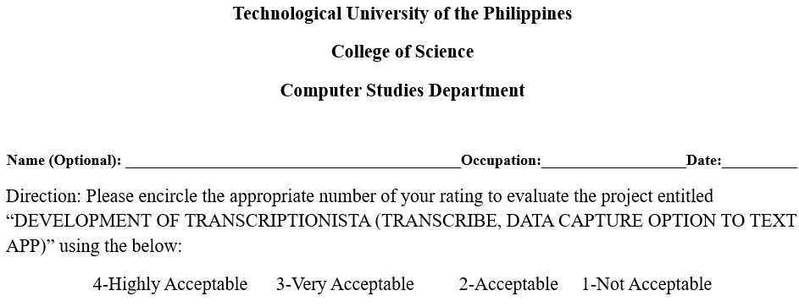
Transcriptionista
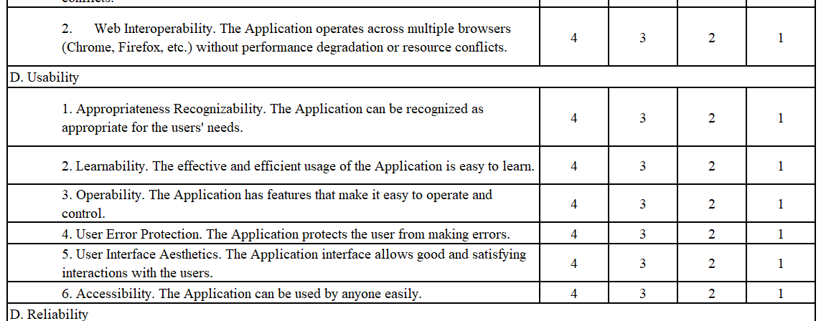
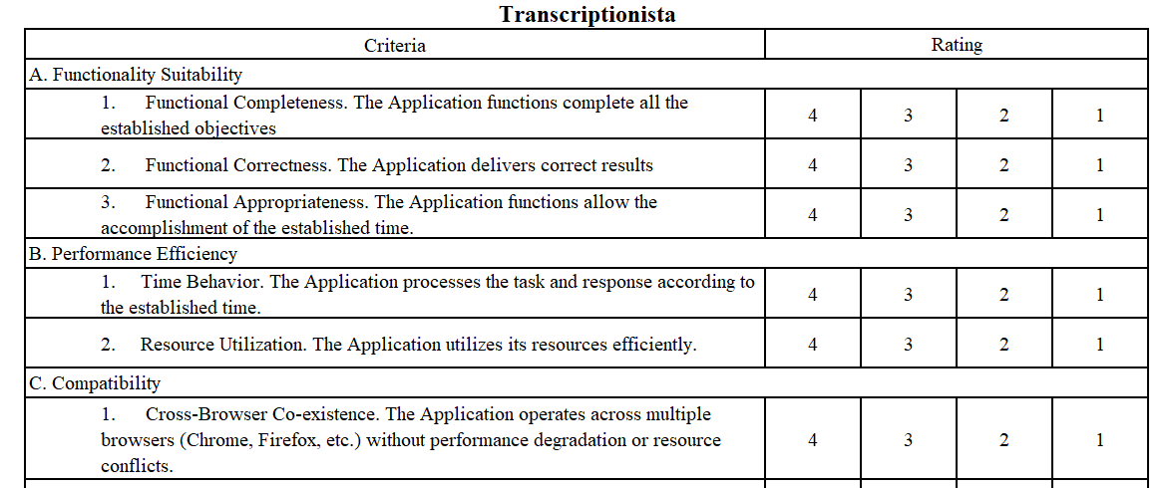
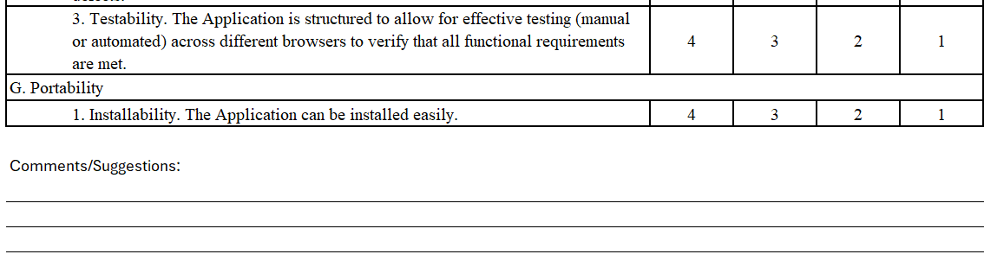
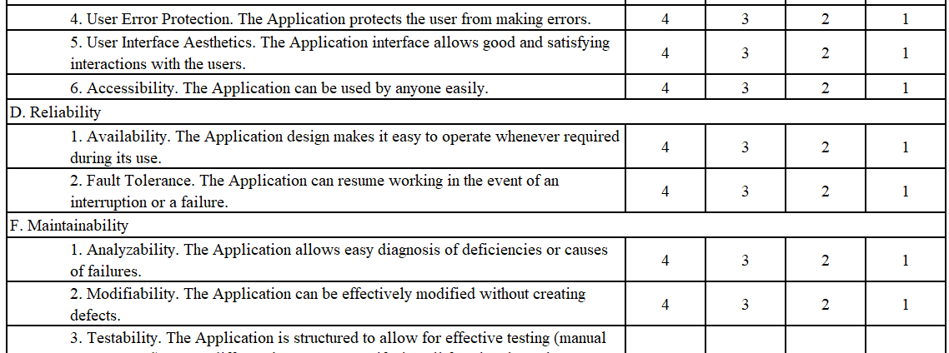

Appendix B

SURVEY QUESTIONNAIRE AND RESULTS SHEETS

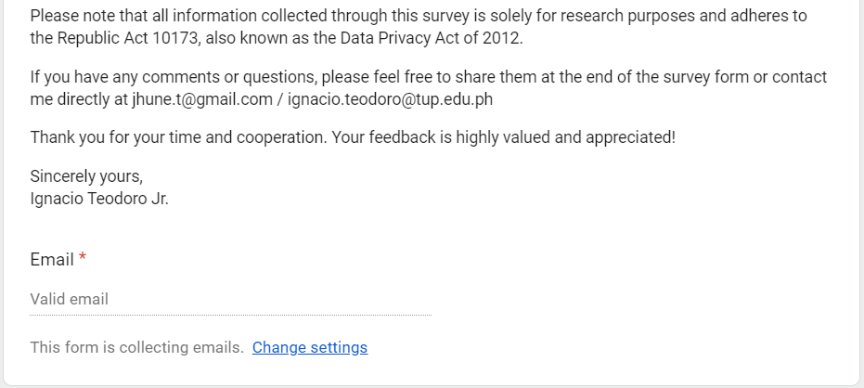
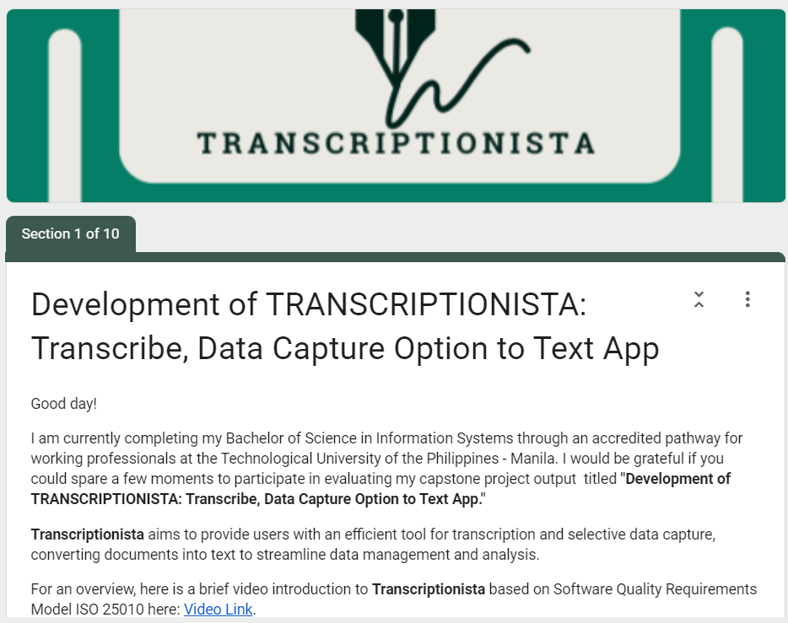

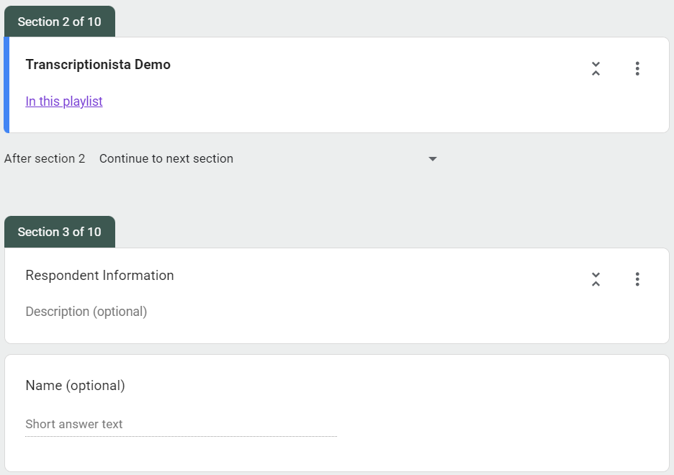
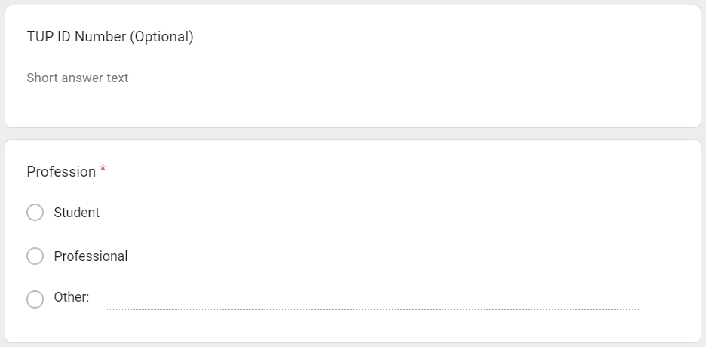

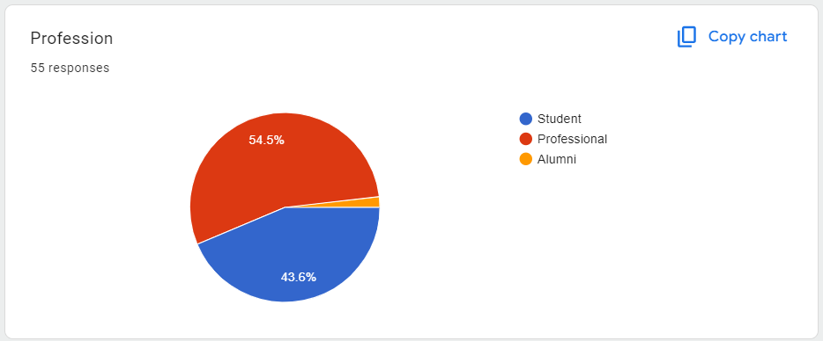
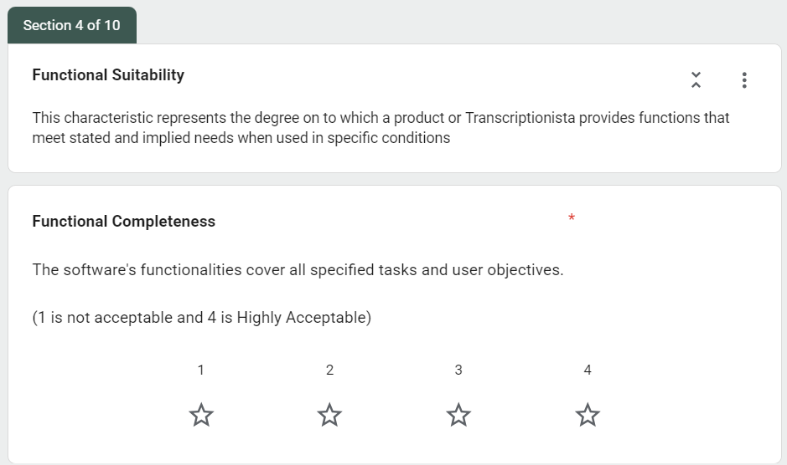
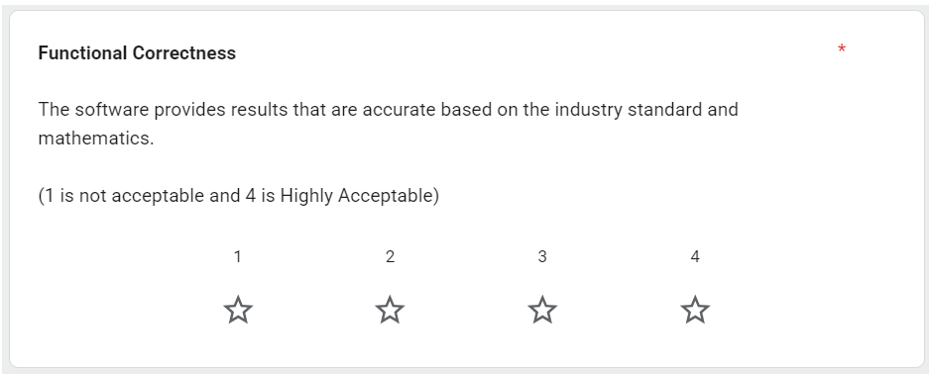
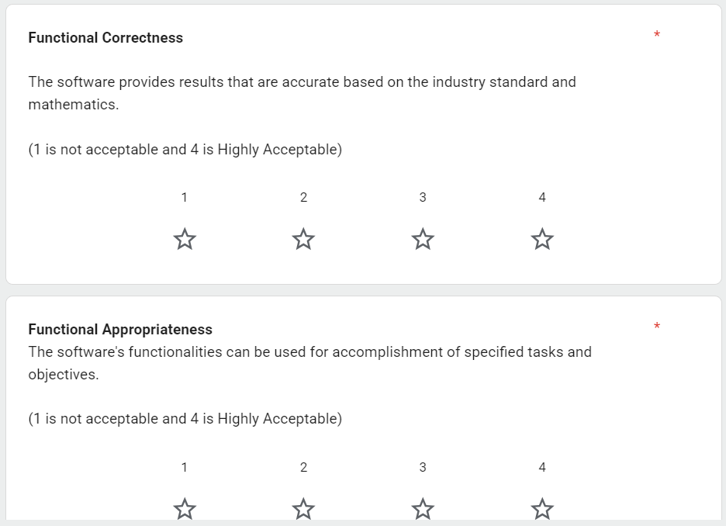
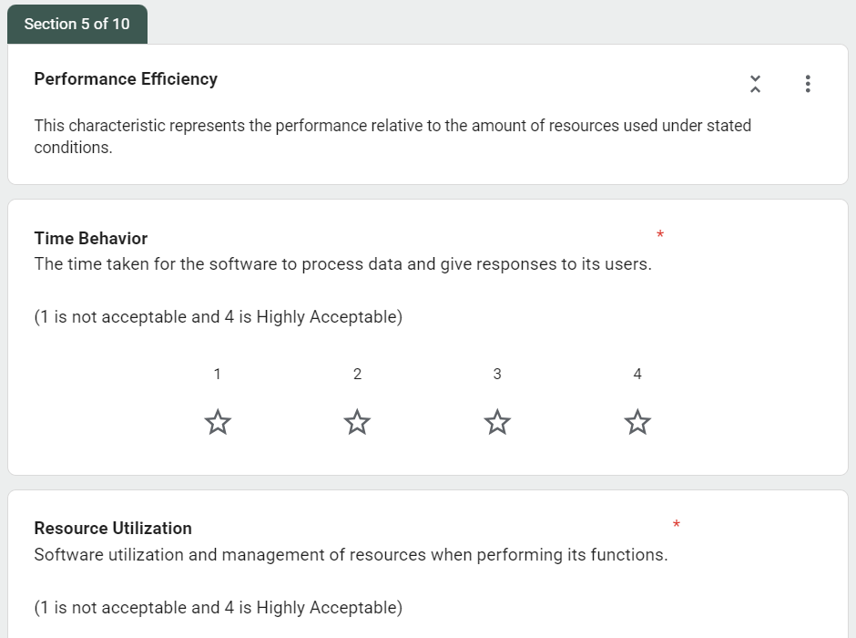
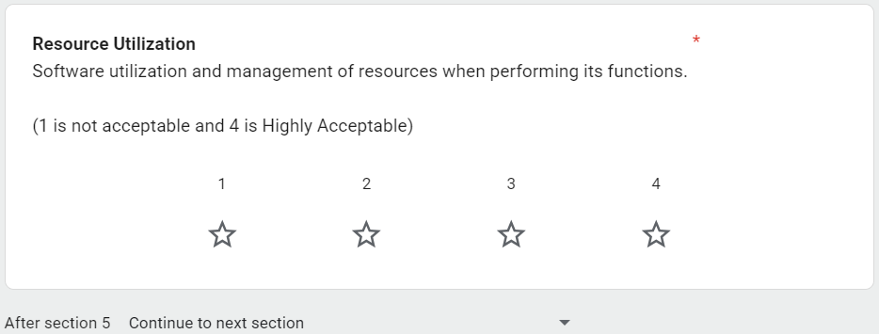
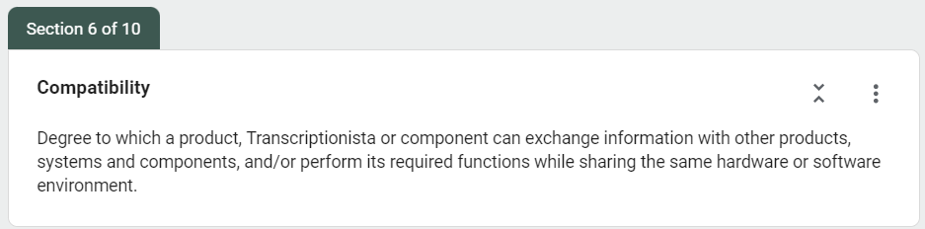
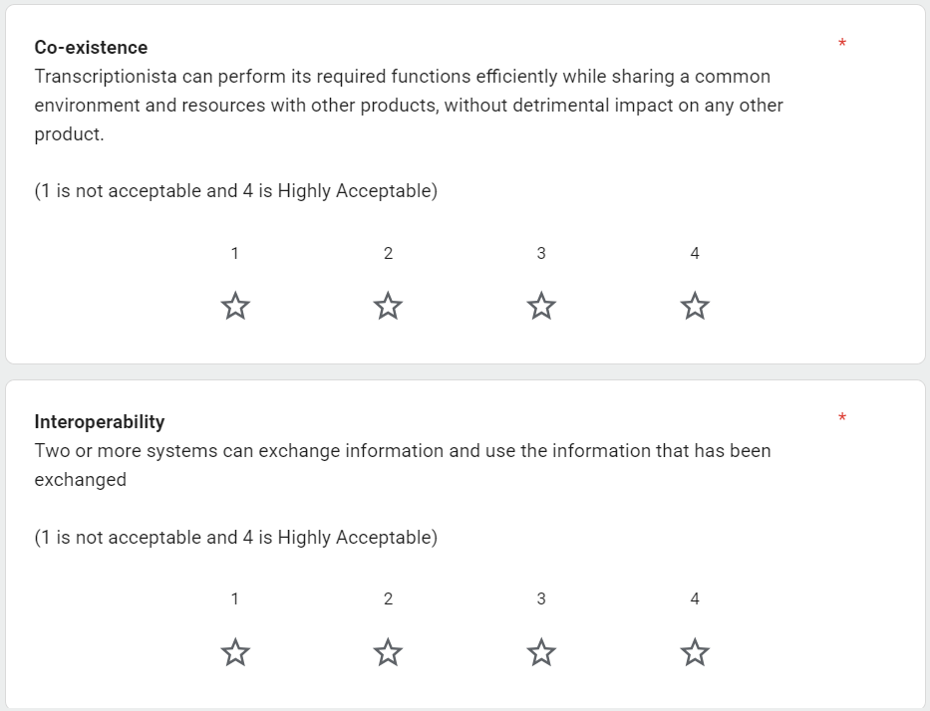
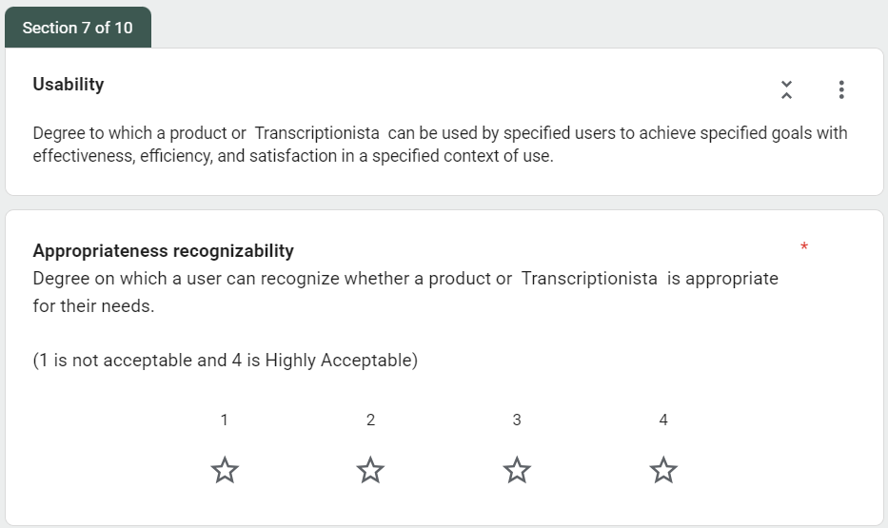
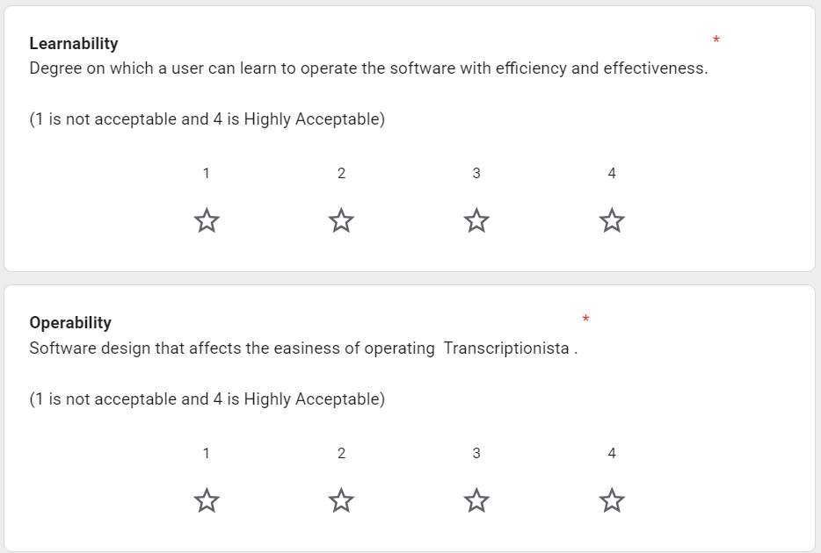
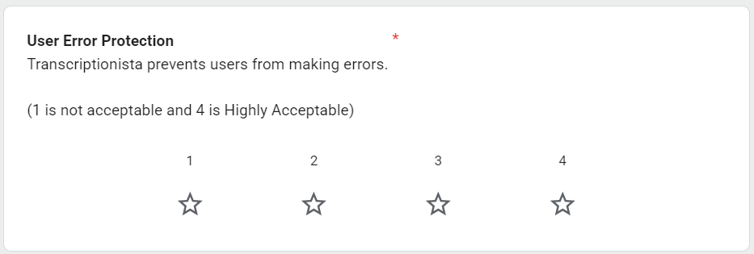
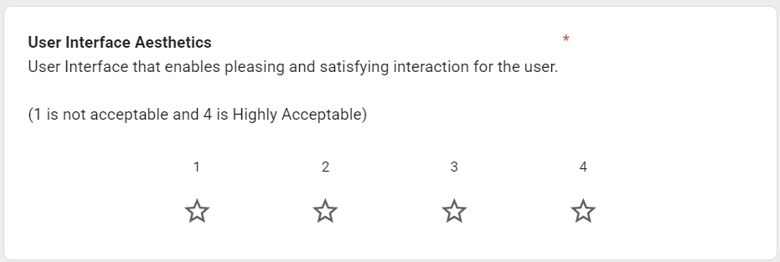
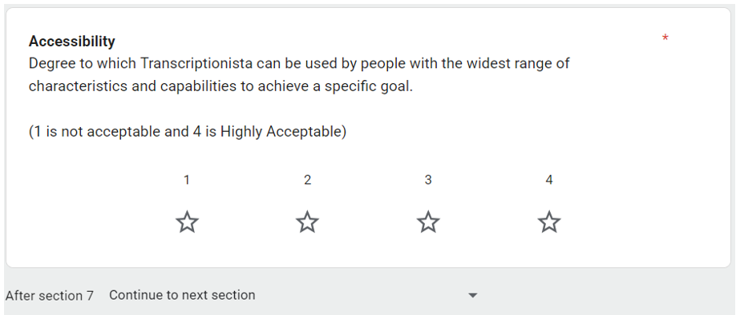
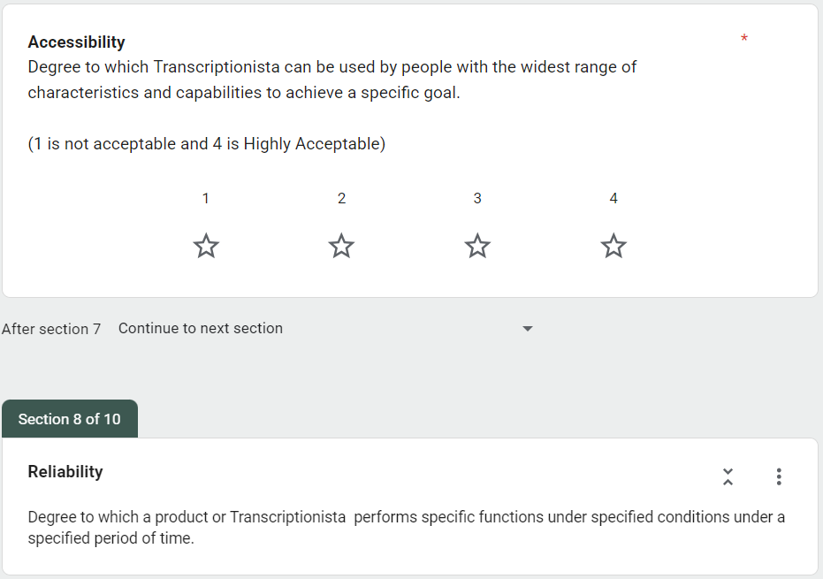
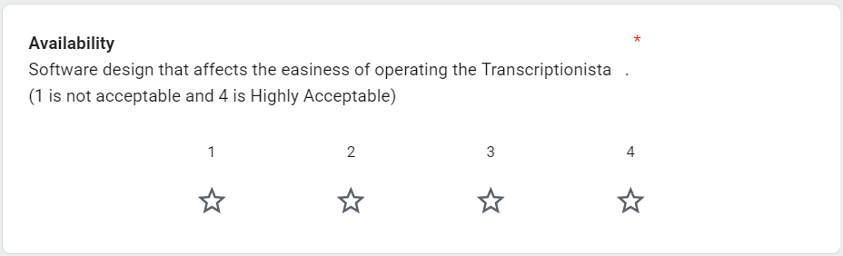
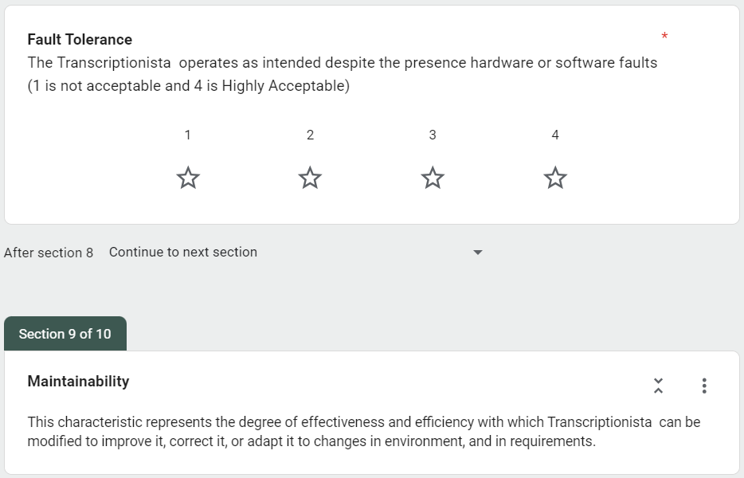
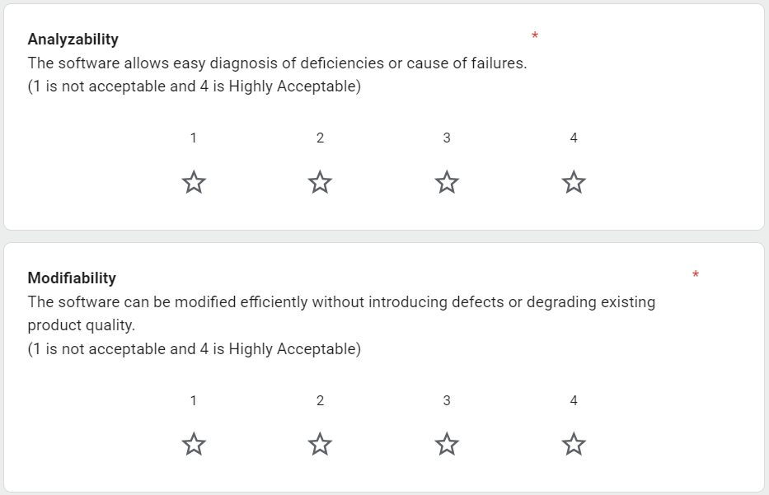
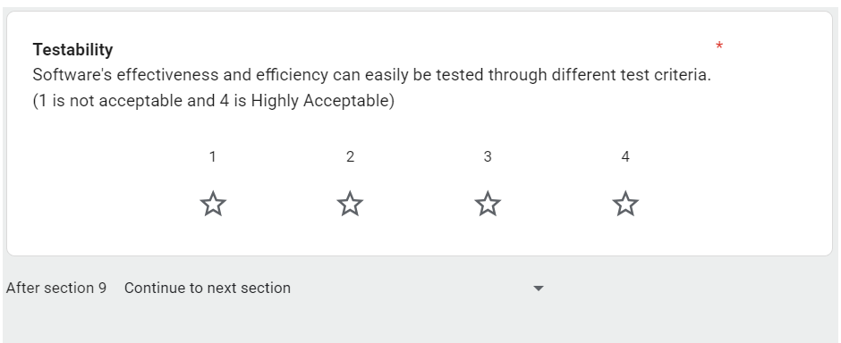
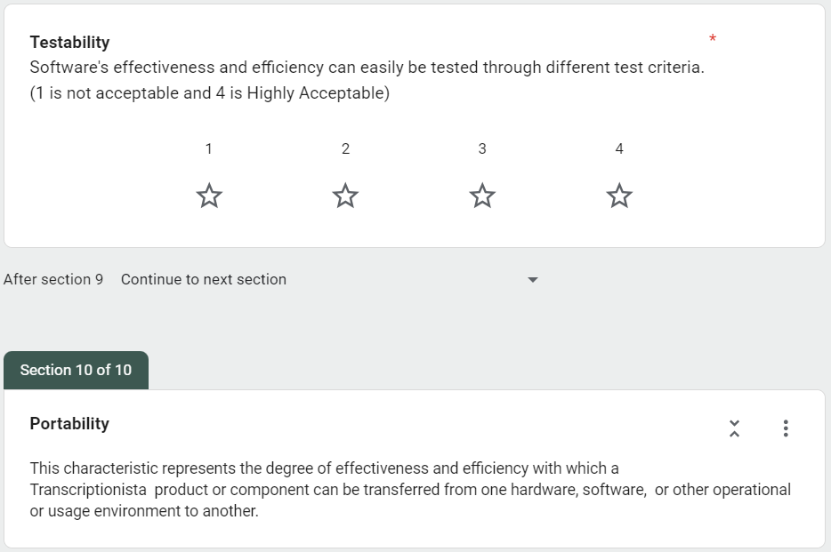
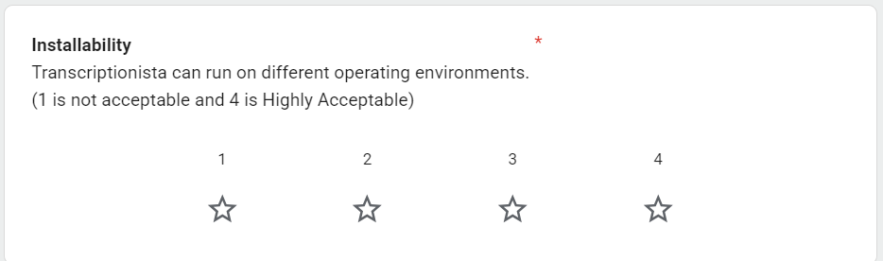
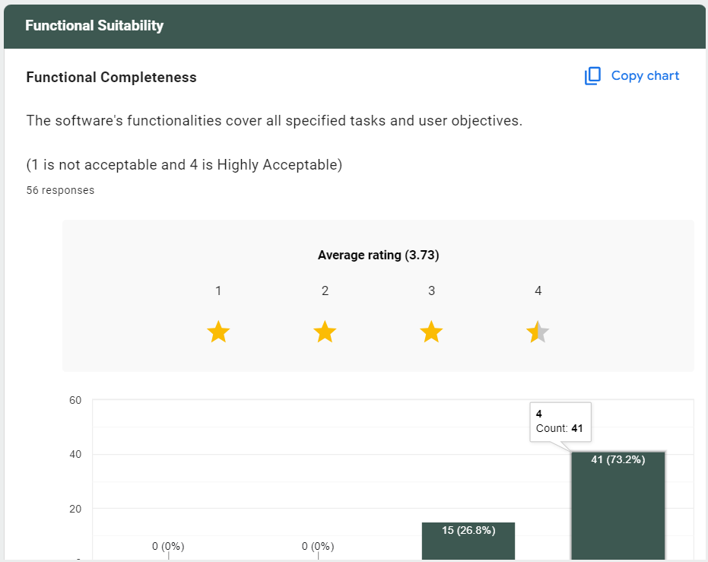

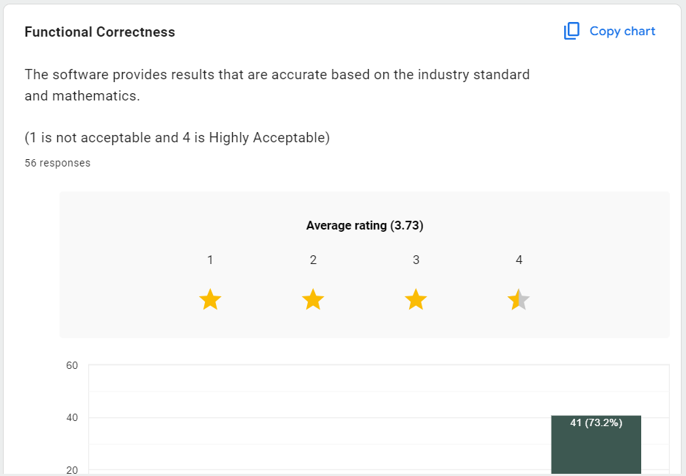
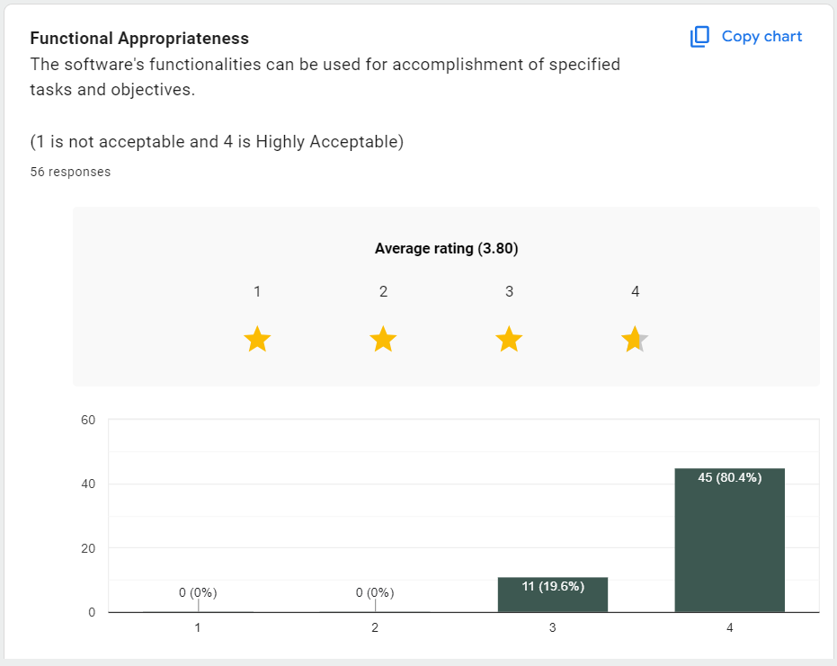
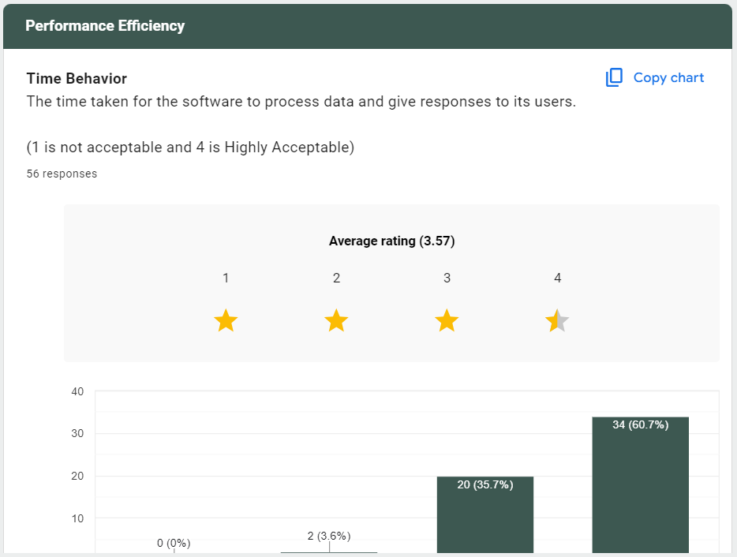
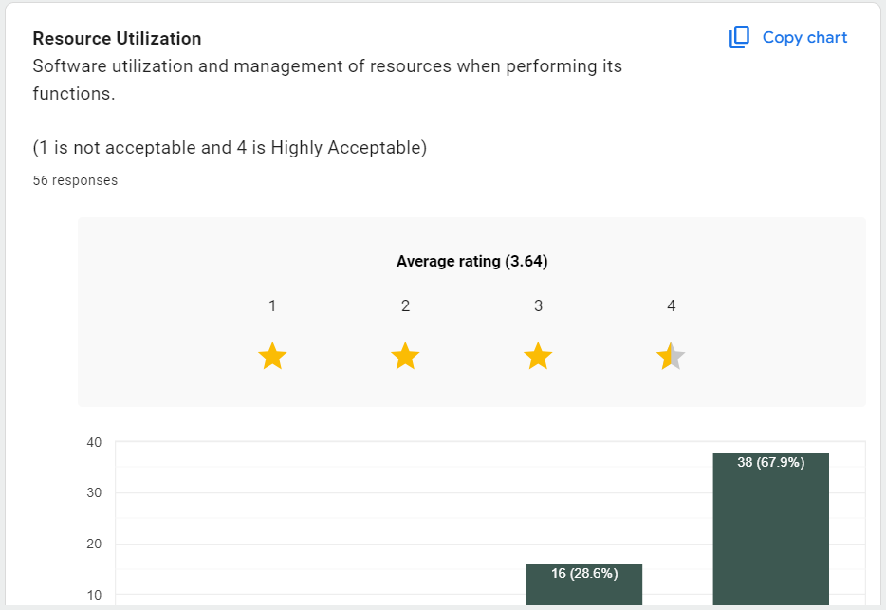

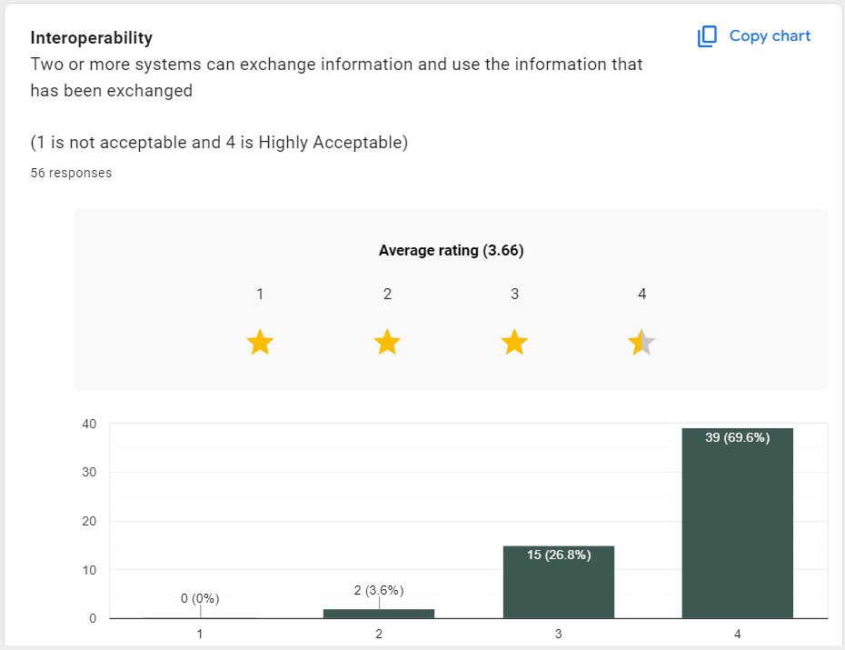
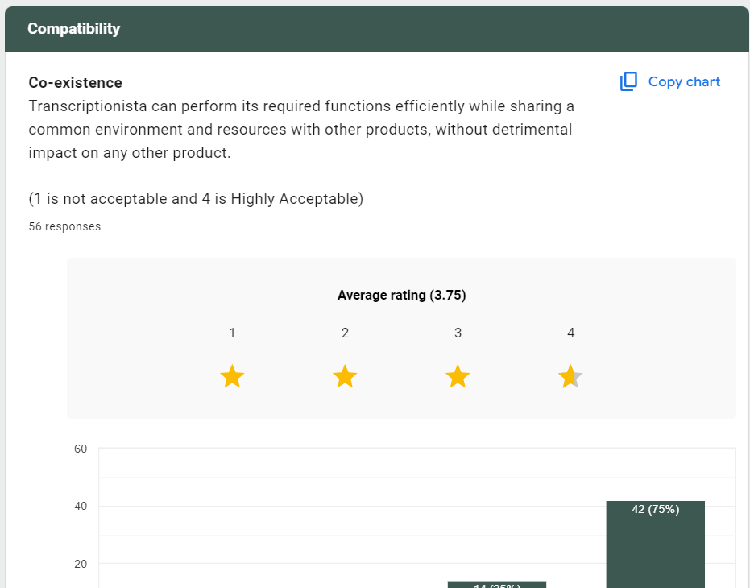
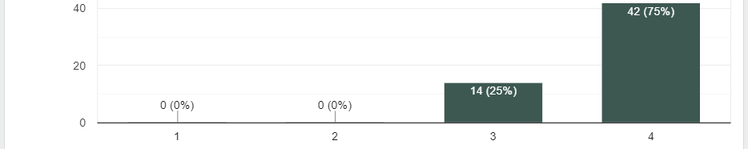

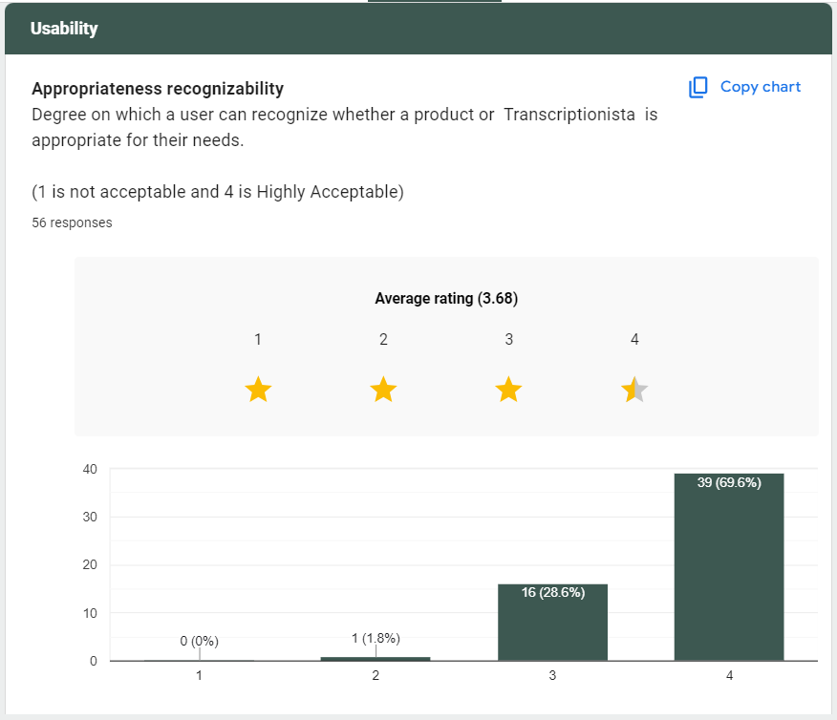
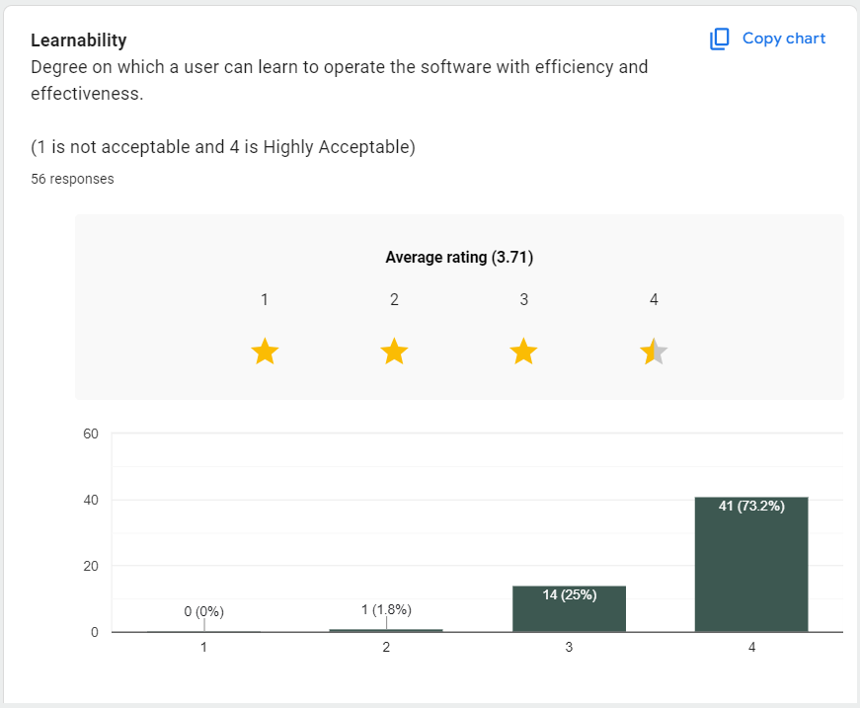
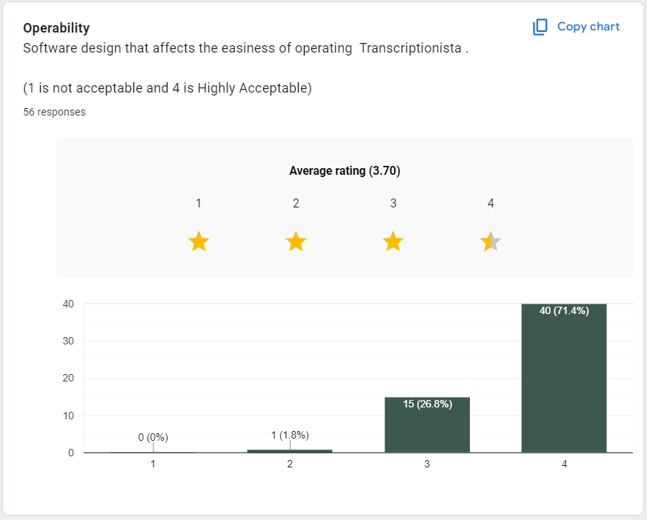
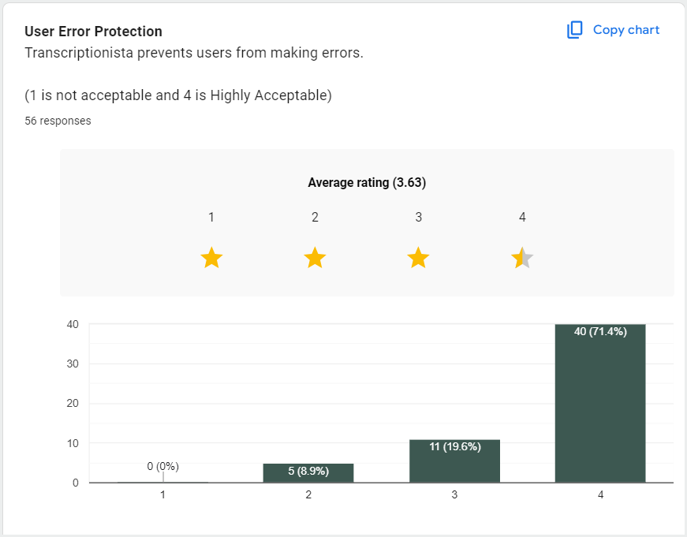
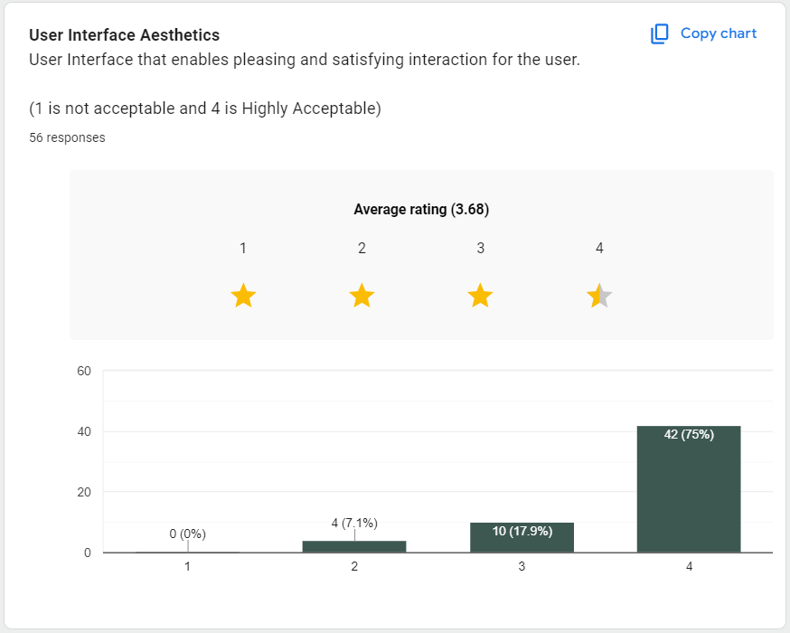
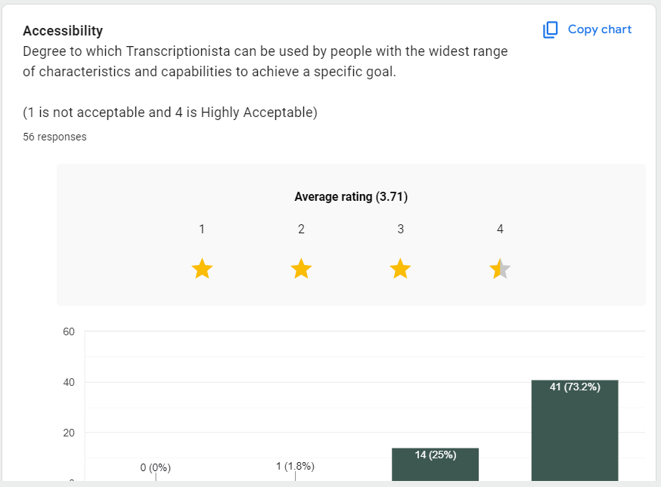
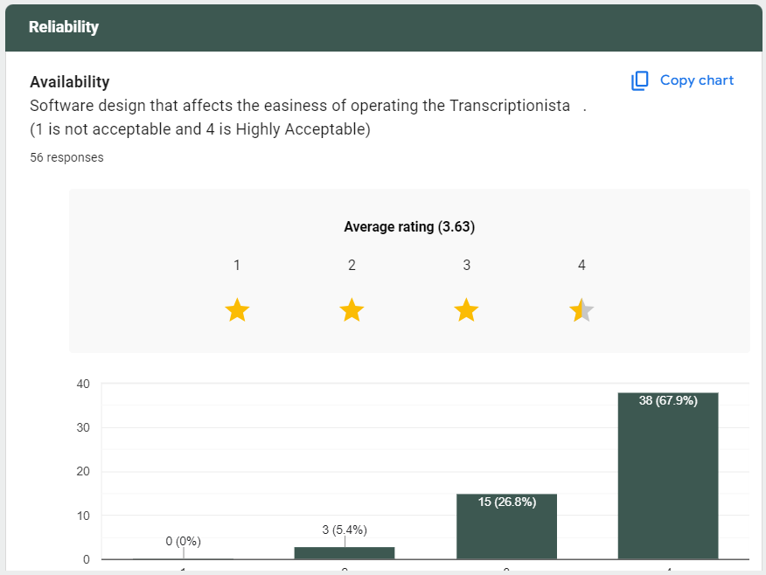
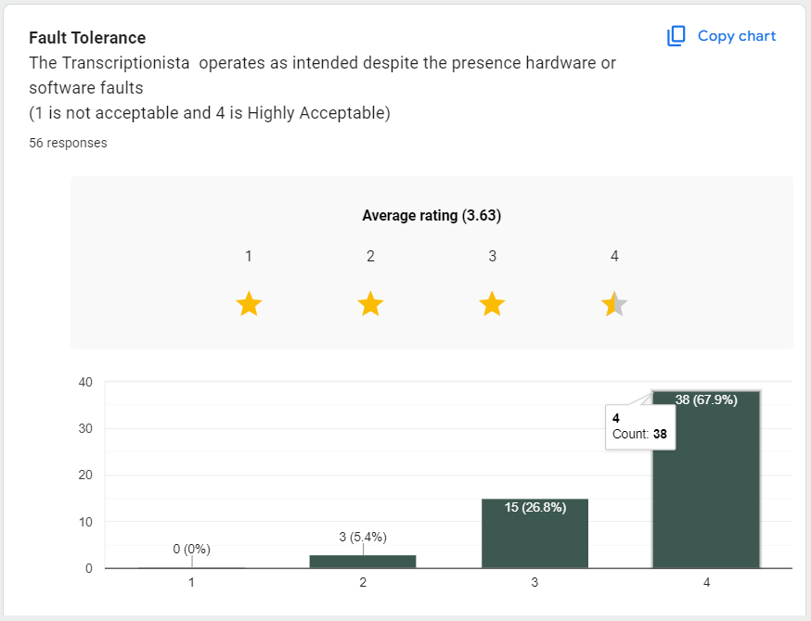
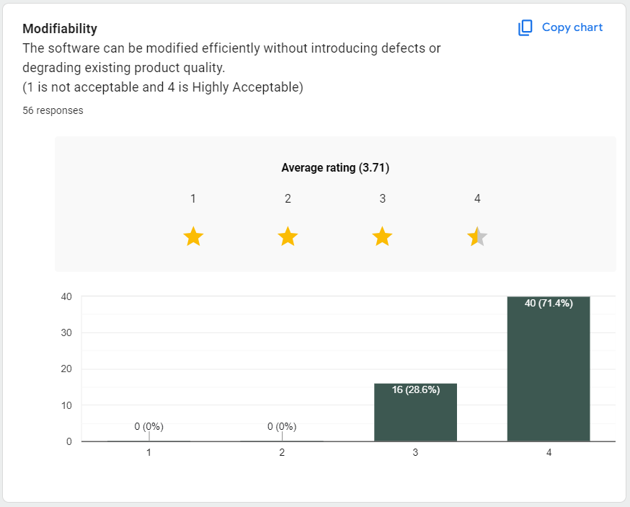
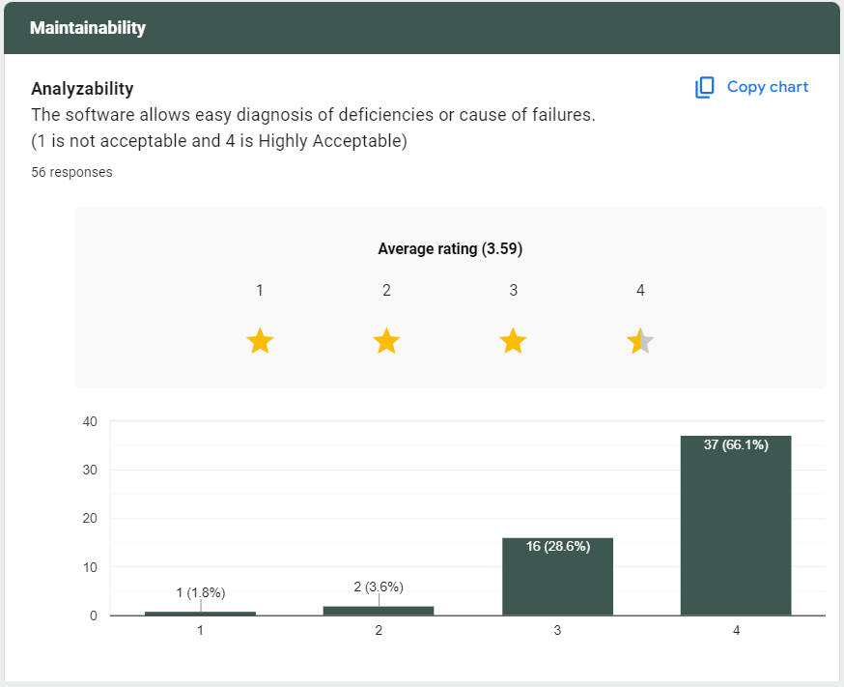
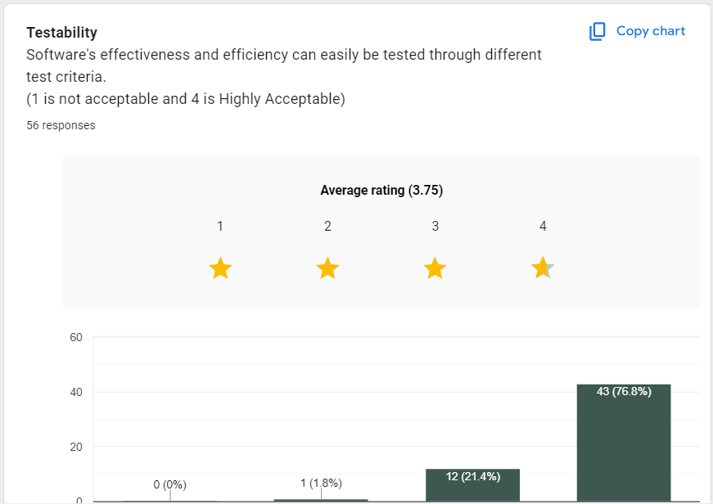
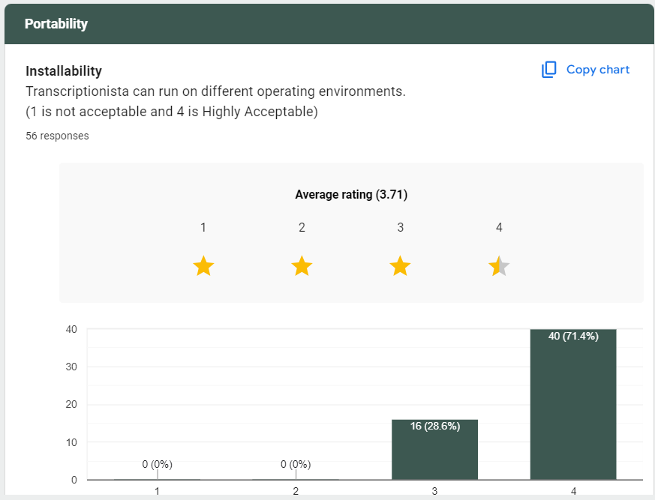

Appendix C

VIDEO INTRODUCTION TO TRANSCRIPTIONISTA

Link: https://www.canva.com/design/DAG49wTLbHs/-CZwbLwN2OJqoO_KmoTjhQ/edit?utm_content=DAG49wTLbHs&utm_campaign=designshare&utm_medium=link2&utm_source=sharebutton

Appendix D

THESIS GRAMMARIAN CERTIFICATION

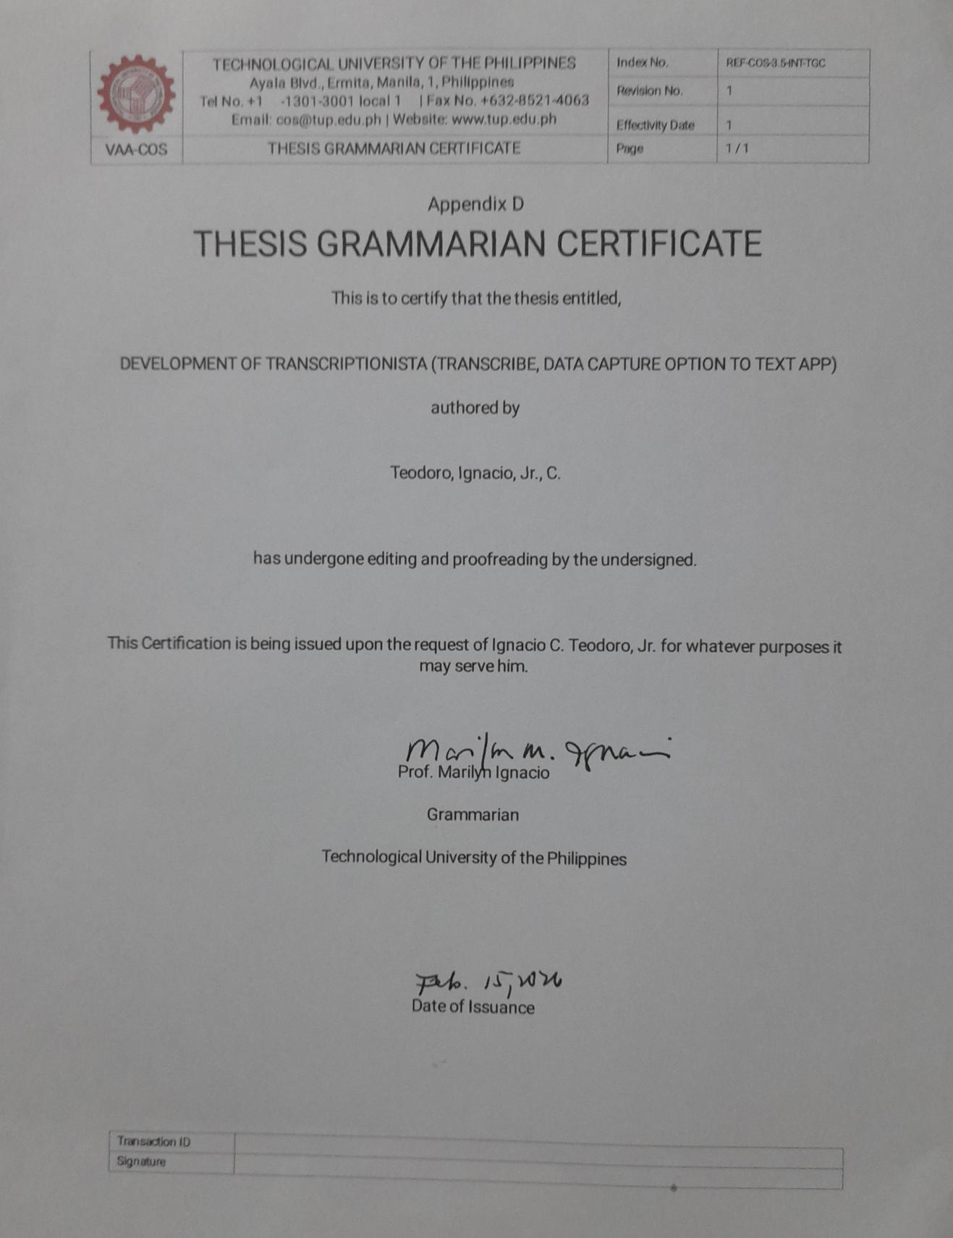

Appendix E

CERTIFICATE OF SIMILARITY INDEX USING TURNITIN

Appendix F

SYSTEM INTERFACE SCREENSHOTS

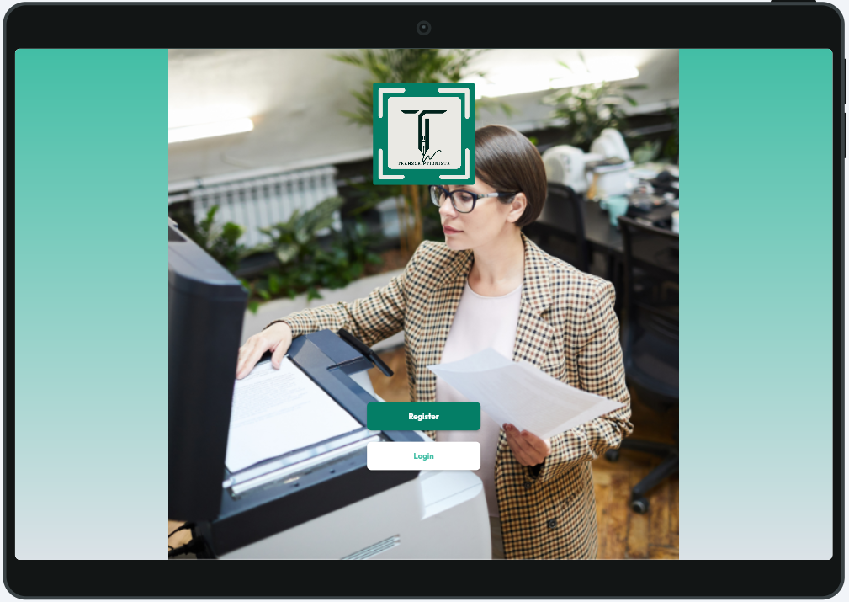

Figure 22: Home Page

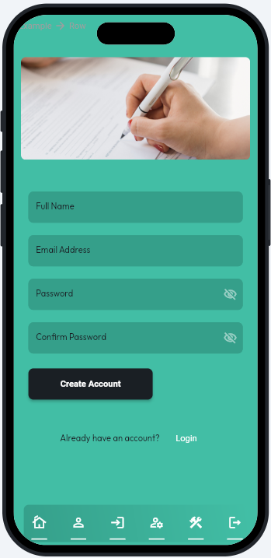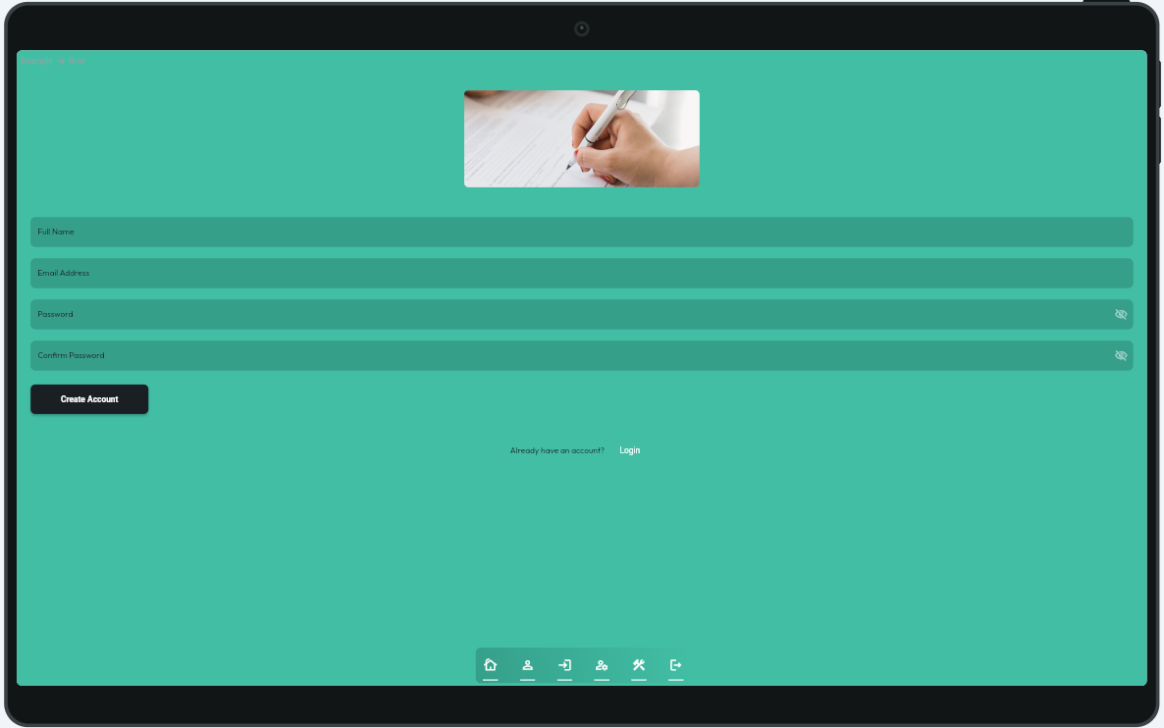

Figure 23: Register Screen

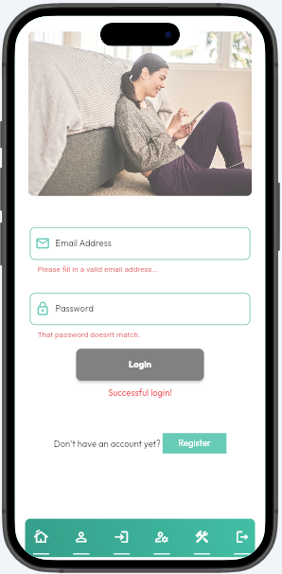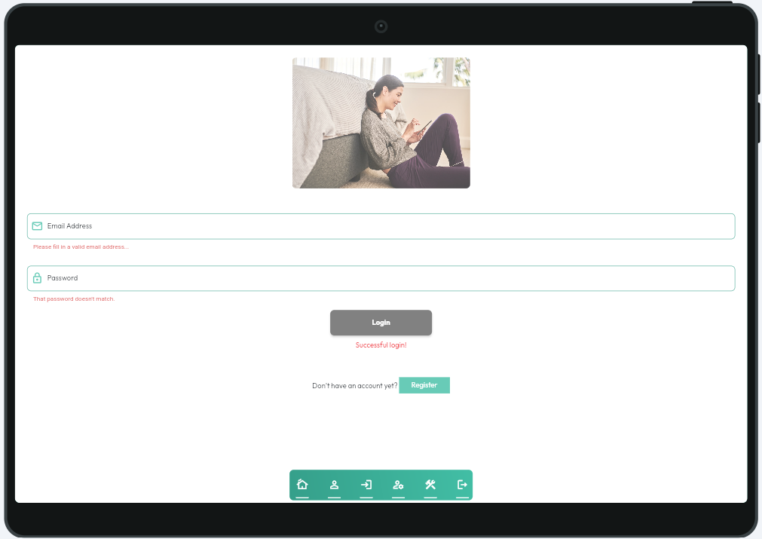

Figure 24: Login Screen

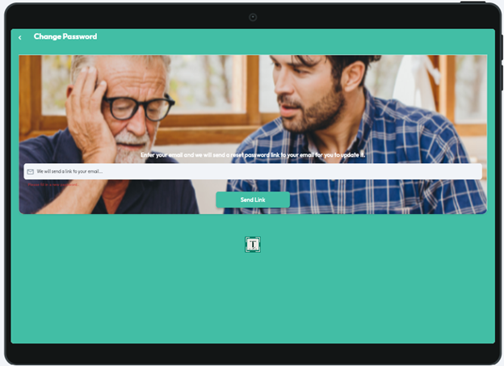

Figure 25: Change Password Screen

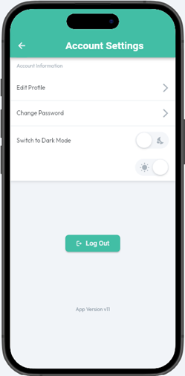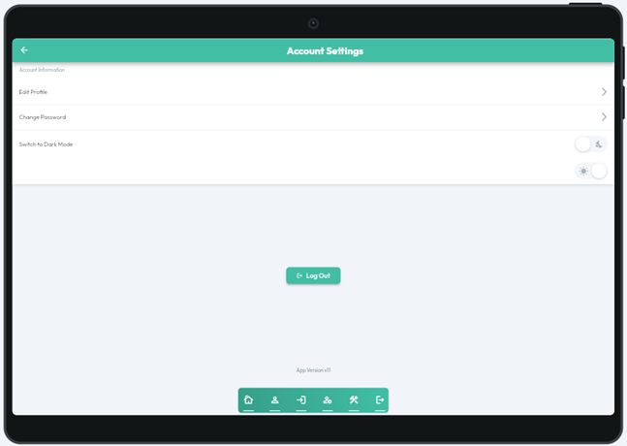

Figure 26: Account Settings Screen

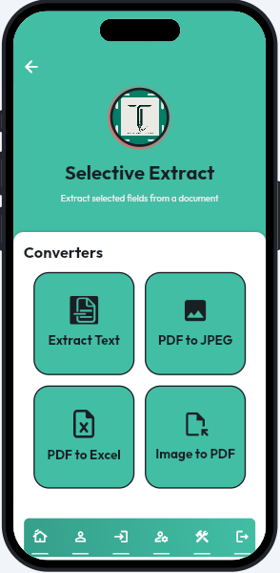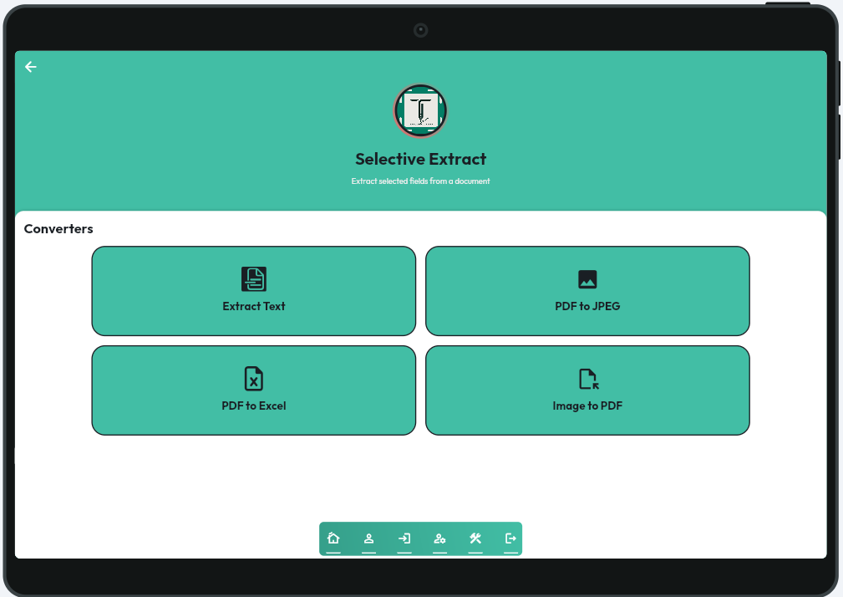

Figure 27 App Menu Screen

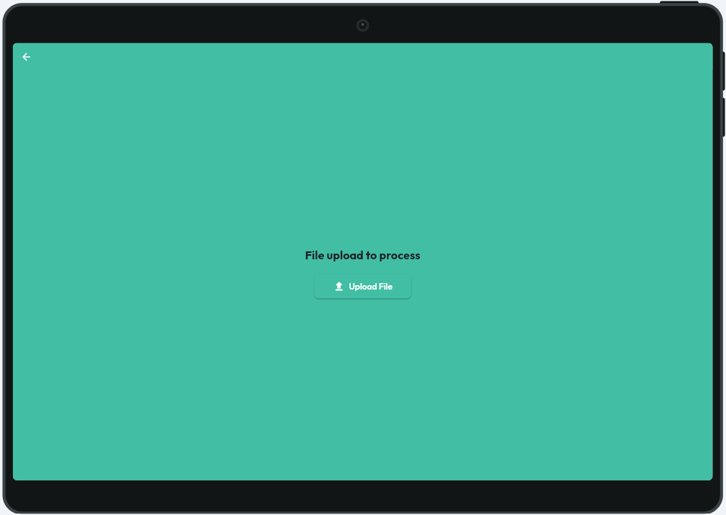

Figure 28: File Upload Screen


Figure 29: Input File Preview Screen



Figure 30: PDF – Image Converter Output Screen

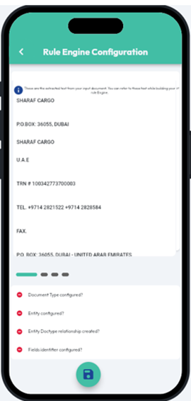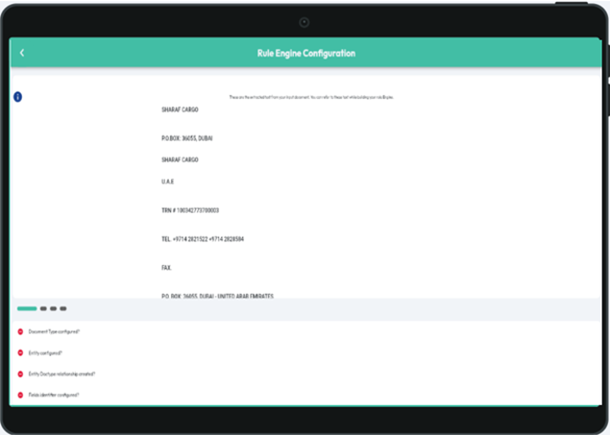

Figure 31: Extracted Text Screen – Rule Engine

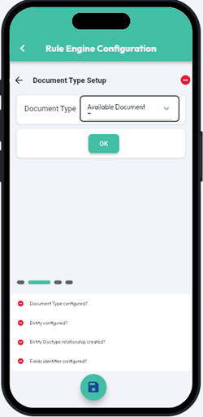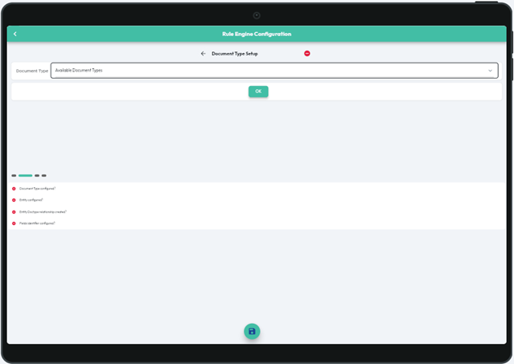

Figure 32: Document Type Configuration Screen – Rule Engine

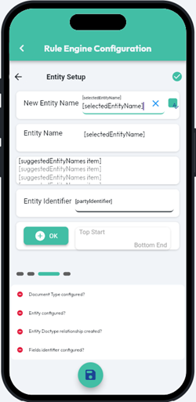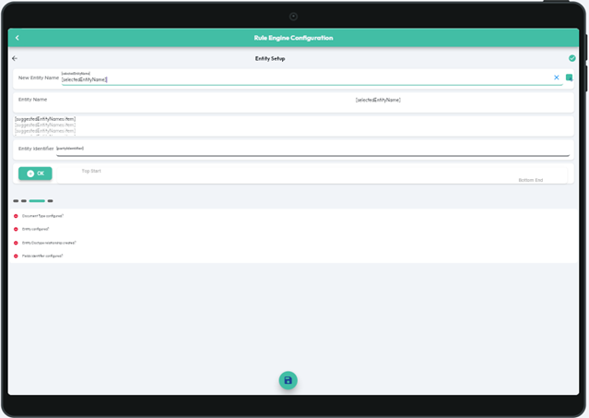

Figure 33: Entity Configuration Screen – Rule Engine

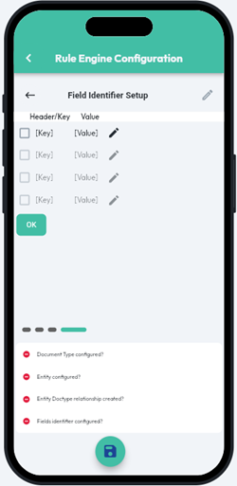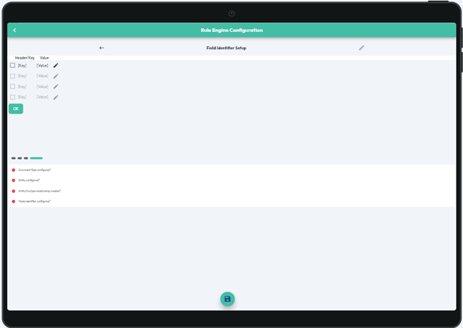

Figure 34: Field Identifier Configuration Screen – Rule Engine

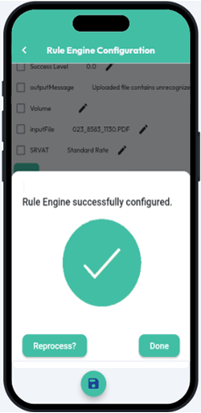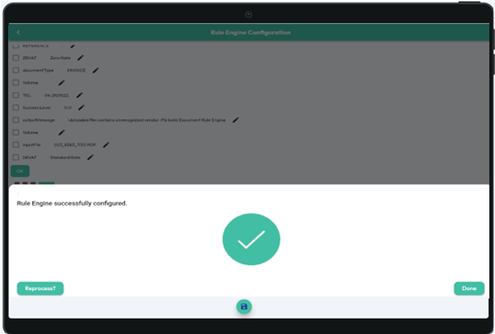

Figure 35: Completed Configuration Screen – Rule Engine

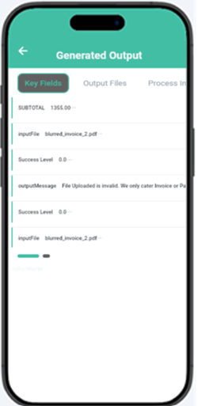

Figure 36: Key Fields Screen – Generated Output

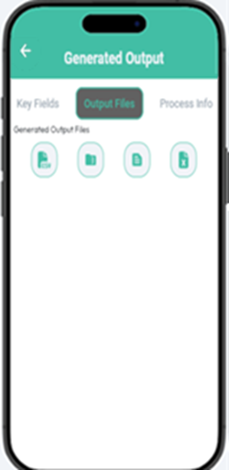

Figure 37: Output Files Screen – Generated Output

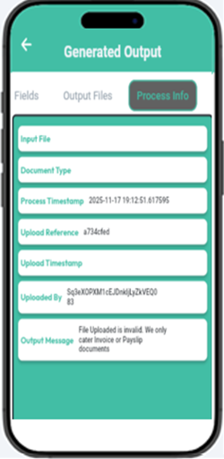

Figure 38: Process Info Screen – Generated Output

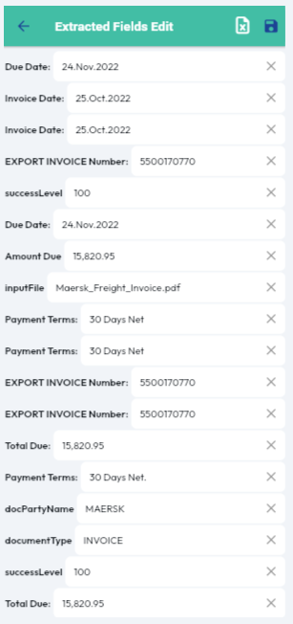

Figure 39: Edit-Before-Export Screen
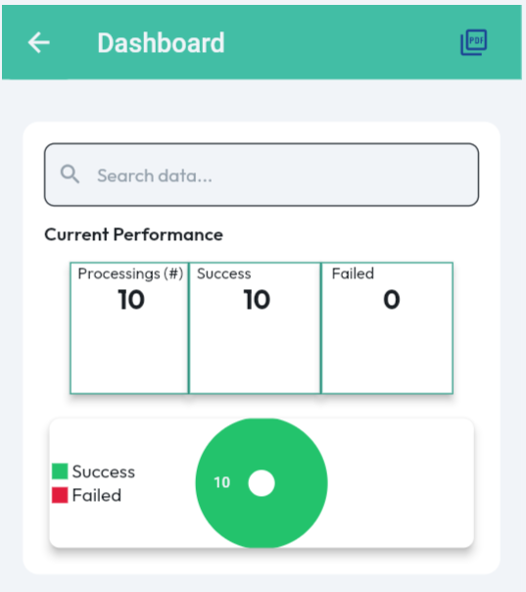
Figure 40: Dashboard Screen
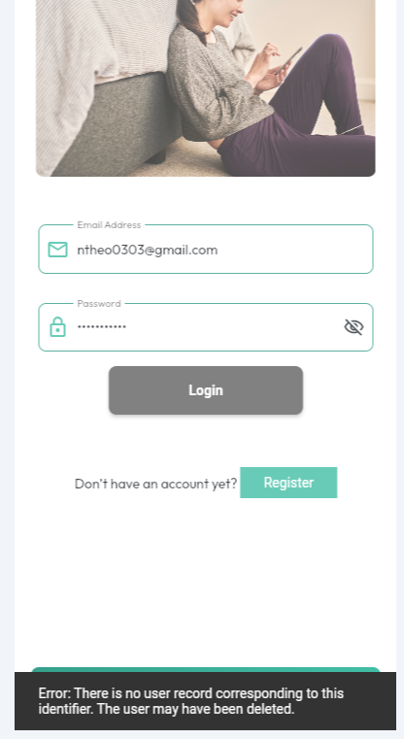
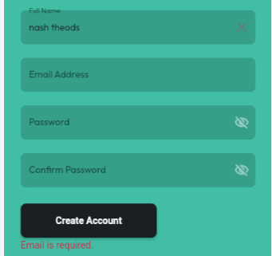
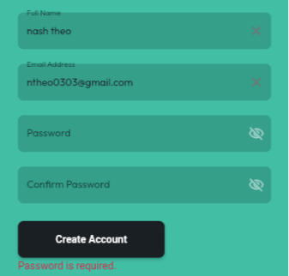
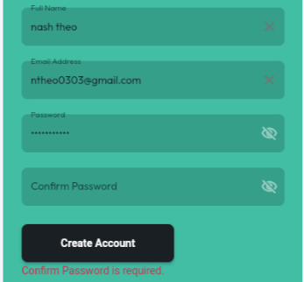
Figure 41: Validation & User Guidance – Invalid user credentials
Figure 42: Validation & User Guidance– Dynamic Inline validation
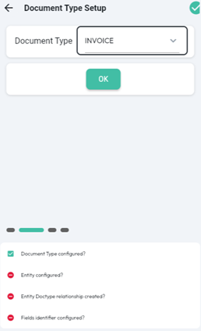
Figure 43: Status-Based Validation Guidance – Setup Readiness Check

Appendix G

RESEARCHER’S PROFILE


