**Land Intelligence System (LIS)**

**1. Introduction**

LIS is a revolutionary platform designed to simplify location scouting for everyone, from individuals seeking a new home to real estate professionals identifying prime investment opportunities.

By integrating vast amounts of geospatial, environmental, and socioeconomic data, LIS acts as an intelligent assistant, providing personalized location recommendations and proactively assessing potential risks. addresses the inefficiencies and hidden risks of traditional location analysis, empowering a diverse range of users to make informed decisions and contributing to smarter urban planning and more resilient communities.

Basically this idea is proposing many useful modules which has its own pros, this platform targets general population whom are looking for buying a house or renting it, or farm house, farm, apartments or even temporary visiting places due to vacations or emergency etc. and focusing on their preferences. Warning them against natural disasters.

**2. The Problem**

Traditional location scouting is plagued by information overload, hidden risks (especially natural disasters), mismatched preferences, and data-poor decisions. These challenges lead to inefficient processes, unforeseen problems, and costly mistakes. LIS aims to solve these by providing a comprehensive, intelligent system for location analysis.

**3. The Solution:**

**Land Intelligence System (LIS)**

LIS is a sophisticated platform that functions as a multi-faceted location intelligence engine. Users simply articulate their needs in natural language, and LIS delivers precise, data-backed recommendations by analyzing global geospatial data, historical environmental patterns, socioeconomic indicators, and infrastructure details.

Recommendations are presented on an interactive map with detailed explanations and risk assessments.

**7. LIS Modules**

**7.1. Land Analysis and Recommendation Module**

This module is the intelligent core, processing user preferences via natural language processing and generating personalized location recommendations. It uses multi criteria decision analysis and machine learning to evaluate suitability across various factors, employing ensemble methods and reinforcement learning for continuous improvement and uncertainty quantification.

<https://arxiv.org/abs/2505.08833>

<https://papers.ssrn.com/sol3/papers.cfm?abstract_id=5169176>

**7.2. Disaster Prediction and Risk Assessment Module**

This module implements state-of-the-art techniques for multi-hazard analysis and risk quantification. It supports multiple prediction models for different hazards (seismic, meteorological, hydrological), integrates climate change impact assessments, and provides advanced risk communication through visualizations and real-time monitoring.

<https://internationaljournalofdisasterriskmanagement.com/Vol1/article/view/145>

**7.3. Generative Spatial Intelligence for Urban Digital Twins**

This module adds a dynamic and predictive layer by integrating Generative Spatial Intelligence and Urban Digital Twins (UDT). It models and predicts urban evolution based on various 'flows' (mobility, resources), fills data gaps, forecasts future urban development, and enables scenario planning. It utilizes advanced generative models to create a 'Large Flow Model' (LFM) for sustainable smart cities [1].

<https://www.sciencedirect.com/science/article/pii/S2666498425000043>

**7.4. Human-Computer Interaction (HCI) for Urban Planning and Real Estate**

This module focuses on intuitive and effective user interfaces. It emphasizes conversational interfaces using large language models (LLMs) for natural interaction,

with potential for immersive visualization (VR/AR). The design prioritizes user-centered principles for accessibility and a positive user experience [2, 3, 4, 5].

<https://link.springer.com/chapter/10.1007/978-3-319-91797-9_8>

**7.5. Advanced Predictive Analytics for Real Estate and Property Valuation**

This module enhances financial intelligence by providing sophisticated predictive capabilities for real estate market trends and property valuation. It forecasts market movements, estimates property values based on comprehensive factors, identifies investment opportunities, and integrates financial risk assessment into recommendations [6, 7, 8, 9].

[**https://predikdata.com/predictive-modeling-the-new-real-estate-journey/**](https://predikdata.com/predictive-modeling-the-new-real-estate-journey/)

**11. Expected Impact**

LIS is expected to deliver a functional platform for superior location decisions, reduce risks in disaster-prone regions, integrate geospatial intelligence with advanced analytics, and demonstrate interdisciplinary skills. It aims to empower millions to find safer, more suitable places to live, work, and thrive.

**12. References**

[1] Huang, J., Bibri, S. E., & Keel, P. (2025). Generative spatial artificial intelligence for sustainable smart cities: A pioneering large flow model for urban digital twin. Environmental Science and Ecotechnology, 24, 100526. https://www.sciencedirect.com/science/article/pii/S2666498425000043 [2] Li, X., et al. (2023). Application of human–computer interaction virtual reality technology in urban cultural creative design. Scientific Reports, 13(1), 15007.

https://www.nature.com/articles/s41598-023-41566-8 [3] Wang, Y., et al. (2022). A framework for human-computer interactive street network design. Computers, Environment and Urban Systems, 94, 101799. https://www.sciencedirect.com/science/article/abs/pii/S0198971522000977 [4] Li, X., & Li, Y. (2018). The Application of Human-Computer Interaction in Smart City Planning. In Smart City Planning and Development (pp. 95-104). Springer, Cham. https://link.springer.com/chapter/10.1007/978-3-319-91797-9_8 [5] Huang, J., & Bibri, S. E. (2025). Understanding Human-LLM Interaction Patterns in Urban Planning. SSRN. https://papers.ssrn.com/sol3/papers.cfm?abstract_id=5169176 [6] The Close. (2024). Predictive Analytics Best Practices for Real Estate Agents. https://theclose.com/best real-estate-predictive-analytics-companies/ [7] Matellio Inc. (2024). How to Implement Predictive Analytics in Real Estate? https://www.matellio.com/blog/predictive analytics-in-real-estate/ [8] Predikdata. (n.d.). Predictive Analytics for Real Estate: Using Data for Strategic Decisions. https://predikdata.com/predictive-modeling-the new-real-estate-journey/ [9] Housing Wire. (2025). Predictive Analytics for Real Estate: Best Tools + Guide. https://www.housingwire.com/articles/predictive-analytics-real estate/ [10] Number Analytics. (2025). Mastering Spatial Data Visualization. https://www.numberanalytics.com/blog/mastering-spatial-data-visualization [11] CARTO. (2024). 24 of the best maps, visualizations & analysis from 2024. https://carto.com/blog/2024-best-maps-dataviz [12] GeoDa Center. (n.d.). GeoDa - An Introduction to Spatial Data Science. https://geodacenter.github.io/ [13] Chen, J., et al. (2025). Generative AI for Urban Planning: Synthesizing Satellite Imagery via Diffusion Models. arXiv preprint arXiv:2505.08833. https://arxiv.org/abs/2505.08833 [14] Ocal, F. E., & Torun, S. (2025). Leveraging Artificial Intelligence for Enhanced Disaster Response Coordination. International Journal of Disaster Risk Management, 7(1), 235-246. https://internationaljournalofdisasterriskmanagement.com/Vol1/article/view/145 [15] Urban AI. (2024). Urban Simulation + Generative AI. Medium. https://medium.com/urban-ai/urban-ai/urban-simulation-generative-ai-

0ee8086b0260

**Figure 1: Urban Digital Twin Visualization**

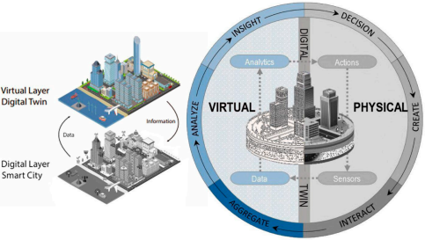

This image illustrates a complex urban digital twin, showcasing the integration of physical and virtual layers to model city dynamics. Such visualizations are crucial for understanding the intricate relationships within urban environments and are a demanding aspect of the Generative Spatial Intelligence module. [Source: MDPI]

**Figure 2: Geospatial AI for Urban Planning**

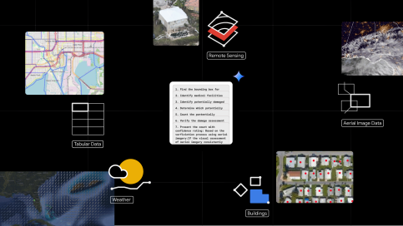

This visual demonstrates the application of geospatial AI in urban planning, highlighting how generative models can be used to synthesize satellite imagery and unlock insights for various urban challenges. This represents the advanced capabilities envisioned for the LIS. [Source: Google Research]

**Figure 3: Spatial Data Visualization Example**

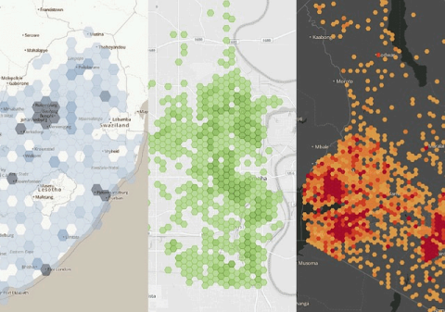

An example of advanced spatial data visualization, showcasing different methods to represent geospatial information. High-quality, interactive visualizations like these are essential for presenting the complex outputs of LIS in an intuitive and understandable way for both expert and layman users. [Source: SafeGraph]