RDA5855E Datasheet V1.01

RDA5855E Bluetooth Multi-Media Single-Chip Terminal

FEATURES

- External Memory Interface
Integrated 8Mbit(or 1MByte) Flash on chip Power efficient using retention technology to avoid floating lines
Flexible IO voltage

- Power Management
Power On reset control
Internal 32K OSC for standby/ shutoff/ sleep state
Battery charger (from USB or AC charger)
Integrated all internal voltages from VBAT Provide all LDOs for external components

- User Interface
ADC serial interface Keypad
- Connectivity
USB 1.1 Device, UART interface 1 SD controller I2C controller I2S controller
General Purpose I/Os
1 GPADC, 10bits, 1 channel

- Audio
1 channel voice ADC, 8kHz, 13 bits/sample for microphone
Voice DAC, 8kHz, 13 bits/sample for receiver
High fidelity Stereo DAC, up to 48kHz, 16 bits per sample
Stereo analog audio line input

- Debug
Host debug interface allowing non intrusive in depth investigation
GDB debugger
Execution logger and profiling through debug port
High level text based debugging using Host debug or USB

- FM
Integrated Broadcast FM tuner which can be tuned world-wide frequency band

- Bluetooth
Integrated Bluetooth SoC complaint with 2.1
+ EDR standard

APPLICATIONS







The high level of integration achieved on RDA5855E allows for highly integrated bluetooth music box and stereo headset without increasing the BOM.

RDA Microelectronics Inc. CONFIDENTIAL 1 / 72



RDA5855E Datasheet V1.01

GENERAL DESCRIPTION

A high performance, high integrated multi-media system-on-chip solution with Bluetooth connectivity.

RDA5855E is a high performance, highly integrated multi-media system-on-chip solution with bluetooth connectivity. This is a newer generation than 5851, which specialized in music and audio applications, such as bluetooth music boom box, bluetooth stereo headset, etc.

Integrating all essential electronic components, including baseband, bluetooth transceiver, power management, FM receiver onto a single system on chip, RDA5855E offers best in class bill of material, space requirement and cost/feature ratio for bluetooth music and audio application.

Built around a cost effective 32-bit XCPU RISC core running at up to 312MHz with 4k of Instruction cache and 4k of Data cache, RDA5855E offers plenty of processing power for multimedia applications. A high performance proprietary 16/32-bit digital signal processing engine can further improve overall performance and user experience when performing complex multimedia tasks.

It is also packed with impressive connectivity for easy scalability of the system, allowing glue less interfaces to SDMMC Memory Cards and USB (slave, full speed).

Additionally, RDA5855E integrates a FM tuner and a Bluetooth module which completely include digital, analogue and RF function. And they can easily work only with a few passive components as filter or matching network.

RDA5855E is available in a small footprint, fine pitch, 6.5 X 6.5, 81 ball TFBGA package.

RDA Microelectronics Inc. CONFIDENTIAL 2 / 72



RDA5855E Datasheet V1.01

Table of Contents

Features 1
Applications 1
General Description 2
- Architecture Overview 6
- Block Description 10
System Modules 10
System CPU (XCPU) 10
Memory Bridge 19
Operations 20
Direct Memory Access (DMA) 21
Page Spy 21
System Intelligent Flow Controller (Sys IFC) 21
AHB2APB bridge operation 22
DMA Operations 22
Debug channel operations 23
System Peripherals 24
System and Clock Control 24
Trace (Normal UART) and Host (Debug UART) Port 26
I2C 32
General Purpose Input Output 34
Keypad 34
Timers 34
Debug Port (EXL, PXTS, Signal Spy) 35
General Purpose Analog to Digital Converter (GP ADC) 35
Timing Control Unit and Low Power Synchronizer (TCU+LPS) 36
System AHB Monitor (Sys AHBC Mon) 36
System IRQ Controller (Sys IRQ) 37
USB Controller 37
SD/MMC Controller 38
Audio Interface Analog + I2S (AIF) 38
Digital Modules 39
Voice Coprocessor (VoC) 39
Analog Modules 39
SPI Interface for Analog IP control 39
Power Management Unit 40
Analog module (ABB) 45
FM 47
General Description 47
Features 47
Block Description 47
Receiver Characteristics 48
RDA Microelectronics Inc. CONFIDENTIAL 3 / 72
RDA5855E Datasheet V1.01
Bluetooth 49
General Description 49
Features 50
Block Description 50
Performance Characteristics 51
- Memory Map 54
- Pins Description 56
Pin-out 56
- Electrical Characteristics 60
Absolute Maximum Rating 60
Temperature Characteristics 60
Audio Characteristics 60
DC Characteristics 62
Digital IO DC Characteristics 67
Digital IO AC Characteristics (SPI Interface Timing) 68
- Packaging 70
- Ball Out 71
- Glossary 72




RDA Microelectronics Inc. CONFIDENTIAL 4 / 72



RDA5855E Datasheet V1.01

Figure Index
Figure B.1: XCPU Block Diagram 11
Figure B.2: Typical transfer operation 22
Figure B.3: Debug channel block diagram 24
Figure B.4: General Message Format 28
Figure B.5: Read Return Message Format 28
Figure B.6: Event Message Format 28
Figure B.7: Tx Switch STM 30
Figure B.8: IrDA SIR Data Format 30
Figure B.9: YUV 4:2:2 Subsampling 42
Figure B.10: SPI Write & Read Timing 46
Figure B.11: PMU Power ON 47
Figure B.12: POR triggered by POWKEY press 48
Figure B.13: Principle schematic for Power-Profiles usage 49
Figure B.14: Charging I-V Curve 51
Figure B.15: PLL Clock Path 52
Figure B.16: USB PHY FS 1.1 53
Figure B.17: GPADC Timing Diagram 54
Figure B.18: FM Tuner Block Diagram 55
Figure B.19: Bluetooth Block Diagram 57
Figure E.1: SCLK Timing Diagram 83
Figure E.2: SPI Write Timing Diagram 83
Figure E.3: SPI Read Timing Diagram 84
Figure G.1: RDA5855E Ball out diagram 86

RDA Microelectronics Inc. CONFIDENTIAL 5 / 72



RDA5855E Datasheet V1.01

- ARCHITECTURE OVERVIEW

RDA5855E is a single chip multi-media solution which integrates PMIC, Audio CODEC, FM, and Bluetooth, as well as all the system requirements for a multi-media platform.

  - Analog modules

    - Analog block:
      - PLL generates 624MHz from 26MHz
      - Differential 13 bit Audio ADC and 16 bit stereo DAC
      - Audio line in
      - Full Speed USB PHY 1.1
      - 1 Channel General Purpose ADC

    - PMU
      - Complete integrated power management system
      - Integrated LDO voltage regulators

- FM Tuner:
  - Support worldwide frequency band 65-108MHz
  - Digital low-IF tuner
  - Fully integrated digital frequency synthesizer
  - Autonomous search tuning
  - Digital auto gain control (AGC)
  - Digital adaptive noise cancellation
  - Programmable de-emphasis (50/75 ms)
  - Receive signal strength indicator (RSSI)
  - Bass boost
  - Volume control
- Bluetooth:
  - Completely integrates bluetooth radio transceiver and baseband processor
  - Also includes sub-controller software stack
  - Compliant with Bluetooth 2.1 + EDR specification

  - Digital Module

RDA5855E Digital Baseband is based on two processors: the system processor (XCPU) and the multi- media dedicated processor (BCPU). Each of these processor is on an AHB bus (AMBA AHB compliant). Those buses can communicate through an AHB to AHB interface module. Each AHB bus has a dedicated APB bus (AMBA APB compliant).

RDA Microelectronics Inc. CONFIDENTIAL 6 / 72



RDA5855E Datasheet V1.01

- Memory Bridge
  - internal ROM 20kB for critical constants and code, XCPU boot monitor
  - internal SRAM 64kB for critical data and code. Shared communication memory between the 2 CPUs
  - External Bus Controller (EBC)
16 bit data bus, up to 32MB memory space

- System Modules
  - System CPU (XCPU)

RDA RISC Core
32x32 bits Multiplier Accumulator (MAC) 16/32 bit instruction set
4 kByte Instruction Cache 4 kByte Data Cache
  - DSP Co-Processor (VoC)
Bi-MAC, dual operation unit
16-bit instruction set with 32-bit extension 20 kByte + 20 kByte data RAM on 32 bits 32 kByte instruction RAM on 32 bits
  - Direct Memory Access (DMA)
All size, all alignment and all source and destination possible 32-bit word pattern mode
  - Page Spy
Six memory spaces can be spied
  - System Intelligent Flow Controller (Sys IFC) 7 channels AHB2APB bridge
Four 8-bit or 32-bit DMA channels to accelerate data transfer between peripherals and memory
Dedicated specialized channels for DBG Host
  - Audio Interface (AIF) Tone generator
4 samples In and Out Fifos I2S / DAI Interface
Serial Input / Output at 8/16 ks/s
Can be used for test purpose in DAI mode Audio Interface
13 bit RX Data from audio ADC 16 bit TX Data to stereo DAC
  - SPI Flash Controller
Up to size 512Mb x 1, or 256Mb x 1, or 128Mb x 2
- System Peripherals
  - System, PLL and Clock Control (Sys & PLL & Clk Ctrl) Provides general controls over the whole system, including:
Reset controls
Power management controls Clock selection

RDA Microelectronics Inc. CONFIDENTIAL 7 / 72

RDA5855E Datasheet V1.01

- Host Port
Some debug features



Software Flow Control (XON/XOFF)
Host Port auto-reseted when a break is detected Multiplexed trace mechanism
Clock input allowing up to 1840kbps baud rate independent from the system clock Secured protocol with 8 bits CRC (no error correction)
- Serial Peripheral Interface (SPI)
Master interface with multi-chip selects 16 bytes FIFO
- I2C Master Peripheral Interface (I2C) Master interface
- General Purpose Input Output (GPIO)
- ADC serial Keypad
- SD/MMC Card Controller can support 2 peripherals
SD Card specification Version 2.0 SDIO Version 1.10
MMC specification Version 3.1
- Timers
1 Real Time Clock Timer (Calendar)
1 24 bits general purpose interval Timers at 16384Hz 1 32 bits uptime counter at 16384Hz
1 Watchdog Timer
- Debug Port
CPU Execution Logger (EXL): Generate strobe and output the selected CPU's program counter
Program Execution Time Stamp (PXTS): Allow to profile running code Hardware Signal Spy, selection of several hardware signal connected to pins. Access to the last PC of the selected CPU when a watchdog reset occurs
- General Purpose Analog to Digital Converter (GP ADC) 1 channel inputs
generate IRQ when programmed threshold is passed
- Timing Control Unit (TCU) Quarter bit precision 60 entries event table
- System AHB Monitor (Sys AHB Monitor)
Measure some bandwidth information from the System AHB bus: Global Bus usage
Master Bus usage and latency
Slave Bus usage and access duration Special resource measurement
Write detection to a single word location
- System IRQ Controller (Sys IRQ) Several masking levels:
Module level IRQ Control level

RDA Microelectronics Inc. CONFIDENTIAL 8 / 72




- BIST
Internal RAMs and ROM test to reduce testing cost in production
- USB Controller
Fully compliant to USB Specification Version 1.1 Slave Full Speed (12Mbps) Device




- BLOCK DESCRIPTION

System Modules

B.I.1 System CPU (XCPU)

The XCPU RISC is a 16/32-bits processor. Using a Reduced Instruction Set Architecture, an efficient 6-stage instruction pipeline and separated Instruction and Data caches, it provides high performance to the system. The Pipeline Stages are as follows:

    - PC. Program Counter. Calculate the address of the next instruction and send it to the instruction cache.
    - IF. Instruction Fetch. In this stage the instruction cache is being accessed and the instruction information is retrieved.
    - RF. Register File. The register file is being accessed and the instruction is decoded.
    - EX. Execution. The instruction is executed
    - DC. Data Memory read and write access.
    - WB. Write Back. Results are written back to the register file.

Features

    - RDA RISC Core.
      - 32x32-bit Multiplier.
      - 32x32-bit -> 64-bit Multiplier Accumulator (MAC) in 2 cycles (pipelined).
      - Read / Write Buffer.
      - 16/32 bit instruction set.
    - 32 interrupt sources.
    - 4 kByte Instruction Cache.
    - 4 kByte Data Cache.
    - 16 byte streaming buffer to accelerate uncached instruction accesses.

Block Diagram

AMBA AHB

System Interface
& Rd / Wr Buffer

System Interface
& Rd / Wr Buffer

Instruction Cache Data Cache

Instruction Cache

Data Cache

Exceptions
Address Translation

Exception Co-processor

Integer Pipeline
Memory Management







Multiply Instructions and Operands

Integer Pipeline

Memory Management

Exception Co-processor

Multiplier Divider

Figure B.1: XCPU Block Diagram

Multiplier Divider

- bit Instruction Set

Instruction Formats

The RISC processor supports three instruction formats:

R – Register base instruction format
  - RD –Target register
  - RS – First operand
  - RT – Second operand
  - SHAMT – Shift amount for shift instructions
  - S Code – Instruction code for R type Instructions

31 | 30 | 29 | 28 | 27 | 26 | 25 | 24 | 23 | 22 | 21 | 20 | 19 | 18 | 17 | 16 | 15 | 14 | 13 | 12 | 11 | 10 | 9 | 8 | 7 | 6 | 5 | 4 | 3 | 2 | 1 | 0
0 |  |  |  |  |  | RS |  |  |  |  | RT |  |  |  |  | RD |  |  |  |  | SHAMT |  |  |  |  | S Code

I – Immediate operand instruction format
- Opcode –Instruction Code
- RS – Source or Base register
- RT – Target Register or Reg-Immediate




- Immediate – 16 bit Immediate or Displacement

31 | 30 | 29 | 28 | 27 | 26 | 25 | 24 | 23 | 22 | 21 | 20 | 19 | 18 | 17 | 16 | 15 | 14 | 13 | 12 | 11 | 10 | 9 | 8 | 7 | 6 | 5 | 4 | 3 | 2 | 1 | 0
Opcode |  |  |  |  |  | RS |  |  |  |  | RT |  |  |  |  | Immediate

J – Jump instruction format
- Opcode –Instruction Code
- Jump Immediate – Immediate 26 bit for jump instruction address

31 | 30 | 29 | 28 | 27 | 26 | 25 | 24 | 23 | 22 | 21 | 20 | 19 | 18 | 17 | 16 | 15 | 14 | 13 | 12 | 11 | 10 | 9 | 8 | 7 | 6 | 5 | 4 | 3 | 2 | 1 | 0
Opcode |  |  |  |  |  | Jump Immediate

Supported Instructions

Arithmetic Instructions.

Name | Type | Description | Opcode | S-Code
ADD | R | RD = RS + RT | 0x00 | 0x20
ADDU | R | Unsigned[RD = RS + RT] | 0x00 | 0x21
SUB | R | RD = RS – RT | 0x00 | 0x22
SUBU | R | Unsigned[ RD = RS – RT] | 0x00 | 0x23
ADDI | I | RT = RS + Signed(Immediate) | 0x08 | n/a
ADDIU | I | RT = RS + Unsigned(Immediate) | 0x09 | n/a

Logical Instructions. Logical instructions are all bit wise operations.

Name | Type | Description | Opcode | S-Code
AND | R | RD = RS and RT | 0x00 | 0x24
OR | R | RD = RS or RT | 0x00 | 0x25
XOR | R | RD = RS xor RT | 0x00 | 0x26
NOR | R | RD = not(RS or RT) | 0x00 | 0x27
ANDI | I | RT = RS and Zero-extend(Immediate) | 0x0c | n/a
ORI | I | RT = RS or Zero-extend(Immediate) | 0x0d | n/a
XORI | I | RT = RS xor Zero-extend(Immediate) | 0x0e | n/a

Shift Instructions.




Name | Type | Description | Opcode | S-Code
SLL | R | RD = RS << SHAMT | 0x00 | 0x00
SRL | R | RD = RS >> SHAMT | 0x00 | 0x02
SRA | R | RD = signed(RS) >> SHAMT | 0x00 | 0x03
SLLV | R | RD = RS << (RT) | 0x00 | 0x04
SRLV | R | RD = RS >> (RT) | 0x00 | 0x06
SRAV | R | RD = signed(RS) >> (RT) | 0x00 | 0x07

Conditional Set Instructions. These instructions are used for magnitude conditional test. If the condition is true, the result register is set to 0x1 otherwise it is set to 0x0.

Name | Type | Description | Opcode | S-Code
SLT | R | RD = 0x1 if(RS < RT) | 0x00 | 0x2a
SLTU | R | RD = 0x1 when unsigned (RS < RT) | 0x00 | 0x2b
SLTI | I | RD = 0x1 when (RS < signed(Immediate)) | 0x0a | n/a
SLTIU | I | RD = 0x1 when unsigned (RS < signed(Immediate)) | 0x0b | n/a

Branch Instructions. BEQ and BNE test 2 operands for equal and non equal conditions. The rest of the branch instructions test a single operand with 0. BLTZAL and BGEZAL save the address of the instruction following the delay slot in R31.

Name | Type | Description | Opcode | S-Code
BEQ | I | Branch to ((Immediate + 1) << 2) when RS = RT | 0x04
BNE | I | Branch to ((Immediate + 1) << 2) when RS != RT | 0x05
BGEZ | I | Branch to ((Immediate + 1) << 2) when RS >= 0 | 0x01 | 0x01
BLEZ | I | Branch to ((Immediate + 1) << 2) when RS <= 0 | 0x06 | n/a
BGTZ | I | Branch to ((Immediate + 1) << 2) when RS > 0 | 0x07 | n/a
BLTZ | I | Branch to ((Immediate + 1) << 2) when RS < 0 | 0x01 | 0x00
BLTZAL | I | Branch to ((Immediate + 1) << 2) when RS < 0 | 0x01 | 0x10
BGEZAL | I | Branch to ((Immediate + 1) << 2) when RS >= 0 | 0x01 | 0x11

Jump Instructions. Jump is performed by combining bit (31:28) of PC with the J_IMME field of the instructions and 0b00 to form the target address. Link instructions also save the address of the instruction following the branch delay slot in R31.

Name | Type | Description | Opcode | S-Code
J | J | Jump | 0x02 | n/a
JAL | J | Jump and link | 0x03 | n/a
JR | R | Jump register | 0x00 | 0x08
JALR | R | Jump register and link | 0x00 | 0x09




Move To and From Multiply and Divide registers.

Name | Type | Description | Opcode | S-Code
MFHI | R | Move from High | 0x00 | 0x10
MTHI | R | Move to High | 0x00 | 0x11
MFLO | R | Move from Low (RS = Low) | 0x00 | 0x12
MTLO | R | Move to Low (Low = RS) | 0x00 | 0x13

Multiply and Divide Instructions.

Name | Type | Description | Opcode | S-Code
MULT | R | Multiply (Low, High) = RS x RT | 0x00 | 0x18
MULTU | R | Multiply unsigned (Low, High) = RS x RT | 0x00 | 0x19
DIV | R | Divide (Low, High) = RS x RT | 0x00 | 0x1a
DIVU | R | Divide unsigned (Low, High) = RS x RT | 0x00 | 0x13

Load Upper Immediate.

Name | Type | Description | Opcode | S-Code
LUI | I | RT[31:16] = Immediate | 0x0f

Load and Store Instructions. The address for the load or store is calculated by adding the DISP field to the content of RS. The value read from or written to the memory is from RT.

Name | Type | Description | Opcode | S-Code
LB | I | Load Byte (sign extend) | 0x20
LH | I | Load Half (sign extend) | 0x21
LW | I | Load Word | 0x23
LBU | I | Load Byte (unsigned) | 0x24
LHU | I | Load Half (unsigned) | 0x25
SB | I | Store Byte | 0x28
SH | I | Store Half | 0x29
SW | I | Store Word | 0x2b

Miscellaneous. In addition to the standard instructions described above, the RISC processor supports the following instructions.

Name | Type | Description | Opcode | S-Code
CACHE | n/a | See the code below. | 0x2f

Cache instruction format:




31 | 30 | 29 | 28 | 27 | 26 | 25 | 24 | 23 | 22 | 21 | 20 | 19 | 18 | 17 | 16 | 15 | 14 | 13 | 12 | 11 | 10 | 9 | 8 | 7 | 6 | 5 | 4 | 3 | 2 | 1 | 0
Opcode |  |  |  |  |  | OP1 |  |  |  |  |  |  |  |  |  |  |  | Address |  |  |  |  |  |  |  |  |  |  | Code

Name | Description
Code Bits [2:0] | Command code as follows:  "000" invalidate all lines of both caches ('A' is ignored)  "001" invalidate all lines of icache ('A' is ignored, dcache is unaffected) "010" invalidate all lines of dcache ('A' is ignored, icache is unaffected) “011” not specified, do not use.  "100" invalidate an Icache line whos address is specified by register OP1  "101" invalidate a single line specified by 'A' from icache "110" invalidate a single line specified by 'A' from dcache  "111" invalidate a Dcache line whos address is specified by register OP1
Address Bits [13:3]  or bits [11:3]  or bits [9:3] | The cache line byte address to invalidate. The actual bits used are (RAM_HIGH downto TAG_LOW).  The XCPU has a 4K of data and instruction cache with 4W line, so the bits used are (11 downto 3). The BCPU has a 1K of data and instruction cache with 4W line, so the  bits used are (9 downto 3).
OP1 Bits [25:21] | Register operand. The content of the CPU register is used as the Address parameter.
Opcode Bits [31:26] | Value: 0x2f.

MAC Instructions. The multiply and accumulate (MAC) option adds supports for the following instructions.

Name | Type | Description | Opcode | S-Code
MADD | R | Signed multiply and accumulate.  {hi, lo} = {hi, lo} + RS * RT | 0x00 | 0x1c
MADDU | R | Unsigned multiply and accumulate.  {hi, lo} = {hi, lo} + RS * RT | 0x00 | 0x1d
MSUB | R | Signed multiply and subtract.  {hi, lo} = {hi, lo} - RS * RT | 0x00 | 0x1e
MSUBU | R | Unsigned multiply and subtract.  {hi, lo} = {hi, lo} - RS * RT | 0x00 | 0x1f

16-bit Instruction Set

The 16 Bit Instruction mode is an option in the configuration file. This chapter assumes that the user chose to enable this mode. The 16 bit instruction set is provided for situations where reducing code size is a priority.

16 Bit and 32 Bit Instruction Modes

The processor determines the Instruction Mode base on bit 0 of the address of the instruction. When bit 0 of the address of the instruction is 0, the processor is in 32 bit mode, and it interprets the instruction as a 32 bit instruction. When bit 0 of the address of the instruction is set, the processor is in 16 bit mode, and it interprets the instruction as a 16 bit instruction.

In this 32 bit mode:




- The instruction counter is incremented by 4 from 1 instruction to the next.
- For Branch and Link instructions, the processor save the address of the instruction + 8 as the return address. This is the instruction after the delay slot.
- The processor will take an Illegal Instruction Exception, if either bit 0 or bit 1 are set.

In this 16 bit mode:

- The instruction counter is incremented by 2 from 1 instruction to the next.
- For Branch and Link instructions, the processor save the address of the instruction + 4 as the return address. This is the instruction after the delay slot.
- The processor passes bit 1 of the instruction address to the memory subsystem. Bit 0 is always sent as 0 to the memory subsystem.

Switching between 32 Bit and 16 Bit modes.

To switch between the modes, bit 0 of the instruction address must be changed from 1 to 0 and back. There are 2 basic mechanisms to achieve this.

JALX instruction. This instruction exists in both 32 bit and 16 bit modes. In addition to changing the execution path to the target address, it also toggles bit 0 of the instruction and hence the mode.

JR, JALR instructions. These instructions take the 32 bit contents of a register and use it as the target address. Bit 0 of the register can be set to reflect the mode of the instructions at the target address.

The 16 Bit Mode Instructions

The following instructions are supported:

Name | 15 .. 11 | 10 | 9 | 8 | 7 | 6 | 5 | 4 | 3 | 2 | 1 | 0
ADDIU2 | 0 1 0 0 1 | rx |  |  | imm8
ADDIU3 | 0 1 0 0 0 | rx |  |  | ry |  |  | 0 | imm4
ADDIUPC | 0 0 0 0 1 | rx |  |  | imm8
ADDIU2SP | 0 1 1 0 0 | 0 | 1 | 1 | imm8
ADDIU3SP | 0 0 0 0 0 | rx |  |  | imm8
ADDU3 | 1 1 1 0 0 | rx |  |  | ry |  |  | rz |  |  | 0 | 1
AND | 1 1 1 0 1 | rx |  |  | ry |  |  | 0 | 1 | 1 | 0 | 0
B | 0 0 0 1 0 | offset
BEQZ | 0 0 1 0 0 | rx |  |  | offset
BNEZ | 0 0 1 0 1 | rx |  |  | offset
BREAK | 1 1 1 0 1 | code |  |  |  |  |  | 0 | 0 | 1 | 0 | 1
BTEQZ | 0 1 1 0 0 | 0 | 0 | 0 | offset
BTNEZ | 0 1 1 0 0 | 0 | 0 | 1 | offset
CMP | 1 1 1 0 1 | rx |  |  | ry |  |  | 0 | 1 | 0 | 1 | 0
CMPI | 0 1 1 1 0 | rx |  |  | imm8
DIV | 1 1 1 0 1 | rx |  |  | ry |  |  | 1 | 1 | 0 | 1 | 0
DIVU | 1 1 1 0 1 | rx |  |  | ry |  |  | 1 | 1 | 0 | 1 | 1
EXTEND | 1 1 1 1 0 | imm(10:5) |  |  |  |  |  | imm(15:11)
JAL | 0 0 0 1 1 | 0 | target(20:16) |  |  |  |  | target(25:21)
JAL 2nd | target(15:0)




Name | 15 .. 11 | 10 | 9 | 8 | 7 | 6 | 5 | 4 | 3 | 2 | 1 | 0
JALR | 1 1 1 0 1 | rx |  |  | 0 | 1 | 0 | 0 | 0 | 0 | 0 | 0
JALRC | 1 1 1 0 1 | rx |  |  | 1 | 1 | 0 | 0 | 0 | 0 | 0 | 0
JALX | 0 0 0 1 1 | 1 | target(20:16) |  |  |  |  | target(25:21)
JALX 2nd | target(15:0)
JRRA | 1 1 1 0 1 | 0 | 0 | 0 | 0 | 0 | 1 | 0 | 0 | 0 | 0 | 0
JRRAC | 1 1 1 0 1 | 0 | 0 | 0 | 1 | 0 | 1 | 0 | 0 | 0 | 0 | 0
JRRX | 1 1 1 0 1 | rx |  |  | 0 | 0 | 0 | 0 | 0 | 0 | 0 | 0
JRRXC | 1 1 1 0 1 | rx |  |  | 1 | 0 | 0 | 0 | 0 | 0 | 0 | 0
LI | 0 1 1 0 1 | rx |  |  | offset
LB | 1 0 0 0 0 | rx |  |  | ry |  |  | offset
LBU | 1 0 1 0 0 | rx |  |  | ry |  |  | offset
LH | 1 0 0 0 1 | rx |  |  | ry |  |  | offset
LHU | 1 0 1 0 1 | rx |  |  | ry |  |  | offset
LW | 1 0 0 1 1 | rx |  |  | ry |  |  | offset
LWPC | 1 0 1 1 0 | rx |  |  | offset
LWSP | 1 0 0 1 0 | rx |  |  | offset
MFHI | 1 1 1 0 1 | rx |  |  | 0 | 0 | 0 | 1 | 0 | 0 | 0 | 0
MFLO | 1 1 1 0 1 | rx |  |  | 0 | 0 | 0 | 1 | 0 | 0 | 1 | 0
MOVEmt32 | 0 1 1 0 0 | 1 | 0 | 1 | r32(2:0) |  |  | r32(4:3) |  | rz
MOVEmf32 | 0 1 1 0 0 | 1 | 1 | 1 | ry |  |  | r32
MULT | 1 1 1 0 1 | rx |  |  | ry |  |  | 1 | 1 | 0 | 0 | 0
MULTU | 1 1 1 0 1 | rx |  |  | ry |  |  | 1 | 1 | 0 | 0 | 1
NEG | 1 1 1 0 1 | rx |  |  | ry |  |  | 0 | 1 | 0 | 1 | 1
NOT | 1 1 1 0 1 | rx |  |  | ry |  |  | 0 | 1 | 1 | 1 | 1
OR | 1 1 1 0 1 | rx |  |  | ry |  |  | 0 | 1 | 1 | 0 | 1
RESTORE | 0 1 1 0 0 | 1 | 0 | 0 | 0 | ra | s0 | s1 | frame size
SAVE | 0 1 1 0 0 | 1 | 0 | 0 | 1 | ra | s0 | s1 | frame size
SB | 1 1 0 0 0 | rx |  |  | ry |  |  | offset
SDBBP | 1 1 1 1 0 | code |  |  |  |  |  | 0 | 0 | 0 | 0 | 1
SEB | 1 1 1 0 1 | rx |  |  | 1 | 0 | 0 | 1 | 0 | 0 | 0 | 1
SEH | 1 1 1 0 1 | rx |  |  | 1 | 0 | 1 | 1 | 0 | 0 | 0 | 1
SH | 1 1 0 0 1 | rx |  |  | ry |  |  | offset
SLL | 0 0 1 1 0 | rx |  |  | ry |  |  | sa |  |  | 0 | 0
SLLV | 1 1 1 0 1 | rx |  |  | ry |  |  | 0 | 0 | 1 | 0 | 0
SLT | 1 1 1 0 1 | rx |  |  | ry |  |  | 0 | 0 | 0 | 1 | 0
SLTI | 0 1 0 1 0 | rx |  |  | imm8
SLTIU | 0 1 0 1 1 | rx |  |  | imm8
SLTU | 1 1 1 0 1 | rx |  |  | ry |  |  | 0 | 0 | 0 | 1 | 1




Name | 15 .. 11 | 10 | 9 | 8 | 7 | 6 | 5 | 4 | 3 | 2 | 1 | 0
SRA | 0 0 1 1 0 | rx |  |  | ry |  |  | sa |  |  | 1 | 1
SRAV | 1 1 1 0 1 | rx |  |  | ry |  |  | 0 | 0 | 1 | 1 | 1
SRL | 0 0 1 1 0 | rx |  |  | ry |  |  | sa |  |  | 1 | 0
SRLV | 1 1 1 0 1 | rx |  |  | ry |  |  | 0 | 0 | 1 | 1 | 0
SUBU | 1 1 1 0 1 | rx |  |  | ry |  |  | rz |  |  | 1 | 1
SW | 1 1 0 1 1 | rx |  |  | ry |  |  | offset
SWSPRX | 0 1 1 0 0 | rx |  |  | offset
SWSPRA | 0 1 1 0 0 | 0 | 1 | 0 | offset
XOR | 1 1 1 0 1 | rx |  |  | ry |  |  | 0 | 1 | 1 | 1 | 0
ZEB | 1 1 1 0 1 | rx |  |  | 0 | 0 | 0 | 1 | 0 | 0 | 0 | 1
ZEH | 1 1 1 0 1 | rx |  |  | 0 | 0 | 1 | 1 | 0 | 0 | 0 | 1

Memory Map

Processor Address Mapping

The addresses are all byte addresses. The Size description is also in byte. The processor offers four different memory spaces.

Segment Name | Base Address | Size | Description
kseg2 | 0xc000,0000 | 0x4000,0000 | 1 GB mapped and cached
kseg1 | 0xa000,0000 | 0x2000,0000 | 0,5 GB unmapped and uncached
kseg0 | 0x8000,0000 | 0x2000,0000 | 0,5 GB unmapped and cached
kuseg | 0x0000,0000 | 0x8000,0000 | 2 GB mapped and cached

Note that kuseg and kseg2 are available only with the use of a MMU. As there is no MMU in RDA5855E, attempts to access those memory segments will trigger an exception.

Memory Access Types

In case of cache miss, a cached access will occur and a full line of 4 x 32 bits ( = 16 bytes) will be loaded.

An uncached access will be a single access or a streaming buffer fill (16 bytes), in case of a streaming buffer miss, if this feature is enabled. A configuration bit allows to enable / disable the streaming feature.

Multiplier & Divider

The RISC processor’s multiplier unit implements a 2 cycle fall through algorithm.

The divider uses a step divide algorithm, which takes 36 cycles to complete a divide operation.




Memory Bridge

The memory bridge is the interface to general memory used by the system, including internal rom, internal sram and access to external memory.

Features

  - Dual AHB Slave
    - A rom/sram controller
    - An Asynchronous FIFO to external controller
  - The bridge is implemented as a crossbar between the 2 AHB and the 2 controller (rom/sram and FIFO)
  - The rom/sram controller can insert wait cycle to the AHB Slave (to manage read/write conflicts and to allow using slower instance if needed).
  - The rom/sram controller integrate a BIST engine to test the ROM by computing a CRC and test the rams with the March C algorithm
  - All AHB burst size are supported
    - Wrap will be split at wrap address
    - Burst longer than the data buffer size of the FIFO will be split
    - Read INCR will read a fixed data size
  - FIFO data buffer can store 2 requests either read or write (each 4x32 bytes) from either AHB slave interface.
  - APB slave for configuration

External Bus Controller Features

  - The controller handles 16 bits data bus width only, however 8 bit memory chips can still be used; by groups of 2. 8 bit peripherals must be connected to the 8 LSBs of data and accessed through even addresses only.
  - Manage page mode SRAM or FLASH.
  - Manage burst mode PseudoSRAM.
  - Manage AD-Mux and AD-Mux burst mode PseudoSRAM.
  - 1 Control Register Enable (M_CRE) Output pin in same power domain than other memory IO for PseudoSRAM register control.
  - FIFO interface for address/data path
  - APB interface for configuration (subset of the mem bridge APB address space)

AHB Master Features

  - AHB Compliant master
  - except the 1K crossing limit defined by AMBA (additional logic required)
  - Memory space divided in 5 spaces with a base address for each (aligned on n Word address, n=FIFO data buffer size)
  - Do not use WRAP (due to FIFO organization)
  - use INCR4, SINGLE or INCR (for 2 or 3 data only) burst type
  - FIFO interface for address/data path
  - APB interface for configuration (subset of the mem bridge APB address space)
  - External clock is provided from outside the IP (and synthesized in the outside clock tree)




Operations

Dual AHB Operation

The Slave allow simultaneous access to rom/sram controller and FIFO from the two slaves. Access to the rom/sram controller are sequenced using WAIT on AHB (HReady low).
Access to the FIFO are sequenced using split when the FIFO busy on the other AHB slave (other split conditions are described bellow in FIFO Operation section).

Arbitration in case of simultaneous access to the same controller: Should try to serve each side (BB and Sys) alternatively.
Simultaneous access to rom/sram controller: memorize the last accepted burst. when the two arrives exactly
simultaneously reply wait to the memorized side and process the other side.
Simultaneous access to FIFO: First serve read of data if data are available for this read. Serve the side that did not enter the FIFO on last Burst in priority.

FIFO Operation

The FIFO can store 2 requests either read or write from either AHB Slave interface. But only one at a time. For each request there is an associated Write Data Buffer and a Read Data Buffer.

If the FIFO is full the master is split, this master will be released when one spot is free in the FIFO (all masters split because FIFO was full are released at the same time).

Write
A burst is stored to the Data buffer until the burst is finished. If the Data buffer is full or the Wrap address of a wrap burst is reached, the Split response is send (the master will be released in the same condition as above).

Read
The request is stored (address, length ...) and the master is split.
The master will be released when the Data buffer has been filled by the external controller (EBC or AHB Master). When the Master comes back, the Data are provided, if the master end the burst the transfer is complete (even
if there is still some data in the buffer, in this case they are lost) if the master request more than the available
Data it receive the Split response and will be released in the same conditions as for FIFO full: the request is not stored.

FIFO Flush status: Read in FIFO at special address space does not impact the external controller but returns when the command has reached the end of the FIFO (so the read returns only when previous writes are done, no pooling is required)

If external controller has error (disabled space for EBC or AHB Error response for master) the FIFO data reads as and error code. “0xD15AB1ED”

EBC Operation

FIFO access are translated to external memory access.

Configuration of Chip select are validated only between access (atomic change)

  - Flash block address remapping and M_CRE control registers are placed in the FIFO space to keep accesses in sequence and avoid using FIFO Flush each time.



RDA5855E Datasheet V1.01

Direct Memory Access (DMA)

The DMA controller relieve the CPU from doing generic memory transfers. A data FIFO is integrated to allow burst transfers. It can generate an interrupt to the system CPU at transfer completion.

Read and Write transfers are supported from and to any memory mapped location (external memory, internal SRAM, modules FIFO…). The addresses can be word, halfword or byte aligned. The DMA can also be used in pattern mode. In this case, a 32-bit word will be used to fill the destination memory zone.

Features

  - Support for linear memory transfers.
  - Support for word, halfword and byte aligned addresses.
  - Burst transfer mode and internal FIFO for best performances.
  - Autonomous transfer up to 64K byte per transfer.
  - Interrupt generation at completion of the transaction.
  - Can fill a part of the memory with a 32-bit pattern.

Page Spy

This module is a System spy that detects read or write access into predefined ranges of memory addresses and triggers an interrupt in case of selected access.

Features

  - Six memory spaces can be spied.
  - Memory space described with a start address (inclusive) and an end address (exclusive) and mode (detect read, write or both).
  - For each space a status register gives the master that triggered the spy, the address that caused it and the mode.

System Intelligent Flow Controller (Sys IFC)

The System Intelligent Flow Controller (SYS_IFC) is a bridge between the system bus and the peripheral bus. The IFC also provides DMA capabilities to allow data transfer from or to peripherals. It supports 7 DMA standard channels for 8-bit or 32-bit and a dedicated DMA channel for the RF SPI module.

Features

  - 7 independent DMA channels. internal FIFO of four 32-bit words per channel.
  - 1 dedicated DMA channel for the debug host
  - Burst mode on AHB bus to enhance transfer rate
  - Support 2 types of transfer: memory to peripheral and peripheral to memory
  - Incremental address for AHB master access and non-incremental address for APB access.
  - Dynamic allocation of the 7 DMA channels, request lines among the following peripherals:
      - SCI

RDA Microelectronics Inc. CONFIDENTIAL 21 / 72





RDA5855E Datasheet V1.01

      - SPI1
      - SPI2
      - SPI3
      - TRACE UART (DBG Host)
      - UART
      - UART2
      - SDMMC

  - Hardware semaphore registers which indicate to the CPU which channel must be used and a global status register indicating which channel is free.
  - AHB to APB bridge, write buffer for a single write access the master isn't stalled, no wait state inserted

AHB2APB bridge operation

The SYS_IFC include a bridge between the AHB bus and the APB bus. The SYS_IFC bus is the only one master on the APB bus. The APB bus is a low bandwidth and low power bus mainly used to configure peripheral register or transfer data with the IFC DMA.

Arbitration

The IFC includes some DMA capability which can access to APB bus, in case of 2 accesses simultaneously (AHB slave and DMA channel), request from the AHB has the highest priority. But if processor requests an access to the APB, and the DMA already have an access in progress, the processor will be stalled until the DMA access is finished.

DMA Operations

The SYS IFC includes 7 DMA channels. Each channel can perform data movements between devices in the AHB bus and peripheral on the APB bus.

Typical transfer

The DMA feature is used to automatically transfer data from memory to peripheral or from peripheral to memory. A typical transfer is defined by a start address, the number of bytes to transfer (TC), a direction (Rx or Tx) and a peripheral address.

memory

start_addr
TC

Figure B.2: Typical transfer operation

RDA Microelectronics Inc. CONFIDENTIAL 22 / 72



RDA5855E Datasheet V1.01

START_ADDR register gives the first address of the data to transfer. TC register gives the number of bytes to transfer.
The direction and the peripheral to access is given by the field REQ_SRC in the control register.

Typical data flow for memory to peripheral transfer

- Check which channel to use and which channel is busy.
- Configure in the given channel of the IFC, the AHB start address.
- Configure in the given channel of the IFC, the number of bytes to transfer (TC register)
- Program the peripheral in which to write and enable the IFC channel to start.
- The IFC start a read burst access on its AHB master interface.
- If the programmable DMA request line (of the peripheral associated to this transfer) is high (meaning the
- peripheral needs data), writes are performed on the APB interface and the current transfer counter (TC) is decremented. This sequence is made until the FIFO of the IFC is empty.
- When the FIFO of the IFC is empty; another read burst access is performed on the AHB bus and return
to the step (6).
- If the transfer is complete (current transfer counter reaches zero), the associated Done signals goes high and the channel is disabled (if the autodisable bit is set)

This is the same flow for peripheral to memory transfer.

Auto-disable bit

At the end of the transfer when TC=0 the channel is not necessary disabled. The state of the autodisable bit determines whether or not the channel is automatically disabled. This allows for one resource to keep the channel, and this resource can launch a new transfer just by writing a new value to the TC.

Incremental TC

It is possible during the transfer to write several time in the TC register. The new TC value will be added to the current value of the TC and the total number of bytes transferred is a the addition of all writes in TC.
For example, at first the processor programs the IFC with TC=50, and the IFC start the transfer.
Later during the transfer the processor again writes TC=30. The total number of transfers will be 80 bytes which is 80=50+30.

Debug channel operations

The SYS IFC includes an additional channel dedicated for debug purpose only. This feature allows access to all the resources of the chip through the Debug Host Port.
The debug channel receive request from the host port. A typical debug request is composed of an address, a
command (read or write), a size and a data to write. The read/write command is the MSB bit of the address (0 for read, 1 for write). The size of the transfer is given by bit 30 and 29 of the address.
The debug channel include a 2 words receive FIFO for receiving debug request from a peripheral and a one word transmit FIFO.

The following figure shows a brief diagram of the architecture.

RDA Microelectronics Inc. CONFIDENTIAL 23 / 72

RDA5855E Datasheet V1.01

AHB
master

Address + R/W data to write

read data






Debug
Channel

Peripheral

Figure B.3: Debug channel block diagram

For a write debug command, the host peripheral transmits by a first DMA request the Address, the R/W bit and the Size and by a second DMA request the DATA to write. Then the debug channel makes an AHB write access to desired resource.

For a read debug command, the host peripheral transmits by a first DMA request the Address, the R/W bit and the Size and by a second DMA request a data to only fill the internal debug command FIFO. The data loaded in the FIFO during this second access is not used. With the address loaded, the IFC performs an AHB read access, the recovered data is stored in the transmit FIFO. When the host peripheral performs a DMA transmit request, a write access is performed on the APB bus for sending data to the peripheral.

System Peripherals

System and Clock Control

The system control provides general controls over the whole system, including reset controls, power management controls, clock selection, and some debug features.

Features

      - Registers for reset control, clock control, fast clock div control, AHBC, some debug feature(like Debug Breakpoints,Lock / Unlock the protected registers),.
      - Automatic clock gating signal generation for APB module (PCLK_DATA and PCLK_CONF)
      - XCPU and CPU special signals for clock management and breakpoint management

Reset Control

After a hardware reset, the XCPU will automatically boot and perform the system initialization. The CPU is held in reset until released by the XCPU.

RDA Microelectronics Inc. CONFIDENTIAL 24 / 72




The reset control allows resetting independently most of the modules of the design. In normal use, there should be no need to reset an individual module and caution must be taken when doing so to avoid crashing the system. This is provided mainly for debug purposes.

A global software reset feature is provided. This feature allows resetting the whole system from the software running on any of the CPUs. The effect of the software reset is the same as a hardware reset except that it does not reset the host interface.

A watchdog timer allows recovering from software crashes. Once enabled, the watchdog timer must be reloaded periodically by the software. If the software fails to do so because of a software crash, the watchdog timer will reach 0 and trigger a software reset automatically. The system will then restart. When the XCPU reboots, it can detect that a watchdog has triggered a reset and can save the context at the time of the watchdog expiration(Program counter, register values, stack location), this should allow for easier software debug.

It is also possible to trigger a software reset from the host interface. A special feature allows preventing the XCPU from booting after this reset. This allows avoiding the XCPU to set the system in an invalid configuration in case the boot code is not valid (flash not programmed or badly programmed) and gaining access to the whole system from the host port to find the cause of the issue or reprogram the boot code in flash.

Clock management

The system has three main sources for the internal clocks generation:
      - a 32.768kHz generated by 26MHz clock
      - a 26MHz clock from the RF transceiver
      - a PLL that generates 624MHz from 26MHz provided by the clock Squarer, this PLL allows to generate a 26MHz, 39MHz, 52MHz, 78MHz, 89MHz, 104MHz, 113MHz, 125MHz, 139MHz, 156MHz, 178MHz,
208MHz, 250MHz, 312MHz;

The other clock source can go only to some part of the design:
      - a dedicated clock input for the HST clock : used by the host module.
      - an audio clock input (BCK) : used for the I2S audio module, note that this pin is actually bidirectional (depending on the connection to a I2S master or I2S slave, this pin is configured as a clock input i_BCK or a clock output o_BCK).

All internal clocks in the design except the clocks for host and in some case audio, derive from one of the three main clock sources. The selection is made through configuration registers. Thanks to glitch free muxes, it is possible to change the internal clock frequency on the fly. Caution must be taken when changing the main clock frequency as some interfaces clocks are divided versions of this main clock. For example, the SPI baud rate directly depends on the main clock frequency so when changing the main clock, it is recommended to make sure that the SPI is not transmitting during the change.

To reduce the power consumption, it is possible to gate the clock signal going to most of the modules individually when a module is not in use. Enabling or disabling the clock going to a module can be automatic (all the modules needing to run over short period of times are able to control their clock themselves. For example the DMA only has a clock while doing a transfer) or manual (for the modules running all the time once they are enabled. For example, the audio interface which needs to output samples continuously once enabled)

Debug features

Hardware breakpoints

This feature allows defining one hardware breakpoint for each CPU. This breakpoint can be either on an instruction fetch, a data read or a data write.




When the breakpoint is reached, the CPU is stalled. A status bit allows to know if the breakpoint has been reached or not. When the CPU is stalled, all its internal registers are accessible through the host port. If the breakpoint is released, the CPU resumes its execution.

Debug clock

It is possible to output any internal clock of the design on the pin DBG_CLK (also used for EXL/PXTS Clock) for debug purposes (check frequency, power saving feature...).
The Debug clock register is defined in the debug_port module.

Trace (Normal UART) and Host (Debug UART) Port

RDA5855E Debug Host module contains 1 normal Universal Asynchronous Receiver Transmitter channels (UART) and 1 Debug UART. The two UARTs share the same Tx/Rx engines, which sends and receives byte data from serial interface. Each UART has its own control sub-module and own APB interface. RDA5855E Debug Host module parses the incoming data from serial interface to switch between the normal UART and the Debug UART.

      - Normal UART
The normal UART can be used for traces and other purposes. For APB interface, it is exactly the same to the
other UARTs in the RDA5855E system. However, if Debug UART is enabled, it should have the same serial interface configuration as the Debug UART. Some of its configuration options will be masked in this case. To
Adapt different clock frequency, the normal UART uses asynchronous FIFO, which uses gray code to represent
the read and write pointer positions.

      - Debug UART
The Debug UART is specially designed for communicating debug information with a PC host. The serial
interface of Debug UART is a simplified version of the normal UART and is less configurable. Each sample is sent serially, has 1 start bit (always zero), 8 data bits, and 1 stop bits (always one). Breaks (data line held low)
can be generated and detected allowing resynchronizing the two devices.

Features

        - Auto normal/Debug UART select by parsing incoming message.
        - Separate UART APB and Debug UART APB interfaces.

Normal UART features:
        - Fully programmable transfer word format.
          - 7 or 8 data bits.
          - 1 or 2 stop bits.
          - Odd, even, mark, space or none parity.
        - Smooth stop feature (the UART stops after the end of the current word transfer).
        - Break generation and detection.
          - Break length programmable.
          - Interrupt can be generated.
        - Supports Automatic Software Flow Control (XON/XOFF).
        - Programmable receive and transmit fifos (16 bytes deep).
        - Supports low speed IrDA 1.0 SIR mode by adding external hardware.
        - DMA capabilities (through the System IFC) to allow fully automated data transfers.

        - Wide selection of programmable interrupts to allow interrupt driven data transfer management.
          - Rx or Tx Fifo trigger reached.
          - Timeout: No characters in or out of the Rx Fifo during the last 4 character times and there is at least one character in the Rx Fifo during this time.
          - DMA timeout: After Rx Sys IFC DMA is started, no characters in or out of the Rx Fifo during the last 4 character times.
          - End of the Sys IFC DMA transfer.
          - CTS detection.
          - Tx or Rx overflow, parity or framing (bad sample format received) error or break.
        - Loop Back capabilities for test purposes.
        - Up to 1843.2 Kbit/s for serial and 115.2 Kbit/s for IrDA.

Debug UART features:
        - Transfer word format.
          - 1 start bit.
          - 8 data bits.
          - 1 stop bit.
        - Tx Break generation when pin reset and Rx break detection.
        - HW reset event.
        - Programmable events allowing CPU directly write to Debug UART.
        - Some serial interface read/write internal registers.
        - DMA capabilities (through the System IFC Debug Channel) for automated data transfers.
        - Up to 1843.2 Kbit/s for serial.

Message Frame

In case of Debug UART is disabled, the message has no format requirement. If Debug UART is enabled, the General message received by the Debug Host should be of the following format:

          - 1 Start byte.
          - 2 Size bytes.
          - 1 Flow Identification byte.
          - N Message Body bytes.
          - 1 CRC byte.

The start byte is 0xAD, which starts a message frame. The 2 size bytes indicates the length of the message ( the length of how many bytes after SIZE field, equals to N Message Body byte + 1 CRC byte = N+1). The Flow Identification byte identifies what kind of Flow is this message, the definition of the Flow Ids can be found in the REMOTE specifications. The message body field length is variable, and has different data structure according to the Flow ID. The CRC field is calculated by an XOR between the Flow ID and each Message body byte.

1 byte 2 bytes 1 byte n bytes 1 byte

0xAD | Size | ID | Message Body | CRC




Debug
CMD |  | Addr | Data

1 byte 4 bytes 1/2/4/4m bytes




Figure B.4: General Message Format

For Debug Messages, the Flow_ID = 255, and the Message Body field is composed of:

- 1 command byte ( bit 7,bits 2 to 0 used).
- x00 for byte.

- x01 for half word.

- x10 for word.

- x11 for block.
- 1xx for internal registers.
- Bit 7 for Write_H (0 for read, 1 for write)
- 4 address bytes (bits 28 to 0 used).
- Byte, half word, word or 4m data bytes(block) in case of write, 1 data byte in case of read (RID).

- Block mode is only for write, in case of read, only byte, half word and word data is supported. The read return message of Debug Message is:

1 byte 2 bytes 1 byte 1 byte 4/2/1 bytes 1 byte

0xAD | Size |  | 255 | RID |  | Data |  | CRC

Figure B.5: Read Return Message Format

- If the CPU send an event, the RID is 0, the format will be:

1 byte 2 bytes 1 byte 1 byte 4 bytes 1 byte

0xAD | Size |  | 255 | 0 |  | Data |  | CRC

Figure B.6: Event Message Format

IFC DMA Data

The Debug UART read and write data from memory by using the IFC DMA. It will encapsulate the received message into a 4-byte command and a 4-byte data. The 4-byte command includes the read or write indicator (bit 31), the type(bit 30 to 29) and the address(bit 28 to 0). The 4-byte data is formed from data field in the message (in case of byte and half word, replicate the data to fill the 4 bytes). When the Command and Data is ready, the Debug UART will generate an IFC Debug Request. In case of block data, the address is recalculate for each 4- byte data.

Normal/Debug UART Select




- Clock Select

The Debug Host detects if there is a host clock. If the host clock exists (an UART Dongle is plugged), it will enable the Debug UART and use this clock for both Debug UART and normal UART. There is also a software configure Force_Host_On signal, which force to enable the Debug UART, in this case, if no host clock is detected, the CLK_UART will be used for the both 2 UARTs. If no host clock is detected and Force_Host_On signal is inactive low, the Debug UART will be disabled, and CLK_UART is used for the normal UART. The following table illustrates the clock selection and the enabling of different function groups. In the table, the columns on left have the priority.

 | HST_CLK Plugged | Force_HST_ON | UART_CLK only
HOST_Func Enabled | Yes | Yes | No
Clock used | CLK_Host | CLK_UART | CLK_UART
Mask UART Config | Yes | Yes | No

- RX UART Select

If host clock exists, the Debug Host parses the Incoming Data from Rx engine permanently. The messages with Flow ID = 255 is a Debug flow and thus host will select the Debug UART, otherwise, the normal UART. The Rx parser will send to Debug Uart only the message body, but if Normal Uart is destined, the Rx parser will send the whole package including the head and CRC.

The Debug Uart has separate Rx and Tx state machines. By de-assert UART RTS, The Rx state machine will be blocked before the next command if previous Debug IFC channel DMA is not finished, to avoid lost of the old command's address and data.

Another case which needs to block Rx is: a new read command comes but previous read has not finished sending its data. In fact, each read operation uses both Rx and Tx machines: The Rx state machine finishes by sending the read request to IFC. On the other side, Tx state machine is triggered either by a event sending request or by read data ready signal. If the current Tx state machine has not finishes, the Rx process will need to wait in order not to lose the old RID and read data.

A CRC checker is enabled if the Rx flow is for Debug UART. When command is Read, if the CRC is bad, the command received will be rejected and not be sent to IFC. When Write, if the destination is host internal register and CRC is bad, the command will be ignored. If the destination is memory, the command will be executed before CRC is calculated. The CRC check result will be put to the CRC check result internal register and can be read through the serial interface. For normal UART, the CRC is checked by software.

- TX UART Select

By default, The Debug UART TX is given priority, so if the normal UART continues to send messages, the TX will switch to Debug UART once the current message is finished. Further more, there is an internal register bit Debug_Force_Prio which is by default to be active high. In this case, whenever the host wants to send anything, it can insert them into the normal Uart package.

If the Debug_force_prio is inactive low, A parser in the normal UART TX path analyzes if the current read operation for normal UART is finished or not, in order that the process is not disturbed by a read request or event from Debug UART. In this case, the arbitration process for TX UART select can be illustrated in the following:

Any byte, Status=0

No

0xAD

Yes, status=0

Recv
N=N+1

N=SIZE
NO

CRC

Host Req
YES
HOST TX

Figure B.7: Tx Switch STM

When the normal UART receives any data from the APB, it will clear the status to 0 which no more grant the Debug UART for TX and waits for start byte 0xAD. Once it founds a 0xAD, the parser will count until number of data declared in SIZE field has been received before it checks the CRC. The CRC result will be put in an internal register and can be read from the host interface. Then the status will be reset to 1, and the Debug UART can send its data if there is a request.

IrDA SIR Operation

IrDA 1.0 SIR mode is available only if the Debug UART is not enabled and can be activated when the user opens a UART. IrDA 1.0 SIR mode supports bi-directional data communications with remote devices using infrared radiation as the transmission medium. IrDA 1.0 SIR mode specifies a maximum baud rate of 115.2 KBaud.

Transmitting an infrared pulse corresponds to a zero, while one is represented by not sending any pulse. The width of a infrared pulse is 3/16 th of a normal serial bit time (depending on the baudrate). Each sample begins with a pulse (the start bit)

Received data is inverted (due to the IrDA physical purposes). Therefore, the Uart_Rx port, has the correct UART polarity. See the following figure for more details.

Uart_Tx

Uart_Tx (IrDA mode)

Uart_Rx (IrDA mode)
Start

3/16
bit period

Stop

Uart_Rx
Start Stop





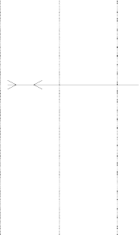
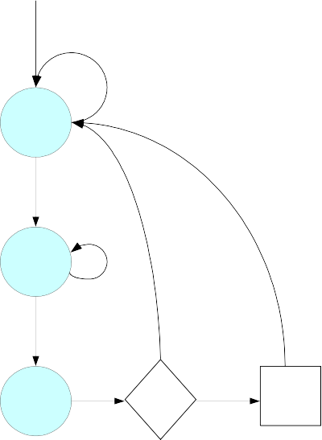
Figure B.8: IrDA SIR Data Format




The UART module operation when IrDA SIR mode is enabled is similar to when the mode is disabled, with one exception: data transfers can only occur in half-duplex fashion when IrDA SIR mode is enabled. This is because the IrDA SIR physical layer specifies a minimum of 10ms delay between transmission and reception. This 10ms delay must be handled by the software.

Break Generation and Reset

A break is generated by the sending UART holds the TXD line to 0 for quite a long time. It can be used to avoid the case RTS line is always inactive and thus blocks the data to be sent any more. When a break is detected, it will reset the state machine of the Rx/Tx engines. If Host is enabled, the break will be sent to both two UART. For debug UART, It will write into the CFG internal register bit Disable_UART to temporarily disconnect the normal UART to the serial interface (in this state, all data destined for normal UART received by RX engine will be discarded, all data in the normal UART FIFO are still kept but will not send to the TX engine, the RTS from normal UART will also be disconnected to the RX engine), this will allow the Debug UART to diagnostic what happens in case of normal UART errors. It will also reset the Debug Host baud-rate. For normal UART, the break will also generate an error IRQ, which can ask soft to perform operations such as a reset for the FIFO etc. The normal UART can be enabled later by clear the Disable UART bit.

If the reset source is coming from pin reset, a break should be sent by the debug host to let the other-side UART configure the baud-rate. This break lasts at least 12 bit long in 115.2K baud-rate, which should be the lowest baud-rate. A hardware reset event should be sent by the debug host in case of system reset.

Clock Detector

This sub-module detects if the Host clock is present or not. This module is located in clock control module, it will generate a Host_Clock_On signal. The Host_Clock_On signal helps to select the system clock or host clock as the input for debug host. When Host_Clock_On is active high, host clock is used, otherwise, UART clock. The Host_Clock_On signal is also send to Debug host to enable or disable the host functionality.

The clock Detector uses 32.768KHz clock to detect 14.7468MHz host clock. There is a 10 bit counter in the host clock domain, and the highest bit is used to generate a 14.4KHz slow clock. The 32KHz clock detects the rising edge of this slow clock, and launch a 2-bit incremental counter. Every time a rising edge detected, the counter will be added by one, until the counter reaches 3. At this moment, the Host_clock_on signal will be asserted and host clock is considered to be connected. There is another 6-bit timeout counter, each time a new rising edge is detected, the timeout counter will be reset to “111111”, otherwise, it will be decremented by one at each 32KHz clock rising edge. If the timeout counter reaches 0, the incremental counter will be reset and Host_clock_on signal will be de-asserted, the host clock is considered to be disconnected.

Software flow control

If sending of characters must be postponed, the character XOFF is sent on the line, to restart the communication again XON is used. Sending the XOFF character only stops the communication in the direction of the device which issued the XOFF.

The XON/XOFF character can be programmed by register bits. However, two bytes have been predefined in the ASCII character set to be used with software flow control. These bytes are named XOFF and XON, because they can stop and restart transmitting. The byte value of XOFF is 19, it can be simulated by pressing Ctrl-S on the keyboard. XON has the value 17 assigned which is equivalent to Ctrl-Q.



RDA5855E Datasheet V1.01

Backslash '/' can be added before XON, XOFF and '/' to signifies their original values instead of flow control marks.

I2C

I2C is a two-wire, bi-directional serial bus that provides a simple and efficient method of data exchange between devices. It is most suitable for applications requiring occasional communication over a short distance between many devices. The I2C standard is a true multi-master bus including collision detection and arbitration that prevents data corruption if two or more masters attempt to control the bus simultaneously.

The interface defines 3 transmission speeds:
- Normal: 100Kbps
- Fast: 400Kbps
- High speed: 3.5Mbps

Only 100Kbps and 400Kbps modes are supported directly.

Features

- Compatible with Philips I2C standard
- Multi Master Operation
- Software programmable clock frequency
- Clock Stretching and Wait state generation
- Software programmable acknowledge bit
- Interrupt or bit-polling driven byte-by-byte data-transfers
- Arbitration lost interrupt, with automatic transfer cancellation
- Start/Stop/Repeated Start/Acknowledge generation
- Start/Stop/Repeated Start detection
- Bus busy detection
- Supports 7 and 10bit addressing mode
- Operates from a wide range of input clock frequencies

Operations

- I2C System configuration

The I2C system uses a serial data line (SDA) and a serial clock line (SCL) for data transfers. All devices connected to these two signals must have open drain or open collector outputs. The logic AND function is exercised on both lines with external pull-up resistors.

Data is transferred between a Master and a Slave synchronously to SCL on the SDA line on a byte-by-byte basis. Each data byte is 8 bits long. There is one SCL clock pulse for each data bit with the MSB being transmitted first. An acknowledge bit follows each transferred byte. Each bit is sampled during the high period of SCL; therefore, the SDA line may be changed only during the low period of SCL and must be held stable during the high period of SCL. A transition on the SDA line while SCL is high is interpreted as a command (see START and STOP signals).

- I2C protocol

START signal

RDA Microelectronics Inc. CONFIDENTIAL 32 / 72



RDA5855E Datasheet V1.01

When the bus is free/idle, meaning no master device is engaging the bus (both SCL and SDA lines are high), a master can initiate a transfer by sending a START signal. A START signal, usually referred to as the S-bit, is defined as a high-to-low transition of SDA while SCL is high. The START signal denotes the beginning of a new data transfer. A Repeated START is a START signal without first generating a STOP signal. The master uses this method to communicate with another slave or the same slave in a different transfer direction (e.g. from writing to a device to reading from a device) without releasing the bus.

The I2C master generates a START signal when the STA-bit in the Command Register is set and the RD or WR bits are set. Depending on the current status of the SCL line, a START or Repeated START is generated.

Slave address transfer
The first byte of data transferred by the master immediately after the START signal is the slave address. This is a seven-bits calling address followed by a RW bit. The RW bit signals the slave the data transfer direction. No two slaves in the system can have the same address. Only the slave with an address that matches the one transmitted by the master will respond by returning an acknowledge bit by pulling the SDA low at the 9 th SCL clock cycle.

Note: The I2C master supports 10bit slave addresses by generating two address transfers. See the Philips I2C specifications for more details.

The I2C master treats a Slave Address Transfer as any other write action. Store the slave device’s address in the Transmit Register and set the WR bit. The I2C master will then transfer the slave address on the bus.

Data Transfer
Once successful slave addressing has been achieved, the data transfer can proceed on a byte-by-byte basis in the direction specified by the RW bit sent by the master. Each transferred byte is followed by an acknowledge bit on the 9th SCL clock cycle. If the slave signals a No Acknowledge, the master can generate a STOP signal to abort the data transfer or generate a Repeated START signal and start a new transfer cycle.

If the master, as the receiving device, does not acknowledge the slave, the slave releases the SDA line for the master to generate a STOP or Repeated START signal.

To write data to a slave, store the data to be transmitted in the Transmit Register and set the WR bit. To read data from a slave, set the RD bit. During a transfer the core set the TIP flag, indicating that a Transfer is In Progress. When the transfer is done the TIP flag is reset, the IF flag set and, when enabled, an interrupt generated. The Receive Register contains valid data after the IF flag has been set. The user may issue a new write or read command when the TIP flag is reset.

Stop signal
The master can terminate the communication by generating a STOP signal. A STOP signal, usually referred to as the P-bit, is defined as a low-to-high transition of SDA while SCL is at logical ‘1’.

- Arbitration Procedure

Clock Synchronization
The I2C bus is a true multi-master bus that allows more than one master to be connected on it. If two or more masters simultaneously try to control the bus, a clock synchronization procedure determines the bus clock.
Because of the wired-AND connection of the I2C signals a high to low transition affects all devices connected to
the bus. Therefore a high to low transition on the SCL line causes all concerned devices to count off their low period. Once a device clock has gone low it will hold the SCL line in that state until the clock high state is
reached. Due to the wired-AND connection the SCL line will therefore be held low by the device with the longest low period, and held high by the device with the shortest high period.

Clock stretching

RDA Microelectronics Inc. CONFIDENTIAL 33 / 72



RDA5855E Datasheet V1.01

Slave devices can use the clock synchronization mechanism to slow down the transfer bit rate. After the master has driven SCL low, the slave can drive SCL low for the required period and then release it. If the slave’s SCL low period is greater than the master’s SCL low period, the resulting SCL bus signal low period is stretched, thus inserting wait-states.

General Purpose Input Output

RDA5855E GPIO modules has configurable number of General Purpose Input or Output ports (GPIO) and General Purpose Output port(GPO). There are 3 GPIOs are used to get external events. They can be used as inputs or outputs.

Keypad

The RDA5855E keypad is realized using ADC serial keypad detection

Timers

RDA5855E includes 1 OS timer, 1 watchdog timer and 1 hardware delay timers. The OS timer serves for OS, and has Ticks of 16384 Hz. It is a decrement timer and the initial value can be programmed. When the OS timer reaches 0, it will cause an interruption. After that, the OS timer will either stop or restart with the initial value (loop mode) or wrap to maximum value (wrap mode).

The watchdog timer can be used to protect against system failure or software mistakes by reinitializing the system. When it’s no longer servicing the watchdog timer, the Watchdog Timer operations are almost identical to the OS Timer. In addition when the counter reaches 0 it can trigger a System Reset. To use the Watchdog function, the software should reload the Watchdog Timer on a periodic basis to avoiding the Watchdog Timer to reach 0 and trigger an interrupt or a system reset (depending on configuration).

The hardware delay timer is an incremental timer. It has Ticks of 16384 Hz. This timer is free running, and the value will be reset to 0. The timer value will wrap to 0 after 0xfffffff, and will generate an IRQ when wrap. The hardware delay timer can also generate an interval IRQ which can be configured to every 1 /8 second,1/4 second, 1/2 second, or 1 second.

The timers module has two IRQs. One dedicated for OS timer, the other is used by all the other timers. (including watchdog timer, hardware delay timer)

Features

      - 1 24-bit decremental timer for OS.
      - 1 32-bit incremental hardware delay timer.
      - 1 24-bit decremental watchdog timer.
      - Multiple IRQ sources: timers wrap, interval arrives.

RDA Microelectronics Inc. CONFIDENTIAL 34 / 72



RDA5855E Datasheet V1.01

Debug Port (EXL, PXTS, Signal Spy)

The DEBUG_PORT module:
- Provide 4 watches.
- Storing the last execution address of the selected CPU in the event of a watchdog reset. This value is not reset on any system reset and can be read when the system was recovered
from the watchdog reset.
- Data packet transfer: debugging tool configurable in 4 different modes:

Features

      - Access to the last PC of the selected CPU when a watchdog reset occurs.
      - Mode Debug_Port_Off : This mode switch off the module
      - Mode Exl : This mode record all the CPU Jump start address send to the Romulator. Generate a strobe and output the selected CPU's PC.
      - Mode Pxts : This mode record all the serial events analyzed by Coolprofile. Generate a Strobe and output the Pxts tag.Through Pxts Enable decoding, we will be able to select one Pxts_tag into 16 Pxts_tag defined.
      - Mode Pxts_Exl: this mode enable both mode PXTS and EXL. PXTS mode has a highest priority compare to mode EXL.
      - Mode Signal_Spy : This mode spy the signals for the debug purpose(Describe the IOCore muxing for IO mode configuration)

General Purpose Analog to Digital Converter (GP ADC)

The GPADC module controls the analog module of general purpose analog to digital converter, which is capable of measuring analog external inputs of the chip. The one external input can be connected to sensors to measure battery voltage, battery temperature, temperature, accessory ID, remote control, or other low frequency analog signal within the specified voltage range.

The GPADC is active periodically at a variable rate if at least one channel is enabled. The value of each channel is readable through the APB interface.

Features

      - 1 analog external channels.
      - Automatic measurement at variable rate.
      - Interrupt when programmed threshold is passed.

Operation

By default, GPADC works in functional mode, GPADC is active periodically at a variable rate and measures all the enabled channel each time.

There is also a test mode for debug purpose, in which GPADC receives a start measure command from APB, and do a measurement once.

Usually, the one GPADC is used for mic detect, and another is for user defined function.

RDA Microelectronics Inc. CONFIDENTIAL 35 / 72



RDA5855E Datasheet V1.01

Timing Control Unit and Low Power Synchronizer (TCU+LPS)

The Timing Control Unit handle the scheduling of individual events with a quarter bit precision.

The TCU is based on a quarter bit counter (13/12 MHz = 1.083 MHz), which wraps at a programmable value. An interruption is generated when the counter wraps (Frame interrupt). The current value of this counter is available at any time. The wrap value can be set at any time. To assure a predictable behavior this value should only be set by the programmer “far” from the wrap time, to make sure this new value will be taken into account the next time.

The programmer can define events associated to particular counter values (dates). When the counter equals the given date, the action associated to the event will take place.

The event are contained in a table of events split into a programming table and an active table. Only the events in the active table are compared to the counter value. The programming table table allows to prepare a full sequence of events which will be transfered to the active table when the counter wraps.

A force signal allows to transfer events from the programming table to the active table immediately.

The LPS Low Power Synchronizer is a part of the TCU, it is responsible for maintaining the time base while running at a slower clock (32kHz) for power saving.

TCU Features

      - Quarter bit precision.
      - 60 entries event table.
      - Programmable counter wrap value.

LPS Features

      - Allow skipping frames by masking the TCU Frame Interrupt.
      - Calibration of the 32kHz clock against the System Clock with an accuracy of 4 System clocks during a programmable time to reach wanted rate accuracy.
      - Low power counters (32kHz) can maintain time base while System clock is suspended.
      - A hardware state machine can assist the CPU for the power up after each exit of the low power mode.

System AHB Monitor (Sys AHBC Mon)

This monitor connected to the System AHB bus can measure several bandwidth and latency information.

Features

      - 8 configurable time windows:
      - 4 asynchronous for gradually going from accuracy to reactivity of the measures.
      - 4 based on frame for GMS related measurements
      - Peak or mean measures.
      - Selection between several resources:

RDA Microelectronics Inc. CONFIDENTIAL 36 / 72



RDA5855E Datasheet V1.01

      - Global bus usage.
      - Bus usage and latency of access for a particular master.
      - Bus usage, number of access and duration of access for a slave.
      - High time, number of rise and duration of high time for a resource selected via the signal select of the debug port.

Mean calculation

Measures are always relative to the time window. Mean latency or duration has to be calculated by dividing the total latency / duration measured by the number of accesses.

Special resource monitoring

The Signal_Select0 and Signal_Select1 signals can be monitored to estimate latency of IRQ handling, or measure any latency/usage of software part. This last case can be achieved by setting Signal_Select0 to Watch(n) in the debug port configuration, monitoring the Signal_Select0 signal; by setting and clearing the Watch(n) during code to profile, you can measure the mean time spent.

System IRQ Controller (Sys IRQ)

In RDA5855E, the interruptions are generated by the modules, they can be filtered at the module level (the mask must be configured in each corresponding module's registers), then they are filtered by the System or Base Band IRQ Controller (the mask is set in System IRQ Control or Base Band IRQ Control registers). The interrupts must be cleared in the corresponding module.

For power saving, one CPU can shut down its own clock. A special wakeup mask allows re-enabling the clock when an interruption enabled in this mask is triggered..

Features

      - A mask at the module level.
      - A mask at the IRQ Control level.
      - A second Mask for Pulse IRQ (that are not masked in the module)
      - Wakeup mask.
      - Sleep Register
      - Driving IRQ inputs to the CPU (6 lines)

USB Controller

Features

      - Fully compliant to USB Specification Version 1.1
      - Slave Full Speed (12Mbps) Device
      - Integrated USB Transceiver
      - Supports Control, Interrupt, Bulk and Isochronous transfer
      - 4 Endpoint with FIFO:
- One Bi-directional Control Endpoint (EP0)

RDA Microelectronics Inc. CONFIDENTIAL 37 / 72



RDA5855E Datasheet V1.01

- Three soft configurable Bi-directional Endpoints
      - SRAM FIFO : 264 words (32bits)

SD/MMC Controller

This module connects inner bus and outer SD or MMC card. It receives the inner command and data, transfers it to outer SD or MMC card, and transfer response or data back.

Features

      - SD Card Specification Version 2.0
      - SDIO Version 1.10
      - MMC specification Version 3.1
      - Hot insertion and removal of media cards will be considered by GPIO module

Audio Interface Analog + I2S (AIF)
The Audio Interface (AIF) module is the audio interface between the RDA5855E system and multimedia chip. AIF can work in master mode in which it generates synchronization signals needed by the multimedia chip,
which contains the audio ADC and DAC to convert the serial digital output data to analog audio signal and the input analog signal to serial digital audio data. It can also works in slave mode which uses synchronization
signals sent from multimedia chip. Please see below for more details about serial data format.

AIF includes both serious and parallel interface. It is able to support multiple sample rate including 8 kHz, 11.025 kHz, 12kHz, 16 kHz, 22,05 kHz, 24kHz, 32kHz, 44,1 kHz, 48kHz and various data format. AIF can also generate common DTMF, comfort tones and side tone with a configurable gain.

Features

      - Common features.
- 4*32-bit RX and 4*32-bit TX FIFO.
- All common DTMF and Comfort Tones can be generated and gained from -15 dB to 0 dB.
- Side Tone fully configurable: Mute or amplification from -36 dB to +6 dB.
- Loop back capabilities for test purposes.
      - Serial Interfaces.
- 16-bit mono or stereo samples.
- MSB/LSB configurable.
- Configurable as master or slave.
- LRCK/BCLK ratio from 16 to 31.
- Supports multiple sample rates (8 kHz; 11.025 kHz; 12kHz; 16 kHz; 22,05 kHz; 24kHz; 32kHz; 44,1 kHz; 48kHz).
- Fully configurable clock polarity: Data can be sampled or sent independently at either rising edge or falling edge of the clock.
- Configurable TX/RX data delays: Digital audio data in can be aligned or 1/2/3 cycles delayed to LRCK edge. Digital audio data out can be aligned or 1 cycle delayed to LRCK edge. 1 cycle supplementary delay is possible for TX data in slave mode.
- Support Audio mode: I2S compatible but can have more configurations.

RDA Microelectronics Inc. CONFIDENTIAL 38 / 72



RDA5855E Datasheet V1.01

- Support voice mode: One cycle strobe pulse at the beginning of each new sample. Compatible to Maxim 9851/9853 voice mode.
      - DAI interface.
- 13-bit mono sample.
- Generate 104 kHz master clock.
- Starts after a pulse on the DAI_RST line.
      - Parallel Interface
- 13-bit mono samples from ADC.
- 16-bit x 2 stereo samples to stereo DAC.
- Separate TX and RX strobe lines for synchronization.

Digital Modules

Voice Coprocessor (VoC)

The Voice Co-Processor (VoC) is designed to process different Vocoders (FR, HR, EFR, AMR)It is developed as a target-specific DSP core, including basic function-call support, able to execute the code with very little (or no) control intervention from the CPU. It is controlled and configured by the CPU through the AMBA bus.

Features

      - Bi-MAC, single test/logic Computational Unit with two 16x16 -> 32-bit multipliers
      - Eight 16-bit general purpose registers, that can be combined in four 32-bit general purpose registers.
      - All 16-bit registers can be used as pointers, four of them are incremental (for easy array addressing).
      - Four 32-bit general purpose registers.
      - 2 x 20 Kbytes data RAM + 32 Kbytes instruction RAM.
      - Double stack with random access: for 32-bit & 16-bit values (push, pop).
      - Function call support (jal, return).
      - Two zero-cycle loop counters.
      - Pointer & Direct addressing modes.
      - DMA sub-module for block transfers between external memory and VoC memories.
      - Simple DAI Interface for Analog test Audio Loop (Loop between DAI interface and Analog Interface designed to test the Audio Filters implemented by VoC)
      - Clock speed : 26MHz, 39MHz, 52MHz, 78MHz, 89MHz, 104MHz, 113MHz, 125MHz, 139MHz, 156MHz, 178MHz, 208MHz, 250MHz, 312MHz.

Analog Modules

SPI Interface for Analog IP control

All the IPs connected to DBB feature an SPI interface dedicated to IP control.

RDA Microelectronics Inc. CONFIDENTIAL 39 / 72

RDA5855E Datasheet V1.01

The Power Management Unit(PMU) and the Analog module(ABB) are controlled by the same SPI of DBB (with different chip-select).

For simplicity sake and ease of use, the SPI protocol settings for PMU and ABB. The chosen SPI setting is the following:
- Data from DBB are issued on falling edge of clock and can be latched on rising edge by the slave.
- Data from the slave are issued on rising edge of the clock and will be latched on falling edge of
clock.
- the SPI frame is 26 bits long : first bit is the R/W selection, then 9 bits of address A 8 to A0, then 16
bits of data D15 to D0.
- Maximum SPI_CLK frequency : 26 MHz

SPI_CLK

SPI_CS_X

SPI_DO
R/W
A8->1
A0 D15 D0

SPI Write Timing

SPI_CLK

SPI_CS_X

SPI_DO
R/W
A8->1 A0

SPI_DI_X
D15 D0





SPI Read Timing

Figure B.9: SPI Write & Read Timing

Power Management Unit

The PMU is controlled from the DBB through SPI.

Power System Management

The PMU performs a POR either when POWKEY is asserted (i.e. Power-ON/OFF button pressed) or when then WAKEUP line is raised (RTC Alarm) or when the charger (or USB) is plugged.

RDA Microelectronics Inc. CONFIDENTIAL 40 / 72

CHG_IN

Charger / USB Detect
PMU

ChargerON

CHG_MASK WAKEUP

PowerON






POWKEY

V_CORE

KEYON

Figure B.10: PMU Power ON

In the presented principle schematic, PowerON is an internal signal of the PMU that reflects that the system needs power. It can either be raised when the Power-ON key is pressed, when the WAKEUP line from DBB is raised or when the charger (or USB) is plugged. When a rising edge of PowerON is detected, the PMU should go through its POR sequence.

The POR sequence consists in turning ON the relevant power supplies then wait for RST delay that is be long enough to ensure that all LDOs are in steady state and that all the chip is correctly powered, then raise the RESETB signal.

In case the POR is trigged by POWKEY, It's DBB responsibility to set the WAKEUP line high when it considers that POWKEY has been pressed long enough. As POWKEY is a VBAT level input, a V_CORE version of POWKEY (named KEYON) is generated for DBB.

POR can also be initiated when the WAKEUP line is being raised directly because of an RTC Alarm (the POWKEY is not pressed).

As long as PowerON is high, the PMU provides voltages supplies that are specified by the current Power-Profile that describes the LDO and DC/DC settings.

RDA5855E Datasheet V1.01

POWKEY

LDO's supplies

RSTdelay

RESETB

DBB boots and sets WAKEUP

WAKEUP

PowerON

B.IV.0.0.b
Figure B.11: POR triggered by POWKEY press






The PMU implements multiple power profiles defining the LDOs and DC/DC activation in various modes.

          - Default_powerOFF_profile: used when the system is OFF( system has been shut-off or first time battery is plugged...). In this case only V_RTC is provided.

          - Default_powerON_profile: used when PowerON is asserted and the POR is trigged, all LDOs that have “reset state ON” are activated.

          - Active_power_profile: used once system has booted and decided to switch from Default_powerON_profile. This profile is programmable.

          - LP_power_profile: used when the system goes to low-power mode (switch from Active to Low-power through LP_MODE line). This profile is programmable.

RDA Microelectronics Inc. CONFIDENTIAL 42 / 72

PowerON

Defaut_powerOFF_profile 0 0
Defaut_powerON_profile 1

LP_power_profile 1
To LDOs and DC/DC control






Active_power_profile 0 1
LP_MODE Software selectable: default to '0', reset to '0'
when PowerON goes low
Figure B.12: Principle schematic for Power-Profiles usage

If the PowerON line goes low, the RESETB signal will be set to Low level then all power supplies excepted V_RTC are switched OFF.

It can be useful to be able to go back to Default_powerOFF_profile (i.e. shut-off all supplies except RTC) even when a charger is plugged. The CHG_MASK (RTC domain) line is used for this purpose, by masking the ChargerON line.

V_USB is not power-on automatically when USB is detected. The USB PHY remains OFF until the software decides to turn it ON.

LDOs

Name | Type | Voltage | Max Current | Usage (power domain)
V_CORE | DC-DC | 1.2V | 300mA | Core
V_CORE | LDO | 1.2V | 20mA | Core
V_PAD | LDO | 1.8V / 2.8V | 200mA | Digital IO
V_ANA | LDO |  | 200mA | Analog module
V_MEM | LDO | 1.8V / 2.8V | 200mA | External Combo flash / ram
V_SPIMEM | LDO | 1.8V / 2.8V | 200mA | External SPI Memory
V_MMC | LDO | 2.8V / 3.2V | 150mA | Memory Card
V_USB | LDO | 3.3V | 300mA | USB PHY
V_MIC | LDO | 1.4V/1.75V | 200mA | Microphone
V_RTC | LDO | 1.2V | 0.6mA | Real time clock

Charger Circuit

The RDA5855E integrates the most of charger circuits, except for a few components such as one PMOS, one accurate resistor and one diode, which should be applied externally.

RDA5855E Datasheet V1.01

When the charger is on, this block controls the charging phase and turns on the appropriate LDOs according to the battery status. If the voltage is greater than 4.2~ 4.4 V, charging is stopped immediately to prevent permanent damage to the battery.

Battery charging states include No Charge mode, Constant Current (CC) charge mode (pre-charge, constant current), and Constant Voltage (CV) charge mode. No matter what state the phone is in, the PMIC charger handles the charging state transition. A typical charging process is described as what the Figure 5 shows.

Pre charging

CC mode CV mode





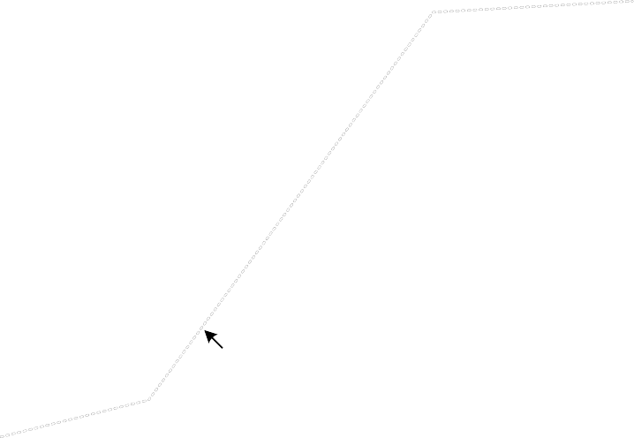

Charge voltage

Charge current

Li-ion cell voltage

t(pre-charge) t(charge)

Figure B.13: Charging I-V Curve
The charge current is calculated by the following expression,

I_charge = I_ref * (200/0.2)

I_ref is 0.05mA in pre_charge mode and 0.5mA in constant mode, and these two mode can be switched by internal charger circuit.

Interrupt management

The PMU has two lines of interruption to DBB:

          - the PENIRQ line dedicated to touchscreen
          - the PMU_INT line that handles several other causes of interruption.

RDA Microelectronics Inc. CONFIDENTIAL 44 / 72

Analog module (ABB)

PLL and clock squarer

ABB includes a PLL that generates 624MHz from a 26MHz input (x24 integer frequency multiplier). It also includes a “clock squarer” that buffers the clock coming from the internal transceiver to provide a clean version (at VCORE levels) of this clock.

The following drawing summarizes the PLL clock path:

XCVR
Clock_Squarer

CLK_RF_26M

CLK_PLL_IN

ABB
PLL

BBCLK_OUT_624M







Figure B.14: PLL Clock Path

AUDIO

The Audio part includes ADC, DAC, Audio Amplifiers and Audio Muxes. The following diagram provides a global view of audio blocks. Voice data can be input from microphone. Voice and audio data can be output to a stereo DAC and connected to peripherals such as receiver, headset and loudspeaker. It is able to support multiple sample rate audio data including 8 kHz, 11.025 kHz, 12kHz, 16 kHz, 22,05 kHz, 24kHz, 32kHz, 44,1 kHz, 48kHz.

USB PHY

USB_OEN USB_DIP USB_DIM
USB PHY

USB_SUSPEND

USB_RXD

USB_DP USB_DM





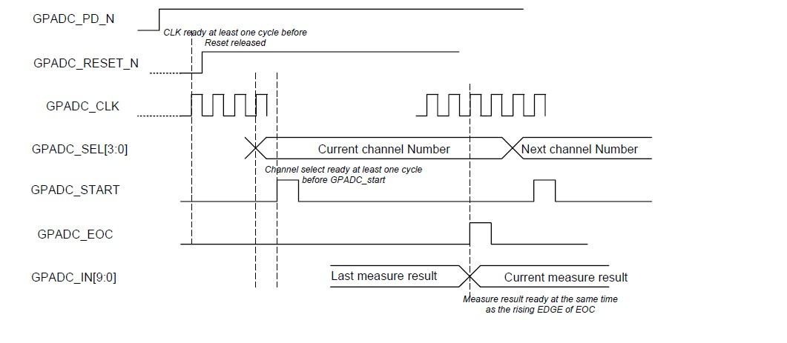
USB_RXDP USB_RXDM

Figure B.15: USB PHY FS 1.1

DIP and DIM pins are really reflecting DP and DM, therefore the following decoding must be done in DBB USB controller:

General Purpose ADC

ABB includes an A to D converter. A functional timing diagram is given below:

Figure B.16: GPADC Timing Diagram




FM

General Description
RDA5855E Integrates a broadcast FM stereo radio tuner with fully integrated synthesizer, IF selectivity and MPX decoder. The tuner requires the least external component. It has a powerful low-IF digital audio processor, this make it have optimum sound quality with varying reception conditions. It can be tuned to the worldwide frequency band.

Features
    - Low Power Consumption
      - Total Current consumption Lower than 22 mA at 3.0 V power supply
    - Support worldwide frequency band
➢ 65-108MHz
    - Digital low-IF tuner
      - Image-reject down-converter
      - High performance A/D converter
      - IF selectivity performed internally
    - Fully integrated digital frequency synthesizer
      - Fully integrated on-chip RF and IF VCO
      - Fully integrated on-chip loop filter
    - Autonomous search tuning
    - Support 32.768KHz crystal oscillator
    - Digital auto gain control (AGC)
    - Digital adaptive noise cancellation
      - Mono/stereo switch
      - Soft mute
      - High cut
    - Programmable de-emphasis (50/75 ms)
    - Receive signal strength indicator (RSSI)
    - Bass boost
    - Volume control
    - FM Record through digital audio interface
    - Line-level analog output voltage
● 32.768 KHz 12M,24M,13M,26M,19.2M,38.4MHz Reference Clock
    - SPI control bus interface
    - Directly support 32Ω resistance loading

Block Description





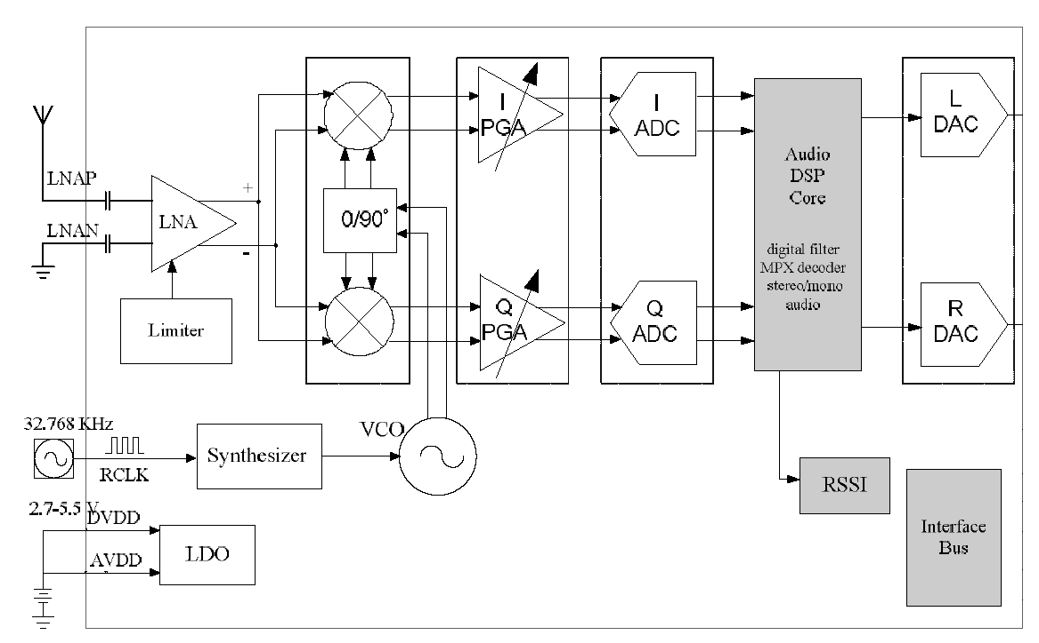

Figure B.17: FM Tuner Block Diagram

The FM receiver uses a digital low-IF architecture that avoids the difficulties associated with direct conversion while delivering lower solution cost and reduces complexity, and integrates a low noise amplifier (LNA) supporting the FM broadcast band (65 to 108MHz), a quadrature image-reject mixer, a programmable gain control (PGA), a high resolution analog-to-digital converters (ADCs).

The LNA has differential input ports (LNAP and LNAN) and supports any input port by set according registers bits. It default input common mode voltage is GND.

The limiter prevents overloading and limits the amount of intermodulation products created by strong adjacent channels.

The quadrature mixer down converts the LNA output differential RF signal to low-IF, it also has image-reject function.

The PGA amplifies the mixer output IF signal and then digitized with ADCs.

The DSP core finishes the channel selection, FM demodulation, stereo MPX decoder and output audio signal. The MPX decoder can autonomous switch from stereo to mono to limit the output noise.

The frequency synthesizer generates the local oscillator signal which divide to quadrature, then be used to down- convert the RF input to a constant low intermediate frequency (IF). The synthesizer reference clock is 32.768 kHz. The synthesizer frequency is defined by register bits with the range from 65MHz to 108MHz.

Receiver Characteristics

(VDD = 2,7 to 5,5V, TA = -25°C to 85 °C, unless otherwise specified)

SYMBOL | PARAMETER | CONDITIONS | MIN | TYP | MAX | UNIT
General Parameters




AM Suppression

Notes:
SYMBOL | PARAMETER | CONDITIONS | MIN | TYP | MAX | UNIT
Fin | FM Input Frequency | BAND=00 | 87 |  | 108 | MHz
 |  | BAND=01 | 76 |  | 91 | MHz
 |  | BAND=02 | 76 |  | 106 | MHz
 |  | BAND=03 | 65 |  | 76 | MHz
Vrf | Sensitivity1,2,3 | (S+N)/N=26dB |  | 1 | 1.5 | µV EMF
Rin | LNA Input Resistance7 |  |  | 150 |  | Ω
Cin | LNA Input Capacitance7 |  | 2 | 4 | 6 | pF
IP3in | Input IP34 | AGCD=1 | 80 |  | - | dBµV
aam | 1,2 | M=0.3 | 40 |  | - | dB
S200 | Adjacent Channel Selectivity | ± 200kHz | 45 |  | - | dB
VAFL;VAFL | Left and Right Audio Frequency output Voltage | Volume [3:0]=1111 |  | 200 |  | mV
(S+N)/N | Maximum Signal Plus Noise to Noise Ratio 1,2 |  | 55 | 60 | - | dB
aSCS | Stereo Channel Separation |  | 35 | - | - | dB
THD | Audio Total Harmonic Distortion1,3,6 |  |  | 0.03 | 0.05 | %
aAOI | Audio Output L/R Imbalance |  |  |  | 0.1 | dB
RL | Audio Output Loading Resistance | Single-ended | 32 | - | - | Ω
Pins LNAN, LNAP
Vcom_rfin | Pins LNAN and LNAP Input Common Mode Voltage |  |  | 0 |  | V
Vcom | Audio Output Common Mode Voltage |  | 0.95 | 1 | 1.05 | V

1. Fin=65 to 108MHz, Fmod=1KHz, de-emphasis=75µS,MONO=1;L=R unless noted otherwise. 2. Δf =22.5KHz.
- BA =300Hz to 15KHz, RBW <= 10Hz.
- | f2-f1|>1MHz, f0=2xf1-f2, AGC disable, Fin=76 to 108MHz.
- PRF=60dbµV.
- Δf =75KHz.
- Measured at VEMF=1mV, FRF=65 to 108MHz.

Bluetooth

General Description
RDA5855E Integrates a highly integrated Bluetooth SoC with radio transceiver and baseband processor, which is compliant with Bluetooth 2.1 + EDR specification and provides an optimal solution for data and voice application.
It has been designed on highest level of integration to extremely reduce the number of external component.





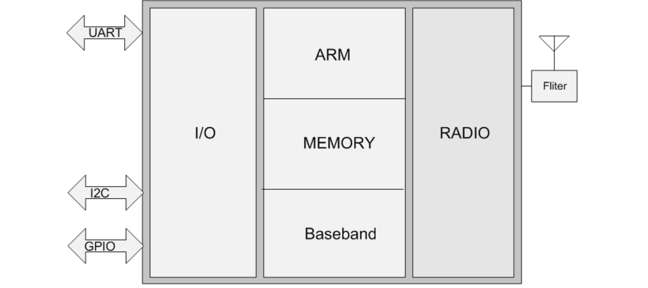

Features
    - CMOS single-chip fully-integrated radio and baseband
    - Compliant with Bluetooth 2.1 + EDR specification
    - Bluetooth Piconet and Scatternet support
    - Support AFH
    - Meet class1, class2 and class3 transmitting power requirement
    - Provides +4dbm transmitting power
    - NZIF receiver with -90dBm sensitivity
    - Up to 4Mbps high speed UART HCI support
    - Low power consumption
    - Minimum external component

Block Description

Figure B.18: Bluetooth Block Diagram

As shown in Figure above, the Bluetooth module on-chip integrates radio unit, baseband core, ARM7 core and memory which provides a complete lower Bluetooth protocol stack including the LC, LM and HCI interface.

The description of individual section is following,
    - Radio Front
- Build-in TX/RX switch
- Fully integrated synthesizer without any external component
- Support DCXO or external reference clock direct input
- Class1，class2 and class3 transmit output power supported and over 30dB dynamic control range
- Supports π/4 DQPSK and 8DPSK modulation
- High performance in receiver sensitivity and over 80dB dynamic range
- Integrated channel filter
    - Baseband
- Internal RAM allows fully speed data transfer, mixed voice and data, and fully piconet operation
- Logic for forward error correction, header error control, access code correlation, CRC, demodulation
, encryption bit stream generation, whitening and transmit pulse shaping
- Support eSCO and AFH
- Support up to Bluetooth v2.1 + EDR
- Support A-law, μ-law and CVSD digitize audio CODEC in PCM interface
    - Stack
- Compliant with Bluetooth 2.1 + EDR specification




Performance Characteristics
Power consumption specification (VBAT = 4.0 V, TA = +27℃, unless otherwise specified)

STATE | DESCRIPION | Condition | TYP. | UNIT
DH1 / DM1 |  |  | 26 | mA
DH3 / DM3 |  |  | 28 | mA
DH5 / DH5 |  |  | 29 | mA
HCI only active |  |  | 5.5 | mA
Sleep |  |  | 100 | uA
Shut off |  |  | 15 | uA

Receiver Characteristics --- Basic Data Rate (VBAT = 4.0 V, TA = +27℃, unless otherwise specified)

SYMBOL | PARAMETER | CONDITION | MIN | TYP. | MAX | UNIT
General Specification
Sensitivity @ 0.1% BER |  |  | / | -90 | / | dBm
Maximum input @ 0.1% BER |  |  | 0 | / | / | dBm
C/I co-channel |  |  | / | 10 | / | dB
Adjacent channel selectivity C/I |  | F = F0 + 1 MHz | / | / | -5 | dB
 |  | F = F0 - 1 MHz | / | / | 0 | dB
 |  | F = F0 + 2 MHz | / | / | -33 | dB
 |  | F = F0 - 2 MHz | / | / | -30 | dB
 |  | F = F0 + 3 MHz | / | / | -45 | dB
 |  | F = F0 - 3 MHz | / | / | -40 | dB
 |  | F = F_image | / | / | 0 | dB
Out-of-band blocking |  | 30MHz–2000MHz | -10 | / | / | dBm
 |  | 2000MHz–2400MHz | -27 | / | / | dBm
 |  | 2500MHz–3000MHz | -27 | / | / | dBm
 |  | 3000MHz–12.5GHz | -10 | / | / | dBm
Inter-modulation |  |  | -35 | / | / | dBm
Spurious output level |  |  | -150 | / | / | dBm

Transmitter Characteristics --- Basic Data Rate (VBAT = 4.0 V, TA = +27℃, unless otherwise specified)

SYMBOL | PARAMETER | CONDITION | MIN | TYP. | MAX | UNIT
General Specification
Max RF output power |  |  | / | 4 | / | dBm
Power control range |  |  | 30 | / | / | dB
20dB bandwidth |  |  | / | 0.9 | / | MHz
Adjacent channel transmitter power |  | F = F0 + 1 MHz | / | -35 | / | dBm




 | F = F0 - 1 MHz | / | -34 | / | dBm
 | F = F0 + 2 MHz | / | -55 | / | dBm
 | F = F0 - 2 MHz | / | -55 | / | dBm
 | F = F0 + 3 MHz | / | -58 | / | dBm
 | F = F0 - 3 MHz | / | -58 | / | dBm
 | F = F0+ > 3 MHz | -58 | / | / | dBm
 | F = F0- > 3 MHz | -58 | / | / | dBm
△f1avg Maximum modulation |  | / | 164 | / | kHz
△f2max Minimum modulation |  | / | 145 | / | kHz
△f2avg/△f1avg |  | 0.8 | / | / | /
ICFT |  | / | 4 | / | kHz
Drift rate |  | / | 0.1 | / | kHz/50 us
Drift (1 slot packet) |  | / | -2 | / | kHz
Drift (5 slot packet) |  | / | -2 | / | kHz

Receiver Characteristics --- Enhanced Data Rate (VBAT = 4.0 V, TA = +27℃, unless otherwise specified)

SYMBOL | PARAMETER | CONDITION | MIN | TYP. | MAX | UNIT
π/4 DQPSK
Sensitivity @0.01% BER |  |  | / | -89 | / | dBm
Maximum input @ 0.1% BER |  |  | 0 | / | / | dBm
C/I co-channel |  |  | / | / | 13 | dB
Adjacent channel selectivity C/I |  | F = F0 + 1 MHz | / | / | 5 | dB
 |  | F = F0 - 1 MHz | / | / | 0 | dB
 |  | F = F0 + 2 MHz | / | / | -30 | dB
 |  | F = F0 - 2 MHz | / | / | -20 | dB
 |  | F = F0 + 3 MHz | / | / | -40 | dB
 |  | F = F0 - 3 MHz | / | / | -40 | dB
 |  | F = F_image | / | / | -7 | dB
8DPSK
Sensitivity @0.01% BER |  |  | / | -83 | / | dBm
Maximum input @ 0.1% BER |  |  | 0 | / | / | dBm
C/I co-channel |  |  | / | / | 18 | dB
Adjacent channel selectivity C/I |  | F = F0 + 1 MHz | / | / | 5 | dB
 |  | F = F0 - 1 MHz | / | / | 5 | dB
 |  | F = F0 + 2 MHz | / | / | -25 | dB
 |  | F = F0 - 2 MHz | / | / | -13 | dB




 | F = F0 + 3 MHz | / | / | -33 | dB
 | F = F0 - 3 MHz | / | / | -33 | dB
 | F = F_image | / | / | 0 | dB

Transmitter Characteristics --- Enhanced Data Rate (VBAT = 4.0 V, TA = +27℃, unless otherwise specified)

SYMBOL | PARAMETER | CONDITION | MIN | TYP. | MAX | UNIT
General Specification
Max RF output power |  |  | / | 2 | / | dBm
Relative transmit control |  |  | / | 1.6 | / | dB
π/4 DQPSK max w0 |  |  | / | 7.4 | / | kHz
π/4 DQPSK max wi |  |  | / | 6.7 | / | kHz
π/4 DQPSK max |wi + w0| |  |  | / | 2.4 | / | kHz
8DPSK max w0 |  |  | / | 7.1 | / | kHz
8DPSK max wi |  |  | / | 4.4 | / | kHz
8DPSK max |wi + w0| |  |  | / | 2.7 | / | kHz
π/4 DQPSK Modulation Accuracy |  | RMS DEVM | / | 4.7 | / | %
 |  | 99% DEVM | / | / | 30 | %
 |  | Peak DEVM | / | 8.8 | / | %
8PSK Modulation Accuracy |  | RMS DEVM | / | 4.6 | / | %
 |  | 99% DEVM | / | / | 20 | %
 |  | Peak DEVM | / | 11.3 | / | %
In-band spurious emissions |  | F = F0 + 1 MHz | / | -14.7 | / | dBm
 |  | F = F0 - 1 MHz | / | -15.2 | / | dBm
 |  | F = F0 + 2 MHz | / | -51 | / | dBm
 |  | F = F0 - 2 MHz | / | -52.2 | / | dBm
 |  | F = F0 + 3 MHz | / | -55.5 | / | dBm
 |  | F = F0 - 3 MHz | / | -55.8 | / | dBm
 |  | F = F0+ > 3 MHz | / | / | -55 | dBm
 |  | F = F0- > 3 MHz | / | / | -55 | dBm
EDR Differential Phase Coding |  |  | / | 100 | / | %




- MEMORY MAP

Memory Name | Description | Address | Size
External CS1 | External memory | 0x02000000 ~ 0x03ffffff | 32MB
FIFO_regs | Internal register | 0x018c0000 ~ 0x018fffff | 256KB
VOC | Voice codec | 0x01940000 ~ 0x0197fffff | 256KB
CPU SRAM | CPU internal sram | 0x01980000 ~ 0x01987fff | 32KB
SYS APB | Sys apb slave | 0x01a00000 ~ 0x01a7ffff | 512KB
USB | Usb controller | 0x01a80000 ~ 0x01abffff | 256KB
XCPU RAM | Xcpu internal sram | 0x01ac0000 ~ 0x01adffff | 128KB
MPMC REG | MPMC REG | 0x01ae4000~0x01ae7ffff | 16KB
MAILBOX | MAILBOX | 0x01b00000~0x01b00800 | 2KB
Internal sram | Internal sram | 0x01c00000 ~ 0x01c0ffff | 64KB
Regs for bcpu patch | Regs for bcpu patch | 0x01d00000~0x01d00100 | 256B
Internal rom | Internal rom | 0x01e00000 ~ 0x01e04fff | 20KB
External spi flash | External spi flash | 0x08000000 ~ 0x0fffffff | 128MB
External psram | External psram | 0x02000000 ~ 0x03ffffff | 32MB
XCPU APB
Sys_ctrl |  | 0x01A00000
Irq |  | 0x01A01000
Timer |  | 0x01A02000
Gpio |  | 0x01A03000
Ebc |  | 0x01A04000
Pwm |  | 0x01A06000
I2c |  | 0x01A07000
Dma |  | 0x01A08000
Ifc |  | 0x01A09000
Comregs |  | 0x01A0b000
Page_spy |  | 0x01A0c000
Debug_port |  | 0x01A0d000
Tcu |  | 0x01A0f000




Sci |  | 0x01A10000
Spi |  | 0x01A11000
Spi2 |  | 0x01A12000
Spi3 |  | 0x01A13000
Debug_uart |  | 0x01A14000
Uart2 |  | 0x01A16000
Sdmmc |  | 0x01A17000
Xcpu_reg |  | 0x01A19000
Xcpu_tag |  | 0x01A1a000
Xcpu_idata |  | 0x01A1b000
Xcpu_ddata |  | 0x01A1c000
Sys_ahb_mon |  | 0x01A1d000
Bb_ahb_mon |  | 0x01A1e000
Bist |  | 0x01A1f000
IFC2 |  | 0x01A20000
I2C2 |  | 0x01A22000
I2C3 |  | 0x01A23000
EXT_APB |  | 0x01A24000
Spi Flash Reg |  | 0x01A25000
Nand Flash Cs0 |  | 0x01A26000
Nand Flash Cs1 |  | 0x01A27000
Nand Flash Cs2 |  | 0x01A28000
Nand Flash Cs3 |  | 0x01A29000
Nand Flash RS |  | 0x01A2a000
Sdmmc2 |  | 0x01A2b000
Debug_host |  | 0x01A3f000
AIF |  | 0x01907000




- PINS DESCRIPTION

D.I Pin-out

PinName | I/O | Type | FirstUsage | SecondUsage | Third Usage | Power Domain | BallNo
I2C2
I2C2_SCL | I/O | D | I2C2Clock | GPIO_24 |  | STD | G7
I2C2_SDA | I/O | D | I2C2Data | GPIO_25 |  | STD | G8
I2S
I2S_BCK | I | D | I2SClock | CAM_DATA_4 | GPIO_18 | STD | E8
I2S_LRCK | I | D | I2SL/RChannelClock | CAM_DATA_5 | GPIO_19 | STD | B9
I2S_DI | I | D | I2SDataIn | CAM_DATA_6 | GPIO_26 | STD | D9
I2S_DO | O | D | I2SDataOut | CAM_DATA_7 | GPIO_27 | STD | C9
MemoryCardInterface
SSD_CLK | O | D | SDClock |  |  | MMC | F6
SSD_CMD | I/O | D | SDCommand |  |  | MMC | E7
SDAT_0 | I/O | D | SDdatabit0 |  |  | MMC | E6
SDAT_1 | I/O | D | SDdatabit1 |  |  | MMC | F5
SDAT_2 | I/O | D | SDdatabit2 |  |  | MMC | D7
SDAT_3 | I/O | D | SDdatabit3 |  |  | MMC | C7
DebugHost
HST_CLK | I | D | HostClockinput |  |  | STD | D3
HST_RXD | I | D | Host datareceive. |  |  | STD | H7
HST_TXD | O | D | Host datatransmit. |  |  | STD | J7
KEYPAD
KEYIN_SENSE | I | A | KeyinputGPADCsense |  |  | ABB | C3
KEY_P | O | A | KeysenseP |  |  | ABB | B1
KEY_N | O | A | KeysenseN |  |  | ABB | B2
UART
UART2_RXD | I/O | D | UART2receive data | GPIO_8 |  | STD | F8
UART2_TXD | I/O | D | UART2transmitdata | GPIO_13 |  | STD | F7
GeneralPurposeI/O
GPIO_1 | I/O | D | GPIO_1 | KEYIN_6 |  | STD | H9
GPIO_3 | I/O | D | GPIO_3 |  |  | STD | H8
GPIO_21 | I/O | D | GPIO_21 | KEYIN_4 |  | STD | E5




PinName | I/O | Type | FirstUsage | SecondUsage | Third Usage | Power Domain | BallNo
GPIO_17 | I/O | D | GPIO_17 |  |  | STD | F1
GPIO_11 | I/O | D | GPIO_11 | KEYOUT_2 |  | STD | E4
GPIO_7 | I/O | D | GPIO_7 | KEYOUT_3 |  | STD | E3
GPIO_8 | I/O | D | GPIO_8 | KEYOUT_4 |  | STD | D5
GPIO<2> | I/O | D | GPO<2> |  |  | STD | D6
MiscellaneousPins
RESETB_EXT | I | D | ExternalResetforchip |  |  | STD | B7
TST_H | ID | D | TestMode |  |  | RTC | A7
XVR_XTAL1 | I | A | 26MHzCrystalportInput |  |  | ABB | J9
XVR_XTAL2 | O | A | 26MHzCrystalportOutput |  |  | ABB | J8
ANA_TEST_EN | I | A | testmode |  |  | ABB | A8
GeneralPurposeADC
GP_ADC_IN_0 | I | A | GPADCinputchannel0 |  |  | ABB | C2
USB
USB_DM | I/O | A | USBD- |  |  | ABB | H5
USB_DP | I/O | A | USBD+ |  |  | ABB | G5
AUDIO
LINE_IN_L | I | A | StereoLineinput |  |  | ABB | F3
LINE_IN_R | I | A | StereoLineinput |  |  | ABB | F4
AU_MIC_P | I | A | AudioIn+ |  |  | ABB | H4
AU_MIC_N | I | A | AudioIn- |  |  | ABB | H3
AU_RCV_P | O | A | ReceiverOut+ |  |  | ABB | G6
AU_RCV_N | O | A | ReceiverOut- |  |  | ABB | H6
AU_HPL | O | A | HeadsetLeftOut |  |  | ABB | G3
AU_HPR | O | A | HeadsetRightOut |  |  | ABB | G4
FM
FMRFIN | I | A | FMRFdifferentialinput |  |  | FM | H1
FMRFIP | I | A | FMRFdifferentialinput |  |  | FM | G1
FM_GND |  | A | FMGND |  |  | FM | H2
Bluetooth
BT_RFIP | I | A | BT RFsignalinput |  |  | BT | G9
DECAP_BTDVDD |  | A | BTDECAP |  |  | BT | J6
PowerManagementControl
POWERKEY | I | A | Power-on switchenable signal.ActiveHigh. |  |  | PMU | D4
AC_R | I | A | InputfromtheAC chargerorUSBinlet |  |  | PMU | C1




PinName | I/O | Type | FirstUsage | SecondUsage | Third Usage | Power Domain | BallNo
GDRV | O | A | Chargerdrive |  |  | PMU | E2
IS_CHG | I | A | CurrentSensforCharger Control |  |  | PMU | D1
VBAT_SENSE | I | A | BatteryvoltageADCdetect |  |  | PMU | D2
PROG_EFUSE | I | A | Highvoltageinputfor OTP/EFUSEprogramming |  |  | PMU | C4
POWER
VBAT_PMU1 | I | A | PMUBatteryPower Supply |  |  | PMU | A5
VBAT_PMU2 | I | A | PMUBatteryPowerSupply |  |  | PMU | B5
V_CORE | O | A | SuppliesBB Core.Outfordecoupling/debug/backup |  |  | PMU | A2
VBUCK2_2V4 | O | A | DCDCpower supply |  |  | PMU | B3
V_ANA | O | A | Out fordecoupling /debug/ backup |  |  | PMU | J1
V_PAD | O | A | SuppliesStandard PADsI/Oring.Out for decoupling/debug /backup |  |  | PMU | J5
V_MMC | O | A | SuppliesMMCPADs I/Oring |  |  | PMU | J4
V_USB | O | A | SuppliesUSBPHY. Outfordebug/ backup/decoupling |  |  | PMU | E1
V_MIC | O | A | MicrophoneBiasing |  |  | PMU | J3
CODEC_GND | O | A | Audio GND |  |  | PMU | J2
SW_BUCK | I | A |  |  |  | PMU | A1
SW_BUCK2 | I | A |  |  |  | PMU | A3
GROUND
SW_GND |  | A | DC/DCSwitchGND |  |  | PMU | A4
SW_GND |  | A | DC/DCSwitchGND |  |  | PMU | B4
BT_GND |  | A | BT_GND |  |  | PMU | E9
BT_GND |  | A | BT_GND |  |  | PMU | F9
CORE_GND |  | A | CORE_GND |  |  | PMU | A6
CORE_GND |  | A | CORE_GND |  |  | PMU | B6
CORE_GND |  | A | CORE_GND |  |  | PMU | C6
CORE_GND |  | A | CORE_GND |  |  | PMU | C5
NC
NC |  |  | TEST1 | QN_RXTXDATA |  | STD | A9




PinName | I/O | Type | FirstUsage | SecondUsage | Third Usage | Power Domain | BallNo
NC |  |  | TEST2 | QP_RXTXEN |  | STD | B8
NC |  |  | TEST3 | IP |  | STD | C8
NC |  |  | TEST4 | IN_STROBE |  | STD | D8
NC |  |  | TEST5 | KEYIN_1 |  | STD | G2
NC |  |  | TEST6 | KEYIN_3 |  | STD | F2




- ELECTRICAL CHARACTERISTICS

Absolute Maximum Rating

Name | Min | Typical | Max | Usage (power domain)
VBAT_ABB, VBAT_XCVR VBAT_PMU | / | 3.8V | 4.5V | For chip
DC Charger |  | 5V | 7V | For charger circuit

Temperature Characteristics

Parameter | Min | Typ | Max | Unit
Work Temperature | -25 | 25 | 70 | °C
Storage Temperature | -40 | / | 125 | °C

Audio Characteristics

Headphone (DAC 1K)
OUT RMS ON | THD | SINAD | OUT RMS OFF | OUT PWR | SNR | Battery Voltage
(v) | (dB) | (dB) | (v)
0.300587 | -87.395959 | 84.666335 | 0.000013 | 0.002824 | 87.28 | 4.2
0.419234 | -82.992762 | 81.398013 | 0.000013 | 0.005492 | 90.17 | 4.2
0.598507 | -81.787859 | 80.477288 | 0.000015 | 0.011194 | 92.02 | 4.2
0.80439 | -26.90873 | 26.054922 | 0.000016 | 0.020220 | 94.03 | 4.2
0.903504 | -15.540343 | 14.428001 | 0.000116 | 0.025510 | 77.83 | 4.2
0.958684 | -12.185718 | 11.094489 | 0.000024 | 0.028721 | 92.03 | 4.2
0.995845 | -10.406701 | 9.398112 | 0.000049 | 0.030991 | 86.16 | 4.2
1.018855 | -9.403151 | 8.515975 | 0.000043 | 0.032440 | 87.49 | 4.2




Headphone (BT 播放)
OUT RMS ON | THD | SINAD | OUT RMS OFF | OUT PWR | SNR | Battery Voltage
(v) | (dB) | (dB) | (v)
0.14699 | -58.267507 | 55.712877 | 0.000145 | 0.000675 | 60.12 | 4.2
0.205512 | -59.297618 | 57.152961 | 0.000145 | 0.001320 | 63.03 | 4.2
0.293039 | -58.827796 | 56.876947 | 0.000145 | 0.002683 | 66.11 | 4.2
0.408420 | -60.100253 | 58.386786 | 0.000145 | 0.005213 | 68.99 | 4.2
0.581057 | -59.365437 | 57.535610 | 0.000145 | 0.010551 | 72.06 | 4.2
0.781355 | -25.945566 | 25.021511 | 0.000145 | 0.019079 | 74.63 | 4.2
0.876165 | -15.675111 | 14.569965 | 0.000145 | 0.023990 | 75.62 | 4.2
0.930585 | -12.246337 | 11.154175 | 0.000145 | 0.027062 | 76.15 | 4.2

E.IV

DC Characteristics

Name | Min.(V) | Typical(V) | Max.(V) | Description
VBAT | 3.4 | 3.8 | 4.2 | Normal work
VCORE | 0.9 | 1.2 | 1.8 | Normal work
V_BUCK_2V4 | 1.4 | 2.4 | 2.8 | Normal work
AVDD_2V4 | 2.4 | 2.4 | 2.7 | Normal work
V_BOOST | 4.1 | 4.3 | 4.5 | Normal work
V_ANA | 2.6 | 2.8 | 3.0 | Normal work
V_RTC | 1.1 | 1.2 | 1.5 | Normal work
V_MIC | 1.3 | 1.4 | 1.5 | Normal work
V_USB |  | 3.3 |  | Normal work
V_PAD,V_MEM, V_SPIMEM, V_ASW, V_MMC | 1.7 | 1.8 | 1.9 | When 1.8V mode
 | 2.6 | 2.8 | 3.0 | When 3.0V mode
V_CORE
Vcore_DCDC 2FH[15:12] | Vbat=4.2V |  | Vbat=3.4V
 | PWM | PFM | PWM | PFM
 | Voltage(V) | Voltage(V) | Voltage(V) | Voltage(V)
0000 | 0.734343 | 0.851079 | 0.734317 | 0.851287
0001 | 0.803534 | 0.913479 | 0.803521 | 0.917133
0010 | 0.873937 | 0.982545 | 0.87401 | 0.986022
0011 | 0.945415 | 1.046256 | 0.94553 | 1.054174
0100 | 1.018249 | 1.125916 | 1.018255 | 1.123417
0101 | 1.086779 | 1.185644 | 1.086697 | 1.187782
0110 | 1.154799 | 1.245822 | 1.154695 | 1.253376
0111 | 1.245088 | 1.331853 | 1.244965 | 1.338222
1000 | 1.323666 | 1.408776 | 1.323419 | 1.412903




1001 | 1.42365 | 1.502113 | 1.423239 | 1.5059
1010 | 1.484614 | 1.560248 | 1.484106 | 1.561996
1011 | 1.554532 | 1.622902 | 1.554064 | 1.625002
1100 | 1.636774 | 1.693612 | 1.636572 | 1.696991
1101 | 1.683802 | 1.732771 | 1.683665 | 1.735503
1110 | 1.735693 | 1.776002 | 1.735418 | 1.775653
1111 | 1.792848 | 1.822333 | 1.792613 | 1.803393
V_BUCK2
Vbuck2_DCDC 2FH[7:4] | Vbat=4.2V |  | Vbat=3.4V
 | PWM | PFM | PWM | PFM
 | Voltage(V) | Voltage(V) | Voltage(V) | Voltage(V)
0000 | 1.372298 | 1.326017 | 1.372103 | 1.326514
0001 | 1.462675 | 1.418426 | 1.462358 | 1.415203
0010 | 1.554009 | 1.495003 | 1.553642 | 1.489541
0011 | 1.646787 | 1.583869 | 1.646447 | 1.569516
0100 | 1.74188 | 1.672534 | 1.741347 | 1.654777
0101 | 1.830813 | 1.751696 | 1.830326 | 1.743785
0110 | 1.919983 | 1.835457 | 1.919578 | 1.836826
0111 | 2.036944 | 1.951065 | 2.036566 | 1.94758
1000 | 2.139276 | 2.060935 | 2.138946 | 2.041343
1001 | 2.268955 | 2.171742 | 2.268683 | 2.16727
1010 | 2.347893 | 2.252698 | 2.347531 | 2.242021
1011 | 2.439514 | 2.338851 | 2.439071 | 2.342576
1100 | 2.548583 | 2.448924 | 2.547497 | 2.451623
1101 | 2.609603 | 2.512368 | 2.60867 | 2.505622
1110 | 2.676921 | 2.570107 | 2.675591 | 2.56608
1111 | 2.750746 | 2.649165 | 2.749533 | 2.629614
V_PAD
VIO_Vsel 04H[12] | 05H[5:3] | Vbat=4.2V | Vbat=3.4V
 |  | Output Voltage(V) | Output Voltage(V)
1 | 000 | 1.727 | 1.724
 | 001 | 1.744 | 1.740
 | 010 | 1.761 | 1.758
 | 011 | 1.780 | 1.776
 | 100 | 1.800 | 1.796
 | 101 | 1.820 | 1.817
 | 110 | 1.844 | 1.840
 | 111 | 1.868 | 1.865
0 | 000 | 2.667251 | 2.666588
 | 001 | 2.666319 | 2.665895




 | 010 | 2.679315 | 2.673723
 | 011 | 2.727957 | 2.722229
 | 100 | 2.780148 | 2.774493
 | 101 | 2.835819 | 2.829775
 | 110 | 2.896831 | 2.89022
 | 111 | 2.960846 | 2.953016
V_MMC
VMC_vsel 04H[8] | 06H[5:3] | Vbat=4.2V | Vbat=3.4V
 |  | Output Voltage (V) | Output Voltage (V)
1 | 000 | 3.011621 | 3.003268
 | 001 | 3.063471 | 3.047207
 | 010 | 3.119571 | 3.080525
 | 011 | 3.177808 | 3.101405
 | 100 | 3.238899 | 3.115282
 | 101 | 3.283025 | 3.124006
 | 110 | 3.309923 | 3.129626
 | 111 | 3.310144 | 3.133079
0 | 000 | 2.663742 | 2.655401
 | 001 | 2.705838 | 2.696863
 | 010 | 2.751196 | 2.741702
 | 011 | 2.798733 | 2.788834
 | 100 | 2.852021 | 2.836747
 | 101 | 2.905989 | 2.874893
 | 110 | 2.965718 | 2.900944
 | 111 | 3.02769 | 2.917139
V_RTC
04H[15:13] | Vbat=4.2V | Vbat=3.4V
 | Output Voltage(V) | Output Voltage(V)
000 | 1.186234 | 1.184931
001 | 1.230272 | 1.229045
010 | 1.274606 | 1.273073
011 | 1.318833 | 1.317157
100 | 1.36277 | 1.360878
101 | 1.406876 | 1.404861
110 | 1.451079 | 1.448805
111 | 1.494915 | 1.492837
V_ASW
Vasw_vsel 04H[11] | 06H[14:12] | Vbat=4.2V | Vbat=3.4V
 |  | Output Voltage(V) | Output Voltage(V)




1 | 000 | 1.898296 | 1.892917
 | 001 | 1.914543 | 1.909376
 | 010 | 1.932078 | 1.926779
 | 011 | 1.950724 | 1.945268
 | 100 | 1.97053 | 1.965045
 | 101 | 1.991559 | 1.986128
 | 110 | 2.014514 | 2.00895
 | 111 | 2.038958 | 2.033227
0 | 000 | 2.597639 | 2.591382
 | 001 | 2.640999 | 2.63448
 | 010 | 2.686948 | 2.680374
 | 011 | 2.735839 | 2.729014
 | 100 | 2.7881 | 2.78095
 | 101 | 2.843998 | 2.836121
 | 110 | 2.904497 | 2.894896
 | 111 | 2.96897 | 2.956203
V_ANA
07H[8:6] | Vbat=4.2V | Vbat=3.4V
 | Output Voltage(V) | Output Voltage(V)
000 | 2.268517 | 2.266341
001 | 2.318284 | 2.315792
010 | 2.374201 | 2.372018
011 | 2.435136 | 2.433037
100 | 2.502894 | 2.500666
101 | 2.577594 | 2.575412
110 | 2.664263 | 2.662017
111 | 2.760628 | 2.758421
V_USB
07H[11:9] | Vbat=4.2V | Vbat=3.4V
 | Output Voltage (V) | Output Voltage (V)
000 | 2.947253 | 2.946909
001 | 3.026925 | 3.026907
010 | 3.116152 | 3.114516
011 | 3.212047 | 3.209178
100 | 3.317436 | 3.314619
101 | 3.433383 | 3.386186
110 | 3.564778 | 3.386197
111 | 3.711378 | 3.386196



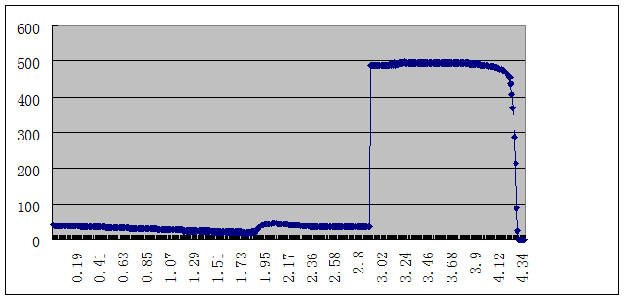

V_MIC
ABB  Mb_sel_bit05H[15:14] | Vbat=4.2V | Vbat=3.4V
 | Output Voltage(V) | Output Voltage(V)
00 | 1.60 | 1.60
01 | 1.71 | 1.71
10 | 1.83 | 1.83
11 | 1.97 | 1.97

Charge Characteristics
CC  current | 13H[9:7]=chr_cc_i_bit | chr_current (mA)
 | 000 | 41
 | 001 | 70
 | 010 | 109
 | 011 | 166
 | 100 | 223
 | 101 | 329
 | 110 | 474
 | 111 | 580



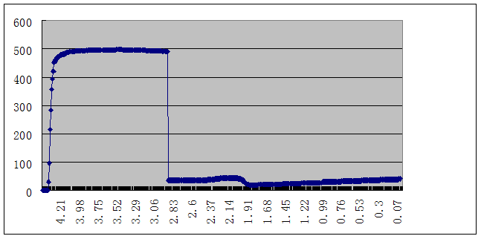

Digital IO DC Characteristics

Symbol | Description | Min.(V) | Typical(V) | Max.(V)
VDD | All of power for digital usage | VDD-0.2 | 1.8/2.8 | VDD+0.2
VIL | CMOS Low Level Input Voltage | 0 | - | 0.3*VDD
VIH | CMOS High Level Input Voltage | 0.7*VDD | - | VDD
VTH | CMOS Threshold Voltage | - | 0.5*VDD | -

Digital IO AC Characteristics (SPI Interface Timing)

Symbol | Description | Min. | Typ. | Max. | Unit
tCLK | SCLK Cycle Time | 35 | - | - | ns
tR | SCLK Rise Time | - | - | 50 | ns
tF | SCLK Fall Time | - | - | 50 | ns
tHI | SCLK High Time | 10 | - | - | ns
tLO | SCLK Low Time | 10 | - | - | ns
tSU | SDI Setup Time to SCLK↑ | 15 | - | - | ns
tHOLD | SDI Hold Time to SCLK↑ | 10 | - | - | ns
tEN1 | SEN↓ to SCLK↑ Delay Time | 10 | - | - | ns
tEN2 | SCLK↑ to SEN↑ Delay Time | 12 | - | - | ns








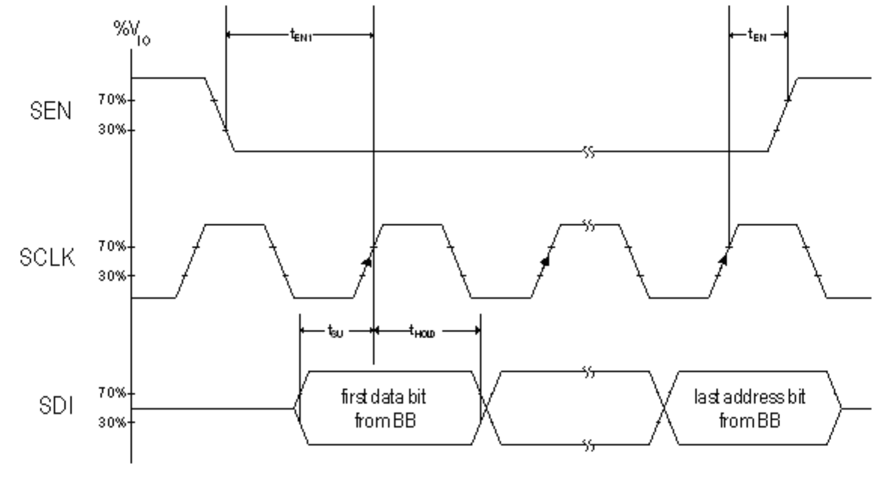
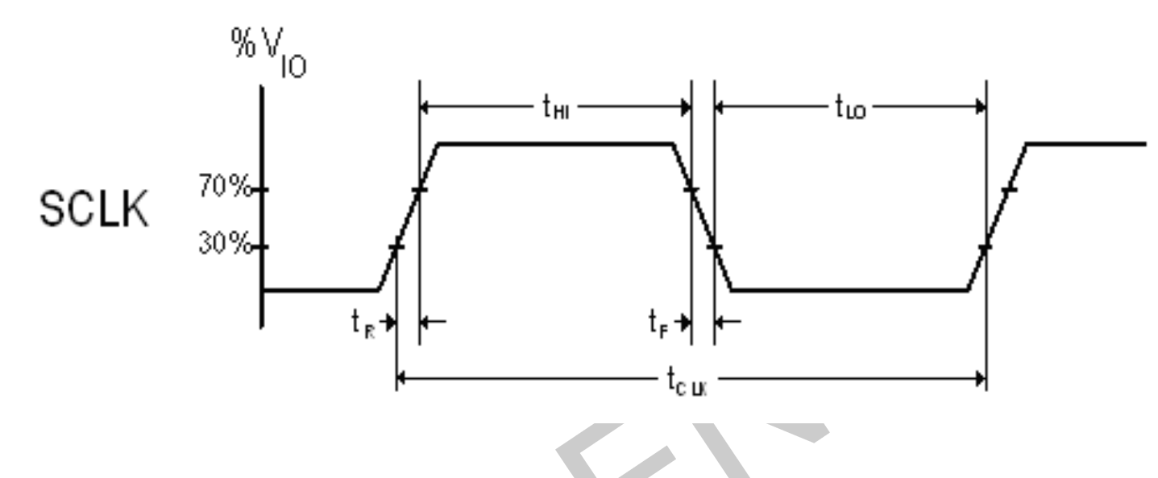

Symbol | Description | Min. | Typ. | Max. | Unit
tEN3 | SEN↑ to SCLK↑ Delay Time | 12 | - | - | ns
tW | SEN Pulse Width | 10 | - | - | ns
tCA | SCLK↑ to SDO Delay Time | - | - | 27 | ns
Cload | Digital Input Pin Capacitance | - | - | 5 | pF
fREF | Crystal Reference Frequency | - | 26 | - | MHz

Figure E.1: SCLK Timing Diagram

Figure E.2: SPI Write Timing Diagram







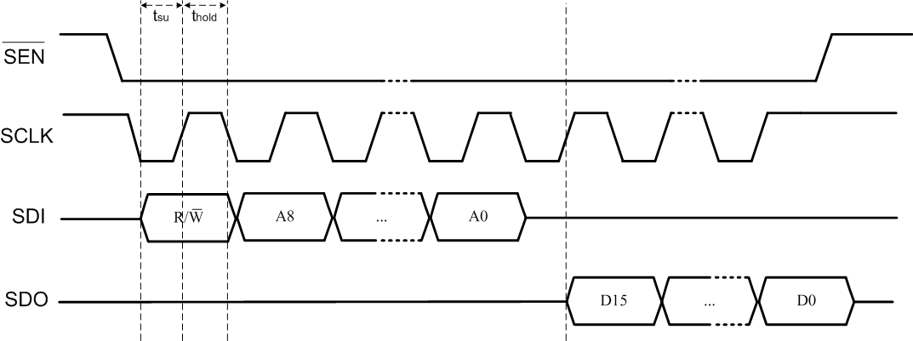

Figure E.3: SPI Read Timing Diagram



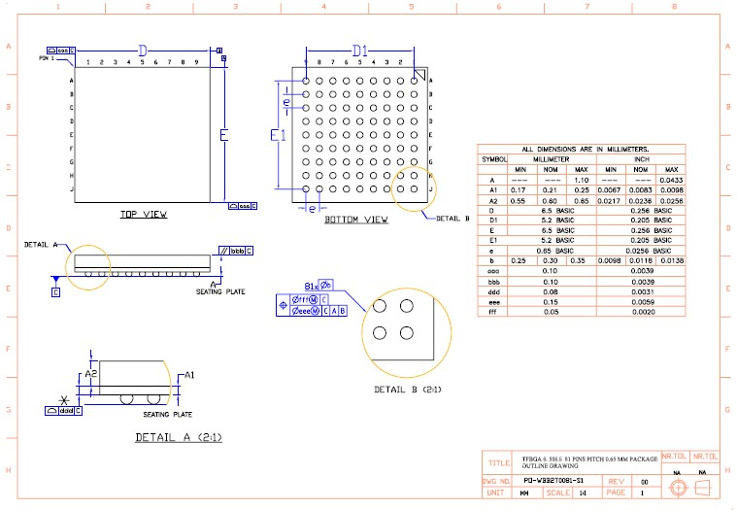

- PACKAGING

- BALL OUT

 | 1 | 2 | 3 | 4 | 5 | 6 | 7 | 8 | 9
A | SW_BUCK | V_CORE | SW_BUCK2 | SW_GND | VBAT_PMU | CORE_GND | TST_H | ANA_TEST_EN | QN_RXTXDATA
B | KEY_P | CLK_OUT | VBUCK2_2V4 | SW_GND | VBAT_PMU | CORE_GND | RESETB_EXT | QP_RXTXEN | CAM_DATA<5>
C | AC_R | GPADC_IN<0> | KEY_SENSE | PROG_EFUSE | CORE_GND | CORE_GND | SDAT<3> | IP | CAM_DATA<7>
D | IS_CHG | VBAT_SENSE | HST_CLK | POWERKEY | KEYOUT<4> | GPIO<2> | SDAT<2> | IN_STROBE | CAM_DATA<6>
E | V_USB | GDRV | KEYOUT<3> | KEYOUT<2> | KEYIN<4> | SDAT<0> | SSD_CMD | CAM_DATA<4> | BT_GND
F | KEYOUT<1> | KEYIN<3> | LINE_IN_L | LINE_IN_R | SDAT<1> | SSD_CLK | UART2_TXD | UART2_RXD | BT_GND
G | FM_RFIP | KEYIN<1> | AU_HPL | AU_HPR | USB_DP | AU_RCV_P | I2C2_SCL | I2C2_SDA | BT_RFIP
H | FM_RFIN | FM_GND | AU_MIC_N | AU_MIC_P | USB_DM | AU_RCV_N | HST_RXD | GPIO<3> | GPIO<1>
J | V_ANA | AUD_GND | V_MIC | V_MMC | V_PAD | DECAP_BTDVDD | HST_TXD | XVR_XTAL2 | XVR_XTAL1

Figure G.1: RDA5855E Ball out diagram




- GLOSSARY

Name | Description
AHB | AMBA Advanced High-performance Bus.
AHB2AHB | Bridge allowing Sys AHB to communicate with BB AHB, and vice versa.
AIF | RDA5855E's Audio Interface, including PCM, DAI and Audio Analog Interface.
APB | AMBA Advanced Peripheral Bus, slow bandwidth bus.
ATR | Answer To Reset, see SCI module for details.
Comfort Tone | Tone generated by the AIF, used to indicate ringing, occupied...
CS | Chip Select.
DAI | Digital Audio Interface, part of the AIF used for test purpose.
DMA | Direct Memory Access, can copy a part of the memory at an other address.
DTMF | Dual Tone Multi Frequency generated by the AIF when a number is dialed.
EBC | External Bus Controller, to connect external RAM, polyphonic chips, MMC...
ETU | Elementary Time Unit, see SCI module for details.
GP ADC | General Purpose Analog to Digital Converter.
IFC | Base Band Intelligent Flow Controller, a bridge between AHB and APB buses.
IrDA | Infra Red communication protocol used by RDA5855E's UART infra red mode.
Mailbox | Communication module between the Sys AHB bus and the BB AHB bus.
MMC | Multi Media Chips.
PCM | Pulse Code Modulation, the part of the AIF that outputs samples in serial.
PLL | Phase-Locked Loop.
SPI | Serial Peripheral Interface.
Sys | System side of RDA5855E, dedicated to the application, MMI.
TCU | Timing Control Unit, handle the scheduling of individual events.
UART | Universal Asynchronous Receiver Transmitter, asynchronous serial port.
VCO | Voltage Controlled Oscillator.
XCPU | System RDA's 16/32-bit RISC CPU.




Document History

The evolution of this document is described in the following table:

Version | Date | Description
1.00 | 2013-05-24 | Initial version.
1.01 | 2013-10-25 | Update pinout

