Library Blockchain Lending Tracker — Formative 2
GitHub: https://github.com/relisha1/Individual-Assignment-1
1. Introduction
Formative 1 built a blockchain ledger for library lending — every borrow and return became a block, chained together with SHA-256 and signed with ECDSA, so a past record couldn't be edited without it being obvious. This formative adds two things on top of that: a token reward for returning books, and a mining step that has to happen before any of it counts.
The idea is to mirror how a real blockchain works a bit more closely. Right now, when someone returns a book, nothing happens instantly — the record just waits in a pending pool. A miner has to come along, do some proof-of-work, and confirm it before it's added to the permanent chain and the member's balance actually changes. I built two different ways of tracking who owns how many tokens (UTXO and account-based), and three different ways of simulating mining (solo, pool, and cloud), since the assignment wanted a sense of how each one works, not just one mining style.
2. How Returning a Book Now Triggers a Token Transaction
Borrowing still works the same as before — the registries get checked, the book gets marked as out. But now, instead of becoming a confirmed block right away, the borrow event goes into a pending pool. It's signed at that point (so no one can later claim it said something different), but it doesn't have a position in the chain yet and it isn't linked to anything.
Returning works the same way. If the book comes back before its due time, the member earns 10 tokens; if it's late, they earn 5. If a book is just never brought back, nothing happens — no block, no transaction, nothing to confirm. The reward amount and a transaction ID (a SHA-256 hash of who, what, and when) get attached to the return block right away, but — and this is the part that's different from Formative 1 — the member doesn't actually receive the tokens yet. That only happens once a miner confirms the block.
One thing worth being upfront about: a real 14-day loan period would make it impossible to demonstrate a late return in a short video, so I set the loan period to 20 seconds instead. It's a clearly marked constant in the code (LOAN_PERIOD_SECONDS) and the README says exactly how to change it back to something realistic.
3. The Pending Pool and How Mining Confirms Blocks
The pending pool is just a second list of blocks, separate from the chain. A block sits there — fully signed, but with no index and no previous_hash yet — until it gets mined. Mining is where a block actually gets its place in the chain: its index is set to wherever the chain currently ends, its previous_hash is copied from the last confirmed block, and then the program searches for a nonce that makes the block's hash start with enough zeros (the difficulty).
Once that nonce is found, the block is appended to the real chain. If it was a return with a reward attached, that's the moment the member's balance actually updates — not before. I think this is the part of the assignment that matters most: it shows that confirmation isn't just a formality, it's the thing that makes a transaction real.
4. The UTXO Model
UTXO stands for "unspent transaction output," and it's the model Bitcoin uses. Instead of a single number representing someone's balance, tokens exist as individual chunks — outputs from past transactions that haven't been spent yet. A member's balance is just the sum of all the unspent chunks that belong to them.
When a book is returned and confirmed, the reward creates a brand new chunk (a "coinbase" style output, since it's new tokens being minted, not moved from somewhere else) owned by that member. No fee applies here, since there's nothing being spent.
Spending is different. If a member wants to send tokens to someone else, the program gathers up their unspent chunks until it has enough to cover the amount plus a 1-token fee. If there's more than needed, the leftover comes back to the sender as a new "change" chunk — the same idea as getting change back from a cash payment. If they don't have enough chunks to cover it, the transfer is rejected outright. Every chunk that gets used is marked spent so it can never be used again, which is what stops double-spending.
5. The Account-Balance Model
This one is simpler to think about, and it's closer to how a bank account or Ethereum works. Each member just has one number: their balance. A reward adds directly to it. A transfer checks that the sender has enough, then subtracts from one balance and adds to the other.
The one extra piece is the nonce. Every account has a counter that starts at 0, and every outgoing transfer has to use the exact next expected number. If someone tries to reuse an old nonce or skip ahead, the transfer is rejected. This is the same idea real blockchains use to stop someone from replaying an old, already-processed transaction. I also keep a running history for each account — a linked list of every transfer that account was part of, including the reward credits — so there's a full paper trail for any member.
6. Comparing the Two Models
 | UTXO | Account balance
How balance is found | sum of unspent outputs | a single stored number
Stops double-spending | marking outputs as spent | the nonce counter
Change | an explicit change output | not needed — balance just updates
History | scattered across many outputs | one linked list per account
Easier to reason about? | more moving parts, closer to real Bitcoin | simpler, closer to a bank account

Neither one is "better" exactly — they trade off differently. UTXO makes it very easy to prove exactly where every token came from, since each one traces back to a specific transaction, but it means more bookkeeping (you can end up with lots of small chunks). Account balances are easier to follow at a glance and need less data, but you lose that direct traceability unless you keep a separate log, which is why I added the transaction history list for that model.
7. How the Mining Simulations Work
7.1 Solo mining — real proof-of-work
This one isn't simulated at all — it's the real thing, just at a small scale. For each pending block, the program tries nonce = 0, 1, 2, and so on, hashing the block each time, until the resulting hash starts with however many zero hex digits the difficulty asks for (default 2). It counts every attempt and shows that number once it succeeds. Raising the difficulty by one roughly multiplies the expected attempts by sixteen, which is easy to see just by bumping it up during a demo.
7.2 Pool mining — shared real work, simulated split
Pool mining still does the same real proof-of-work search for every pending block, so the total attempt count is genuine. What's simulated is how that work gets divided: I generate a handful of fake miners, each given a random "hash power" weight, and split the real attempt count between them proportionally to those weights. A 2% pool fee comes off the top of the block reward first, and what's left is shared out the same way — more weight means a bigger share of both the attempts and the reward. The result is printed as a table.
7.3 Cloud mining — rental economics
Cloud mining is framed differently on purpose: in real life, a cloud miner doesn't do any hashing themselves, they just pay for someone else's. So this mode runs for however many rounds the user rents (1 to 5), and each round charges a fixed rental fee and credits a reward (which varies, since real mining payouts aren't constant). If there's still something in the pending pool, that round actually mines and confirms a real block behind the scenes. The program tracks gross earnings, total fees, and net profit across all rounds, and prints a warning the moment cumulative fees pass cumulative rewards — which happens more often than you'd think, which is sort of the point of the warning.
8. Design Choices and Assumptions
- Loan period is 20 seconds for demo purposes, documented clearly in both the code and the README, with the real 14-day value left as a comment.
- The miner's own reward (solo/pool/cloud) is displayed but not credited to any member account, since a miner isn't necessarily a library member — it's shown to demonstrate the mechanism, not to model miner identity.
- UTXO transfers made during a session aren't written to blockchain.dat — only lending blocks are. On restart, reward credits reappear because they're replayed from the chain, but manual transfers from the previous session don't carry over. I'm noting this here rather than hiding it, since it's a real limitation of the current persistence approach.
- The ledger model (UTXO vs account) is chosen once at startup and applies for that whole session, rather than letting someone switch mid-run, since mixing the two models on the same data would be confusing to reason about.
9. Screenshots
UTXO model: borrowing, mining a return on time, viewing the confirmed chain, the UTXO set, and a transfer with change returned:
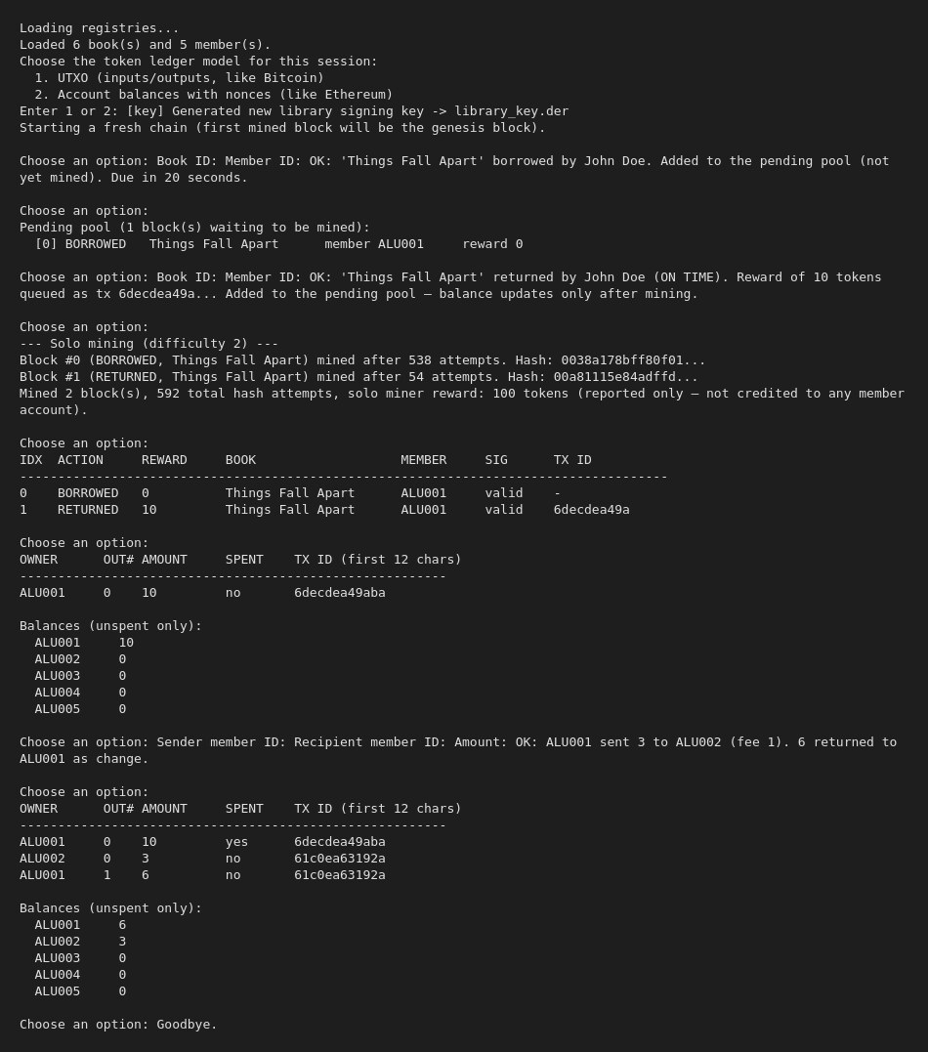
Account model: an overdue loan being flagged, a late return earning the reduced reward, a nonce-based transfer, and the resulting transaction history:
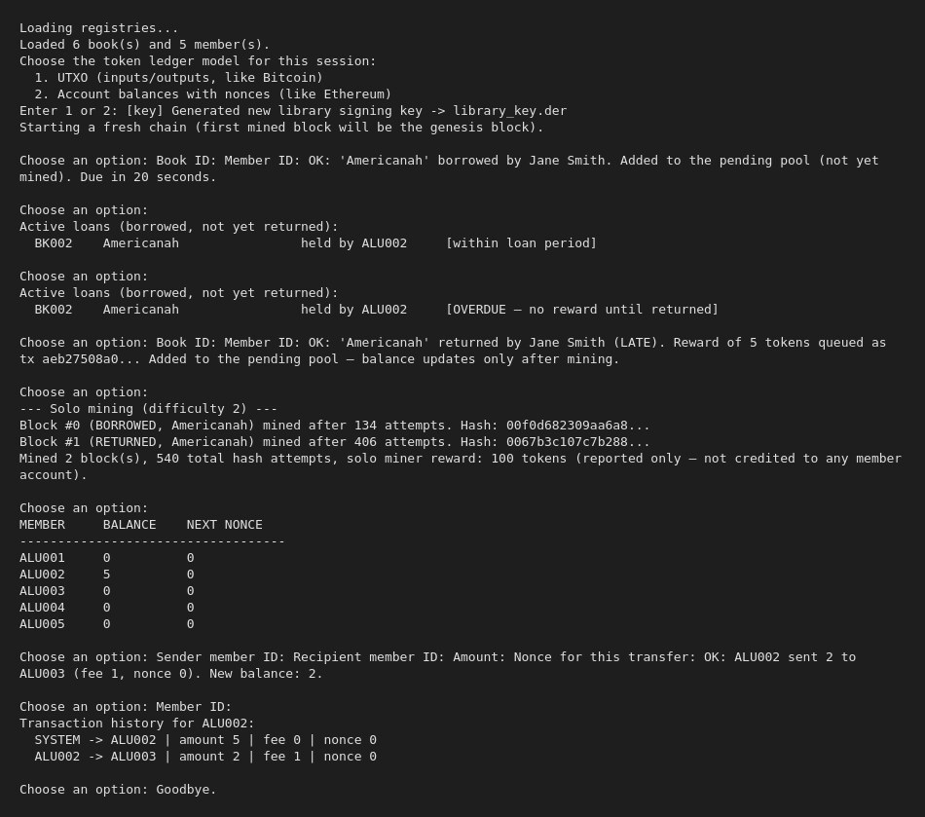
Pool mining's reward-sharing table, cloud mining running into an unprofitable round, and tamper detection catching an edited block then confirming the chain is valid again once restored:
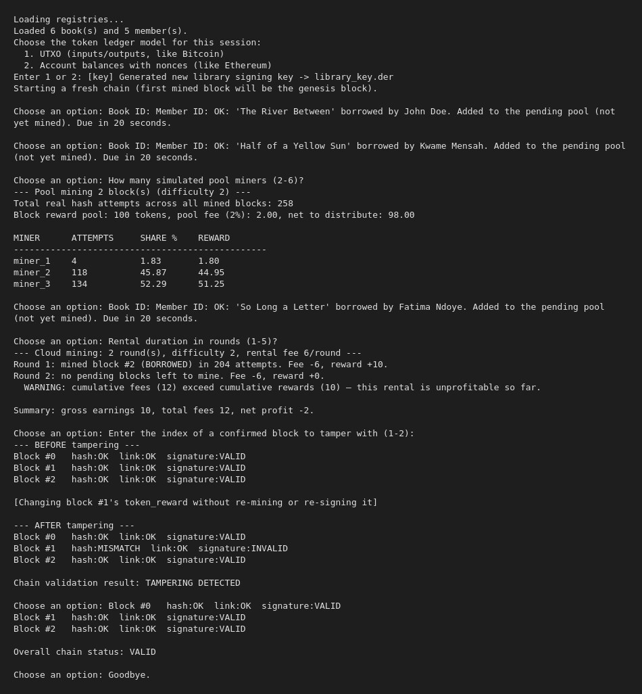
10. Test Results for Edge Cases
Case | What I tested | Result
Book never returned | Left a book borrowed and just checked option 5 without returning it | Shown as an active/overdue loan; no transaction, no block, exactly as expected
Insufficient balance | Tried to send more tokens than a member had (both models) | Rejected with the exact shortfall shown
Reused/incorrect nonce | Sent a transfer with the wrong nonce under the account model | Rejected: "ERROR: wrong nonce. Expected X, got Y."
Unprofitable cloud rental | Ran cloud mining with rounds where the pending pool ran dry partway through | Fee still charged with no reward that round, and the program printed the unprofitability warning once fees passed rewards
Tampering | Edited a confirmed block's token_reward directly in memory, without re-mining or re-signing it | Hash mismatch and invalid signature caught immediately by chain validation
11. System Design
This lays out the full flow — how a borrow or return becomes a pending block, how mining turns it into a confirmed one, and how that confirmation feeds into whichever ledger model is active.
Borrow / Return
checked against books.txt / members.txt
return compares now vs. due_date
on time = 10 tokens, late = 5, none if never returned
↓
Pending Pool
block is signed here (ECDSA)
no index or previous_hash yet
waits for a miner
↓
Solo Mining  real nonce search  leading-zero hash target  reports attempt count | Pool Mining  same real search  simulated miner split  2% pool fee | Cloud Mining  rental fee per round  reward per round  profit/loss tracked
↓
Confirmed Chain
block gets its index + previous_hash
hash now includes the nonce
chain validation checks hash, link, and signature
↓
UTXO Ledger  reward = new unspent output  transfers spend outputs + fee  leftover returned as change | Account Ledger  reward credited to balance  transfers need the right nonce  full history per member

