Design and Implementation of a Blockchain-Based
Library Book Lending Tracker
Technical Report

1. Introduction
Traditional library lending logs are ordinary files or database rows: anyone with write access to them can quietly edit a record after the fact — a librarian marking a lost book “returned”, or a disputed borrow silently disappearing. This project addresses that trust problem by recording every borrow and return event as a block in an append-only blockchain, where each block is cryptographically linked to the one before it and digitally signed by the library's signing key.
Any attempt to alter a past record — even a single character in a book title or an action field — changes that block's SHA-256 hash, breaks the hash-chain linkage to the following block, and invalidates the ECDSA signature that was computed over the original data. The system therefore does not prevent someone from editing the underlying data file directly, but it guarantees that such tampering is always detectable during chain validation.
The system is implemented in C, using only the C standard library plus the OpenSSL cryptography library (libcrypto) for SHA-256 hashing and ECDSA digital signatures. It is a single-process, single-library command-line application: books and members are loaded from plain-text registries, lending actions are validated against those registries, and the resulting chain is persisted to disk between runs.

2. Description of the Blockchain Implementation

2.1 Data model
Two registries are loaded at startup into fixed-size arrays of structs:
Struct | Fields | Source file
Book | book_id[20], title[80], author[50] | books.txt
Member | member_id[20], full_name[50], course_code[10] | members.txt

Every lending event becomes a Block with the following fields, matching the assignment specification:
Field | Type | Description
index | int | Position in the chain (0 = genesis)
timestamp | time_t | Unix time the block was created
book_id / book_title | char[20] / char[80] | Copied from the book registry
member_id / member_name | char[20] / char[50] | Copied from the member registry
action | char[10] | BORROWED, RETURNED (or GENESIS for block 0)
previous_hash | char[65] | Hex SHA-256 hash of the previous block
signature | unsigned char[72] | ECDSA (P-256) signature over the block's core fields
hash | char[65] | Hex SHA-256 hash of the core fields plus the signature

The chain itself is a dynamically-growing array of Block structs (starting at 16 slots and doubling with realloc as needed), rather than a fixed-size array, so the ledger is not capped at a hard-coded number of transactions.

2.2 Block creation pipeline
Creating a block happens in two cryptographic steps, in this order:
- Sign: the block's core fields (index, timestamp, book_id, book_title, member_id, member_name, action, previous_hash) are concatenated into a single buffer, hashed with SHA-256 to produce a 32-byte digest, and that digest is signed with the library's ECDSA P-256 private key to produce the signature field.
- Hash: the same core-field buffer is concatenated with the signature bytes and hashed again with SHA-256 to produce the block's own hash field, which is what the next block's previous_hash will point to.
Signing the digest of the core fields (rather than the raw fields) and then separately hashing core fields + signature keeps the two cryptographic roles distinct: the signature authenticates who created the record (the library system, using its private key), while the hash provides the tamper-evident chain linkage.

2.3 Lending logic
- Borrow: both book_id and member_id must resolve in their registries, or the operation is rejected with “ERROR: Book or Member not found”. The chain is scanned backwards for the most recent block referencing that book_id; if its action is BORROWED, the book is already on loan and the request is rejected.
- Return: the same backward scan must find a block whose action is BORROWED for that book_id (and belonging to the same member); otherwise the return is rejected as having no active loan.
- Genesis: block 0 is created automatically the first time the program runs with no existing chain, with previous_hash set to 64 ASCII zero characters.

3. Security Mechanisms

3.1 SHA-256 hashing
SHA-256 is used in two places: to build the ECDSA signing digest, and to compute each block's own hash. Both use OpenSSL's SHA256() function. Because the hash is computed over the core fields and the signature together, an attacker cannot simply strip or replace the signature without also changing the block's hash — which would then no longer match the next block's stored previous_hash.

3.2 ECDSA digital signatures
Every block is signed with a 256-bit ECDSA key on the NIST P-256 curve (OpenSSL's ECDSA_sign / ECDSA_verify with curve id NID_X9_62_prime256v1). The library generates this keypair once on first launch and persists it (DER-encoded, via i2d_ECPrivateKey / d2i_ECPrivateKey) to library_key.der, so every block — across every run of the program — is verifiable against the same public key. Chain validation calls ECDSA_verify on every block's stored signature; a forged or edited block that was not re-signed with the correct private key fails verification immediately.
Implementation note: the sandbox this project was built and tested in ships the OpenSSL runtime library (libcrypto) but not the “libssl-dev” header package. Rather than vendor the full OpenSSL header tree, include/openssl_compat.h hand-declares the small number of function prototypes used (SHA256, EC_KEY_new_by_curve_name, EC_KEY_generate_key, ECDSA_sign, ECDSA_verify, i2d_ECPrivateKey, d2i_ECPrivateKey) and the build links directly against libcrypto.so.3. This was verified to compile, link and produce valid, verifiable 256-bit ECDSA signatures. On a machine with libssl-dev installed, these declarations can be swapped for the real <openssl/sha.h>, <openssl/ec.h> and <openssl/ecdsa.h> headers with no other code changes — see the comment block at the top of openssl_compat.h.

3.3 Chain validation
Validation walks every block in the chain and checks three independent conditions: (1) recomputing the block's hash from its stored fields and signature and comparing it to the stored hash value; (2) confirming the block's previous_hash equals the preceding block's stored hash (or 64 zeros, for the genesis block); and (3) verifying the ECDSA signature against the library's public key. A failure in any one of these three checks, on any block, causes the whole chain to be reported as tampered.

4. Data Persistence Approach
Two files persist state across runs:
- blockchain.dat — one pipe-delimited line per block (index, timestamp, book_id, book_title, member_id, member_name, action, previous_hash, signature length, hex-encoded signature, hash). Rewritten after every successful borrow or return, and re-parsed into the in-memory chain array on startup.
- library_key.der — the DER-encoded ECDSA keypair, generated once and reused so that signatures remain verifiable across restarts.
The book and member registries (books.txt, members.txt) are treated as read-only reference data: they are re-read from disk on every startup but never written to by the program.

5. Error Handling Strategy
- Startup: if either registry file is missing or contains zero valid rows, the program prints a specific error (“Could not open book registry...” / “...is empty.”) and exits before any chain operations are possible.
- Unknown IDs: borrow/return requests referencing a book_id or member_id absent from the registries are rejected with “ERROR: Book or Member not found” and no block is created.
- Business-rule violations: borrowing an already-on-loan book, or returning a book with no active loan (or a different borrower), are rejected with a specific message rather than silently creating an inconsistent block.
- Malformed persisted data: load_chain() skips any line in blockchain.dat that does not parse into exactly the expected number of fields, rather than crashing, so a partially-corrupted file degrades gracefully instead of taking down the whole program.
- Input parsing: menu selections and numeric prompts guard against non-numeric input (scanf failure) and clear the input buffer before re-prompting.

6. Screenshots of Application Execution
Registry loading, a valid borrow, two different invalid-ID rejections, viewing records and validating an intact chain:
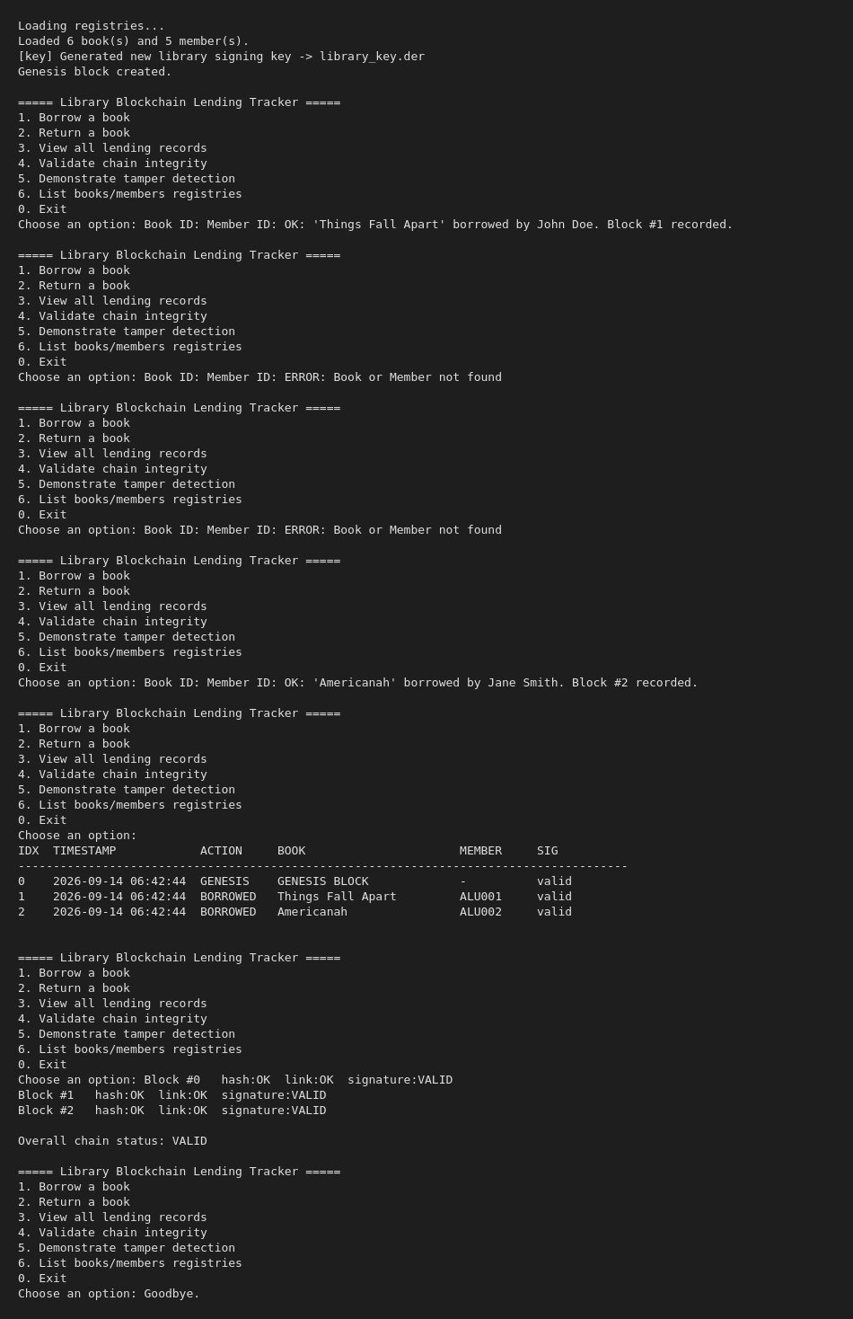
The tamper-detection demo: block #1 is edited in memory without re-signing it (exactly what a manual edit to a plain log file would look like), and chain validation immediately flags the broken hash and invalid signature:
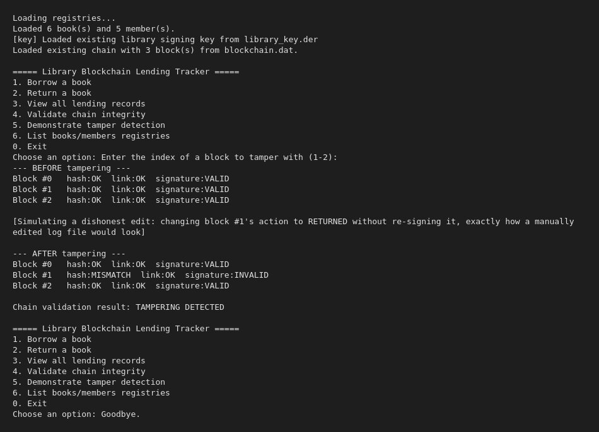

7. Challenges Encountered and Solutions
Challenge | Solution
No libssl-dev headers available in the build environment, only the OpenSSL runtime library. | Hand-declared the exact function prototypes needed in openssl_compat.h and linked directly against libcrypto.so.3; verified real ECDSA P-256 signatures (72-byte DER, matching the spec's signature[72] field) sign and verify correctly.
ECDSA signatures are variable-length (up to 72 bytes for P-256/DER), but the spec fixes signature as a 72-byte array. | Kept the fixed 72-byte buffer as specified, and added a companion siglen field recording the actual number of bytes used, so ECDSA_verify is always called with the correct length rather than assuming all 72 bytes are meaningful.
Demonstrating tamper detection without corrupting the real persisted ledger. | The tamper-detection menu option mutates only the in-memory chain, then reloads the in-memory chain from blockchain.dat afterwards — the on-disk ledger is never touched by the demo.
Keeping a stable identity for signature verification across separate runs of the program. | Generate the ECDSA keypair once, persist it (DER-encoded) to library_key.der, and reload it on every subsequent run instead of generating a fresh, unverifiable key each time.

8. System Design Diagram
The diagram below shows the registry-loading flow, the block-creation pipeline (sign, then hash), the resulting hash-linked chain, and how validation and persistence relate to it.


