

Mohd.Razia
Rella Sai Charan Reddi
2520090184
CSIT
CO-6

Case Study Topic: Pet Treatment Cost Optimization using 0/1 Knapsack Dynamic Programming
Developed an AVL Tree-based indexing system for managing pet records.
Implemented Dynamic Programming using the 0/1 Knapsack approach for treatment planning.
Features
- Treatment selection
- Budget optimization
- Maximum health benefit calculation
- Efficient decision-making
Real World Relevance
Hospitals and healthcare systems frequently use optimization algorithms to allocate resources effectively while minimizing costs.

Problem Statement

In a veterinary clinic, pet owners may have a limited treatment budget while multiple treatments are available such as vaccination, blood tests, X-rays, surgery, and medications.
The challenge is to select the best combination of treatments that provides maximum health benefits without exceeding the owner's budget.

Proposed Solution
The 0/1 Knapsack Dynamic Programming algorithm is used to determine the optimal combination of treatments.
Each treatment has:
- Cost (Weight)
- Health Benefit (Value)
The algorithm identifies the combination that maximizes total health benefit while staying within the budget limit.

Implementation Details:
Algorithm Used
0/1 Knapsack Dynamic Programming
Operations Performed
- Define treatment costs
- Define treatment benefits
- Set owner's budget
- Apply Dynamic Programming
- Calculate maximum benefit
- Time Complexity
Operation | Complexity
Knapsack DP | O(n × W)

Where:
n = Number of treatments
W = Budget limit

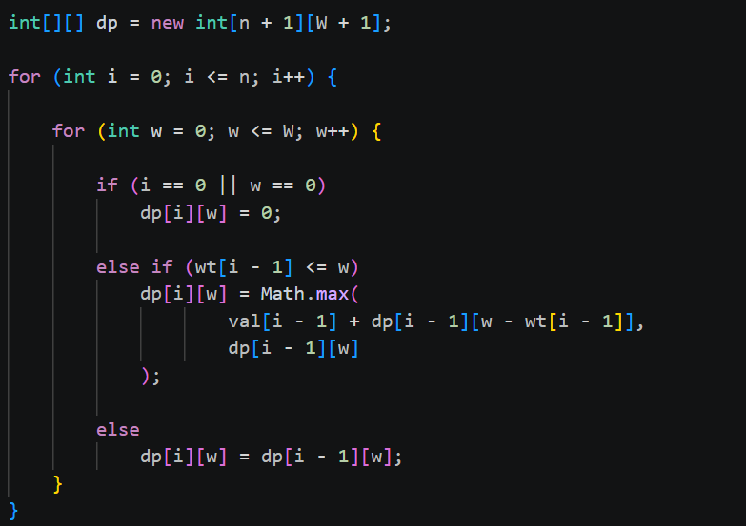

OUTPUT:
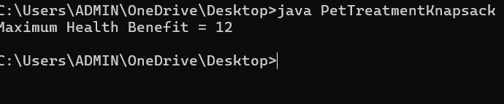

GitHub Link:

https://github.com/rellasaicharanreddy-bot/-PetCare-Smart-Veterinary-Clinic-Pet-Health-Management-System

