

Mohd.Razia
Rella Sai Charan Reddi
2520090184
CSIT
CO-4

Case Study Topic: Emergency Pet Ambulance Route Optimization using Dijkstra's Algorithm

Implemented Dijkstra's Shortest Path Algorithm for emergency route optimization.
Features
- Route distance calculation
- Shortest path identification
- Efficient graph traversal
- Emergency response planning
Real World Relevance
Veterinary hospitals use route optimization systems to improve emergency transportation and medical response services.

Problem Statement

In a smart veterinary healthcare system, emergency pet ambulances must reach pet owners quickly. The clinic network consists of multiple locations connected by roads with different travel distances.
The challenge is to determine the shortest route from the veterinary hospital to the pet owner's location to reduce emergency response time.

Proposed Solution

Dijkstra's Algorithm is used to calculate the shortest path between the veterinary clinic and pet locations.
The algorithm:
- Finds minimum travel distance.
- Reduces emergency response time.
- Improves ambulance routing efficiency.
- Supports real-time navigation systems

Implementation Details:

Algorithm Used
Dijkstra's Algorithm
Operations Performed
- Create clinic location graph
- Assign distances between locations
- Find shortest path
- Display minimum distance
Time Complexity
Operation | Complexity
Dijkstra | O(V²)
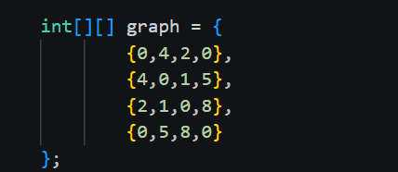

OUTPUT:
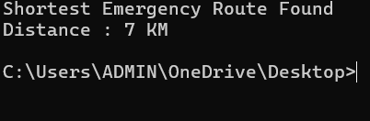

GitHub Link:

https://github.com/rellasaicharanreddy-bot/-PetCare-Smart-Veterinary-Clinic-Pet-Health-Management-System

