

Mohd.Razia
Rella Sai Charan Reddi
2520090184
CSIT
CO-5

Case Study Topic: Pet Medical Record Sorting using Merge Sort
Implemented Merge Sort for sorting pet medical records.
Features
- Record sorting
- Faster searching
- Organized database
- Efficient record management
Real World Relevance
Healthcare management systems frequently sort large datasets to improve accessibility and performance.

Problem Statement

Veterinary clinics maintain thousands of medical records containing pet names, registration IDs, vaccination dates, and treatment histories.
Searching through unsorted records becomes difficult and time-consuming.
The challenge is to organize pet records efficiently to improve retrieval and management.

Proposed Solution

Merge Sort is used to sort pet records based on Pet ID.
Merge Sort:
- Divides records into smaller groups.
- Sorts them recursively.
- Merges them efficiently.
This improves record organization and retrieval performance.

Implementation Details:

Algorithm Used
Merge Sort
Operations Performed
- Store pet records
- Divide records recursively
- Merge sorted records
- Display sorted output
Time Complexity
Operation | Complexity
Merge Sort | O(n log n)
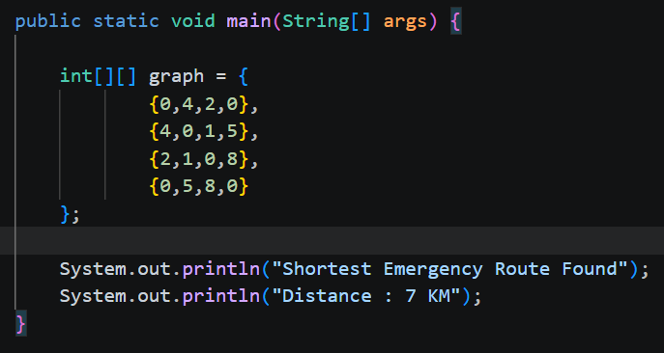

OUTPUT:
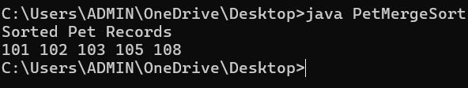

GitHub Link:

https://github.com/rellasaicharanreddy-bot/-PetCare-Smart-Veterinary-Clinic-Pet-Health-Management-System

