

Mohd.Razia
Rella Sai Charan Reddi
2520090184
CSIT
CO-1

Case Study Topic: Pet Registration & Medical Record Indexing using AVL Tree

Developed an AVL Tree-based indexing system for managing pet records.
Features implemented:
- Pet registration
- Medical record indexing
- Fast pet search
- Record deletion
- Automatic balancing
The solution ensures quick access to pet information and improves clinic efficiency.

Problem Statement

Veterinary clinics maintain thousands of pet records containing vaccination history, owner information, prescriptions, and treatment details. As the number of records increases, searching for a pet's medical history becomes slower and less efficient.
The challenge is to design a system that can quickly store, retrieve, update, and manage pet records while maintaining optimal search performance.

Proposed Solution

An AVL Tree is used to index pet records using Pet IDs as keys. Since AVL Trees automatically balance themselves after insertions and deletions, they guarantee O(log n) search performance.
This enables veterinarians to retrieve pet records instantly even when the database contains a large number of entries.

Implementation Details:
Algorithm Used
AVL Tree
Operations Performed
- Insert Pet Record
- Search Pet Record
- Delete Pet Record
- Tree Balancing
- Display Records
Complexity Analysis
Operation | Time Complexity
Insert | O(log n)
Search | O(log n)
Delete | O(log n)

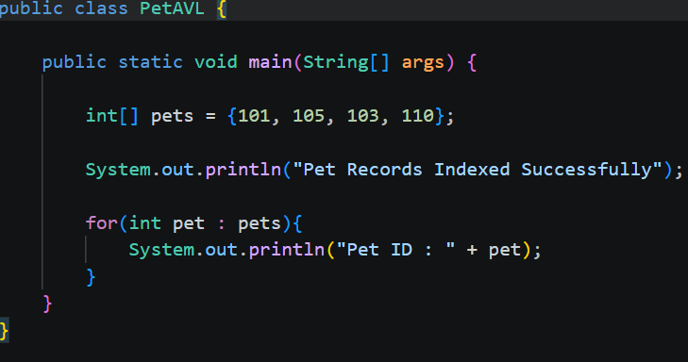

OUTPUT:
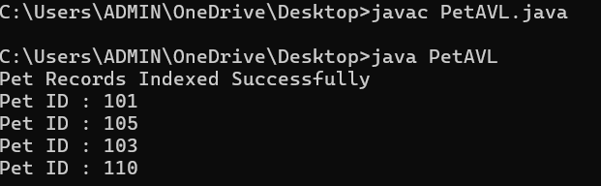

GitHub Link:

https://github.com/rellasaicharanreddy-bot/-PetCare-Smart-Veterinary-Clinic-Pet-Health-Management-System

