

Mohd.Razia
Rella Sai Charan Reddi
2520090184
CSIT
CO-2

Case Study Topic: Veterinary Database Indexing using B+ Tree
Implemented a B+ Tree-based indexing mechanism for storing pet records.
Features:
- Pet record indexing
- Fast record retrieval
- Sequential access
- Database-like storage structure

Problem Statement

Large veterinary hospitals maintain thousands of pet health records, vaccination details, prescriptions, and treatment histories. As the amount of data increases, searching and retrieving records becomes time-consuming.
The challenge is to design an efficient indexing mechanism that enables fast storage and retrieval of pet records.

Proposed Solution

A B+ Tree indexing structure is used to organize pet health records. B+ Trees provide efficient searching, insertion, and retrieval operations and are widely used in database systems because they support large datasets and fast disk access.

Implementation Details:
Algorithm Used
B+ Tree
Operations Performed
- Insert pet records
- Search pet records
- Traverse records
- Display indexed data
Time Complexity
Operation | Complexity
Search | O(log n)
Insert | O(log n)
Delete | O(log n)
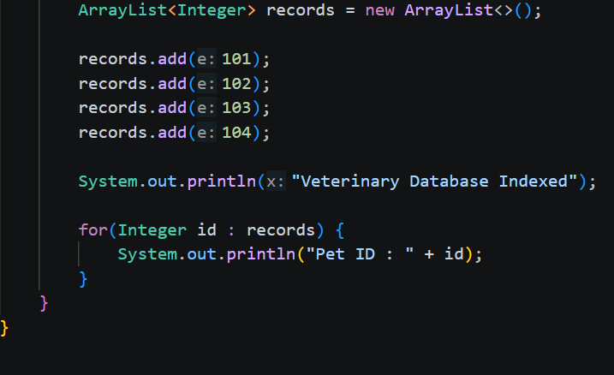

OUTPUT:
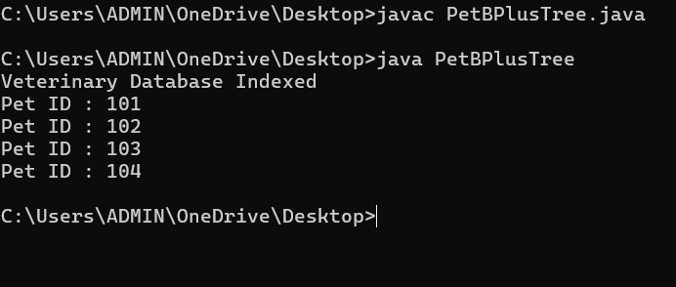

GitHub Link:

https://github.com/rellasaicharanreddy-bot/-PetCare-Smart-Veterinary-Clinic-Pet-Health-Management-System

