

Mohd.Razia
Rella Sai Charan Reddi
2520090184
CSIT
CO-3

Case Study Topic: Clinic Department Navigation using DFS Traversal
Implemented a graph-based clinic navigation system using DFS traversal.
Features:
- Department mapping
- Graph traversal
- Service flow visualization
- Efficient navigation
Real-World Relevance
Hospitals and clinics use graph structures to represent workflows, patient movement, and department connectivity.

Problem Statement

A veterinary clinic contains multiple departments such as Registration, Vaccination, Laboratory, Pharmacy, and Emergency Care. Efficient navigation among these departments is necessary for managing patient flow and clinic operations.

Proposed Solution

The clinic structure is represented as a graph. DFS traversal is used to explore all connected departments efficiently. This helps visualize service flow and supports workflow management.

Implementation Details:
Algorithm Used
Depth First Search (DFS)
Operations Performed
- Create clinic graph
- Connect departments
- Traverse departments
- Display navigation order
Time Complexity
Algorithm | Complexity
DFS | O(V + E)
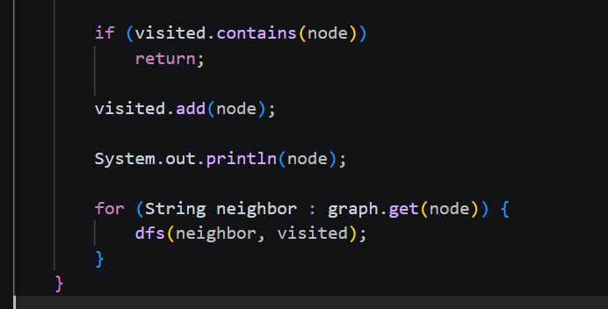

OUTPUT:
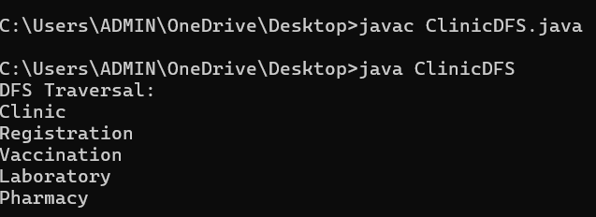

GitHub Link:

https://github.com/rellasaicharanreddy-bot/-PetCare-Smart-Veterinary-Clinic-Pet-Health-Management-System

