K L (DEEMED TO BE) UNIVERSITY
DEPARTMENT OF ARTIFICIAL INTELLIGENCE & DATA SCIENCE (AI&DS)

COMMUNITY-DETECTION PLATFORM
A Web-Based Platform for Weighted Graph Analysis and Community Detection

Project Report submitted for the partial fulfilment of grade for the course
Data Structures and Algorithms - 3 (25CS2103E)
A.Y. 2026–2027

Submitted by
C. Srikar Reddy (2520090164)
G. Manideep Patel (2520090100)
R. Sai Charan Reddi (2520090184)

Team Number: 20 | Section: 13

Under the guidance of
Dr. Dyuti Banerjee
Assistant Professor, Department of AI&DS
Hyderabad – 500090, Telangana, India

K L (DEEMED TO BE) UNIVERSITY
DEPARTMENT OF ARTIFICIAL INTELLIGENCE & DATA SCIENCE

DECLARATION
We hereby declare that the project report entitled “Community-Detection Platform” is a record of work prepared by C. Srikar Reddy (2520090164), G. Manideep Patel (2520090100), and R. Sai Charan Reddi (2520090184), submitted in partial fulfilment of the requirements for the course Data Structures and Algorithms - 3 (25CS2103E) at K L (Deemed to be) University. The report is based on the project abstract provided by our team. Any implementation-specific details should be verified against the final working application.
C. Srikar Reddy – 2520090164
G. Manideep Patel – 2520090100
R. Sai Charan Reddi – 2520090184

K L (DEEMED TO BE) UNIVERSITY
DEPARTMENT OF ARTIFICIAL INTELLIGENCE & DATA SCIENCE

CERTIFICATE
This is to certify that the project report entitled “Community-Detection Platform” is submitted by C. Srikar Reddy (2520090164), G. Manideep Patel (2520090100), and R. Sai Charan Reddi (2520090184) in partial fulfilment of the requirements for the course Data Structures and Algorithms - 3 (25CS2103E), during the academic year 2026–2027.

Signature of the Supervisor: ______________________________
Signature of the HOD: ____________________ Signature of the External Examiner: ____________________

ACKNOWLEDGEMENT
We express our sincere gratitude to our project guide, Dr. Dyuti Banerjee, for her guidance and support in preparing the Community-Detection Platform project. We also thank the Department of Artificial Intelligence & Data Science and K L (Deemed to be) University for providing the academic environment and resources required for this work.
We are grateful to our faculty members, classmates, friends, and families for their encouragement and assistance throughout the project. Their support helped us understand the problem, organize the proposed solution, and prepare this report.
C. Srikar Reddy – 2520090164
G. Manideep Patel – 2520090100
R. Sai Charan Reddi – 2520090184

TABLE OF CONTENTS
S. No. | Contents | Page
1 | Abstract | —
2 | Introduction | —
3 | Literature Survey | —
4 | Problem Statement and Objectives | —
5 | Hardware and Software Requirements | —
6 | System Design and Methodology | —
7 | Implementation | —
8 | Results and Discussion | —
9 | Conclusion and Future Scope | —
10 | References | —
Note: Page numbers can be updated after final formatting in Microsoft Word.

1. ABSTRACT
The Community-Detection Platform is a web-based system designed to identify and analyze communities in social, collaboration, and communication networks. It combines content information with graph connections to create a weighted interaction graph, providing a more meaningful representation of relationships between users or entities. The system processes text and interaction data, assigns weights based on connection strength and content similarity, and applies community-detection techniques to group closely related nodes. An interactive dashboard presents detected communities and quality measures such as modularity, density, and conductance. Users can explore network structure, community sizes, and partition results. The platform is intended to support analysis of complex networks and may be useful for social-media moderation, marketing analysis, research collaboration, and communication analysis. The project focuses on discovering hidden patterns and understanding how groups are connected.
Team Name: Community-Detection Platform — Team 20
Team Members: C. Srikar Reddy, G. Manideep Patel, R. Sai Charan Reddi

2. INTRODUCTION
Networks are used to represent relationships among people, organizations, documents, and other entities. In a social network, for example, nodes can represent users and edges can represent interactions or relationships. Some nodes form closely connected groups, commonly called communities. Identifying these groups can help explain how information flows and how different parts of a network relate to one another.
The Community-Detection Platform is proposed as a web-based tool for constructing and analyzing weighted interaction graphs. It combines graph connections with content similarity so that relationships can reflect more than the presence of an interaction alone. The platform groups closely related nodes and presents the resulting structure through an interactive dashboard.

2.1 Purpose
The purpose is to make community analysis easier to understand by presenting graph structure, community membership, and selected quality metrics in one interface.

2.2 Scope
The stated scope includes social, collaboration, and communication networks. Potential application areas include social-media moderation, marketing analysis, research collaboration, and communication analysis. The exact supported input formats and deployment scale depend on the final implementation.

3. LITERATURE SURVEY
Community detection is a common graph-analysis task that seeks groups of nodes with stronger or more meaningful relationships within groups than between groups. Network-analysis systems often represent entities as vertices and relationships as edges, while weighted graphs use edge weights to express connection strength.
The supplied project abstract extends this idea by combining interaction data with content information. Text similarity can help represent semantic relationships, while interaction strength captures how entities connect. A weighted graph can therefore provide a richer basis for grouping than an unweighted graph alone.
The abstract also identifies modularity, density, and conductance as measures for examining detected communities. These metrics provide different perspectives on group quality; no single metric should be treated as a complete judgment of a partition. The abstract does not specify a particular detection algorithm or dataset, so this report does not claim that a specific algorithm or external dataset was used.

4. PROBLEM STATEMENT AND OBJECTIVES

4.1 Problem Statement
Complex networks may contain many entities and relationships, making it difficult to identify meaningful groups and understand the connections between them manually.

4.2 Proposed Solution
Develop a web-based platform that combines interaction links and content similarity into a weighted graph, applies community-detection techniques, and presents community structure and quality metrics through an interactive dashboard.

4.3 Objectives
- Represent users or entities and their relationships as a graph.
- Combine interaction information and content similarity to assign meaningful edge weights.
- Apply community-detection techniques to group closely related nodes.
- Display network structure, community sizes, and partition results through a dashboard.
- Present modularity, density, and conductance to support interpretation of detected communities.
- Support analysis use cases such as moderation, marketing, collaboration, and communication analysis.

5. HARDWARE AND SOFTWARE REQUIREMENTS

5.1 Hardware Requirements
- Laptop or desktop computer
- Keyboard and pointing device
- At least 4 GB RAM recommended for basic development; larger graphs may require more memory
- Sufficient storage for source code and graph/input data

5.2 Software Requirements
- Operating system capable of running the selected development stack
- Web browser for accessing the dashboard
- Code editor or IDE
- A backend/runtime and graph-processing library appropriate to the implementation
- Data files containing interaction records and/or content information
The supplied abstract does not name the implementation language, framework, database, or graph library. The items above are general requirements for a web-based graph-analysis system; replace them with the exact technologies used in the final project.

6. SYSTEM DESIGN AND METHODOLOGY

6.1 High-Level Workflow
- Input collection: obtain content information and interaction records for the entities being analyzed.
- Graph construction: represent entities as nodes and their relationships as edges.
- Weight assignment: calculate or assign edge weights using interaction strength and content similarity.
- Community detection: apply a selected graph community-detection technique to group closely related nodes.
- Metric calculation: calculate modularity, density, and conductance for the resulting communities where supported.
- Dashboard presentation: display the graph, group sizes, and partition results for user exploration.

6.2 Core Data Model
A node represents a user or other entity. An edge represents a relationship or interaction between two nodes. Each edge may carry a weight that reflects the strength of the interaction, the similarity of associated content, or a combination of both. The exact weighting formula should be documented from the implemented code.

6.3 Community Quality Metrics

Modularity
Modularity estimates how strongly a network partition separates communities compared with a reference expectation. Higher values often indicate a clearer community structure, but interpretation depends on the graph and method.

Density
Density describes how many edges exist among nodes in a group relative to the number of possible edges. In an undirected simple graph, density is the ratio of observed internal edges to possible internal edges.

Conductance
Conductance compares connections leaving a group with the total degree or volume of the group. Lower conductance often indicates that a group has fewer connections to the outside relative to its total connectivity.

6.4 Dashboard Design
The abstract specifies an interactive dashboard that presents detected communities, network structure, community sizes, partition results, and quality metrics. Specific visual components and interaction controls should be described using screenshots from the completed application.

7. IMPLEMENTATION

Module 1 — Data Input and Processing
This module receives content information and interaction data. Records are prepared so entities and their relationships can be represented consistently. Input validation and handling of missing or duplicate records should be considered.

Module 2 — Weighted Interaction Graph
The graph module creates nodes for entities and edges for relationships. Edge weights are assigned using connection strength and content similarity, as stated in the project abstract. The implementation should document the normalization and combination rules used to calculate each weight.

Module 3 — Community Detection
The community-detection module applies a graph clustering technique to identify groups of closely related nodes. The supplied abstract does not identify the exact algorithm, so the final report should name the algorithm used in the source code and explain its parameters.

Module 4 — Metric Calculation
This module reports modularity, density, and conductance to help users inspect the quality and separation of detected communities. Metric definitions and calculation scope should remain consistent across displayed results.

Module 5 — Interactive Dashboard
The dashboard presents the graph structure, detected groups, community sizes, and partition results. It is intended to help users explore network organization without having to interpret raw graph data manually.

7.1 Algorithmic Considerations
Processing cost depends on the number of nodes, number of edges, content-similarity method, and community-detection algorithm selected. For large graphs, sparse graph representations, efficient preprocessing, and avoiding unnecessary pairwise comparisons can improve performance. Actual runtime and complexity should be reported only after measuring the implemented system.

8. RESULTS AND DISCUSSION
According to the supplied abstract, the intended output is an interactive dashboard that displays detected communities, community sizes, network structure, partition results, and metrics including modularity, density, and conductance. The platform is designed to make relationships and hidden group patterns easier to inspect.
The project’s main contribution is the combination of content information and graph connections into a weighted interaction graph, followed by community grouping and dashboard-based interpretation. The usefulness of the results depends on the quality of input data, the edge-weighting method, and the community-detection technique.
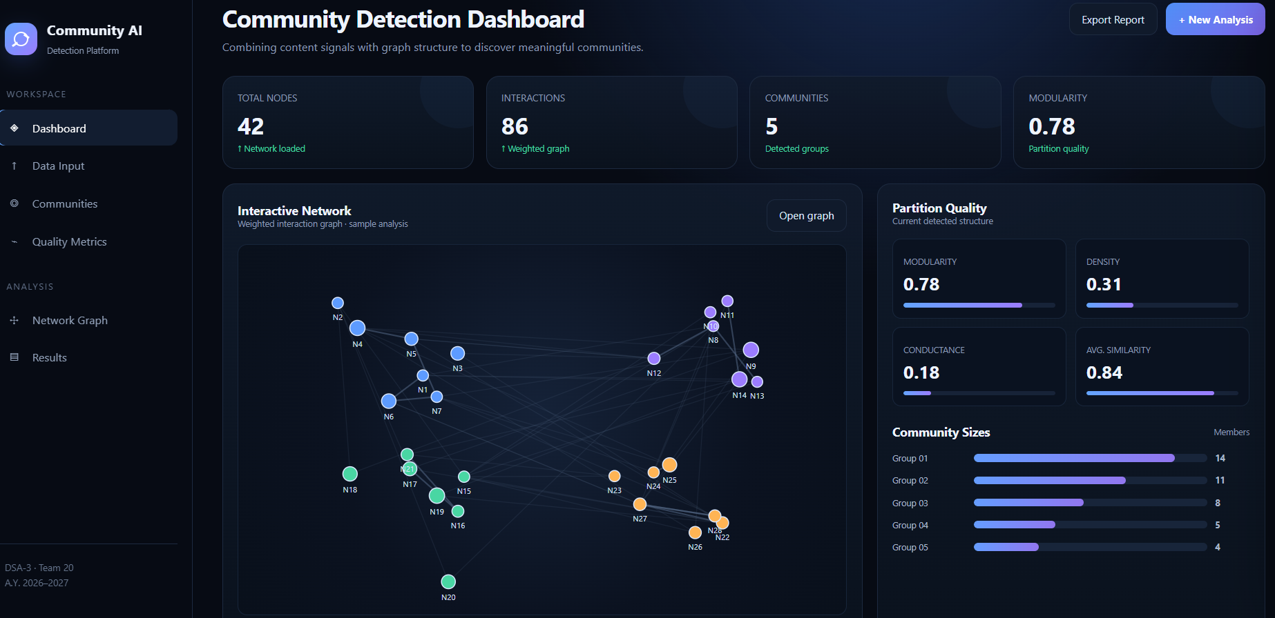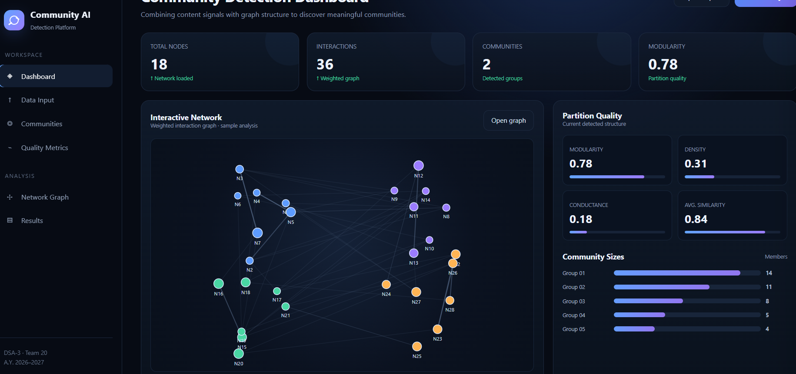

8.1 Results to Document from the Working Application
- Screenshot of the main dashboard and graph view.
- Example input network and the resulting detected communities.
- Community-size summary and partition visualization.
- Displayed modularity, density, and conductance values.
- Execution time and graph size for any performance test actually conducted.
No screenshots, numerical evaluation results, benchmark measurements, or named detection algorithm were included in the supplied abstract. These details should be added from the actual running application rather than invented.

9. CONCLUSION AND FUTURE SCOPE

9.1 Conclusion
The Community-Detection Platform proposes a web-based approach to identifying and analyzing communities in social, collaboration, and communication networks. By combining content similarity with graph interactions, the system constructs a weighted representation of relationships and groups closely related nodes. The dashboard is intended to present community structure and quality measures such as modularity, density, and conductance in an accessible form. The project illustrates how graph analysis can help reveal patterns that may be difficult to identify by inspecting individual relationships.

9.2 Future Scope
- Support larger networks through scalable graph storage and processing.
- Add import options for common network data formats and clearer data-validation reports.
- Allow users to compare different community-detection algorithms and parameters.
- Improve dashboard exploration with filtering, search, and node/community details.
- Add time-based analysis to study how communities change.
- Provide exportable reports and repeatable evaluation results.
- Strengthen privacy, access control, and responsible handling of interaction data.

10. REFERENCES
The project abstract does not provide formal citations for algorithms, graph metrics, or software libraries. Add references corresponding to the specific algorithm, libraries, and datasets used in the implementation. The following are suitable foundational references to verify and format according to the institution’s required citation style:
- Newman, M. E. J. (2006). Modularity and community structure in networks. Proceedings of the National Academy of Sciences, 103(23), 8577–8582.
- Fortunato, S. (2010). Community detection in graphs. Physics Reports, 486(3–5), 75–174.
- Wasserman, S., & Faust, K. (1994). Social Network Analysis: Methods and Applications. Cambridge University Press.

